 |  | 
How to import and process syncWriter data

Technical requirements

- Mac OS X (10.2. – Jaguar) with Java 1.3.1. (this combination was tested successfully, following versions should be OK also as long as the MAC has a PowerPC, not an Intel, chip and comes with the „Classic“ mode for running MAC OS 9.x applications).
- A runnable version of syncWriter (we tested with version D1-2.0.2. We don’t know whether other versions behave differently).
- The EXMARaLDA Partitur-Editor in its current version
- The Apple Script ExSync (downloadable from the EXMARaLDA Website: Download > Utilities > Apple Scripts)
- The Apple Script CountEntries (downloadable from the EXMARaLDA Website: Download > Utilities > Apple Scripts)

Preprocessing the syncWriter document

- Open the document in syncWriter, close all other syncWriter documents.
- Delete all image, movie and script tracks – those cannot be imported.
- For each track: if there isn’t a syncTab at the very beginning, insert a syncTab there and synchronise the first entry in the track with that syncTab
- If a track is not formatted in a standard font (e.g. and particularly in “HIAT Times”), select the whole track (⌘ + A) and assign that font to it (menu “Text”, item “Schrift”). That way, you make sure that the whole track is formatted in one font only.
- Start the script „CountEntries“. You’ll get a dialog showing you how many entries each track contains:

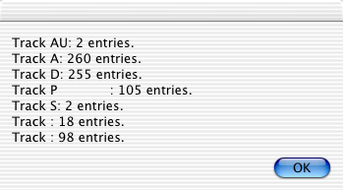

- Close that dialog by clicking on OK.
- Choose the tier with the largest number of entries (in the example above: Track A) and enter in it as many syncTabs as possible. For that purpose, go through all existing syncTabs. If the track in question is not synchronised with a given syncTab:
- select that syncTab
- put the cursor at the end of the nearest preceding entry in that track
- choose Sync > Mit Ziel-syncTab verbinden (or press the tabulator key)
- Save the syncWriter document under a new name and close it without quitting the syncWriter application

Reading out the syncWriter document
- Start the „ExSync“ script.
- You are asked to specify the document to be read out. Choose the document you saved in step #7.
- You are asked to specify the name of the output document. Browse to the desired folder and enter a name, appending the suffix „.xml”.
- The document is read out. This can take several minutes. During readout, a round, black and white cursor is shown – as long as this cursor is displayed, you should leave the computer alone – doing other things simultaneously can cause crashes. If the readout was successful, you’ll get the following message:

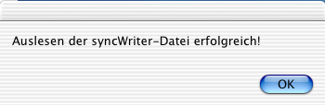

Importing the readout document in EXMARaLDA
- Start the EXMARaLDA Partitur-Editor
- Choose File > Import and then „ExSync file (*.xml)“
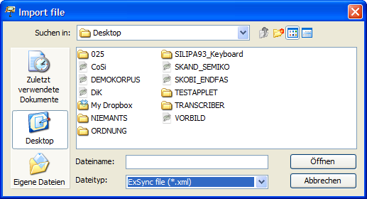
- Browse to the document created in steps 8-11 and click on Open. The document will be imported, and you’ll get a dialog with a message importing you about the import:

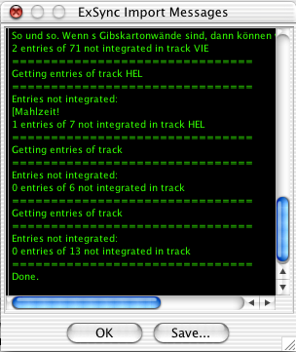

Ideally, you get the message „0 entries of n not integrated in Track xxx“. for each track, meaning that all entries from the syncWriter document could be integrated into the EXMARaLDA transcription. If this is not the case, those entries that could not be integrated, will be listed. In this case, proceed as follows:
- If the number of entries that could not be integrated is small, click on „Save...“ to save the messages in a text file. You can then open this text file in a (Unicode enabled) text editor and integrate the missing entries via Copy&Paste.
- If the number of entries that could not be integrated is big, this is a sign that you made errors in preprocessing the syncWriter document. In this case, repeat the steps described above.

- Close the dialog by clicking on OK. The imported transcription will be displayed in the Partitur-Editor and can be postprocessed.

Postproecessing
Speakertable
syncWriter does not have a speakertable. The import tries to construct a speakertable from the names of tracks. Check the result via Transcription > Speakertable... and correct it if necessary.

Assign tiers to speakers, categories and types
Tiers in EXMARaLDA must be assigned a speaker, a type and a category (see „Understanding the basics of EXMARaLDA). Carry out this assignment by selecting each tier and then choose Tier > Edit tier properties.

ExSync Event Shrinker
syncTabs in syncWriter mark the beginning of a simultaneous passage. It is theoretically possible to also mark the end of such passages. This, however, is often not done in practice. EXMARaLDA transcriptions, however, require the end points to be marked also. In the conversion process, therefore, an absent endpoint is simply replaced by the nearest following startpoint. The following structure in syncWriter...

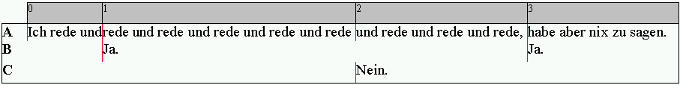

... thus results in the following structure in EXMARaLDA.

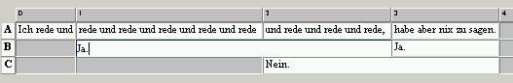

The first entry of speaker B extends over several time intervals reaching to the next entry in the same tier. The “„ExSync Event Shrinker“ can partly remedy this. It calculates, on the basis of the typographic extent whether an earlier endpoint can be chosen. After calling the „ExSync Event Shrinker“ the above transcription would look as follows:

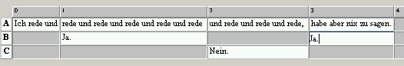

Although this is still not the desired structure, it is an improvement over the original one. Since the event shrinker can be applied fully automatically, it can thus save you some time in the postprocessing. To apply it, proceed as follows:

- Format the tiers in EXMARaLDA thus that the font sizes are similar to the font sizes used in the original syncWriter document.
- Choose Transcription > ExSync Event Shrinker… . You’ll get the following dialog:

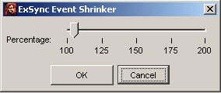

- The dialog asks you for a threshhold value for the shrink operation. Example: if the available space is smaller than 110% of the typographic extent of an entry, the entry will not be further shrinked. Usually, the default value of 105% works OK.
- Close the dialog by clicking on OK. The partitur will first be reformatted. Then the shrinker is applied, and the partitur is again reformatted. With larger transcriptions, this process can take a while.

Further postprocessing of end points
In the above example, there are still events remaining whose end points do not correspond to the actuual temporal relations. For example, the utterance “Ja” of speaker B most certainly ends long before speaker C starts his utterance “Nein”.

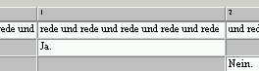

To correct this, you should ideally listen to the original recording and find out how the endpoint of B’s utterance relates to A’s utterance. Alternatively, you can estimate this point by looking at the typographic extent of the transcribed text. Then proceed as follows:

- Place the cursor in A’s utterance at the point where B’s utterance ends (here: in front of the first „und“):

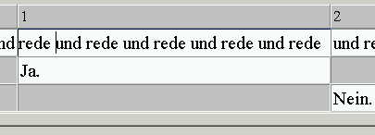

- Choose Event > Split Event. The event will be split at the cursor position.

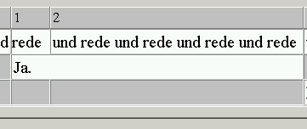

- Place the cursor in the event of speaker B and choose Event > Shrink event on the right. The right event boundary is moved to the left:

