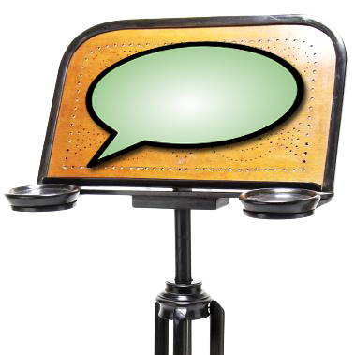 | 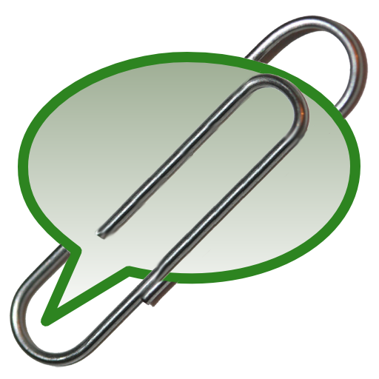 | 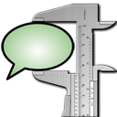
How to get started

This document explains how to install the EXMARaLDA tools and how to use the EXMARaLDA demo corpus to get a first impression of the EXMARaLDA system.

Contents

1. Installation of the tools 2
2. Demo corpus 2
3. Partitur Editor 2
4. Corpus Manager 2
5. EXAKT 2

1. Installation of the tools

2. Demo corpus

3. Partitur Editor

4. Corpus Manager

5. EXAKT

