 |  | 
How to make a transcription from a digital recording

This document explains how to use the EXMARaLDA Partitur-Editor for transcribing a digital recording of an interaction. Before you start reading this document, you should read

- Understanding the basics of EXMARaLDA
- How to get started
- Audio and video support in EXMARaLDA.

You should also have a digital recording, preferably a WAV audio file, with which you can try out the steps described in this document. This document uses the 'Monty Python: My theory' recording from the EXMARaLDA demo corpus.

Contents

1. Setting up the transcription 2
Create meta information 2
Create a speaker table 2
Link the recording 3
Create tiers 4
2. Transcribing 4
Append an interval 5
Fine tune the end point 5
Enter transcription 6
Repeat... 6
Transcribing complex passages 6
3. Additional hints 8
Buttons on the right side below the waveform 8
Navigation and selection in the waveform view 8
Transcribing a video 9

1. Setting up the transcription
When you start the Partitur-Editor (or when you choose File > New), you get a transcription with a predefined speaker 'X', one tier of category 'v' and type 't' for that speaker, and a timeline with two timepoints:

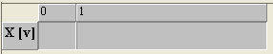

Before you start transcribing, you have to setup some general things for the transcription.

Create meta information
Transcription > Meta information... takes you to a dialog in which you can enter some general information about the transcription:

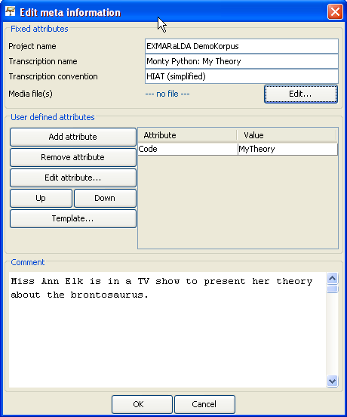

Some categories are predefined; others can be freely added in the section "User defined attributes". Press OK when you're finished.

Create a speaker table
Transcription > Speakertable... takes you to a dialog in which you can define speakers and enter general information about them.

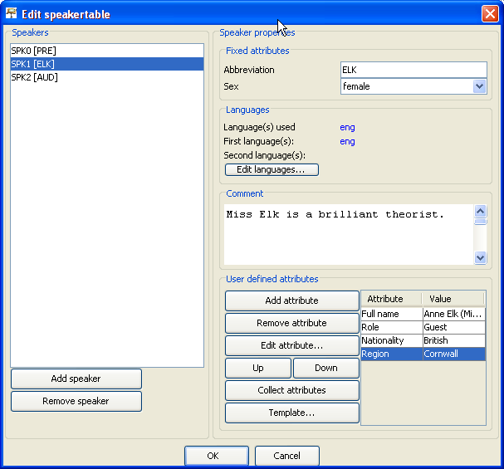

Uses the Add speaker button to add as many speakers as participate in the interaction you have recorded (three in this example). Make sure that you give each speaker a meaningful Abbreviation – these abbreviations (PRE for 'Presenter', ELK for 'Miss Elk' and AUD for the audience in the example) will reappear in several places during transcription. Press OK when you're finished.

Link the recording
Transcription > Recordings... takes you to a dialog in which you can specify one or several recordings with which you want to work.

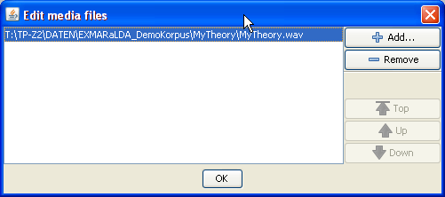

Click the Add... button and navigate to your WAV recording. Then click OK. The Partitur-Editor will then do three things.

- the WAV file will be loaded into the editor's player
- the waveform panel will display a waveform of the recording
- the first timepoint in the recording will be assigned the value 0.0 (for the beginning of the recording), the last timepoint will be assigned the value which corresponds to the end of the recording. You will also notice that the last timepoint now appears in red and that you are not able any more to enter text into the last interval.

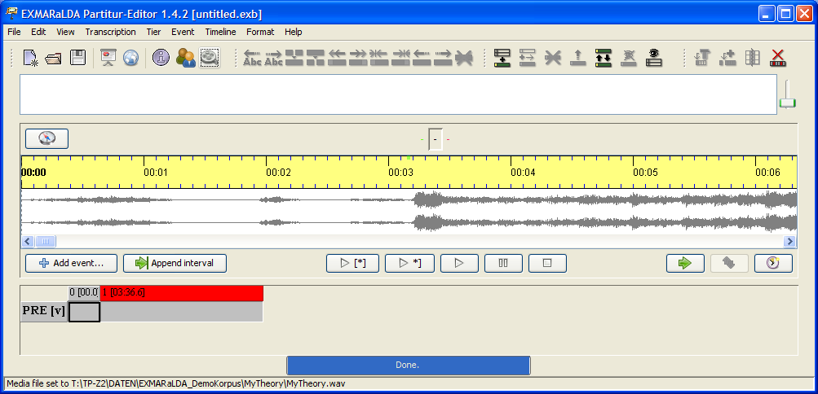

Create tiers
As a last step, you need to create tiers for every speaker. Tier > Add tier... will display a dialog in which you can specify tier properties:

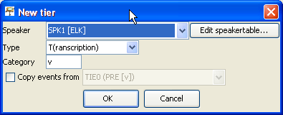

For the purposes of this tutorial, you should add one tier of type 'T(ranscription)' and category 'v' (for: verbal) for each speaker. Tier types and categories are explained in ' Understanding the basics of EXMARaLDA'. Your transcription should then look something like this...

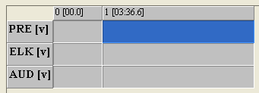

... and you're ready to start transcribing.

2. Transcribing
As long as the speakers in the communication speak one at a time (i.e. there is no overlap), the most efficient way to transcribe consists of three recurring steps:
- Append an interval on the timeline
- Fine tune the end point of this interval
- Enter a transcription for this interval into an appropriate tier

Append an interval
Press the Append interval... button. This will make a selection in the recording of two seconds length after the last-but-second point of the timeline. Since we've just started and the timeline only contains two timepoints, the first selection will stretch from 0.0 to 2.0 seconds:

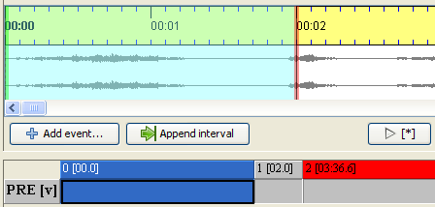

Note that the left boundary of the selected interval is now green, the right boundary is red, and the interval labeled '0' in the partitur is selected. This means that the left boundary is now attached to timepoint 0, the right boundary to timepoint 1. If you click on the Play Selection button, this part of the recording will be played.

Fine tune the end point
You can now move the right boundary by dragging it with the mouse (or, provided your mouse cursor is near the right boundary, by scrolling the mouse wheel). You'll notice that the absolute time value of timepoint 1 in the partitur will change as you move the right boundary of the selection:

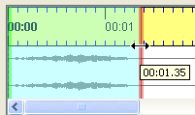

Use the Play Selection button and move the right boundary repeatedly until the selection in the recording corresponds to something you want to transcribe.

Enter transcription
Enter an appropriate transcription into the appropriate cell in the partitur.

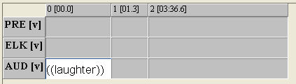

Repeat...
Press the Append interval... button again. The selection will be shifted such that the old end point becomes the new start point. Fine tune the new end point and enter the next piece of transcription as described above.

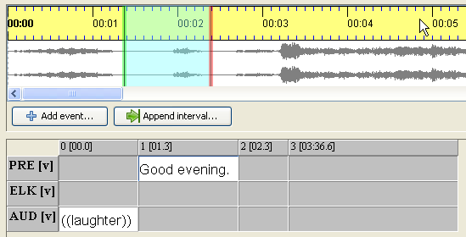

Transcribing complex passages
The method using the Append interval... button works fine as long as only one speaker is speaking or speakers are taking turns in an "orderly" manner. As soon as there is overlap between speaker turns, however, you will need to use a different method. Let's say you already transcribed one speaker's turn in such an overlapping passage:

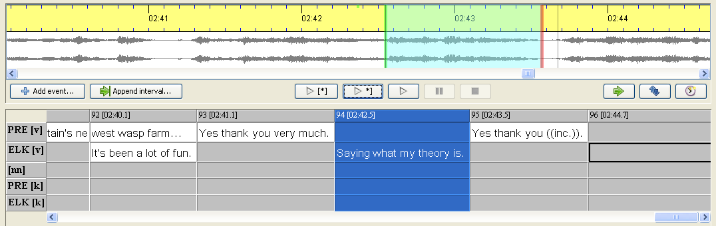

The overlap, in this case, is an utterance by speaker 'PRE' which starts after and ends before ELK's utterance "Saying what my theory is". Mark the correpsponding passage in the waveform. Note that, since the selection is not attached to any existing timepoint, the boundaries are now blue instead of green/red.
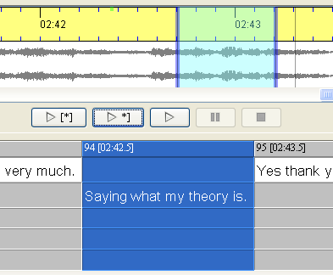

Now press the Add event... button. This will result in a new interval being inserted for the interval corresponding to the current selection. The boundaries of the selection are now atteched to this interval and are therefore green and red. Above the Add event... button, a dialog appears in which all those tiers are listed which don't yet have an event for this interval.

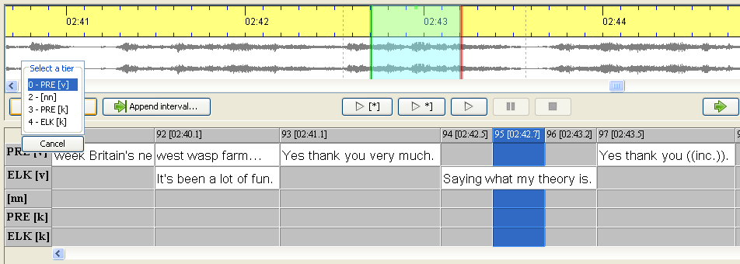

Since you want to transcribe an utterance of speaker PRE, you choose the first of the tiers. The cursor in the partitur will then be placed in the appropriate event and you can start transcribing.

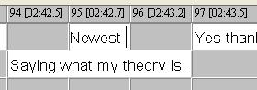

3. Additional hints

Buttons on the right side below the waveform

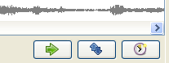
There are three additional buttons on the right side below the waveform which can help you to navigate in the recording and manipulate the timeline:
- The first button Shift selection makes a new selection in the waveform panel such that the old end point becomes the new start point. This is a further help for creating a transcription without temporal gaps.
- The second button Detach selection disconnects the current selection in the waveform from any points in the timeline of the transcription. The selection boundaries will become blue instead of green/red, and moving the boundaries in the waveform will now have no effect on the timeline of the partitur.
- The third button Assign times assigns the current selection boudary times of the waveform panel to the currently selected interval in the partitur.

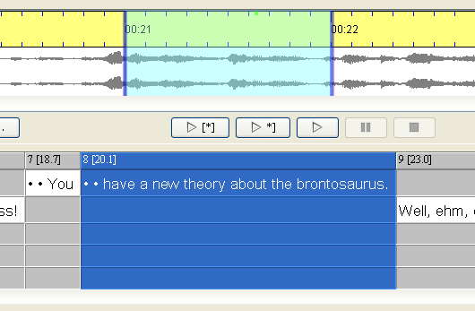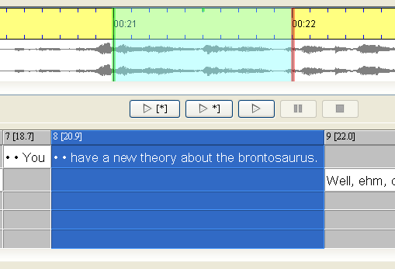

Navigation and selection in the waveform view
You can change the appearance of the waveform view in two ways:

- Scrolling the mouse wheel with the Control key pressed will zoom the waveform view horizontally, i.e. it will increase or decrease the amounts of pixels per second in the recording:
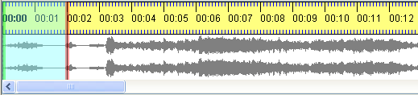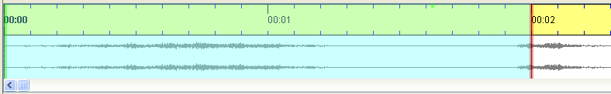
Zoom out (fewer pixels per second, left) and zoom in (more pixels per second, right)

- Scrolling the mouse wheel with the Control and the Shift key pressed will zoom the waveform view vertically, i.e. it will magnify the waveform. 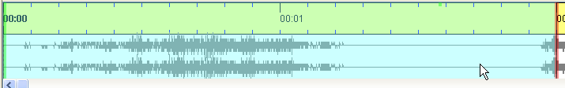
Normal (left) and vertically magnified waveform view (right)

As mentioned above, selection in the waveform view can be done either by dragging boundaries with the mouse or by scrolling the mouse wheel while pointing somewhere near the boundaries. For longer stretches, you can also use one of the following methods:
- Set a mark by double clicking at a place in the waveform view. The next double click will then make a selection from that mark to the position of the second double click.

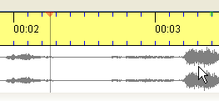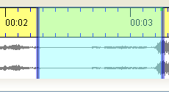
1st double click: set a mark (left), 2nd double click: make a selection

- Click on the Navigation Button at the top left corner of the waveform view and set selection and cursor times via a dialog:

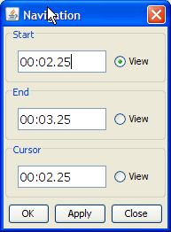

Transcribing a video
If you want to transcribe from a video file, you basically follow the same steps as described above. The video is displayed inside the audio/video panel, so you need to make sure that this panel is visible (View > Audio/Video Panel). If you only link a video to the transcription, the waveform panel will only display a timeline, not a waveform:

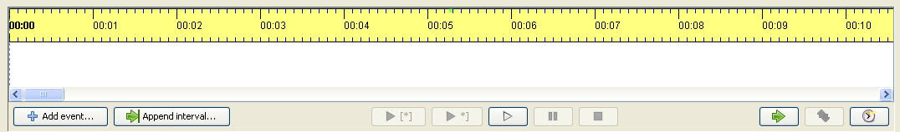

In order to get both a waveform and a video file displayed, you simply link two recordings to your transcription. You can link as many recordings as you like – the waveform panel will always look for the first wav-file in your list of media files, the audio/video-panel will always pick the first file in the list.

