Sextant Tagger
The Sextant-Tagger offers a simple facility to add EXMARaLDA standoff-annotation to segmented transcriptions.

Starting the Program
You need an installed Java-Runtime-Envoirement, Version 6 or newer to launch the program.
The program can be downloaded as an executable Java-package (jar) on the website
http://www.exmaralda.org/sextant.
Start the program by double-clicking the jar-file. You should see something like the following on your screen:
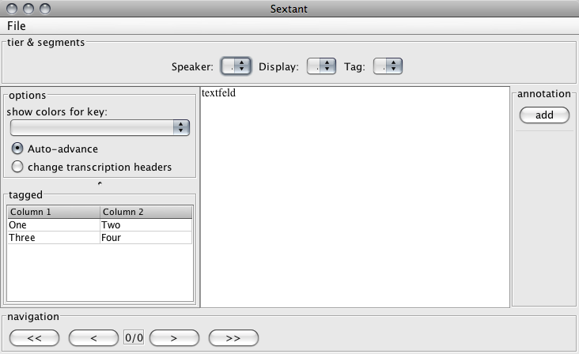

Using the Program
To annotate a segmented EXMARaLDA-transcription, open the transcription-file throught the file-menu.
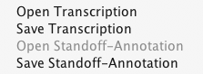

Selecting segments
After opening the transcription, the drop-down-menus on the top of the screen will update. The first drop-down-menu lets you select the speaker for which the segments will be displayed.
The second drop-down-menu lets you select the segmentation unit that will be displayed on the screen, the third drop-down-menu lets you select the segmentation unit that you want to annotate.
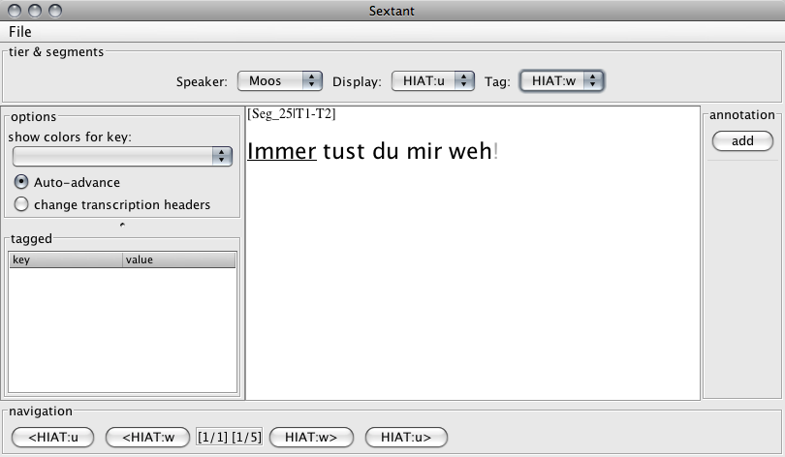
In this example, we chose to display HIAT:u-segments (utterances in the HIAT transcription conventions) and to add annotations to HIAT:w-segments (words in the HIAT transcription conventions).

Navigating
You can now navigate the tier of the selected speaker through the navigation buttons on the bottom of the screen: the leftmost and the rightmost buttons move backwards and forwards through the display-segments, the buttons between move backwards and forwards through the elements you want to annotate. The actual segment to annotate is underlined in the text-display.

Adding annotation options
You can add annotation-options ("tags") by clicking on the "add"-button on the right side of the screen. You will be presented with a dialog asking for a parameter-value-pair that will result in the actual annotation in the standoff-annotation file.
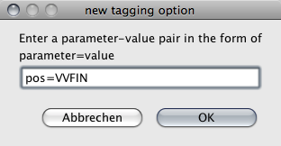
For each tagging option you add, a new button is added to the rightmost column of the program. A unique color is automatically assigned to each button.

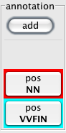

Adding Annotation
You add the actual annotation by navigation to the segment that you wish to annotate and clicking on one of the buttons that represent the tagging option. If you selected the same key for display (see „options“) that you annotated, the segment will get the same color as the button for the annotation.
You can save your annotations by selecting "Save Standoff Annotation" from the file-menu. Remember to save the file alongside the annotated transcription file to keep the links to it intact.

Options
On the leftmost side of the window, you can select options for the annotation process:
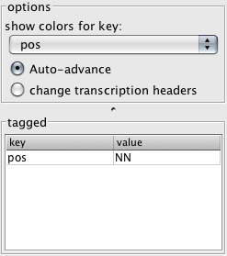
Show colors for key:
When your annotation-options contain more than one unique key, you can select the key that will be shown as a color in the text display in this drop-down-menu.
Auto-advance
Selecting this radio button will make the tagger jump to the next taggable segment when clicking on an annotation-option.
Change transcription headers
When this radio button is selected, the tagger will write a reference to the standoff-annotation file inside the annotated transcription on saving.
tagged-Table
This table displays all the annotations that have been assignet to the selected segment.

