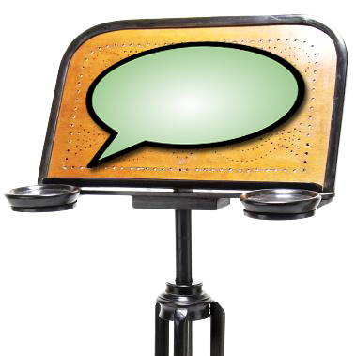 |  | 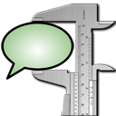
Audio and Video support in EXMARaLDA

This document explains audio and video support in EXMARaLDA and gives some recommendations about media file formats.

Contents

Audio and video support in EXMARaLDA 2
Player types 3
Sun’s and FOBS implementation of the JMF 4
Summary: which player type? which JMF implementation? 4
Some more recommendations 4

Audio and video support in EXMARaLDA

EXMARaLDA supports the playback of digital audio or video files and their synchronisation with the transcriptions through the audio-/video panel, the Praat panel and the timeline viewer in the Partitur-Editor, and through corresponding components in EXAKT.

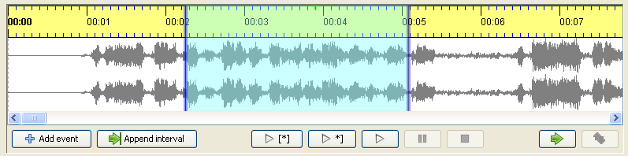

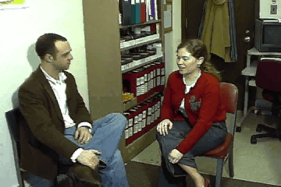
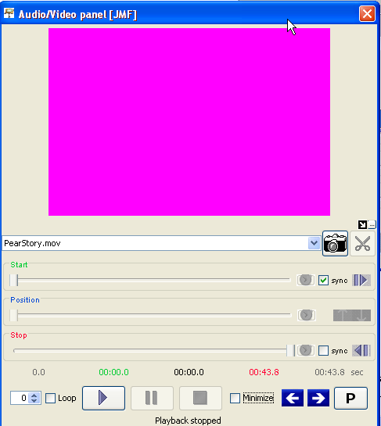

Whether and how audio or video support works for a given media file can be tricky to find out because it depends on many parameters:

- Your sound and video card
- Your operating system (e.g. MAC OS, Windows, Linux)
- Certain pieces of software you have or have not installed on your system (e.g. media frameworks like Quicktime or certain codecs, i.e. software to decode a media format like divx)
- The file format of your media file (e.g. wav, mov or avi etc.)
- The codec used to compress the data in your media file (e.g. mpeg-2, divx, soerensen etc.)
- Other encoding parameters of your media file (e.g. bitrate, framerate etc.)
Because there are many ways of combining these parameters, it is very difficult to compile a full list of possible combinations and to say whether or not EXMARaLDA supports them. If you intend to use EXMARaLDA with a certain media file, you should read this document and then try to determine yourself whether or not this EXMARaLDA supports the format.

Player types

EXMARaLDA allows you to choose between different player types. You can make this choice by going to “Edit > Preferences” in the Partitur-Editor and then selecting the “Media” tab. In order for the changes to take effect, you need to quit and restart the software.

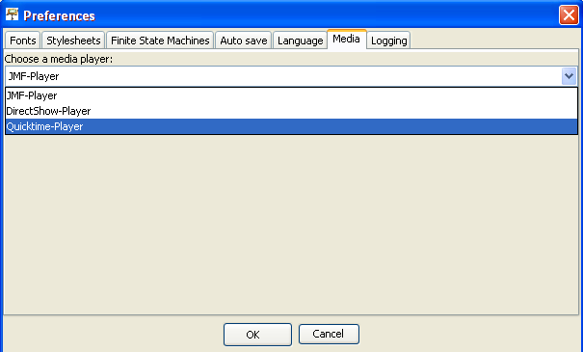

The player types to choose from are:

- JMF-Player – JMF stands for Java Media Framework. This is the default player. It is known to work well on Windows, on Linux and on Macintosh computers with an Intel processor. It does not work very well on Macintosh Computers with a PowerPC processor. The biggest problem with the JMF player used to be that it did not support newer video codecs like MPEG-4, DivX or xvid. With version 1.3.4. of the EXMARaLDA Partitur-Editor, we were able to remedy this by using a FOBS implementation of the JMF (see below).
- Quicktime-Player – This is a player which, in principle, supports all the file types that are also supported by the Quicktime Player. If you work on a Macintosh, you can simply choose this player type if you have problems with the other ones. On Macintosh computers with a PowerPC processor, this is likely to be the best available option. On a Windows computer, you need to install Quicktime (from http://www.apple.com/de/quicktime/) before you can choose this player.
- DirectShow-Player – this is a player, developed by the MPI in Nijmegen, which plugs into the native media playback framework DirectShow on Windows. It is therefore only available on Windows computers. The DirectShow player supports a big range of file types, and it is often more accurate and plays more smoothly than the JMF-Player.

Sun’s and FOBS implementation of the JMF
There are two implementations of the Java Media Framework: One by Sun and one open source implementation by FOBS. Sun’s implementation is known to run well on Windows computers, but it lacks support for some newer video codecs like MPEG-4, DivX or xvid. The FOBS implementation is known to run well on Windows computers and on Macintosh computers with Intel processors. It will not run on Macintosh computers with PowerPC processors. Therefore on Windows, you have a choice between using Sun’s JMF or the FOBS JMF. You make this choice by selecting the appropriate entry in the EXMARaLDA start menu folder (choose “EXMARaLDA” for the SUN implementation and “EXMARaLDA (with FOBS)” for the FOBS implementation.

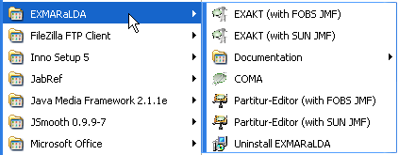

On Macintosh, the choice is already made for you: the Macintosh PowerPC version of EXMARaLDA comes with Sun’s JMF, the Macintosh Intel version comes with the FOBS JMF. The Linux version also comes with FOBS JMF.

Summary: which player type? which JMF implementation?

To sum up, the following combinations are recommended

- Macintosh Power PC: Use the Quicktime player
- Macintosh Intel PC: Use the JMF player or the Quicktime player
- Windows PC: Use the JMF player or the DirectShow player. With JMF, if the default version of the Partitur-Editor ("Partitur-Editor (with SUN JMF)" does not support your media file, try to start the Partitur-Editor with "Partitur-Editor (with SUN JMF)" instead .
- Linux: Use the JMF player.

Some more recommendations

- If you want a maximum portability of sound across different computers, use WAV audio files. If you need to save space, MP3 is the best option.
- We cannot make a similar recommendation for video files. At the moment xvid seems like a good candidate for a codec, but this is not supported by Macintoshs with a PowerPC processor.
- If you plan to create a bigger corpus, make extensive experiments with your media files on different types of computer before you start transcribing.
- There is good and free software for converting between formats and codecs. It is usually much less work to convert your media file to a good format than to work with a format that is not well supported.
- If you cannot play a given media file, first try to choose a different player type. If that does not help and you’re on a Windows computer, try using FOBS JMF implementation rather than Sun’s (see above).

