 |  | 
Understanding the basics of EXMARaLDA

This document explains the basic concepts of the EXMARaLDA system and the terminology used in the tools' menus and dialogs and in all other documentation.

Contents

1. Transcriptions 2
Events, timeline, tiers and speakers 2
Tier types and categories 3
Segment chains 4
2. Corpora 4
Communications and speakers 4
Recordings and transcriptions 4

1. Transcriptions

An EXMARaLDA transcription is a well-defined structure consisting of a few basic entities which are put in relation to one another. In order to explain the basic entities of an EXMARaLDA transcription and their relationships, we will use the short transcription example of the following figure.

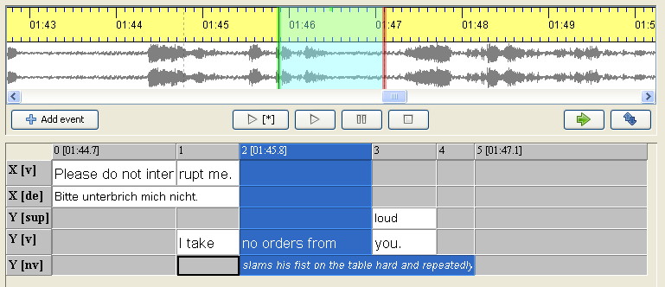

Events, timeline, tiers and speakers

The fundamental unit in an EXMARaLDA transcription is the event. An event consists of a piece of text describing some incident in the transcribed recording.

The above example contains altogether eight events – the white cells in the partitur interface. Five of these describe words (or word parts) uttered by the two speakers ('Please do not inter', 'rupt me.', 'I take', 'no orders from' and 'you.'). One event ('slams his fist on the table hard and repeatedly') describes nonverbal behaviour. The remaining two events contain a German translation of X's utterance ('Bitte unterbrich mich nicht') and a suprasegemental characterisation ('loud') of the word 'you' uttered by speaker Y.

Each event is assigned a place in the transcription through its reference to a timeline and a tier.

The timeline is simply an ordered sequence of timepoints. Each timepoint can (but need not) be assigned an absolute time value which is interpreted as a pointer into the corresponding audio or video recording. The above example has a timeline containing altogether six timepoints – the gray, numbered cells in the top row of the partitur interface. Three of these timepoints (0, 2 and 5) are assigned absolute time values ('01:44.7', '01:45.8' and '01:47.1', respectively). Assigning an event to the timeline means specifying a start and an end timepoint for it on the timeline. For instance, the event labeld 'I take' starts at timepoint 2 and ends at timepoint 3, the event labeled 'slams his fist...' also starts at timepoint 2 but ends later at time point 5 and thus stretches over a longer interval. Since timepoint 2 is assigned an absolute time value, we have the additional information that these two events start at time '01:45:8' in the transcribed recording. The editor uses this information to select a corresponding stretch in the waveform view of the recording.

A tier assembles events with similar properties, typically all events describing the same type of action (e.g. verbal or nonverbal) of one speaker. The above example contains altogether five tiers – the rows after the top row of the partitur including tier labels in the gray, leftmost cells (labelled 'X [v]', 'X [de] etc.).

Each tier in turn can be assigned to a speaker. Speakers are assembled in a speakertable. The speakertable of the above example contains two speakers labelled 'X' and 'Y'.

Tier types and categories
Besides the (optional) speaker assignment, each tier also gets an assignment to a type and a category. These assignments are very important for many automatic processing steps, so it is crucial that you use them correctly if you want to do reliable searches and transformations with your data.

Categories specify the exact type of information described in the events of a tier. In the above example, the two tiers with events describing verbal behaviour have the category 'v', the other three tiers have the categories 'de', 'sup' and 'nv' for 'German (deutsche) translation', 'suprasegemtals' and 'non-verbal', respectively. Categories can be freely chosen (i.e. you might as well label a verbal tier with the category 'verbal'), but you should make sure that category assignment is consistent throughout your corpus (i.e. don't give verbal tiers the category 'v' in one transcription, 'V' in the next, and 'verbal' in another).

Types are predefined classifications for tiers. There are three different types:

- Type 't' stands for 'transcription'. This is normally the type for tiers in which verbal behaviour is described. You should have one and only one tier of this type for each speaker, and you should not have a tier of this type without a speaker assignment. In the above example, the first and the fourth tier are of this type
- Type 'd' stands for 'description'. This is the type for tiers in which non-verbal behaviour is described. You can have as many tiers of this type as you need for each speaker (e.g. three if you want to distinguish facial expression, hands movement and body movement or none if you do not transcribe non-verbal behaviour). It is also possible to have tiers of this type without a speaker assignment (e.g. for background noises, applause etc.). In the above example, the last tier is of this type.
- Type 'a' stands for 'annotation'. This is the type for tiers containing additional analytic information about events in tiers of type 't'. You can have as many tiers of this type as you need for each speaker (e.g. one for a German translation, one for a morphological transliteration). Since annotations depend on something to be annotated, events in tiers of this type should always have a corresponding event (or sequence of events) in a tier of type 't' assigned to the same speaker. In the above example, the second and third tiers are of this type. Note that for the events in these tiers, there are corresponding events in tiers of type 't' assigned to the same speaker ('Bitte unterbrich mich nicht' corresponds to the two events 'Please do not inter' and 'rupt me', while 'loud' corresponds to the single event 'you.'). In contrast, the event 'very loud' does not have a corresponding set of events in the second tier. Such structures are not allowed inside tiers of type 'a'.

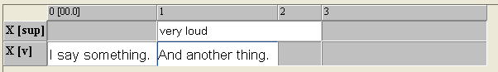

Segment chains

Having understood the definition of tiers, events and tier types, understanding segment chains is straightforward: a segment chain is defined as an uninterrupted sequence of events in a tier of type 't'. Thus, the above example contains two segment chains – the first ('Please do not interrupt me.') consists of the two events, the second ('I take no orders from you.') of three events. Segment chains can be used to generate non-partitur output formats: if you order all segment chains of a transcription by their start points, you can produce a drama-script-like presentation like the following one:

X: Please do not interrupt me.
Y: I take no orders from you.

Segment chains also play a crucial role in the process of segmentation (see 'How to use segmentation').

2. Corpora

Communications and speakers

Recordings and transcriptions

