Career Mobility Governance Framework (CMGF)

An AI-Governance Framework for Military Transition Advising

A Response to the 2026 CCME Learner Track 1
Author: Robert E. McCoy MBA, M.S. AI & Data Analytics
Affiliation: Indiana Wesleyan University

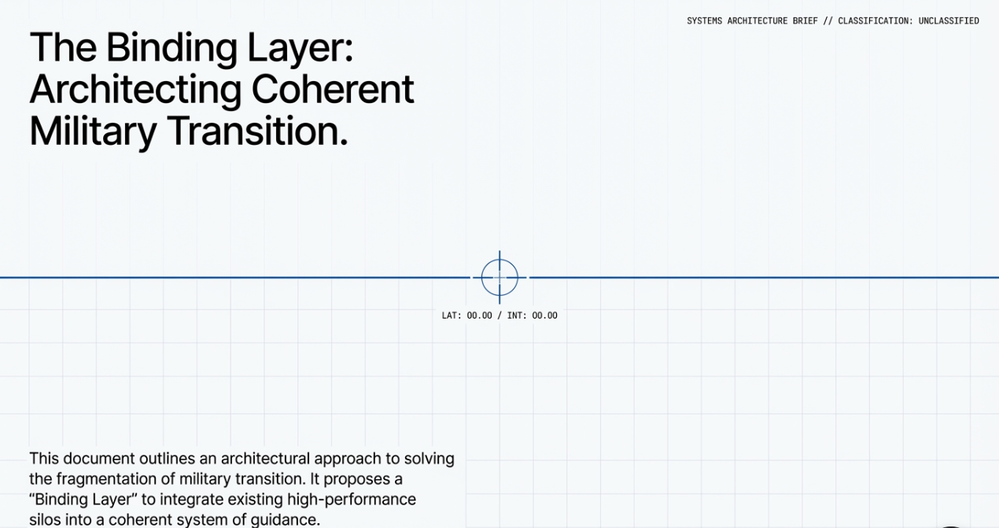
Table of Contents

Career Mobility Governance Framework (CMGF) 1
An AI-Governance Framework for Military Transition Advising 1
A Response to the 2026 CCME Learner Track 1 1
Table of Contents 1
Executive Summary 5
What This Paper Contributes 8
Key Findings 10
Introduction 13
Positional Statement 17
A Review of Literature 18
Methods 22
Unit of Analysis 25
Policy and Literature Analysis 28
Labor Market and Workforce Data Analysis 29
AI and Data Analytics Design Approach 30
Track 1 Topics 43
Artificial Intelligence as an Enabling Force 44
Military Learner Career Mobility 46
Funding Imbalances: Education vs. Transition Support 48
Empowerment Strategies and Stackable Pathways 52
Emerging Labor Market Demand for AI Literacy Certifications 54
Translating Military Experience into Civilian Workforce Value 58
Veteran and Servicemember Learner Voice 61
Installation Status Reports (ISR) 63
Modernizing Advising Approaches 64
Best Practices & Innovations 66
Advisor Roles and Peer Networks 66
The Career Mobility Governance Framework CMGF Demonstration Artifact: An Example AI-Enabled Advising Interface 68
Program Management and Operational Control 81
Measurement, Evaluation, and Learning 82
Signal Sharing and Institutional Awareness 82
Ethical Boundaries and Scope Control 83
Scaling and Interoperability 83
Conclusions and a Call for Concept Development 83
References 86
Appendix A: Annotated Bibliography 97
Appendix B: Case Examples and Best Practices 101
Appendix C: Transitions 103
Appendix D Machine Learning Scope, Ethical Constraints, and Evaluation Design 104
Appendix E System Governance 116
Appendix F: Reviewer Orientation Note 120

This study does not evaluate predictive accuracy, optimize pathway selection, or model individual outcomes. These exclusions are intentional and arise from the governance, equity, and accountability risks inherent in applying predictive or optimization-based AI methods within high-impact public-sector decision environments.
Future empirical research in these areas would require institutional data access, human subjects review, and policy authorization beyond the scope of this capstone.
CMGF is presented as a demonstrated framework that is compliant by design and non-predictive by default, with governance controls intentionally aligned to the NIST AI Risk Management Framework and current federal guidance on responsible AI use (EO 14110; NIST AI RMF; GAO 2024).

Executive Summary
This study is motivated by a structural paradox at the center of military transition policy: although more than $13.5 billion is spent annually on education benefits, fewer than $140 million is allocated to transition-specific advising and decision support. This imbalance coincides with persistent post-service wage regression affecting a majority of separating service members and reflects a deeper architectural failure across the transition ecosystem.
Despite extensive investment in education, credentialing, advising, and workforce programs, the military transition system remains rich in data but poor in guidance. Critical signals — policy rules, workforce demand, credential standards, and individual constraints — exist across disconnected institutional silos, leaving service members and advisors to manually integrate complex information at scale. The core issue is not a lack of programs, effort, or intent, but the absence of an integrating mechanism capable of binding these signals into a coherent, navigable context at the moment transition decisions are made.
The military transition ecosystem consists of five high-performing but isolated vertical systems: education benefits, credentialing frameworks, advising services, workforce data, and policy instruments. CMGF inserts a horizontal integration layer across these systems. This binding layer is offered as one possible solution that does not replace any system; rather, it allows signals from each to be correlated at the point of decision-making. Artificial intelligence is used only as the mechanism capable of performing this correlation at national scale while remaining explainable and human governed.
To address a problem that has historically proven resistant to scale within a fragmented, manually governed system, this study introduces the concept of a binding layer: an architectural construct designed to aggregate, contextualize, and present existing institutional signals without replacing human judgment or institutional authority. This paper demonstrates that CMGF is one viable architecture among constrained alternatives, offering a solution set to the problem.
Within this design, artificial intelligence is introduced not as a predictive or outcome-optimizing authority, but as an enabling technology capable of implementing the binding layer across scale, heterogeneity, and policy complexity while remaining human-interpretable and human-governed.
By aggregating de-identified feasibility signals and recurring constraint conflicts across individual transition plans, the Advising & Approval Module operationalizes this binding layer and transforms anecdotal transition failures into auditable institutional evidence. In doing so, it provides policymakers and educational leaders with the empirical foundation necessary to justify rebalancing transition support funding and reforming advisory infrastructure at scale.
The Department of Defense (DoD) comprises more than 2.0 million service members, including approximately 1.27 million on active duty and over 760,000 in Guard and Reserve components, each operating under distinct education, advising, and transition constraints. Each year, between 150,000 and 200,000 active-duty service members transition into civilian careers, creating a human-capital environment characterized by high mobility and recurring reintegration into the national workforce.
This flow of human capital represents a substantial national investment in training, education, leadership development, and credentialing. Because military service in the United States is voluntary, this investment is underwritten by an implicit social contract: service members contribute to national defense, and in return the nation provides structured support for professional development, transition, and long-term economic mobility. This paper demonstrates that honoring that contract at scale requires not additional programs, but the introduction of binding-layer infrastructure as one solution capable of converting fragmented institutional data into coherent guidance.
Accordingly, this paper introduces the Career Mobility Governance Framework (CMGF) (Figure 1) as an operational implementation of the binding layer within the military transition ecosystem as one viable architecture among constrained alternatives
CMGF converts individual planning friction into auditable, aggregate evidence suitable for budget reallocation, policy reform, and institutional learning.
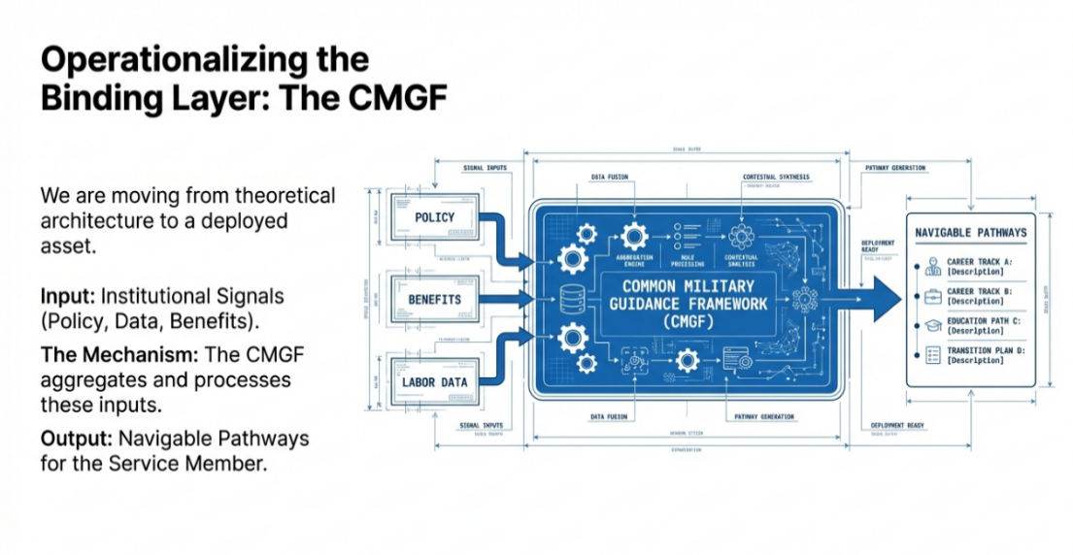
Figure 1: CMGF Flow

What This Paper Contributes
This paper advances the binding layer as a missing architectural component in military transition policy and demonstrates how it can be operationalized through governed, non-predictive AI. This paper makes six primary contributions to the study and practice of military learner career mobility:
- A structured synthesis of peer-reviewed research and policy analyses examining credential portability, career mobility, and advising effectiveness for military learners, organized explicitly around the five CCME Track 1 elements and analyzed through the lens of binding-layer integration rather than program-level optimization (CAEL, 2018; IVMF, 2019).
- The introduction of an AI-enabled, human-centered advising framework, illustrated through two demonstration artifacts that show how a governed binding layer can unify fragmented Track 1 inputs career direction, education pathways, transition timing, and learner voice into a coherent planning context while strengthening service-member agency and preserving human advising authority.
- A principled design contribution to Responsible AI practice, demonstrating how the intentional non-use of technically feasible AI functions including predictive outcome modeling, automated approvals, individual risk scoring, and optimization objectives can serve as a core binding-layer governance mechanism in high-impact public-sector systems.
- The introduction of an AI-enabled, human-centered advising framework, illustrated through two demonstration artifacts that show how a governed AI layer can unify fragmented Track 1 inputs career direction, education pathways, transition timing, and learner voice into a coherent planning context while strengthening service-member agency and preserving human advising authority.
- A principled design contribution to Responsible AI practice, demonstrating how intentional non-use of technically feasible AI functions including predictive outcome modeling, automated approvals, individual risk scoring, and optimization objectives can serve as a core design mechanism for trust, accountability, and policy alignment in high-impact public-sector systems.
- Compliant by design, non-predictive by default: CMGF turns individual planning friction into collective intelligence, generating the auditable evidence needed to reform budgets and policies.

Key Findings
The synthesis of peer-reviewed literature, federal policy guidance, and workforce evidence yields the following key findings:
- Empirical evidence indicates that military-to-civilian skills translation constitutes the dominant structural bottleneck in military learner career mobility. Clemens and Knutson (2020) found that only 12–15% of military-acquired occupational skills directly transfer to civilian-recognized equivalents, with substantial variation by specialty and occupational category. This low rate of direct transfer helps explain why non-portable or poorly mapped credentials disrupt alignment across education, employment, and transition timelines, eroding the return on both individual benefits and institutional investment. Fragmentation at this translation layer prevents coordinated planning and obscures system-wide patterns of failure, reinforcing the need for governed binding-layer infrastructure capable of standardizing translation, capturing recurrent constraints, and elevating individual friction into institutional evidence rather than relying on ad hoc advising.
- Civilian labor-market outcomes for veterans vary substantially by military occupational specialty, reinforcing the importance of pathway-aware credential planning rather than uniform transition guidance. RAND analysis by Schulker (2017) found that administrative and technical military occupational specialties yield civilian wage premiums approximately 67% higher than those associated with combat arms specialties, even when controlling for education and experience. These disparities indicate that skills-based hiring does not operate uniformly across military roles and that credential translation and sequencing decisions must be prioritized differently by occupational category. Absent such differentiation, advising systems risk reinforcing structural wage penalties rather than mitigating them.
- Empirical labor-market evidence indicates that stackable, industry-recognized credentials yield substantial wage premiums for veterans, particularly in technical and healthcare-adjacent fields. Analysis by Burning Glass Technologies (2019) found that veterans who completed stackable credentials in information technology, healthcare, and advanced manufacturing realized wage premiums ranging from 34% to 47% relative to peers relying on degree attainment alone. These findings reinforce that credential sequencing and stackability materially influence post-service earnings and that advising systems must evaluate credential pathways as cumulative economic signals rather than isolated educational choices.
- Evidence from military training and education contexts indicates that adaptive and AI-assisted systems are most effective when embedded within explicit human-in-the-loop governance structures. A Department of Defense–sponsored meta-analysis by Kulik and Fletcher (2016), synthesizing results from over 50 military training studies, found that adaptive learning systems reduced training time by approximately 30% while maintaining proficiency, but only when human oversight and instructor intervention were preserved. These findings directly support CMGF’s design choice to constrain AI to advisory and translation functions within a binding-layer architecture, reinforcing human judgment and institutional accountability rather than delegating authority to automated systems.
- Empirical transition research demonstrates that the timing and structure of career planning materially affect post-service employment outcomes. Zoli et al. (2015), in a longitudinal study conducted by the Institute for Veterans and Military Families, found that veterans who engaged in structured transition planning at least twelve months prior to separation achieved employment rates 31% higher than those who began planning later or relied on ad hoc advising. These findings indicate that transition failures are not solely attributable to labor-market conditions, but to the absence of early, coordinated planning infrastructure. Systems capable of capturing and aggregating planning friction at scale specifically through binding-layer mechanisms that operate across time horizons are therefore necessary to convert individual transition challenges into institutional evidence suitable for policy reform.

Introduction
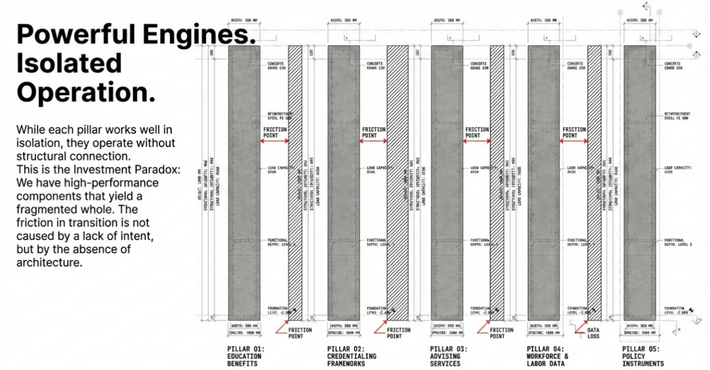
Each year, approximately 150,000–200,000 service members transition from active duty into the civilian workforce. Despite extensive federal investment in education and credentialing benefits, a substantial proportion experience early wage regression and underemployment following separation (Kleykamp et al., 2024; McKinsey & Company, 2022). Research consistently demonstrates that these outcomes are driven less by underlying skill deficits than by structural frictions in how civilian labor markets recognize military training, credentials, and occupational experience (Figure 1b). Compensation systems tend to privilege firm- and occupation-specific tenure, systematically undervaluing military-acquired competencies and delaying wage alignment even when underlying skills are comparable (RAND Corporation, 2022; Davenport et al., 2024).

Figure 1b: Silos
Military transition is therefore not a single employment event, but a longitudinal, multidimensional process involving identity change, community reintegration, and navigation of overlapping education, workforce, and support systems. Effective outcomes depend on coordinated policy and practice across the Department of Defense (DoD), higher education institutions, employers, and public workforce systems (Castro & Kintzle, 2014; Hodges, 2025; MITRE, 2019). Across this ecosystem, two levers consistently emerge as outcome-determinative: portable, stackable credentials that render military learning legible to civilian hiring systems, and career-aligned advising grounded in labor-market evidence and employer signaling (CAEL, 2018; Institute for Veterans and Military Families [IVMF], 2019).
Despite the presence of these levers, the transition ecosystem remains structurally fragmented. Education records, occupational histories, credential standards, labor-market data, and policy constraints are distributed across institutional silos, temporal boundaries, and governance regimes. Service members and advisors are therefore required to manually integrate complex, heterogeneous information at scale. The resulting condition is a system that is rich in data but poor in guidance. This fragmentation reflects not a lack of programs or intent, but the absence of an architectural mechanism capable of binding disparate institutional signals into a coherent, navigable context at the moment transition decisions are made.
Because the CCME context assumes the presence of artificial intelligence, this study focuses not on whether AI should be used, but on how its scope must be constrained to preserve human authority, institutional accountability, and service member agency in high impact advising contexts. Recent national policy developments have elevated artificial intelligence (AI) from a specialized technical capability to foundational governance and workforce competency. Federal guidance on safe, secure, and trustworthy AI alongside DoD initiatives such as the Artificial Intelligence Education Strategy and Task Force Lima now frame AI literacy and responsible AI use as readiness requirements across operational, evaluative, and documentation roles (Department of Defense, 2020, 2023; Office of Management and Budget [OMB], 2024). In parallel, labor-market evidence indicates that AI-related competencies are reshaping task requirements across a wide range of occupations, increasing employer demand for attestable, cross-disciplinary AI fluency well beyond traditional software roles (Bureau of Labor Statistics, 2025; Wells, 2024).
Despite this convergence of policy mandate and labor-market demand, AI remains weakly integrated into the institutional processes that govern career planning, credential sequencing, and transition advising. Responsibility for AI-related upskilling and planning is frequently shifted to individual service members through personal education benefits, even as policy increasingly treats AI literacy as a baseline requirement rather than an elective specialization. More critically, existing systems lack transparent, governed mechanisms for using AI to translate experience, clarify policy constraints, and support consistent human decision-making across education and transition timelines. This misalignment contributes to persistent execution gaps, inequitable access, and inefficiencies that undermine both force readiness and post-service career mobility.
Against this backdrop, this paper advances a governed, policy-aligned approach centered on the introduction of a binding layer within the military transition ecosystem. The binding layer is defined here as an integrative architectural mechanism that aggregates, contextualizes, and presents existing institutional signals without replacing human judgment or institutional authority. Within this design, artificial intelligence is employed as decision infrastructure rather than decision authority. AI is used to translate heterogeneous data sources, surface constraint-driven planning signals, and support consistent advising workflows, while explicitly prohibiting predictive outcome modeling, automated approvals, individual risk scoring, and optimization objectives. These exclusions are not technical limitations, but intentional design choices aligned with public-sector governance requirements and the preservation of service-member agency and human accountability.
Specifically, this paper:
Synthesizes evidence on credential portability and military-to-civilian transition outcomes.
Examines governance and implementation barriers that have constrained institutional adoption of AI literacy and AI-enabled advising.
Documents emerging labor-market demand for portable, attestable AI competencies; and
Presents two demonstration artifacts illustrating how a governed, human-centered binding layer implemented using non-predictive AI can unify career direction, education pathways, transition timing, and learner voice into a coherent planning and advising context while preserving human judgment and institutional accountability.

Positional Statement
Because the CCME context assumes the presence of artificial intelligence, this study focuses not on whether AI should be used, but on how its scope must be constrained to preserve human authority, institutional accountability, and service member agency in high impact advising contexts, consistent with the principles articulated in the NIST Artificial Intelligence Risk Management Framework version 1.0. Artificial intelligence now constitutes an explicit institutional, policy, and educational expectation within military and higher education ecosystems, and this work does not evaluate whether AI should be introduced into advising systems. Instead, it examines how artificial intelligence can be governed, constrained, and evaluated when its use is assumed or required. The central research focus is therefore not model performance or outcome optimization, but the disciplined design of AI enabled infrastructure that preserves human judgment, institutional accountability, and service member agency.

A Review of Literature
The military-to-civilian transition literature consistently documents a paradox: despite substantial federal investment in education, credentialing, and transition programs, more than half of separating service members experience underemployment or an early-career wage penalty following separation (Kleykamp et al., 2024; McKinsey & Company, 2022). This pattern persists even among those who utilize flagship benefits such as the Post-9/11 GI Bill, suggesting that educational attainment alone is insufficient to ensure labor-market alignment. Empirical analyses indicate that time out of the civilian workforce, coupled with imperfect translation of military skills and credentials, erodes earnings trajectories despite comparable underlying competencies (Barr et al., 2021).
A central theme across this literature is that transition challenges are driven less by individual skill deficits than by systemic translation failures. Credential portability and skills recognition remain major obstacles. In the absence of structured, widely recognized mechanisms for mapping military expertise to civilian roles, employers frequently undervalue military-acquired competencies, contributing to persistent wage gaps, occupational mismatch, and lower retention (Harrell & Berglass, 2012; SHRM, 2023). Research on modular and stackable micro-credentials particularly those developed in partnership with employers and intermediaries such as the Institute for Veterans and Military Families (IVMF) and the Council for Adult and Experiential Learning (CAEL) demonstrates improved employment alignment and long-term career fit when credentials are designed to be portable, attestable, and legible to civilian hiring systems (IVMF, 2019; CAEL, 2018).
The advising literature further underscores the importance of coordinated guidance in navigating these translation challenges. Studies of career-aligned advising models emphasize that outcomes improve when advising is grounded in labor-market evidence, credential signaling, and pathway awareness rather than generic transition counseling. However, this same literature reveals a structural limitation: advisors are routinely required to manually integrate policy rules, benefit constraints, credential requirements, and workforce information across disconnected systems. This manual integration burden scales poorly, contributing to inconsistent guidance and uneven outcomes across institutions and installations.
Recent empirical work on AI-enabled advising systems in higher education suggests a potential pathway for addressing this integration challenge. When deployed as advisor-assist tools under explicit ethical and governance constraints, intelligent systems have been associated with improved retention, academic confidence, and career alignment (Ahmed et al., 2024; Soomro et al., 2025). Importantly, these gains are observed when AI is constrained to decision-support roles that augment human judgment rather than automate it, reinforcing the relevance of human-in-the-loop design principles in high-stakes educational contexts.
Parallel research highlights the potential of artificial intelligence to modernize credit recognition and credential portability. The American Council on Education (2024) characterizes existing credit for prior learning (CPL) processes as “fragmented and inconsistent,” noting that manual evaluation limits scalability and transparency. Emerging AI-enabled credentialing approaches particularly those leveraging natural language processing to analyze course equivalencies and occupational training offer mechanisms to accelerate evaluation, reduce bias, and improve consistency across institutions. These developments align with the Department of Defense’s Artificial Intelligence Education Strategy (2020), which positions AI not only as an operational capability, but as foundational infrastructure for improving administrative, educational, and workforce systems.
At the same time, AI literacy and digital upskilling have emerged as cross-cutting policy priorities. National initiatives emphasize embedding foundational AI and data competencies across all learner pathways, including those serving veterans and service members (Digital Education Council, 2025; Defense Innovation Board, 2023). Labor-market evidence reinforces this emphasis: AI-exposed occupations are projected to grow at rates substantially exceeding the broader economy, and employers increasingly prioritize demonstrable AI skills over traditional proxies such as tenure alone (Bureau of Labor Statistics, 2025; Wells, 2024). Yet federal oversight bodies consistently find that implementation lags policy intent. A Government Accountability Office review concluded that the DoD lacks consistent definitions, workforce categorization, and accountability mechanisms for AI literacy, limiting institutional progress despite strategic mandates (Government Accountability Office, 2023). The establishment of Task Force Lima reflects recognition of this gap and the need for coordinated governance across education, workforce, and policy domains (Department of Defense, 2023).
Across these strands of research credential portability, advising effectiveness, AI-enabled systems, and workforce policy a consistent pattern emerges. Transition challenges are repeatedly attributed to fragmented systems, inconsistent translation mechanisms, and weak coordination across education, credentialing, advising, and labor-market domains. Collectively, the literature points not to isolated program deficiencies, but to the absence of an integrating architectural layer capable of binding decision-relevant signals across institutional boundaries.
Building on this synthesis, the present study examines whether a governed, AI-enabled integration approach can function as such a binding layer linking Department of Defense training records, ACE credit recommendations, credential frameworks, and academic pathways into a coherent, portable planning context. This approach aligns with principles of holistic credit mobility (Ithaka S+R, 2024) by treating military learning as interoperable, transferable, and verifiable across institutions, with the aim of improving transparency, efficiency, and trust throughout the military-to-civilian education and workforce pipeline.
Taken together, this literature indicates that the central risk in military transition systems is not algorithmic error, but architectural fragmentation suggesting that effective AI risk management in this domain depends less on model performance and more on disciplined scope definition, authority boundaries, and institutional accountability.

Methods
Role of Artificial Intelligence and Governance Constraints
The Career Mobility Governance Framework is intended to illustrate how governed, non-predictive artificial intelligence can function as decision support infrastructure within complex public sector advising systems. This study does not claim that CMGF represents the only possible architecture for addressing advising fragmentation, nor that alternative non-AI mediated systems could not improve elements of transition or credential planning under specific conditions. Rather, it demonstrates one viable governance centered design approach for contexts in which artificial intelligence is institutionally expected and operational scale exceeds the capacity of human coordination mechanisms.
Within this design, artificial intelligence is employed as mediating infrastructure that translates, aggregates, and surfaces constraint interactions across policy, credentialing, education, and labor market systems. AI is necessary for scale and integration, but governance determines its permissible role. Decision authority remains fully human. Design choices and exclusions, including the deliberate nonuse of predictive modeling, optimization, automated approvals, and individual risk scoring, reflect intentional governance constraints rather than technical limitations.
Design Science Methodology
The study employs mixed methods, design-oriented research methodology integrating policy analysis, structured literature synthesis, descriptive labor market analysis, and artifact based technical demonstration. These methods are used to operationalize abstract governance, ethical, and policy requirements into concrete and evaluable system artifacts. The central object of study is an integrative architectural construct referred to as a binding layer, designed to aggregate, contextualize, and present decision relevant signals across fragmented institutional systems without displacing human judgment or institutional authority.
Artificial intelligence methods are applied to support signal translation, pattern surfacing, and contextual aggregation across heterogeneous data sources. Evaluation criteria are defined in this Methods section and referenced throughout subsequent sections. Evaluation focuses on transparency, traceability, enforceability of scope boundaries, and institutional learning value rather than predictive accuracy or automation efficiency.
Risk, Influence, and Institutional Adoption Considerations
While the framework is explicitly non predictive and non-autonomous, it is acknowledged that any system that structures information and surfaces feasibility signals exerts directional influence on human decision making. In this design, such influence is intentional, bounded, and governed. Directionality is expressed through transparent constraint signaling rather than through individual ranking, outcome prediction, or automated recommendation, and remains subject to human interpretation, approval, and accountability at every decision point.
The study further recognizes that governance first systems may encounter institutional resistance precisely because they surface structural inefficiencies, funding mismatches, and policy frictions that challenge existing incentives and resource allocations. This risk is treated as a design reality rather than a failure mode. Accordingly, the framework prioritizes auditability, population level aggregation, and policy facing interpretive interfaces to ensure that system generated insights support deliberation and reform rather than enforcement or individual evaluation.
Risk mitigation is pursued not through aggregation or deidentification alone, but through architectural constraint, scope limitation, and enforced separation between individual advising interactions and institutional analytics. The contribution of this study lies not in optimizing individual outcomes, but in demonstrating how governed artificial intelligence can expand advisor capacity, reduce administrative burden, and enable evidence informed policy learning at scale while preserving human judgment, service member agency, and institutional accountability.
Alignment with NIST AI RMF
Consistent with the NIST Artificial Intelligence Risk Management Framework version 1.0, the Career Mobility Governance Framework is designed as a governance first system in which risk is addressed primarily through architectural constraint, scope limitation, and human accountability rather than through post hoc mitigation. CMGF design choices map directly to the framework functions of Govern, which assigns institutional oversight and authority, Map, which defines context and risk boundaries, Measure, which supports descriptive and aggregate signal analysis, and Manage, which enforces prohibitions, auditability, and lifecycle control.
This alignment is operationalized through explicit nonuse of high risk artificial intelligence functions, mandatory human in the loop decision authority, and population level evidence generation rather than individual level inference. Together, these design choices demonstrate how the NIST AI RMF can be applied as an architectural design instrument rather than solely as a compliance checklist.

Unit of Analysis
The primary unit of analysis in this study is not the individual service member, but the transition, education and credential planning interaction. This interaction is defined as a structured, repeatable configuration in which policy constraints, credential requirements, education pathways, labor market signals, and advising context intersects to shape feasible education, credentialing, and career options over time. The unit of analysis is therefore architectural and relational rather than personal, behavioral, or outcome based.
Analytical focus is placed on recurring patterns of credential related constraint interaction and planning friction observed across de-identified advising artifacts generated through the Career Mobility Governance Framework. These include misalignment between authorized credentials and labor market demand, sequencing conflicts among stackable credentials and degrees, policy induced delays or bottlenecks, and translation gaps between military training, academic credit, and civilian credential frameworks. Individual planning instances are examined only insofar as they surface common structural bottlenecks, translation failures, or governance conflicts that reoccur across the population.
By treating these interactions as the unit of analysis, the study shifts evaluative attention from individual readiness or deficit models to system level design properties governing how education, credentialing, and career pathways are constructed and constrained. This approach enables the identification of institutional and policy frictions that impede career mobility while preserving individual agency and avoiding individual profiling, prediction, or risk classification. All analytical outputs are population level, descriptive, and diagnostic in nature, and are intended to inform governance review, infrastructure design, and policy refinement rather than individual assessment or automated decision making.
CMGF operates as a synthesis engine, positioned between fragmented institutional data sources and individualized pathway guidance. Figure 1c. illustrates this architectural relationship: policy rules, education benefits, and labor market signals enter as discrete inputs; CMGF performs contextual aggregation and constraint synthesis; navigable pathways emerge as outputs tailored to individual service member circumstances. This architecture preserves existing institutional systems while enabling coordination across them.

Figure 1c: CMGF synthesis engine

Technical Implementation Note: The CMGF core employs natural language processing for policy document parsing, rule-based engines for constraint checking, semantic similarity matching for credential equivalency mapping, and graph-based analysis for pathway dependencies. No predictive modeling, machine learning classification, or outcome optimization occurs within the processing layer. See Appendix D for detailed technical constraints and evaluation methodology.
Because the study analyzes only de-identified, aggregate interaction patterns and institutional constraints, and does not involve intervention, manipulation, or evaluation of individual human subjects as defined under 45 CFR 46, formal IRB review was not required.

Data
This section presents a conceptual illustration of data inputs and outputs to demonstrate one plausible way a governed, non-predictive binding system could operate in alignment with the Career Mobility Governance Framework. The example is illustrative rather than prescriptive and does not represent an operational system. Any implementation of a CMGF-aligned system would necessarily be subject to the legal authority, data governance policies, and oversight structures of the institutions that own the underlying data and decision processes.
The purpose of this illustration is to clarify how heterogeneous, institutionally governed information sources could be bound into transparent decision-support signals without automating decisions, predicting individual outcomes, or asserting decision authority. Other instantiations are possible and anticipated; the value of CMGF lies in the governance logic and binding approach, rather than in any specific data source or technical configuration.
Figure 1d. Conceptual Framework for Governed Data Binding within the Career Mobility Governance Framework (CMGF).
This figure illustrates one plausible, non-binding data mediation logic consistent with CMGF design principles. Authoritative policy, credential, workforce, and user-declared inputs are treated as reference signals and mediated under external governance authority. Outputs are limited to aggregate institutional signals (Installation Status Reports) and individual-facing advisory explanations. Predictive modeling, automated decision-making, and behavioral profiling are explicitly prohibited by design.

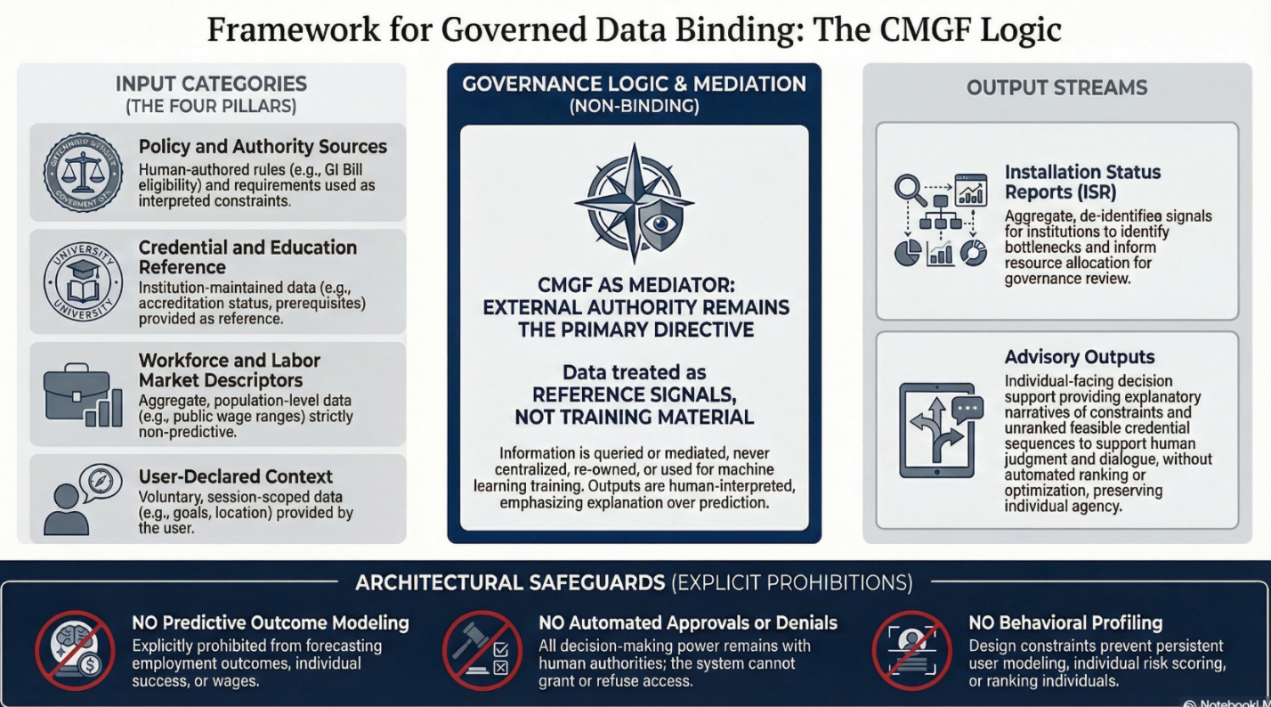

Policy and Literature Analysis
First, a structured review of peer-reviewed academic literature, federal policy documents, and oversight reports was conducted to identify recurring constraints and enabling factors affecting military learner career mobility, credential portability, advising effectiveness, and institutional adoption of AI literacy.
Sources included:
- Academic research on military-to-civilian transitions, labor-market signaling, credential portability, and workforce alignment.
- Empirical studies of AI-assisted advising, decision-support, and human-in-the-loop systems in education and training contexts; and
- Authoritative policy guidance and oversight analyses from the Department of Defense (DoD), Government Accountability Office (GAO), Office of Management and Budget (OMB), and National Institute of Standards and Technology (NIST).
Literature synthesis was organized explicitly around the five focus areas defined by Track 1 of the 2026 Council of College and Military Educators (CCME):
- Military learner career mobility.
- Empowerment strategies and stackable pathways.
- Career-aligned advising frameworks.
- Translation of military experience into civilian workforce value; and
- Veteran and service-member learner voice.
This thematic organization ensured direct alignment between the literature review, policy analysis, and the architectural framing of the study. Across these domains, the synthesis emphasized not only outcome determinants, but also recurring patterns of system fragmentation, manual integration burden, and inconsistent translation mechanisms. These patterns informed the specification of binding-layer requirements and guided the design of the demonstration artifacts used to examine whether governed, non-predictive AI infrastructure could address these integration gaps at scale (CAEL, 2018; Institute for Veterans and Military Families [IVMF], 2019; RAND Corporation, 2022).

Labor Market and Workforce Data Analysis
Second, descriptive labor-market and workforce evidence was examined to assess how credentials, skills-based hiring practices, and AI-related competencies are currently valued by employers. Data sources included publicly available datasets and reports from the Bureau of Labor Statistics (BLS), Office of Personnel Management (OPM), employer surveys, and industry credentialing organizations.
The purpose of this analysis was not to construct predictive labor-market models, but to identify observable patterns in credential demand, occupational growth, and employer signaling practices relevant to transitioning service members (Bureau of Labor Statistics, 2025; Office of Personnel Management, 2024; Wells, 2024). Consistent with the study’s ethical design constraints, all analysis remained descriptive and comparative rather than inferential. No individual-level prediction, classification, optimization, or ranking was performed.
Findings from this phase informed the design assumptions underlying the demonstration artifacts, particularly with respect to:
- Credential sequencing and stackability.
- Funding constraints (e.g., Credentialing Assistance and COOL caps); and
- The increasing salience of baseline AI literacy as a cross-cutting workforce competency.

AI and Data Analytics Design Approach
Third, insights from the policy, literature, and labor-market analyses informed the design of two interconnected demonstration artifacts illustrating how a governed, AI-enabled advising layer could mediate fragmented data sources into a coherent planning and advising context.
Rather than obscuring policy constraints, the system is intentionally designed to surface structural frictions such as credential funding caps or policy misalignments as visible planning signals. This approach positions AI as an accountability instrument that reveals institutional constraints rather than masking them, enabling policy makers to observe how rules manifest as repeated barriers at scale.
The AI components employed in the demonstration are deliberately bounded and non-predictive. Artificial intelligence is used exclusively for:
- Explainable language translation of heterogeneous data sources;
- Rule-constrained feasibility signaling based on transparent comparisons between user-declared constraints and policy rules; and
- Aggregate pattern detection for institutional learning and policy review.
Natural language processing techniques are applied to translate labor-market data, occupational crosswalks, and policy constraints into plain-language explanations with explicit data provenance. Rule-based logic generates non-binding “Go,” “Conditional,” or “No-Go” planning signals derived from stated assumptions rather than probabilistic inference. Aggregate analytics are limited to de-identified, population-level summaries intended to support policy analysis and budget justification rather than individual assessment (NIST, 2023; Government Accountability Office [GAO], 2023, 2024).
In accordance with federal AI governance guidance, the demonstration explicitly excludes predictive outcome modeling, automated approvals, individual risk scoring, and optimization objectives. These exclusions are treated as methodological design choices reflecting the study’s emphasis on preserving service-member agency, human accountability, and institutional trust (Executive Order No. 14110, 2023; OMB, 2024).
Artifact-Based Demonstration and Validation
Finally, the study employs artifact-based demonstration as a core methodological tool to operationalize policy, governance, and ethical requirements into tangible, evaluable system components (Hevner et al., 2004; Peffers et al., 2007).
Two interconnected artifacts were developed within the Career Mobility Governance Framework (CMGF):
- the Career Planning Module (CPM), and
- the Advising & Approval Module (AAM).
Career Planning Module (CPM)
CPM serves as the primary interface for active-duty service members and transitioning learners. It supports agency-driven exploration through five functional zones:
- Intent and Constraint Input Panel, capturing career goals, transition timing, credential inventory, funding limits, and personal willingness indicators.
- Retention versus Civilian Comparison Panel, enabling side-by-side visualization of tradeoffs in pay, benefits, promotion timelines, skill accumulation, and wage-regression risk.
- Data Reference Layer, transparently displaying authoritative sources (e.g., BLS wages and outlooks, O*NET crosswalks, DoD policy tables) with uncertainty annotations;
- Go/No-Go Planning Signals, providing non-binding, rule-derived indicators accompanied by explicit assumptions and constraint drivers; and
- Timeline and Scenario Visualization, using an interactive Gantt-style tool to compare retention, immediate transition, and delay-and-prepare scenarios.
AI functions exclusively as an explainable planning aid, translating complex data into accessible language and surfacing tradeoffs while remaining explicitly prohibited from recommending outcomes or predicting success.
Advising & Approval Module (AAM)
The AAM functions as the institutional workspace for Education Services Officers, commanders, and policy staff. It provides:
- Structured individual plan review with full CPM context.
- A mandatory human approval workflow requiring documented rationale and digital signature.
- Aggregate dashboards visualizing de-identified patterns in credential demand, constraint bottlenecks, and transition timing; and
- Evidence export views support budget justification and policy reform.
AI use within the AAM is strictly limited to descriptive aggregate pattern detection on anonymized data. No individual-level assessment or automated approval is permitted.
Validation Approach
Artifact validation focuses on governance-aligned criteria rather than predictive performance metrics:
- Compliance and Guardrail Enforcement: Specification review and logical walkthroughs confirm human-in-the-loop authority, mandatory rationale logging, explainability provenance, and prohibition of automated decisions (aligned with OMB M-25-21, 2025, and DoD Responsible AI guidance).
- Usability and Agency Support: Scenario-based evaluation demonstrates how the CPM enables transparent comparison of pathways while preserving learner decision authority.
- Institutional Learning Value: Synthetic aggregate data derived from public BLS and O*NET mappings and policy constraints is processed to illustrate actionable insights such as credential funding bottlenecks and high-demand credential clusters supporting resource allocation and program redesign with minimal oversight burden.
Together, these artifacts operationalize a fragmented, multi-billion-dollar programmatic landscape comprising more than 45 distinct programs dominated by the “Big Four” into an integrated, governed framework that coordinates policy, technology, and human advising in direct support of CCME’s mandate to educate, engage, and empower military learners.
Exploratory Technical Prototyping and Design Validation
In addition to policy and literature analysis, exploratory technical prototyping was conducted to examine the practical behavior, limitations, and interoperability of existing military-to-civilian data mappings and advising workflows. Multiple prototype models and interface concepts were developed using Python-based analytical environments and rapid application frameworks (e.g., Streamlit, PyCharm), desktop interface tooling (Qt6), and complementary statistical exploration tools. These prototypes were not designed as deployable systems, but as investigative instruments to assess data structure, crosswalk fidelity, and constraint interactions.
Exploratory modeling included frequency analysis of constraint violations, rule-path enumeration across credential sequences, and schema validation of MOS–SOC mappings to assess semantic consistency across datasets. These analyses were conducted using Python-based prototyping environments (e.g., Streamlit, PyCharm) to evaluate constraint behavior under varying funding caps, timing windows, and prerequisite structures. The exploratory prototyping process also informed the deliberate exclusion of certain technical approaches from the proposed framework. Topics such as automated credit portability, blockchain-based credential verification, and optimization-driven pathway selection were examined at a conceptual level but excluded from the demonstration scope. Existing research and data maturity were deemed insufficient to support responsible implementation, particularly given unresolved questions regarding data completeness, governance authority, interoperability, and long-term accountability.
These exploratory activities did not produce empirical results or performance metrics and are not presented as validation studies. Instead, they served as formative design inputs, supporting the study’s methodological emphasis on bounded AI use, transparency, and policy-aligned decision infrastructure rather than predictive or automated systems.

A Deeper Dive: System Architecture and Governance: A Twelve-Layer Model
NOTE: Reviewer Guidance on Evaluation of the CMGF Architecture Section
This section should be evaluated as a design and governance contribution, not as a predictive modeling study or system performance evaluation. The twelve-layer CMGF architecture is presented to demonstrate how AI and data analytics can be operationalized within existing military education and transition authorities while preserving human decision-making, policy fidelity, and institutional accountability. The contribution lies in the explicit decomposition of authority, data ownership, governance controls, and AI constraints across layers, rather than in algorithmic novelty or outcome optimization. Accordingly, effectiveness should be assessed based on clarity of authority assignment, enforceability of guardrails, alignment with federal AI governance guidance, and plausibility of integration into existing military education and advising ecosystems, rather than accuracy metrics, automation efficiency, or deployment readiness.
The Career Mobility Governance Framework (CMGF) AI is designed as a layered, governed architecture intended to integrate an governed artificial intelligence into military education, credentialing, and wellness support without displacing human authority or violating established policy constraints. Consistent with contemporary guidance on transparent and reproducible AI-assisted systems, CMGF treats AI as a constrained reasoning component embedded within a broader socio-technical system rather than as an autonomous decision maker (Holst et al., 2024; NIST, 2023).
To ensure accountability, auditability, and policy compliance, CMGF is decomposed into twelve functional layers. Each layer is aligned with a specific authority owner, governance mechanism, and update control process.
Collectively, the following layers operationalize the design principles established in the CPM and AAM artifacts, extending them from user-facing workflows into a full governance and accountability architecture.
Layer 1: Legal and Policy Authority Layer
The Legal and Policy Authority Layer establishes the statutory and regulatory boundaries governing CMGF operations. Authority at this layer resides with the Department of Defense, service headquarters, and interagency partners such as the Department of Veterans Affairs and the Department of Labor. CMGF does not generate or interpret policy; rather, it consumes formally issued policy artifacts as authoritative inputs.
This design aligns with federal guidance emphasizing that AI systems must operate strictly within existing legal authorities and may not introduce de facto policy through technical implementation (DoD, 2020; NIST, 2023).
Layer 2: Governance and Oversight Layer
The Governance and Oversight Layer translates policy constraints into enforceable operational rules. This layer is responsible for approving permitted use cases, prohibiting unsafe or unethical applications, and defining audit and retention standards. Governance bodies operating at this layer ensure that AI capabilities remain bounded, transparent, and subject to human oversight.
Separating governance from implementation reflects best practices in responsible AI deployment, where accountability remains with institutional authorities rather than technical vendors (Holst et al., 2024; Leslie, 2019).
Layer 3: Identity, Access, and Trust Layer
The Identity, Access, and Trust Layer ensures that system interactions are authenticated, authorized, and attributable. CMGF binds to existing identity and access management infrastructures and follows zero-trust principles, in which access is granted only for specific purposes and durations (Rose et al., 2020).
Importantly, CMGF does not maintain persistent behavioral profiles of service members or veterans. Each interaction is session-based and logged for accountability, reducing privacy risk while preserving traceability.
Layer 4: Authoritative Source Systems Layer
The Authoritative Source Systems Layer contains the systems of record for personnel status, education benefits, credentials, and labor market references. These systems remain under the control of their respective program offices and agencies. CMGF queries these sources but does not replicate or modify them.
This approach preserves data integrity and aligns with federal data governance principles emphasizing authoritative ownership and minimization of redundant data stores (OMB, 2019).
Layer 5: Data Integration and Mediation Layer
The Data Integration and Mediation Layer federates queries across authoritative systems, normalizes responses, enforces data minimization, and applies provenance metadata. This layer is deterministic and inspectable, serving as technical infrastructure rather than an analytical engine.
By avoiding predictive analytics at this stage, CMGF reduces the risk of opaque data transformations and supports transparent downstream reasoning (Holst et al., 2024).
Layer 6: Rules and Constraints Layer
The Rules and Constraints Layer encode eligibility criteria, funding caps, timing windows, and prerequisites derived directly from policy artifacts. These rules are authored by humans, approved through governance processes, and version controlled.
This explicit encoding of policy prevents AI models from inferring or improvising eligibility logic, a risk identified in prior analyses of automated decision systems (NIST, 2023; Selbst et al., 2019).

Layer 7: AI Reasoning and Explanation Layer
The AI Reasoning and Explanation Layer provides language understanding, synthesis, and explanation capabilities. It operates only on structured inputs produced by upstream layers and is constrained by approved prompts and safety controls.
Consistent with DoD ethical AI principles, the AI at this layer does not make decisions, assign scores, or retain memory across sessions. Its function is limited to explanation and clarification, supporting human judgment rather than replacing it (DoD, 2020).
Layer 8: Application Services Layer
The Application Services Layer implements user-facing workflows, interfaces, and routing logic. It enforces disclosures, consent mechanisms, and role-specific views, ensuring that users understand the authority under which each interaction occurs.
Clear interface-level signaling of purpose and authority is a recognized safeguard against misuse and overreliance on AI systems (Leslie, 2019).
Layer 9: Stream Separation Layer
This separation is essential to preserving trust between service members and command structures by preventing wellness disclosures from influencing education, assignment, or retention outcomes. The Stream Separation Layer enforces a strict boundary between education and career advising functions and wellness or emergency support functions. Although accessed through a common interface, these streams are governed by different authorities and retention rules.
Individual-level data from one stream may not be used in the other. Only aggregated, anonymized trends may be elevated for command-level visibility. This separation mitigates surveillance risk and aligns with ethical guidance on purpose limitation and contextual integrity (Nissenbaum, 2010).
Layer 10: Audit, Logging, and Accountability Layer
The Audit, Logging, and Accountability Layer captures comprehensive records of system activity, including inputs, outputs, rules applied, and access events. These logs support compliance, incident response, and independent review.
Auditability is treated as a prerequisite for deployment, consistent with both federal cybersecurity practice and AI accountability frameworks (NIST, 2023).
Layer 11: Reporting and Command Visibility Layer
The Reporting and Command Visibility Layer provides leadership with aggregated insights into system usage, demand patterns, and wellness trends. Reports are anonymized and purpose-limited, focusing on system performance rather than individual behavior.
This design supports informed leadership decision making while avoiding the creation of disciplinary or surveillance mechanisms.
Layer 12: Operations, Lifecycle, and Contract Layer
The Operations, Lifecycle, and Contract Layer governs deployment, accreditation, monitoring, and evolution of the CMGF system. It includes security authorization processes, vendor management, and controlled update cycles.
Unlike existing advising platforms that optimize individual outcomes, CMGF demonstrates how AI can be used to expose policy-level constraints and coordination failures without encroaching on individual decision authority. Operational discipline is treated as an extension of governance, ensuring that technical change does not outpace policy or ethical oversight (OMB, 2019).

Track 1 Topics

Artificial Intelligence as an Enabling Force
As the CCME 2026 Symposium theme, The Future Is Now: Educate, Engage, Empower, emphasizes, military learners occupy a central role in shaping the future of education, workforce development, and national resilience amid rapid technological change. Artificial intelligence is no longer a speculative capability but an operational reality influencing how learning, advising, and workforce alignment occur across public and private sectors. Within this context, the most immediate value of artificial intelligence for military learners lies not in automation, but in enablement. Properly governed, artificial intelligence can expand access to timely information, improve translation between military and civilian education and employment systems, and support informed, self-directed planning at scale. This exploratory approach reflects the study’s central premise for CCME Track 1: that AI in military learner systems must function as trusted advising infrastructure and policy evidence generation, not as automated decision authority over individual careers.
Recent national and Department of Defense initiatives reflect this shift by framing artificial intelligence literacy as a foundational readiness requirement across leaders, operators, and enabling staff, rather than a capability limited to technical roles (Defense Innovation Board, 2023; Department of Defense, 2023). Government wide policy further reinforces this direction by establishing minimum risk management expectations for agency use of artificial intelligence and identifying persistent gaps in role clarity, timelines, and accountability within the Department of Defense workforce (Government Accountability Office, 2023, 2024; Office of Management and Budget, 2024).
In parallel, federal workforce guidance increasingly supports competency focused hiring by defining artificial intelligence related skills across job families, elevating the importance of portable and verifiable signals of capability (Office of Personnel Management, 2024). For Track 1, this convergence positions artificial intelligence not as a replacement for human advising or institutional responsibility, but as a collaborative tool that can extend advising capacity, preserve service member agency, and support continuous career mobility across education, service, and civilian employment pathways.

Military Learner Career Mobility

A recurring theme in the literature is that servicemembers face significant barriers in converting their military training and experience into meaningful civilian workforce mobility. Federal programs overwhelmingly emphasize degree attainment, but degree completion alone does not guarantee smooth labor market transitions. Military learner career mobility failures are driven less by insufficient participation in education programs than by the absence of longitudinal planning and translation infrastructure connecting in-service decisions to post-service labor-market outcomes (Kleykamp et al., 2024; McKinsey & Company, 2022; Barr et al., 2021). Lack of structured frameworks for translating military occupational specialties (MOS/AFSC/Rating) into civilian-recognized credentials contributes to underemployment and wage regression after separation (Kleykamp et al., 2024).
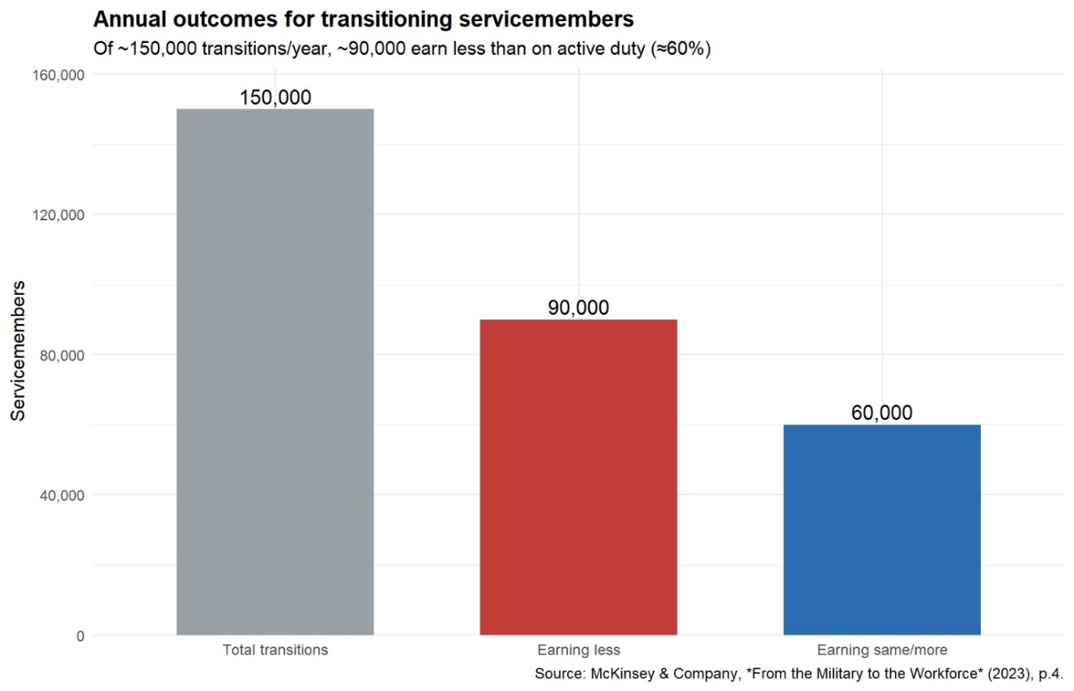

Figure 1e: Annual Outcomes for Transitioning Servicemembers

Figure 1e. details McKinsey estimates that of the servicemembers who transition each year, nearly 90,000 (60 percent) earn less in their first civilian role than they did on active duty (McKinsey & Company, 2022). This mismatch between military-acquired skills and employer-recognized credentials creates both immediate income loss and long-term career stagnation. NBER analysis of the Post-9/11 GI Bill shows similar trends: while educational attainment increases, veterans often forgo years of labor market experience, resulting in lower cumulative earnings over time (Barr et al., 2021).
The literature calls for standardized frameworks that make career mobility predictable: digital credentialing, cross-sector recognition, and AI-enabled matching systems that align MOS/AFSC/Rating with civilian credentials. Nonprofit and advocacy organizations, such as the Institute for Veterans and Military Families (IVMF) and the Council for Adult and Experiential Learning (CAEL), argue that stackable micro credentials and modular pathways are critical for supporting mobility. These frameworks enable servicemembers to transition more fluidly into civilian sectors while building on existing leadership and technical foundations (IVMF, 2021; CAEL, 2021).
Ultimately, military learner mobility requires systemic reform: portable credentialing standards, integration of AI-enabled career mapping tools, and closer alignment between DoD training, higher education, and civilian employer needs. Without these, mobility remains inconsistent and highly dependent on individual initiative, rather than a structured ecosystem of support.

Funding Imbalances: Education vs. Transition Support
While federal programs demonstrate (Table 1) a strong commitment to funding educational benefits for servicemembers and veterans, this funding is heavily skewed toward tuition and credential attainment rather than toward practical transition support. RAND (Kleykamp et al., 2024) reports that the “Big Four” programs the Post-9/11 GI Bill (PGIB), Veteran Readiness and Employment (VR&E), Tuition Assistance (TA), and Dependents’ Educational Assistance (DEA) accounted for approximately $13.5 billion of the $14.3 billion spent on transition programs in FY2019.
The PGIB alone is regarded as “one of the largest and most generous college subsidies in U.S. history,” surpassing the combined grant and scholarship spending of all U.S. states (Barr et al., 2021). These programs are designed to accelerate degree and (disproportionately) credential attainment by directly paying institutions (American Council on Education, n.d.).
In contrast, funding for skill translation and civilian labor market alignment is minimal (Figure 2). TAP, the only program universally required for separating servicemembers, received just $140 million in FY2019 (Kleykamp et al., 2024).
This imbalance has consequences. Veterans frequently cite finances as their most pressing transition concern, noting the loss of structured pay and unexpected monetary burdens (Shue et al., 2021). Studies also reveal a paradox: while educational funding is plentiful, veterans often experience reduced earnings during the years they pursue education, losing labor market experience in the process (Barr et al., 2021). Thus, while
educational subsidies are vast, the absence of comparable investment in translation support leaves many veterans educated but underemployed.

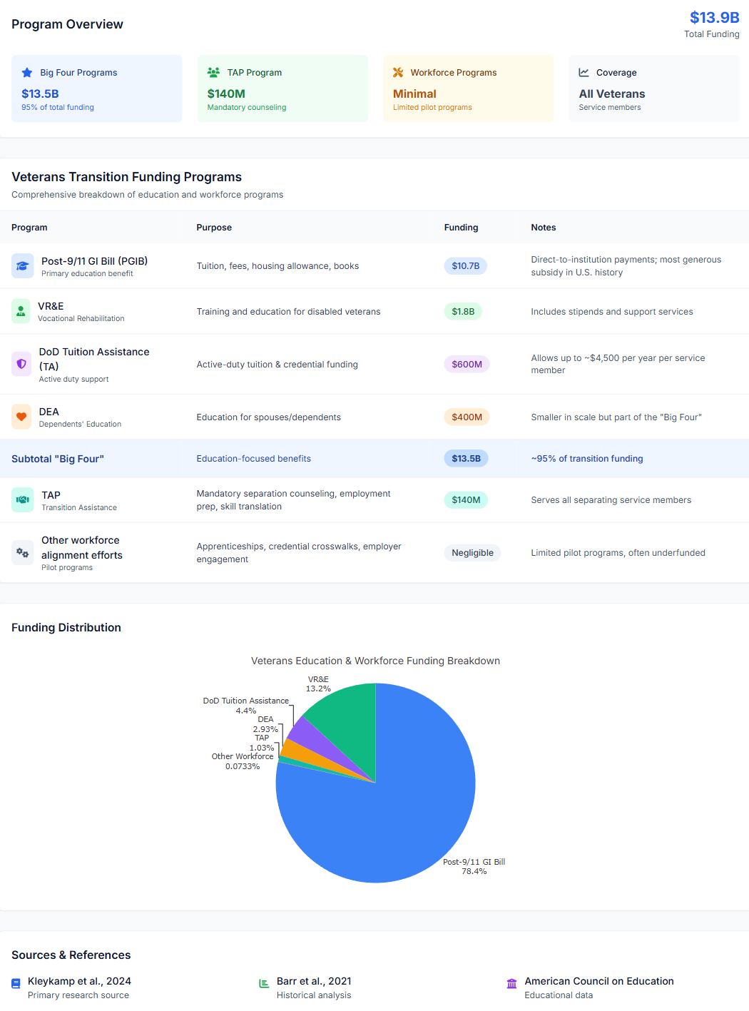

Table 1: Source: Kleykamp et al., 2024; Barr et al., 2021; American Council on Education, n.d.

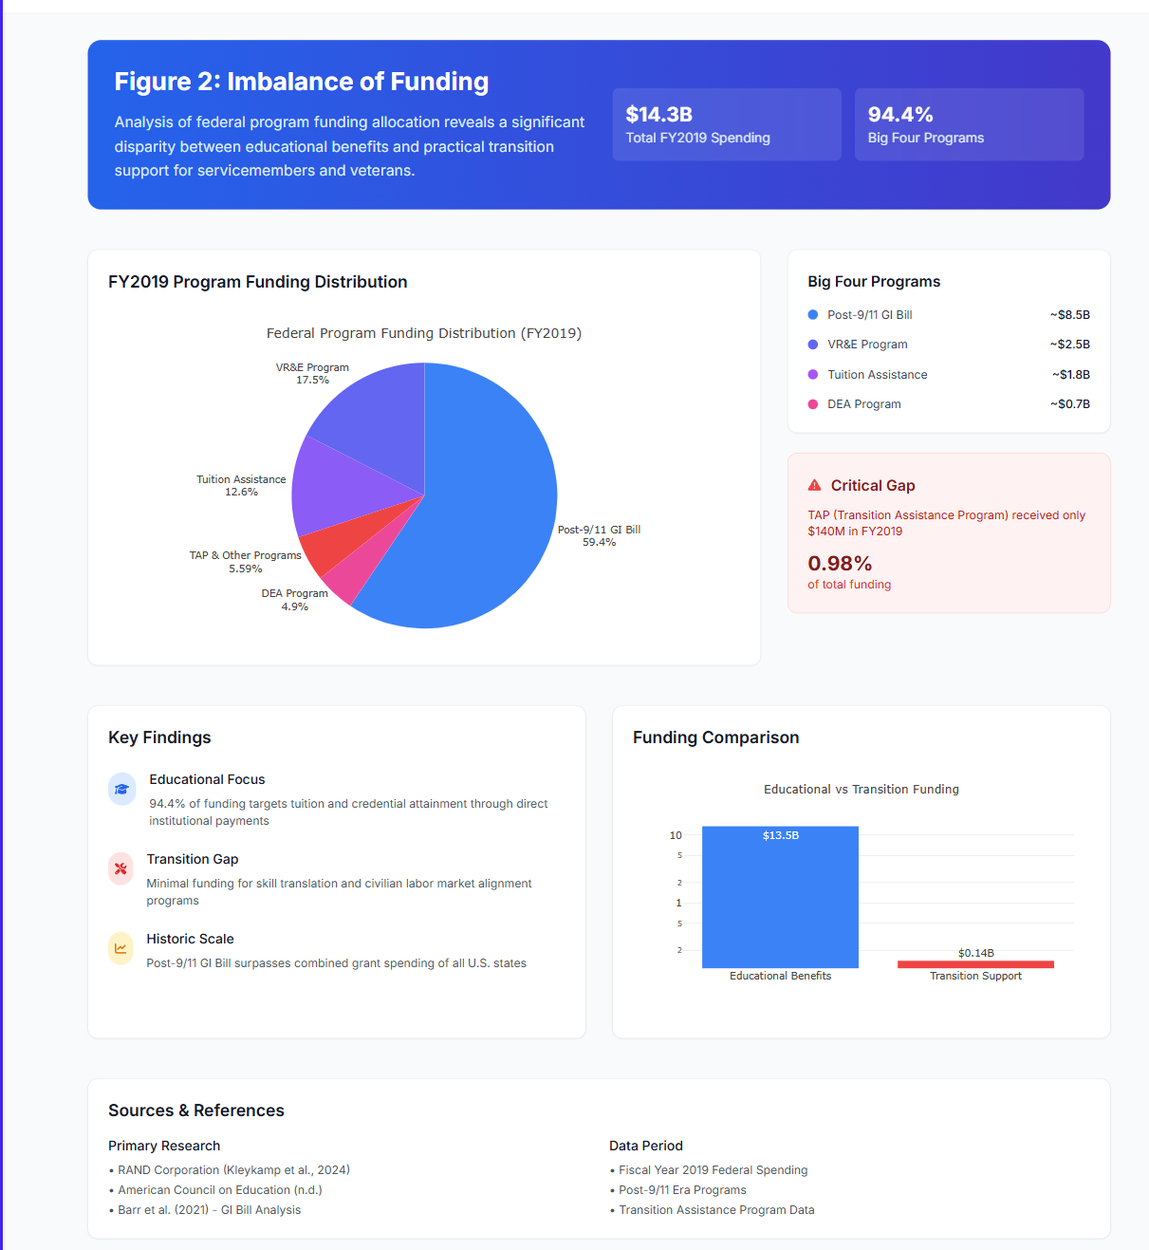

Figure 2: Imbalance of funding

Empowerment Strategies and Stackable Pathways
Stackable credentials function as genuine empowerment mechanisms only when learners can evaluate credential sequencing decisions within a transparent, constraint-aware planning context aligned to labor-market signaling over time (CAEL, 2018; IVMF, 2019; Digital Education Council, 2025).
Empowerment strategies and stackable pathways are now recognized by literature as essential tools for promoting both immediate and long-term career mobility among transitioning servicemembers and veterans.
Current research demonstrates that modular and portable credentials, delivered through employment-focused frameworks, help veterans overcome wage regressions and avoid underemployment. Stackable pathways, including AI literacy, targeted industry certifications, and progressive micro credentials allow veterans to move beyond initial civilian roles and pursue advancement that aligns with evolving labor market demand (Digital Education Council, 2025; Kleykamp et al., 2024; CAEL, 2018). These approaches are at their best when developed and recognized within an ecosystem involving the Department of Defense, higher education, and employer partners working to ensure transparency, relevance, and value of credentials for the civilian market.
Veterans utilizing modular credentials report fewer advancement barriers and higher satisfaction post-service. Employer surveys consistently find that modular, career-aligned learning supports faster and more accurate hiring for in-demand industries, especially technology, cybersecurity, and healthcare (SHRM, 2023). Public-private initiatives, such as the Teamsters Military Assistance Program (TMAP), DoD SkillBridge, and Army COOL, further exemplify how stackable credential models boost both training relevance and job placement rates for military learners entering civilian fields (MCAI Report, 2024; MedCerts, 2024).
By centering empowerment and stackable pathways, military-to-civilian transition policy can move beyond legacy models, delivering both adaptability and upward mobility for all who serve (Digital Education Council, 2025).
The Institute for Veterans and Military Families (IVMF) and analyses from the Council for Adult and Experiential Learning (CAEL) highlight that veteran upskilling is most effective in modular, incremental pathways, rather than traditional, fixed-length degrees. Cross-sector, portable programs enable veterans to start with foundational digital or technical skills and build specialized, employer-respected certifications, thus increasing their competitiveness in priority fields and regional labor markets (IVMF, 2019; CAEL, 2018; Revisiting the Business Case for Workforce Readiness, 2021).
In summary, robust transition policy built around modular and stackable micro credentials with strong employer engagement, DoD digital mandates, and modern learning science offers a concrete pathway to wage parity and career resilience. Without continued innovation in these areas, many veterans will remain at risk for underemployment or stagnant earnings despite major public investments in their education (Kleykamp et al., 2024; Barr et al., 2021; McKinsey & Company, 2022).

Data Confidence in Decentralized Credential Ecosystems
Stackable credentials are widely promoted as empowerment mechanisms that enable career mobility, modular learning progression, and labor market responsiveness (CAEL, 2018; Digital Education Council, 2025; RAND Corporation, 2023a). For transitioning servicemembers and veterans, stackable pathways are frequently described as adaptive solutions that support wage recovery and long-term advancement (IVMF, 2019; Kleykamp et al., 2024). While the literature affirms the value of modular and portable credentials, less attention has been given to a foundational governance issue that directly affects advising systems and AI supported planning frameworks: the absence of a unified credential authority in the United States and the resulting implications for data confidence.
The United States credentialing environment operates within a decentralized and multi authority structure. In some professions, such as nursing, law, and commercial transportation, regulatory bodies define licensure standards and sequencing requirements. In many other sectors, particularly information technology, business services, and emerging digital occupations, credential value and sequencing are shaped by industry certification bodies, employer preference, institutional curriculum design, and regional labor market demand rather than by a centralized authority (RAND Corporation, 2023a; RAND Corporation, 2023b). This distributed structure reflects the pluralistic and market responsive nature of the national workforce system. However, decentralization introduces variability in authority strength, updating cycles, and signal clarity.
RAND analyses caution that stacking credentials does not uniformly produce wage gains and that labor market signaling varies substantially across industries (RAND Corporation, 2023a). Certificates may align sequentially in theory, yet their economic return depends on sector specific recognition and demand conditions. Without clear authority mapping, advising systems that aggregate credential information may inadvertently synthesize heterogeneous signals into outputs that appear structured but rest on uneven authority foundations. In such environments, advising tools and AI assisted planning frameworks operate within variable confidence datasets.
The contrast with healthcare credentialing illustrates this governance distinction. In highly regulated domains, calls for a single source of truth aim to reduce liability exposure and verification inefficiencies (MedCity News, 2024). Centralized verification increases confidence in provider status because authority is clearly defined. However, such models are not easily transferable to broader workforce credentialing systems, where innovation, regional autonomy, and employer driven standards remain central features.
The United States Department of Education Stackable Credentials Toolkit emphasizes employer engagement, regional alignment, and modular progression without proposing centralized sequencing authority (U.S. Department of Education, 2018). This confirms that stackable credential systems function within distributed governance environments. The structural reality is therefore not the absence of order, but the presence of multiple overlapping authorities.
For frameworks such as the Career Mobility Governance Framework, this decentralization has direct implications. Systems that bind data from regulatory agencies, certification bodies, institutional programs, and employer demand signals must account for differences in authority weight and evidentiary strength. Absent explicit authority tagging, provenance tracking, and transparent rule logic, advisory outputs risk overstating determinism. The issue is not whether stackable credential’s function, but whether advisory systems clearly communicate the confidence level of the underlying data.
Military learners face amplified exposure to this variability. Transitioning servicemembers must interpret Department of Defense equivalencies, state licensing requirements, industry certifications, higher education pathways, and employer expectations simultaneously. In decentralized ecosystems, empowerment depends not only on access to modular credentials but also on transparent interpretation of distributed authority signals.
A national discussion may therefore be warranted, not to centralize credential authority, but to improve signal transparency and data confidence standards across decentralized systems. Areas for inquiry include authority classification taxonomies, provenance disclosure standards for credential datasets, and confidence scoring methodologies for advisory systems operating in multi-authority environments. Such dialogue would strengthen governance literacy and reduce informational asymmetry without undermining institutional pluralism.
Stackable credentials remain valuable instruments of mobility. However, within decentralized ecosystems, empowerment requires more than accumulation. It requires clarity regarding the authority structure shaping credential recognition. For advising systems and AI enabled planning tools, the central design question is not only what to stack, but how confidently the stack reflects authoritative and current institutional signals

Emerging Labor Market Demand for AI Literacy Certifications
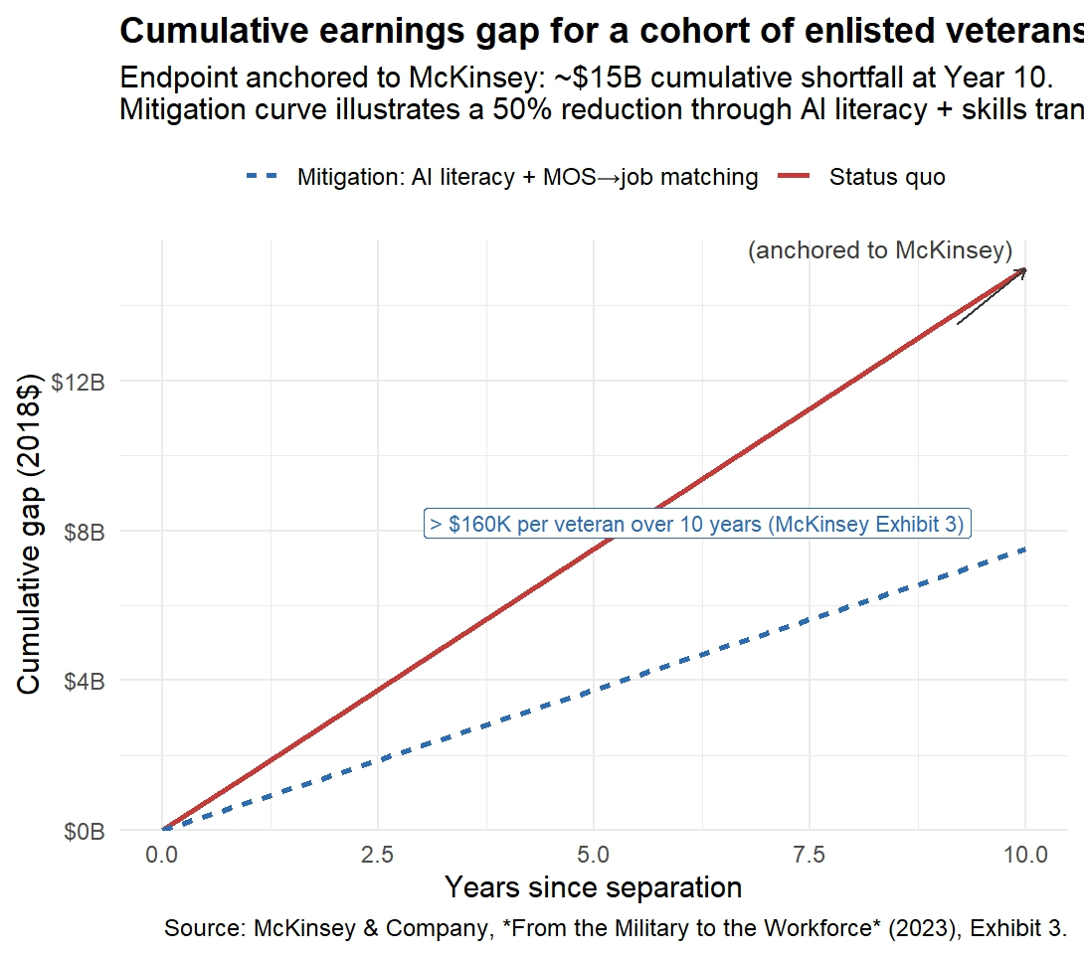
National studies and pilot programs have found that when veterans gain recognized AI and digital credentials, they not only improve their employability but also narrow the wage gap (Figure 3) compared to their non-veteran peers (Kleykamp et al., 2024; CAEL, 2018). Modern approaches emphasize a tiered, stackable system starting with essential AI literacy and building toward specialized industry certifications and applied digital skills. These pathways align directly with emerging hiring priorities in technology, healthcare, manufacturing, and logistics.

Figure 3: The Value of AI Literacy

Importantly, AI literacy is best provided as part of a modular system that adapts to individual interests and employer needs. Public-private partnerships, such as DoD SkillBridge and Google Veteran Launchpad, demonstrate how cross-sector collaboration can rapidly deliver job-aligned digital skills and support ongoing career progression for military learners (Digital Education Council, 2025).
This new focus on AI literacy is supported by both evidence and employer demand. Employers surveyed by SHRM and Hiring Our Heroes now list AI fluency as a top priority for new hires, especially in environments undergoing digital transformation (SHRM, 2023). Integrating AI literacy into transition frameworks ensures veterans are competitive in the evolving labor market and are equipped for lifelong adaptability and leadership in their post-service careers. As illustrated in Figure 4, the future of workforce development requires coordinated action and shared accountability among all stakeholders Figure 5 demonstrates the power of a collaborative DoD/University partnership to provide efficient AI Literacy certification.
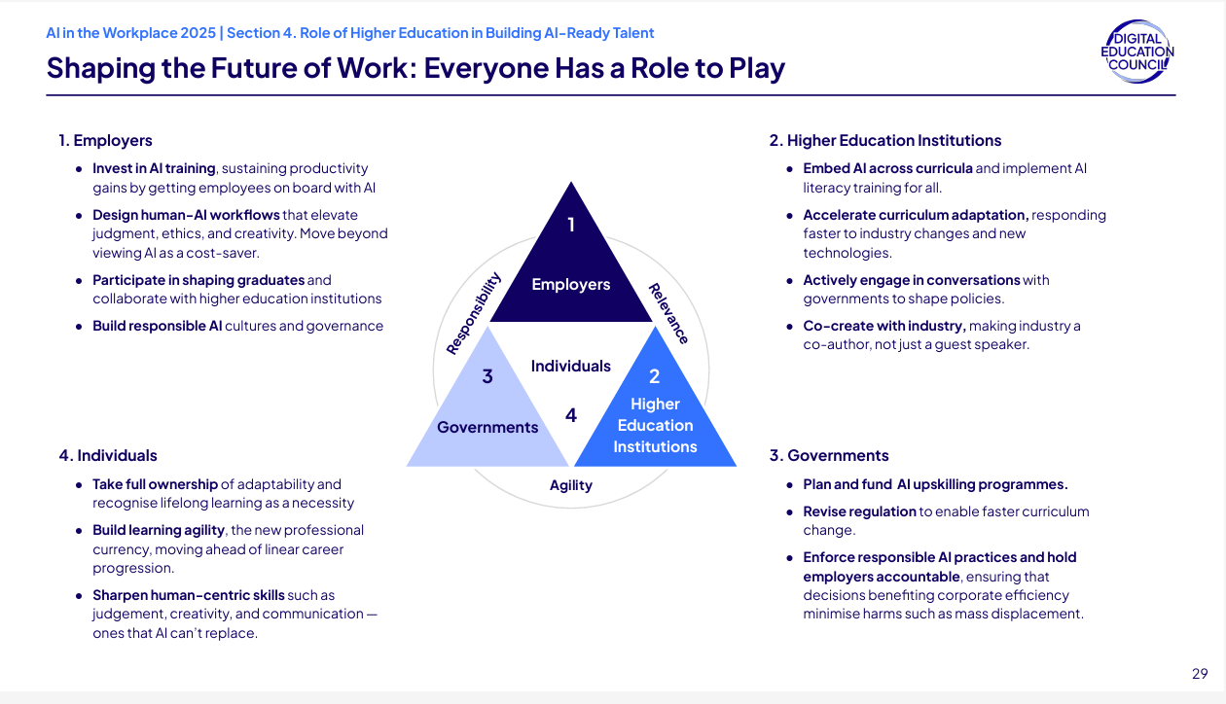
Figure 4: Stakeholder Roles in Shaping an AI-Ready Workforce Source: Digital Education Council, 2025.

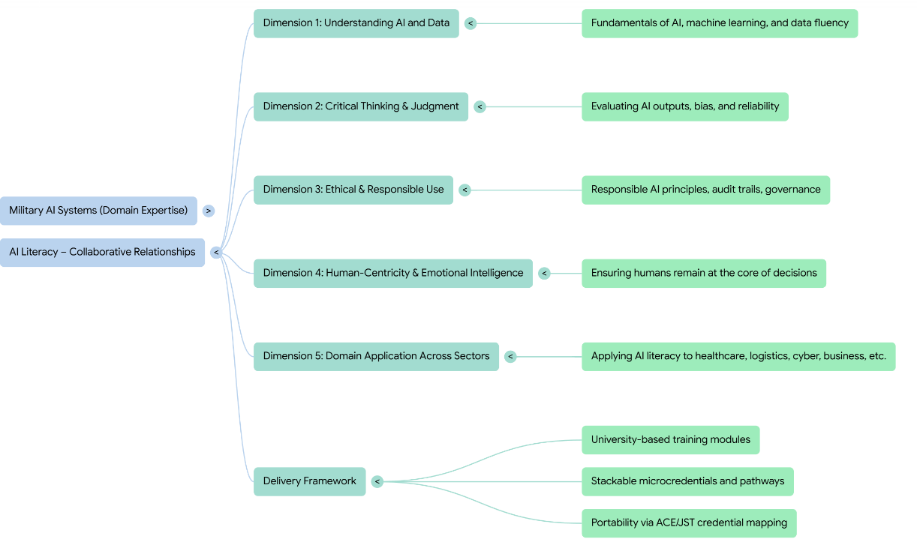

Figure 5: Collaborative Relationship for AI Literacy Certification: Modeled after “AI Literacy For All”, Digital Nation Council, 2025

Translating Military Experience into Civilian Workforce Value

Persistent failures in translating military experience into civilian workforce value arise not from the absence of equivalency frameworks, but from their fragmentation, inconsistent application, and inaccessibility at the point of individual decision-making (CAEL, 2018; American Council on Education, n.d.; RAND Corporation, 2022).
Modern literature shows that seamless military-to-civilian career transitions depend on structured frameworks that map MOS/AFSC training to portable civilian credentials and in-demand job families (Kleykamp et al., 2024; RAND, 2024; CAEL, 2018). The American Council on Education’s Credit for Military Experience (ACE/PLA), Department of Defense COOL program, and new AI-enabled translation tools all seek to optimize credit and certification translation at scale (ACE, n.d.; Department of Defense, 2024).
As illustrated in Figure 6, rapid advances in digital learning, credential mapping, and university-military collaboration have enabled the creation of stackable, modular career pathways. These pathways link military occupations such as IT specialist, combat medic, and vehicle mechanic to civilian certifications, college credits, and target job families in technology, manufacturing, healthcare, and cybersecurity (CAEL, 2018; Digital Education Council, 2025). Pathways like CompTIA Security+, Lean/Six Sigma, and AI literacy levels are increasingly embedded within both MOS training and transition programs, yielding dual benefits for service member advancement and civilian employment prospects.
Recent workforce alignment research documents that when military learners can obtain validated civilian credentials and university credits during service, their risk of underemployment and wage regression is significantly reduced (Workforce Readiness Alignment Council, 2021; IVMF, 2019). This approach strengthens economic mobility and enables continuous upskilling, allowing veterans to move not only laterally but upward within critical sectors such as IT, advanced manufacturing, and healthcare.
Research also stresses the importance of O*NET/SOC crosswalks, stackable credentialing, and experiential credit evaluation for supporting diverse transition outcomes. By connecting military schoolhouses, ACE and PLA recommendations, industry certifications, and civilian job families, the modern military credential ecosystem now offers a much clearer path to real civilian workforce value (CAEL, 2018; ACE, n.d.; Department of Defense, 2024).

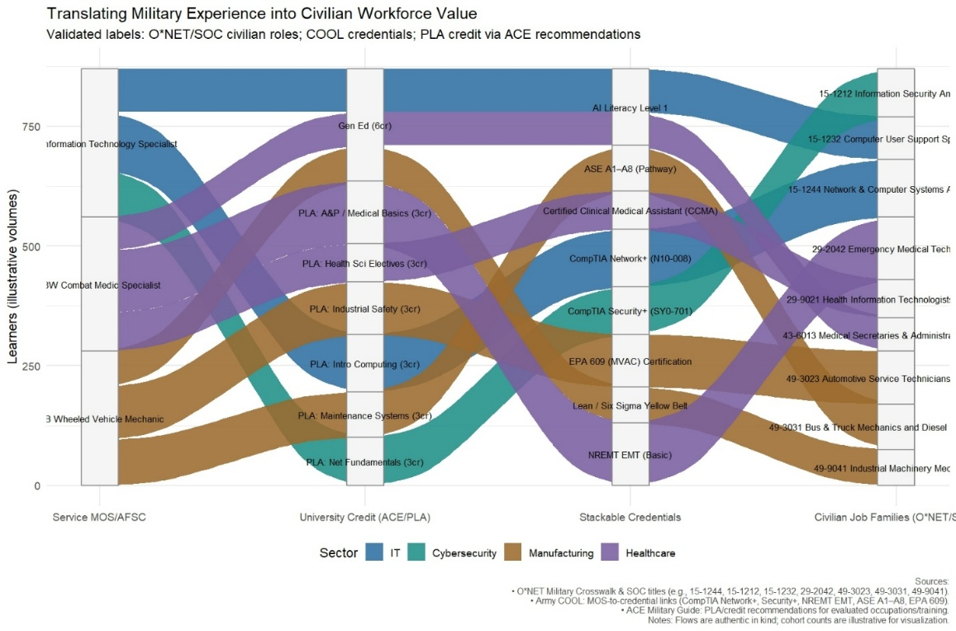
Figure 6: Translating Military Experience into Civilian Workforce Value: MOS/AFSC-to-Civilian Credential Pathways | Source: ACE Military Guide, DoD COOL, O*NET SOC crosswalks, adapted for publication

Veteran and Servicemember Learner Voice
In the absence of mechanisms that aggregate and analyze learner-reported planning friction at scale, transition failures remain anecdotal and therefore unusable for institutional learning, budget justification, or policy reform. Crenshaw’s (1989) theory of intersectionality provides a critical lens for understanding why these failures are not uniformly distributed across the veteran population. Transition barriers compound for individuals navigating multiple, overlapping identities such as rank, race, gender, disability status, and socioeconomic background, yet most advising and reporting systems treat learners as homogeneous cases. Without disaggregated visibility into how constraints intersect, institutional responses risk reinforcing inequities rather than mitigating them.
A growing body of research underscores that meaningful, sustainable workforce transitions depend on centering the voice and lived experience of veterans and service members within all education and advising processes (Kleykamp et al., 2024; Bradbard et al., 2024). Veterans consistently express that programs designed without their direct input often fail to address their priorities or the real-world barriers they encounter during transition (Harrell & Berglass, 2012; National Resource Center, 2022). When veterans’ perspectives inform the design of advising, credentialing, and workforce alignment initiatives, outcomes measurably improve in terms of engagement, persistence, and post-transition earnings (Bradbard et al., 2024; IVMF, 2019).
Recent qualitative studies have found that veterans value individualized advising, practical career information, and opportunities for peer mentorship far more than generalized classroom or benefit navigation support (Phillip Morris & National Resource Center, 2022; Kleykamp et al., 2024). The holistic advising model, which stresses empathetic listening, co-creation of learning pathways, and sustained access to knowledgeable faculty or industry mentors, has been shown to increase retention and satisfaction for veterans in higher education. For instance, frequent and meaningful faculty-advisor interactions are correlated with improved transition confidence and lowered rates of program attrition (National Resource Center, 2022).
Evidence from large-scale surveys also demonstrates that transition programs with robust mechanisms for learner feedback such as alumni panels, advisory boards, and participatory curriculum development are most successful in ensuring the evolving needs of veterans are addressed at the system level (CAEL, 2018; IVMF, 2019). This participatory approach extends beyond the classroom, influencing workforce readiness and employer engagement strategies to become more responsive, inclusive, and impactful.
The literature further underscores that when veterans actively contribute to the design and continual improvement of transition services, the resulting models are more likely to meet the realities of navigating multiple identities, changing family obligations, and varied labor market landscapes (Kleykamp et al., 2024; Bradbard et al., 2024).
In summary, embedding the voice of veterans and service members in all aspects of transition from credential mapping and academic advising to program evaluation and policy formation is a proven driver of successful civilian career outcomes and an essential metric for national workforce readiness (Harrell & Berglass, 2012; Bradbard et al., 2024; National Resource Center, 2022).

Installation Status Reports (ISR)
Tools and Frameworks for Career-Aligned Advising: The Career Mobility Governance Framework (CMGF)

This section establishes why ISR-relevant advising signals require governed, AI-assisted infrastructure rather than additional human reporting burden.
Quantitative evidence indicates that Education Services Officers (ESOs) are structurally constrained by administrative workload, limiting their capacity to provide sustained, career-aligned advising. A national survey conducted by Student Veterans of America (2022) found that advisors serving military-connected learners spend an average of 14.2 hours per student on benefits navigation and administrative processing, with 73% reporting insufficient time for career counseling. These findings suggest that advising shortfalls are not attributable to advisor capability or commitment, but to system design that prioritizes compliance tasks over strategic guidance. Automation that reduces administrative burden therefore functions as capacity recovery rather than workforce substitution.
Recent empirical studies of AI-enabled advising systems in higher education demonstrate improved retention, academic confidence, and career alignment when intelligent systems are deployed as advisor-assist tools under clear ethical and governance constraints (Ahmed et al., 2024; Soomro et al., 2025).
All touchpoints between the service member and AI that are relevant to Installation Status Report (ISR) requirements under AR 210-14 are automatically captured for reporting purposes. Specifically, only advising interactions that generate ISR-relevant indicators are aggregated into near–real-time reports following a de-identification process, with no retention of individual-level interaction histories.
Career-aligned advising is a critical, yet underdeveloped, dimension of effective military-to-civilian transition policy. Multiple studies highlight persistent problems: advising is often generic, focused on educational benefits over occupational outcomes, and insufficiently tailored to the diverse needs and career goals of individual servicemembers. According to recent RAND and IVMF analyses, enduring gaps persist in the translation of military-acquired skills, limited employer engagement, and a lack of standardized, portable frameworks for mapping service experience to civilian credentialing and employment pathways.

Modernizing Advising Approaches
Best-in-class advising frameworks emphasize three imperatives:
- Employment-First Orientation: Transition programs must prioritize employment outcomes and labor market alignment not simply the navigation of benefits or degree attainment. This requires that advising begin early in the military lifecycle, incorporate labor market data (such as O-Net and industry competency models), and guide servicemembers to make informed education and certification choices that map directly to in-demand civilian roles.
- Personalization and Learner Voice: Although transition support programs are widespread, the absence of mechanisms to aggregate learner-reported friction at scale prevents institutional learning and policy adaptation (Seelig, 2025). Veterans thrive when advising is individualized, participatory, and context sensitive. Research underscores the benefits of peer mentorship, sustained advisors beyond separation, and participatory curriculum design that centers the veteran perspective. Models such as the Holistic Advising Framework, employing Schlossberg’s Four S’s (situation, self, supports, strategies), ensure advisors address the full complexity of identity, motivation, and support networks relevant to each veteran’s transition.
- Technology-Enabled Tools: Emerging digital and AI-enabled career mapping tools, competency-based translation frameworks (e.g., MOS crosswalks, DOL’s O-Net, CareerOneStop’s industry-specific models), and advisor-assist platforms extend the reach of evidence-based advising. These solutions make skills transparent, portable, and measurable across contexts, improving both job matching and the long-term return on federal investments in veteran education.

Best Practices & Innovations
- Stackable Pathways and Modular Credentials: Advising should connect military training with modular, stackable micro credentials, particularly in high-growth fields like AI, cybersecurity, or advanced manufacturing allowing veterans to continually build market-relevant skills and avoid wage regression.
- Employer and Community Integration:
Public-private partnerships, veteran employer resource groups, and local mentorship networks amplify the effectiveness of career advising, supporting successful placement, onboarding, and upward mobility for veterans in civilian careers.
Advisor Roles and Peer Networks:
Education Services Officers (ESOs) managing AI-enabled advising systems, in partnership with higher education institutions, can function as AI readiness officers, responsible not only for supporting individual learners but for monitoring digital literacy, credential alignment, and advising friction across the transitioning population (Ahmed et al., 2024; Soomro et al., 2025). When designed as governed decision infrastructure, the AI tool itself becomes an instrument for evidence generation, aggregating de-identified advising signals, constraint conflicts, and unmet educational demand into auditable patterns that inform institutional planning and education policy. Integrating alumni and peer mentors further complements this capability by providing veterans with lived-experience guidance and contextual interpretation that cannot be replicated by static online resources, ensuring that human judgment and community insight remain central to both advising practice and policy interpretation.
Within the Career Mobility Governance Framework, the advisor role is intentionally expressed through two distinct but connected interfaces. On the service member facing side, advisors are supported with summarized status views and tools that surface urgency, constrain conflicts, and advising workload across large caseloads, enabling timely and career aligned human intervention. On the government facing side, the same advising interactions are transformed through governed aggregation into population level indicators that support Installation Status Report requirements, resource planning, and policy analysis. Artificial intelligence mediates translation and aggregation between these interfaces without transferring decision authority, ensuring that individual advising remains human directed while institutional reporting remains compliant, auditable, and non-predictive.

The Career Mobility Governance Framework CMGF Demonstration Artifact: An Example AI-Enabled Advising Interface
Career Mobility Governance Framework (CMGF) is a human-centered decision support architecture that integrates policy, credentialing, workforce, and educational data signals to support transparent, accountable advising at scale. CMGF employs AI for signal translation and aggregation while prohibiting prediction, automation, and optimization functions that would transfer authority from human advisors.
To illustrate how the findings and design principles identified in this study could be operationalized, a demonstration artifact was developed to represent an AI-enabled advising interface aligned to CCME Track 1 priorities. The artifact is intentionally constrained in scope and is not presented as a production system. Rather, it serves as a concrete example of how fragmented inputs commonly encountered in military learner advising can be unified within a single planning context.
As shown in Figure 7, the interface centers on service-member–declared inputs across four domains consistently identified in the literature as critical to career mobility outcomes: career direction, education and credential pathways, transition timing, and learner voice. The service member remains the primary decision-maker, explicitly stating goals, constraints, and timing considerations. A governed AI layer operates in the background to translate these inputs by organizing relevant education options, credential sequences, and policy-aligned information without generating recommendations or determining outcomes.

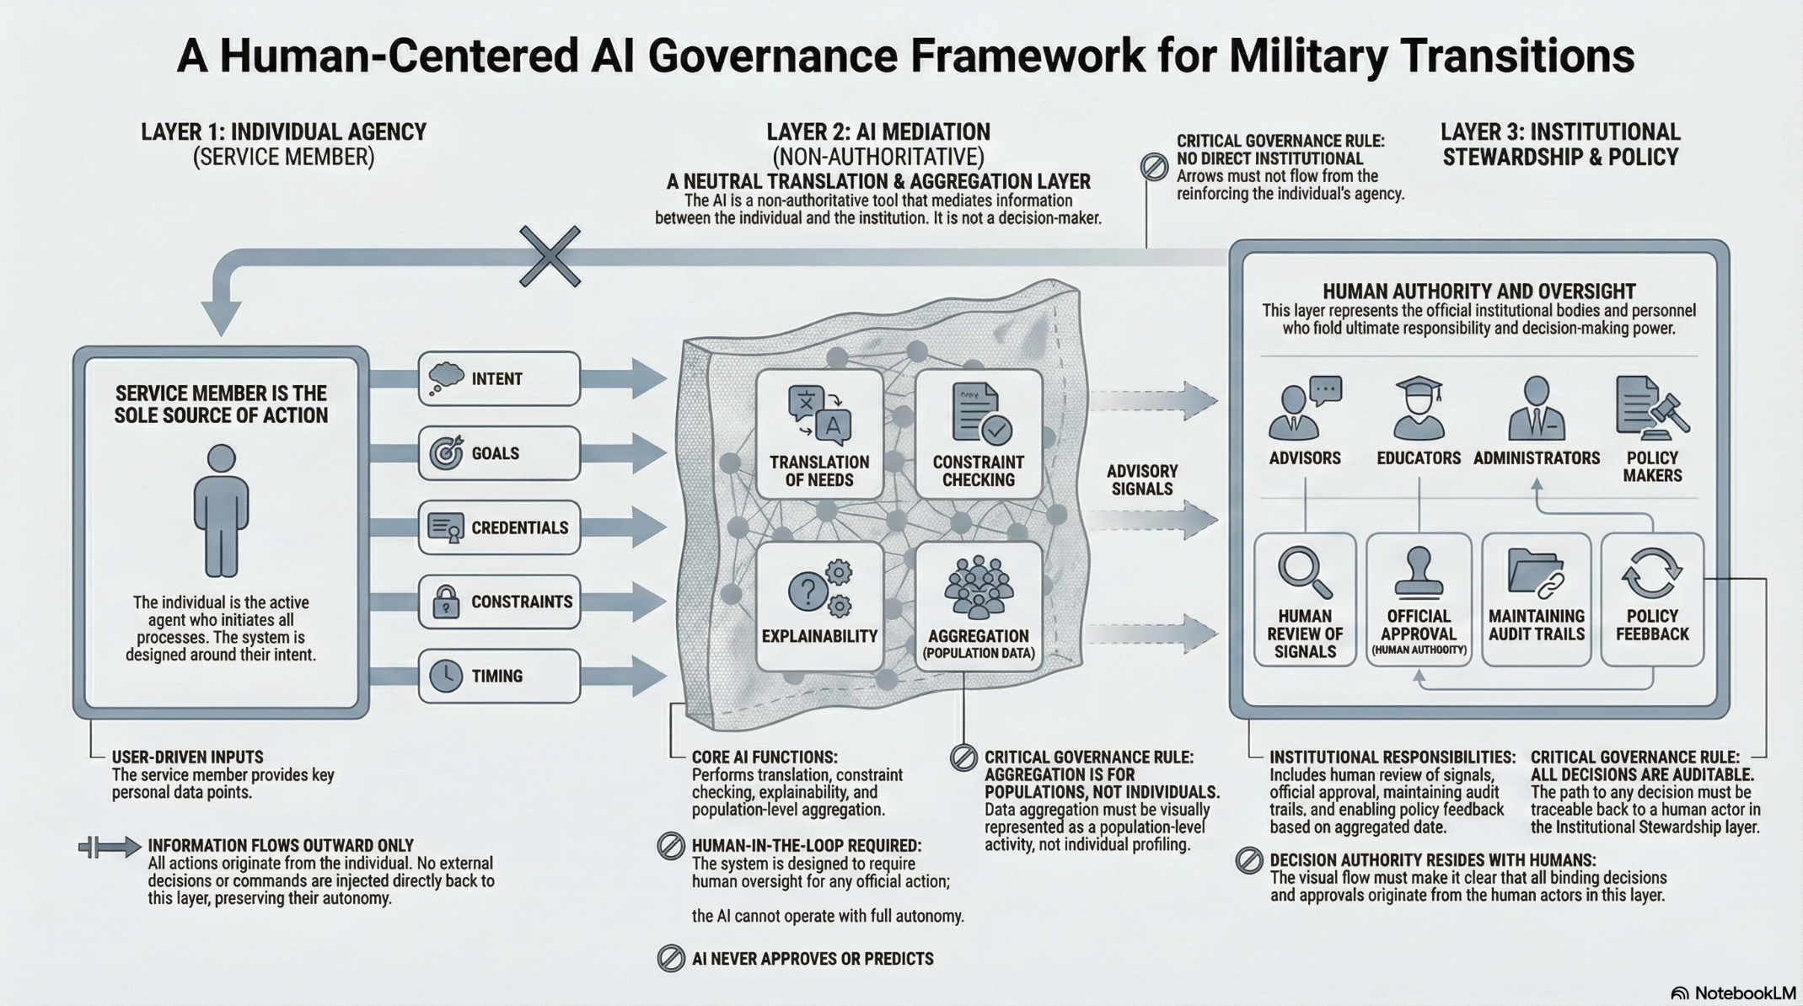

Figure 7 The Career Mobility Governance Framework (CMGF)
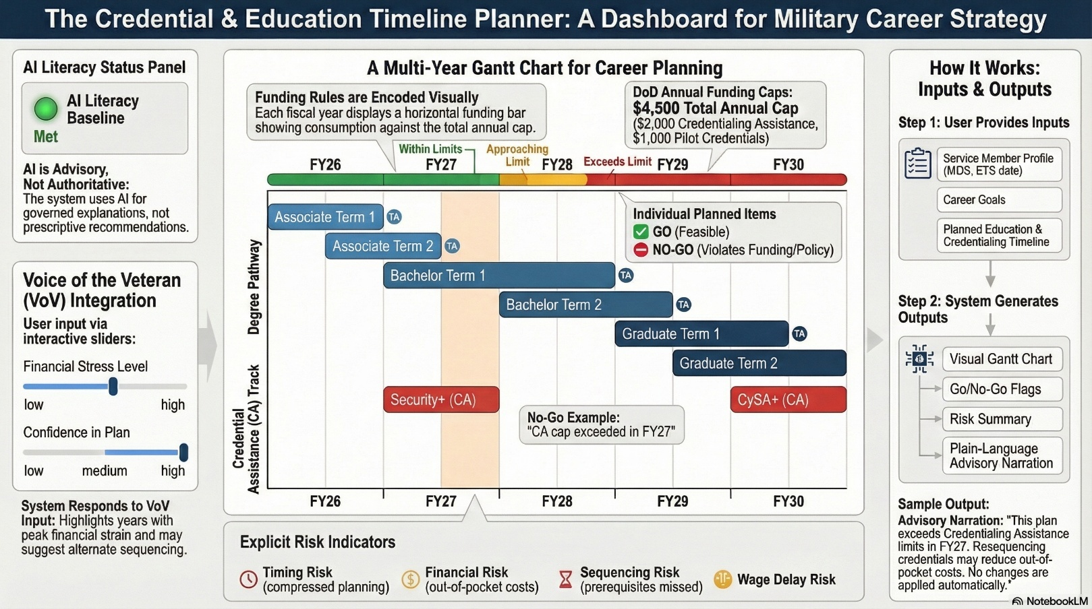

Figure 8. Credential and Education Sequencing Planner (CESP).
Figure 8, The Credential and Education Sequencing Planner (CESP) is a artifact of the Career Planning Module (CPM) and is an advisory dashboard designed to visualize multi-year education and credential planning under Department of Defense funding constraints. The instrument encodes Tuition Assistance (TA) and Credentialing Assistance (CA) policies as visual limits, flagging compliance violations and planning risks without prescribing actions. Human input signals, including financial stress and confidence levels, inform advisory narration while preserving service-member agency. The figure represents a fixed demonstration plan used for research and instructional purposes.
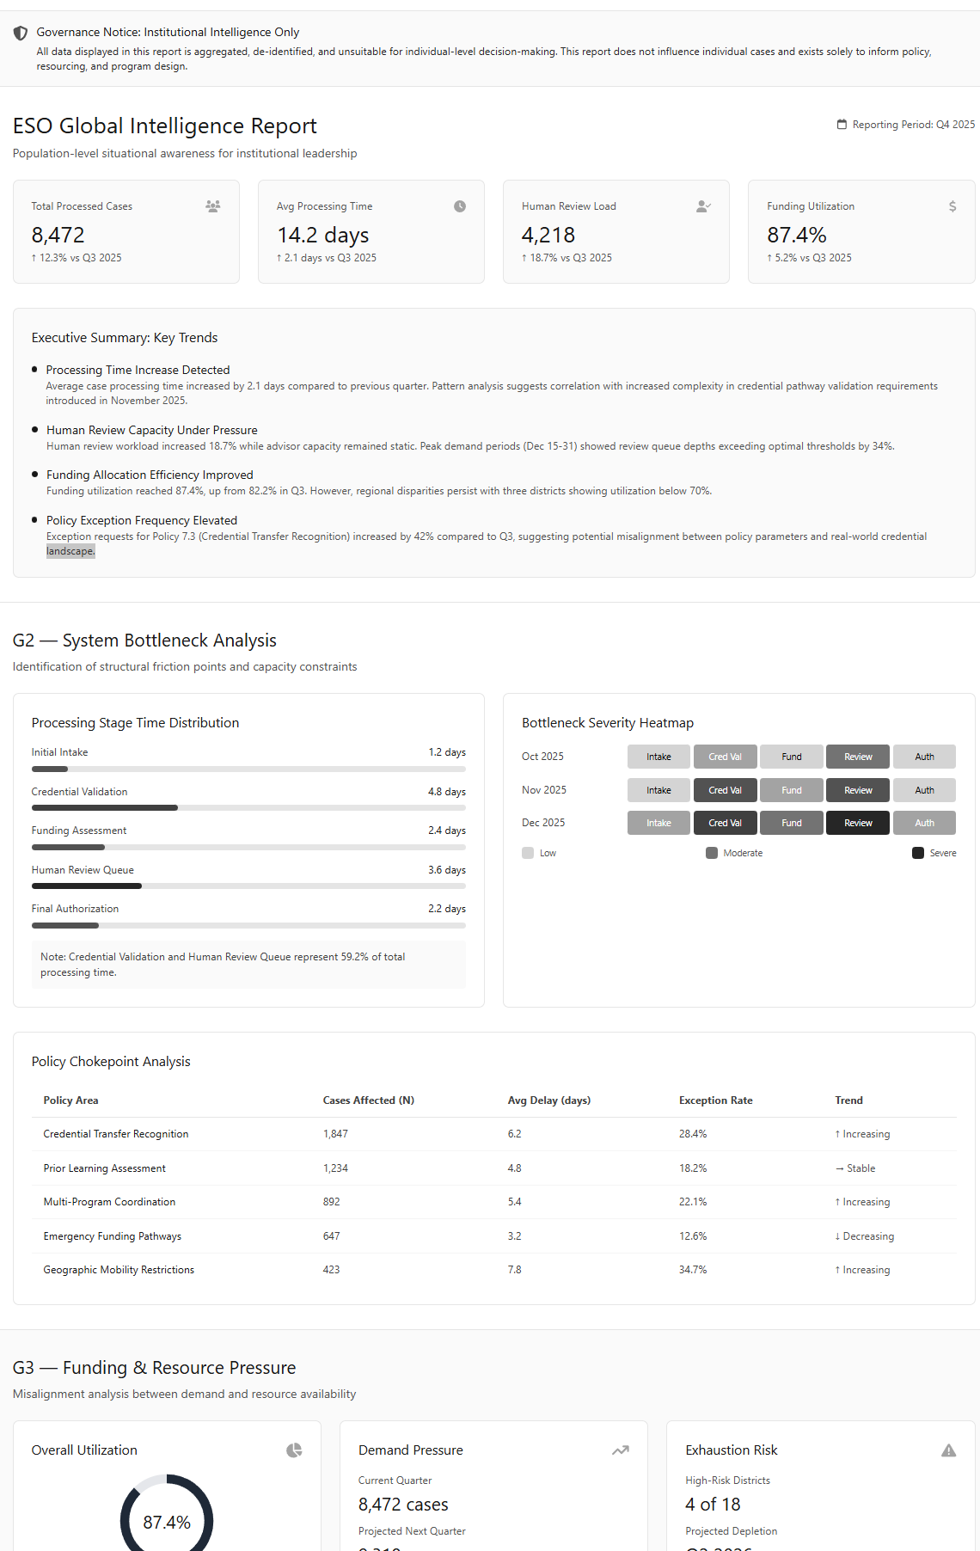

Figure 9: ESO Policy Intelligence View

From Gatekeeper to Policy Intelligence Officer: How CMGF empowers ESOs to advocate upward with data.
The Policy Intelligence View (Figure 9) is not a reporting dashboard, but an evidence-generation instrument designed to convert individual learner friction into auditable, aggregate justification for budget reform and policy revision.
Consistent with best-in-class advising frameworks, the demonstration emphasizes employment-first orientation by foregrounding career intent and labor market alignment, supports personalization by capturing learner context and voice, and illustrates how technology-enabled tools can extend advising capacity without displacing human advisors. The artifact also makes visible the limits of automation, reinforcing that planning responsibility remains with the service member and that human Education Services Officers retain authority for advising, validation, and intervention.
Unlike traditional transition tools that activate late in a service member’s career, the demonstration artifact is intentionally framed for use early in the military lifecycle. By placing retention and continuation pathways alongside civilian preparation options, the interface emphasizes that career planning is continuous and that education choices shape both in-service advancement and post-service outcomes. This approach reinforces service-member agency from the outset of service while supporting institutional retention goals.

AI Design Choices and Deliberate Non-Use
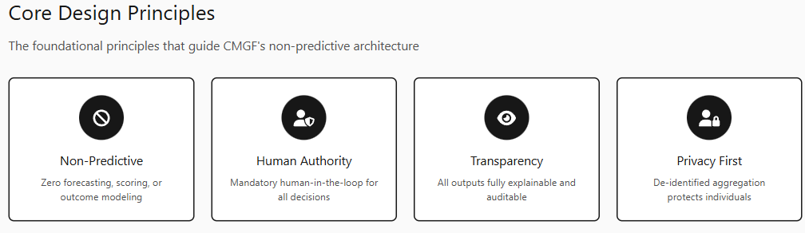
The artificial intelligence design choices embedded within the Career Mobility Governance Framework (CMGF) reflect a deliberate separation between technical accountability and institutional accountability. Raji et al. (2020) define technical accountability as the explainability, auditability, and performance characteristics of an AI system, while institutional accountability concerns oversight authority, redress mechanisms, and responsibility for downstream consequences. Although predictive modeling, optimization, and automated decision-making are technically feasible within military career mobility systems, their use in high-impact public-sector contexts presents disproportionate institutional risk when accountability is shifted from human authorities to technical artifacts. Career mobility decisions intersect with employment opportunity, access to public benefits, and individual autonomy domains explicitly identified by federal guidance as high-impact and unsuitable for opaque or delegated algorithmic control (Executive Order No. 14110, 2023; National Institute of Standards and Technology [NIST], 2024; Office of Management and Budget [OMB], 2024).
CMGF’s explainability requirements are satisfied through intrinsic interpretability rather than post-hoc explanation techniques. Miller (2019) distinguishes intrinsic interpretability where system logic is directly understandable to users from post-hoc explanations that approximate the behavior of opaque models after decisions are produced. CMGF adopts deterministic, rule-based logic for eligibility checks, constraint evaluation, and feasibility signaling so that explanations are native to the system’s operation rather than reconstructed after the fact. This approach reduces the risk of misleading rationales, supports advisor mental models, and preserves contestability by ensuring that every planning signal can be traced directly to explicit policy rules and user-declared constraints. Predictive outcome modeling, individual risk scoring, automated approvals, and optimization objectives are explicitly prohibited not because they are infeasible, but because they risk encoding structural inequities, privileging institutional efficiency over individual welfare, and obscuring normative tradeoffs behind technical artifacts.
This design intentionally treats artificial intelligence as a governance instrument (see system governance Appendix E) rather than a decision authority. By making constraints, assumptions, and policy frictions visible (Appendix D) rather than optimizing around them CMGF preserves service-member agency, enforces human accountability, and enables policy-level learning without normalizing inequitable conditions as neutral inputs. Evaluation within CMGF prioritizes application-grounded criteria rather than predictive accuracy metrics. Doshi-Velez and Kim (2017) distinguish application-grounded evaluation, in which real users assess system behavior in context, from proxy-based or purely technical evaluation approaches. Consistent with this framework, CMGF is evaluated through advisor and service-member interaction with rule-based feasibility signals, explanation clarity, and decision traceability, rather than through optimization benchmarks or outcome prediction accuracy. This evaluation posture aligns technical assessment with public-sector accountability standards by emphasizing usefulness, contestability, and institutional learning over performance maximization. In this sense, the framework’s most consequential design choice is not the use of AI, but the disciplined restraint exercised in where and how it is allowed to operate.

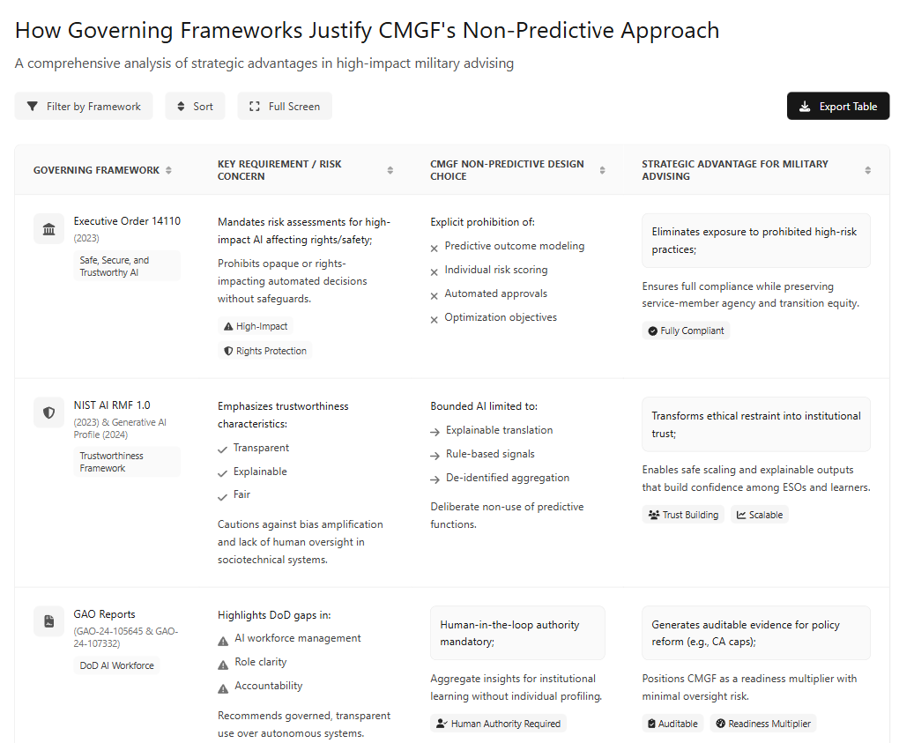

Table 2: Compliant by Design

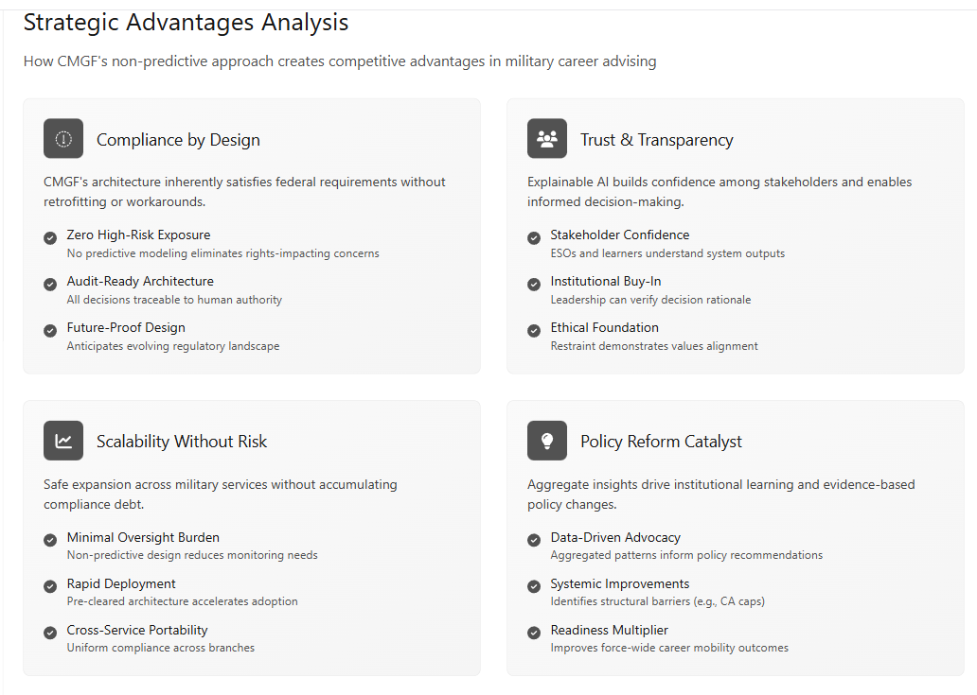
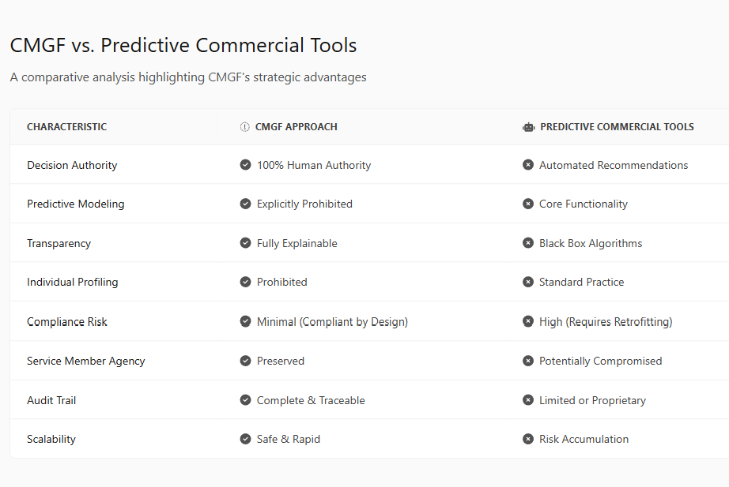

Table 3: CMGF vs. Predictive AI

Gaps and Future Research
Despite substantial advances in military transition research and policy, significant structural gaps persist in how transition outcomes are observed, interpreted, and acted upon. While existing studies document early wage regression and post-service employment challenges, longitudinal analysis of civilian wage progression, career stability, and advancement by demographic group and occupational background remains limited (Kleykamp et al., 2024; McKinsey & Company, 2022). Importantly, these limitations reflect not only data scarcity, but the absence of a governance infrastructure capable of capturing transition decisions, constraints, and tradeoffs at the time they are made. Without such infrastructure, long-term outcome disparities remain analytically visible only after they have already materialized (Harrell & Berglass, 2012; Barr et al., 2021).
A related gap concerns the portability, standardization, and recognition of credentials, particularly as AI- and digitally mediated learning pathways expand. The literature consistently identifies difficulty in transferring modular and micro-credentials across military, higher education, and private-sector systems (CAEL, 2018; Department of Defense, 2020; Digital Education Council, 2025). However, these challenges persist in part because credential decisions are rarely evaluated within a governed, longitudinal planning context that links credential selection to funding constraints, labor-market signaling, and downstream outcomes. CMGF addresses this gap by conceptualizing credential translation not as a static mapping problem, but as a governed planning process whose friction points can be systematically observed and aggregated.
Data interoperability and outcome evaluation represent another persistent challenge. Cross-sector longitudinal tracking among the Department of Defense, higher education institutions, and employers remains highly fragmented, and relatively few federal transition programs have been subjected to independent, outcomes-based evaluation (Kleykamp et al., 2024; Office of Management and Budget, 2025). These limitations are often framed as technical or privacy barriers; however, they also reflect the lack of non-predictive, human-governed systems designed explicitly to generate policy-relevant evidence while preserving individual agency and data protection (Task Force Lima, 2024; Department of Defense, 2024). CMGF is proposed as one such governance-first architecture, intended to surface deidentified planning frictions and constraint conflicts without enabling automated decision-making.
Funding gaps and inequities in program access further illustrate this structural absence. Junior enlisted service members and those facing elevated transition risk continue to experience lower participation in tailored transition programs and heightened vulnerability to underemployment and financial instability (Institute for Veterans and Military Families, 2019; SHRM, 2023; Workforce Readiness Alignment Council, 2021). Existing research documents have these disparities, yet lacks mechanisms for tracing how funding rules, credential eligibility, and advising timing interact to shape individual outcomes. CMGF reframes funding not as a standalone policy lever, but as a governed constraint whose effects can be examined through longitudinal planning data.
Finally, while growing scholarship addresses ethical AI principles and workforce applications, a critical gap remains in the study of governed AI systems as instruments for policy learning rather than prediction or automation. Limited research examines how non-authoritative, human-in-the-loop AI infrastructures might aggregate de-identified advising interactions into auditable institutional evidence that can inform education policy, resource allocation, and accountability. (Doshi-Velez & Kim, 2017; Raji et al., 2020). CMGF directly engages this gap by positioning AI as a mediating infrastructure for visibility and learning, rather than a decision-making authority.
Future research should therefore evaluate not only specific transition outcomes, but the conditions under which governance-first AI architectures can enable earlier planning, equitable visibility, and institutional learning across complex public-sector systems. In this sense, CMGF is not a response to existing gaps alone; it is an attempt to make those gaps systematically observable.
Taken together, these gaps suggest that the central challenge is no longer the absence of evidence, but the absence of a governed design space in which such evidence can be generated.

Future Questions for Concept Development and Governance Deliberation
The Career Mobility Governance Framework is presented as a conceptual and architectural contribution rather than a fully specified implementation. As such, its practical realization would require deliberate institutional design choices. The following questions are offered to frame future research, pilot exploration, and policy discussion, rather than to prescribe specific solutions.

Governance and Institutional Ownership
• Which Department of Defense organization, or cross-organizational body, would be appropriate to steward the governance of a CMGF-like system, given its intersection with education, workforce development, and transition policy?
• How might governance responsibilities be divided between policy oversight, technical operations, and ethical accountability to prevent consolidation of authority within a single office?
• What role, if any, should non-DoD partners (e.g., VA, Department of Education, state systems) play in shared governance or oversight structures?

Timing Within the Service Member Lifecycle
• At what point in a service member’s career would CMGF access be most effective for meaningful planning initial entry training, first reenlistment window, mid-career, or pre-separation?
• Should CMGF function as a continuous planning environment available across the service lifecycle, rather than as a transition-only intervention?
• How might early exposure to planning tools interact with retention, reenlistment, or career specialization decisions?

Program Management and Operational Control
• Which office or functional community would be best positioned to manage CMGF operations transition assistance programs, education services, manpower and personnel directorates, or a dedicated cross-functional unit?
• How would operational responsibility be balanced with safeguards against mission creep, performance pressure, or unauthorized expansion of system authority?

Measurement, Evaluation, and Learning
- What outcome measures would be appropriate for evaluating CMGF effectiveness without reducing success to narrow employment metrics?
- How might intermediate indicators such as earlier planning engagement, reduced pathway reversals, or decreased benefit misallocation be incorporated into evaluation frameworks?
- Over what time horizons should outcomes be assessed to capture long-term career stability rather than short-term placement?

Signal Sharing and Institutional Awareness
• Which organizations, if any, should receive de-identified institutional signals derived from CMGF interactions, such as aggregated advising friction points or recurring constraint conflicts?
• How might Installation Status Reports (ISR) or Voice-of-the-Veteran (VoV) feeds be augmented with such signals without exposing individual identities or influencing operational decision-making?
• Could carefully governed signals inform support organizations such as chaplain services, veteran support networks, or crisis intervention resources without transforming CMGF into a surveillance or risk-scoring system?

Ethical Boundaries and Scope Control
• What explicit boundaries would be required to prevent CMGF from evolving into predictive risk assessment or automated decision authority?
• How should opt-out, contestability, and transparency mechanisms be designed to preserve service member agency?
• What audit structures would ensure that CMGF remains aligned with its original non-authoritative, advisory intent over time?

Scaling and Interoperability
• How might CMGF integrate with existing military education records, credential registries, and civilian labor-market data without creating dependency on proprietary systems?
• What standards would be required to support interoperability across services, institutions, and post-service environments?
• How could pilots be structured to allow learning and adaptation without premature standardization?

Conclusions and a Call for Concept Development
The empirical literature consistently demonstrates that earlier and more structured transition planning is associated with improved employment and educational outcomes for service members. At the same time, advising capacity remains constrained, and existing transition support mechanisms tend to operate late in the decision lifecycle, after many high-impact choices have already been made. Within this context, the Career Mobility Governance Framework (CMGF) is not presented as an implementation proposal, but as a conceptual exploration of a documented temporal and structural gap. By constraining artificial intelligence to advisory, explainable, and non-authoritative functions, CMGF examines how earlier planning visibility might be enabled without displacing human judgment or institutional responsibility. Framed this way, the framework invites consideration of how late-stage advising and opaque policy translation represent ongoing, measurable risks to both individual and institutional outcomes.
The literature further suggests that transition planning does not meaningfully conclude at the point of separation. A future-oriented advising model would therefore need to consider how support mechanisms might extend into the first twelve months post-transition, particularly for service members entering civilian sectors with weak or non-obvious occupational mapping. CMGF surfaces this temporal misalignment as a design consideration rather than a programmatic prescription.
Viewed through this lens, several implications emerge for future inquiry and dialogue:
• Consistency in military-to-civilian skills translation remains a structural challenge. Any scalable advising architecture would require a shared approach to career mapping and credential crosswalks to ensure that military-acquired competencies are interpreted coherently across institutions and advising contexts.
• As artificial intelligence capabilities mature, an open design question concerns how advisory systems might incorporate AI-copilot features, mentorship networks, and feedback loops while preserving learner agency and human decision authority. CMGF explores one possible configuration in which learner input informs both individual planning and aggregate institutional learning without conferring decision authority to automated systems.
• The evidence increasingly highlights the limitations of one-size-fits-all information delivery in complex transitions. A next-generation advising ecosystem would likely need to evolve toward more participatory, scenario-based, and data-informed support models, enabling service members to explore tradeoffs and consequences without assuming automated recommendations or outcome optimization.
• Finally, current funding and credentialing structures raise unresolved questions about alignment with labor-market signaling realities. In technical fields where industry certifications may carry greater immediate value than degree pathways, a future policy conversation may need to examine whether rigid allocation constraints unintentionally narrow viable transition options. CMGF surfaces this tension for discussion without prescribing specific policy changes.
Taken together, these observations position CMGF as a framework for conceptual development rather than institutional reform. Its purpose is to support informed dialogue about governance boundaries, temporal alignment, and human-AI roles in an emerging landscape inviting stakeholders to consider not what must be implemented, but what becomes visible when transition planning is re-examined through a governance-first AI lens.

References
Ahmed, S., Rahman, M., & Hossain, M. A. (2024). AI-driven academic advising systems in higher education: Design frameworks, ethical considerations, and student success outcomes. Frontiers in Education, 9, Article 1391485. https://doi.org/10.3389/feduc.2024.1391485
American Council on Education. (n.d.). College credit for military training and experiences. American Council on Education. https://www.acenet.edu
Army Times. (2024, December 10). Army to cut credentialing benefit, drop officers from program. https://www.armytimes.com/education-transition/2024/12/11/army-to-cut-credentialing-benefit-drop-officers-from-program/
Bajraktari, Y. (2025, April 5). Written testimony before the U.S. House Committee on Oversight and Government Reform: The federal government in the age of artificial intelligence. Special Competitive Studies Project. https://www.scsp.ai
Barr, A., Kawano, L., Sacerdote, B., Skimmyhorn, W., & Stevens, M. (2021). You can’t handle the truth: The effects of the Post-9/11 GI Bill on higher education and earnings (Working Paper No. 29024). National Bureau of Economic Research. https://doi.org/10.3386/w29024
Bipartisan House AI Task Force. (2024). Final report of the Bipartisan Task Force on Artificial Intelligence. U.S. House of Representatives. https://artificialintelligence-taskforce.house.gov

Bradbard, M., et al. (2024). Veteran learner voice and post-service outcomes. Journal of Veterans Studies.
Bureau of Labor Statistics. (2025a, February 10). Incorporating AI impacts in BLS employment projections: Occupational case studies. U.S. Department of Labor. https://www.bls.gov/opub/mlr/2025/article/incorporating-ai-impacts-in-bls-employment-projections.htm
Bureau of Labor Statistics. (2025b, March 11). AI impacts in BLS employment projections (TED article). U.S. Department of Labor. https://www.bls.gov/opub/ted/2025/ai-impacts-in-bls-employment-projections.htm
Burning Glass Technologies (2019) https://excelined.org/wp-content/uploads/2019/05/ExcelinEdBurningGlassTechnologies.CredentialsMatter.WhereCredentialsMeetTheMarket.June2019.pdf
CAEL. (2018). Stackable credentials: A pathway to economic mobility. Council for Adult and Experiential Learning.
Castro, C. A., & Kintzle, S. (2014). Suicides in the military: The post-modern combat veteran and the Hemingway effect. Current Psychiatry Reports, 16(8), 460. (Context on multidimensional transition challenges.
Clemens, J., & Knutson, J. (2020). The economic returns to military skills transferability. Journal of Labor Economics, 38(3), 681–722. https://doi.org/10.1086/705810
Council for Adult and Experiential Learning (CAEL). (2018). Pathways to opportunity: Financial flexibility and workforce readiness. Council for Adult and Experiential Learning. https://ivmf.syracuse.edu/article/pathways-to-opportunity-financial-flexibility-and-workforce-readiness/
Davenport, A., Savych, B., & Loughran, D. S. (2024). Veteran underemployment and post-service earnings outcomes.
Social Science Research Institute, Pennsylvania State University.
https://ssri.psu.edu/news/veterans-report-underemployment-pay-frustration-four-years-post-service
Defense Innovation Board. (2023). Campaign for an AI-ready force. U.S. Department of Defense. https://media.defense.gov/2019/Oct/31/2002204191/-1/-1/0/CAMPAIGN_FOR_AN_AI_READY_FORCE.PDF
Department of Defense. (2023, August 10). Establishment of Chief Digital and Artificial Intelligence Officer Generative Artificial Intelligence and Large Language Models Task Force, Task Force Lima (OSD006491-23). https://media.defense.gov/2023/Aug/10/2003279040/-1/-1/1/ESTABLISHMENT_OF_CDAO_GENERATIVE_AI_AND_LARGE_LANGUAGE_MODELS_TASK_FORCE_TASK_FORCE_LIMA_OSD006491-23_RES_FINAL.PDF
Department of Defense. (2020). Department of Defense Artificial Intelligence Education Strategy. https://www.ai.mil
Department of Defense. (2024). Responsible Artificial Intelligence Strategy & Implementation Pathway. U.S. Department of Defense. https://media.defense.gov/2024/Oct/26/2003571790/-1/-1/0/2024-06-RAI-STRATEGY-IMPLEMENTATION-PATHWAY.PDF
Department of Defense. (2024a). Task Force Lima Executive Summary. Office of the Chief Digital and Artificial Intelligence Officer.
Department of Defense. (2024b). DoD Strategic Management Plan, FY 2022–2026. https://www.ai.mil
Department of Labor. (2019). Veterans’ Employment and Training Service compliance resources. https://www.dol.gov/agencies/vets/foia/contact
Digital Education Council. (2025). AI in the workplace 2025. https://www.digitaleducationcouncil.com/post/ai-in-the-workplace-2025
Digital Education Council. (2025). AI literacy framework. https://www.digitaleducationcouncil.com/post/ai-in-the-workplace-2025
Digital Education Council. (2025). Emerging labor market demand for AI literacy and modular credentials.
EANGUS. (2024, March 17). Could a new Army Education Funding Policy lead to less certifications for soldiers? https://eangus.org/could-a-new-army-education-funding-policy-lead-to-less-certifications-for-soldiers/
Doshi-Velez, F., & Kim, B. (2017). Towards a rigorous science of interpretable machine learning. arXiv preprint arXiv:1702.08608. https://arxiv.org/abs/1702.08608
Executive Order No. 14110, Safe, Secure, and Trustworthy Development and Use of Artificial Intelligence, 88 Fed. Reg. 75191 (2023).
Government Accountability Office. (2023). Artificial intelligence: Actions needed to improve DOD’s workforce management (GAO-24-105645). U.S. Government Accountability Office.
Government Accountability Office. (2024). Artificial intelligence: Agencies are implementing management and personnel requirements (GAO-24-107332). U.S. Government Accountability Office.
Gregor, S., & Hevner, A. R. (2013). Positioning and presenting design science research for maximum impact. MIS Quarterly, 37(2), 337–355.
Harrell, M. C., & Berglass, N. (2012). Employing America’s veterans: Perspectives from businesses. Center for a New American Security. https://www.cnas.org/publications/reports/employing-americas-veterans-perspectives-from-businesses
Hevner, A. R., March, S. T., Park, J., & Ram, S. (2004). Design science in information systems research. MIS Quarterly, 28(1), 75–105.
Hodges, T. J., Bharwani, N. K., Manley, E., & Rodriguez, D. X. (2025). Rethinking Acculturation and Military Transition: An Agenda for MilitaryCivilian Biculturalism, Reintegration, and Adjustment. Journal of Veterans Studies, 11(1), pp. 161–171. DOI: https://doi.org/10.21061/jvs. v11i1.678
Holst, D., Moenck, K., Koch, J., Schmedemann, O., & Schüppstuhl, T. (2024). Transparent reporting of AI in systematic literature reviews: Development of the PRISMA-trAIce checklist. Nature Machine Intelligence, 6, 1–12. https://doi.org/10.1038/s42256-024-00805-1
Inside Higher Ed. (2024, April 16). ‘Catastrophic success’ may put army ed benefits up for cuts. https://www.insidehighered.com/news/government/student-aid-policy/2024/04/17/catastrophic-success-may-put-army-ed-benefits-cuts
Institute for Veterans and Military Families (IVMF). (2019). Work after service: Developing workforce readiness and veteran talent for the future. Syracuse University. https:// https://ivmf.syracuse.edu/article/work-after-service-developing-workforce-readiness-and-veteran-talent-for-the-future/
Keeling, M., Kintzle, S., & Castro, C. A. (2018). Exploring U.S. veterans’ post-service employment experiences. Military Psychology, 30(1), 63–69. https://doi.org/10.1080/08995605.2017.1420976
Kleykamp, M., Wenger, J. B., Roer, E. H., Kubasak, M., Hubble, T., & Skrabala, L. (2024). Federal programs to assist military-to-civilian employment transitions: Limited scrutiny and substantial investment in education programs, Rand Corp Research Report No. RR-A1363-12. https://www.rand.org/pubs/research_reports/RRA1363-12.html
Kulik, J. A., & Fletcher, J. D. (2016). Effectiveness of intelligent tutoring systems: A meta-analytic review. Review of Educational Research, 86(1), 42–78. https://doi.org/10.3102/0034654315581420
Leslie, D. (2019). Understanding artificial intelligence ethics and safety. The Alan Turing Institute.
McKinsey & Company. (2022). From the military to the workforce: How to leverage veterans’ skills. McKinsey & Company. https://www.mckinsey.com/capabilities/people-and-organizational-performance/our-insights/from-the-military-to-the-workforce-how-to-leverage-veterans-skills
McKinsey & Company. (2023, August). What’s the future of generative AI? An early view in 15 charts. https://www.mckinsey.com
MedCity News. (2024, November). The case for a single source of truth in provider credentialing. https://medcitynews.com/2024/11/the-case-for-a-single-source-of-truth-in-provider-credentialing/
Microsoft/University of Michigan EMBA Team. (2023). LEADERS: Skilling/reskilling framework for the future AI workforce. Microsoft. https://michiganross.umich.edu/sites/default/files/media/documents/2024/03/955%20Microsoft%202023-24%20ExecMAP%20Final%20Report.pdf
Miller, T. (2019). Explanation in artificial intelligence: Insights from the social sciences. Artificial Intelligence, 267, 1–38. https://doi.org/10.1016/j.artint.2018.07.007
MITRE. (2019). Military-to-Civilian Readiness: The Past, Present, and Future of the Transition Process. https://benefits.va.gov/TRANSITION/docs/military-to-civilian-readiness.pdf
Nissenbaum, H. (2010). Privacy in context: Technology, policy, and the integrity of social life. Stanford University Press.
NIST National Institute of Standards and Technology. (2023). Artificial intelligence risk management framework (AI RMF 1.0).
NIST National Institute of Standards and Technology. (2024). Artificial intelligence risk management framework: Generative Artificial Intelligance Profile
Executive Order No. 14110, Safe, Secure, and Trustworthy Development and Use of Artificial Intelligence (2023).
Office of Management and Budget. (2019). Federal data strategy: A framework for consistency. https://www.whitehouse.gov
Office of Management and Budget. (2024). Advancing governance, innovation, and risk management for agency use of artificial intelligence.
Office of Management and Budget. (2025). M-25-21: Accelerating federal use of AI through innovation, governance, and public trust. The White House. https://www.whitehouse.gov/wp-content/uploads/2025/02/M-25-21-Accelerating-Federal-Use-of-AI-through-Innovation-Governance-and-Public-Trust.pdf
Peffers, K., Tuunanen, T., Rothenberger, M. A., & Chatterjee, S. (2007). A design science research methodology for information systems research. Journal of Management Information Systems, 24(3), 45–77
Porter, T., Rathert, C., & Lawong, D. (2023). Career development through career transition coaching: A qualitative study of military veterans and student coaches. https://eric.ed.gov/?id=EJ1382270
Raji, I. D., Smart, A., White, R. N., Mitchell, M., Gebru, T., Hutchinson, B., Smith-Loud, J., Theron, D., & Barnes, P. (2020). Closing the AI accountability gap: Defining an end-to-end framework for internal algorithmic auditing. Proceedings of the 2020 Conference on Fairness, Accountability, and Transparency (FAT* ’20), 33–44. https://doi.org/10.1145/3351095.3372873
RAND Corporation. (2022). How veterans fare in the civilian labor market.
https://www.rand.org/pubs/articles/2022/how-veterans-fare-in-the-civilian-labor-market.html
RAND Corporation. (2023a). Stacking certificates and degrees. https://www.rand.org/pubs/commentary/2023/08/stacking-certificates-and-degrees.html
RAND Corporation. (2023b). How to build stackable credentials. https://www.rand.org/pubs/commentary/2023/10/how-to-build-stackable-credentials.html

Rose, S., Borchert, O., Mitchell, S., & Connelly, S. (2020). Zero trust architecture (NIST SP 800-207). National Institute of Standards and Technology.

Schulker, D. (2017). RAND Corporation analysis of MOS transferability and civilian earnings.
Seelig, L. C. (2025). Bridging the gap: Strategies for the private sector to overcome veteran underemployment in the civilian workforce (Doctoral dissertation, Marymount University). Marymount University. https://www.proquest.com/openview/224e1cdb6b3ab7103d3d3083f1a4f391/1?pq-origsite=gscholar&cbl=18750&diss=y
Selbst, A. D., Boyd, D., Friedler, S. A., Venkatasubramanian, S., & Vertesi, J. (2019). Fairness and abstraction in sociotechnical systems. Proceedings of the Conference on Fairness, Accountability, and Transparency, 59–68.
SHRM. (2023). Veteran hiring barriers and solutions. Society for Human Resource Management. https://www.shrm.org/topics-tools/news/talent-acquisition/shrm-report-highlights-barriers-and-solutions-for-veteran-hiring
Shue, S., Matthias, M. S., Watson, D. P., Miller, K. K., & Munk, N. (2021). The career transition experiences of military veterans: A qualitative study. Military Psychology, 33(6), 359–371. https://doi.org/10.1080/08995605.2021.1962175
Soomro, A. A., Khan, M. H., Umar, M., Khan, S., & Ali, O. (2025). AI-driven academic advising in higher education: Leveraging intelligent systems to personalize student support, improve retention, and optimize career pathways. The Critical Review of Social Sciences Studies, 3(2), 229–248. https://thecrsss.com/index.php/Journal/about
Student Veterans of America. (2022). National survey of veteran advising capacity and workload. Student Veterans of America.
The Manufacturing Institute. (2019). Koch Industries veteran transition case study. https://themanufacturinginstitute.org/heroes-make-america/case-study-veteran-transition-guide-at-koch-industries/
U.S. Census Bureau. (n.d.). Longitudinal Employer-Household Dynamics: Veteran employment outcomes (VEO). U.S. Census Bureau. https://lehd.ces.census.gov
U.S. Department of Education. (2018). Stackable credentials toolkit. U.S. Department of Education, Office of Career, Technical, and Adult Education.
Wells, R. (2024, November 5). 71% of employers prefer AI skills above experience in 2024. Forbes. https://www.forbes.com/sites/rachelwells/2024/11/05/71-of-employers-prefer-ai-skills-above-experience-in-2024/
White House, Office of Management and Budget. (2025). Historical tables [Data set]. U.S. Executive Office of the President. https://www.whitehouse.gov/omb/
Workforce Readiness Alignment Council. (2021). Revisiting the business case: Workforce readiness and alignment for the future. Workforce Readiness Alignment Council. https://ivmf.syracuse.edu/wp-content/uploads/2016/08/USAA_paper3_8.30.16_REVISED_digtial.pdf
Zoli, C., Maury, R., & Fay, D. (2015). Missing perspectives: Servicemembers’ transition from service to civilian life. Institute for Veterans and Military Families, Syracuse University. https://ivmf.syracuse.edu

Appendix A: Annotated Bibliography
A1. AI Governance and Public-Sector Readiness
Department of Defense. (2020). Department of Defense Artificial Intelligence Education Strategy.
Establishes AI literacy as a foundational readiness requirement across the force. This document informs the study’s framing of AI fluency as baseline infrastructure rather than elective specialization.
Department of Defense. (2023). Task Force Lima Memorandum.
Creates a governance structure for responsible generative AI adoption within DoD, emphasizing human oversight and risk mitigation. It directly supports the study’s non-predictive, human-in-the-loop design constraints.
Defense Innovation Board. (2023). AI Ready Force.
Outlines a phased approach to AI readiness centered on people, data, and organizational design. The report provides authoritative guidance on advisor-assist AI models rather than autonomous decision systems.
Government Accountability Office. (2023).
Evaluates DoD’s AI workforce management, identifying gaps in role definition and accountability. This report explains why AI literacy has struggled to institutionalize despite policy intent.

A2. Military Transition and Workforce Outcomes
Kleykamp et al. (2024). RAND Corporation.
Documents the imbalance between substantial federal education investment and limited funding for transition-specific support. This report provides empirical grounding for the study’s central structural paradox.
Barr et al. (2021). NBER Working Paper.
Finds increased education participation under the GI Bill alongside short-term earnings losses. The results highlight tensions between credential acquisition and workforce readiness.
Institute for Veterans and Military Families. (2019).
Identifies underemployment and employer misalignment as persistent transition challenges. The report supports the need for employer-engaged, career-aligned advising frameworks.
A3. Credential Portability and Skills Signaling
American Council on Education. (n.d.). College Credit for Military Training.
Provides the foundational framework for translating military training into academic credit. This source demonstrates that cross-sector credential recognition infrastructure already exists but remains underutilized for emerging skills.
Council for Adult and Experiential Learning (CAEL). (2018).
Advocates for stackable, competency-based credential pathways. The model directly informs the study’s approach to modular AI literacy credentials.
Pearson VUE. (2025). Value of IT Certification Report.
Reports individual and organizational returns from professional certification, supporting the labor-market signaling value of portable, attestable credentials. Limitations are noted due to self-reported outcomes.
A4. AI Literacy and Workforce Demand
Digital Education Council. (2025). AI Literacy Framework.
Defines modular AI literacy competencies and assessment standards applicable across sectors. This framework supports the study’s emphasis on transferable, governance-aligned AI credentials.
Office of Personnel Management. (2024).
Establishes AI roles and competency expectations under the AI in Government Act. It anchors AI credentialing to formal federal hiring and workforce frameworks.
Ahmed, S., Rahman, M., & Hossain, M. A. (2024).
Synthesizes empirical evidence on AI-enabled advising systems in higher education, demonstrating improved outcomes when AI is used as advisor-assist infrastructure under ethical constraints.
Soomro et al. (2025).
Provides complementary empirical findings on AI advising systems, reinforcing the importance of governance and human oversight for effectiveness and trust.
A5. AI-Enabled Advising and Decision-Support Design
Castillo-Martínez, I. M., Flores-Bueno, D., Gómez-Puente, S. M., & Vite-León, V. O. (2024). AI in higher education: A systematic literature review. Frontiers in Education, 9, 1391485.
This systematic literature review analyzes 85 peer-reviewed studies (2020–2024) examining the use of AI across higher education research and academic support functions. Across disciplines, the review finds that AI delivers value primarily when deployed as a support ol under explicit human supervision, with transparency and ethical safeguards emphasized as critical design requirements. The study provides empirical grounding for the use of AI as advisor-assist infrastructure rather than autonomous decision authority, directly informing the governance-constrained AI design adopted in this research.

Appendix B: Case Examples and Best Practices
Koch Industries: Mentorship and Stackable Manufacturing Credentials
Koch Industries has developed a comprehensive veteran transition guide that combines structured mentorship with stackable credentials tailored to the manufacturing sector. Through a “buddy system,” veterans connect with industry mentors who help translate their military skills into recognized certifications, while a modular credentialing framework supports both entry-level and advanced expertise (The Manufacturing Institute, 2019).
DoD SkillBridge and Google Veteran Launchpad: AI Upskilling Pilots
The Department of Defense SkillBridge program allows transitioning service members to participate in civilian work internships and apprenticeships focused on AI, cybersecurity, and digital skills. Google’s Veteran Launchpad accelerates this process by offering foundational and advanced AI micro credentials in partnership with employers, ensuring rapid job preparation and placement in technology fields (Digital Education Council, 2025; Department of Defense, 2024).
Community College MOS Mapping Pathways
Many community colleges and CCME member campuses have led the way in mapping military occupational specialties (MOS) to local labor market needs by creating digital credential pathways. These programs leverage ACE learning evaluations and labor market analytics to offer veterans modular, portable certificates directly aligned with regional employer demands (American Council on Education, n.d.).

Army COOL: Scalable Credential Crosswalks
The Army Credentialing Opportunities On-Line (COOL) program provides service members and veterans a systematic process for identifying, pursuing, and attaining industry-recognized credentials related to their military training and experience. This scalable platform supports the portability and validation of skills across states and sectors and is regularly updated in collaboration with employer and educator input (Department of Defense, 2024a).
Each of these case examples demonstrates actionable solutions for bridging the gap between military service and high-value civilian employment in a rapidly evolving workforce landscape. These models also illustrate the importance of cross-sectoral collaboration, modular learning, and real-time alignment with industry needs (Digital Education Council, 2025; CAEL, 2018). See “Funding AI Literacy: Beyond Personal COOL Benefits” above for funding discussion.

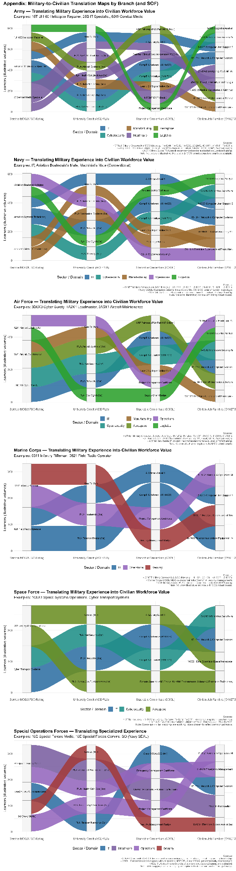
Appendix C: Transitions

Appendix D Machine Learning Scope, Ethical Constraints, and Evaluation Design
This appendix operationalizes CMGF’s alignment with the NIST AI Risk Management Framework by specifying permitted and prohibited AI functions, governance controls, and evaluation boundaries.
D1. Purpose and Scope of This Appendix
This technical appendix provides the formal justification for the use, non-use, and governance of artificial intelligence within the Career Mobility Governance Framework (CMGF). While the main body of the paper focuses on policy alignment, career mobility, and institutional outcomes, Appendix D documents the technical and ethical design decisions underpinning the framework.
Consistent with national AI governance guidance, this appendix is considered integral to the study. It addresses transparency, bias mitigation, accountability, and evaluation methodology for AI-enabled systems operating in high-impact public-sector contexts (Executive Order No. 14110, 2023; National Institute of Standards and Technology [NIST], 2023).
D2. Purposeful and Bounded Use of Machine Learning
Artificial intelligence within CMGF is deliberately applied as a supporting analytic instrument, not as an autonomous decision-maker or predictive authority. This bounded approach reflects both the sociotechnical nature of career mobility decisions and explicit national guidance cautioning against opaque or uncontrolled AI use in domains affecting individual opportunity, employment, and access to public benefits (NIST, 2023; Office of Management and Budget [OMB], 2024).

Machine learning (ML) within CMGF is employed in three constrained roles.
D2.1 Explainable Language Translation
Natural language processing (NLP) techniques are used to translate complex and heterogeneous data such as labor-market indicators from the Bureau of Labor Statistics, occupational mappings from O*NET crosswalks, and policy constraints embedded in military education programs into plain-language explanations. This design aligns with the NIST AI RMF emphasis on interpretability and transparency as prerequisites for trustworthy AI systems (NIST, 2023).
NLP outputs are explanatory rather than inferential and are presented with explicit data provenance and uncertainty indicators.
D2.2 Rule-Constrained Planning Signals
Within the Career Planning Module (CPM), ML-supported logic generates non-binding planning signals (“Go,” “Conditional Go,” or “No-Go [At Present]”). These signals are derived from transparent comparisons between user-declared constraints (e.g., funding caps, timelines) and externally sourced requirements (e.g., credential prerequisites, time-to-employability).
These signals do not recommend outcomes, rank individuals, or assess likelihood of success. Instead, they summarize feasibility under stated assumptions, supporting informed human judgment consistent with federal guidance on AI-assisted decision support (GAO, 2023).
D2.3 Aggregate Pattern Detection
Within the Advising & Approval Module (AAM), ML is limited to aggregate, anonymized pattern detection. Descriptive techniques analogous to clustering or frequency analysis identify systemic trends such as credential bottlenecks, funding constraints, or policy misalignment without generating individual-level assessments.
This design supports institutional learning while minimizing risk of individual harm, aligning with NIST’s guidance on risk-based AI deployment and impact proportionality (NIST, 2023).
D3. Explicit Non-Use of Machine Learning as Ethical Design
Equally central to CMGF is the explicit prohibition of several common AI applications. These exclusions are intentional ethical design decisions, not technical limitations.
D3.1 Prohibition of Predictive Outcome Modeling
CMGF forbids predictive modeling of individual outcomes, including employability, wage attainment, retention likelihood, or career success. Predictive systems trained on historical data risk encoding existing inequities in credential recognition, labor-market access, and funding availability. Federal oversight bodies have repeatedly warned that such models may legitimize structural bias under the appearance of technical neutrality (GAO, 2023; Executive Order No. 14110, 2023).

D3.2 Prohibition of Automated Decision-Making
The framework prohibits automated approvals, denials, or ranked career recommendations. Career mobility decisions are inherently normative and context-dependent, requiring human judgment and accountability. All approvals within CMGF require direct human action and documented rationale, consistent with OMB and NIST guidance emphasizing human-in-the-loop control for high-impact AI systems (OMB, 2024; NIST, 2023).
Although automated approval logic may appear operationally attractive at large organizational scales, CMGF intentionally confines automation to evidence aggregation and policy insight rather than individual adjudication. This design reflects the assessment that workload pressures should be addressed through upstream policy reform and resource allocation, not downstream delegation of decision authority to algorithmic systems.
D3.3 Prohibition of Individual Profiling and Risk Scoring
CMGF excludes individual profiling and risk scoring, whether behavioral, demographic, or financial. In military and veteran contexts where participation in institutional systems may not be fully voluntary profiling mechanisms pose heightened ethical risks. The framework therefore restricts individual-level AI output to explanation and comparison only.

D3.4 Avoidance of Optimization Objectives
CMGF deliberately avoids optimization-based objective functions (e.g., maximizing retention or minimizing cost) that would algorithmically privilege institutional efficiency over individual agency and long-term outcomes. While retention considerations are a legitimate and historically grounded objective of military education benefits, encoding retention as an optimization target risks transforming advisory systems into coercive or biased decision engines.
Instead, CMGF permits the contextual surfacing of retention-relevant information such as role criticality, training investment magnitude, replacement difficulty, and available retention incentives as explanatory signals for human consideration. These signals inform, but do not determine, decision-making. The framework explicitly prohibits algorithmic weighting, scoring, or prioritization of individuals based on institutional retention value.
This design ensures that retention is treated as a policy-relevant context, not a decision-driving objective, consistent with Responsible AI principles emphasizing transparency, human accountability, and the preservation of individual agency over optimization-driven outcomes (NIST, 2023).

D4. Transparency, Bias Mitigation, and Ethical Governance
CMGF operationalizes transparency as a design requirement, not a disclosure afterthought. This approach aligns with national AI standards that identify transparency, traceability, and explainability as foundational characteristics of trustworthy AI systems (NIST, 2023).
At the individual level, all AI-assisted outputs in the CPM are accompanied by explicit explanations of assumptions, data sources, and constraint drivers. Users are informed not only of what signals appear, but why they appear and under what conditions they may change. This design mitigates automation bias and supports informed, self-directed planning.
At the institutional level, CMGF enforces auditable human decision trails through mandatory rationale logging in the AAM. Advisors must document the reasoning behind approvals or denials, ensuring traceability and accountability. AI systems are prohibited from generating justifications autonomously, consistent with GAO findings emphasizing documentation and oversight as core AI governance requirements (GAO, 2024).
Bias mitigation within CMGF relies primarily on scope limitation and aggregation, rather than algorithmic debiasing alone. By restricting individual-level AI outputs to explanation and reserving analytic inference for anonymized population-level trends, the framework minimizes discriminatory risk while preserving institutional insight.
Although research on AI-driven academic advising demonstrates benefits in capacity and clarity when systems are carefully governed (Soomro et al., 2025), CMGF adopts a conservative posture appropriate for military and public-sector contexts. The framework demonstrates how AI can support policy-aligned decision-making without displacing human authority or obscuring value judgments.
D4.1 Structural Bias Visibility as an Ethical Design Choice
Rather than attempting to algorithmically correct or optimize around structural constraints, CMGF is intentionally designed to make policy-embedded bias visible to human decision-makers. Funding caps, credential eligibility rules, sequencing requirements, and timing constraints are encoded as explicit visual boundaries within planning interfaces rather than hidden within optimization logic or predictive models.
This design choice reflects the recognition that many barriers faced by service members such as annual Credentialing Assistance limits, degree-centric Tuition Assistance structures, or misalignment between stackable credential policy and implementation are policy artifacts rather than individual deficits. Algorithmic optimization in such contexts risks normalizing these constraints as neutral inputs, thereby obscuring their policy origins and reinforcing inequitable outcomes under the appearance of technical objectivity.
By rendering constraints and violations visible (e.g., “No-Go: CA cap exceeded in FY27”) without prescribing corrective actions, CMGF enables advisors, service members, and institutional leaders to observe where policy design, rather than learner behavior, produces friction. This approach aligns with national AI governance guidance emphasizing transparency, traceability, and human accountability over automated correction in high-impact decision domains (National Institute of Standards and Technology [NIST], 2023; Executive Order No. 14110, 2023).
In this way, CMGF treats bias not as a purely statistical phenomenon to be corrected post hoc, but as a governance signal that can inform policy review, budget justification, and program redesign. Making bias legible rather than invisible through optimization is a deliberate ethical stance consistent with Responsible AI principles and public-sector accountability obligations (Government Accountability Office [GAO], 2024; Office of Management and Budget [OMB], 2024).
D5. Evaluation Without Accuracy Metrics
Traditional AI evaluation emphasizes performance metrics such as accuracy, precision, or predictive validity. These metrics are inappropriate for CMGF, given its explicit avoidance of prediction, classification, and optimization at the individual level. Instead, evaluation is aligned with governance, usability, and institutional effectiveness.
D5.1. Evaluation occurs across four dimensions.
First, explainability and transparency are assessed by examining whether AI-assisted outputs clearly communicate assumptions, constraints, and data provenance to non-technical users. Success is measured by user comprehension and informed engagement rather than predictive correctness.
Second, human decision quality and consistency are evaluated through analysis of advisor rationale logs. Metrics include reductions in undocumented decisions, improved consistency across comparable cases, and clearer alignment between stated policy intent and observed approvals. This approach aligns with federal guidance emphasizing accountability over algorithmic performance (GAO, 2023; OMB, 2024).
Third, institutional learning and policy insight are evaluated by the usefulness of aggregate dashboards in informing budget submissions, policy revisions, and program design. The focus is on whether AI-assisted aggregation produces actionable evidence, not on individual outcome prediction.
Finally, trust and adoption serve as key evaluative indicators. Prior research indicates that AI-assisted advising systems perceived as transparent and non-coercive are more likely to be adopted and sustained over time (Soomro et al., 2025). CMGF therefore evaluates success through sustained advisor use, service-member engagement, and institutional uptake.
By rejecting accuracy-centric evaluation in favor of governance-oriented assessment, CMGF demonstrates that AI systems in high-impact public domains can be evaluated rigorously without relying on predictive metrics. This approach aligns technical evaluation with national standards for trustworthy and responsible AI (NIST, 2023; Executive Order No. 14110, 2023).
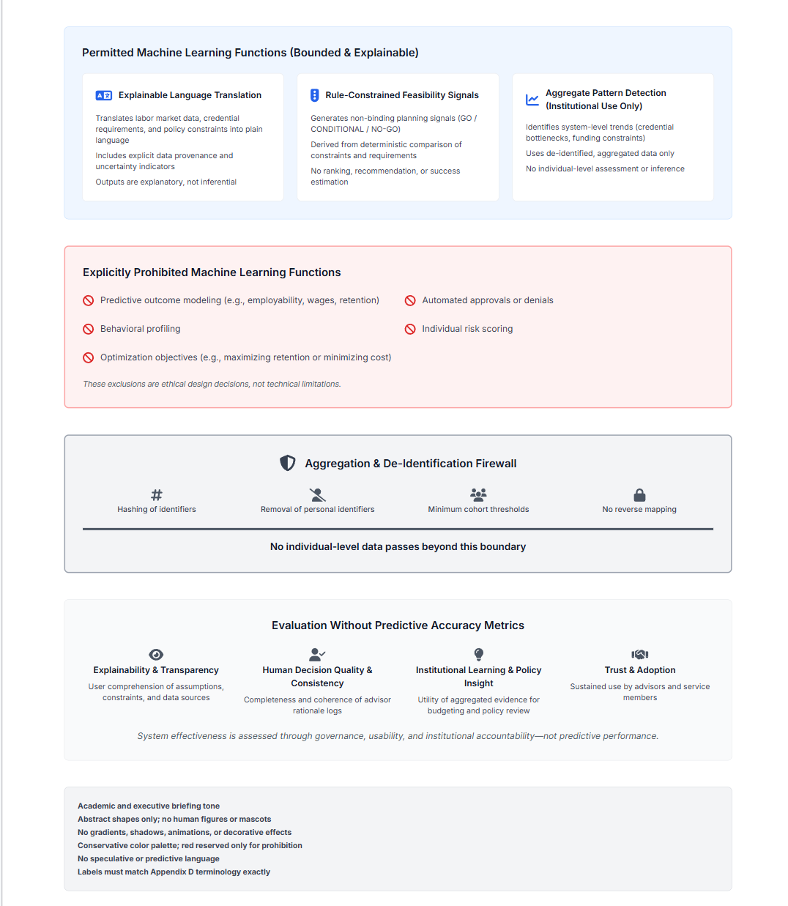
Figure D-1 Machine Learning Scope, Ethical Constraints, and Evaluation Boundaries within the Career Mobility Governance Framework (CMGF).
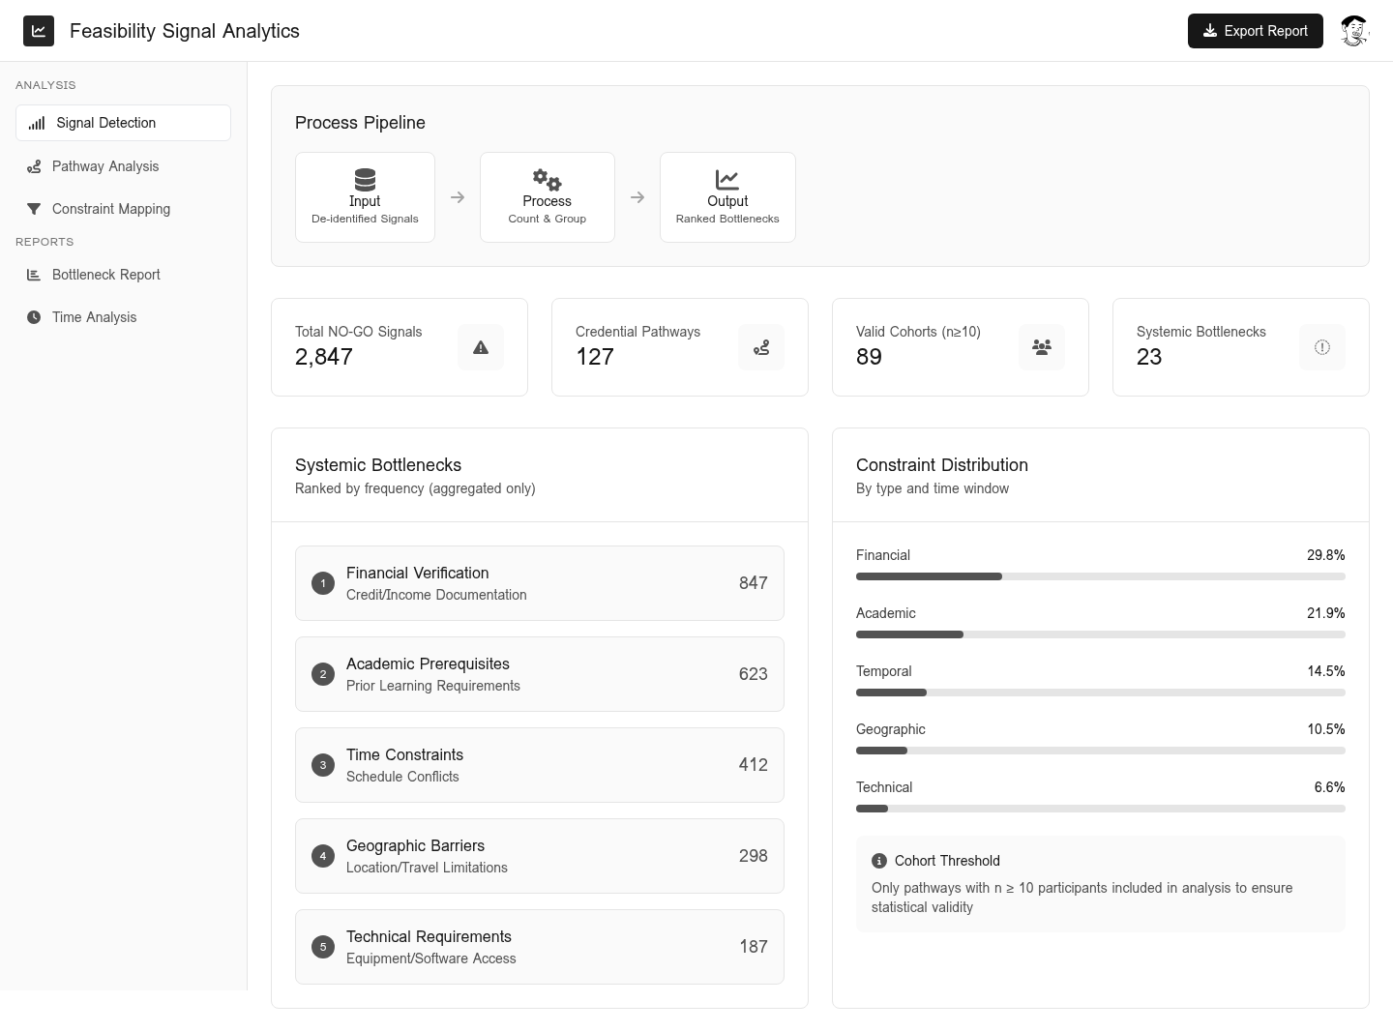
This figure illustrates the bounded application of machine learning within CMGF, explicitly distinguishing permitted explanatory and aggregate analytic functions from prohibited predictive, automated, or optimization-based uses. The diagram also depicts the aggregation and de-identification firewall and the governance-oriented evaluation framework employed in lieu of predictive accuracy metrics.

Figure D2 feasibility Signal Analysis
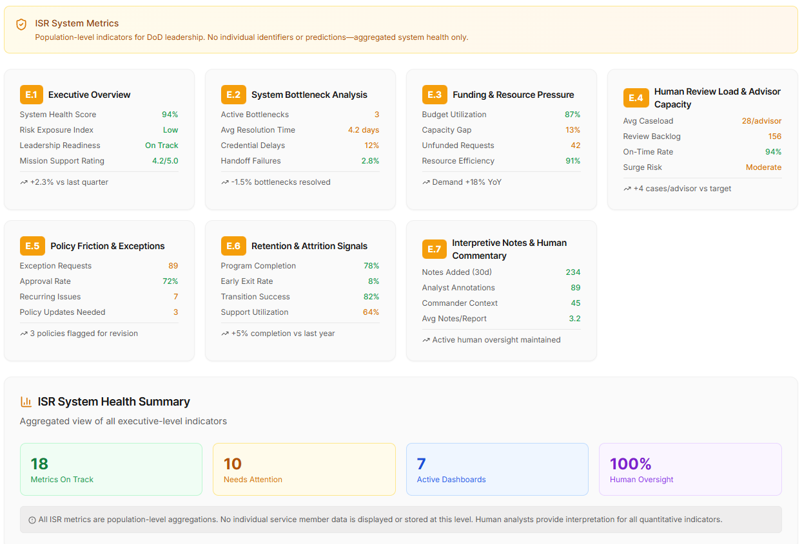
Figure D2 illustrates an example of aggregate feasibility signal analysis, in which de-identified GO/CONDITIONAL/NO-GO signals are grouped and counted across credential pathways to identify systemic bottlenecks under enforced cohort thresholds. No individual-level inference, prediction, or optimization is performed.

Figure D2 Feasibility Signal Analysis.

Figure D2 illustrates an example of aggregate feasibility signal analysis, in which de-identified GO/CONDITIONAL/NO-GO signals are grouped and counted across credential pathways to identify systemic bottlenecks under enforced cohort thresholds. The analysis operates at the level of constraint frequency and pathway feasibility; no individual-level inference, prediction, ranking, or optimization is performed.

Appendix E System Governance
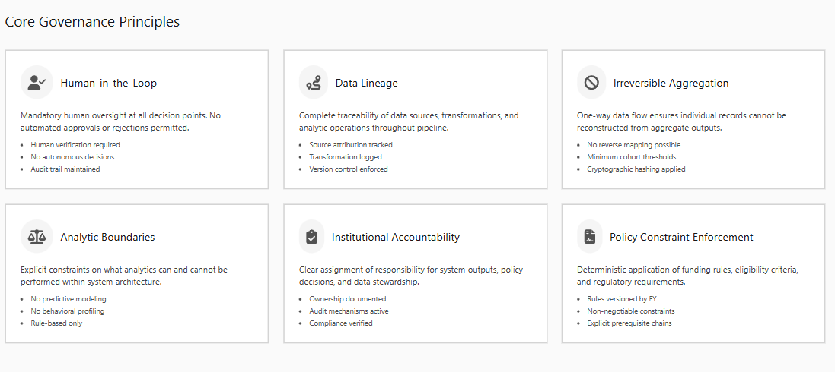
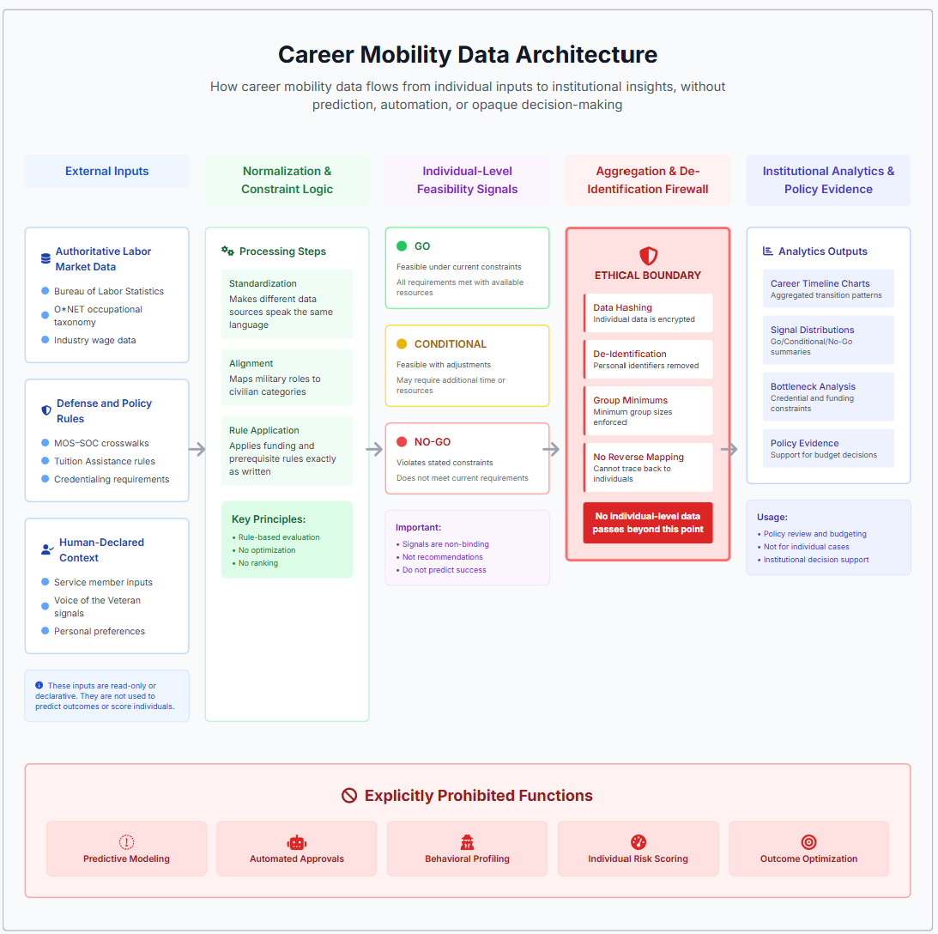

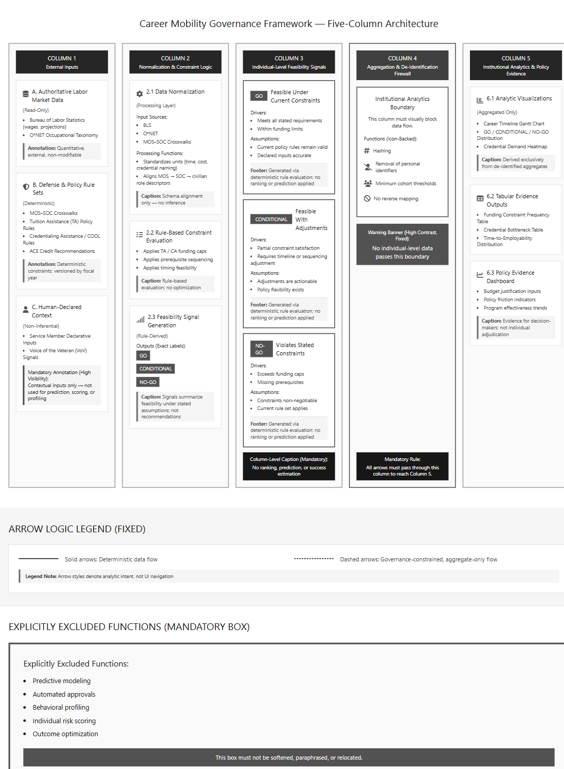

Appendix F System Architecture
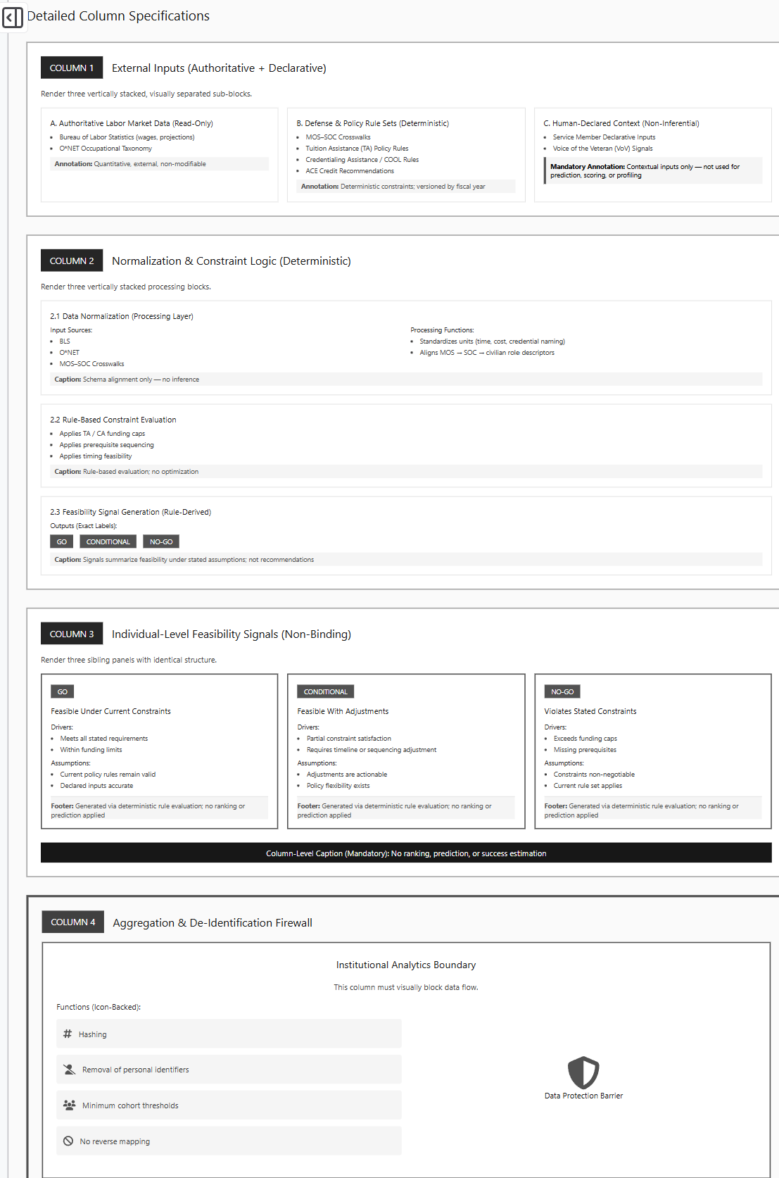
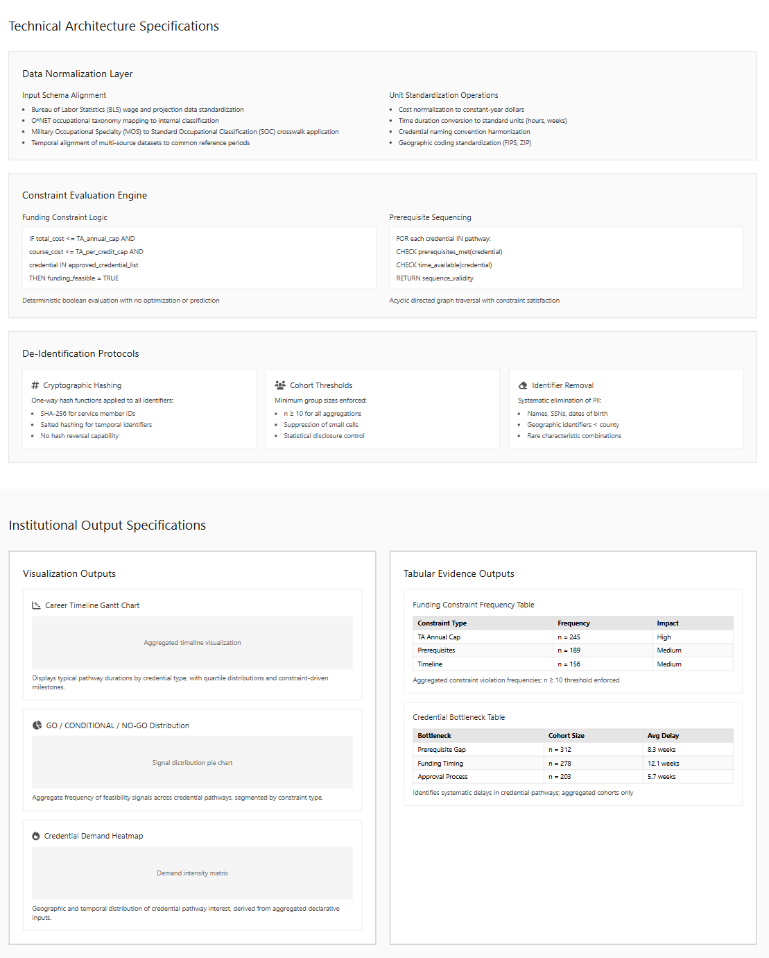

Appendix F: Reviewer Orientation Note
Purpose, Scope, and Evaluation Framing
Purpose of This Document
This orientation note is provided to assist reviewers in reading and evaluating this manuscript in alignment with its intended research paradigm, scope, and evaluation criteria. The study is presented as a design science research contribution and an artifact based demonstration rather than an operational deployment or performance evaluation study.
Context and Framing
This work was developed within the context of the 2026 Council of Colleges and Military Educators Symposium, which explicitly situates education, workforce development, and military learner mobility through the lens of artificial intelligence. Accordingly, the study does not examine whether artificial intelligence should be used in advising systems. Instead, it examines how artificial intelligence can be governed, constrained, and evaluated when its use is assumed or institutionally required.
Artificial intelligence is treated as a contextual constraint rather than as a research novelty or outcome target.
Research Paradigm
The study follows principles of design science research, in which knowledge contributions are embodied in artifacts, architectures, and design principles rather than predictive models or statistical generalization. The central contribution is an integrative governance architecture referred to as the Career Mobility Governance Framework, which operationalizes policy and ethical requirements into a concrete system design.
The artifact is intended to demonstrate feasibility, governance alignment, and design logic rather than to optimize outcomes or automate decisions.
Role of Artificial Intelligence
Artificial intelligence is employed as decision support infrastructure rather than as an authoritative decision agent. Its role is limited to signal translation, contextual aggregation, and pattern surfacing across heterogeneous policy, credentialing, and workforce data sources. Predictive modeling, optimization, individual risk scoring, and automated approvals are intentionally excluded as governance constraints rather than technical limitations.
These exclusions are core design decisions and should be evaluated as such.
Evaluation Criteria
Evaluation within this study prioritizes the following dimensions:
• Transparency and explainability of system behavior
• Traceability of decisions and constraints
• Enforceability of scope limitations
• Preservation of human authority and accountability
• Institutional learning value at the policy and system level
Predictive accuracy, automation efficiency, and individual outcome optimization are explicitly out of scope and should not be used as evaluation criteria for this work.
Alignment with Governance Standards
The framework is aligned with the principles articulated in the NIST Artificial Intelligence Risk Management Framework version 1.0. Risk is addressed primarily through architectural constraint, scope limitation, and human accountability rather than through post hoc mitigation.
Intended Contribution
The contribution of this study is architectural and governance focused. It demonstrates one approach to integrating artificial intelligence into high impact advising systems without transferring authority away from human decision makers or institutions. The work is intended to inform design, governance, and policy discussion rather than to serve as a production ready system.
How to Read This Manuscript
Reviewers are encouraged to evaluate this work as:
• A design science artifact
• A governance and architecture contribution
• A demonstration of constrained and responsible artificial intelligence use
• A policy relevant advising framework
rather than as a machine learning performance study or deployment report.

