Career Mobility Governance Framework (CMGF)
A Response to the 2026 CCME Learner Track 1
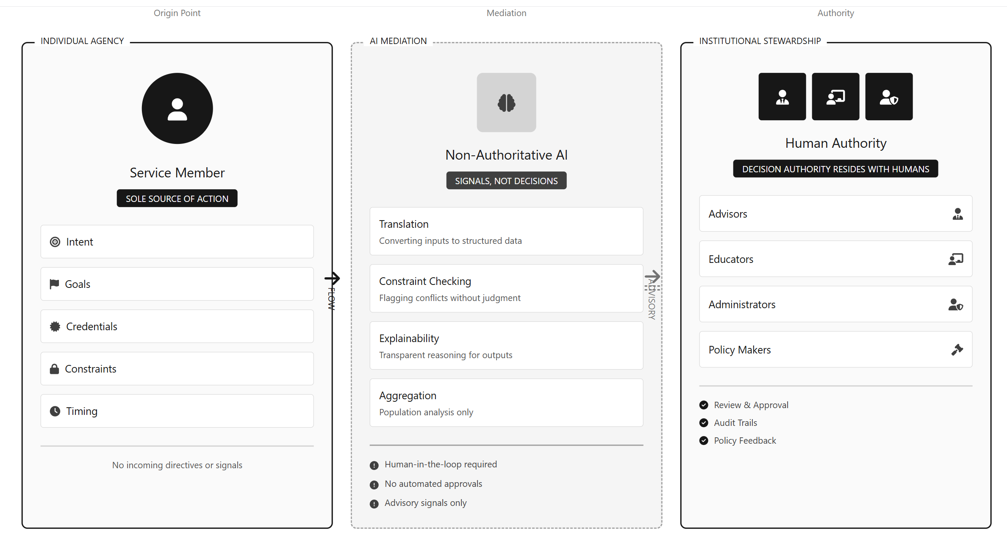
Author: Robert E. McCoy MBA, M.S. AI & Data Analytics
Affiliation: Indiana Wesleyan University

Table of Contents

Career Mobility Governance Framework (CMGF) 1
Table of Contents 2
Executive Summary 4
What This Paper Contributes 7
Key Findings 9
Introduction 11
A Review of Literature 14
Methods 18
Labor Market and Workforce Data Analysis 20
AI and Data Analytics Design Approach 21
Track 1 Topics 33
Artificial Intelligence as an Enabling Force 34
Military Learner Career Mobility 36
Funding Imbalances: Education vs. Transition Support 38
Empowerment Strategies and Stackable Pathways 42
Emerging Labor Market Demand for AI Literacy Certifications 44
Translating Military Experience into Civilian Workforce Value 48
Veteran and Servicemember Learner Voice 51
Installation Status Reports (ISR)Tools and Frameworks for Career-Aligned Advising: The Career Mobility Governance Framework (CMGF) 53
Modernizing Advising Approaches 54
Best Practices & Innovations 56
• Stackable Pathways and Modular Credentials 56
• Employer and Community Integration 56
• Advisor Roles and Peer Networks 56
Demonstration Artifact: An Example AI-Enabled Advising Interface 58
66
Recommandations 67
Gaps and Future Research/Action 68
Recommended priorities for future research and action 71
References 74
Appendix A: Annotated Bibliography 84
Appendix B: Case Examples and Best Practices 88
Appendix C: Transitions 90
Appendix D Machine Learning Scope, Ethical Constraints, and Evaluation Design 91
Appendix E System Governance 103

This study does not attempt to evaluate predictive accuracy, optimize pathway selection, or model individual outcomes. These omissions are intentional and reflect unresolved governance, equity, and accountability risks in high-impact public-sector contexts. Future empirical work would require institutional data access, human subjects review, and policy authorization beyond the scope of this capstone.
CMGF is a demonstrated framework that is compliant by design and non-predictive by default, eliminating exposure to prohibited high-risk practices while still delivering scalable decision support. Built against (EO 14110, NIST AI RMF, GAO-24 reports).

Executive Summary

This study is motivated by a structural paradox at the center of military transition policy: although more than $13.5 billion is spent annually on education benefits, fewer than $140 million is allocated to transition-specific advising and decision support, a mismatch that coincides with persistent post-service wage regression affecting a majority of separating service members. To address a problem that has historically proven difficult to address at scale within a fragmented system reliant on manual advising alone, the study introduces a deliberately governed application of modern artificial intelligence designed not to predict outcomes, but to integrate policy, workforce data, and individual constraints into a transparent, human-centered planning environment.
By aggregating de-identified feasibility signals and recurring constraint conflicts across individual plans, the Advising & Approval Module transforms anecdotal transition failures into auditable institutional evidence, providing policymakers and educational leaders with the empirical foundation necessary to justify rebalancing transition support funding and reforming advisory infrastructure at scale.
The Department of Defense (DoD) comprises more than 2.0 million service members, including approximately 1.27 million on active duty and over 760,000 in Guard and Reserve components, each operating under distinct education, advising, and transition constraints. Each year, between 150,000 and 200,000 active-duty service members transition into civilian careers, creating a human capital environment characterized by high mobility and recurring reintegration into the national workforce.
This flow of human capital represents a substantial national investment in training, education, leadership development, and credentialing. These investments are essential to military readiness and contribute directly to U.S. economic resilience by supplying highly skilled professionals and technicians to civilian industries. Because military service in the United States is voluntary, this investment is underwritten by an implicit social contract: service members contribute to national defense, and in return the nation provides structured support for professional development, transition, and long-term economic mobility.
This paper introduces the Career Mobility Governance Framework (CMGF) which directly addresses this paradox by converting individual planning friction into auditable, aggregate evidence that justifies budget reallocation and policy reform.
This paper examines five areas of impact defined by Track 1 of the 2026 Council of College and Military Educators (CCME):
- Military learner career mobility
- Empowerment strategies and stackable pathways (e.g., Credentialing Assistance [CA], Credentialing Opportunities On-Line [COOL], credential maps)
- Tools and frameworks for career-aligned advising (e.g., interest inventories, outcome tracking)
- Translating military experience into civilian workforce value
- Veteran and service member learner voice: barriers and breakthroughs
This study intentionally rejects predictive and outcome-optimizing AI as a design choice, positioning non-predictive, human-governed analytics as the primary technical mechanism for preserving service-member agency, institutional accountability, and public trust.
Through these lenses, the paper analyzes the role of artificial intelligence, digital transformation, and cross-sector collaboration in unlocking new pathways for upskilling, reskilling, and workforce alignment. Rather than positioning AI as a decision-maker or predictive authority, the paper advances a governance-first perspective in which AI serves as bounded decision infrastructure that supports transparency, planning, and institutional learning while preserving human judgment and service-member agency (Defense Innovation Board, 2023; Government Accountability Office, 2024).
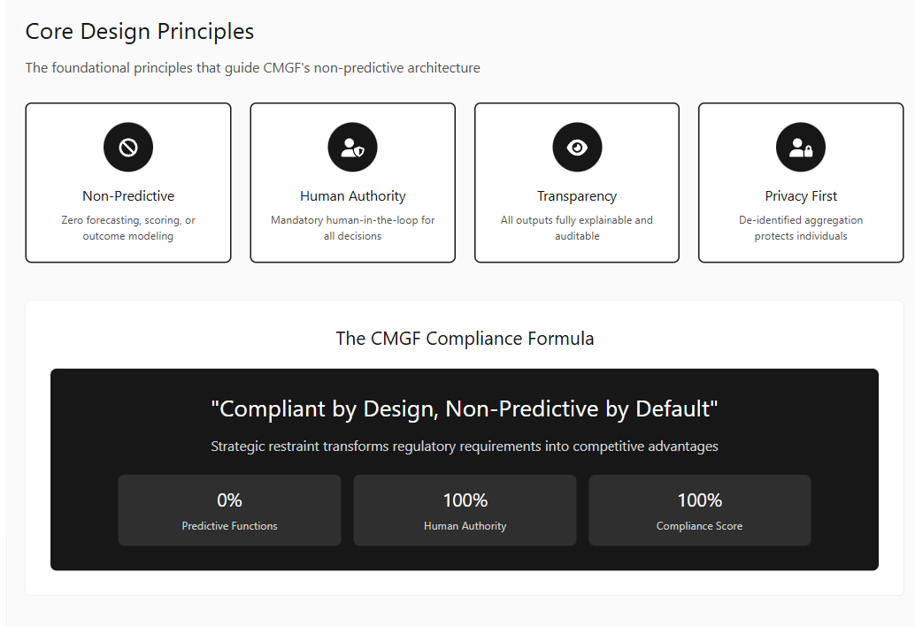

What This Paper Contributes
This paper makes six primary contributions to the study and practice of military learner career mobility:
- A structured synthesis of peer-reviewed research and policy analyses examining credential portability, career mobility, and advising effectiveness for military learners, organized explicitly around the five CCME Track 1 elements (CAEL, 2018; Institute for Veterans and Military Families [IVMF], 2019).
- An evidence-based examination of labor-market signaling, demonstrating that employers increasingly reward attestable, portable credentials and emerging forms of AI fluency, particularly when competencies can be verified across institutional and sector boundaries (Pearson VUE, 2025; Wells, 2024).
- A diagnosis of persistent governance and implementation gaps that have prevented AI literacy, credential alignment, and career-aligned advising from becoming standardized policy across the Department of Defense, despite repeated federal guidance and oversight recommendations (Department of Defense, 2023; Government Accountability Office, 2023, 2024; Office of Management and Budget, 2024).
- The introduction of an AI-enabled, human-centered advising framework, illustrated through two demonstration artifacts that show how a governed AI layer can unify fragmented Track 1 inputs career direction, education pathways, transition timing, and learner voice into a coherent planning context while strengthening service-member agency and preserving human advising authority.
- A principled design contribution to Responsible AI practice, demonstrating how intentional non-use of technically feasible AI functions including predictive outcome modeling, automated approvals, individual risk scoring, and optimization objectives can serve as a core design mechanism for trust, accountability, and policy alignment in high-impact public-sector systems.
- Compliant by design, non-predictive by default: CMGF turns individual planning friction into collective intelligence, generating the auditable evidence needed to reform budgets and policies.

Key Findings
The synthesis of peer-reviewed literature, federal policy guidance, and workforce evidence yields the following key findings:
- Credential translation constitutes the dominant structural bottleneck in military learner career mobility, as non-portable, non-stackable, or poorly mapped credentials disrupt alignment across education, employment, and transition timelines, eroding the return on both individual benefits and institutional investment (CAEL, 2018; Institute for Veterans and Military Families [IVMF], 2019). Fragmentation at this translation layer prevents coordinated planning and obscures system-wide patterns of failure.
- Skills-based hiring practices increasingly treat standardized, attestable credentials as primary labor-market signals, indicating that verified competencies rather than tenure or occupational labels alone now function as cross-sector currency between military experience and civilian employment (Office of Personnel Management, 2024; Pearson VUE, 2025). This shift heightens the consequences of poor credential mapping and amplifies the cost of misalignment during transition.
- Baseline AI literacy has emerged as a governance and readiness prerequisite, not merely a technical skill, necessary to ensure transparency, quality assurance, and accountable use of AI-enabled systems in advising and workforce planning. Despite its growing centrality to both civilian employability and institutional decision support, AI literacy remains unevenly defined, inconsistently funded, and inequitably accessed across roles and populations (Office of Management and Budget [OMB], 2024; Office of Personnel Management, 2024).
- AI-enabled advising tools demonstrate the greatest value when deliberately constrained to decision-support functions, enabling explainable translation, rule-based feasibility assessment, and comparative scenario analysis without displacing human judgment or authority. Evidence indicates that governed, non-predictive AI architectures improve advising clarity and institutional trust relative to autonomous or outcome-optimizing systems (IVMF, 2019; Defense Innovation Board, 2023).
- Persistent execution gaps across policy translation, role definition, and accountability reflect not isolated program failures but a systemic evidence deficit, in which individual advising frictions remain anecdotal and therefore unusable for institutional learning or budgetary justification. Governed AI frameworks capable of aggregating de-identified constraint conflicts and feasibility signals offer a viable mechanism for converting distributed transition failures into auditable evidence suitable for policy reform and resource reallocation (Government Accountability Office [GAO], 2023, 2024).

Introduction
Each year, approximately 150,000–200,000 service members transition from active duty into the civilian workforce. Despite extensive federal investment in education and credentialing benefits, a substantial proportion experience early wage regression and underemployment following separation (Kleykamp et al., 2024; McKinsey & Company, 2022). Research consistently demonstrates that these outcomes are driven less by underlying skill deficits than by structural frictions in how civilian labor markets recognize military training, credentials, and occupational experience. Compensation systems tend to privilege firm- and occupation-specific tenure, systematically undervaluing military-acquired competencies and delaying wage alignment even when underlying skills are comparable (RAND Corporation, 2022; Davenport et al., 2024).
Military transition is therefore not a single employment event, but a longitudinal, multidimensional process involving identity change, community reintegration, and navigation of overlapping education, workforce, and support systems. Effective outcomes depend on coordinated policy and practice across the Department of Defense (DoD), higher education institutions, employers, and public workforce systems (Castro & Kintzle, 2014; Hodges, 2025; MITRE, 2019). Across this ecosystem, two levers consistently emerge as outcome-determinative: portable, stackable credentials that render military learning legible to civilian hiring systems, and career-aligned advising grounded in labor-market evidence and employer signaling (CAEL, 2018; Institute for Veterans and Military Families [IVMF], 2019).
Recent national policy developments have elevated artificial intelligence (AI) from a specialized technical capability to a foundational governance and workforce competency. Federal guidance on safe, secure, and trustworthy AI alongside DoD initiatives such as the Artificial Intelligence Education Strategy and Task Force Lima now frame AI literacy and responsible AI use as readiness requirements across operational, evaluative, and documentation roles (Department of Defense, 2020, 2023; Office of Management and Budget [OMB], 2024). In parallel, labor-market evidence indicates that AI-related competencies are reshaping task requirements across a wide range of occupations, increasing employer demand for attestable, cross-disciplinary AI fluency well beyond traditional software roles (Bureau of Labor Statistics, 2025; Wells, 2024).
Despite this convergence of policy mandate and labor-market demand, AI remains weakly integrated into the institutional processes that govern career planning, credential sequencing, and transition advising. Responsibility for AI-related upskilling and planning is frequently shifted to individual service members through personal education benefits, even as policy increasingly treats AI literacy as a baseline requirement rather than an elective specialization. More critically, existing systems lack transparent mechanisms for using AI to translate experience, clarify policy constraints, and support consistent human decision-making across education and transition timelines. This misalignment contributes to persistent execution gaps, inequitable access, and inefficiencies that undermine both force readiness and post-service career mobility.
Against this backdrop, this paper advances a governed, policy-aligned approach for integrating baseline AI literacy and non-predictive AI decision support into stackable credential pathways and career-aligned advising models. Central to this approach is the deliberate use of AI as decision infrastructure rather than decision authority. AI is employed to translate heterogeneous data sources, surface constraint-driven planning signals, and support consistent advising workflows, while explicitly prohibiting predictive outcome modeling, automated approvals, individual risk scoring, and optimization objectives. These exclusions are not technical limitations, but intentional design choices aligned with public-sector governance requirements and the preservation of service-member agency and human accountability.
Specifically, this paper:
(1) synthesizes evidence on credential portability and military-to-civilian transition outcomes;
(2) examines governance and implementation barriers that have constrained institutional adoption of AI literacy and AI-enabled advising;
(3) documents emerging labor-market demand for portable, attestable AI competencies; and
(4) presents two demonstration artifacts illustrating how a governed, human-centered AI advising layer can unify career direction, education pathways, transition timing, and learner voice into a coherent planning and advising context while preserving human judgment and institutional accountability.

A Review of Literature
The transition process remains complex, often resulting in underemployment or a wage penalty for more than half of transitioning service members, despite substantial federal investment in education and credentialing benefits (Kleykamp et al., 2024; McKinsey & Company, 2022). Major analyses highlight that while programs such as the Post-9/11 GI Bill increase educational attainment, they often do not prevent decreased earnings, as time out of the workforce and imperfect skills translation erode long-term outcomes (Barr et al., 2021).
Credential portability and skill translation remain major obstacles. Without structured, widely recognized frameworks that map military expertise to civilian roles, employers often fail to recognize the value of military-acquired competencies, contributing to systemic wage gaps and lower retention (Harrell & Berglass, 2012; SHRM, 2023). Modular, stackable micro credentials, developed in partnership with employers and education advocates such as IVMF and CAEL, have been shown to improve veterans’ odds of securing employment aligned with their skills and long-term career goals (IVMF, 2019; CAEL, 2018).
Recent empirical studies of AI-enabled advising systems in higher education demonstrate improved retention, academic confidence, and career alignment when intelligent systems are deployed as advisor-assist tools under clear ethical and governance constraints (Ahmed et al., 2024; Soomro et al., 2025).
Recent research points to the potential of artificial intelligence to modernize credit recognition and portability. The American Council on Education (2024) emphasizes that existing credit for prior learning (CPL) processes are “fragmented and inconsistent,” requiring new methods to validate nontraditional learning at scale. AI-driven credentialing systems particularly those using natural language processing to analyze course equivalencies and occupational training offer a pathway to automate evaluation, reduce bias, and accelerate transcript production. These capabilities align with the DoD’s Artificial Intelligence Education Strategy (2020), which envisions AI not only as a warfighting capability but as a foundational tool for improving administrative and educational efficiency.
AI literacy and digital upskilling have emerged as pivotal, cross-cutting priorities. The Digital Education Council (2025) and other national initiatives call for embedding foundational AI/data skills and ethical awareness into all learner pathways, including those tailored to veterans. The Campaign for an AI Ready Force similarly underscores that AI readiness requires broad literacy across the force, extending to both technical specialists and non-technical leaders (Defense Innovation Board, 2023). Yet, despite this strategic intent, a GAO review found that DoD has not fully defined its AI workforce, lacks consistent terminology across strategy documents, and has not assigned clear responsibility or timelines for implementation, limiting progress toward institutionalized AI literacy (Government Accountability Office, 2023). The creation of Task Force Lima in 2023 reflects DoD’s recognition of this gap, charging a cross-agency body to coordinate the responsible adoption of generative AI and to guide workforce education (Department of Defense, 2023).
In mid-2025 The White House unveiled a new AI action plan resulting in increased funding in the 2026 budget to fund operational measures to accelerate AI adoption across the U.S. Government and military, amplifying various high-level AI policy documents. These policies mandate federal agencies to establish AI literacy and data proficiency as core workforce competencies. For the DoD, this creates both a compliance requirement and an innovation opportunity: to embed AI competency within existing education and credential systems, rather than developing parallel structures. Integrating AI into credit evaluation and credential mapping directly fulfills this national policy agenda while positioning the DoD as a leader in responsible AI-enabled workforce transformation.
Labor market trends reinforce the case for AI literacy certifications. The Bureau of Labor Statistics (2025) projects accelerated growth in AI-exposed occupations, with software developers projected to grow by 17.9% compared with 4% across the overall economy. These projections suggest that AI will reshape tasks rather than eliminate jobs, creating a premium on adaptable, cross-disciplinary skills. Employers confirm this trend: in a 2024 survey, 71% of hiring leaders preferred candidates with AI skills over those with greater experience, underscoring the rise of skills-first hiring (Wells, 2024). Parallel developments in federal workforce policy, such as the Office of Personnel Management’s AI Classification Policy (2024), reinforce this emphasis by defining AI roles, competencies, and pathways for skills-based hiring.
Finally, the literature highlights the importance of designing transition policy and advising not just for, but with, veterans and employers. Effective programs employ participatory models, alumni-driven mentoring, and sustained career advising linked to employer needs and labor market data, producing better long-term outcomes (National Resource Center, 2022; IVMF, 2019).
Synthesizing these insights, the field increasingly recognizes the need for an ecosystem approach. Transition success depends on coordinated responsibility spanning DoD, higher education, employers, and veterans themselves, all supported by robust evidence, portable credentials, and a commitment to continuous improvement (Digital Education Council, 2025; Defense Innovation Board, 2023; Government Accountability Office, 2023). Building on these insights, this study explores whether AI-enabled, partnership-based credential platforms could provide the connective tissue between fragmented systems, linking DoD training data, ACE recommendations, and academic pathways into a unified, portable transcript model. Such an approach would align with the principles of holistic credit mobility (Ithaka S+R, 2024) by treating military learning as interoperable, transferable, and verifiable across institutions, ultimately improving transparency, efficiency, and trust in the military-to-civilian education pipeline.

Methods
Research Design and Methodological Orientation
This study employs a mixed-methods, design-oriented research methodology integrating policy analysis, structured literature synthesis, descriptive labor-market analysis, and artifact-based technical demonstration. The methodological approach is explicitly aligned with federal guidance on responsible artificial intelligence (AI) use in high-impact public-sector contexts, emphasizing transparency, explainability, and human-in-the-loop control rather than predictive optimization or automated decision-making (National Institute of Standards and Technology [NIST], 2023; Office of Management and Budget [OMB], 2024).
The study adopts principles from design science research (DSR) to operationalize abstract governance, ethical, and policy requirements into concrete, evaluable system artifacts (Hevner et al., 2004; Peffers et al., 2007). AI is treated as decision-support infrastructure, not as an authoritative decision agent. Methodological exclusions such as predictive outcome modeling, automated approvals, and individual risk scoring are treated as intentional design constraints rather than technical limitations.
Policy and Literature Analysis
First, a structured review of peer-reviewed academic literature, federal policy documents, and oversight reports was conducted to identify recurring constraints and enabling factors affecting military learner career mobility, credential portability, advising effectiveness, and AI literacy adoption.
Sources included:
- Academic research on military-to-civilian transitions, workforce signaling, and credentialing frameworks;
- Empirical studies of AI-assisted advising and decision-support systems; and
- Authoritative policy guidance from the Department of Defense (DoD), Government Accountability Office (GAO), Office of Management and Budget (OMB), and National Institute of Standards and Technology (NIST).
The literature synthesis was organized explicitly around the five focus areas defined by Track 1 of the 2026 Council of College and Military Educators (CCME):
- Military learner career mobility;
- Empowerment strategies and stackable pathways;
- Career-aligned advising frameworks;
- Translation of military experience into civilian workforce value; and
- Veteran and service-member learner voice.
This thematic organization ensured direct alignment between the literature review, policy analysis, and the conceptual framework guiding the study (CAEL, 2018; Institute for Veterans and Military Families [IVMF], 2019; RAND Corporation, 2022).

Labor Market and Workforce Data Analysis
Second, descriptive labor-market and workforce evidence was examined to assess how credentials, skills-based hiring practices, and AI-related competencies are currently valued by employers. Data sources included publicly available datasets and reports from the Bureau of Labor Statistics (BLS), Office of Personnel Management (OPM), employer surveys, and industry credentialing organizations.
The purpose of this analysis was not to construct predictive labor-market models, but to identify observable patterns in credential demand, occupational growth, and employer signaling practices relevant to transitioning service members (Bureau of Labor Statistics, 2025; Office of Personnel Management, 2024; Wells, 2024). Consistent with the study’s ethical design constraints, all analysis remained descriptive and comparative rather than inferential. No individual-level prediction, classification, optimization, or ranking was performed.
Findings from this phase informed the design assumptions underlying the demonstration artifacts, particularly with respect to:
- Credential sequencing and stackability;
- Funding constraints (e.g., Credentialing Assistance and COOL caps); and
- The increasing salience of baseline AI literacy as a cross-cutting workforce competency.

AI and Data Analytics Design Approach
Third, insights from the policy, literature, and labor-market analyses informed the design of two interconnected demonstration artifacts illustrating how a governed, AI-enabled advising layer could mediate fragmented data sources into a coherent planning and advising context.
Rather than obscuring policy constraints, the system is intentionally designed to surface structural frictions such as credential funding caps or policy misalignments as visible planning signals. This approach positions AI as an accountability instrument that reveals institutional constraints rather than masking them, enabling policy makers to observe how rules manifest as repeated barriers at scale.
The AI components employed in the demonstration are deliberately bounded and non-predictive. Artificial intelligence is used exclusively for:
- Explainable language translation of heterogeneous data sources;
- Rule-constrained feasibility signaling based on transparent comparisons between user-declared constraints and policy rules; and
- Aggregate pattern detection for institutional learning and policy review.
Natural language processing techniques are applied to translate labor-market data, occupational crosswalks, and policy constraints into plain-language explanations with explicit data provenance. Rule-based logic generates non-binding “Go,” “Conditional,” or “No-Go” planning signals derived from stated assumptions rather than probabilistic inference. Aggregate analytics are limited to de-identified, population-level summaries intended to support policy analysis and budget justification rather than individual assessment (NIST, 2023; Government Accountability Office [GAO], 2023, 2024).
In accordance with federal AI governance guidance, the demonstration explicitly excludes predictive outcome modeling, automated approvals, individual risk scoring, and optimization objectives. These exclusions are treated as methodological design choices reflecting the study’s emphasis on preserving service-member agency, human accountability, and institutional trust (Executive Order No. 14110, 2023; OMB, 2024).
Artifact-Based Demonstration and Validation
Finally, the study employs artifact-based demonstration as a core methodological tool to operationalize policy, governance, and ethical requirements into tangible, evaluable system components (Hevner et al., 2004; Peffers et al., 2007).
Two interconnected artifacts were developed within the Career Mobility Governance Framework (CMGF):
- the Career Planning Module (CPM), and
- the Advising & Approval Module (AAM).
Career Planning Module (CPM)
The CPM serves as the primary interface for active-duty service members and transitioning learners. It supports agency-driven exploration through five functional zones:
- Intent and Constraint Input Panel, capturing career goals, transition timing, credential inventory, funding limits, and personal willingness indicators;
- Retention versus Civilian Comparison Panel, enabling side-by-side visualization of tradeoffs in pay, benefits, promotion timelines, skill accumulation, and wage-regression risk;
- Data Reference Layer, transparently displaying authoritative sources (e.g., BLS wages and outlooks, O*NET crosswalks, DoD policy tables) with uncertainty annotations;
- Go/No-Go Planning Signals, providing non-binding, rule-derived indicators accompanied by explicit assumptions and constraint drivers; and
- Timeline and Scenario Visualization, using an interactive Gantt-style tool to compare retention, immediate transition, and delay-and-prepare scenarios.
AI functions exclusively as an explainable planning aid, translating complex data into accessible language and surfacing tradeoffs while remaining explicitly prohibited from recommending outcomes or predicting success.
Advising & Approval Module (AAM)
The AAM functions as the institutional workspace for Education Services Officers, commanders, and policy staff. It provides:
- Structured individual plan review with full CPM context;
- A mandatory human approval workflow requiring documented rationale and digital signature;
- Aggregate dashboards visualizing de-identified patterns in credential demand, constraint bottlenecks, and transition timing; and
- Evidence export views supporting budget justification and policy reform.
AI use within the AAM is strictly limited to descriptive aggregate pattern detection on anonymized data. No individual-level assessment or automated approval is permitted.
Validation Approach
Artifact validation focuses on governance-aligned criteria rather than predictive performance metrics:
- Compliance and Guardrail Enforcement: Specification review and logical walkthroughs confirm human-in-the-loop authority, mandatory rationale logging, explainability provenance, and prohibition of automated decisions (aligned with OMB M-25-21, 2025, and DoD Responsible AI guidance).
- Usability and Agency Support: Scenario-based evaluation demonstrates how the CPM enables transparent comparison of pathways while preserving learner decision authority.
- Institutional Learning Value: Synthetic aggregate data derived from public BLS and O*NET mappings and policy constraints is processed to illustrate actionable insights such as credential funding bottlenecks and high-demand credential clusters supporting resource allocation and program redesign with minimal oversight burden.
Together, these artifacts operationalize a fragmented, multi-billion-dollar programmatic landscape comprising more than 45 distinct programs dominated by the “Big Four” into an integrated, governed framework that coordinates policy, technology, and human advising in direct support of CCME’s mandate to educate, engage, and empower military learners.
Exploratory Technical Prototyping and Design Validation
In addition to policy and literature analysis, exploratory technical prototyping was conducted to examine the practical behavior, limitations, and interoperability of existing military-to-civilian data mappings and advising workflows. Multiple prototype models and interface concepts were developed using Python-based analytical environments and rapid application frameworks (e.g., Streamlit, PyCharm), desktop interface tooling (Qt6), and complementary statistical exploration tools. These prototypes were not designed as deployable systems, but as investigative instruments to assess data structure, crosswalk fidelity, and constraint interactions.
Exploratory modeling included frequency analysis of constraint violations, rule-path enumeration across credential sequences, and schema validation of MOS–SOC mappings to assess semantic consistency across datasets. These analyses were conducted using Python-based prototyping environments (e.g., Streamlit, PyCharm) to evaluate constraint behavior under varying funding caps, timing windows, and prerequisite structures. The exploratory prototyping process also informed the deliberate exclusion of certain technical approaches from the proposed framework. Topics such as automated credit portability, blockchain-based credential verification, and optimization-driven pathway selection were examined at a conceptual level but excluded from the demonstration scope. Existing research and data maturity were deemed insufficient to support responsible implementation, particularly given unresolved questions regarding data completeness, governance authority, interoperability, and long-term accountability.
These exploratory activities did not produce empirical results or performance metrics and are not presented as validation studies. Instead, they served as formative design inputs, supporting the study’s methodological emphasis on bounded AI use, transparency, and policy-aligned decision infrastructure rather than predictive or automated systems.
A Deeper Dive: System Architecture and Governance: A Twelve-Layer Model
NOTE: Reviewer Guidance on Evaluation of the CMGF Architecture Section
This section should be evaluated as a design and governance contribution, not as a predictive modeling study or system performance evaluation. The twelve-layer CMGF architecture is presented to demonstrate how AI and data analytics can be operationalized within existing military education and transition authorities while preserving human decision-making, policy fidelity, and institutional accountability. The contribution lies in the explicit decomposition of authority, data ownership, governance controls, and AI constraints across layers, rather than in algorithmic novelty or outcome optimization. Accordingly, effectiveness should be assessed based on clarity of authority assignment, enforceability of guardrails, alignment with federal AI governance guidance, and plausibility of integration into existing military education and advising ecosystems, rather than accuracy metrics, automation efficiency, or deployment readiness.
The Career Mobility Governance Framework (CMGF) AI is designed as a layered, governed architecture intended to integrate an governed artificial intelligence into military education, credentialing, and wellness support without displacing human authority or violating established policy constraints. Consistent with contemporary guidance on transparent and reproducible AI-assisted systems, CMGF treats AI as a constrained reasoning component embedded within a broader socio-technical system rather than as an autonomous decision maker (Holst et al., 2024; NIST, 2023).
To ensure accountability, auditability, and policy compliance, CMGF is decomposed into twelve functional layers. Each layer is aligned with a specific authority owner, governance mechanism, and update control process.
Collectively, the following layers operationalize the design principles established in the CPM and AAM artifacts, extending them from user-facing workflows into a full governance and accountability architecture.
Layer 1: Legal and Policy Authority Layer
The Legal and Policy Authority Layer establishes the statutory and regulatory boundaries governing CMGF operations. Authority at this layer resides with the Department of Defense, service headquarters, and interagency partners such as the Department of Veterans Affairs and the Department of Labor. CMGF does not generate or interpret policy; rather, it consumes formally issued policy artifacts as authoritative inputs.
This design aligns with federal guidance emphasizing that AI systems must operate strictly within existing legal authorities and may not introduce de facto policy through technical implementation (DoD, 2020; NIST, 2023).
Layer 2: Governance and Oversight Layer
The Governance and Oversight Layer translates policy constraints into enforceable operational rules. This layer is responsible for approving permitted use cases, prohibiting unsafe or unethical applications, and defining audit and retention standards. Governance bodies operating at this layer ensure that AI capabilities remain bounded, transparent, and subject to human oversight.
Separating governance from implementation reflects best practices in responsible AI deployment, where accountability remains with institutional authorities rather than technical vendors (Holst et al., 2024; Leslie, 2019).
Layer 3: Identity, Access, and Trust Layer
The Identity, Access, and Trust Layer ensures that system interactions are authenticated, authorized, and attributable. CMGF binds to existing identity and access management infrastructures and follows zero-trust principles, in which access is granted only for specific purposes and durations (Rose et al., 2020).
Importantly, CMGF does not maintain persistent behavioral profiles of service members or veterans. Each interaction is session-based and logged for accountability, reducing privacy risk while preserving traceability.
Layer 4: Authoritative Source Systems Layer
The Authoritative Source Systems Layer contains the systems of record for personnel status, education benefits, credentials, and labor market references. These systems remain under the control of their respective program offices and agencies. CMGF queries these sources but does not replicate or modify them.
This approach preserves data integrity and aligns with federal data governance principles emphasizing authoritative ownership and minimization of redundant data stores (OMB, 2019).
Layer 5: Data Integration and Mediation Layer
The Data Integration and Mediation Layer federates queries across authoritative systems, normalizes responses, enforces data minimization, and applies provenance metadata. This layer is deterministic and inspectable, serving as technical infrastructure rather than an analytical engine.
By avoiding predictive analytics at this stage, CMGF reduces the risk of opaque data transformations and supports transparent downstream reasoning (Holst et al., 2024).
Layer 6: Rules and Constraints Layer
The Rules and Constraints Layer encodes eligibility criteria, funding caps, timing windows, and prerequisites derived directly from policy artifacts. These rules are authored by humans, approved through governance processes, and version-controlled.
This explicit encoding of policy prevents AI models from inferring or improvising eligibility logic, a risk identified in prior analyses of automated decision systems (NIST, 2023; Selbst et al., 2019).
Layer 7: AI Reasoning and Explanation Layer
The AI Reasoning and Explanation Layer provides language understanding, synthesis, and explanation capabilities. It operates only on structured inputs produced by upstream layers and is constrained by approved prompts and safety controls.
Consistent with DoD ethical AI principles, the AI at this layer does not make decisions, assign scores, or retain memory across sessions. Its function is limited to explanation and clarification, supporting human judgment rather than replacing it (DoD, 2020).
Layer 8: Application Services Layer
The Application Services Layer implements user-facing workflows, interfaces, and routing logic. It enforces disclosures, consent mechanisms, and role-specific views, ensuring that users understand the authority under which each interaction occurs.
Clear interface-level signaling of purpose and authority is a recognized safeguard against misuse and overreliance on AI systems (Leslie, 2019).
Layer 9: Stream Separation Layer
This separation is essential to preserving trust between service members and command structures by preventing wellness disclosures from influencing education, assignment, or retention outcomes. The Stream Separation Layer enforces a strict boundary between education and career advising functions and wellness or emergency support functions. Although accessed through a common interface, these streams are governed by different authorities and retention rules.
Individual-level data from one stream may not be used in the other. Only aggregated, anonymized trends may be elevated for command-level visibility. This separation mitigates surveillance risk and aligns with ethical guidance on purpose limitation and contextual integrity (Nissenbaum, 2010).
Layer 10: Audit, Logging, and Accountability Layer
The Audit, Logging, and Accountability Layer captures comprehensive records of system activity, including inputs, outputs, rules applied, and access events. These logs support compliance, incident response, and independent review.
Auditability is treated as a prerequisite for deployment, consistent with both federal cybersecurity practice and AI accountability frameworks (NIST, 2023).
Layer 11: Reporting and Command Visibility Layer
The Reporting and Command Visibility Layer provides leadership with aggregated insights into system usage, demand patterns, and wellness trends. Reports are anonymized and purpose-limited, focusing on system performance rather than individual behavior.
This design supports informed leadership decision making while avoiding the creation of disciplinary or surveillance mechanisms.
Layer 12: Operations, Lifecycle, and Contract Layer
The Operations, Lifecycle, and Contract Layer governs deployment, accreditation, monitoring, and evolution of the CMGF system. It includes security authorization processes, vendor management, and controlled update cycles.
Unlike existing advising platforms that optimize individual outcomes, CMGF demonstrates how AI can be used to expose policy-level constraints and coordination failures without encroaching on individual decision authority. Operational discipline is treated as an extension of governance, ensuring that technical change does not outpace policy or ethical oversight (OMB, 2019).

Track 1 Topics

Artificial Intelligence as an Enabling Force
As the CCME 2026 Symposium theme, The Future Is Now: Educate, Engage, Empower, emphasizes, military learners occupy a central role in shaping the future of education, workforce development, and national resilience amid rapid technological change. Artificial intelligence is no longer a speculative capability but an operational reality influencing how learning, advising, and workforce alignment occur across public and private sectors. Within this context, the most immediate value of artificial intelligence for military learners lies not in automation, but in enablement. Properly governed, artificial intelligence can expand access to timely information, improve translation between military and civilian education and employment systems, and support informed, self-directed planning at scale. This exploratory approach reflects the study’s central premise for CCME Track 1: that AI in military learner systems must function as trusted advising infrastructure and policy evidence generation, not as automated decision authority over individual careers.
Recent national and Department of Defense initiatives reflect this shift by framing artificial intelligence literacy as a foundational readiness requirement across leaders, operators, and enabling staff, rather than a capability limited to technical roles (Defense Innovation Board, 2023; Department of Defense, 2023). Government wide policy further reinforces this direction by establishing minimum risk management expectations for agency use of artificial intelligence and identifying persistent gaps in role clarity, timelines, and accountability within the Department of Defense workforce (Government Accountability Office, 2023, 2024; Office of Management and Budget, 2024).
In parallel, federal workforce guidance increasingly supports competency focused hiring by defining artificial intelligence related skills across job families, elevating the importance of portable and verifiable signals of capability (Office of Personnel Management, 2024). For Track 1, this convergence positions artificial intelligence not as a replacement for human advising or institutional responsibility, but as a collaborative tool that can extend advising capacity, preserve service member agency, and support continuous career mobility across education, service, and civilian employment pathways.

Military Learner Career Mobility

A recurring theme in the literature is that servicemembers face significant barriers in converting their military training and experience into meaningful civilian workforce mobility. Federal programs overwhelmingly emphasize degree attainment, but degree completion alone does not guarantee smooth labor market transitions. Military learner career mobility failures are driven less by insufficient participation in education programs than by the absence of longitudinal planning and translation infrastructure connecting in-service decisions to post-service labor-market outcomes (Kleykamp et al., 2024; McKinsey & Company, 2022; Barr et al., 2021). Lack of structured frameworks for translating military occupational specialties (MOS/AFSC/Rating) into civilian-recognized credentials contributes to underemployment and wage regression after separation (Kleykamp et al., 2024).
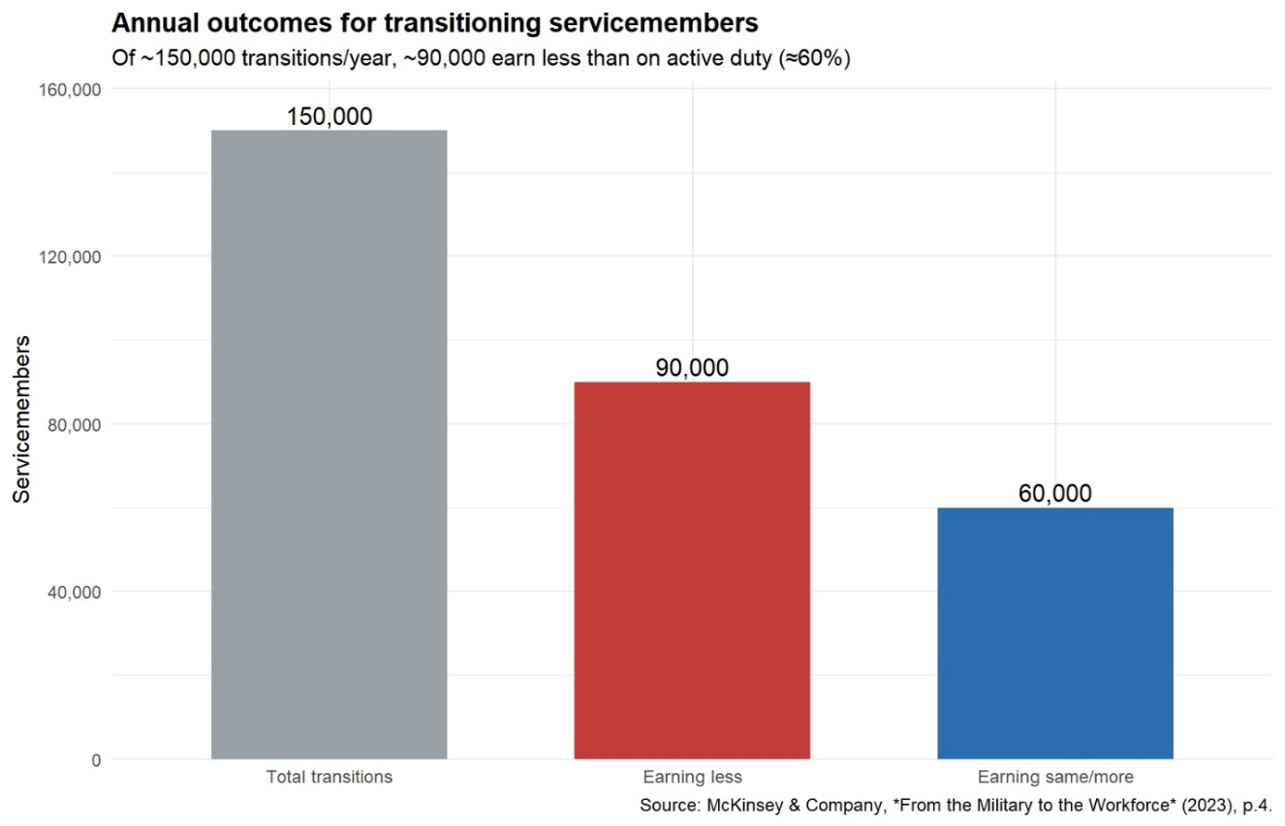

Figure 1: Annual Outcomes for Transitioning Servicemembers

Figure 1 details McKinsey estimates that of the servicemembers who transition each year, nearly 90,000 (60 percent) earn less in their first civilian role than they did on active duty (McKinsey & Company, 2022). This mismatch between military-acquired skills and employer-recognized credentials creates both immediate income loss and long-term career stagnation. NBER analysis of the Post-9/11 GI Bill shows similar trends: while educational attainment increases, veterans often forgo years of labor market experience, resulting in lower cumulative earnings over time (Barr et al., 2021).
The literature calls for standardized frameworks that make career mobility predictable: digital credentialing, cross-sector recognition, and AI-enabled matching systems that align MOS/AFSC/Rating with civilian credentials. Nonprofit and advocacy organizations, such as the Institute for Veterans and Military Families (IVMF) and the Council for Adult and Experiential Learning (CAEL), argue that stackable micro credentials and modular pathways are critical for supporting mobility. These frameworks enable servicemembers to transition more fluidly into civilian sectors while building on existing leadership and technical foundations (IVMF, 2021; CAEL, 2021).
Ultimately, military learner mobility requires systemic reform: portable credentialing standards, integration of AI-enabled career mapping tools, and closer alignment between DoD training, higher education, and civilian employer needs. Without these, mobility remains inconsistent and highly dependent on individual initiative, rather than a structured ecosystem of support.

Funding Imbalances: Education vs. Transition Support
While federal programs demonstrate (Table 1) a strong commitment to funding educational benefits for servicemembers and veterans, this funding is heavily skewed toward tuition and credential attainment rather than toward practical transition support. RAND (Kleykamp et al., 2024) reports that the “Big Four” programs the Post-9/11 GI Bill (PGIB), Veteran Readiness and Employment (VR&E), Tuition Assistance (TA), and Dependents’ Educational Assistance (DEA) accounted for approximately $13.5 billion of the $14.3 billion spent on transition programs in FY2019.
The PGIB alone is regarded as “one of the largest and most generous college subsidies in U.S. history,” surpassing the combined grant and scholarship spending of all U.S. states (Barr et al., 2021). These programs are designed to accelerate degree and (disproportionately) credential attainment by directly paying institutions (American Council on Education, n.d.).
In contrast, funding for skill translation and civilian labor market alignment is minimal (Figure 2). TAP, the only program universally required for separating servicemembers, received just $140 million in FY2019 (Kleykamp et al., 2024).
This imbalance has consequences. Veterans frequently cite finances as their most pressing transition concern, noting the loss of structured pay and unexpected monetary burdens (Shue et al., 2021). Studies also reveal a paradox: while educational funding is plentiful, veterans often experience reduced earnings during the years they pursue education, losing labor market experience in the process (Barr et al., 2021). Thus, while
educational subsidies are vast, the absence of comparable investment in translation support leaves many veterans educated but underemployed.

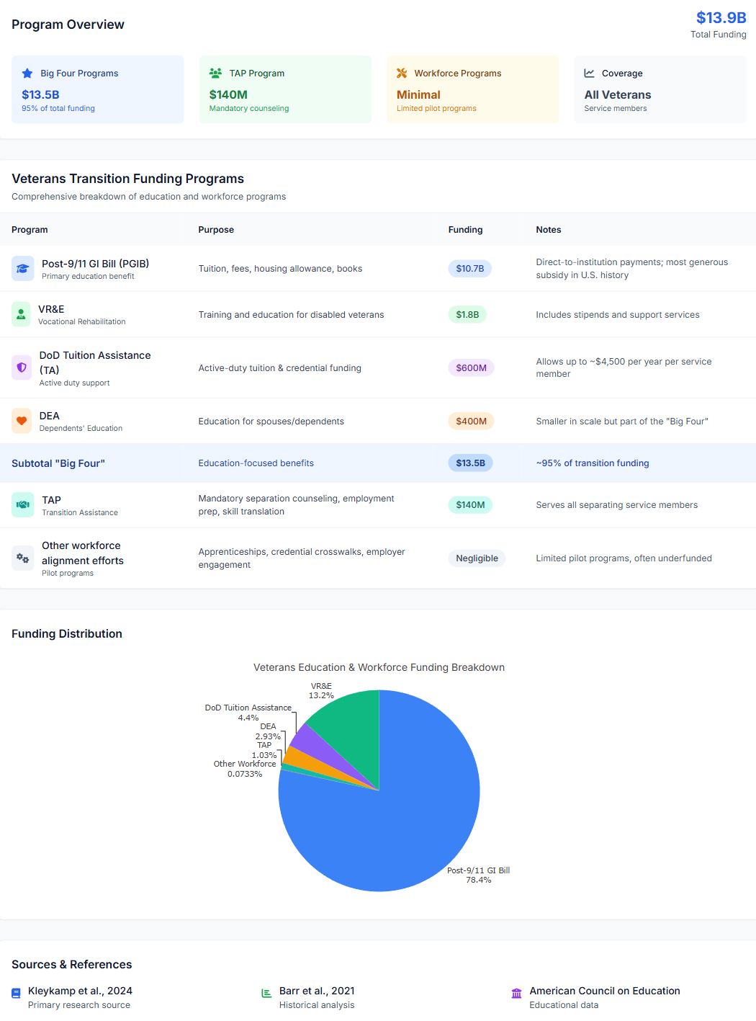

Table 1: Source: Kleykamp et al., 2024; Barr et al., 2021; American Council on Education, n.d.

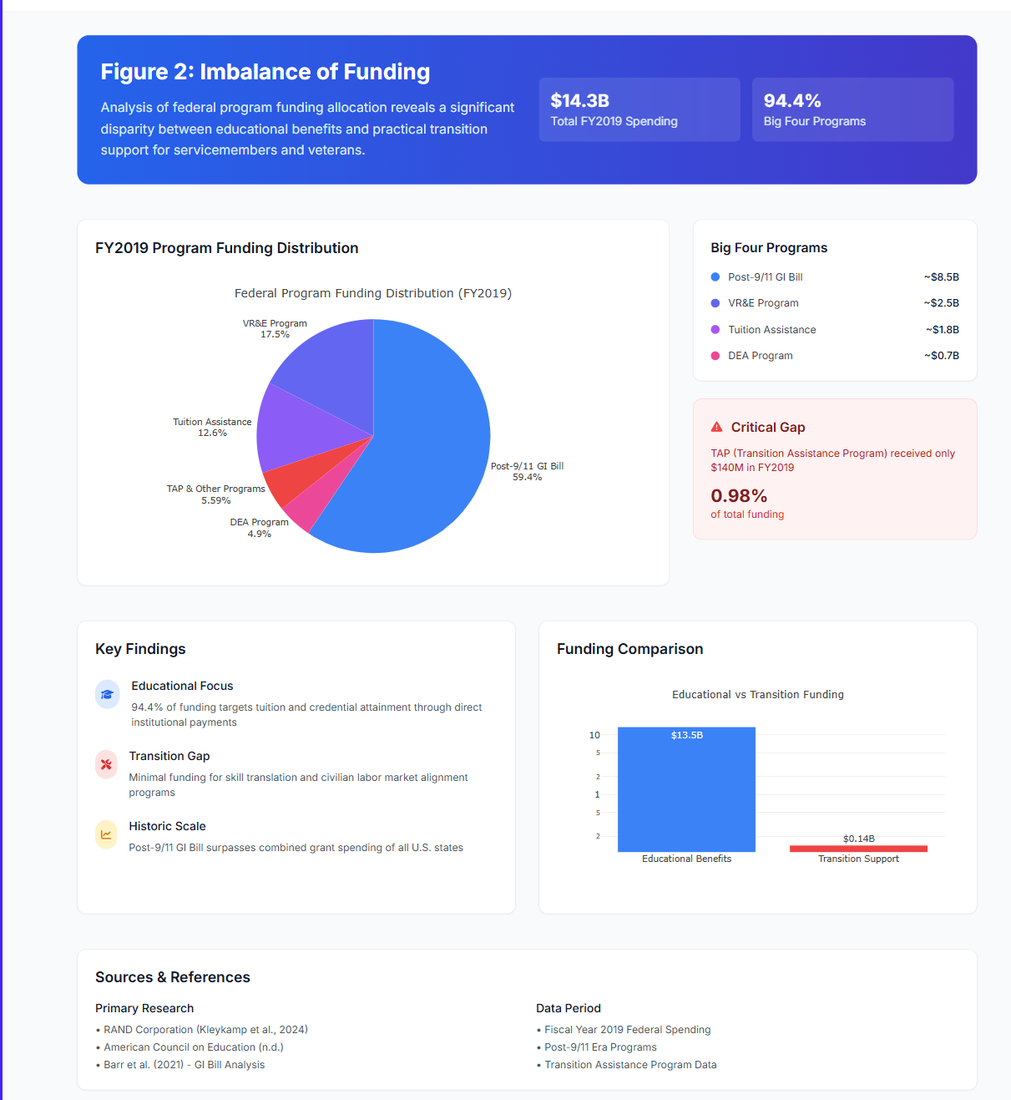

Figure 2: Imbalance of funding

Empowerment Strategies and Stackable Pathways
Stackable credentials function as genuine empowerment mechanisms only when learners can evaluate credential sequencing decisions within a transparent, constraint-aware planning context aligned to labor-market signaling over time (CAEL, 2018; IVMF, 2019; Digital Education Council, 2025).
Empowerment strategies and stackable pathways are now recognized by literature as essential tools for promoting both immediate and long-term career mobility among transitioning servicemembers and veterans.
Current research demonstrates that modular and portable credentials, delivered through employment-focused frameworks, help veterans overcome wage regressions and avoid underemployment. Stackable pathways, including AI literacy, targeted industry certifications, and progressive micro credentials allow veterans to move beyond initial civilian roles and pursue advancement that aligns with evolving labor market demand (Digital Education Council, 2025; Kleykamp et al., 2024; CAEL, 2018). These approaches are at their best when developed and recognized within an ecosystem involving the Department of Defense, higher education, and employer partners working to ensure transparency, relevance, and value of credentials for the civilian market.
Veterans utilizing modular credentials report fewer advancement barriers and higher satisfaction post-service. Employer surveys consistently find that modular, career-aligned learning supports faster and more accurate hiring for in-demand industries, especially technology, cybersecurity, and healthcare (SHRM, 2023). Public-private initiatives, such as the Teamsters Military Assistance Program (TMAP), DoD SkillBridge, and Army COOL, further exemplify how stackable credential models boost both training relevance and job placement rates for military learners entering civilian fields (MCAI Report, 2024; MedCerts, 2024).
By centering empowerment and stackable pathways, military-to-civilian transition policy can move beyond legacy models, delivering both adaptability and upward mobility for all who serve (Digital Education Council, 2025).
The Institute for Veterans and Military Families (IVMF) and analyses from the Council for Adult and Experiential Learning (CAEL) highlight that veteran upskilling is most effective in modular, incremental pathways, rather than traditional, fixed-length degrees. Cross-sector, portable programs enable veterans to start with foundational digital or technical skills and build specialized, employer-respected certifications, thus increasing their competitiveness in priority fields and regional labor markets (IVMF, 2019; CAEL, 2018; Revisiting the Business Case for Workforce Readiness, 2021).
In summary, robust transition policy built around modular and stackable micro credentials with strong employer engagement, DoD digital mandates, and modern learning science offers a concrete pathway to wage parity and career resilience. Without continued innovation in these areas, many veterans will remain at risk for underemployment or stagnant earnings despite major public investments in their education (Kleykamp et al., 2024; Barr et al., 2021; McKinsey & Company, 2022).

Emerging Labor Market Demand for AI Literacy Certifications
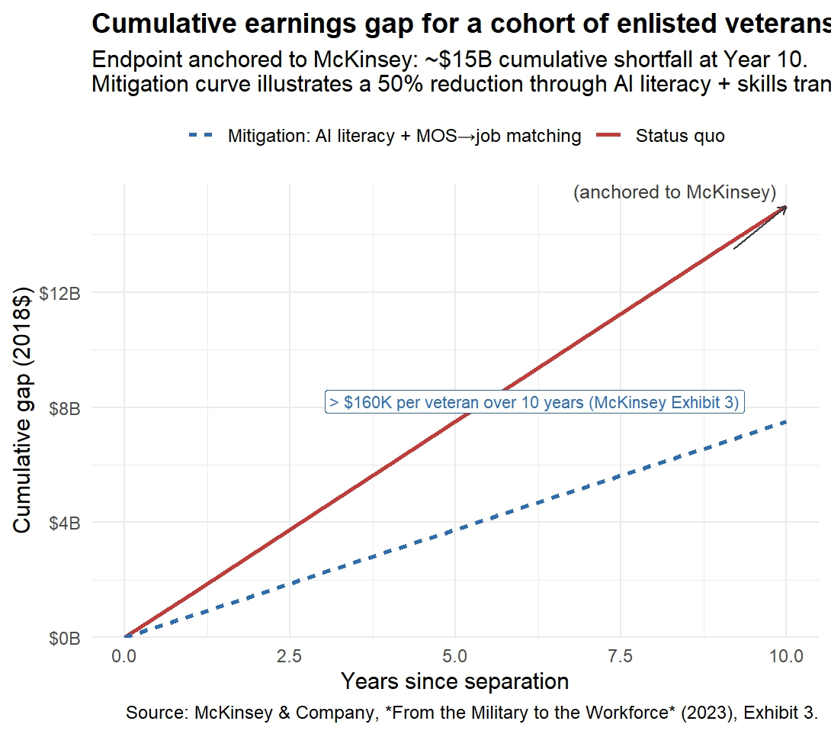
National studies and pilot programs have found that when veterans gain recognized AI and digital credentials, they not only improve their employability but also narrow the wage gap (Figure 3) compared to their non-veteran peers (Kleykamp et al., 2024; CAEL, 2018). Modern approaches emphasize a tiered, stackable system starting with essential AI literacy and building toward specialized industry certifications and applied digital skills. These pathways align directly with emerging hiring priorities in technology, healthcare, manufacturing, and logistics.

Figure 3: The Value of AI Literacy

Importantly, AI literacy is best provided as part of a modular system that adapts to individual interests and employer needs. Public-private partnerships, such as DoD SkillBridge and Google Veteran Launchpad, demonstrate how cross-sector collaboration can rapidly deliver job-aligned digital skills and support ongoing career progression for military learners (Digital Education Council, 2025).
This new focus on AI literacy is supported by both evidence and employer demand. Employers surveyed by SHRM and Hiring Our Heroes now list AI fluency as a top priority for new hires, especially in environments undergoing digital transformation (SHRM, 2023). Integrating AI literacy into transition frameworks ensures veterans are competitive in the evolving labor market and are equipped for lifelong adaptability and leadership in their post-service careers. As illustrated in Figure 4, the future of workforce development requires coordinated action and shared accountability among all stakeholders Figure 5 demonstrates the power of a collaborative DoD/University partnership to provide efficient AI Literacy certification.
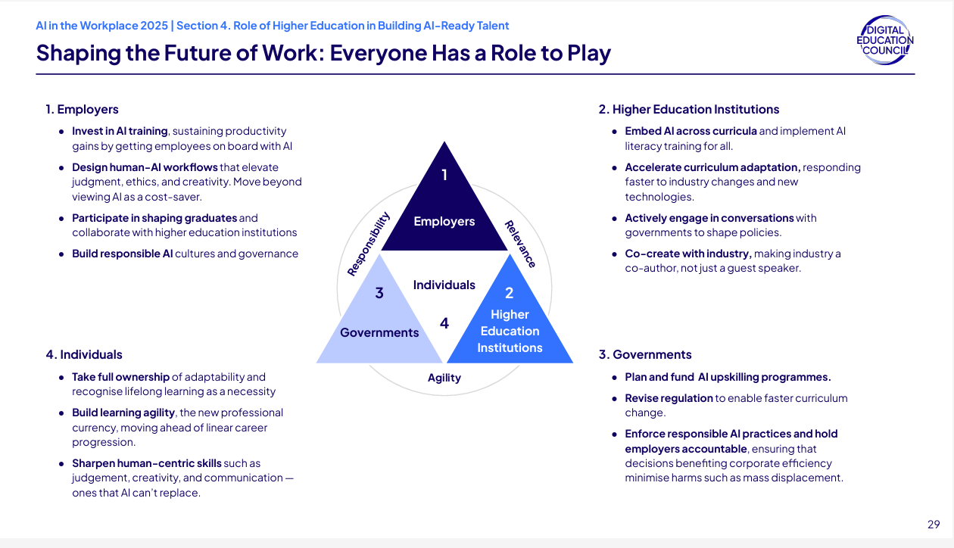
Figure 4: Stakeholder Roles in Shaping an AI-Ready Workforce Source: Digital Education Council, 2025.

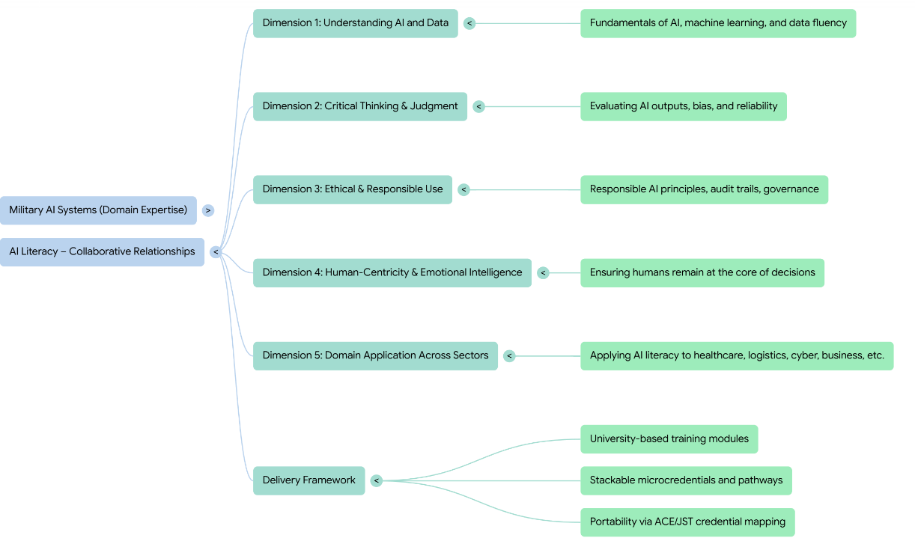

Figure 5: Collaborative Relationship for AI Literacy Certification: Modeled after “AI Literacy For All”, Digital Nation Council, 2025

Translating Military Experience into Civilian Workforce Value

Persistent failures in translating military experience into civilian workforce value arise not from the absence of equivalency frameworks, but from their fragmentation, inconsistent application, and inaccessibility at the point of individual decision-making (CAEL, 2018; American Council on Education, n.d.; RAND Corporation, 2022).
Modern literature shows that seamless military-to-civilian career transitions depend on structured frameworks that map MOS/AFSC training to portable civilian credentials and in-demand job families (Kleykamp et al., 2024; RAND, 2024; CAEL, 2018). The American Council on Education’s Credit for Military Experience (ACE/PLA), Department of Defense COOL program, and new AI-enabled translation tools all seek to optimize credit and certification translation at scale (ACE, n.d.; Department of Defense, 2024).
As illustrated in Figure 6, rapid advances in digital learning, credential mapping, and university-military collaboration have enabled the creation of stackable, modular career pathways. These pathways link military occupations such as IT specialist, combat medic, and vehicle mechanic to civilian certifications, college credits, and target job families in technology, manufacturing, healthcare, and cybersecurity (CAEL, 2018; Digital Education Council, 2025). Pathways like CompTIA Security+, Lean/Six Sigma, and AI literacy levels are increasingly embedded within both MOS training and transition programs, yielding dual benefits for service member advancement and civilian employment prospects.
Recent workforce alignment research documents that when military learners can obtain validated civilian credentials and university credits during service, their risk of underemployment and wage regression is significantly reduced (Workforce Readiness Alignment Council, 2021; IVMF, 2019). This approach strengthens economic mobility and enables continuous upskilling, allowing veterans to move not only laterally but upward within critical sectors such as IT, advanced manufacturing, and healthcare.
Research also stresses the importance of O*NET/SOC crosswalks, stackable credentialing, and experiential credit evaluation for supporting diverse transition outcomes. By connecting military schoolhouses, ACE and PLA recommendations, industry certifications, and civilian job families, the modern military credential ecosystem now offers a much clearer path to real civilian workforce value (CAEL, 2018; ACE, n.d.; Department of Defense, 2024).

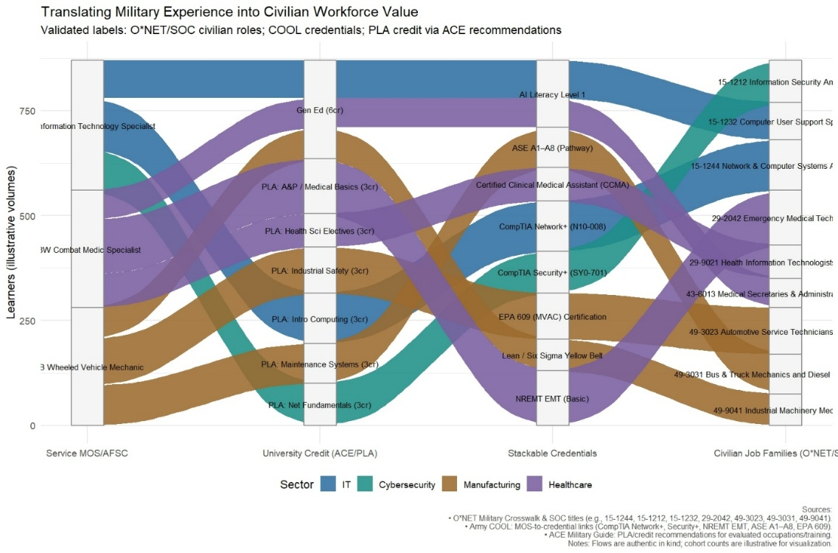
Figure 6: Translating Military Experience into Civilian Workforce Value: MOS/AFSC-to-Civilian Credential Pathways | Source: ACE Military Guide, DoD COOL, O*NET SOC crosswalks, adapted for publication

Veteran and Servicemember Learner Voice
In the absence of mechanisms that aggregate and analyze learner-reported planning friction at scale, transition failures remain anecdotal and therefore unusable for institutional learning, budget justification, or policy reform (IVMF, 2019; Kleykamp et al., 2024; Bradbard et al., 2024).
A growing body of research underscores that meaningful, sustainable workforce transitions depend on centering the voice and lived experience of veterans and service members within all education and advising processes (Kleykamp et al., 2024; Bradbard et al., 2024). Veterans consistently express that programs designed without their direct input often fail to address their priorities or the real-world barriers they encounter during transition (Harrell & Berglass, 2012; National Resource Center, 2022). When veterans’ perspectives inform the design of advising, credentialing, and workforce alignment initiatives, outcomes measurably improve in terms of engagement, persistence, and post-transition earnings (Bradbard et al., 2024; IVMF, 2019).
Recent qualitative studies have found that veterans value individualized advising, practical career information, and opportunities for peer mentorship far more than generalized classroom or benefit navigation support (Phillip Morris & National Resource Center, 2022; Kleykamp et al., 2024). The holistic advising model, which stresses empathetic listening, co-creation of learning pathways, and sustained access to knowledgeable faculty or industry mentors, has been shown to increase retention and satisfaction for veterans in higher education. For instance, frequent and meaningful faculty-advisor interactions are correlated with improved transition confidence and lowered rates of program attrition (National Resource Center, 2022).
Evidence from large-scale surveys also demonstrates that transition programs with robust mechanisms for learner feedback such as alumni panels, advisory boards, and participatory curriculum development are most successful in ensuring the evolving needs of veterans are addressed at the system level (CAEL, 2018; IVMF, 2019). This participatory approach extends beyond the classroom, influencing workforce readiness and employer engagement strategies to become more responsive, inclusive, and impactful.
The literature further underscores that when veterans actively contribute to the design and continual improvement of transition services, the resulting models are more likely to meet the realities of navigating multiple identities, changing family obligations, and varied labor market landscapes (Kleykamp et al., 2024; Bradbard et al., 2024).
In summary, embedding the voice of veterans and service members in all aspects of transition from credential mapping and academic advising to program evaluation and policy formation is a proven driver of successful civilian career outcomes and an essential metric for national workforce readiness (Harrell & Berglass, 2012; Bradbard et al., 2024; National Resource Center, 2022).

Installation Status Reports (ISR)Tools and Frameworks for Career-Aligned Advising: The Career Mobility Governance Framework (CMGF)
This section establishes why ISR-relevant advising signals require governed, AI-assisted infrastructure rather than additional human reporting burden.
Human advising alone cannot scale to provide continuous, evidence-based career guidance across a population characterized by frequent transitions, heterogeneous constraints, and fragmented policy regimes (IVMF, 2019; Kleykamp et al., 2024; Ahmed et al., 2024).
Recent empirical studies of AI-enabled advising systems in higher education demonstrate improved retention, academic confidence, and career alignment when intelligent systems are deployed as advisor-assist tools under clear ethical and governance constraints (Ahmed et al., 2024; Soomro et al., 2025).
All touchpoints between the service member and AI that are relevant to Installation Status Report (ISR) requirements under AR 210-14 are automatically captured for reporting purposes. Specifically, only advising interactions that generate ISR-relevant indicators are aggregated into near–real-time reports following a de-identification process, with no retention of individual-level interaction histories.
Career-aligned advising is a critical, yet underdeveloped, dimension of effective military-to-civilian transition policy. Multiple studies highlight persistent problems: advising is often generic, focused on educational benefits over occupational outcomes, and insufficiently tailored to the diverse needs and career goals of individual servicemembers. According to recent RAND and IVMF analyses, enduring gaps persist in the translation of military-acquired skills, limited employer engagement, and a lack of standardized, portable frameworks for mapping service experience to civilian credentialing and employment pathways.

Modernizing Advising Approaches
Best-in-class advising frameworks emphasize three imperatives:
- Employment-First Orientation: Transition programs must prioritize employment outcomes and labor market alignment not simply the navigation of benefits or degree attainment. This requires that advising begin early in the military lifecycle, incorporate labor market data (such as O-Net and industry competency models), and guide servicemembers to make informed education and certification choices that map directly to in-demand civilian roles.
- Personalization and Learner Voice: Although transition support programs are widespread, the absence of mechanisms to aggregate learner-reported friction at scale prevents institutional learning and policy adaptation (Seelig, 2025). Veterans thrive when advising is individualized, participatory, and context sensitive. Research underscores the benefits of peer mentorship, sustained advisors beyond separation, and participatory curriculum design that centers the veteran perspective. Models such as the Holistic Advising Framework, employing Schlossberg’s Four S’s (situation, self, supports, strategies), ensure advisors address the full complexity of identity, motivation, and support networks relevant to each veteran’s transition.
- Technology-Enabled Tools: Emerging digital and AI-enabled career mapping tools, competency-based translation frameworks (e.g., MOS crosswalks, DOL’s O-Net, CareerOneStop’s industry-specific models), and advisor-assist platforms extend the reach of evidence-based advising. These solutions make skills transparent, portable, and measurable across contexts, improving both job matching and the long-term return on federal investments in veteran education.

Best Practices & Innovations
- Stackable Pathways and Modular Credentials: Advising should connect military training with modular, stackable micro credentials, particularly in high-growth fields like AI, cybersecurity, or advanced manufacturing allowing veterans to continually build market-relevant skills and avoid wage regression.
- Employer and Community Integration:
Public-private partnerships, veteran employer resource groups, and local mentorship networks amplify the effectiveness of career advising, supporting successful placement, onboarding, and upward mobility for veterans in civilian careers.
- Advisor Roles and Peer Networks:
Education Services Officers (ESOs) managing AI-enabled advising systems, in partnership with higher education institutions, can function as AI readiness officers, responsible not only for supporting individual learners but for monitoring digital literacy, credential alignment, and advising friction across the transitioning population (Ahmed et al., 2024; Soomro et al., 2025). When designed as governed decision infrastructure, the AI tool itself becomes an instrument for evidence generation, aggregating de-identified advising signals, constraint conflicts, and unmet educational demand into auditable patterns that inform institutional planning and education policy. Integrating alumni and peer mentors further complements this capability by providing veterans with lived-experience guidance and contextual interpretation that cannot be replicated by static online resources, ensuring that human judgment and community insight remain central to both advising practice and policy interpretation.

Demonstration Artifact: An Example AI-Enabled Advising Interface
To illustrate how the findings and design principles identified in this study could be operationalized, a demonstration artifact was developed to represent an AI-enabled advising interface aligned to CCME Track 1 priorities. The artifact is intentionally constrained in scope and is not presented as a production system. Rather, it serves as a concrete example of how fragmented inputs commonly encountered in military learner advising can be unified within a single planning context.
As shown in Figure 7, the interface centers on service-member–declared inputs across four domains consistently identified in the literature as critical to career mobility outcomes: career direction, education and credential pathways, transition timing, and learner voice. The service member remains the primary decision-maker, explicitly stating goals, constraints, and timing considerations. A governed AI layer operates in the background to translate these inputs by organizing relevant education options, credential sequences, and policy-aligned information without generating recommendations or determining outcomes. The working Demonstration resides at https://cmgfdemo.robertmccoyprojects.com/.

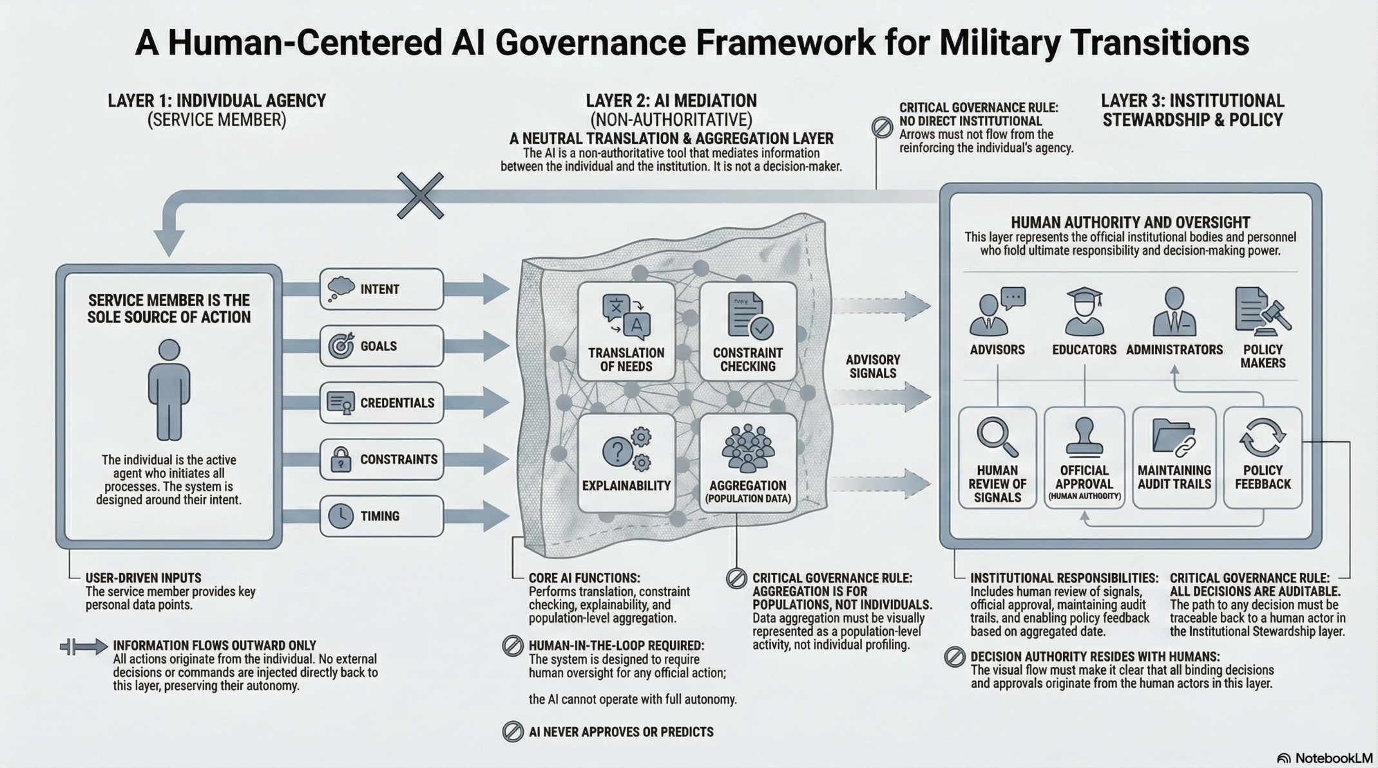

Figure 7 The Career Mobility Governance Framewok(CMGF)
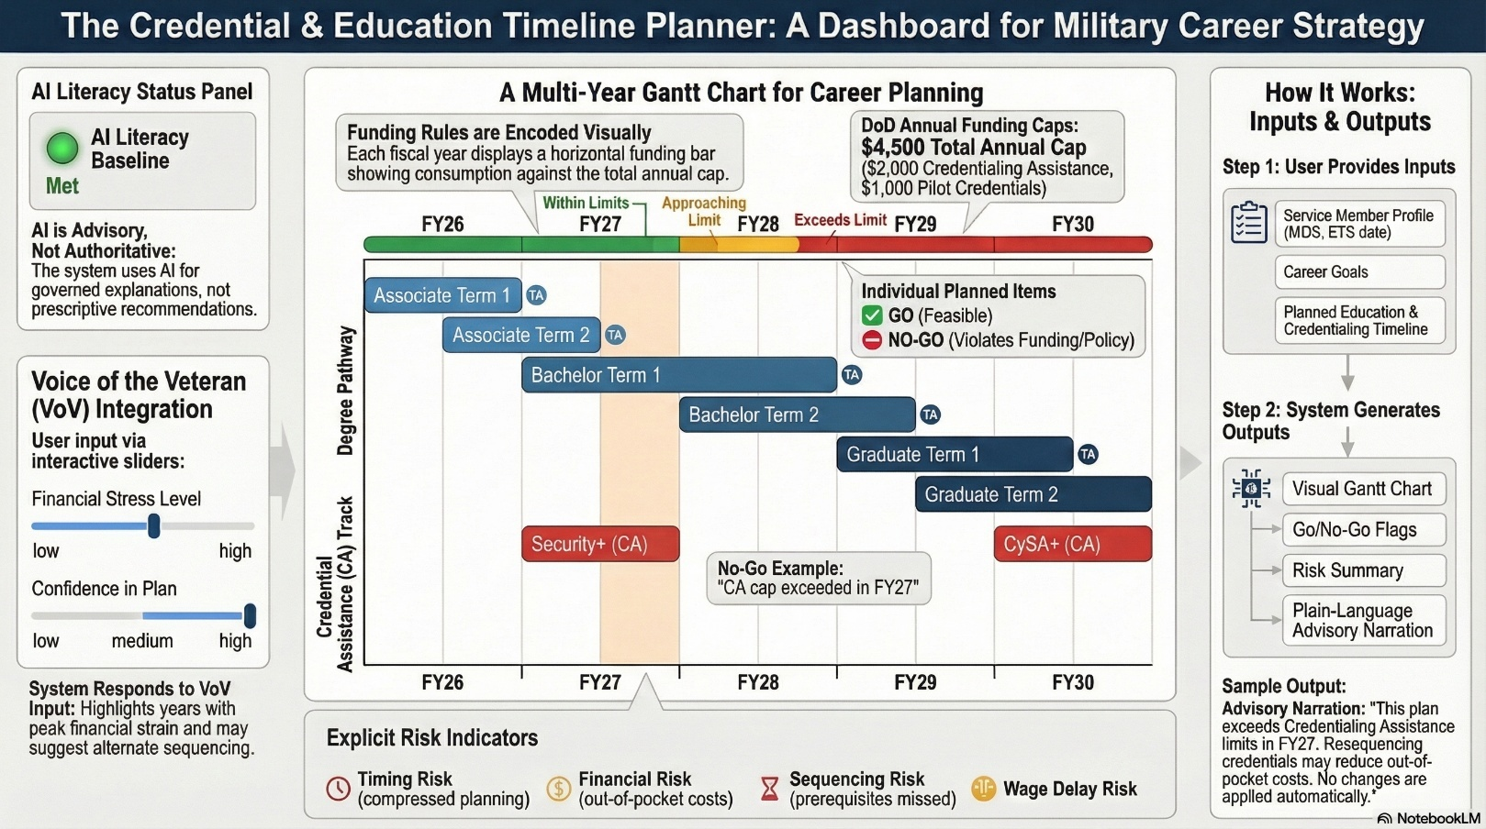

Figure 8. Credential and Education Sequencing Planner (CESP).
Figure 8, The Credential and Education Sequencing Planner (CESP) is a artifact of the Career Planning Module (CPM) and is an advisory dashboard designed to visualize multi-year education and credential planning under Department of Defense funding constraints. The instrument encodes Tuition Assistance (TA) and Credentialing Assistance (CA) policies as visual limits, flagging compliance violations and planning risks without prescribing actions. Human input signals, including financial stress and confidence levels, inform advisory narration while preserving service-member agency. The figure represents a fixed demonstration plan used for research and instructional purposes.
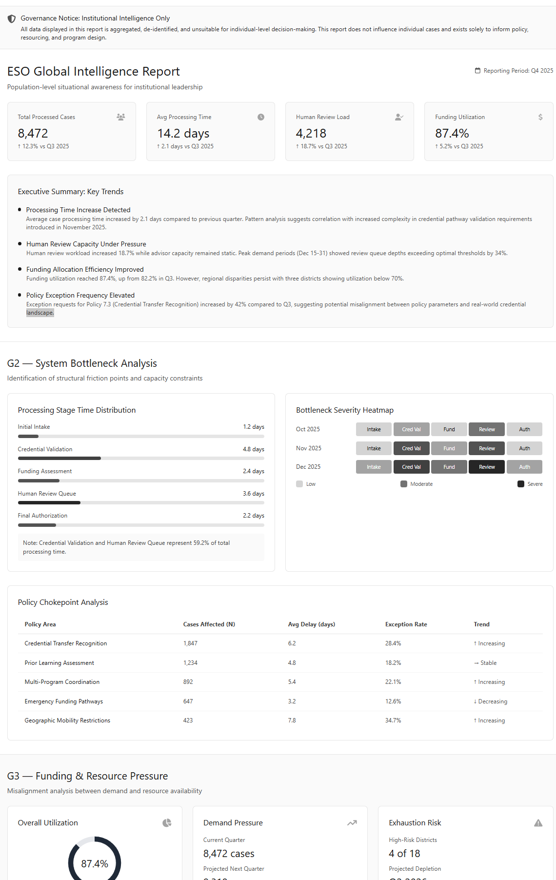

Figure 9: ESO Policy Intelligence View

From Gatekeeper to Policy Intelligence Officer: How CMGF empowers ESOs to advocate upward with data.
The Policy Intelligence View is not a reporting dashboard, but an evidence-generation instrument designed to convert individual learner friction into auditable, aggregate justification for budget reform and policy revision.
Consistent with best-in-class advising frameworks, the demonstration emphasizes employment-first orientation by foregrounding career intent and labor market alignment, supports personalization by capturing learner context and voice, and illustrates how technology-enabled tools can extend advising capacity without displacing human advisors. The artifact also makes visible the limits of automation, reinforcing that planning responsibility remains with the service member and that human Education Services Officers retain authority for advising, validation, and intervention.
Unlike traditional transition tools that activate late in a service member’s career, the demonstration artifact is intentionally framed for use early in the military lifecycle. By placing retention and continuation pathways alongside civilian preparation options, the interface emphasizes that career planning is continuous and that education choices shape both in-service advancement and post-service outcomes. This approach reinforces service-member agency from the outset of service while supporting institutional retention goals.

AI Design Choices and Deliberate Non-Use
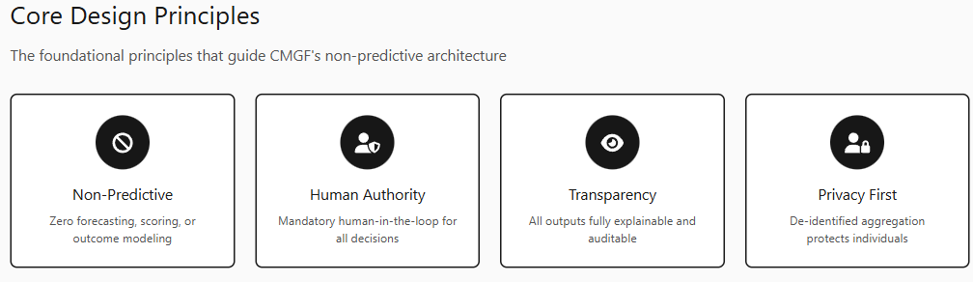
Tables 2 and 3 outline the artificial intelligence design choices within the Career Mobility Governance Framework (CMGF) reflect a deliberate, policy-aligned assessment of both technical capability and ethical risk rather than a limitation of methodological ambition. Although predictive modeling, optimization, and automated decision-making are technically feasible within this domain, their application in military career mobility and education governance presents disproportionate risk relative to benefit. Career mobility decisions intersect with employment opportunity, access to public benefits, and individual autonomy domains explicitly identified by federal guidance as high-impact and unsuitable for opaque or delegated algorithmic control (Executive Order No. 14110, 2023; National Institute of Standards and Technology [NIST], 2024; Office of Management and Budget [OMB], 2024).
Accordingly, CMGF confines machine learning to bounded, explainable functions that augment human understanding without substituting judgment. Natural language processing is used solely for translation and explanation of heterogeneous policy, labor-market, and credential data; rule-constrained logic generates non-binding feasibility signals rather than recommendations; and analytic inference is restricted to aggregate, de-identified pattern detection for institutional learning. Predictive outcome modeling, individual risk scoring, automated approvals, and optimization objectives are explicitly prohibited not because they are infeasible, but because they risk encoding structural inequities, privileging institutional efficiency over individual welfare, and obscuring normative tradeoffs behind technical artifacts.
This design intentionally treats artificial intelligence as a governance instrument (see system governance Appendix E) rather than a decision authority. By making constraints, assumptions, and policy frictions visible (Appendix D) rather than optimizing around them CMGF preserves service-member agency, enforces human accountability, and enables policy-level learning without normalizing inequitable conditions as neutral inputs. Evaluation therefore prioritizes explainability, auditability, decision consistency, and institutional insight over predictive accuracy metrics, aligning technical assessment with public-sector accountability standards. In this sense, the framework’s most consequential design choice is not the use of AI, but the disciplined restraint exercised in where and how it is allowed to operate.

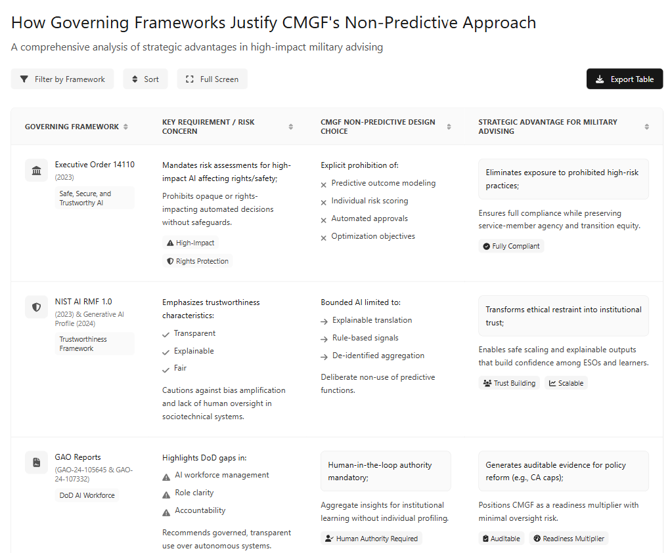

Table 2: Compliant by Design

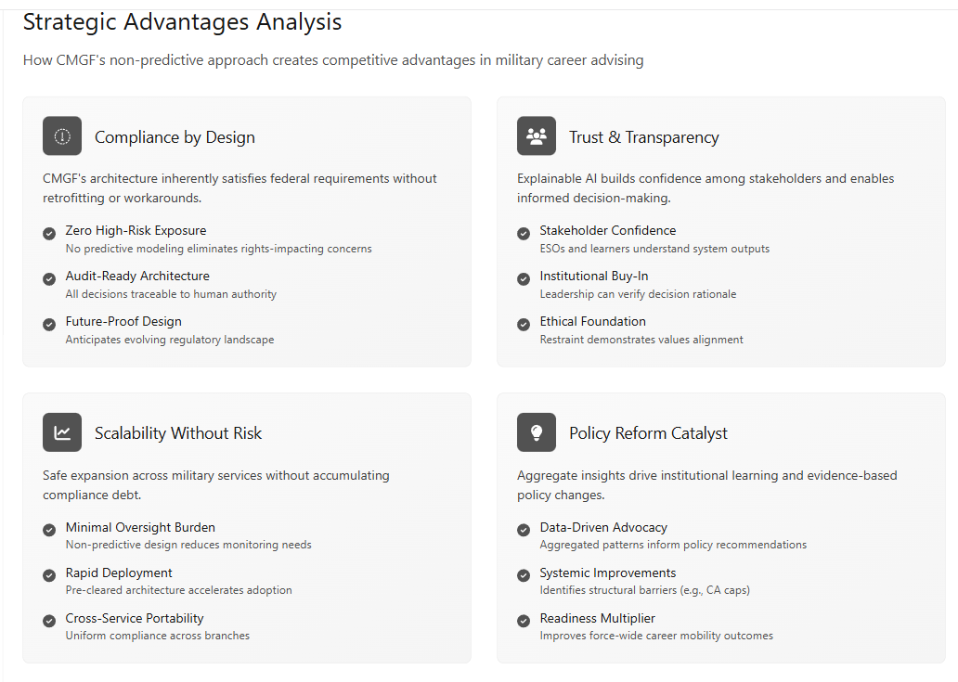
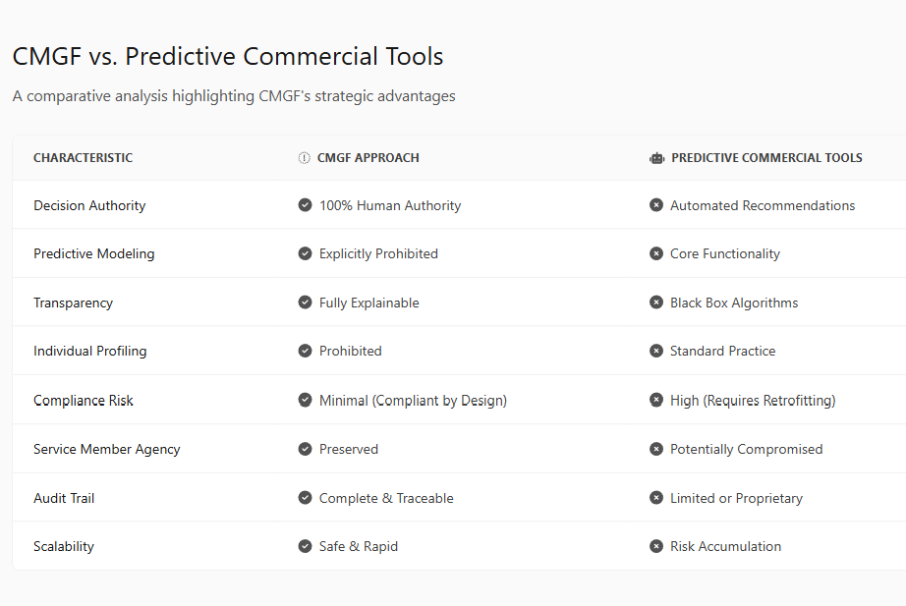

Table 3: CMGF vs. Predictive AI

Recommandations
- Expand personalized advising beyond the point of separation to at least twelve months’ post-transition, with special attention to those entering sectors that do not map obviously from military experience.
- Standardize the use of career mapping and credential crosswalk tools in all advising processes, ensuring consistent translation of skills and maximizing the value of military-acquired competencies.
- Integrate AI-copilot features, mentorship platforms, and feedback loops that prioritize learner input in the design of transition programs.
- A robust, career-aligned advising system must move decisively beyond traditional, one-size-fits-all information delivery to become a proactive, data-driven, and participatory resource closing the gap between military service and sustained civilian career success.
- Revising or removing rigid Tuition Assistance/Credentialing Assistance allocation ratios would allow service members in high-demand technical fields to pursue multiple industry-recognized certifications when degree pathways are not the most efficient or relevant option. Eliminate the $2,000 Cert limit.

Gaps and Future Research/Action
Despite major advances in military transition research and policy, significant gaps persist. First, there remains limited longitudinal analysis of civilian wage progression and career advancement for veterans by demographic group and occupational background, leaving outcomes across regions and sectors insufficiently measured (Kleykamp et al., 2024; McKinsey & Company, 2022). Existing studies consistently document early wage regression, yet deeper inquiry is needed into long-term upward mobility, career stability, and parity with civilian peers over extended post-service horizons (Harrell & Berglass, 2012; Barr et al., 2021).
A second area for growth involves the portability, standardization, and public recognition of AI and digital credentials. The literature identifies persistent difficulty for veterans in transferring modular and micro-credentials across government, higher education, and private-sector systems, underscoring the need for nationally recognized, industry-validated credential standards that support both employability and workforce transparency (Digital Education Council, 2025; CAEL, 2018; Department of Defense, 2020).
Challenges in data interoperability and outcome evaluation also remain acute. Cross-sector longitudinal tracking among the Department of Defense, higher education institutions, and employers is highly fragmented, and relatively few federal transition programs have been subject to independent, outcomes-based evaluation (Kleykamp et al., 2024; Office of Management and Budget, 2025). Additional research is needed to address privacy protection, accountability mechanisms, and the development of secure data-sharing frameworks capable of supporting valid measurement of employment, earnings, and credential utilization outcomes (Task Force Lima, 2024; Department of Defense, 2024).
Relatedly, funding gaps and inequities in program access remain a persistent concern, particularly for junior enlisted populations and service members facing elevated transition risk. Current evidence suggests that these groups experience lower participation rates in tailored transition programs and face heightened risks of underemployment, financial instability, and social hardship following separation (Institute for Veterans and Military Families, 2019; SHRM, 2023; Workforce Readiness Alignment Council, 2021).
New research should also examine differential transition experiences among historically underrepresented populations, including women veterans, racial and ethnic minorities, and individuals with service-connected disabilities (Keeling, Kintzle, & Castro, 2018; Shue et al., 2021; ADA National Network, 2019). Issues related to identity, discrimination, family reintegration, and health disparities remain insufficiently studied within existing transition frameworks.
Finally, a critical gap exists in the study of governed AI systems as instruments for policy evidence generation rather than predictive decision-making. While growing scholarship addresses ethical AI principles and workforce applications, limited research examines how non-predictive, human-in-the-loop AI infrastructures can aggregate de-identified advising frictions, constraint conflicts, and planning signals into auditable evidence capable of informing education policy, funding decisions, and institutional accountability. Future research should evaluate how such systems can be designed, governed, and validated to support longitudinal policy learning while preserving individual agency, data privacy, and human authority particularly in high-impact public-sector domains such as military education and transition support.

Recommended priorities for future research and action
Based on the findings of this study, the following priorities emerge for near-term research, pilot implementation, and institutional action:
- Piloting AI literacy credential transparency initiatives with regional industry and education partners to improve employer recognition, transferability, and advising clarity (Digital Education Council, 2025; CAEL, 2018).
- Developing secure, privacy-protected longitudinal data frameworks capable of measuring workforce participation, credential utilization, and earnings outcomes across military, higher education, and civilian employment systems (Office of Management and Budget, 2025; Department of Defense, 2024).
- Expanding individualized transition interventions and supports for junior enlisted personnel and high-risk populations, who face disproportionate exposure to underemployment and financial instability during and after separation (Institute for Veterans and Military Families, 2019; Harrell & Berglass, 2012).
- Co-designing modular, stackable career pathways with employers and local education providers that are explicitly mapped to regional labor-market demand and validated skill signals (Kleykamp et al., 2024; Koch Industries & The Manufacturing Institute, 2019).
- Conducting independent, published evaluations of transition programs using valid, longitudinal metrics to support evidence-based policy refinement and resource allocation (RAND Corporation; Kleykamp et al., 2024; McKinsey & Company, 2022).
Funding AI Literacy: Beyond Personal COOL Benefits
As the Army and Department of Defense elevate AI literacy to a core readiness and workforce requirement, reliance on Army COOL personal education benefits to fund baseline AI skills is increasingly insufficient and misaligned with stated policy objectives. Recent reductions in COOL funding caps, driven by sustained demand, further constrain access and limit the ability of service members to acquire foundational AI competencies during critical transition windows (Army Times, 2024; Inside Higher Ed, 2024).
AI literacy now functions comparably to foundational technical, digital, and leadership training. Requiring service members to finance baseline AI competencies through scarce personal professional development benefits funds more appropriately reserved for advanced specialization or career differentiation undermines efforts to make AI fluency a universal, equitable capability. Policy and workforce analyses increasingly argue that such competencies should be centrally funded and delivered as part of the core military training and transition pipeline, rather than treated as discretionary or elective expenses borne by individuals (Digital Education Council, 2025; Department of Defense, 2024; CAEL, 2018).
Providing guaranteed, centrally funded access to baseline AI literacy for all service members would advance equity, strengthen readiness, and preserve individual opportunity to build on these essential skills as the future of work continues to evolve. Addressing these priorities is essential to ensuring that military-connected learners are continuously upskilled, equitably supported, and empowered for long-term success in an AI-enabled economy (Digital Education Council, 2025; Kleykamp et al., 2024; McKinsey & Company, 2022).

References
Ahmed, S., Rahman, M., & Hossain, M. A. (2024). AI-driven academic advising systems in higher education: Design frameworks, ethical considerations, and student success outcomes. Frontiers in Education, 9, Article 1391485. https://doi.org/10.3389/feduc.2024.1391485
American Council on Education. (n.d.). College credit for military training and experiences. American Council on Education. https://www.acenet.edu
Army Times. (2024, December 10). Army to cut credentialing benefit, drop officers from program. https://www.armytimes.com/education-transition/2024/12/11/army-to-cut-credentialing-benefit-drop-officers-from-program/
Bajraktari, Y. (2025, April 5). Written testimony before the U.S. House Committee on Oversight and Government Reform: The federal government in the age of artificial intelligence. Special Competitive Studies Project. https://www.scsp.ai
Barr, A., Kawano, L., Sacerdote, B., Skimmyhorn, W., & Stevens, M. (2021). You can’t handle the truth: The effects of the Post-9/11 GI Bill on higher education and earnings (Working Paper No. 29024). National Bureau of Economic Research. https://doi.org/10.3386/w29024
Bipartisan House AI Task Force. (2024). Final report of the Bipartisan Task Force on Artificial Intelligence. U.S. House of Representatives. https://artificialintelligence-taskforce.house.gov

Bradbard, M., et al. (2024). Veteran learner voice and post-service outcomes. Journal of Veterans Studies.
Bureau of Labor Statistics. (2025a, February 10). Incorporating AI impacts in BLS employment projections: Occupational case studies. U.S. Department of Labor. https://www.bls.gov/opub/mlr/2025/article/incorporating-ai-impacts-in-bls-employment-projections.htm
Bureau of Labor Statistics. (2025b, March 11). AI impacts in BLS employment projections (TED article). U.S. Department of Labor. https://www.bls.gov/opub/ted/2025/ai-impacts-in-bls-employment-projections.htm
Castro, C. A., & Kintzle, S. (2014). Suicides in the military: The post-modern combat veteran and the Hemingway effect. Current Psychiatry Reports, 16(8), 460. (Context on multidimensional transition challenges.
Council for Adult and Experiential Learning (CAEL). (2018). Pathways to opportunity: Financial flexibility and workforce readiness. Council for Adult and Experiential Learning. https://ivmf.syracuse.edu/article/pathways-to-opportunity-financial-flexibility-and-workforce-readiness/
Davenport, A., Savych, B., & Loughran, D. S. (2024). Veteran underemployment and post-service earnings outcomes.
Social Science Research Institute, Pennsylvania State University.
https://ssri.psu.edu/news/veterans-report-underemployment-pay-frustration-four-years-post-service
Defense Innovation Board. (2023). Campaign for an AI-ready force. U.S. Department of Defense. https://media.defense.gov/2019/Oct/31/2002204191/-1/-1/0/CAMPAIGN_FOR_AN_AI_READY_FORCE.PDF
Department of Defense. (2023, August 10). Establishment of Chief Digital and Artificial Intelligence Officer Generative Artificial Intelligence and Large Language Models Task Force, Task Force Lima (OSD006491-23). https://media.defense.gov/2023/Aug/10/2003279040/-1/-1/1/ESTABLISHMENT_OF_CDAO_GENERATIVE_AI_AND_LARGE_LANGUAGE_MODELS_TASK_FORCE_TASK_FORCE_LIMA_OSD006491-23_RES_FINAL.PDF
Department of Defense. (2020). Department of Defense Artificial Intelligence Education Strategy. https://www.ai.mil
Department of Defense. (2024). Responsible Artificial Intelligence Strategy & Implementation Pathway. U.S. Department of Defense. https://media.defense.gov/2024/Oct/26/2003571790/-1/-1/0/2024-06-RAI-STRATEGY-IMPLEMENTATION-PATHWAY.PDF
Department of Defense. (2024a). Task Force Lima Executive Summary. Office of the Chief Digital and Artificial Intelligence Officer.
Department of Defense. (2024b). DoD Strategic Management Plan, FY 2022–2026. https://www.ai.mil
Department of Labor. (2019). Veterans’ Employment and Training Service compliance resources. https://www.dol.gov/agencies/vets/foia/contact
Digital Education Council. (2025). AI in the workplace 2025. https://www.digitaleducationcouncil.com/post/ai-in-the-workplace-2025
Digital Education Council. (2025). AI literacy framework. https://www.digitaleducationcouncil.com/post/ai-in-the-workplace-2025
EANGUS. (2024, March 17). Could a new Army Education Funding Policy lead to less certifications for soldiers? https://eangus.org/could-a-new-army-education-funding-policy-lead-to-less-certifications-for-soldiers/
Executive Order No. 14110, Safe, Secure, and Trustworthy Development and Use of Artificial Intelligence, 88 Fed. Reg. 75191 (2023).
Government Accountability Office. (2023). Artificial intelligence: Actions needed to improve DOD’s workforce management (GAO-24-105645). U.S. Government Accountability Office.
Government Accountability Office. (2024). Artificial intelligence: Agencies are implementing management and personnel requirements (GAO-24-107332). U.S. Government Accountability Office.
Harrell, M. C., & Berglass, N. (2012). Employing America’s veterans: Perspectives from businesses. Center for a New American Security. https://www.cnas.org/publications/reports/employing-americas-veterans-perspectives-from-businesses
Hevner, A. R., March, S. T., Park, J., & Ram, S. (2004). Design science in information systems research. MIS Quarterly, 28(1), 75–105.
Hodges, T. J., Bharwani, N. K., Manley, E., & Rodriguez, D. X. (2025). Rethinking Acculturation and Military Transition: An Agenda for MilitaryCivilian Biculturalism, Reintegration, and Adjustment. Journal of Veterans Studies, 11(1), pp. 161–171. DOI: https://doi.org/10.21061/jvs. v11i1.678
Holst, D., Moenck, K., Koch, J., Schmedemann, O., & Schüppstuhl, T. (2024). Transparent reporting of AI in systematic literature reviews: Development of the PRISMA-trAIce checklist. Nature Machine Intelligence, 6, 1–12. https://doi.org/10.1038/s42256-024-00805-1
Inside Higher Ed. (2024, April 16). ‘Catastrophic success’ may put army ed benefits up for cuts. https://www.insidehighered.com/news/government/student-aid-policy/2024/04/17/catastrophic-success-may-put-army-ed-benefits-cuts
Institute for Veterans and Military Families (IVMF). (2019). Work after service: Developing workforce readiness and veteran talent for the future. Syracuse University. https:// https://ivmf.syracuse.edu/article/work-after-service-developing-workforce-readiness-and-veteran-talent-for-the-future/
Keeling, M., Kintzle, S., & Castro, C. A. (2018). Exploring U.S. veterans’ post-service employment experiences. Military Psychology, 30(1), 63–69. https://doi.org/10.1080/08995605.2017.1420976
Kleykamp, M., Wenger, J. B., Roer, E. H., Kubasak, M., Hubble, T., & Skrabala, L. (2024). Federal programs to assist military-to-civilian employment transitions: Limited scrutiny and substantial investment in education programs, Rand Corp Research Report No. RR-A1363-12. https://www.rand.org/pubs/research_reports/RRA1363-12.html
Leslie, D. (2019). Understanding artificial intelligence ethics and safety. The Alan Turing Institute.
McKinsey & Company. (2022). From the military to the workforce: How to leverage veterans’ skills. McKinsey & Company. https://www.mckinsey.com/capabilities/people-and-organizational-performance/our-insights/from-the-military-to-the-workforce-how-to-leverage-veterans-skills
McKinsey & Company. (2023, August). What’s the future of generative AI? An early view in 15 charts. https://www.mckinsey.com
Microsoft/University of Michigan EMBA Team. (2023). LEADERS: Skilling/reskilling framework for the future AI workforce. Microsoft. https://michiganross.umich.edu/sites/default/files/media/documents/2024/03/955%20Microsoft%202023-24%20ExecMAP%20Final%20Report.pdf
MITRE. (2019). Military-to-Civilian Readiness: The Past, Present, and Future of the Transition Process. https://benefits.va.gov/TRANSITION/docs/military-to-civilian-readiness.pdf
Nissenbaum, H. (2010). Privacy in context: Technology, policy, and the integrity of social life. Stanford University Press.
NIST National Institute of Standards and Technology. (2023). Artificial intelligence risk management framework (AI RMF 1.0).
NIST National Institute of Standards and Technology. (2024). Artificial intelligence risk management framework: Generative Artificial Intelligance Profile
Executive Order No. 14110, Safe, Secure, and Trustworthy Development and Use of Artificial Intelligence (2023).
Office of Management and Budget. (2019). Federal data strategy: A framework for consistency. https://www.whitehouse.gov
Office of Management and Budget. (2024). Advancing governance, innovation, and risk management for agency use of artificial intelligence.
Office of Management and Budget. (2025). M-25-21: Accelerating federal use of AI through innovation, governance, and public trust. The White House. https://www.whitehouse.gov/wp-content/uploads/2025/02/M-25-21-Accelerating-Federal-Use-of-AI-through-Innovation-Governance-and-Public-Trust.pdf
Office of Personnel Management. (2024, April 29). The Artificial Intelligence Classification Policy and Talent Acquisition Guidance The AI in Government Act of 2020. U.S. Office of Personnel Management. https://www.opm.gov/chcoc/transmittals/2024/The%20Artificial%20Intelligence%20Classification%20Policy%20and%20Talent%20Acquisition%20Guidance%20-%20The%20AI%20in%20Government%20Act%20of%202020.pdf
Pearson VUE. (2025). 2025 value of IT certification candidate report. https://go.pearsonvue.com/voc
Peffers, K., Tuunanen, T., Rothenberger, M. A., & Chatterjee, S. (2007). A design science research methodology for information systems research. Journal of Management Information Systems, 24(3), 45–77

Porter, T., Rathert, C., & Lawong, D. (2023). Career development through career transition coaching: A qualitative study of military veterans and student coaches. https://eric.ed.gov/?id=EJ1382270
RAND Corporation. (2022). How veterans fare in the civilian labor market.
https://www.rand.org/pubs/articles/2022/how-veterans-fare-in-the-civilian-labor-market.html
Rose, S., Borchert, O., Mitchell, S., & Connelly, S. (2020). Zero trust architecture (NIST SP 800-207). National Institute of Standards and Technology.
Seelig, L. C. (2025). Bridging the gap: Strategies for the private sector to overcome veteran underemployment in the civilian workforce (Doctoral dissertation, Marymount University). Marymount University. https://www.proquest.com/openview/224e1cdb6b3ab7103d3d3083f1a4f391/1?pq-origsite=gscholar&cbl=18750&diss=y
Selbst, A. D., Boyd, D., Friedler, S. A., Venkatasubramanian, S., & Vertesi, J. (2019). Fairness and abstraction in sociotechnical systems. Proceedings of the Conference on Fairness, Accountability, and Transparency, 59–68.
SHRM. (2023). Veteran hiring barriers and solutions. Society for Human Resource Management. https://www.shrm.org/topics-tools/news/talent-acquisition/shrm-report-highlights-barriers-and-solutions-for-veteran-hiring
Shue, S., Matthias, M. S., Watson, D. P., Miller, K. K., & Munk, N. (2021). The career transition experiences of military veterans: A qualitative study. Military Psychology, 33(6), 359–371. https://doi.org/10.1080/08995605.2021.1962175
Soomro, A. A., Khan, M. H., Umar, M., Khan, S., & Ali, O. (2025). AI-driven academic advising in higher education: Leveraging intelligent systems to personalize student support, improve retention, and optimize career pathways. The Critical Review of Social Sciences Studies, 3(2), 229–248. https://thecrsss.com/index.php/Journal/about
The Manufacturing Institute. (2019). Koch Industries veteran transition case study. https://themanufacturinginstitute.org/heroes-make-america/case-study-veteran-transition-guide-at-koch-industries/
U.S. Census Bureau. (n.d.). Longitudinal Employer-Household Dynamics: Veteran employment outcomes (VEO). U.S. Census Bureau. https://lehd.ces.census.gov
Wells, R. (2024, November 5). 71% of employers prefer AI skills above experience in 2024. Forbes. https://www.forbes.com/sites/rachelwells/2024/11/05/71-of-employers-prefer-ai-skills-above-experience-in-2024/
White House, Office of Management and Budget. (2025). Historical tables [Data set]. U.S. Executive Office of the President. https://www.whitehouse.gov/omb/
Workforce Readiness Alignment Council. (2021). Revisiting the business case: Workforce readiness and alignment for the future. Workforce Readiness Alignment Council. https://ivmf.syracuse.edu/wp-content/uploads/2016/08/USAA_paper3_8.30.16_REVISED_digtial.pdf

Appendix A: Annotated Bibliography
A1. AI Governance and Public-Sector Readiness
Department of Defense. (2020). Department of Defense Artificial Intelligence Education Strategy.
Establishes AI literacy as a foundational readiness requirement across the force. This document informs the study’s framing of AI fluency as baseline infrastructure rather than elective specialization.
Department of Defense. (2023). Task Force Lima Memorandum.
Creates a governance structure for responsible generative AI adoption within DoD, emphasizing human oversight and risk mitigation. It directly supports the study’s non-predictive, human-in-the-loop design constraints.
Defense Innovation Board. (2023). AI Ready Force.
Outlines a phased approach to AI readiness centered on people, data, and organizational design. The report provides authoritative guidance on advisor-assist AI models rather than autonomous decision systems.
Government Accountability Office. (2023).
Evaluates DoD’s AI workforce management, identifying gaps in role definition and accountability. This report explains why AI literacy has struggled to institutionalize despite policy intent.

A2. Military Transition and Workforce Outcomes
Kleykamp et al. (2024). RAND Corporation.
Documents the imbalance between substantial federal education investment and limited funding for transition-specific support. This report provides empirical grounding for the study’s central structural paradox.
Barr et al. (2021). NBER Working Paper.
Finds increased education participation under the GI Bill alongside short-term earnings losses. The results highlight tensions between credential acquisition and workforce readiness.
Institute for Veterans and Military Families. (2019).
Identifies underemployment and employer misalignment as persistent transition challenges. The report supports the need for employer-engaged, career-aligned advising frameworks.
A3. Credential Portability and Skills Signaling
American Council on Education. (n.d.). College Credit for Military Training.
Provides the foundational framework for translating military training into academic credit. This source demonstrates that cross-sector credential recognition infrastructure already exists but remains underutilized for emerging skills.
Council for Adult and Experiential Learning (CAEL). (2018).
Advocates for stackable, competency-based credential pathways. The model directly informs the study’s approach to modular AI literacy credentials.
Pearson VUE. (2025). Value of IT Certification Report.
Reports individual and organizational returns from professional certification, supporting the labor-market signaling value of portable, attestable credentials. Limitations are noted due to self-reported outcomes.
A4. AI Literacy and Workforce Demand
Digital Education Council. (2025). AI Literacy Framework.
Defines modular AI literacy competencies and assessment standards applicable across sectors. This framework supports the study’s emphasis on transferable, governance-aligned AI credentials.
Office of Personnel Management. (2024).
Establishes AI roles and competency expectations under the AI in Government Act. It anchors AI credentialing to formal federal hiring and workforce frameworks.
Ahmed, S., Rahman, M., & Hossain, M. A. (2024).
Synthesizes empirical evidence on AI-enabled advising systems in higher education, demonstrating improved outcomes when AI is used as advisor-assist infrastructure under ethical constraints.
Soomro et al. (2025).
Provides complementary empirical findings on AI advising systems, reinforcing the importance of governance and human oversight for effectiveness and trust.
A5. AI-Enabled Advising and Decision-Support Design
Castillo-Martínez, I. M., Flores-Bueno, D., Gómez-Puente, S. M., & Vite-León, V. O. (2024). AI in higher education: A systematic literature review. Frontiers in Education, 9, 1391485.
This systematic literature review analyzes 85 peer-reviewed studies (2020–2024) examining the use of AI across higher education research and academic support functions. Across disciplines, the review finds that AI delivers value primarily when deployed as a support ol under explicit human supervision, with transparency and ethical safeguards emphasized as critical design requirements. The study provides empirical grounding for the use of AI as advisor-assist infrastructure rather than autonomous decision authority, directly informing the governance-constrained AI design adopted in this research.

Appendix B: Case Examples and Best Practices
Koch Industries: Mentorship and Stackable Manufacturing Credentials
Koch Industries has developed a comprehensive veteran transition guide that combines structured mentorship with stackable credentials tailored to the manufacturing sector. Through a “buddy system,” veterans connect with industry mentors who help translate their military skills into recognized certifications, while a modular credentialing framework supports both entry-level and advanced expertise (The Manufacturing Institute, 2019).
DoD SkillBridge and Google Veteran Launchpad: AI Upskilling Pilots
The Department of Defense SkillBridge program allows transitioning service members to participate in civilian work internships and apprenticeships focused on AI, cybersecurity, and digital skills. Google’s Veteran Launchpad accelerates this process by offering foundational and advanced AI micro credentials in partnership with employers, ensuring rapid job preparation and placement in technology fields (Digital Education Council, 2025; Department of Defense, 2024).
Community College MOS Mapping Pathways
Many community colleges and CCME member campuses have led the way in mapping military occupational specialties (MOS) to local labor market needs by creating digital credential pathways. These programs leverage ACE learning evaluations and labor market analytics to offer veterans modular, portable certificates directly aligned with regional employer demands (American Council on Education, n.d.).

Army COOL: Scalable Credential Crosswalks
The Army Credentialing Opportunities On-Line (COOL) program provides service members and veterans a systematic process for identifying, pursuing, and attaining industry-recognized credentials related to their military training and experience. This scalable platform supports the portability and validation of skills across states and sectors and is regularly updated in collaboration with employer and educator input (Department of Defense, 2024a).
Each of these case examples demonstrates actionable solutions for bridging the gap between military service and high-value civilian employment in a rapidly evolving workforce landscape. These models also illustrate the importance of cross-sectoral collaboration, modular learning, and real-time alignment with industry needs (Digital Education Council, 2025; CAEL, 2018). See “Funding AI Literacy: Beyond Personal COOL Benefits” above for funding discussion.

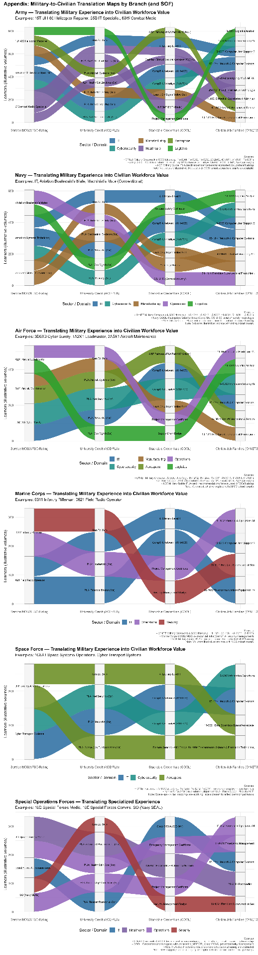
Appendix C: Transitions

Appendix D Machine Learning Scope, Ethical Constraints, and Evaluation Design
D1. Purpose and Scope of This Appendix
This technical appendix provides the formal justification for the use, non-use, and governance of artificial intelligence within the Career Mobility Governance Framework (CMGF). While the main body of the paper focuses on policy alignment, career mobility, and institutional outcomes, Appendix D documents the technical and ethical design decisions underpinning the framework.
Consistent with national AI governance guidance, this appendix is considered integral to the study. It addresses transparency, bias mitigation, accountability, and evaluation methodology for AI-enabled systems operating in high-impact public-sector contexts (Executive Order No. 14110, 2023; National Institute of Standards and Technology [NIST], 2023).
D2. Purposeful and Bounded Use of Machine Learning
Artificial intelligence within CMGF is deliberately applied as a supporting analytic instrument, not as an autonomous decision-maker or predictive authority. This bounded approach reflects both the sociotechnical nature of career mobility decisions and explicit national guidance cautioning against opaque or uncontrolled AI use in domains affecting individual opportunity, employment, and access to public benefits (NIST, 2023; Office of Management and Budget [OMB], 2024).

Machine learning (ML) within CMGF is employed in three constrained roles.
D2.1 Explainable Language Translation
Natural language processing (NLP) techniques are used to translate complex and heterogeneous data such as labor-market indicators from the Bureau of Labor Statistics, occupational mappings from O*NET crosswalks, and policy constraints embedded in military education programs into plain-language explanations. This design aligns with the NIST AI RMF emphasis on interpretability and transparency as prerequisites for trustworthy AI systems (NIST, 2023).
NLP outputs are explanatory rather than inferential and are presented with explicit data provenance and uncertainty indicators.
D2.2 Rule-Constrained Planning Signals
Within the Career Planning Module (CPM), ML-supported logic generates non-binding planning signals (“Go,” “Conditional Go,” or “No-Go [At Present]”). These signals are derived from transparent comparisons between user-declared constraints (e.g., funding caps, timelines) and externally sourced requirements (e.g., credential prerequisites, time-to-employability).
These signals do not recommend outcomes, rank individuals, or assess likelihood of success. Instead, they summarize feasibility under stated assumptions, supporting informed human judgment consistent with federal guidance on AI-assisted decision support (GAO, 2023).
D2.3 Aggregate Pattern Detection
Within the Advising & Approval Module (AAM), ML is limited to aggregate, anonymized pattern detection. Descriptive techniques analogous to clustering or frequency analysis identify systemic trends such as credential bottlenecks, funding constraints, or policy misalignment without generating individual-level assessments.
This design supports institutional learning while minimizing risk of individual harm, aligning with NIST’s guidance on risk-based AI deployment and impact proportionality (NIST, 2023).
D3. Explicit Non-Use of Machine Learning as Ethical Design
Equally central to CMGF is the explicit prohibition of several common AI applications. These exclusions are intentional ethical design decisions, not technical limitations.
D3.1 Prohibition of Predictive Outcome Modeling
CMGF forbids predictive modeling of individual outcomes, including employability, wage attainment, retention likelihood, or career success. Predictive systems trained on historical data risk encoding existing inequities in credential recognition, labor-market access, and funding availability. Federal oversight bodies have repeatedly warned that such models may legitimize structural bias under the appearance of technical neutrality (GAO, 2023; Executive Order No. 14110, 2023).

D3.2 Prohibition of Automated Decision-Making
The framework prohibits automated approvals, denials, or ranked career recommendations. Career mobility decisions are inherently normative and context-dependent, requiring human judgment and accountability. All approvals within CMGF require direct human action and documented rationale, consistent with OMB and NIST guidance emphasizing human-in-the-loop control for high-impact AI systems (OMB, 2024; NIST, 2023).
Although automated approval logic may appear operationally attractive at large organizational scales, CMGF intentionally confines automation to evidence aggregation and policy insight rather than individual adjudication. This design reflects the assessment that workload pressures should be addressed through upstream policy reform and resource allocation, not downstream delegation of decision authority to algorithmic systems.
D3.3 Prohibition of Individual Profiling and Risk Scoring
CMGF excludes individual profiling and risk scoring, whether behavioral, demographic, or financial. In military and veteran contexts where participation in institutional systems may not be fully voluntary profiling mechanisms pose heightened ethical risks. The framework therefore restricts individual-level AI output to explanation and comparison only.

D3.4 Avoidance of Optimization Objectives
CMGF deliberately avoids optimization-based objective functions (e.g., maximizing retention or minimizing cost) that would algorithmically privilege institutional efficiency over individual agency and long-term outcomes. While retention considerations are a legitimate and historically grounded objective of military education benefits, encoding retention as an optimization target risks transforming advisory systems into coercive or biased decision engines.
Instead, CMGF permits the contextual surfacing of retention-relevant information such as role criticality, training investment magnitude, replacement difficulty, and available retention incentives as explanatory signals for human consideration. These signals inform, but do not determine, decision-making. The framework explicitly prohibits algorithmic weighting, scoring, or prioritization of individuals based on institutional retention value.
This design ensures that retention is treated as a policy-relevant context, not a decision-driving objective, consistent with Responsible AI principles emphasizing transparency, human accountability, and the preservation of individual agency over optimization-driven outcomes (NIST, 2023).

D4. Transparency, Bias Mitigation, and Ethical Governance
CMGF operationalizes transparency as a design requirement, not a disclosure afterthought. This approach aligns with national AI standards that identify transparency, traceability, and explainability as foundational characteristics of trustworthy AI systems (NIST, 2023).
At the individual level, all AI-assisted outputs in the CPM are accompanied by explicit explanations of assumptions, data sources, and constraint drivers. Users are informed not only of what signals appear, but why they appear and under what conditions they may change. This design mitigates automation bias and supports informed, self-directed planning.
At the institutional level, CMGF enforces auditable human decision trails through mandatory rationale logging in the AAM. Advisors must document the reasoning behind approvals or denials, ensuring traceability and accountability. AI systems are prohibited from generating justifications autonomously, consistent with GAO findings emphasizing documentation and oversight as core AI governance requirements (GAO, 2024).
Bias mitigation within CMGF relies primarily on scope limitation and aggregation, rather than algorithmic debiasing alone. By restricting individual-level AI outputs to explanation and reserving analytic inference for anonymized population-level trends, the framework minimizes discriminatory risk while preserving institutional insight.
Although research on AI-driven academic advising demonstrates benefits in capacity and clarity when systems are carefully governed (Soomro et al., 2025), CMGF adopts a conservative posture appropriate for military and public-sector contexts. The framework demonstrates how AI can support policy-aligned decision-making without displacing human authority or obscuring value judgments.
D4.1 Structural Bias Visibility as an Ethical Design Choice
Rather than attempting to algorithmically correct or optimize around structural constraints, CMGF is intentionally designed to make policy-embedded bias visible to human decision-makers. Funding caps, credential eligibility rules, sequencing requirements, and timing constraints are encoded as explicit visual boundaries within planning interfaces rather than hidden within optimization logic or predictive models.
This design choice reflects the recognition that many barriers faced by service members such as annual Credentialing Assistance limits, degree-centric Tuition Assistance structures, or misalignment between stackable credential policy and implementation are policy artifacts rather than individual deficits. Algorithmic optimization in such contexts risks normalizing these constraints as neutral inputs, thereby obscuring their policy origins and reinforcing inequitable outcomes under the appearance of technical objectivity.
By rendering constraints and violations visible (e.g., “No-Go: CA cap exceeded in FY27”) without prescribing corrective actions, CMGF enables advisors, service members, and institutional leaders to observe where policy design, rather than learner behavior, produces friction. This approach aligns with national AI governance guidance emphasizing transparency, traceability, and human accountability over automated correction in high-impact decision domains (National Institute of Standards and Technology [NIST], 2023; Executive Order No. 14110, 2023).
In this way, CMGF treats bias not as a purely statistical phenomenon to be corrected post hoc, but as a governance signal that can inform policy review, budget justification, and program redesign. Making bias legible rather than invisible through optimization is a deliberate ethical stance consistent with Responsible AI principles and public-sector accountability obligations (Government Accountability Office [GAO], 2024; Office of Management and Budget [OMB], 2024).
D5. Evaluation Without Accuracy Metrics
Traditional AI evaluation emphasizes performance metrics such as accuracy, precision, or predictive validity. These metrics are inappropriate for CMGF, given its explicit avoidance of prediction, classification, and optimization at the individual level. Instead, evaluation is aligned with governance, usability, and institutional effectiveness.
D5.1. Evaluation occurs across four dimensions.
First, explainability and transparency are assessed by examining whether AI-assisted outputs clearly communicate assumptions, constraints, and data provenance to non-technical users. Success is measured by user comprehension and informed engagement rather than predictive correctness.
Second, human decision quality and consistency are evaluated through analysis of advisor rationale logs. Metrics include reductions in undocumented decisions, improved consistency across comparable cases, and clearer alignment between stated policy intent and observed approvals. This approach aligns with federal guidance emphasizing accountability over algorithmic performance (GAO, 2023; OMB, 2024).
Third, institutional learning and policy insight are evaluated by the usefulness of aggregate dashboards in informing budget submissions, policy revisions, and program design. The focus is on whether AI-assisted aggregation produces actionable evidence, not on individual outcome prediction.
Finally, trust and adoption serve as key evaluative indicators. Prior research indicates that AI-assisted advising systems perceived as transparent and non-coercive are more likely to be adopted and sustained over time (Soomro et al., 2025). CMGF therefore evaluates success through sustained advisor use, service-member engagement, and institutional uptake.
By rejecting accuracy-centric evaluation in favor of governance-oriented assessment, CMGF demonstrates that AI systems in high-impact public domains can be evaluated rigorously without relying on predictive metrics. This approach aligns technical evaluation with national standards for trustworthy and responsible AI (NIST, 2023; Executive Order No. 14110, 2023).
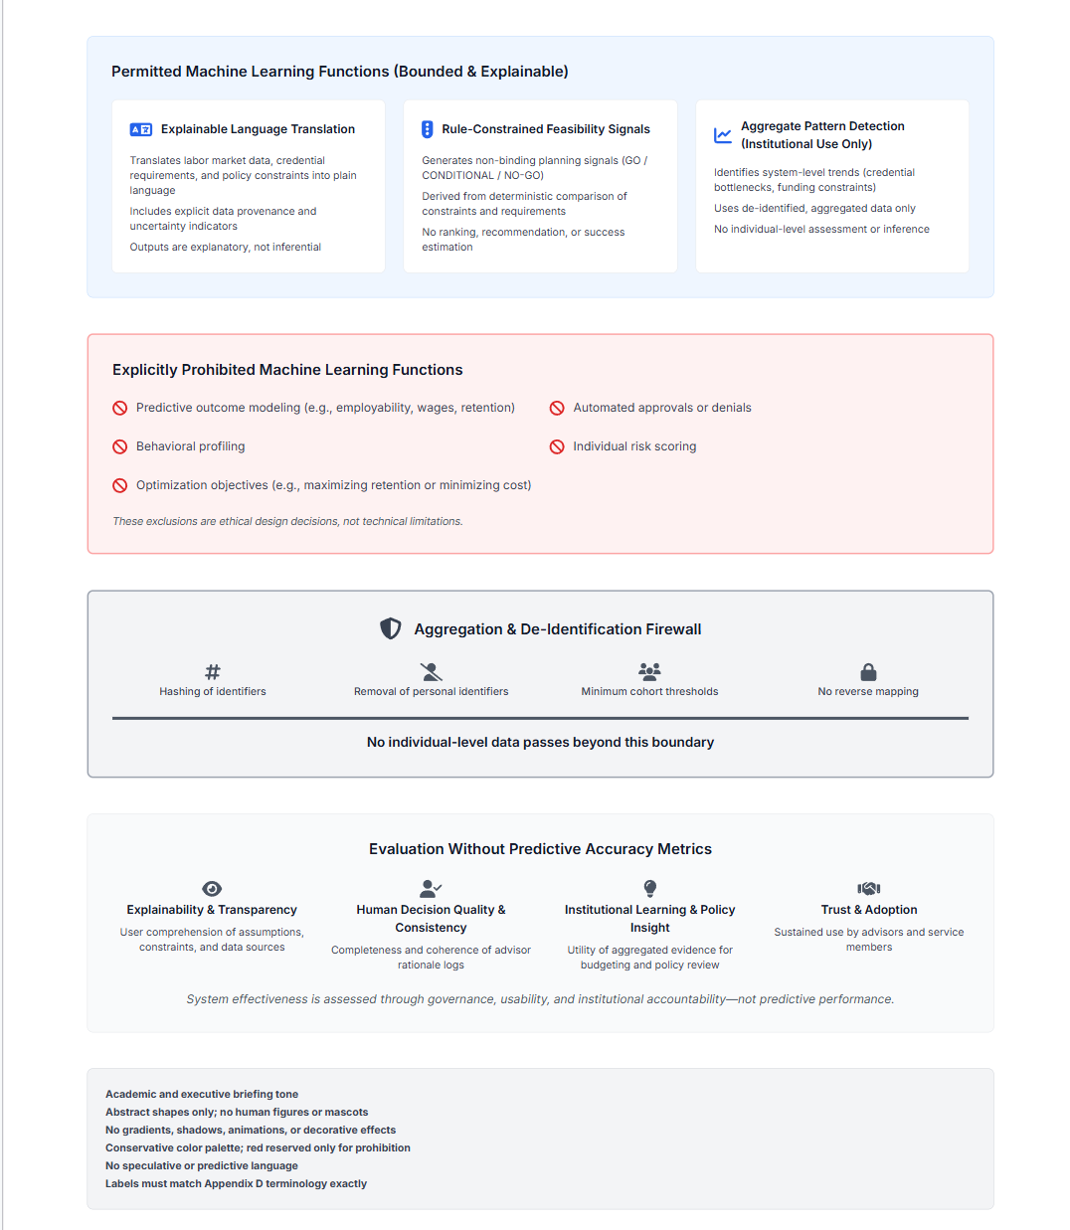
Figure D-1 Machine Learning Scope, Ethical Constraints, and Evaluation Boundaries within the Career Mobility Governance Framework (CMGF).
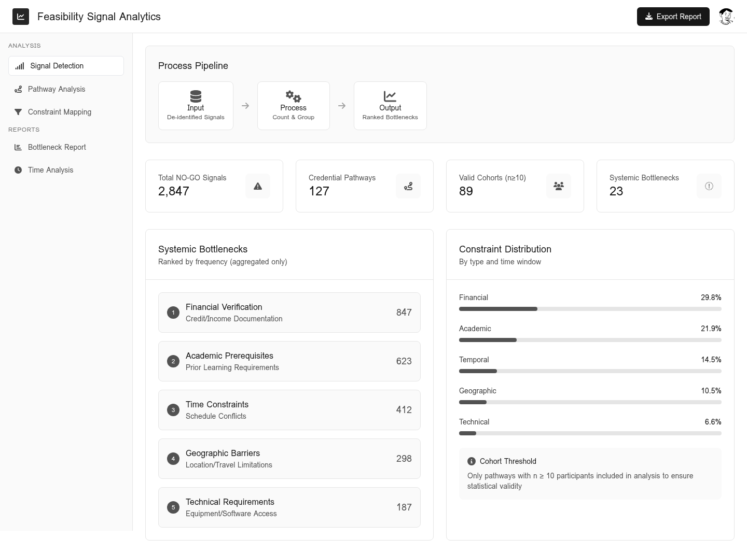
This figure illustrates the bounded application of machine learning within CMGF, explicitly distinguishing permitted explanatory and aggregate analytic functions from prohibited predictive, automated, or optimization-based uses. The diagram also depicts the aggregation and de-identification firewall and the governance-oriented evaluation framework employed in lieu of predictive accuracy metrics.

Figure D2 feasibility Signal Analysis
Figure D2 illustrates an example of aggregate feasibility signal analysis, in which de-identified GO/CONDITIONAL/NO-GO signals are grouped and counted across credential pathways to identify systemic bottlenecks under enforced cohort thresholds. No individual-level inference, prediction, or optimization is performed.

Appendix E System Governance
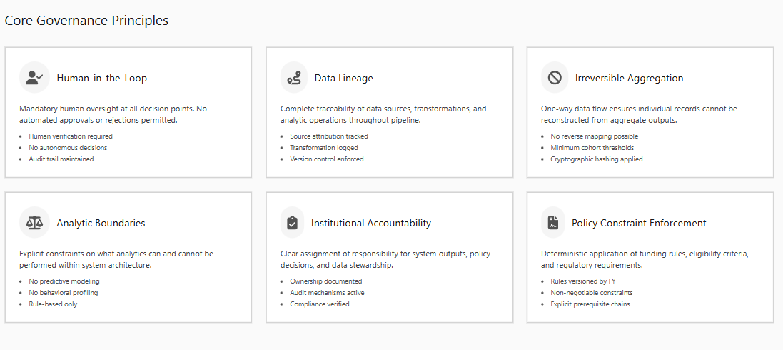
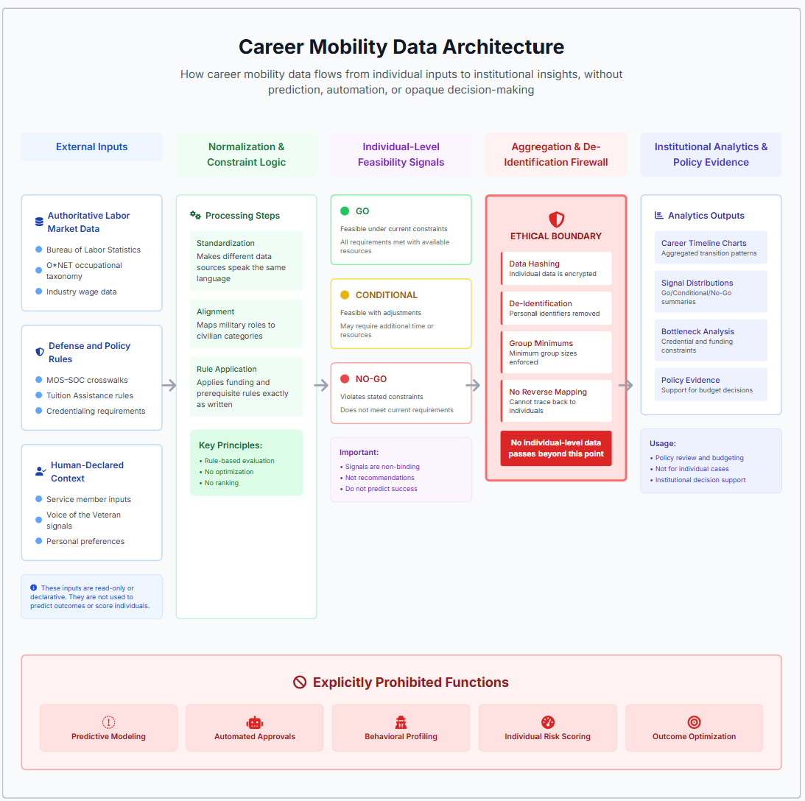

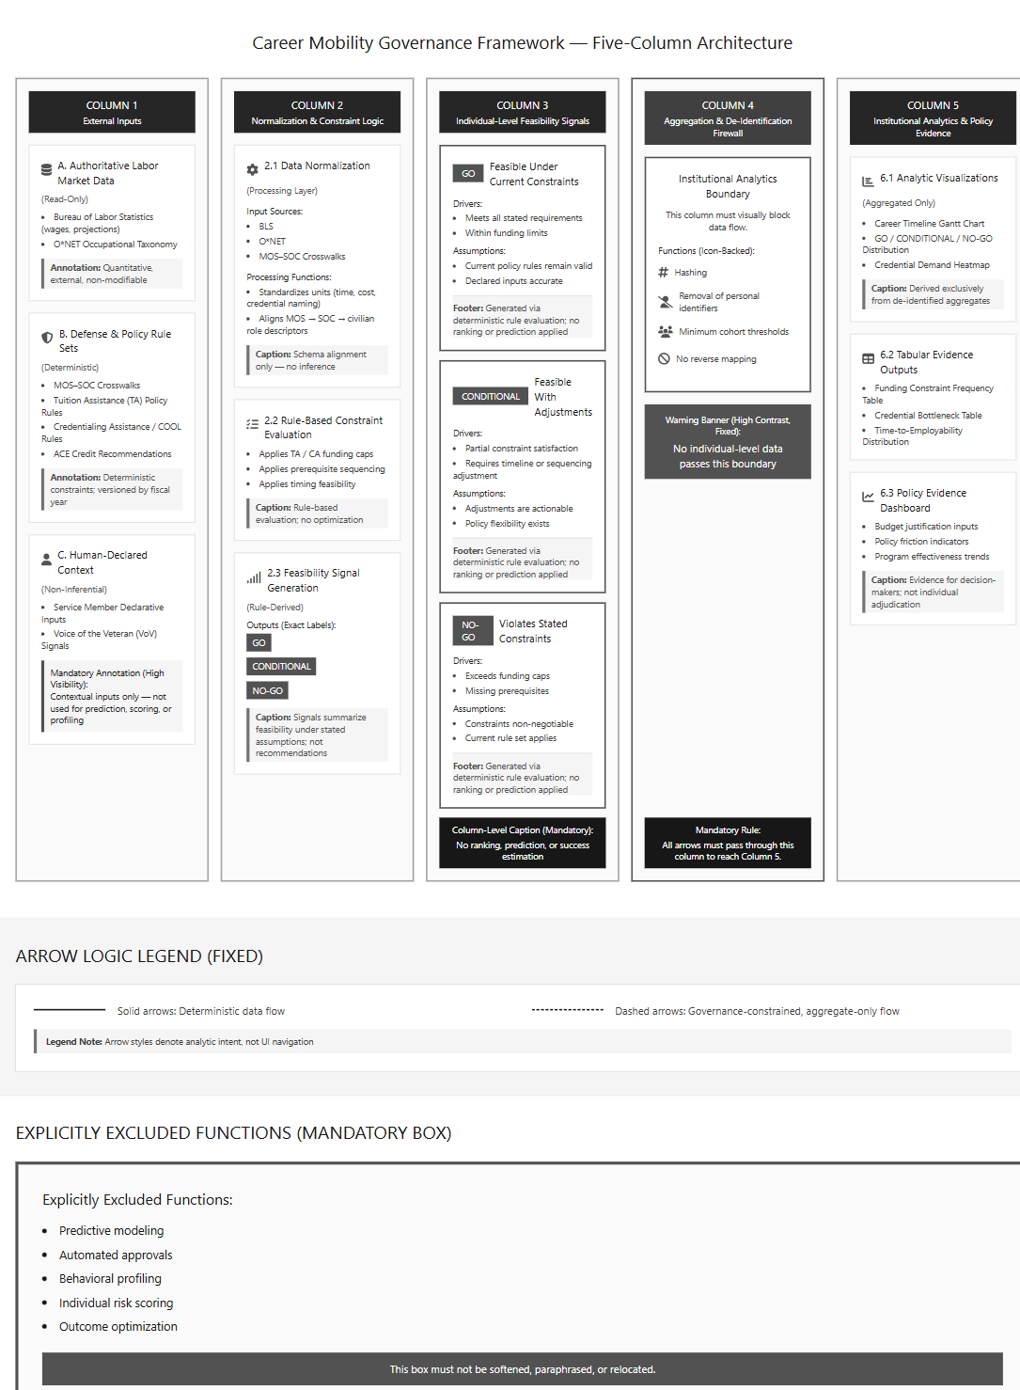

Appendix F System Architecture
