**ORIGINAL DOCUMENT:**

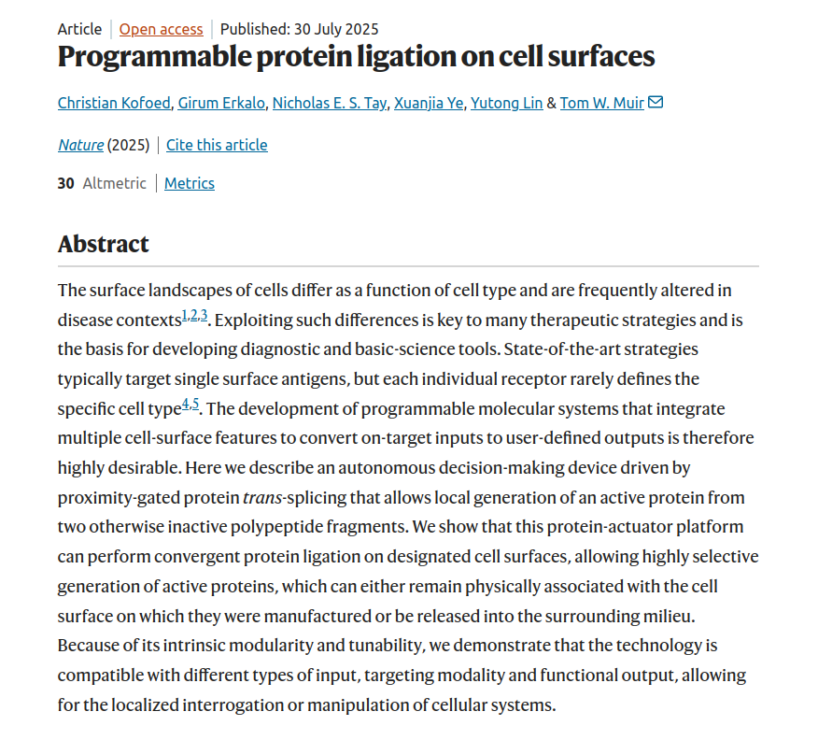

**Summary of Research Abstract:**

The research presents a programmable protein-actuation system that enables targeted protein ligation on cell surfaces. This system uses proximity-gated protein *trans*-splicing to activate proteins only when certain cell-surface features are detected. It allows precise generation of active proteins from inactive fragments on specific cell types, offering modular, tunable, and selective control.

This technology has potential applications in:

* Targeted therapy
* Cell diagnostics
* Manipulating cell behavior

It stands out because it works with multiple input types, targets specific cells, and adapts its function/output based on context.