Just a Sample Document

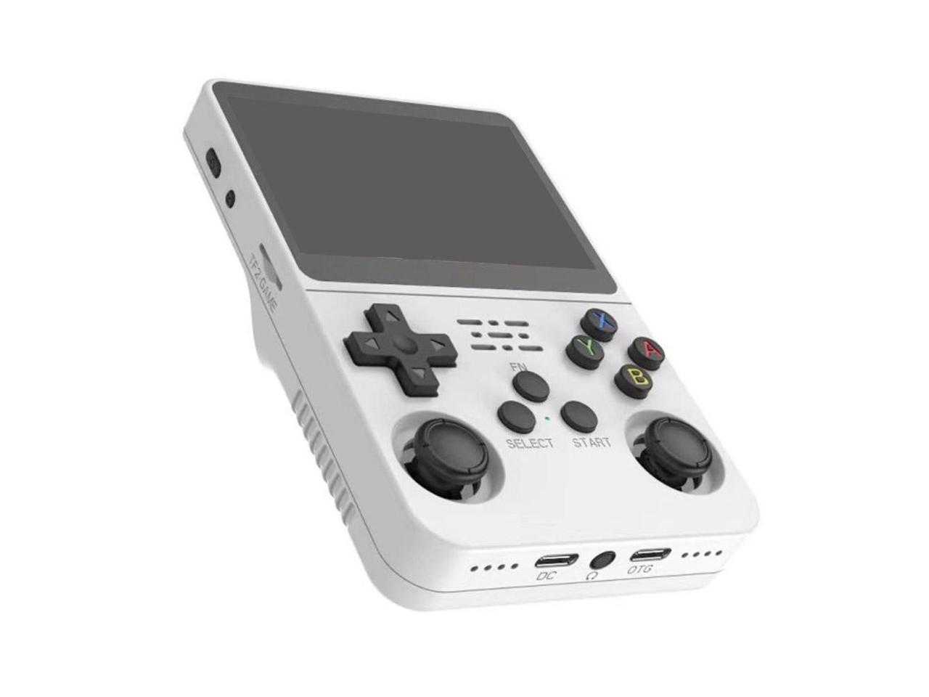

* **Multifunctional Linux System:** The R36S runs on a 64-bit Linux system, supports 32-bit apps, and offers wired controller compatibility, making it more than just a gaming device.
* *3500mAh Battery*: Enjoy extended playtime of 7-8 hours with the R36S, featuring a 3.5-inch IPS full-view screen with 640x480 resolution for an immersive gaming experience.
* Compact and Portable Designed for convenience, the R36S's lightweight and small form factor, along with a protective case, makes it ideal for travel and on-the-go gaming.
* High-Definition IPS Screen: The console's 3.5-inch 640x480 IPS display delivers vivid colors and sharp details, enhancing your gaming experience.
* Ideal Gift Option: At 17.4cm x 8.4cm x 2.1cm, the R36S is a perfect handheld size for gamers of all ages, making it a great gift for various occasions.