**Multidimensional Arrays**

**Processing Matrices and Multidimensional Tables**

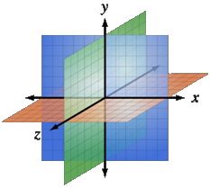Table of Contents

1. Matrices and Multidimensional Arrays
   * Declaring
   * Usage
2. Jagged Arrays
   * Declaring
   * Usage
3. The Array Class
   * Sorting
   * Binary Search
4. **Multidimensional Arrays (Using Array of Arrays, Matrices and Cubes)**

What is **Multidimensional Array**?

* Multidimensional arrays have more than one dimension (2, 3, …)
  + The most important multidimensional arrays are the 2-dimensional
    - Known as matrices or tables
* Example of matrix of integers with 2 rows and 4 columns:

Declaring and Creating Multidimensional Arrays

Declaring multidimensional arrays:

int[,] intMatrix;

float[,] floatMatrix;

string[,,] strCube;

* Creating a multidimensional array
  + Use new keyword
  + Must specify the size of each dimension

int[,] intMatrix = new int[3, 4];

float[,] floatMatrix = new float[8, 2];

string[,,] stringCube = new string[5, 5, 5];

Initializing Multidimensional Arrays with Values

* Creating and initializing with values multidimensional array:

int[,] matrix =

{

{1, 2, 3, 4}, // row 0 values

{5, 6, 7, 8}, // row 1 values

}; // The matrix size is 2 x 4 (2 rows, 4 cols)

* + Matrices are represented by a list of rows
    - Rows consist of list of values
  + The first dimension comes first, the second comes next (inside the first)

Accessing The Elements of Multidimensional Arrays

* Accessing N-dimensional array element:

nDimensionalArray[index1, … , indexn]

* Getting element value example:

int[,] array = {{1, 2}, {3, 4}}

int element11 = array[1, 1]; // element11 = 4

* Setting element value example:

int[,] array = new int[3, 4];

for (int row=0; row<array.GetLength(0); row++)

for (int col=0; col<array.GetLength(1); col++)

array[row, col] = row + col;

Reading a Matrix – Example

* Reading a matrix from the console

int rows = int.Parse(Console.ReadLine());

int columns = int.Parse(Console.ReadLine());

int[,] matrix = new int[rows, columns];

String inputNumber;

for (int row=0; row<rows; row++)

{

for (int column=0; column<cols; column++)

{

Console.Write("matrix[{0},{1}] = ", row, column);

inputNumber = Console.ReadLine();

matrix[row, column] = int.Parse(inputNumber);

}

}

Printing Matrix – Example

* Printing a matrix on the console:

for (int row=0; row<matrix.GetLength(0); row++)

{

for (int col=0; col<matrix.GetLength(1); col++)

{

Console.Write("{0} ", matrix[row, col]);

}

Console.WriteLine();

}

* Reading and Printing Matrices - Live Demo

Maximal Platform – Example

* Finding a 2 x 2 platform in a matrix with a maximal sum of its elements

int[,] matrix = {

{7, 1, 3, 3, 2, 1},

{1, 3, 9, 8, 5, 6},

{4, 6, 7, 9, 1, 0}   
};

int bestSum = int.MinValue;

for (int row=0; row<matrix.GetLength(0)-1; row++)

for (int col=0; col<matrix.GetLength(1)-1; col++)

{

int sum = matrix[row, col] + matrix[row, col+1]   
 + matrix[row+1, col] + matrix[row+1, col+1];

if (sum > bestSum)

bestSum = sum;

}

* Maximal Platform - Live Demo

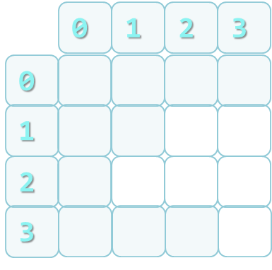

1. **Jagged Arrays**

What are Jagged Arrays and How to Use Them?

* Jagged arrays are like multidimensional arrays
  + But each dimension has different size
  + A jagged array is array of arrays
  + Each of the arrays has different length
* How to create jagged array?

int[][] jagged = new int[3][];

jagged[0] = new int[3];

jagged[1] = new int[2];

jagged[2] = new int[5];

Initialization of Jagged Arrays

* When creating jagged arrays
  + Initially the array is created of null arrays
  + Need to initialize each of them

int[][] jagged=new int[n][];

for (int i=0; i<n; i++)  
{

jagged[i] = new int[i];  
}

Example of Jagged Arrays

* Check a set of numbers and group them by their remainder when dividing to 3 (0, 1 and 2)
* Example: 0, 1, 4, 113, 55, 3, 1, 2, 66, 557, 124, 2
* First we need to count the numbers - Done with a iteration
* Make jagged array with appropriate sizes
* Each number is added into its jagged array

Example of Jagged Arrays

int[] numbers = {0,1,4,113,55,3,1,2,66,557,124,2};

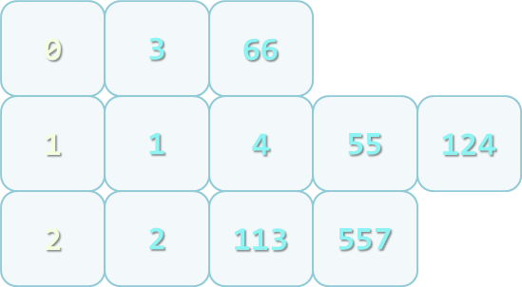int[] sizes = new int[3];

int[] offsets = new int[3];

foreach (var number in numbers)

{

int remainder = number % 3;

sizes[remainder]++;

}

int[][] numbersByRemainder = new int[3][] {

new int[sizes[0]], new int[sizes[1]],

new int[sizes[2]] };

foreach (var number in numbers)

{

int remainder = number % 3;

int index = offsets[remainder];

numbersByRemainder[remainder][index] = number;

 offsets[remainder]++;

}

* Remainders of 3 – Live Demo
* Matrix Multiplication – Live Demo
* Pascal's Triangle - Live Demo

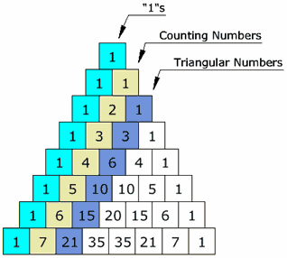

1. **Array Class**

* What Can We Use?
* The System.Array class
  + Parent of all arrays
  + All arrays inherit from it
  + All arrays have the same:
    - Basic functionality
    - Basic properties
    - E.g. Length property

Methods of Array

* Important methods and properties of System.Array
  + Rank – number of dimensions
  + Length – number of all elements through all dimensions
  + GetLength(index) – returns the number of elements in the specified dimension
    - Dimensions are numbered from 0
* **GetEnumerator()** – returns IEnumerator for the array elements
* **BinarySearch(…)** – searches for a given element into a sorted array (uses binary search)
* **IndexOf(…)** – searches for a given element and returns the index of the first occurrence (if any)
* **LastIndexOf(…)** – searches for a given element and returns the last occurrence index
* **Copy(src, dest, len)** – copies array elements; has many overloads
* **Reverse(…)** – inverts the arrays   
  elements upside down
* **Clear(…)** – assigns value 0 (null) for each elements
* **CreateInstance(…)** – creates an array
  + Accepts as parameters the number of dimensions, start index and number of elements
* Implements ICloneable, IList, ICollection and IEnumerable interfaces

Sorting Arrays

* Sorting in .NET is usually done with System.Array.Sort()
  + Sort(Array) – sorts array elements
    - Elements should implement IComparable
  + Sort(Array, IComparer) – sorts array elements by given external IComparer
  + Sort(Array, Comparison<T>) – sorts array elements by given comparison operation
    - Can be used with lambda expression

Sorting Arrays – Example

static void Main()

{

String[] beers = {"Zagorka", "Ariana",

"Shumensko","Astika", "Kamenitza", "Bolqrka",

"Amstel"};

Console.WriteLine("Unsorted: {0}",

String.Join(", ", beers));

// Elements of beers array are of String type,

// which implement IComparable

Array.Sort(beers);

Console.WriteLine("Sorted: {0}",

String.Join(", ", beers));

// Result: Sorted: Amstel, Ariana, Astika,

// Bolyarka, Kamenitza, Shumensko, Zagorka

}

* Sorting with IComparer<T> and Lambda Expressions – Example

class Student

{

…

}

public class StudentAgeComparer : IComparer<Student>

{

public int Compare(Student firstStudent, Student secondStudent)

{

return firstStudent.Age.CompareTo(secondStudent.Age);

}

}

…

Array.Sort(students, new StudentAgeComparer());

…

Array.Sort(students, (x, y) => x.Name.CompareTo(y.Name));

* Sorting with IComparer<T> and Lambda Expressions - Live Demo

Binary Search

* Binary search is a fast method for searching for an element in a sorted array
  + Has guaranteed running time of O(log(n)) for searching among arrays of with n elements
* Implemented in the Array.BinarySearch( Array, object) method
  + Returns the index of the found object or a negative number when not found
* All requirements of the Sort() method are applicable for BinarySearch()
  + Either all elements should implement IComparable<T> or instance of IComparer<T> should be passed
* Binary Search – Example

static void Main()

{

String[] beers = {"Zagorka", "Ariana", "Shumensko","Astika", "Kamenitza", "Bolqrka", "Amstel"};

Array.Sort(beers);

string target = "Astika";

int index = Array.BinarySearch(beers, target);

Console.WriteLine("{0} is found at index {1}.", target, index);

// Result: Astika is found at index 2.

target = "Heineken";

index = Array.BinarySearch(beers, target);

Console.WriteLine("{0} is not found (index={1}).", target, index);

// Result: Heineken is not found (index=-5).

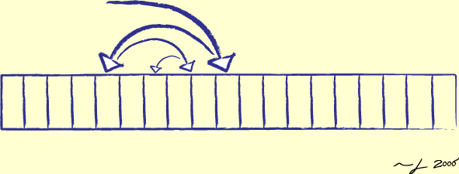}

Binary Search - Live Demo

**Advices for Working with Arrays**

* When given method returns an array and should return an empty array   
  (array with 0 elements) instead of null
* Arrays are passed by reference
  + To be sure that given method will not change the passed array, pass a copy of it
* **Clone()** returns shallow copy of the array
  + You should implement your own deep clone when working with reference types