Daniel Plascencia 2/23/2024

**Homework 2**

**CPP MAPS**

(OOA and OOD)

**Part 1 – Use Case(OOA)**

You will create an application similar to **Google Maps** called **CPP Maps**. As this is a large application you will first create Use Cases to help create a more modular application. You have selected the following 5:

1. **Navigation** – Get directions from a starting location to a destination location.
2. **Search** – Search for a place by name such as Nordstrom, Disneyland…etc
3. **Explore** – Search for a place by category such as Restaurant, Gym, University…etc
4. **Share Location** – Send location to a friend or family using messaging app on phone.
5. **Share Rideshare** – Send location to rideshare app such as Uber or Lyft.

**Part 2 – (OOA)**

1. Highlight all the nouns to determine possible potential classes.
2. Highlight all the verbs and verb phrases to determine possible methods and relationships.
3. Create a rough graph showing how all the classes are connected.

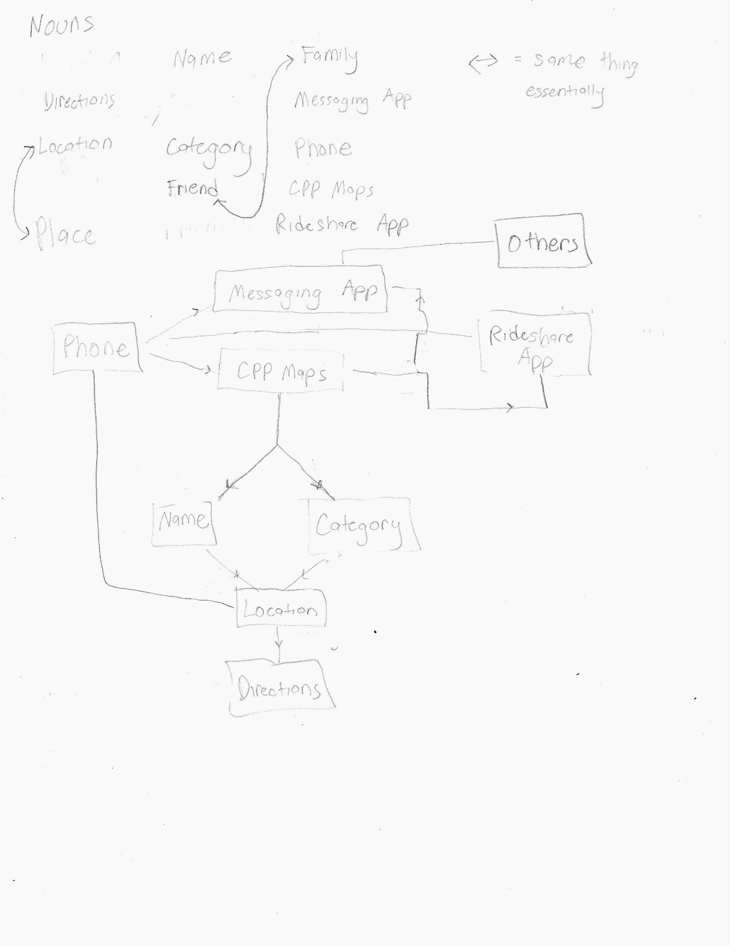

**Part 3** **– (OOD)** NOTE: *Use word editor such as MS word/Apple Pages*

1. Create CRC cards of the classes you have selected from the potential list above.

|  |  |
| --- | --- |
| Phone | |
| Access and Interact with the appropriate Apps. | CPP Maps Ridesharing App  Messaging App |

|  |  |
| --- | --- |
| Messaging App | |
| To Receive and send messages to other people, including the current location. | Phone  Others  CPP Maps |

|  |  |
| --- | --- |
| Ridesharing App | |
| To share the searched location from a user to the driver (like Uber or Lyft) | Phone  Others  CPP Maps  Messaging App |

|  |  |
| --- | --- |
| CPP Maps | |
| Used to Search, Send and get directions from users current location to where they want to go. | Name  Category  Ridesharing App  Messaging App  Phone |

|  |  |
| --- | --- |
| Name | |
| Hold the name of the location searched for | CPP Maps  Location  Category |

|  |  |
| --- | --- |
| Category | |
| Categories that can be assigned to locations for easier searches. | CPP Maps  Location  Name |

|  |  |
| --- | --- |
| Directions | |
| The set of directions to the locations from the user’s location | Phone  Location |

|  |  |
| --- | --- |
| Location | |
| Stores the location searched for by the user and user’s current location. | Directions  Name  Category  Phone |

|  |  |
| --- | --- |
| Others | |
| All necessary info regarding the people the user’s location/destination is sent to. | Messaging App  Ridesharing App  Phone |

1. Create a final graph connecting all the Class names with their Collaborators.

