|  |  |
| --- | --- |
| Project name | Calculator |
| Program language | **Python** |
| Developer | **Akshay Shankar** |
| Mentor/guide | **Mudappala Pranav Nair** |

Phase 1

# Requirement :

Build a calculator to enable the user to execute both basic and scientific calculations.

# use case

1. User should be able to select between the normal calculator and scientific calculator
2. User should be able to enter multiple input values for the operation
3. User should be able to give input both int and decimal values
4. User should be able to select the specified operation from the pre-defined set of operations
5. User should be able to select multiple operations and order of operations, E.g a+b-c
6. User should be able to perform operations with previous execution results,
   1. E.g op1= (a+b-c)
   2. Op2=op1*c
7. Users should be able to see their output value at the end of the execution.

# Functional Specification:

## Input Validation:

* Input validation for all the exceptions will be handled (spaces, undefinable characters/strings.

## Operation Validation :

* Operation Validation for all the operation exceptions will be handled (E.g divided by zero, multiplied by 0).

## Normal calculator module:

* Modules for all the basic operations (+-*/) will be defined.

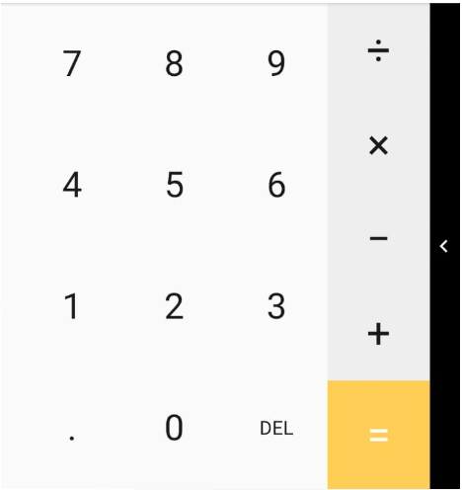

## Scientific calculator module :

* Modules for trigonometry basic operators (sin, cos, tan), In, Log, Inv, DEG, %, e, pi, root will be defined based on the user's input.

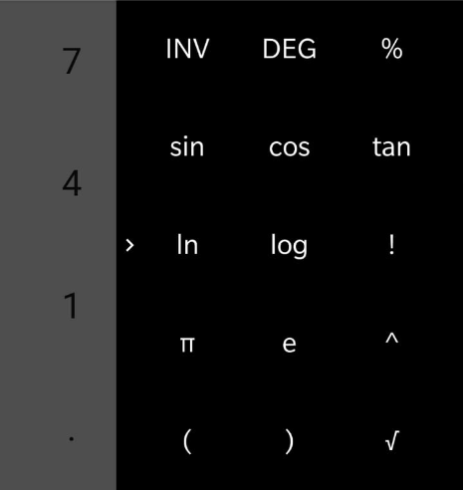

## Output validation:

* Output validation handling needs to be implemented.

## Out of scope :

* UI/UX is out of scope for phase one and it will be a command driven program.
* DEL function is out of scope for a normal calculator.
* (), nested operations are out of scope for phase one.

My Repositry: <https://github.com/Exodude/Smaowl-adv-Calculator>