CUSTOMER SATISFACTION SURVEY SYSTEM

FOR UNIVERSITY OF RIZAL SYSTEM

A

Capstone Project   
Presented to the

Faculty of College of Computer Studies

University of Rizal System

Binangonan, Rizal

In Partial Fulfillment

of the Requirements of the Degree

Bachelor of Science in Information Technology

JAYMILYN S. ARAMIL

JENRICK P. ARAN

MARK JOSH S. BENITO

WILLIAM JAMES J. LAGONOY

JB LIE MERTOLA

November 2024

**APPROVAL SHEET**

This Capstone Project entitled CUSTOMER SATISFACTION SURVEY SYSTEM FOR UNIVERSITY OF RIZAL SYSTEM has been prepared and submitted in partial fulfillment of the requirements for the degree Bachelor of Science in Information Technology by JAYMILYN S. ARAMIL, JENRICK P. ARAN, MARK JOSH S. BENITO, WILLIAM JAMES J. LAGONOY and JB LIE MERTOLA who are hereby recommended for corresponding pre-oral examination.

___________________  **JAYSON A. DALUYON, DIT (CAR)**

Date Adviser

Approved in partial fulfillment of the requirements for the degree Bachelor of Science in Information Technology by the Pre-Oral Examination Committee.

**FRANCHESCA RENELLE A. CERDA, MSCpE(CAR) NEIL RICHARD S. COLADA, DIT(CAR)**

Member Member

**MARTHEA ANDREA O. DALUYON, DIT (CAR)**

Chairman

Accepted in partial fulfillment of the requirements for the degree Bachelor of Science in Information Technology.

_________________ **JOY SG. CRUZ, PhD.**

Date Dean, CCS

**ACKNOWLEDGMENT**

Completing this capstone project will not be possible without the support of several generous individuals. The project team would like to extend its deepest and most heartfelt gratitude to those who will contribute to the successful execution of this capstone project in the field of Information Technology.

First and foremost, to the ALMIGHTY GOD, for granting us strength, faith, guidance, and knowledge, helping us stay resilient as we navigate challenging times.

DR. JOANNE S. CONCEPCION, Campus Director, for her anticipated support for the College of Computer Studies, especially in the area of capstone projects;

PROF. JOY SG. CRUZ, College of Computer Studies’ Dean, for her ongoing assistance to the college and the advisement and knowledge she will continue to offer as we undertake this capstone project;

PROF. JAYSON A. DALUYON, capstone adviser, for the invaluable assistance, wisdom, and expertise that will significantly shape our team into a professional and knowledgeable group. His patience, generosity, compassion, support, and guidance throughout the development of this project, along with his encouraging remarks and advice, will be instrumental in our journey;

PROF. MARTHEA ANDREA O. DALUYON, chairman of the panel, for her anticipated support, suggestions, and ideas throughout the execution of this project;

PROF. NEIL RICHARD S. COLADA, panel member, for the valuable insights and comments he will offer for the refinement and development of this project;

PROF. FRANCHESCA RENELLE A. CERDA, panel member, for her valuable suggestions that will contribute to enhancing this project;

PROF. RUBY S. SAN JUAN, the university CSS head, for her invaluable support and insightful guidance, which will greatly influence the quality and direction of this project.

And lastly, to our LOVED ONES, for their ongoing moral and financial support, as well as the love and inspiration they will continue to provide as we pursue our bachelor’s degree.

# DEDICATION

Above all, the project team dedicates this project to God Almighty, whose blessings and guidance have been a constant source of strength throughout this journey.

The project team also dedicates this project to everyone who has shared their resources and expertise, contributing significantly to its completion.

Primarily, this project is dedicated to the University of Rizal System Binangonan, whose support and guidance have been fundamental. The team also extends deep gratitude to their professors for their continuous encouragement, inspiring the creation of this system with the hope it will positively impact the organization.

To their adviser, whose patience has been unwavering through every challenge encountered, the team offers sincere thanks.

To their instructor who inspires them to dare and challenge themselves.

Finally, to their families, friends, and loved ones, whose support and encouragement have motivated them to persevere.

**JAYMI**

**JB**

**JENRICK**

**MAKI**

**WJAMES**

**TABLE OF CONTENTS**

|  |  |  |
| --- | --- | --- |
|  |  | Page |
| TITLE PAGE | …………………………………………………… | i |
| APPROVAL SHEET | …………………………………………………… | ii |
| ACKNOWLEDGMENT | …………………………………………………… | iii |
| DEDICATION | …………………………………………………… | iv |
| TABLE OF CONTENTS | …………………………………………………… | v |
| LIST OF FIGURES | …………………………………………………… | vii |
| LIST OF TABLES | …………………………………………………… | viii |

Chapter

|  |  |  |  |
| --- | --- | --- | --- |
| 1 | THE BACKGROUND OF THE PROJECT | | |
|  |  | Introduction………………………………………………………... | 1 |
|  |  | Objectives of the Project ……………………………….………. | 3 |
|  |  | Scope and Limitation of the Project…………………………… | 3 |
|  |  | Significance of the Project……………………………………… | 5 |
|  |  | Definition of Terms……………………………………………….. | 6 |
|  |  |  |  |
| 2 | REVIEW OF RELATED LITERATURE | | |
|  |  | Customer Feedback Evaluation ……………………………….. | 10 |
|  |  | Mobile Based Evaluation System ……………………………… | 12 |
|  |  | Web-Based Evaluation System ………………………………… | 13 |
|  |  | Management Information System ……………………………… | 14 |
|  |  | Natural Language Processing ………………………………….. | 15 |
|  |  | Sentiment Analysis ………………………………………………. | 18 |
|  |  | Trend Analysis …………………………………………………… | 19 |
|  |  | Software Quality and Testing …………………………………… | 21 |
|  |  | ISO 25010 ………………………………………………………… | 22 |
|  |  |
| 3 | METHODOLOGY | | |
|  |  |  |  |
|  |  | Research Development Framework …………………………… | 26 |
|  |  | Locale of the Project …………………………………………….. | 30 |
|  |  | Subject of the Project ……………………………………………. | 31 |
|  |  | Procedures of the Project ……………………………………….. | 32 |
|  |  |  |  |
|  |  |  |  |
| BIBLIOGRAPHY ………………………………………………………..…… | | | 34 |
|  | | |  |
| APPENDICES…………………………………………………………….…. | | | 38 |
|  |  |  |  |
|  | A | Gantt Chart of Activities………………..………………………… | 39 |
|  |  |  |  |
|  | B | Project Team Assignment Form………………………………… | 40 |
|  |  |  |  |
|  | C | Letter of Permission to Conduct the Project…………………... | 41 |
|  |  |  |  |
|  | D | Approved Project Title Form ……………………………………. | 42 |
|  |  |  |  |
|  | E | Letter of Acceptance of the Adviser and Panel………………… | 43 |
|  |  |  |  |
|  | F | User Acceptance Evaluation Questionnaire ..………………… | 47 |
|  |  |  |  |
| CURRICULUM VITAE ……………………………………………….…..… | | | 50 |

# LIST OF FIGURES

|  |  |  |
| --- | --- | --- |
| Figure |  | Page |
|  |  |  |
| 1 | Project Framework for the Development of Customer Satisfaction Survey System for University of Rizal …..…………………………..…… | 28 |
|  |  |  |

**Chapter 1**

**THE BACKGROUND OF THE PROJECT**

**Introduction**

Feedback is an information that can be used to improve the quality and performance of an organization to meet the overall satisfaction of the clients. This is gained from the customer’s reaction about a product or service. This information is widely used nowadays along with the help of technology where data is essential to enhance applicable processes.

Organizations utilize different ways to gather feedback from customers such as online platforms and application systems to make things easier and faster. Institutions with complex processes often implement systems to efficiently collect extensive feedback. For instance, the University of Rizal System has Customer Satisfactory System (CSS) to support comprehensive feedback gathering.

Management information systems are used to organize data that circulates on the internet. The internet has been widely used throughout the years as a communication medium to connect people globally since sharing information has been made easy by devices with internet access which resulted to web-based management information systems. With the composition of MIS and internet, a powerful way to connect an organization’s information has been developed.

A web-based management information system (MIS) is a systematic approach of using a database for data storage and processing that generates reports and supports the organization’s management. Web-based MIS provides organizations with the tools to proficiently administer an organization. It is also used to reach out various customers in terms of accessibility, and user experience, providing support in websites by data-driven decisions, organizing information and allowing areas for advancement.

By using an MIS, an organization can competently manage the system record and operate technology-based transactions that will enhance handling, operating, and data storing.

Numerous organizations and associations require a reliable computer-based system to properly arrange their daily operations and data storing. University of Rizal System is one of the organizations that use this type of system.

One of the departments the university has is the Customer Satisfaction Survey Unit which assess the feedback received from their products and services. They currently operate using Google services like Forms and Sheets which meets their needs but delays in data and reports from each campus and departments is another issue these platforms can’t resolve. Given the university’s extensive operation, they encounter difficulties in managing and keeping track of the information they have specifically with the feedback of customers.

With the stated circumstances experienced by University of Rizal System, the proponents proposed to develop a system especially for the Customer Satisfaction Survey to aid the organization in managing its data and improve its overall quality management processes in a more technological way.

**Objectives of the Project**

The general objective of the proposed project is to design and develop a Customer Satisfaction Survey System for University of Rizal System.

Specifically, the project aims to:

1. Determine the result of the quality assurance testing with a target passing rate of 95%.
2. Assess the user acceptance level of the proposed system based on ISO 25010 in terms of functional suitability, performance efficiency, compatibility, usability, reliability, security, maintainability, and portability.

**Scope and Limitation of the Project**

The project will focus on the design and development of Customer Satisfaction Survey System for University of Rizal System during the Academic Year 2024-2025.

The proposed system will be developed using Android Studio, Flutter, HTML, and JavaScript as programming languages, and MySQL for database.

The Customer Satisfaction Survey System will consist of seven end users: customers, unit heads, Data Control Center (DCC), campus directors, CSS coordinators, MIS, and CSS Head that will have different access levels for the proposed system. Customers can submit feedback. Unit heads have the same access as customers but can access automated reports. Data Control Center (DCC) can receive and validate the generated reports by affixing the university’s official seal or stamp. Campus directors can endorse reports and manage Non-Conformity and Corrective Action Reports (NCAR). CSS coordinators can access the generated reports and feedback, and consolidating data. MIS can manage users, review system performance, and generate custom reports. And the university CSS head has the same access as the MIS but cannot manage data responses.

The proposed system has the following features that will make it more convenient and proficient to use: A mobile-based application for data input by CSS coordinators. As for the web-based system, creation of surveys with real-time data gathering for instant submission. The system integrates direct data processing to update feedback data, ensures secured storage with access control, and offers data export capabilities. Automated report generation and sorting customer feedback with the use of sentiment analysis and trend analysis. Sentiment analysis features a computational method that automates the evaluation of sentiments, feelings, and emotions conveyed through comments by identifying the positive, neutral and negative feedback from the text-driven databases. For non-customer user in the web-browser, two-factor authentication during the login process is an additional feature for security of the system aside from password.

The software development life cycle Rapid Application Development (RAD) model will be used by the project team as the project development framework. Using stratified purposeful sampling technique, a target of three hundred seventy-nine (379) are intended to test the acceptability of the system. The respondents comprise of one (1) CSS Head, five (5) MIS, five (5) CSS coordinators, five (5) campus directors, five (5) IT experts, and three hundred fifty-eight (358) customers from University of Rizal System who will evaluate the proposed system using an adaptive questionnaire based on the ISO 25010 standard.

**Significance of the Project**

The proposed project Customer Satisfaction Survey System for University of Rizal System will be beneficial to the following:

University of Rizal System. The proposed project will help the university in elevating the quality of services and maintain accreditation standards to meet the demands and expectations of all students, faculty, staff, and visitors. Through the proposed system, the university can address and make actions from emerging issues and concerns in different departments and offices to foster a more positive and productive academic environment.

Customers. The proposed project will help to meet customer expectations by enhancing service quality and identifying areas for improvement. It provides a user-friendly platform for real-time feedback on interactions with the university's services and facilities, ensuring that concerns are addressed and improvements are made where needed. other terms.

Unit Heads. The proposed project will help the departments in assessing and identifying the concerns through feedback, allowing them to create strategic plans, to reduce performance and service issues, as well as identifying trends and areas for improvement.

CSS Coordinators. The proposed project will help coordinators in assessing the concerns and monitor the improvements of performance and services through the reports from feedback. Also, it helps them in collecting, generating reports, managing, and organizing massive volumes of data without difficulties and traffic.

Project Team. The project team will be knowledgeable when it comes to the relevance of Customer Satisfaction Survey and will adapt strategies throughout the process in developing the system.

Future Project Team. The future project team may utilize this project as a reference for conducting new studies.

**Definition of Terms**

To ensure clarity and understanding of the project, the following key terms are defined conceptually:

Android Studio. An integrated development environment (IDE) for developing applications. It contains tools for coding, designing, testing, and deploying apps that will be used for the project.

Compatibility. It is one of the standards in ISO 25010 that will help the project team verify whether the software system is capable to share or exchange data with other systems using the same services.

Customer Satisfaction Survey (CSS). A structured tool used to collect feedback from clients, employees, and stakeholders regarding their satisfaction with the university’s services and programs.

Flutter. An open-source framework that will be used by the project team to develop applications across mobile, web, and desktop platforms using a single codebase.

Functional suitability. It is one of the standards in ISO 25010 that will be utilized by the project team to check if the specified functional requirements meet their purpose.

HTML. A standard markup language for creating web pages and consists of a series of elements. In this project, it will be used to ensure that the project is accessible across different web browsers and devices.

JavaScript. A client-side scripting language that allows the project team to add interactivity and dynamic content to web applications, ensuring smooth experience for users.

Maintainability. It is one of the standards in ISO 25010 that will help the project team to check if the system can be modified to correct defects, improve performance, or adapt changes in the environment.

MySQL. An open-source written in PHP that handles the administration of MySQL or MariaDB database server that will be used by the project team throughout the development process.

Performance efficiency. It is one of the standards in ISO 25010 that enables the project team to test how well the system can adapt to changes in user demands.

Portability. It is one of the standards in ISO 25010 that will be used by the project team to test if the system can be transferred from one environment to another.

QR Code Generator. Quick Response (QR) code is an online software used to track information quickly. In the project, it will be created by the project team for the system.

QA Testing. A procedure that will be used by the project team to ensure that the system will meet the specified requirements and improves quality, reliability, and performance of the system.

Reliability. It is one of the standards in ISO 25010 that will help the project team check if the system can perform its function consistently.

Security. It is one of the standards in ISO 25010 that will be applied by the project team to ensure that the system will protect data and information from unauthorized access.

Sentiment Analysis. Used in people's survey responses and determining whether the user’s feedback feels positive, negative, or neutral by the process of understanding the emotional tone.

Trend Analysis. It is based on the historical data that analyzes feedback trends and predicts future outcomes.

Usability. It is one of the standards in ISO 25010 that will be used by the project team to test whether the users can successfully achieve their specified goals using the system based on its functions.

Website. An online resource comprising multiple web pages, and engagement tools that will be developed by the project team, which can be accessed via browsers or hosted on a server.

**Chapter 2**

**REVIEW OF RELATED LITERATURE AND STUDY**

In this chapter, the review of related literature and studies are being presented which is relevant to the developed project.

**Customer Feedback Evaluation**

Customer feedback collection is crucial for every organization in managing customer satisfaction. In order to identify current trends and preferences in the industry, feedback collection is utilized to gather insights from customers that will serve as a guiding resource to develop new and improved products or services. By implementing a well-organized plan on collecting feedback, organizations can continuously adapt and innovate in the demands and conditions of the customers.

According to the Edward Elgar Publishing eBooks (2022), customer feedback encompasses voluntary comments from customers, either negative and positive. It is intended to provide an evaluation and communicate details about their transaction or travel experiences which can be expressed through several means and channels including suggestion boxes, email surveys, paper and electronic questionnaires, etc. Each channel or form of feedback varies based on the technology utilized, the target audience, its intended purpose, and the methods used to gather it.

In the study undertaken by Sinha et.al (2024), customer feedback shapes businesses and improves customer experiences in the age of advanced technology and interconnectedness that it has become crucial in the area of business analytics in recent years.

Classifying customer feedback helps to achieve several goals, such as expanding datasets, aligning with user preferences, detecting new trends, and measuring system reliability. These efforts lead to the development of more accurate and user-oriented classification systems. Future directions could focus on developing models that merge sentiment analysis and natural language understanding, allowing for a more precise interpretation of the subtle complexities in user opinions and preferences (Sidek et. al, 2024).

Based on the study of Mishra & Vegad (2024), improvements in technology and shifting techniques for collecting customer feedback are resulting in larger volumes of unstructured text data, making it harder for coordinators to analyze the information. Assessing customer feedback is a necessary condition for achieving success in co-creation within a service environment.

As indicated by Gorospe et.al (2021), customer feedback is an influential predictor of academic life to ensure services meet the right standards. It helps determine if services are suitable, relevant, and reliable. The results show that heads of offices have made good progress and are highly satisfied.

Customer feedback reflects the quality of services that customers experiences when they interact with the university or institution. Customer feedback is the experience that students and stakeholders have when interacting with their school or institution. When they experience good customer service, they become happier and more loyal. More so, the provision of customer satisfaction also sets an institution on a competitive edge. the university is posed with the challenge of pursuing consistency in providing a satisfactory customer experience through the different services offered (University of Baguio, 2023).

In conclusion, evaluating comments and suggestions is necessary to have proper analysis as customer feedback is an asset for every organization which can help them to continuously improve their products and services.

**Mobile Based Evaluation System**

Mobile device is a portable, handheld computer that has been an integral part of daily lives. This technology with internet connectivity enables users to communicate and access information wherever they are. With its constant development, different systems can now be utilized in it allowing organizations to leverage its capability to all applicable requirements.

The study of Duffy & Wu (2022) mentioned that designing the mobile applications that users tend to use is of great significance. They specified how usability plays an indispensable role in affecting the users understanding in using a mobile based system. Moreover, they evaluate mobile applications usability using bibliometric analysis which helps in creating a systematic review.

The success of an organization can be determined using the perceived level of the quality by a user in particular to the usability of the system. In a study conducted by Weichbroth (2019), taking advantage of both qualitative and quantitative methods to collect data that would describe all usability attributes must be put into consideration to produce a reliable and valuable mobile application.

Following the statements above, feedback and suggestions from mobile users is highly needed to successfully evaluate a mobile based system. It must undergo an evaluation specifically for its usability and reliability in order to meet particular requirements and provide its necessary usage.

**Web-Based Evaluation System**

A web-based evaluation system is an online platform that allows users to engage from any device with an internet connection. It is built to assess and evaluate performance in different areas, particularly in education and feedback satisfaction. With its user-friendly interface, it simplifies the evaluation process, making the users easily conduct evaluation. Web-based systems boost efficiency, improve productivity, and provide functional insights from data it collects.

According to Mahfida & Nusrat (2020), the process of evaluating teachers is still done manually at Stanford University Bangladesh, which takes a lot of time and it is a slow progress. With the help of their study, teachers from various programs were evaluated using predetermined questions in a web-based platform gathering different opinions from students. The study shows that it'll be more convenient to conduct evaluation using a web-based system. Additionally, this study offers a modern solution, turning the traditional and manual evaluation process into a web-based system that emphasizes efficiency, clarity, and the potential for teacher improvement through structured feedback.

The traditional methods of evaluation rely on student surveys, usually manuals that aren't entirely accurate and don't meet the required standards. This web-based faculty evaluation system features collaborative online student feedback to improve the quality of teaching and facilitates it accurately through targeted surveys, self-examination exercises, and peer observation. This study was proposed to break through traditional methods by integrating multiple sources (Santillan, 2024).

As stated above, this web-based evaluation process enhances the perception of various feedback from students. Tools such as online surveys and self-reflection can provide substantial help to optimize the system that will be developed by the project team. Additionally, the study will be beneficial to the project team in terms of accuracy and reliability, minimizing administrative workloads, and having a comprehensive and precise evaluation using web-based systems, ensuring higher-quality feedback.

**Management Information System**

Management information system (MIS) is utilized by an organization to control, analyze, and visualize its information. In the organizational setting of the study of MIS, the following are involved: people, procedures, and technology. The primary goal of MIS is to enhance the profit and value of a company or organization. Additionally, MIS are designed to meet the needs and requirements of different types of businesses.

Based on a project conducted by Arambulo & Dela Coste (2019), management information system (MIS) helps in transforming manual procedures into more streamlined and accurate processes in an organization like the academe. The developed system by Arambulo & Dela Coste (2019) received positive feedback from the respondents with a claim that MIS can be used in learning management processes.

In accordance with Martinez et.al (2024), implementing management information systems is used to enhance administrative management in micro and small businesses. It allows administrators to obtain relevant information quickly and easily, optimizing decision-making times. It enables reducing time allocated in generating reports.

Based on the study of Fadhil et.al (2024), applying management information systems increases organizations and employee’s quality services. University management is encouraged to consistently improve the current management information system and provide a training program for all administrative staff.

With the continuous development of technology, existing processes evolves too, making it easier and more accessible to people. By utilizing MIS, the decision-making process of an organization is faster achieving high level of agility and competitive performance.

**Natural Language Processing**

Natural language processing (NLP) enables computers to comprehend, generate, and manipulate human language as it is a machine learning technology that is a subfield of computer science and artificial intelligence (AI).

NLP techniques is a branch of AI that were known as useful tools in different applications such as natural language text or voice translation, stock price prediction, and semantic analysis. It became faster to compute large amounts of data (Shuang, 2020).

Singh (2019) stated that NLP techniques are already a huge contributor to multiple users and are implemented in a much wider variety of applications. Some examples of applications that are mostly used these days are speech recognition, chatbots, language translation, spam detection, recommender systems, and sentiment analysis. It can handle a massive data collection. This study explains a series of steps in processing text data and applying the algorithm of machine learning on it.

This study has shown that natural language processing increases knowledge particularly on customer satisfaction. The authors also stated that the first step to establish models of response to customers is automated NLP. Satisfaction is neither vertical nor horizontal. It emphasizes the connection between the level of satisfaction and the number of themes discussed, testing the traditional methods that don't seem to analyze the differences in communication between customers who are satisfied and those who aren't. With the use of NLP methods, it has become easier to categorize documents, and identify the nature of qualities that influence customer satisfaction and to limit traditional approaches (Piris et. al, 2020).

As stated by Camacho-Collados et.al (2022), TweetNLP is a unified platform for natural language processing (NLP) that supports a wide range of NLP tasks, offering specialized models and tools for tasks such as sentiment analysis, named entity recognition, emoji prediction, and the detection of offensive language. Its key contribution is the integration of a Python library that provides a modern toolkit designed for analysis, utilizing various models specifically adapted to the social domain. Moreover, TweetNLP includes an interactive online demo, enabling users to experiment with these models easily without requiring any coding skills.

TweetNLP will be utilized by the project team upon developing the system as it allows users to run the models without needing cloud services or hardware. With this, it can be accessible for a wider variety of users. Additionally, it is a user-friendly tool where the resources are built to enable experimentation and using these models easy for everyone, this design allows people to engage with regardless of their programming skills. The goal is to make advanced NLP tools accessible to all, opening the door for a broader range of users to explore and benefit from them. This platform also makes it easy for non-programmers to examine the models, which is important for identifying any harmful biases or errors. This feature is designed to help improve the models over time by encouraging a better understanding of their limitations and biases.

According to the articles mentioned above, natural language processing can automatically detect emotions by using sentiment analysis, providing deeper understanding into customer satisfaction surveys, enhancing data analysis, and categorizing feedback as positive, negative, or neutral that enables the project team to develop the system with greater ease. Overall, NLP is a powerful tool that must be utilized especially in the modern times where every manual process has a technological equivalent. Proper application of NLP can change how a system function fully.

**Sentiment Analysis**

Sentiment analysis is a method of extracting sentiments to determine the emotions conveyed in a particular text and data. This method utilizes classification techniques to identify the positive and negative feedback from the text-driven databases. It provides automated techniques for examining massive amounts of feedback, enabling businesses to base decisions on data-driven decisions. Additionally, it focuses on categories such as positive, negative, or neutral feedback.

Sentiment analysis refers to a computational method that automates the evaluation of sentiments, feelings, and emotions conveyed through comments, feedback, or critiques. Over the last years, sentiment analysis captured the attention of researchers due to its broad applications applied across numerous sectors, including business, government, education, telecommunications, etc. (Umarani et al., 2021).

According to Gulcin (2022), sentiment analysis is a candidate for assessing the difficulties in a rapid way since it deals with extensive qualitative data sets, time sensitive projects, the necessity to disseminate findings in a short time frame, or projects that may involve a rapidly evolving dynamic environment. It may assist qualitative data analysis by optimizing time in interpreting how an intervention may or may not be successful through rapid opinion mining of text or transcripts.

As stated by Subramanian et.al (2024), sentiment analysis is widely applied to assess voice of the customer content, such as reviews, survey responses, and Q&A interactions, to gain a deeper understanding of products and services. It provides trends, reviewer sentiments, emotional reactions, and customer experiences. Analyzing this information allows to determine the authenticity of services and clarify any ambiguities in customer feedback.

Also, sentiment analysis enables businesses to gain insights into customer emotions and feedback, allowing them to respond productively. AI-based sentiment analysis tools facilitate the understanding of customer feelings and provide the ability to anticipate trends and spot potential issues early on. This ensures that sentiment analysis models remain accurate and relevant as new data emerges (Rane et al., 2024).

To sum up, sentiment analysis is a method that aims to identify if the emotion from the feedback given is positive or negative. It assesses the difficulties since it deals with a massive amount of data sets and can generate findings in a short time frame. Learning this topic can be beneficial in the development of the proposed system as the main objective of the system is to assess the feedback and comments of customers to the services provided by the university.

**Trend Analysis**

Trend Analysis method contains gathering time-ordered data from the object being monitored. It generates a trend chart for each monitoring category of the observed object based on time-sequenced data, then applies statistical analysis using a predefined trend analysis algorithm to identify the extreme points in each trend graph.

According to Wang (2019), sentiment analysis executes statistics using a preset trend algorithm to identify the extreme points in each trend graph. It evaluates whether the monitoring category associated with the trend chart shows abnormalities by analyzing the extreme point in each chart. However, when the monitoring category is identified as abnormal, relevant warning information is provided based on the attribute data of the category's extreme point.

In the study undertaken by Baucells et.al (2021), trend analysis aims to visualize the effect of input assumptions and parameters into model output. Assessing the properties of several trend analyses used in simulation and machine learning, it is observed that not all of them provide consistent results when applied to well-understood problems. It shows that certain metrics, such as individual conditional expectations (ICE), gradients, and partial dependence functions, consistently show convexity and monotonicity, even in the presence of dependent inputs, whereas other metrics, like ALE plots, regression lines, and correlation coefficients, may not exhibit these properties.

Based on the mentioned articles, trend analysis aims to give accurate results by executing trend charts to monitor the possible feedback that shows if statistical analysis provides abnormalities. Learning this topic is highly functional for the proposed system by identifying possible patterns that can be used in improving and assessing the overall quality of the service provided within the university.

**Software Quality and Testing**

Software testing plays a crucial part in software development life cycle. Software must meet quality standards and perform the desired outcome. In addition to the study, the software also needs to be examined thoroughly. It has been made to improve the operation of the software (Springer International Publishing, 2022).

Testing has a significant role in verifying the validity of software and ensuring that the requirements have been correctly administered. Software testing is both a constructive and destructive process. The objective of the study is to verify the accuracy of the software, and identify as many issues as possible. Testing is characterized as a dual-function activity. On one aspect, the study concludes that software testing provides a fundamental understanding of its values and significance in ensuring software quality (Regan, 2019).

Rapp (2023) stated that quality assurance testing has a critical role in software development. It emphasizes that it is essential in customers expectation and ensuring the success of software project. Quality assurance testing is a required step in terms of fundamental part of the development process. This also highlights the goal of QA in building applications and meeting or exceeding the customers satisfaction, ensuring that the final output will align to the requirements in which it’ll lead to success. Furthermore, this study points out how QA is performed can essentially impact the outcome of the project. This study also mentioned that the success of the software project depends on the quality assurance process.

To summarize the studies above, software quality assurance and testing plays an essential role for the success of the system. By focusing on functionality, this ensures that every feature that will be included in the system, users can have a smooth experience upon using it. Testing has a significant impact on customer satisfaction survey system as it enhances the reliability of the system by analyzing its performance under various conditions, such as crowded access, securing that it remains stable and responsive even with heavy user load. Data accuracy and security are given importance specifically in customer satisfaction survey system through comprehensive testing, in which the system manages sensitive customer data. Additionally, quality assurance testing verifies that the system is user-friendly and easy to navigate, motivating more users to complete the survey without issues.

As the final point, the studies cited above confirms that the project aligns with its initial goals and specifications, reducing the chances of alteration that could impact its overall performance. By focusing on these factors, software quality assurance and testing is dependable, proficient, and user-friendly in the proposed system.

**ISO 25010 Standard**

The ISO 25010 Standard is the standardized test for systems to ensure the quality and completeness of a developed system. It provides consistency in terms of specifying and evaluating system and software product quality using characteristics and sub-characteristics.

According to Keibach & Shayesteh (2022), ISO 25010 quality model provides a comprehensive framework to compare the capabilities of different software tools.

In a study conducted by Atikah et.al (2020), functional suitability is important in a system to assess the software quality. Their study identifies three main attributes functional suitability which are completeness, correctness, and appropriateness.

As per Damayanti et.al (2020), performance efficiency is a primary consideration in order to maximize the main function of a system. Time behavior, resource utilization, and capacity assessment are the sub-characteristics used to assess how efficient a system performance is.

In accordance with Amalia et.al (2020), compatibility focuses on the software's ability to operate with other systems and software without conflict. This highlights the importance of how a system can co-exist and interoperate in multiple devices leading to its interaction capability which is another quality of the ISO 25010.

According to Nishadha (2022), reliability is a crucial factor in computer programs since it reduces the cost of software repair. A system can is reliable if it fucntions as intended within a given environment for a specific duration without any errors.

As stated by Fadilah & Rochimah (2023), security in a system includes attributes like confidentiality, integrity, authentication, accountability, and non-repudiation which is essential for evaluating information systems. This ensures the privacy and safety of the data of the entire system.

As reported by Britton (2021), maintainability refers to how well a product or system can be modified to improve, correct, or adapt to changes in the environment as well as requirements. This is beneficial in a system or software application for it to be improve and corrected. Also, as asserted by Dewi et.al (2020), the many software quality standards that exist today show the importance of achieving software quality emphasizing the importance of maintainability quality standards based on ISO 25010.

In conformity with Codacy (2021), flexibility pertains to the ease of transfer between different environments. This quality includes adaptability, installability, and replaceability.

Following Amalia et.al (2020), safety focuses on protecting information and data from unauthorized access and ensuring system integrity. This helps in avoiding a state in which human life, health, property, or the environment is endangered.

Based on the statement above, ISO 25010 ensures quality and effectiveness of a developed system by providing support to the usage of software testing. It supplies the necessary standards to deliver quality software.

As noted above, every software system must meet the following criteria provided by the ISO 25010 for it to be completely beneficial to the organization and to satisfy all applicable stakeholders. In agreement with the International Organization for Standardization (2023), software products are increasingly used to perform a wide variety of personal and organizational activities in which a comprehensive specification and evaluation of the target product is a key factor in ensuring value to stakeholders.

Overall, standardized testing for software products is necessary, especially with the fast pacing of technology nowadays. Following the standardized procedure which is the ISO 25010 is the only way for us to identify if the software or system suffices the needed requirements.

**Chapter 3**

**METHODOLOGY**

In this chapter, the methods and techniques that the project team will utilize for developing the proposed project are presented.

**Project Development Framework**

The software development life cycle Rapid Application Development (RAD) model will be used by the project team as the project development framework. As mentioned by Sherrer (2023), Rapid Application Development (RAD) is a methodology that focuses on swift prototyping and review feedback before the development period. It is a flexible and convenient development life cycle as it contains four main phases: first is to define project requirements, next is to create the prototype, followed by feedback gathering and finalization, lastly, is to implement the product. This will be the entire process of creating the system from formulating ideas to designing and developing the system up to testing and deploying it.

Rapid application development was created in the 1980s. It is a continuous form of development philosophies where, compared to the waterfall model, it wasn't a singular resource that needed a fixed structure. RAD is adaptive and meets the needs of the user.

Corresponding with other software development frameworks, Rapid Application Development (RAD) approach includes a successive set of prototypes and prioritizes building without actually starting with planning. Additionally, it receives feedback from end users on each iteration. This will help the project team ensure that the final outcome of the system is more quality-focused and meets the users’ requirements.

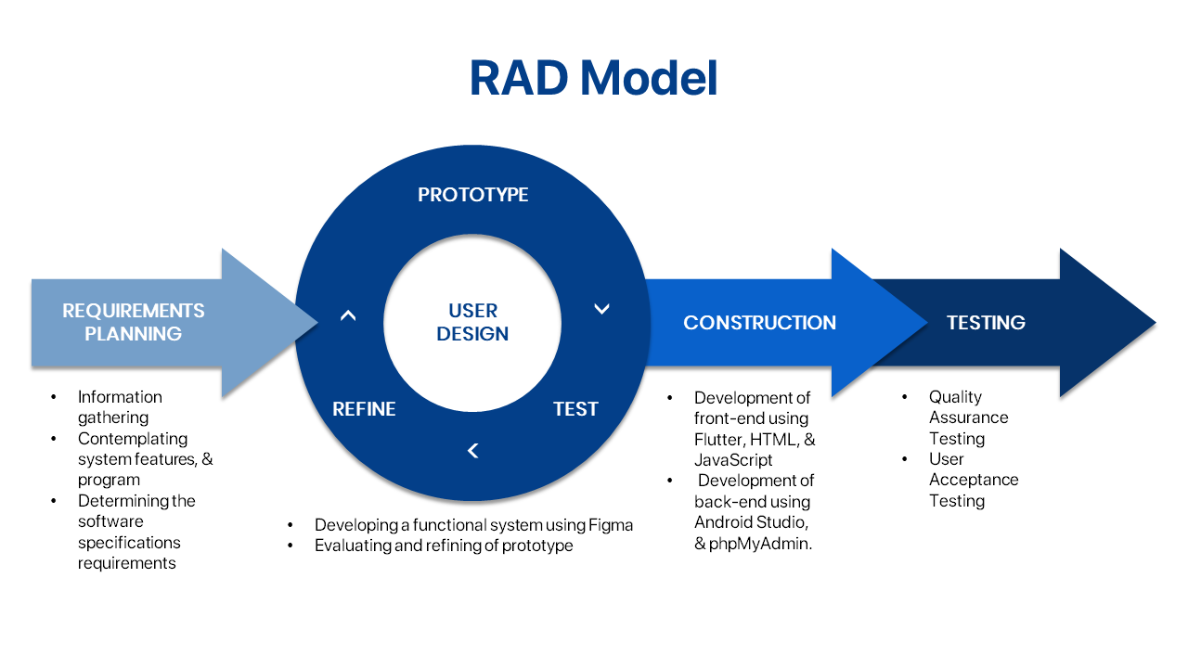

**Figure 1**

Project Framework for the Development of Customer Satisfaction Survey

System for University of Rizal System

The first phase is requirements planning in which the project team gathers information and analyzes what is needed for developing the system including features, and program and software specifications. The project team consulted with the CSS coordinator before visiting the University of Rizal System-Morong campus to conduct an interview with the head of the Customer Satisfaction Survey (CSS) for possible issues that are being experienced by the university.

The second phase is prototyping in which the project team will focus on developing a functional system using a collaborative web-application for interface design, specifically Figma. The prototype will highlight the features and visual representation of the system. This will include user evaluation and refinement of the prototype.

The third phase is rapid construction in which the project team will begin with coding the entire system. The front-end will be programmed using Flutter, HTML, and JavaScript, while Android Studio and phpMyAdmin will be used for back-end development. In this phase, it also includes testing the quality of the system in order to get rid of potential bugs and issues that may be encountered and to ensure its credibility.

The last phase is testing of the product wherein the project team will finalize the system and perform final testing to ensure that all the requirements are met before deploying it.

The project development framework is ideal for this project since it will assist in analyzing and completing the system development process. Additionally, it describes the whole process that will be done by the project team from requirements analysis to system implementation.

**Locale of the Project**

The project team has identified University of Rizal System as the project’s setting. According to the report by Faulve (2024), University Administrative Officer, there is a total of 25,821 student population in the university for the academic year 2023-2024. The population of students increased by a total of 3.28%. The mentioned university comprises 10 campuses and 16 colleges offering different programs.

University of Rizal System is located in the province of Rizal. The university is an extension campus of Rizal Technological University and a merger of two state colleges which are the Rizal Polytechnic College and Rizal State College. In 2001, it was established as State University in the province of Rizal that was followed by the foundation of extension campuses in Angono, Antipolo, Binangonan, Cainta, Pililla, Rodriguez, and Tanay. Tanay campus was then issued as the main campus of the university in 2002. As of now, the university has 10 campuses located in different parts of Rizal province. Moreover, they offer different college programs on each campus. The University of Rizal System has different offices and departments that provide services for their stakeholders which is open for evaluation to improve their overall processes. This evaluation can be used for various purposes such as enhancing teaching quality, feedback for improvement, measuring program effectiveness, and support for the accreditation process.

With the aforementioned number of populations above, the reports for the customer satisfaction survey are handled by the coordinator per campus which is supposed to make it easier for the university but they sometimes experience delay in transacting the needed data and information.

**Subject of the Project**

Using the stratified purposeful sampling technique, respondents from University of Rizal System will be carefully selected to participate in the study. By using this sampling method, individuals are chosen based on their relevance to the objectives of the project ensuring that roles directly related to the system being developed is prioritized. The sample will provide a comprehensive understanding of the system’s potential impact as key stakeholders within the university.

A total of three hundred seventy-nine (379) will be the respondents for the project which includes the one (1) CSS Head, five (5) MIS, five (5) CSS coordinators, five (5) campus directors, five (5) IT experts, and three hundred fifty-eight (358) customers.

This approach allows the project team to gather targeted feedback from individuals who are familiar with the university's operations and customer satisfaction processes. The team ensures that the data collected will be insightful and relevant to the system’s purpose by selecting respondents who actively engage in these processes. The project team is certain that the respondents can accurately assess the system that is to be developed since the features that will be present in the system are specific for the university’s operation.

**Procedures of the Project**

In creation of this project, the project team adhered to a step-by-step procedure as every good capstone project has similar characteristics in having a scientific and systematic nature.

Initially, the project team consulted with their capstone project instructor with their primary ideas for possible system titles then finalized during their meeting the best among the rest.

Following that, they conducted several interviews for them to have additional ideas in particular to the various issues an organization might be facing. The proponents used their new found knowledge from the interviews to formulate their system titles and have prepared features in respective titles in preparation for the title defense. After that, their capstone instructor assessed their formulated system titles. Subsequently, the project team had a title defense where the panel examined their proposed system titles including the features and scope of the study. At last, it has been decided by the panel members that the project team will have the “Customer Satisfaction Survey System for University of Rizal System” as their capstone project title.

The project team started the collection of data and system requirements to be used in the development of the system. After this, they looked for a project adviser whom they think can aid them in preparing for the pre-oral defense. Along with this, they begin with the writing of chapters in the manuscript specifically the Chapter 1 to 3. It was followed by their wireframing of the system before they proceed to the actual designing and prototyping. For the upcoming colloquium, the project team will present the developed design for their title in which the panels will scrutinize to give comments and suggestions on what can be improved for their capstone project. Thereafter, the project team will revise the contents of their manuscript following the given remarks and statements before they proceed with the soft binding that will be passed to their capstone project instructor.

# BIBLIOGRAPHY

**BIBLIOGRAPHY**

1. **BOOK**

Dela Coste, R., Arambulo, A. J. (2019*). E-learning Management System for Raises Montessori Academe in Angono Rizal*. University of Rizal System Binangonan Rizal.

1. **ONLINE JOURNAL ARTICLE**

Mishra, K., Vegad, M. (2024). Customer Feedback Analysis Using Text Mining. International journal of scientific research in computer science, engineering and information technology. https://doi.org/10.32628/cseit2410238

Sinha, P., Roychowdhury, S., Tanaji, B. H. (2024). Customer Feedback Analysis Using Aspect Based Sentiment Analysis and Fuzzy Analytic Hierarchy Process. https://doi.org/10.1109/i2ct61223.2024.10544032

Weichbroth, P. (2019). A mixed-methods measurement and evaluation methodology for mobile application usability studies. *20*, 101-106. https://doi.org/10.15439/2019F299

Mahfida, A., Nusrat, J. L. (2020). A Web Based Automated Tool for Course Teacher Evaluation System (TTE). International Journal of Education and Management Engineering, *10*(2), 11-19. https://doi.org/10.5815/IJEME.2020.02.02

Santillan, K. M. Streamlining Faculty Evaluations: A Web-Based System for Enhanced Efficiency and Data-Driven Insights. *6*(2), 41-48. https://doi.org/10.69478/jitc2024v6n002a04

Fadhil, S. N., Mahmood, N., Ahmed, N. (2021). The Significance of Management Information System in Improving Organizational Performance and Effectiveness. *7*(4), 195-211. https://doi.org/10.24271/GARMIAN.207017

Martinez, S. J., Castro, E. D., Pacheco, A. (2024). Management information system, a strategic tool to enhance decision making in micro and small businesses. F1000Research. https://doi.org/10.12688/f1000research.144450.1

Piris, Y., Gay, A. C. (2020). Customer satisfaction and natural language processing. 264-271. https://doi.org/10.1016/j.jbusres.2020.11.065

Umarani, V., Julian, A., Deepa, J. (2021). Sentiment Analysis using various Machine Learning and Deep Learning Techniques. 385-394. https://doi.org/10.46481/JNSPS.2021.308

Baucells, M., Borgonovo, E., Plischke, E., Barr, J., Rabitz, H. (2021). Trend Analysis in the Age of Machine Learning. Social Science Research Network. https://doi.org/10.2139/SSRN.3867894

Springer International Publishing, (2022). A Literature Review on Software Testing Techniques. EAI/Springer Innovations in Communication and Computing, 59-75. https://doi.org/10.1007/978-3-031-07297-0_5

Keibach, E., Shayesteh, H. (2022). BIM for Landscape Design Improving Climate Adaptation Planning: The Evaluation of Software Tools Based on the ISO 25010 Standard. Applied Sciences, *12*(2), 739-739. https://doi.org/10.3390/app12020739

Shuang, Z. (2020). Business analytics using machine learning and large-scale textual data: Three essays. https://typeset.io/papers/business-analytics-using-machine-learning-and-large-scale-3c66xx5xhd

Rane, N., Choudhary, S., & Rane J. (2024). Artificial intelligence, machine learning, and deep learning for sentiment analysis in business to enhance customer experience, loyalty, and satisfaction. Social Science Research Network. <https://typeset.io/papers/artificial-intelligence-machine-learning-and-deep-learning-16dfkzm8dr>

Camacho-Collados, J., Rezaee, K., Riahi, T., Ushio, A., Loureiro, D., Antypas, D., Boisson, J., Espinosa Anke, L., Liu, F., Martínez-Cámara, E., Medina, G., Bührmann, T., Barbieri, F., & Neves, L. (2022). TweetNLP: Cutting-Edge Natural Language Processing for Social Media. arXiv. <https://arxiv.org/abs/2206.14774>

Sidek, Z., Syed Ahmad, S. S., Jaya Kumar, Y., Ibrahim Teo, N. H. (2024). Text Classification on Customer Feedback: A Systematic Literatures Review. Indonesian Journal of Electrical Engineering and Computer Science <https://doi.org/10.11591/ijeecs.v34.i2.pp1258-1267>

Smith, J. (2021). Exploring education practices in modern classrooms. Journal of Educational Research, *45*(3), 123-145. https://files.eric.ed.gov/fulltext/EJ1313255.pdf

1. **ONLINE BOOK CHAPTER**

Elgar, E. Publishing eBooks (2022). Customer Feedback. 729-731.<https://typeset.io/papers/customer-feedback-35xktapv>

Singh, P. (2019). Natural Language Processing. 191-218. https://typeset.io/papers/natural-language-processing-4tbby003pk

Gulcin, H. (2022). Sentiment analysis for use within rapid implementation research. 116-117.<https://typeset.io/papers/sentiment-analysis-for-use-within-rapid-implementation-24i7u5fn>

Regan, G. (2019). Fundamentals of Software Testing. 59-78. [https://typeset.io/papers/fundamentals-of-software-testing-3rnd1xrww1](https://typeset.io/papers/fundamentals-of-software-testing-3rnd1xrww1?fbclid=IwZXh0bgNhZW0CMTAAAR0KW3xH7yKpaut438Sugv1Xcq46NF6xu6zU1-gtTr9c12enlB5W8usImdw_aem_qzTaKM1vDUd3_sjOFVv0Zw)

ISO/IEC JTC 1/SC 7, (2023). ISO/IEC 25010:2023. *Systems and software engineering — Systems and software Quality Requirements and Evaluation (SQuaRE) — Product quality model.*<https://www.iso.org/standard/78176.html#lifecycle>

Rapp, D. (2023). Testing and Quality Assurance. 235-273. <https://doi.org/10.1007/978-1-4842-9385-0_6>

Venkata, A., Subramanian, V., Ganesan, V., & Ramasamy, V. (2024). Analyzing Consumer Product Feedback Dynamics with Confidence Intervals. 115-128. <https://doi.org/10.1201/9781003388241-13>

1. **CONFERENCE PAPER**

Wu, J., Duffy, V.G. (2022). Mobile Applications Usability Evaluation: Systematic Review and Reappraisal. 499-516. https://doi.org/10.1007/978-3-031-17615-9_35

Dewi, M. R., Ngaliah, N., Rochimah, S. (2020). Maintainability Measurement and Evaluation of myITS Mobile Application Using ISO 25010 Quality Standard. https://typeset.io/papers/maintainability-measurement-and-evaluation-of-myitsmobile1blr3av0jk

Hasanah, N. A., Atikah, L., Rochimah, S. (2020). Functional Suitability Measurement Based on ISO/IEC 25010 for e-Commerce Website. https://doi.org/10.1109/ICITACEE50144.2020.9239194

Yuniasri, D., Damayanti, P., Rochimah, S. (2020). Performance Efficiency Evaluation Frameworks Based on ISO 25010. https://doi.org/10.1109/EECCIS49483.2020.9263432

Fadilah, M. D., Rochimah, S. (2023). Security Evaluation of Insurance Portal Agency Information System Based on ISO/IEC 25010 Quality Standard Utilizing OWASP ZAP. 352-357. <https://doi.org/10.1109/icicyta60173.2023.10428701>

University of Baguio. (2023). UB client satisfaction survey (Version 2) [PDF]. University of Baguio. <https://ubaguio.edu/wp-content/uploads/2023/06/UB-Client-Satisfaction-Surveryv2.pdf>

1. **PATENT**

Wang, Y. (2019). Data trend analysis method and system, computer device and readable storage medium. <https://typeset.io/papers/data-trend-analysis-method-andsystem-computer-device-and-7k2nhlk05d>

1. **ONLINE BLOG**

Sherrer, K. (2024, April 5). What is Rapid Application Development (RAD)?. *TechnologyAdvice*. https://technologyadvice.com/blog/project-management/rapid-application-development/

Nishadha. (2022, May 11). Tech Talks ~ The Importance of Reliability. *Creately*. https://creately.com/blog/development/tech-talks-the-importance-of-reliability-2/

Britton, J. (2021, May 6). What Is ISO 25010?. *Perforce*. https://www.perforce.com/blog/qac/what-is-iso-25010#main

Codacy. (2021, March 17). An Exploration of the ISO/IEC 25010 Software Quality Model. *Codacy*. https://blog.codacy.com/iso-25010-software-quality-model

# APPENDICES

**Appendix A**

Gantt Chart of Activities

|  |  |  |  |  |  |  |  |  |  |  |  |  |  |  |  |  |  |  |  |  |  |  |  |  |  |  |  |  |  |  |  |  |  |  |  |  |  |  |
| --- | --- | --- | --- | --- | --- | --- | --- | --- | --- | --- | --- | --- | --- | --- | --- | --- | --- | --- | --- | --- | --- | --- | --- | --- | --- | --- | --- | --- | --- | --- | --- | --- | --- | --- | --- | --- | --- | --- |
| **Activities** | **Aug** | | **September** | | | | **October** | | | | **November** | | | | **December** | | | | **January** | | | | **February** | | | | **March** | | | | **April** | | | | **May** | | | |
| Identifying Problems |  |  |  |  |  |  |  |  |  |  |  |  |  |  |  |  |  |  |  |  |  |  |  |  |  |  |  |  |  |  |  |  |  |  |  |  |  |  |
| Formulation of Title |  |  |  |  |  |  |  |  |  |  |  |  |  |  |  |  |  |  |  |  |  |  |  |  |  |  |  |  |  |  |  |  |  |  |  |  |  |  |
| Title Defense |  |  |  |  |  |  |  |  |  |  |  |  |  |  |  |  |  |  |  |  |  |  |  |  |  |  |  |  |  |  |  |  |  |  |  |  |  |  |
| Gathering of Data |  |  |  |  |  |  |  |  |  |  |  |  |  |  |  |  |  |  |  |  |  |  |  |  |  |  |  |  |  |  |  |  |  |  |  |  |  |  |
| Development of chapter 1-3 |  |  |  |  |  |  |  |  |  |  |  |  |  |  |  |  |  |  |  |  |  |  |  |  |  |  |  |  |  |  |  |  |  |  |  |  |  |  |
| Wireframe & System Prototype Development |  |  |  |  |  |  |  |  |  |  |  |  |  |  |  |  |  |  |  |  |  |  |  |  |  |  |  |  |  |  |  |  |  |  |  |  |  |  |
| Consultation with capstone project adviser |  |  |  |  |  |  |  |  |  |  |  |  |  |  |  |  |  |  |  |  |  |  |  |  |  |  |  |  |  |  |  |  |  |  |  |  |  |  |
| Finalizing of manuscript |  |  |  |  |  |  |  |  |  |  |  |  |  |  |  |  |  |  |  |  |  |  |  |  |  |  |  |  |  |  |  |  |  |  |  |  |  |  |
| Pre-Oral Defense |  |  |  |  |  |  |  |  |  |  |  |  |  |  |  |  |  |  |  |  |  |  |  |  |  |  |  |  |  |  |  |  |  |  |  |  |  |  |
| Revision of manuscript |  |  |  |  |  |  |  |  |  |  |  |  |  |  |  |  |  |  |  |  |  |  |  |  |  |  |  |  |  |  |  |  |  |  |  |  |  |  |
| Submission of Softbound |  |  |  |  |  |  |  |  |  |  |  |  |  |  |  |  |  |  |  |  |  |  |  |  |  |  |  |  |  |  |  |  |  |  |  |  |  |  |
| Development of the system |  |  |  |  |  |  |  |  |  |  |  |  |  |  |  |  |  |  |  |  |  |  |  |  |  |  |  |  |  |  |  |  |  |  |  |  |  |  |
| Development of chapter 4 |  |  |  |  |  |  |  |  |  |  |  |  |  |  |  |  |  |  |  |  |  |  |  |  |  |  |  |  |  |  |  |  |  |  |  |  |  |  |
| System Testing |  |  |  |  |  |  |  |  |  |  |  |  |  |  |  |  |  |  |  |  |  |  |  |  |  |  |  |  |  |  |  |  |  |  |  |  |  |  |
| Consultation with the adviser and panel members |  |  |  |  |  |  |  |  |  |  |  |  |  |  |  |  |  |  |  |  |  |  |  |  |  |  |  |  |  |  |  |  |  |  |  |  |  |  |
| Acceptance Testing |  |  |  |  |  |  |  |  |  |  |  |  |  |  |  |  |  |  |  |  |  |  |  |  |  |  |  |  |  |  |  |  |  |  |  |  |  |  |
| Development chapter 5 and finalization of the manuscript |  |  |  |  |  |  |  |  |  |  |  |  |  |  |  |  |  |  |  |  |  |  |  |  |  |  |  |  |  |  |  |  |  |  |  |  |  |  |
| Oral Defense |  |  |  |  |  |  |  |  |  |  |  |  |  |  |  |  |  |  |  |  |  |  |  |  |  |  |  |  |  |  |  |  |  |  |  |  |  |  |
| Revision of Manuscript and System |  |  |  |  |  |  |  |  |  |  |  |  |  |  |  |  |  |  |  |  |  |  |  |  |  |  |  |  |  |  |  |  |  |  |  |  |  |  |
| Submission of Hardbound copy |  |  |  |  |  |  |  |  |  |  |  |  |  |  |  |  |  |  |  |  |  |  |  |  |  |  |  |  |  |  |  |  |  |  |  |  |  |  |

**Appendix B**

Project Team Assignment Form

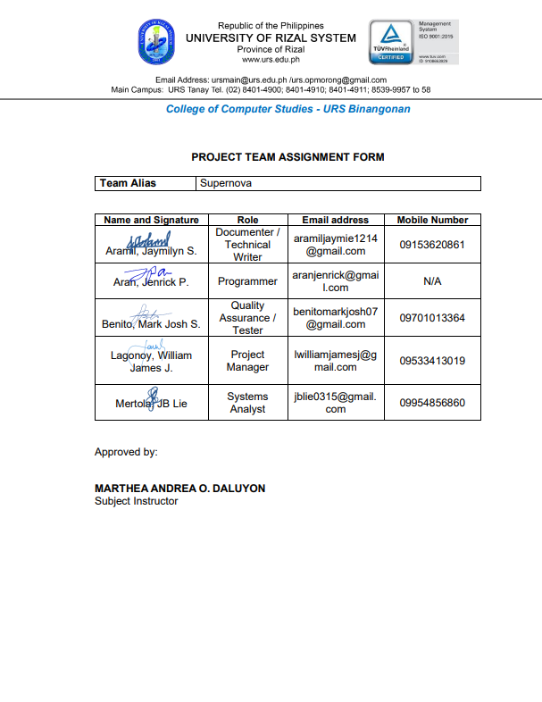

**Appendix C**

Letter of Permission to Conduct the Project



**Appendix D**

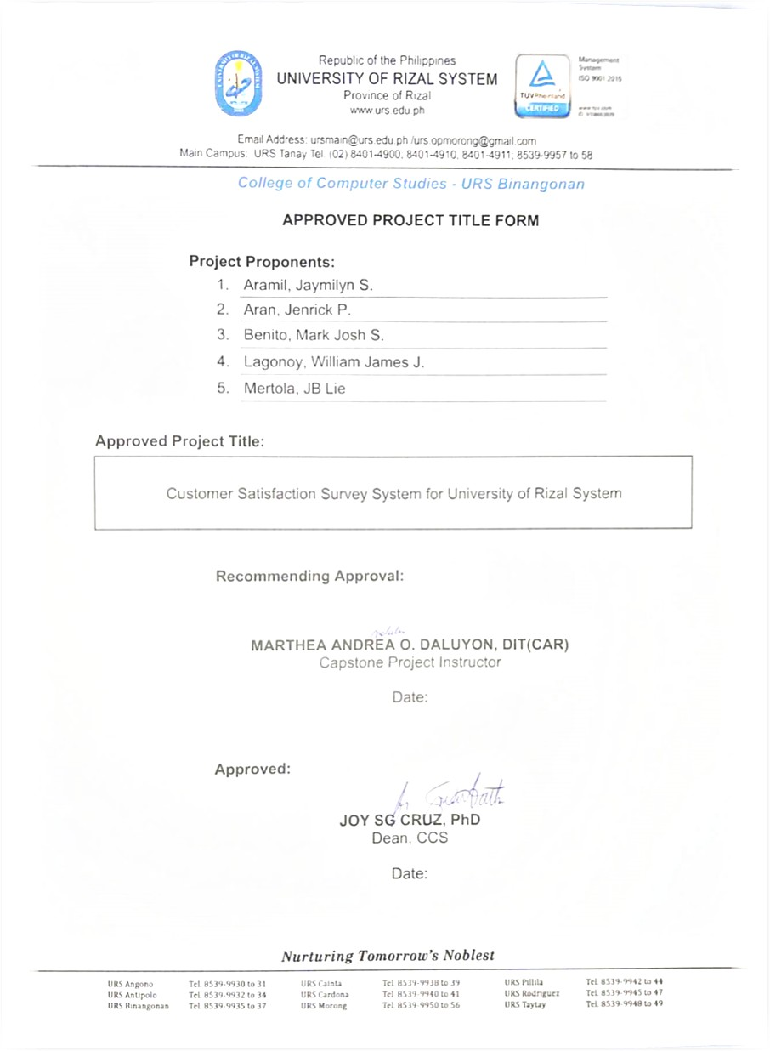Approved Project Title Form

**Appendix E**

Letter of Acceptance of the Adviser and Panel

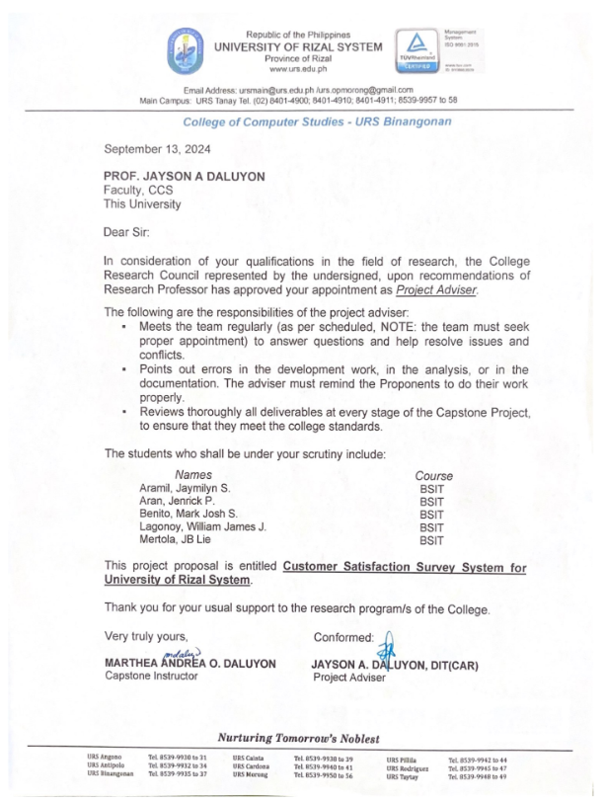

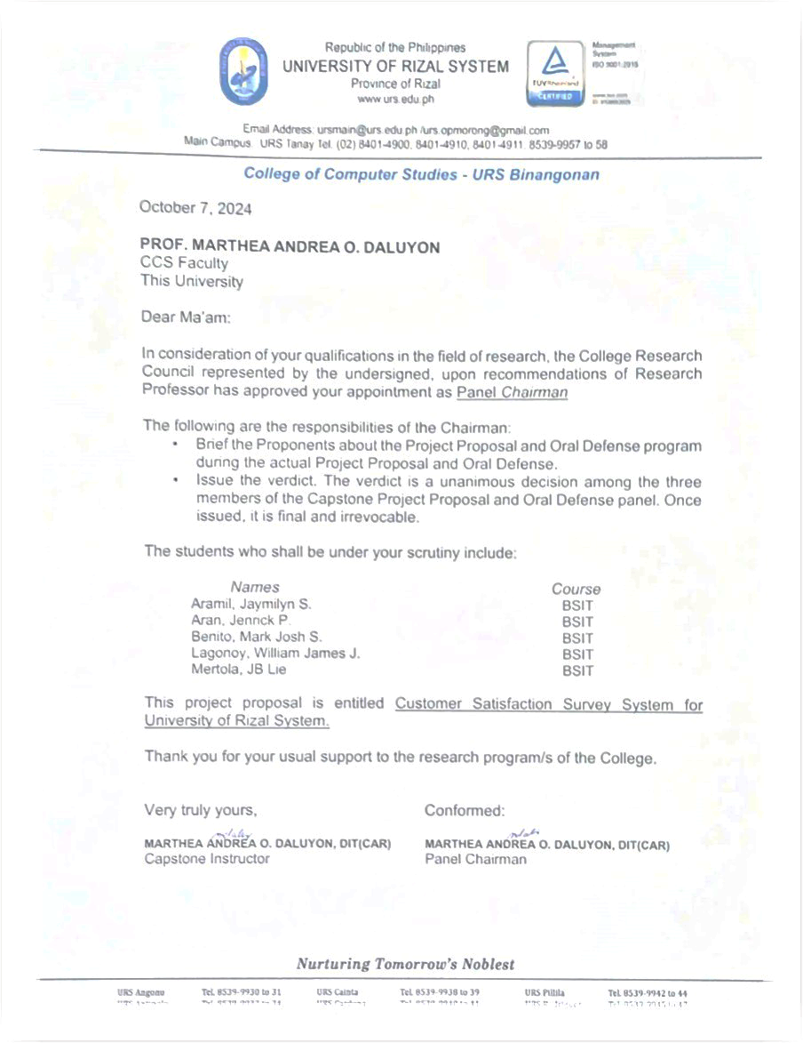

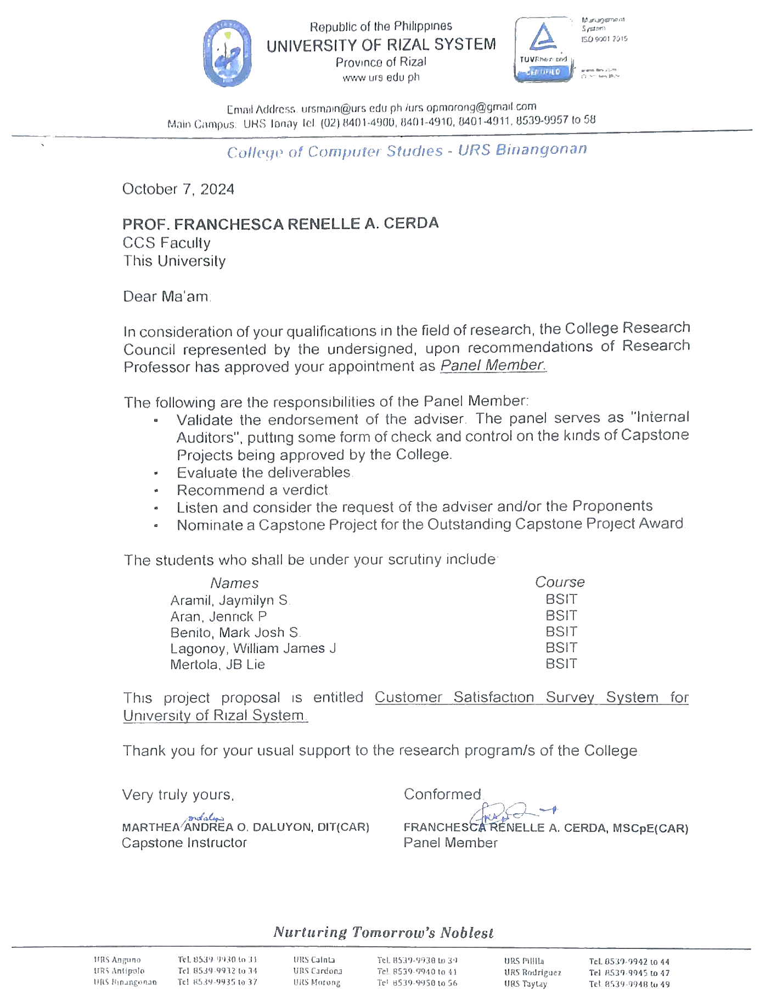

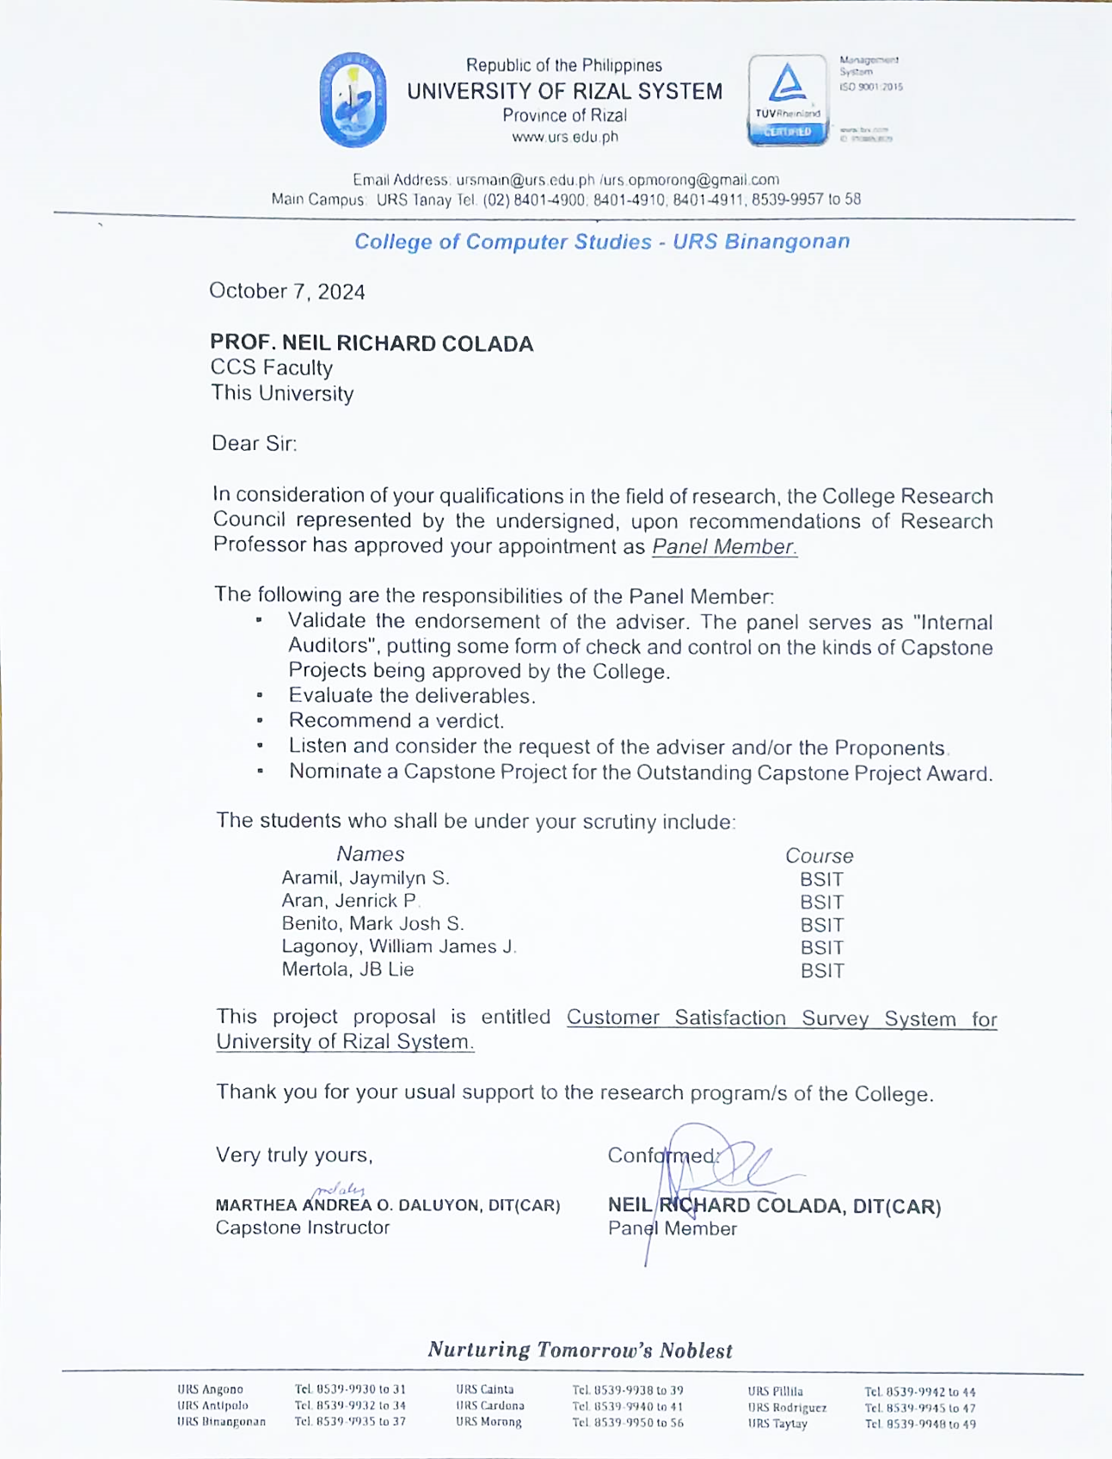

**Appendix F**

**User Acceptance Evaluation Questionnaire**

Customer Satisfaction Survey System for

University of Rizal System

**Part I. RESPONDENT’S PROFILE**

Name (Optional): _______________________________ Campus: ___________

Respondent: 🞏 Customers 🞏 CSS Head 🞏 MIS 🞏 CSS Coordinator

🞏 Campus Director 🞏 Data Control Center (DCC)

🞏 IT Practitioners

**Part II. EVALUATION OF THE LEVEL OF ACCEPTABILITY**

**Instruction:** Using scale below, please put a check (✓) to indicate your answer on the following. Only one check is allowed per item.

**Legend:**

4 – Highly Acceptable

3 – Acceptable

2 – Moderately Acceptable

1 – Not Acceptable

|  |  |  |  |  |  |
| --- | --- | --- | --- | --- | --- |
|  | | **4** | **3** | **2** | **1** |
| **1. Functional Suitability** | | | | | |
| **1.1** | **Functional completeness.** Degree to which the set of functions covers all the specified tasks and user objectives. |  |  |  |  |
| **1.2** | **Functional correctness.** Degree to which the E-Learning Management System for IGPAI provides the correct results with the needed degree of precision. |  |  |  |  |
| **1.3** | **Functional appropriateness.**  Degree to which the functions facilitate the accomplishment of specified tasks and objectives. |  |  |  |  |
|  | | | | | |
| **2. Interaction Capability** | | | | | |
| **2.1** | **Appropriateness recognizability.**Degree to which users can recognize whether E-Learning Management System for IGPAI is appropriate for their needs. |  |  |  |  |
| **2.2** | **Learnability -** Degree to which the functions of a product or system can be learnt to be used by specified users within a specified amount of time |  |  |  |  |
| **2.3** | **Operability.** Degree to which the E-Learning Management System for IGPAI has attributes that make it easy to operate and control. |  |  |  |  |
| **2.4** | **User error protection.** Degree to which the E-Learning Management System for IGPAI users against making errors. |  |  |  |  |
| **2.5** | **User engagement -** Degree to which a user interface presents functions and information in an inviting and motivating manner encouraging continued interaction |  |  |  |  |
| **3. Reliability** | | | | | |
| **3.1** | **Faultlessness**. Degree to which the E-Learning Management System for IGPAI meets needs for reliability under normal operation |  |  |  |  |
| **3.2** | **Availability.** Degree to which the E-Learning Management System for IGPAI is operational and accessible when required for use. |  |  |  |  |
| **3.3** | **Fault tolerance.** Degree to which the E-Learning Management System for IGPAI operates as intended despite the presence of hardware or software faults. |  |  |  |  |
| **3.4** | **Recoverability**. Degree to which, in the event of an interruption or a failure, the E-Learning Management System for IGPAI can recover the data directly affected and re-establish the desired state of the system. |  |  |  |  |
|  | | | | | |
| **4. Security** | | | | | |
| **4.1** | **Confidentiality.** Degree to which the E-Learning Management System for IGPAI ensures that data are accessible only to those authorized to have access. |  |  |  |  |
| **4.2** | **Integrity.** Degree to which the E-Learning Management System for IGPAI prevents unauthorized access to, or modification of, computer programs or data. |  |  |  |  |
| **4.3** | **Non-repudiation.** Degree to which actions or events can be proven to have taken place, so that the events or actions cannot be repudiated later. |  |  |  |  |
| **4.4** | **Accountability.** Degree to which the actions of an entity can be traced uniquely to the entity. |  |  |  |  |
| **4.5** | **Authenticity.** Degree to which the identity of a subject or resource can be proved to be the one claimed. |  |  |  |  |
|  | | | | | |
| **5. Maintainability** | | | | | |
| **5.1** | **Modularity.** Degree to which the E-Learning Management System for IGPAI is composed of discrete components such that a change to one component has minimal impact on other components. |  |  |  |  |
| **5.2** | **Reusability.** Degree to which an asset can be used in more than one system, or in building other assets. |  |  |  |  |
| **5.3** | **Analyzability.** Degree of effectiveness and efficiency with which it is possible to assess the impact on the E-Learning Management System for IGPAI of an intended change to one or more of its parts, or to diagnose a system for deficiencies or causes of failures, or to identify parts to be modified. |  |  |  |  |
| **5.4** | **Modifiability.** Degree to which the E-Learning Management System for IGPAI can be effectively and efficiently modified without introducing defects or degrading existing system quality. |  |  |  |  |
|  | | | | | |
| **6. Flexibility** | | | | | |
| **6.1** | **Adaptability.** Degree to which the E-Learning Management System for IGPAI can effectively and efficiently be adapted for different or evolving hardware, software or other operational or usage environments. |  |  |  |  |
| **6.2** | **Installability.** Degree of effectiveness and efficiency with which the E-Learning Management System for IGPAI can be successfully installed and/or uninstalled in a specified environment. |  |  |  |  |
|  | | | | | |
| **7. Safety** | | | | | |
| **7.1** | **Operational constraint -** Degree to which a product or system constrains its operation to within safe parameters or states when encountering operational hazard. |  |  |  |  |
| **7.2** | **Risk identification -** Degree to which a product can identify a course of events or operations that can expose life, property or environment to unacceptable risk. |  |  |  |  |

**CURRICULUM VITAE**



**JAYMILYN S. ARAMIL**

Taytay, Rizal

aramiljaymie1214@gmail.com

**Educational Background**

**Name of School Year-Attended**

|  |  |  |  |
| --- | --- | --- | --- |
| **College:** |  | University of Rizal System - Binangonan  **Course:** BS Information Technology | 2022 – Present |
| **Senior High School:** |  | Golden Faith Academy | 2020 – 2022 |
| **High School:** |  | Taytay National High School | 2016 – 2020 |
| **Elementary:** |  | San Francisco Elementary School | 2010 – 2016 |

**Seminar and Training Attended**

|  |  |
| --- | --- |
|  |  |
| **Rizal ICT Conference 2024 “Navigating the Digital Frontier: Integrate. Innovate. Inspire.”**  DICT Rizal in collaboration with CCS Student Body & i-Connect Student Society  April 25, 2024 | **Basic Accounting “Accounting Equation”**  URSB, College of Accountancy  February 26, 2024 |
| **Starting Up a Business**  URSB, College of Business  February 26, 2024 | **SASS Simplified: Understanding the Basic of SASS and Contrasts from CSS**  URSB, Information Technology Students’ League  January 27, 2024 |

**Achievements**

**Dean’s Lister**

**1st Year, Academic Year 2022-2023**

2nd Semester



**JENRICK P. ARAN**

Binangonan, Rizal

aranjenrick@gmail.com

**Educational Background**

**Name of School Year-Attended**

|  |  |  |  |
| --- | --- | --- | --- |
| **College:** |  | University of Rizal System - Binangonan  **Course:** BS Information Technology | 2022 – Present |
| **Senior High School:** |  | Vicente Madrigal Integrated School | 2020 – 2022 |
| **High School:** |  | Mahabang Parang National High School | 2016 – 2020 |
| **Elementary:** |  | Casimiro A. Ynares Sr. Elementary School | 2010 – 2016 |

**Seminar and Training Attended**

|  |  |
| --- | --- |
|  |  |
| **Rizal ICT Conference 2024 “Navigating the Digital Frontier: Integrate. Innovate. Inspire.”**  DICT Rizal in collaboration with CCS Student Body & i-Connect Student Society  April 25, 2024 | **Basic Accounting “Accounting Equation”**  URSB, College of Accountancy  February 26, 2024 |
| **Starting Up a Business**  URSB, College of Business  February 26, 2024 |  |
|  |  |

**Organization/s Affiliation**

|  |  |  |
| --- | --- | --- |
| **Organization Name** | **Position** | **Inclusive date of Membership** |
| Information Technology Students’ League | Technical Committee  Project Manager | 2024-2025  2023-2024 |
|  |  |  |

**Achievements**

**Dean’s Lister**

**2nd Year, Academic Year 2023-2024**

1st Semester



**MARK JOSH S. BENITO**

Taytay, Rizal

Benitomarkjosh@gmail.com

**Educational Background**

**Name of School Year-Attended**

|  |  |  |  |
| --- | --- | --- | --- |
| **College:** |  | University of Rizal System - Binangonan  **Course:** BS Information Technology | 2022 – Present |
| **Senior High School:** |  | Golden Faith Academy | 2020 – 2022 |
| **High School:** |  | Muzon National High School | 2016 – 2020 |
| **Elementary:** |  | Muzon Elementary School | 2010 – 2016 |

**Seminar and Training Attended**

|  |  |
| --- | --- |
|  |  |
| **Rizal ICT Conference 2024 “Navigating the Digital Frontier: Integrate. Innovate. Inspire.”**  DICT Rizal in collaboration with CCS Student Body & i-Connect Student Society  April 25, 2024 | **Basic Accounting “Accounting Equation”**  URSB, College of Accountancy  February 26, 2024 |
| **Starting Up a Business**  URSB, College of Business  February 26, 2024 |  |



**WILLIAM JAMES J. LAGONOY**

Taytay, Rizal

lwilliamjamesj@gmail.com

**Educational Background**

|  |  |  |  |
| --- | --- | --- | --- |
|  |  | **Name of School** | **Year Attended** |
| **College:** |  | University of Rizal System - Binangonan  **Course:** BS Information Technology | 2022 – Present |
| **Senior High School:** |  | Our Lady of Fatima University – Antipolo Campus | 2020 – 2022 |
| **High School:** |  | Casimiro A. Ynares Sr., Memorial National High School | 2016 – 2020 |
| **Elementary:** |  | Taytay Elementary School | 2010 – 2016 |

**Seminar and Training Attended**

|  |  |
| --- | --- |
|  |  |
| **Rizal ICT Conference 2024 “Navigating the Digital Frontier: Integrate. Innovate. Inspire.”**  DICT Rizal in collaboration with CCS Student Body & i-Connect Student Society  April 25, 2024 | **Basic Accounting “Accounting Equation”**  URSB, College of Accountancy  February 26, 2024 |
| **Starting Up a Business**  URSB, College of Business  February 26, 2024 | **SASS Simplified: Understanding the Basic of SASS and Contrasts from CSS**  URSB, Information Technology Students’ League  January 27, 2024 |

**Organization/s Affiliation**

|  |  |  |
| --- | --- | --- |
| **Organization Name** | **Position** | **Inclusive date of Membership** |
|  |  |  |
| URSB Student Electoral Tribunal | Chairman | 2024 |
| College of Computer Studies – Student Body (CCS-SB) | President | 2023-2024 |
| i-Connect Student Society | Secretary | 2022-2023 |
| IT Students’ League | Deputy | 2023 |

**Achievements**

|  |  |
| --- | --- |
| **Dean’s Lister** |  |
|  |  |
| **2nd Year, Academic Year 2023-2024**  1st Semester | **1st Year, Academic Year 2022-2023**  1st Semester |
| **1st Year, Academic Year 2022-2023**  2nd Semester |  |



**JB LIE MERTOLA**

Binangonan, Rizal

jblie0315@gmail.com

**Educational Background**

**Name of School Year-Attended**

|  |  |  |  |
| --- | --- | --- | --- |
| **College:** |  | University of Rizal System - Binangonan  **Course:** BS Information Technology | 2022 – Present |
| **Senior High School:** |  | Zambales National High School | 2020 – 2022 |
| **High School:** |  | Guisguis National High School | 2016 – 2020 |
| **Elementary:** |  | Guisguis Elementary School | 2010 – 2016 |

**Seminar and Training Attended**

|  |  |
| --- | --- |
|  |  |
| **Rizal ICT Conference 2024 “Navigating the Digital Frontier: Integrate. Innovate. Inspire.”**  DICT Rizal in collaboration with CCS Student Body & i-Connect Student Society  April 25, 2024 | **Basic Accounting “Accounting Equation”**  URSB, College of Accountancy  February 26, 2024 |
| **Starting Up a Business**  URSB, College of Business  February 26, 2024 | **SASS Simplified: Understanding the Basic of SASS and Contrasts from CSS**  URSB, Information Technology Students’ League  January 27, 2024 |

**Achievements**

|  |  |
| --- | --- |
| **Dean’s Lister** |  |
|  |  |
| **2nd Year, Academic Year 2023-2024**  1st Semester | **1st Year, Academic Year 2022-2023**  1st Semester |
| **1st Year, Academic Year 2022-2023**  2nd Semester |  |