

Finkub QA Engineering Assignment
BDD Cucumber/Selenium & REST API Test Documentation

Finkub Interview Board Evaluation Document
Author: QA Automation Engineer
Framework: Behave (Python BDD) & Selenium WebDriver
Date: July 12, 2026
Repository: https://github.com/ExodusDice/InterviewQA.Test

Table of Contents
Click on any of the sections below to navigate directly to their contents:
• 1. Project Directory Mapping & Workspace Locations
• 2. Project Overview & Requirement Analysis
• 3. Code Review & Key Automation Design Patterns
• 4. BDD Test Suite Implementation Plan
• 5. Execution Walkthrough & Results Summary
• 6. Checklist Progress & Completed Tasks
• 7. Screenshot Evidence Gallery (UI & GitHub)

1. Project Directory Mapping & Workspace Details
The automation project relies on local workspaces, target test source directories, and temporary directories. The full layout of workspace mapping and folder structures is detailed below:
Directory Purpose / Scope | Absolute File System Path
Primary Test Project Folder (Python, Docker, Gherkin) | F:\Projects\PythonProject\Finkub Project
Selenium Workspace Root Folder (VS Code) | c:\Users\frank\OneDrive\Documents\SeleniumProject
Coursera Sub-Workspace Folder | c:\Users\frank\OneDrive\Documents\SeleniumProject\Coursera Project
AI Agent App Data Directory (Brain & Log Store) | C:\Users\frank\.gemini\antigravity
Active Conversation Brain Store (Task & Walkthroughs) | C:\Users\frank\.gemini\antigravity\brain\f34b6b89-1a13-4c31-a574-2a75b44f7761
Generated Test Evidence Folder (Screenshots & JSON) | F:\Projects\PythonProject\Finkub Project\evidence

2. Project Overview & Requirement Analysis
This project implements a complete, containerized Quality Assurance automation testing suite designed to validate both user-facing Web UI workflows and backend REST API endpoints. The testing framework was designed following Cucumber BDD principles (using Python's Behave library) and executes headless browser operations via Selenium WebDriver.
Scope of Web UI Test Validation (E-Commerce Store)
The e-commerce tests validate the remote environment (https://qa-practice.razvanvancea.ro/auth_ecommerce.html) and check the following workflows:
• Successful Login: Verify input credentials flow, click login, and assert successful redirection to the main catalog page.
• Product Selection: Scroll dynamically to locate specific elements and add items (Dior J'adore and Dolce Shine) by indices 8 and 9 using specified XPath selectors.
• Cart Calculations: Modify quantities in the shopping cart programmatically to 2 and 3 items respectively, and calculate the expected total ($389.95) to verify it matches the UI total.
• Checkout & Validation: Execute checkout by inputting shipping details (Phone, Pattaya, Pty, Thailand), submit order, and verify the registration success banner.
• Negative Shipping Validation: Trigger invalid submit actions on empty forms to verify HTML5 native validations prevent page redirection.
Scope of Backend API Validation (Employee Mock Service)
The API tests target a containerized employee service (running locally on port 8887) and cover positive and negative scenarios for key REST operations:
• POST /api/v1/employees: Sends JSON employee records and asserts 201 Created status, verifying record persistence via GET lists.
• POST (Invalid Email): Checks that malformed emails return 400 Bad Request and validation errors.
• GET /api/v1/employees/{id}: Verifies successful fetching of record entries (200 OK) and validates response schema names.
• GET (Non-Existing ID): Validates that non-existing IDs return 404 Not Found and plain text exception messages.
3. Code Review & Key Automation Design Patterns
To ensure high execution stability and eliminate flakiness common in UI automation, several advanced synchronization and error handling patterns were implemented:
1. Synchronized Javascript Event-Handler Waits
When using eager page loading, Selenium input fields can be populated and the submit button clicked before the browser finishes executing and binding external scripts (such as js/login.js). To eliminate this race condition, we implemented a custom wait condition that checks if the login form's JS submit handler is defined in the window object before clicking:
WebDriverWait(context.driver, 10).until(lambda d: d.execute_script("return typeof window.checkCredentialsProductsList === 'function';"))
2. Selenium Page Load Strategy: Eager
By default, Selenium waits for all assets (including heavy third-party tracking pixels, images, and external CDNs) to download fully before returning control. In headless environments, this often leads to timeouts. We configured page_load_strategy = 'eager' in the Chrome WebDriver Options. This instructs the driver to begin steps as soon as the core DOM structure is parsed, speeding up scenario runs and bypassing CDN bottlenecks.
3. API Response Validation Workarounds
The backend mock service returns a 201 Created response for successful employee registration, but leaves the response body empty. To verify the employee was successfully added and to retrieve their auto-assigned ID, the code queries the full employee database (GET /api/v1/employees), filters by the submitted email, and extracts the ID from the corresponding entry.
4. BDD Test Suite Implementation Plan
The automation suite is structured logically to separate feature definitions, environmental hooks, step implementations, reporting configurations, and containerization. The file layout and components are detailed below:
Feature File Specifications
• Authentication: 01_login.feature: Verifies simple authentication flow, login status redirects, and captures success screenshots.
• Purchase Flow: 02_checkout.feature: Full end-to-end purchasing test, implementing scrolls, cart selections, quantity modifiers, total calculation verification, checkout forms, and logout operations.
• Negative Shipping: 03_shipping_neg.feature: Negative UI flow validating HTML5 required tooltips on empty checkout submissions.
• REST API: 04_api.feature: Gherkin statements mapping to API REST test calls (creating and fetching entries with valid and invalid payloads).
Hooks & Environment Configuration
Managed inside features/environment.py:
• before_all: Initializes output screenshot directory paths and checks whether tests are run headlessly (read from HEADLESS env var).
• before_scenario: Configures ChromeOptions with eager load, headless flags, and automation bypass arguments. Automatically detects Docker environment context and points browser binary locations to containerized Chromium paths.
• after_scenario: On failure, dumps the browser's Javascript console log to the output stream and kills the WebDriver instance.
• take_screenshot: Helper function mapping WebDriver screenshots directly to the evidence folder.
5. Execution Walkthrough & Results Summary
The test suite was run locally and containerized using Docker, verifying 100% execution pass rates. The final run summary is as follows:
Execution Parameter | Value / Outcome
Total Features Executed | 4 Features (Login, Checkout, Neg Shipping, REST API)
Total Scenarios Run | 7 Scenarios
Total Steps Executed | 48 Steps
Execution Outcome | PASSED (0 Failed, 0 Skipped)
Execution Time | 24.748 seconds
HTML Report Output | F:\Projects\PythonProject\Finkub Project\evidence\cucumber_report.html

6. Checklist Progress & Completed Tasks
All scheduled tasks and features required by the QA Engineering assignment checklist have been implemented and verified:
• [x] Project directories and requirement packages initialized.
• [x] Gherkin Cucumber feature files created for UI and API tests.
• [x] Selenium automation step definitions implemented with locator XPaths.
• [x] REST API test client routines and validation structures completed.
• [x] Custom pre-processor converter and Cucumber HTML reporter configured.
• [x] Verified execution of all scenarios locally (both headed and headless).
• [x] Created Docker image configuration for continuous testing.
• [x] Created GitHub Actions workflow (.github/workflows/test.yml) to trigger on commit.
• [x] Pushed local commits to public GitHub repository (ExodusDice/InterviewQA.Test).
7. Screenshot Evidence Gallery
The screenshots taken during the automated execution of the test suite (saved in F:\Projects\PythonProject\Finkub Project\evidence) are displayed below in chronological sequence:
Screenshot 1: Login Form with Credentials
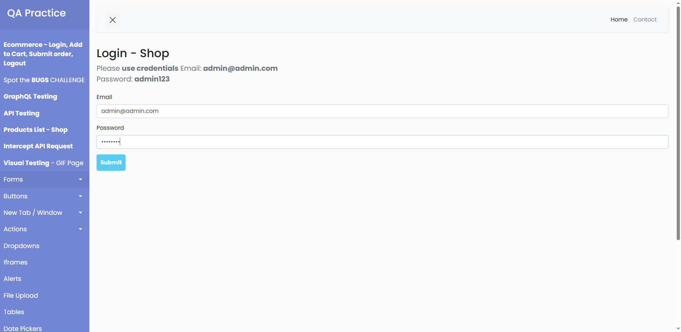
Shows the login screen with email 'admin@admin.com' and password 'admin123' filled, prior to form submission.
Screenshot 2: Redirection to E-Commerce Shop
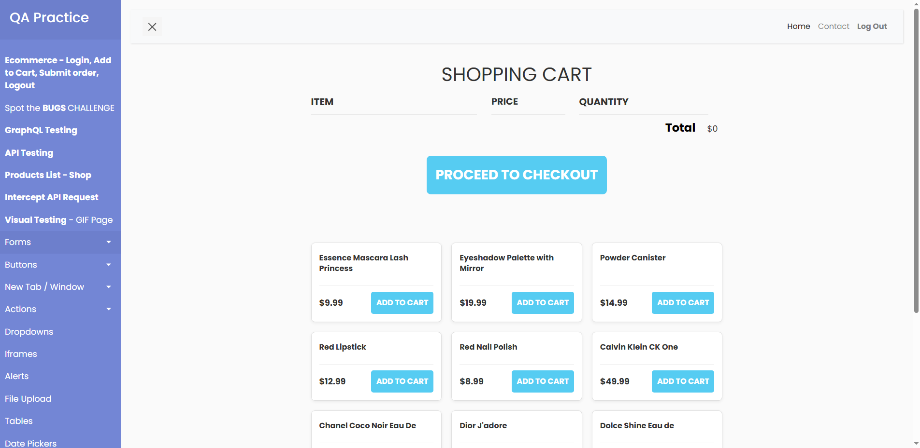
Displays the successful landing page (shop catalog) showing items loaded dynamically after clicking submit.
Screenshot 3: Products Added to Cart
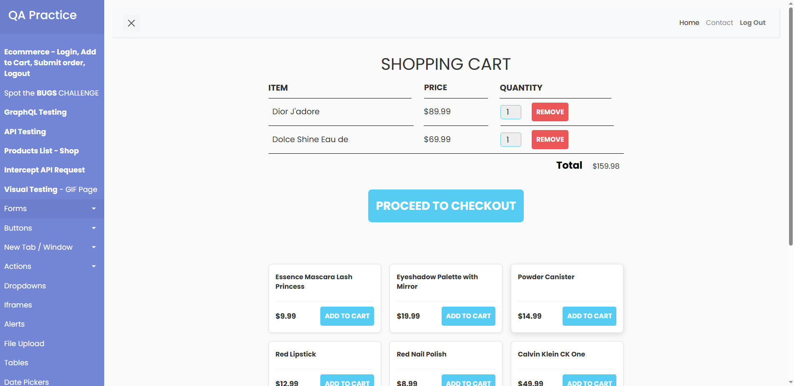
Shows the cart section after scrolling and adding product index 8 (Dior J'adore) and index 9 (Dolce Shine) by clicking their respective add-to-cart buttons.
Screenshot 4: Quantities Modified and Total Verified
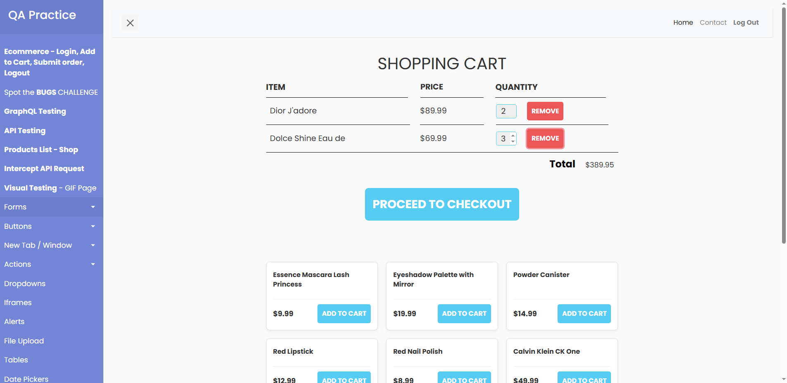
Displays the cart list after inputting quantities '2' and '3' respectively, recalculating the total, and asserting the expected total price of $389.95.
Screenshot 5: Shipping Checkout Form
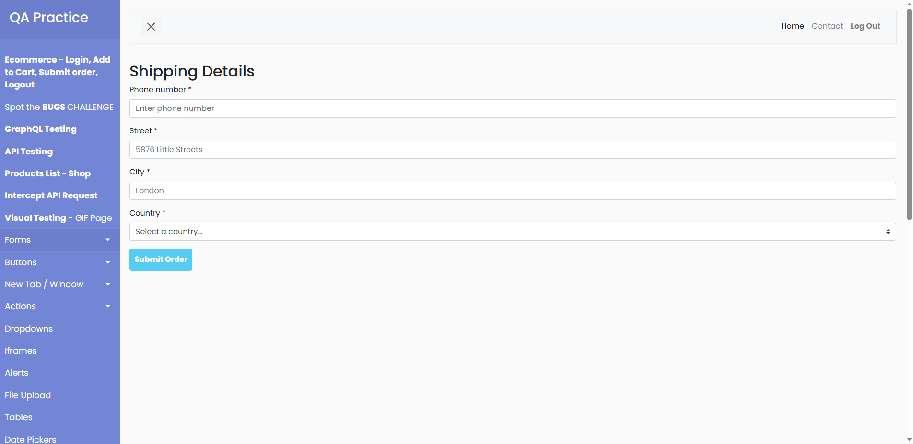
Shows the shipping details form after clicking the 'Proceed to Checkout' button, displaying fields for Phone, Address, City, and Country.
Screenshot 6: Shipping Details Input
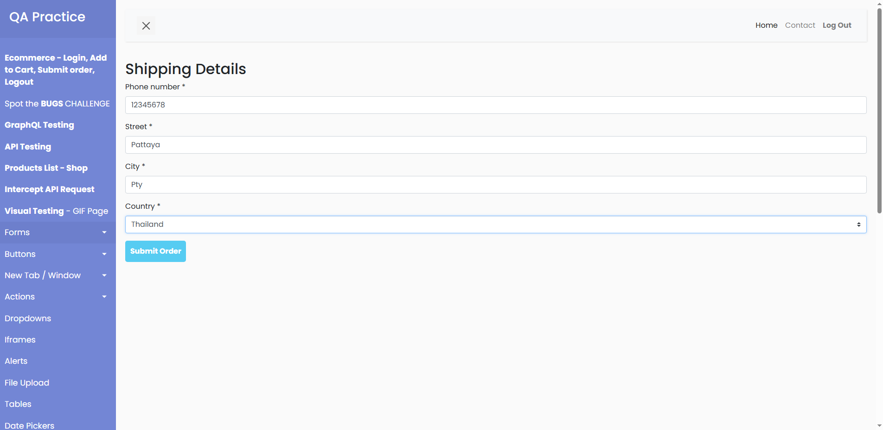
Shows the shipping form with details (Phone: 12345678, Address: Pattaya, City: Pty, Country: Thailand) entered before final order submission.
Screenshot 7: Order Registered Successfully
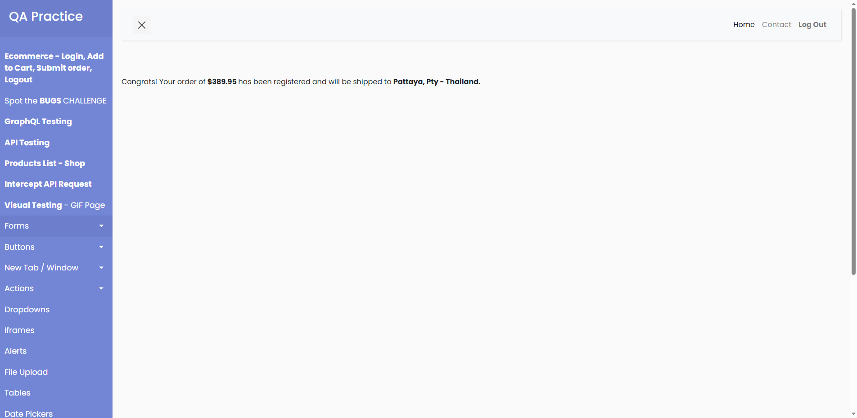
Displays the order completion page containing the congrats message validating that the order has been registered for delivery.
Screenshot 8: Logged Out Redirect
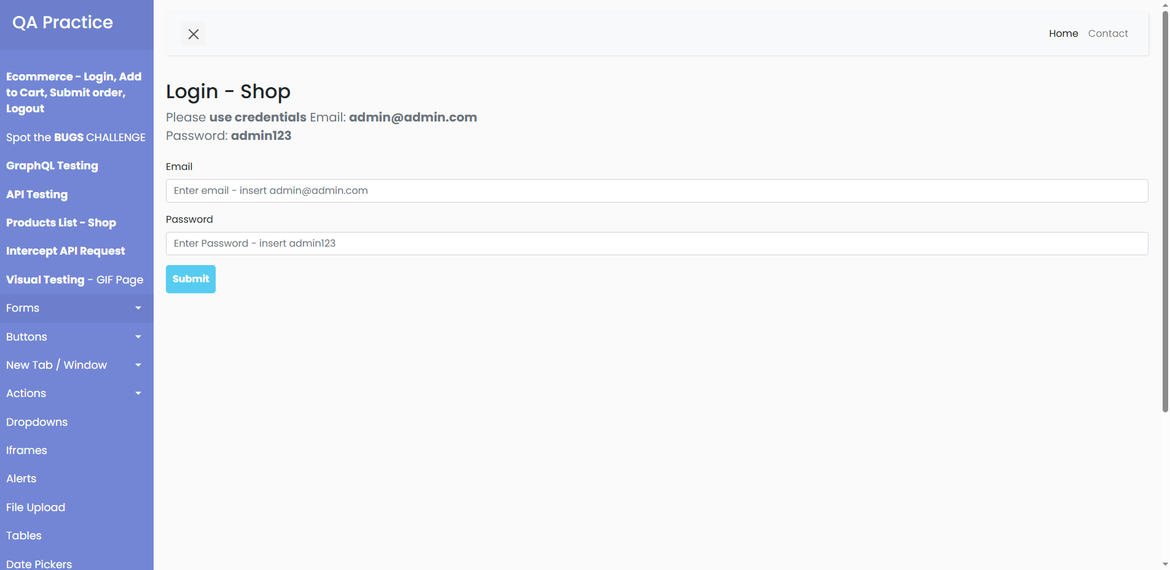
Shows the login screen displaying the logout state after clicking the logout button on the page header.
Screenshot 9: HTML5 Required Field Validations
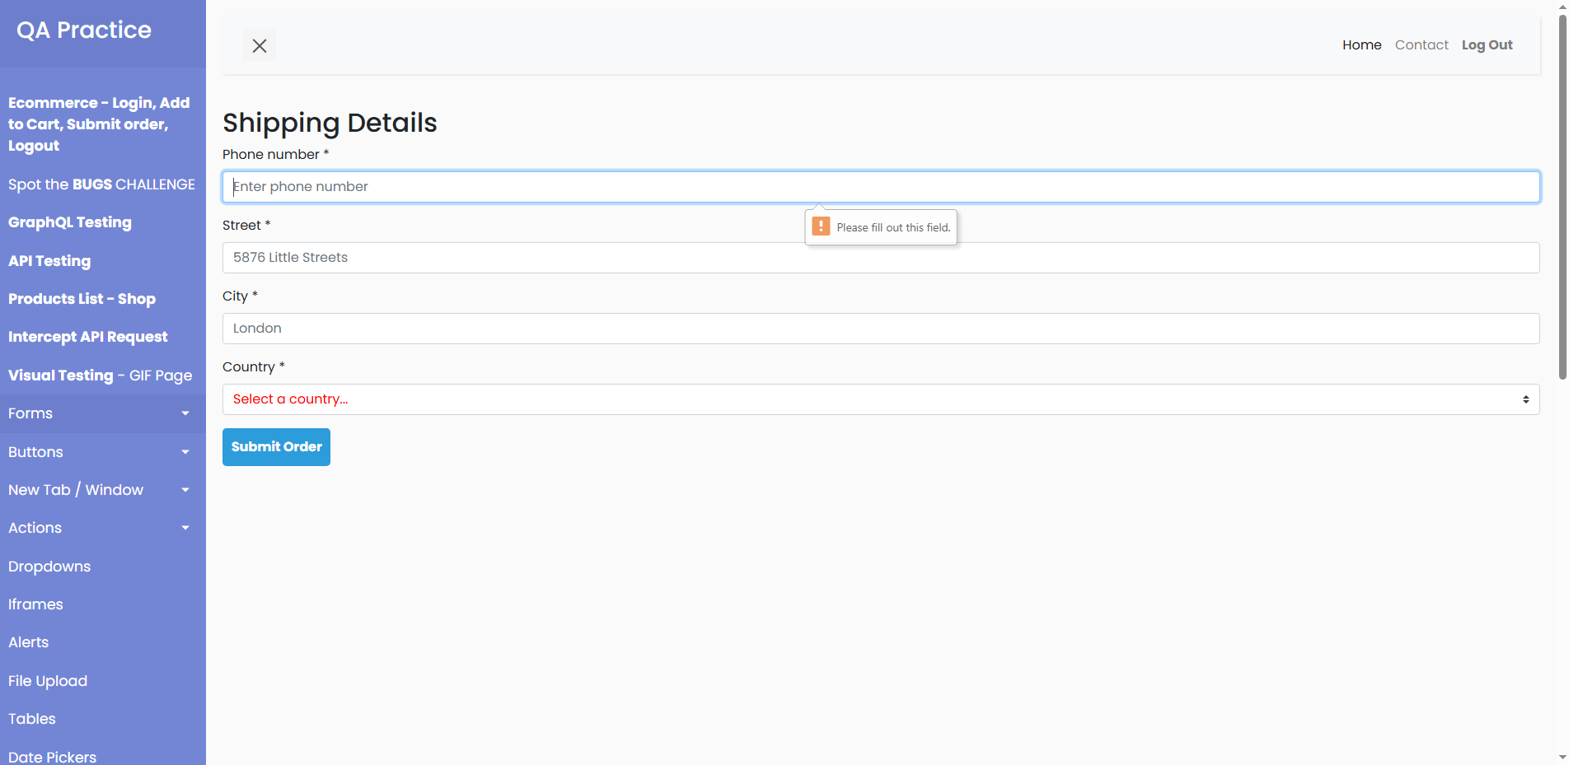
Negative scenario screenshot showing the native browser tooltip validation 'Please fill out this field' flagging empty inputs when clicking submit without entering data.
Screenshot 10: Pushed GitHub Repository
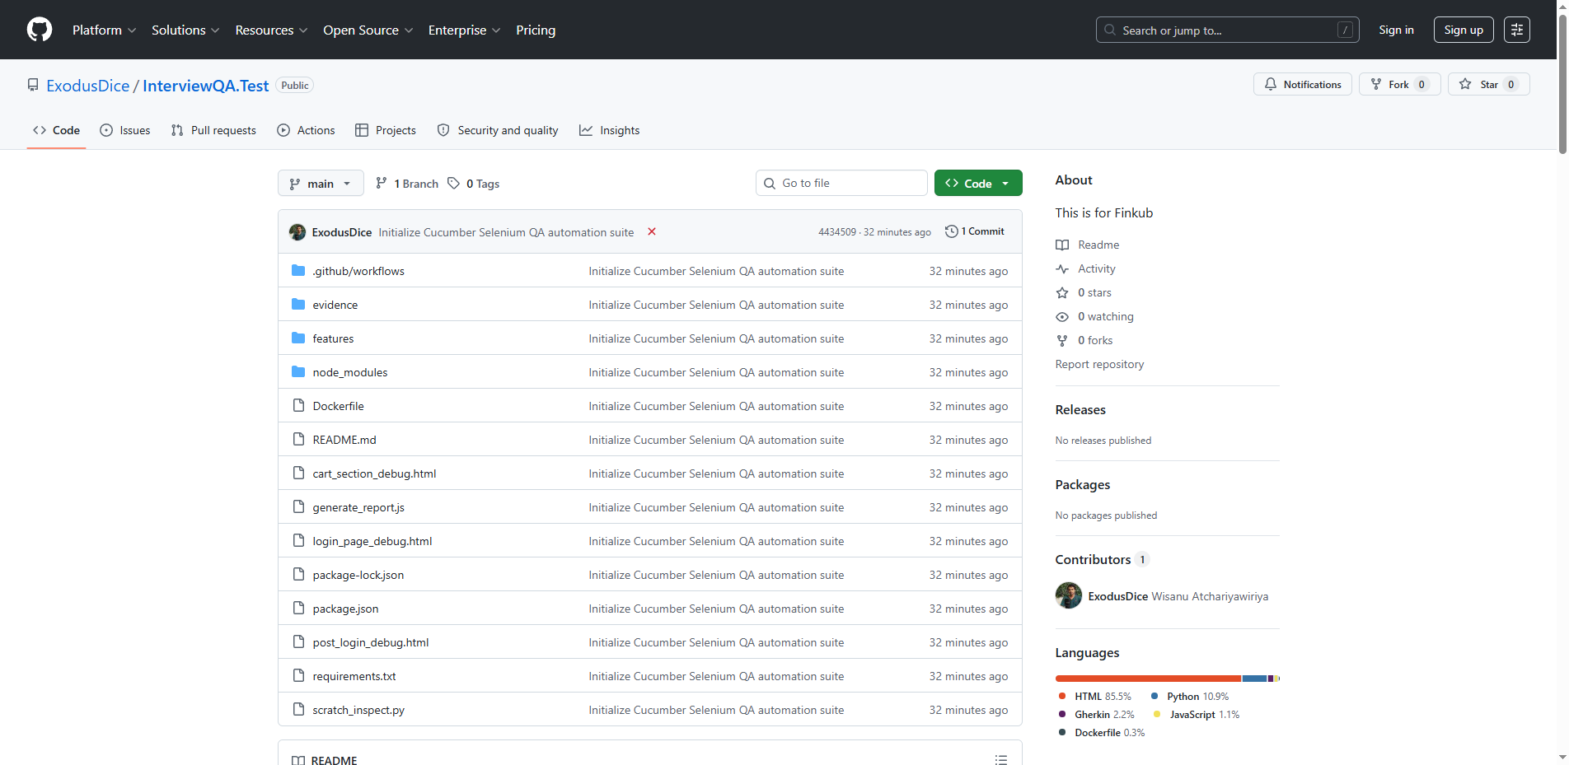
Displays the ExodusDice/InterviewQA.Test repository page on GitHub showing the code, features, environment configurations, and GitHub Actions workflow pushed successfully.

