**Name:** Manu Rajesh Naik

**Superset ID:** 6365342

***Nunit- HandsOn***

**TestFixture & Test**

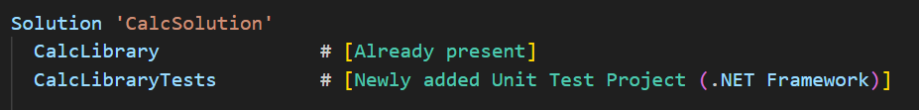

Adding the CalcLibrary project as a reference



**Creating** CalculatorTests.cs

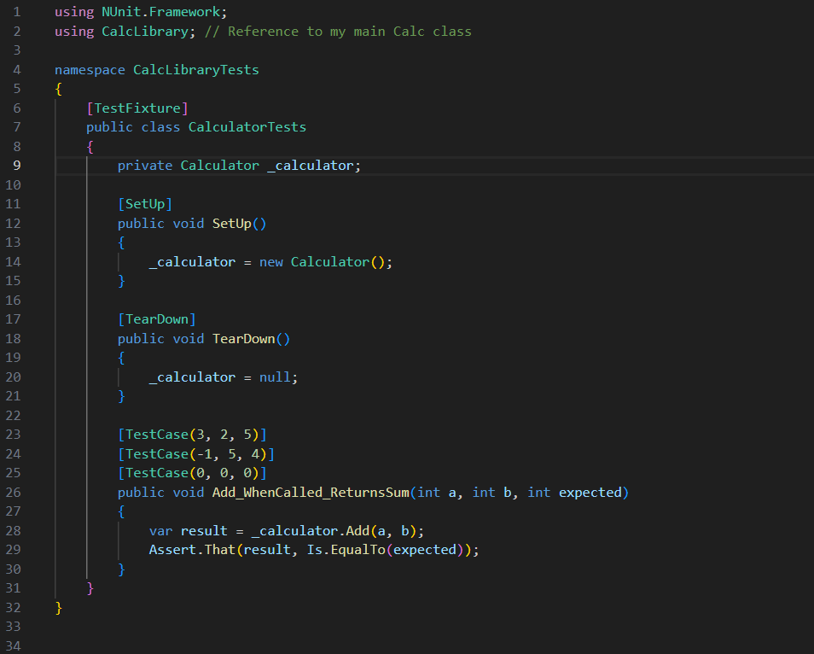

Output:

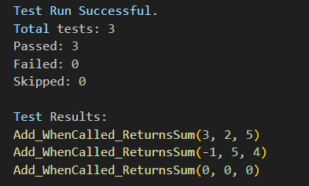

CalcLibrary/Calculator.cs

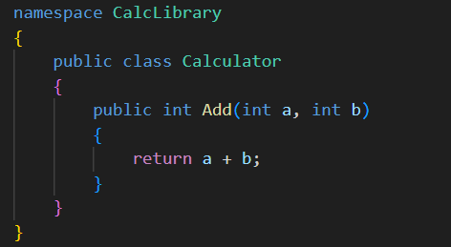

***Moq- HandsOn***

**Write Testable Code with MOQ**

Creating MailSender.cs

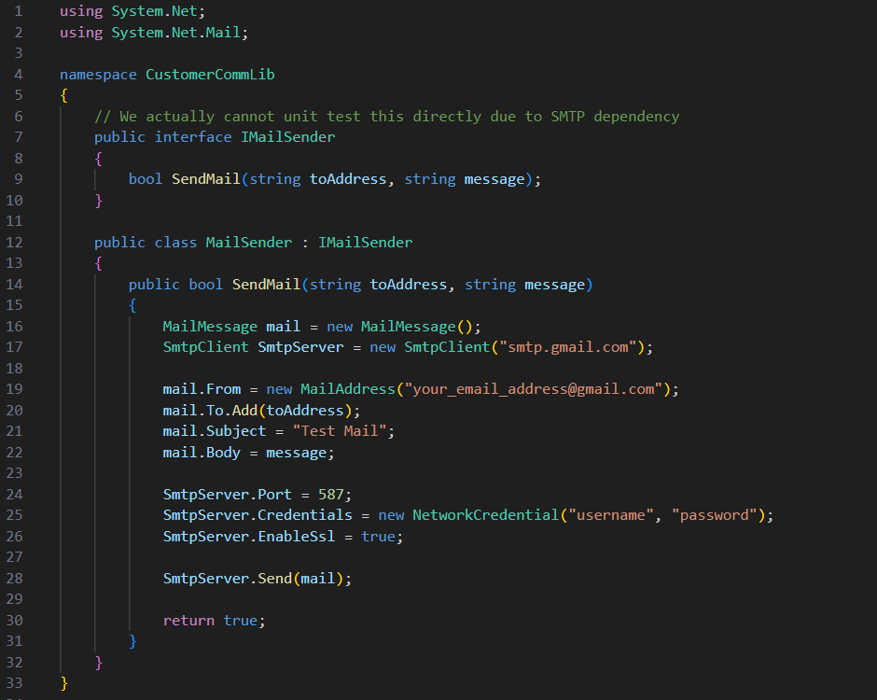

Creating Customercomm.cs

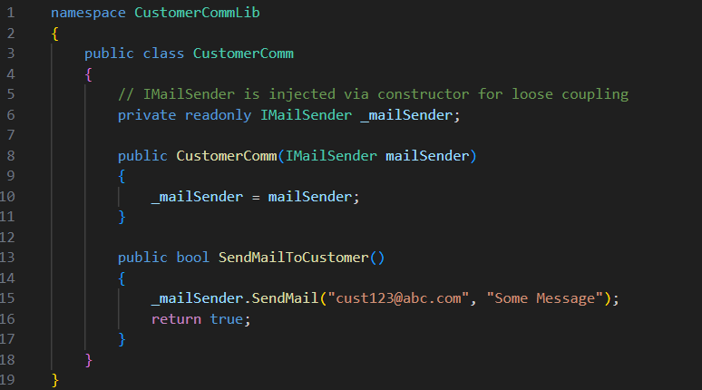

Creating Unit Test Project **CustomerCommTests.cs**

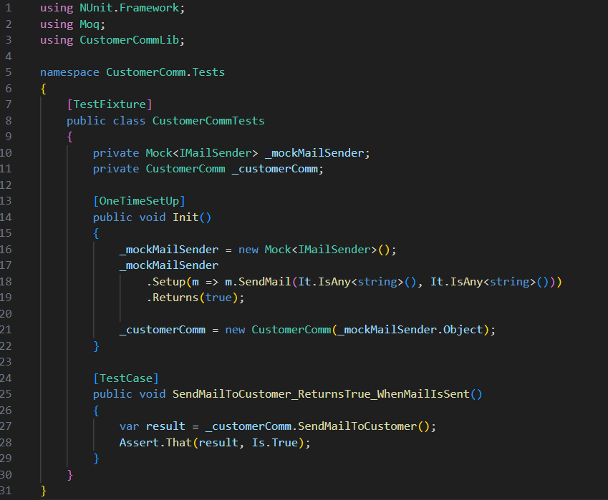

Output:

