**Name:** Manu Rajesh Naik

**Superset ID:** 6365342

***Web API Net Core***

**1. First Web Api using .Net core**

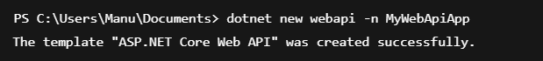



Controllers/ValuesController.cs

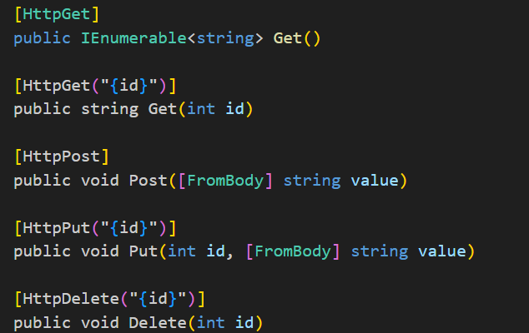

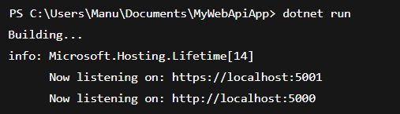

**2. Web Api using .Net core with Swagger**



Adding Swagger in Startup.cs

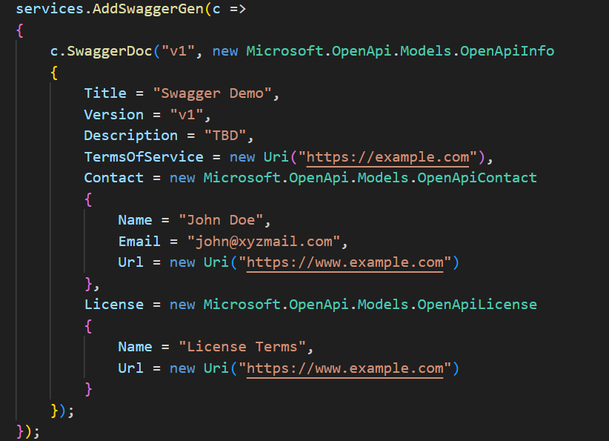



Creating EmployeeController.cs

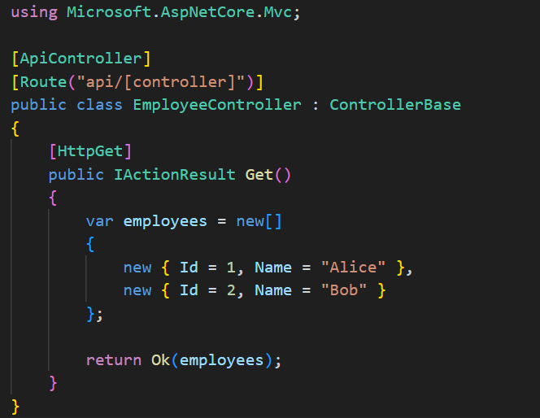

**3. Web Api using custom model class**

Department.cs

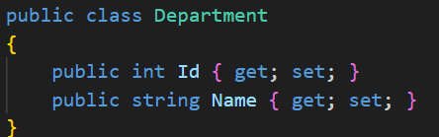

Skill.cs

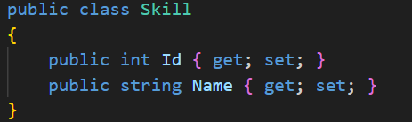

Employee.cs

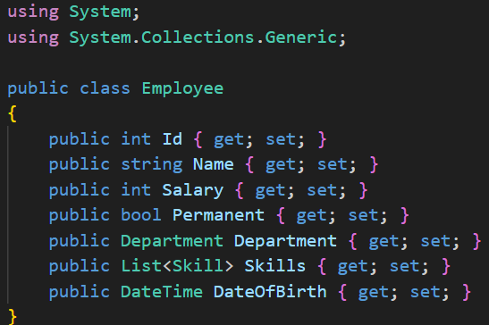

Creating EmployeeController.cs

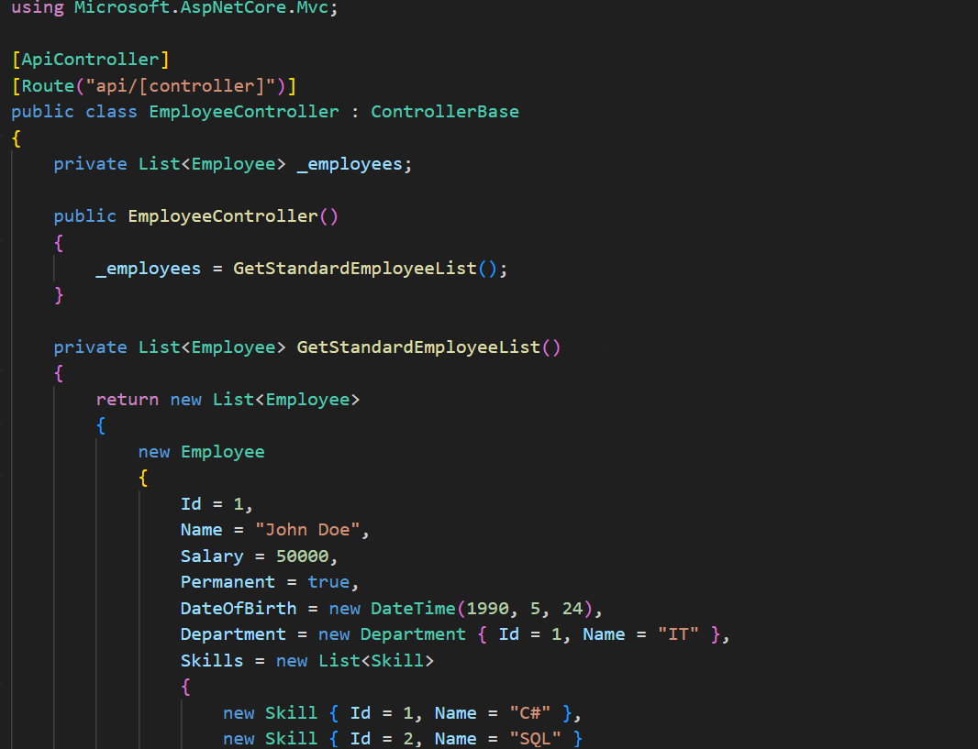

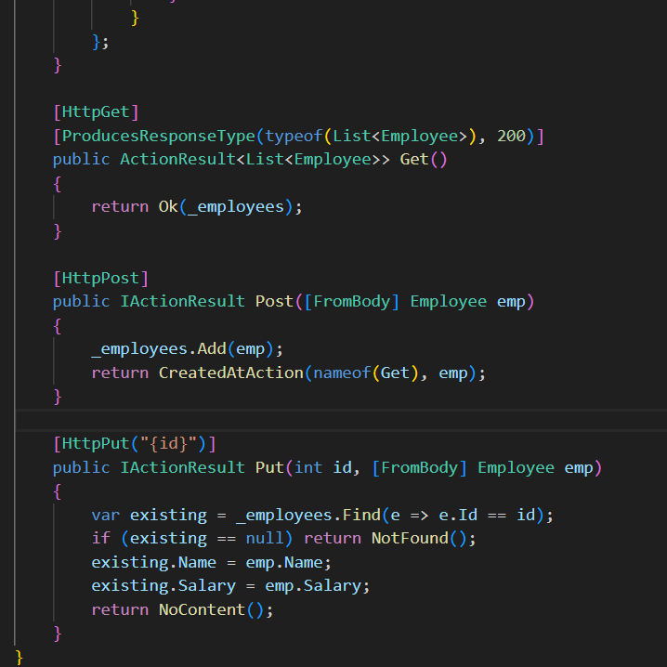

Creating CustomAuthFilter.cs

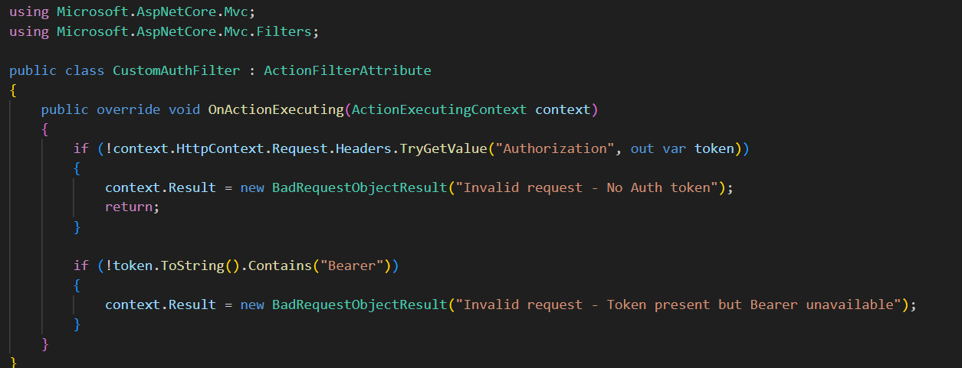



Installing Required NuGet



Creating CustomExceptionFilter.cs

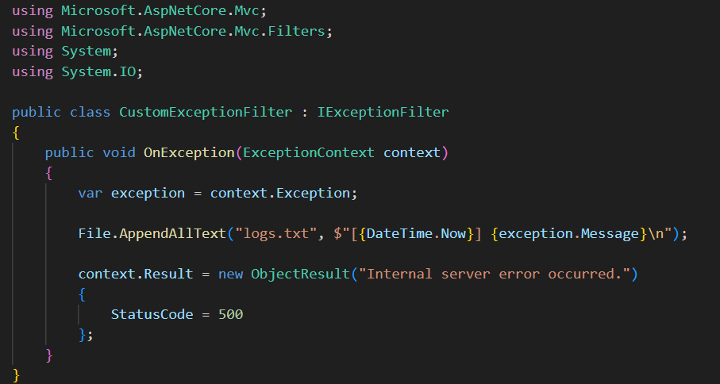

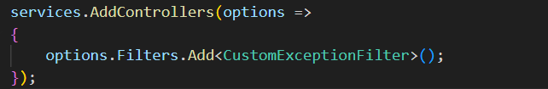

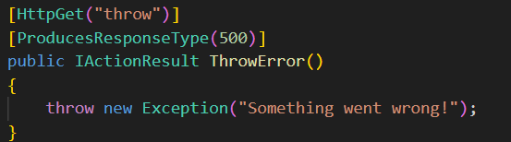

**4. Web Api CRUD operation**

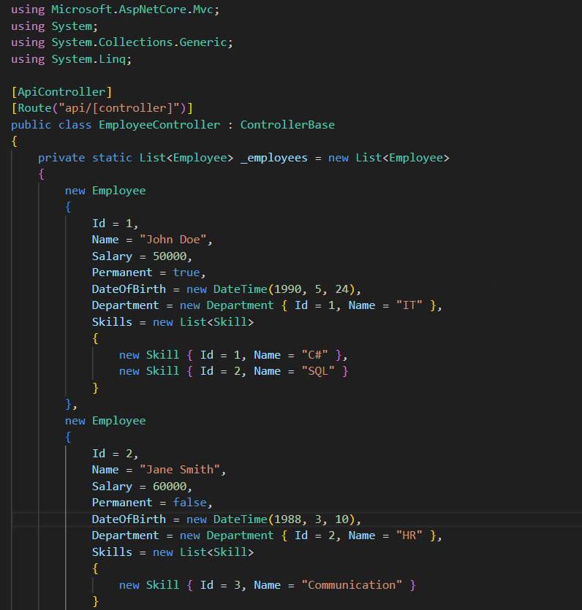

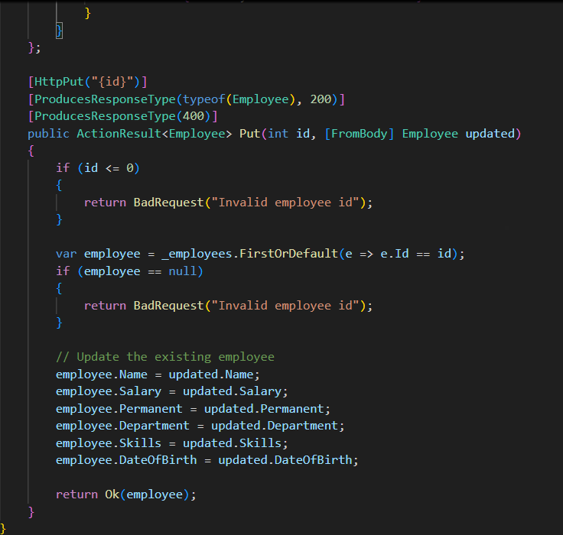

Input:

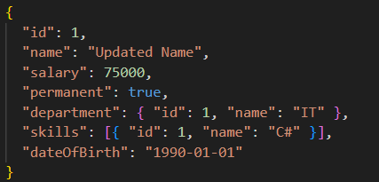

Output:

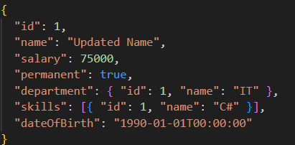

**5. Week 5 HandsOn**

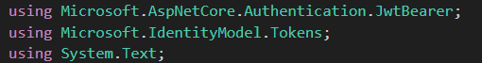

In ConfigureServices:

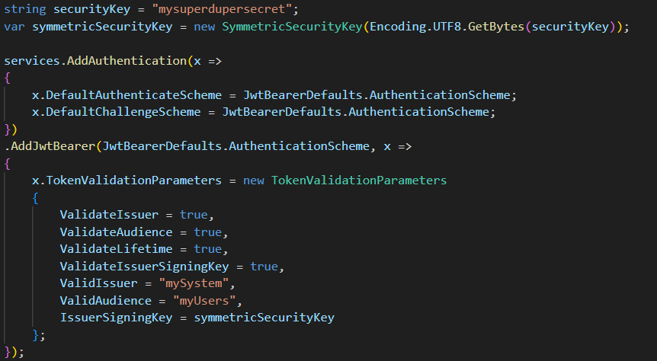

Controllers/AuthController.cs

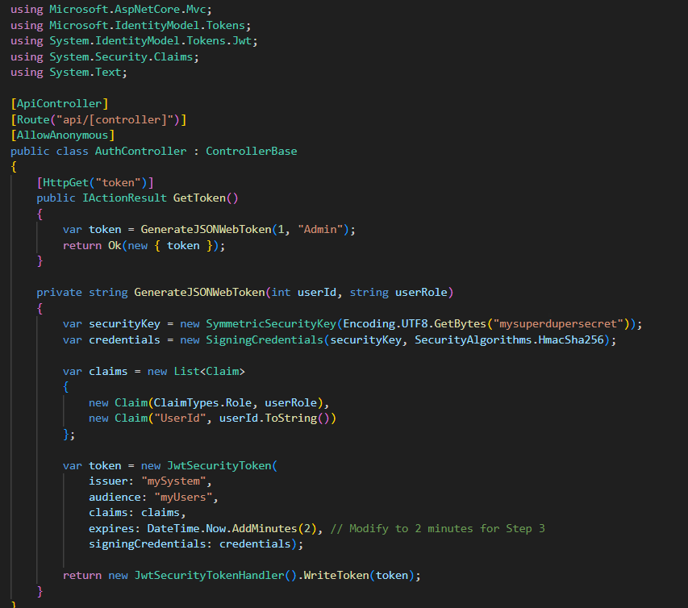

### Updated Controllers/EmployeeController.cs

