**Name:** Manu Rajesh Naik

**Superset ID:** 6365342

***Microservices JWT***

**Question 1: Implement JWT Authentication in ASP.NET Core Web API**



**appsettings.json**

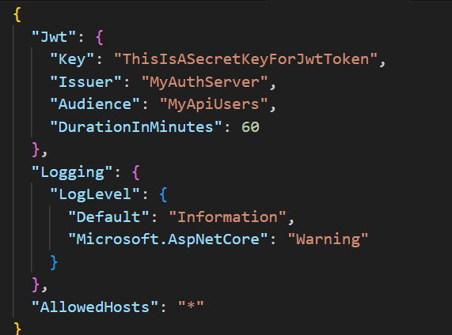

**Program.cs**

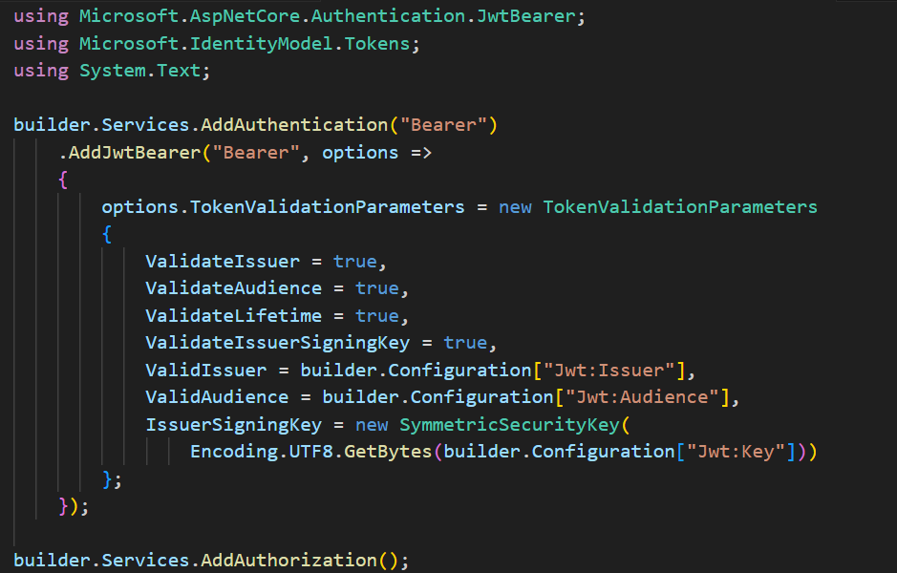

**LoginModel.cs**

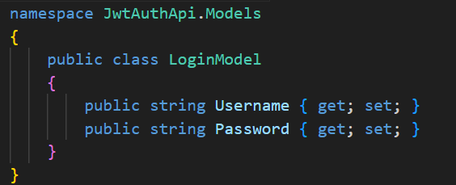

**AuthController.cs**

