**Name:** Manu Rajesh Naik

**Superset ID:** 6365342

***Web API Net Core***

**6. Create a Chat Application which uses Kafka as a streaming platform and consume the chat messages in the command prompt.**

Zookeeper Running

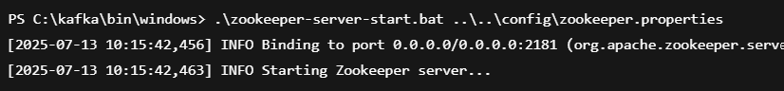

**Kafka Server Running**

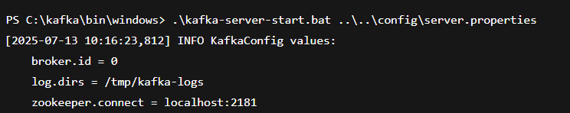

**Kafka Topic Created**



**Kafka Consumer** 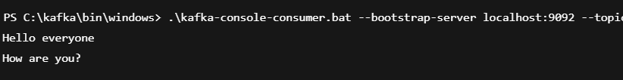

Output:

