**Name:** Manu Rajesh Naik

**Superset ID:** 6365342

***React JS***

1. **Create a React Application named “cricketapp”**



App.jsx

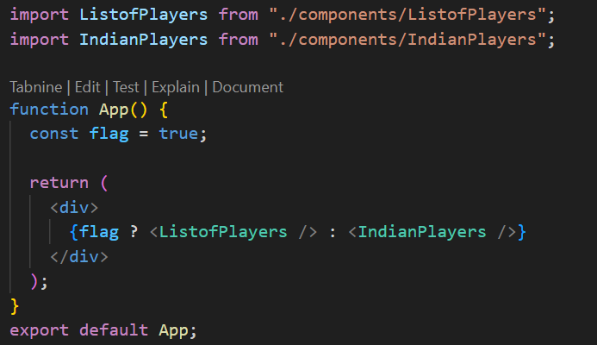

ListofPlayers.jsx

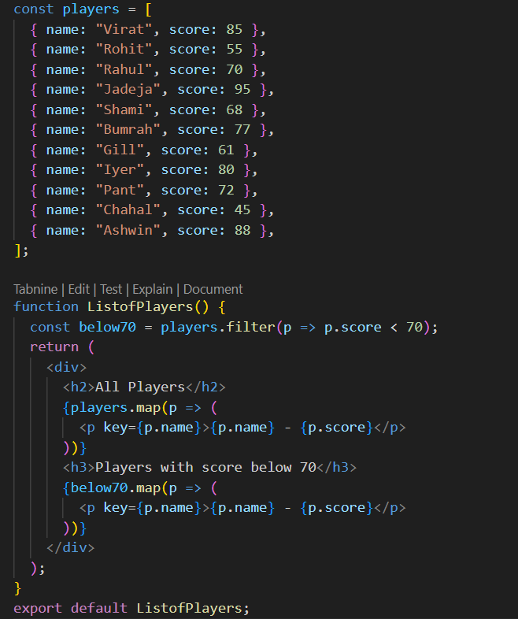

IndianPlayers.jsx

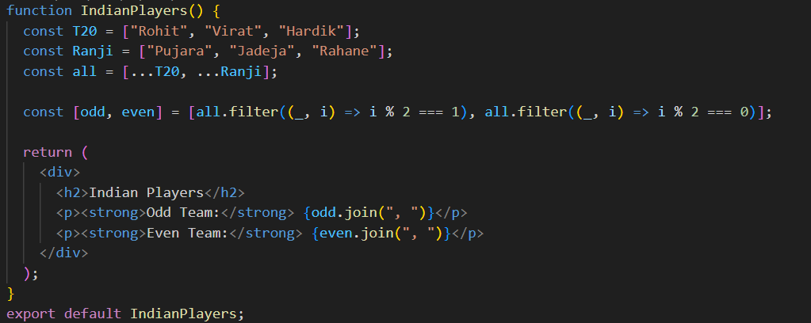

1. **Create a React Application named “officespacerentalapp” which uses React JSX to create elements, attributes and renders DOM to display the page.**



App.jsx

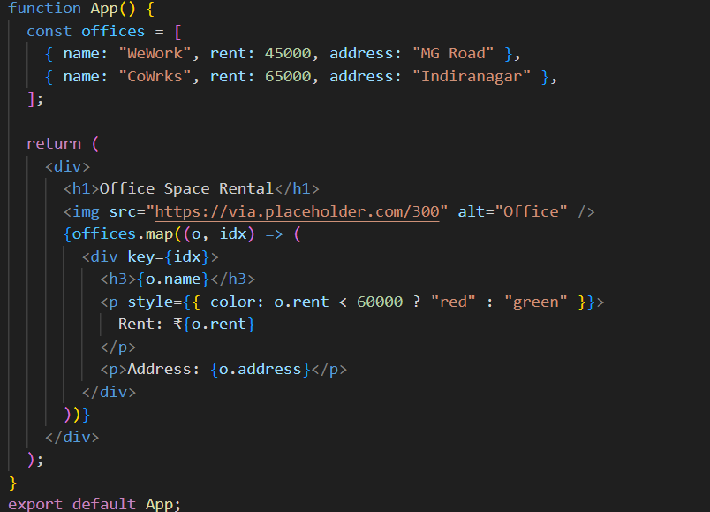

1. **Create a React Application “eventexamplesapp” to handle various events of the form elements in HTML.**



App.jsx

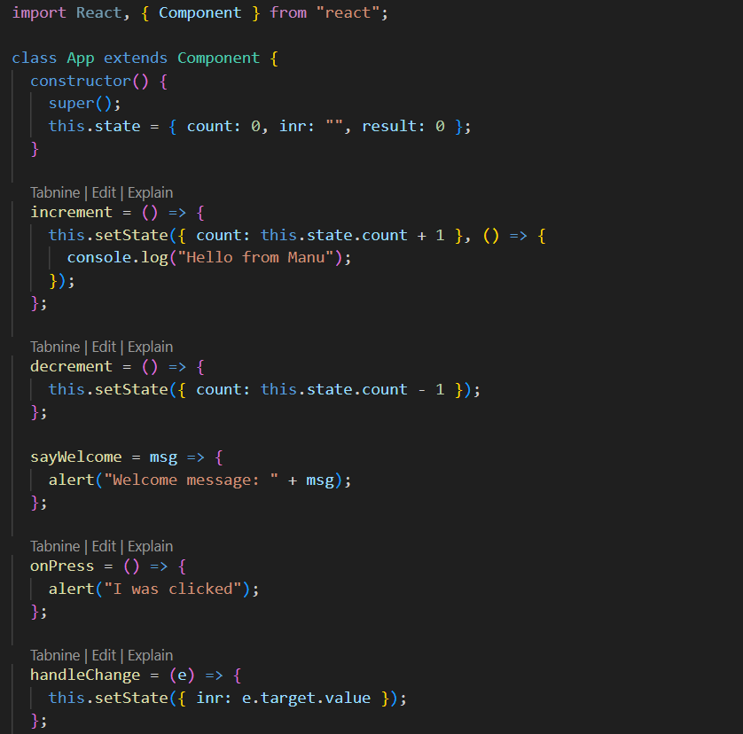

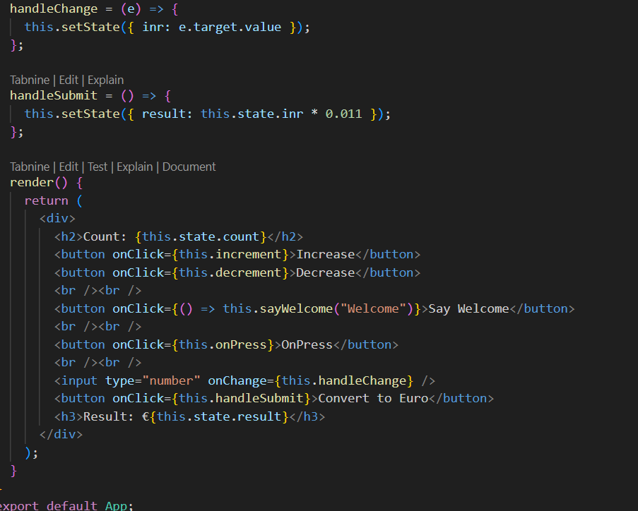

1. **Create a React Application named “ticketbookingapp” where the guest user can browse the page where the flight details are displayed whereas the logged in user only can book tickets.**



App.jsx

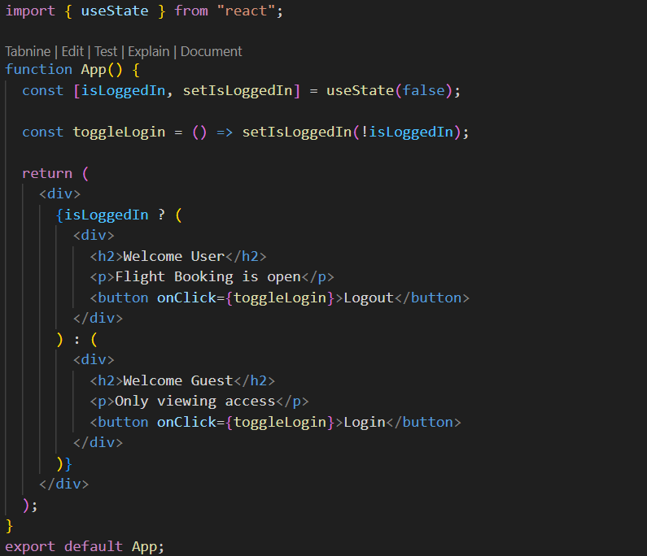

1. **Create a React App named “bloggerapp” in with 3 components.**
2. **Book Details**
3. **Blog Details**
4. **Course Details**

**Implement this with as many ways possible of Conditional Rendering.**

App.jsx

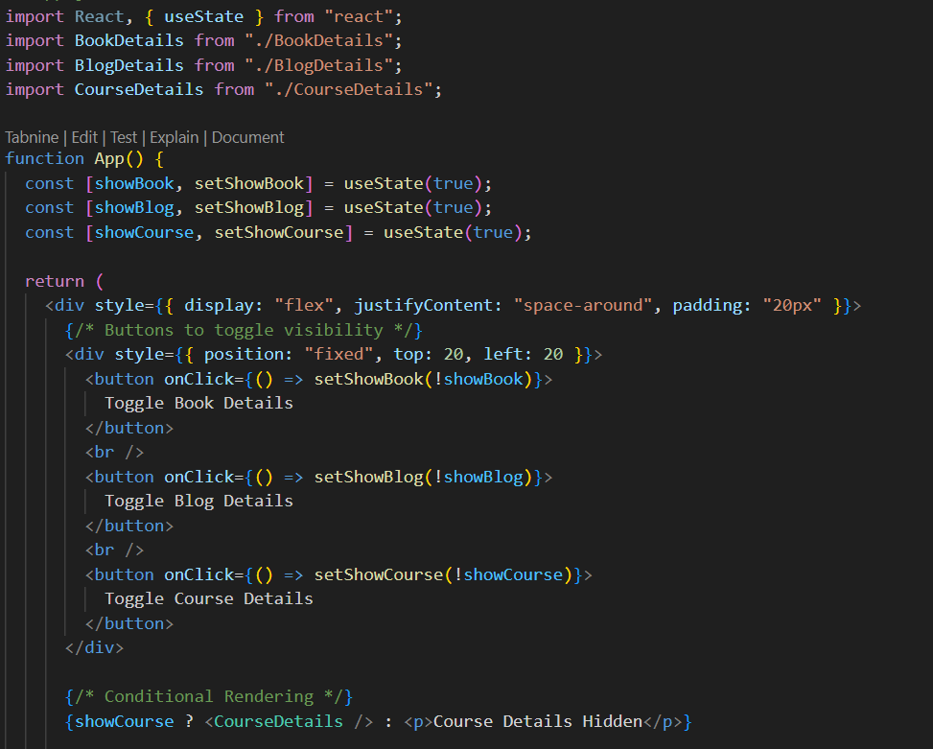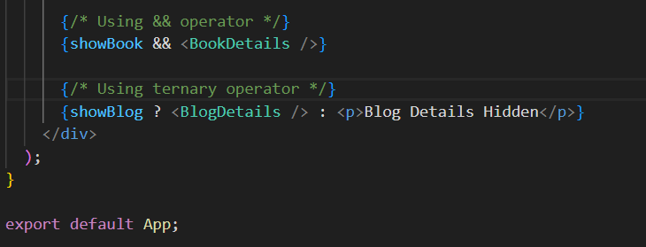

BookDetails.jsx

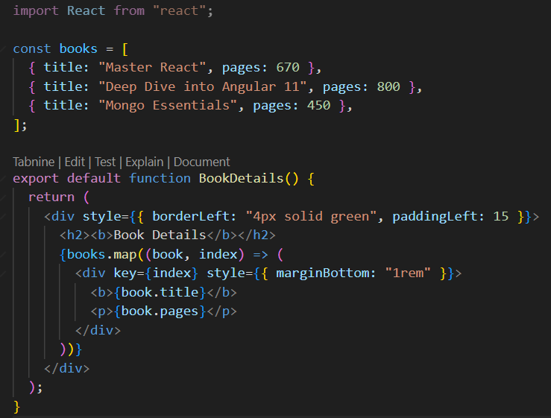

BlogDetails.jsx

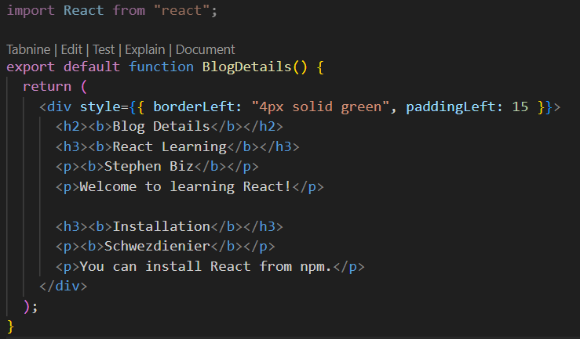

CourseDetails.jsx

