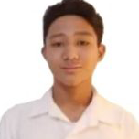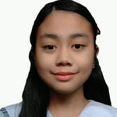

**GROUP 1 – 10 Diamond**

Deleon, Justine R.

De Belen, Michael M.

Hilario, Luis Gabriel L.

Clemente, Rhian Quincee R.

Faundo, Ashly Nicole B.

Joven, Raquel O.

Sacdalan, Angela G.

Santos, Gillian M.

Sulit, Rosemarie kim S.

Dulatas, Jhoshcel Margareth SA. SA SA.