Design Review: Autonomous Robot Car (INF2004)
Submission Detail | Student Entry
GROUP ID | IS29
Public GitHub repository | https://github.com/teck1341/ICT_INF2004_Embedded

Team Role and Subsystem Ownership
Buddy | Student Name | Student ID | Primary subsystem / responsibility
Buddy 1 | Subque | 2500599 | Comms: Comm, Telemetry, radio; CI/build coordinator
Buddy 2 | Ong Teck Ang | 2500738 | Motion: Motion task, motors, encoders; pin-table keeper
Buddy 3 | Tan Yi Jian Ethan | 2501528 | Optical: Line task, barcode; Vehicle navigation co-owner
Buddy 4 | Dian Ze | 2500916 | Terrain: IMU task, tilt, motion class, hump height
Buddy 5 | Siang Hong | 2503147 | Obstacles: Scan, Vehicle; Safety/app integration

1. Requirements

1.1 Functional Requirements
ID | Requirement
FR1 (B3) | The robot shall follow the 18 mm black line autonomously, robust to minor lighting, track and speed variation (FOLLOW, Line).  Verification: Course trials at agreed lighting and speed; line-loss count
FR2 (B3) | The robot shall decode barcodes (≈ 141 mm long, 20 mm from the line) into LEFT/RIGHT/STRAIGHT/U-TURN; ignore unknown codes.  Verification: Labelled official corpus; wrong actions 0; codebook pending lecturer
FR3 (B3, B2) | The robot shall execute the decoded action at the next junction: drive the edge-to-axle approach, then pivot (NAVIGATE).  Verification: Junction trials: axle over the crossbar at the pivot
FR4 (B2) | The robot shall control speed (≤ 0.15 m/s), distance and turns with encoder feedback and PID (Motion).  Verification: Measured distance and turn error after encoder calibration
FR5 (B4) | The robot shall detect humps, estimate height and report the run's highest peak (estimator accepts 5–300 mm).  Verification: Known-height humps; reported peak vs ground truth
FR6 (B4) | The robot shall classify motion (turn rate = encoder yaw) and tilt; detect collision; tilt > 0.60 rad or collision → FAULT (IMU, Safety).  Verification: Orientation, turning (encoder yaw rate, no gyroscope) and injected-impact cases
FR7 (B5) | The robot shall detect obstacles on or near the line; profile width, nearest range and clear side (±60°: 10° coarse, 2° fine).  Verification: Briefing p8 A–D: detection 100/95/90/80 %; width error ≤ 10/20/30/40 %; direction likewise
FR8 (B5, B2, B3) | The robot shall bypass on a permitted side, minimise deviation, reacquire the original line; ‘reverse and reattempt’ (Write-up p9): not implemented; see 8.2 decision (T-51).  Verification: Zero collisions, clearance, no false-line lock; Briefing p8: reacquire 100/95/90/80 %, bypass < 3/5/7/10 s (≈ 31–36 s estimated, unmeasured); heading-error trial
FR9 (B1) | The robot shall publish MQTT telemetry: status 5 Hz (the liveness signal), perception and diagnostics 1 Hz, ≤ 256 B frames; ‘online’ after SUBACK, Last Will ‘offline’; reconnect.  Verification: Broker trace with outage and reconnect; drop counters
FR10 (B1) | The robot shall accept only whitelisted, non-retained commands; remote STOP only; START/RESET stay local.  Verification: Whitelist and retained tests; lecturer policy answer
FR11 (All) | The robot shall brake and inhibit on STOP or a critical fault; never restart without an eligible RESET, then a separate START.  Verification: STOP, stale-data and reset regressions; measured motor response
FR12 (All) | The robot shall detect the course finish: rule unresolved, not implemented.  Verification: Obtain the rule, then model and test

1.2 Non-Functional Requirements
ID | Requirement
NFR1 | The system shall use C, the Pico C SDK 2.2.0 and micro T-Kernel, following the course template GitHub repo (Write-up p1 gives no URL; we build into the lecturer's port sirfonzie/mtk3smp-rp2040 at 2e8e6ad, to be confirmed as that template).  Verification: Pinned versions; fresh builds
NFR2 | The system shall conform to the BARR-C:2018 coding standard; deviations justified.  Verification: Automated style subset + review
NFR3 | The system shall use bounded memory: 8 × 4 KiB task, 4 KiB init, 6 KiB radio stacks, bounded buffers, one MQTT client.  Verification: Map file; stack high-water
NFR4 | The system shall run Safety/Line/Scan at 2 ms, Motion/Comm 5, Vehicle/IMU 10, Telemetry 200 ms.  Verification: Target jitter, sample gaps (T-36)
NFR5 | The system shall zero motor drive ≤ 10 ms after the STOP latch (V02); STOP polled every 2 ms, rechecked at motor commit.  Verification: Host regressions; measured latency, stopping distance
NFR6 | The system shall report state, values in fixed integer units (mm, mm/s, mrad, ms), calibration version and first fault code in telemetry, and a start-up refusal reason on UART0.  Verification: Schema tests; start-up log
NFR7 | The system shall keep radio load from starving control: RX 4×32 B, STOP 1×4 B, TX 4×256 B (enqueue overflow counted); ≤ 1 publish/100 ms.  Verification: Queue/drop tests; loaded trials
NFR8 | The system shall keep documents, diagrams, source and evidence on one revision.  Verification: §9 software identity; CI; team sign‑off

2. Hardware Integration Pin Layout
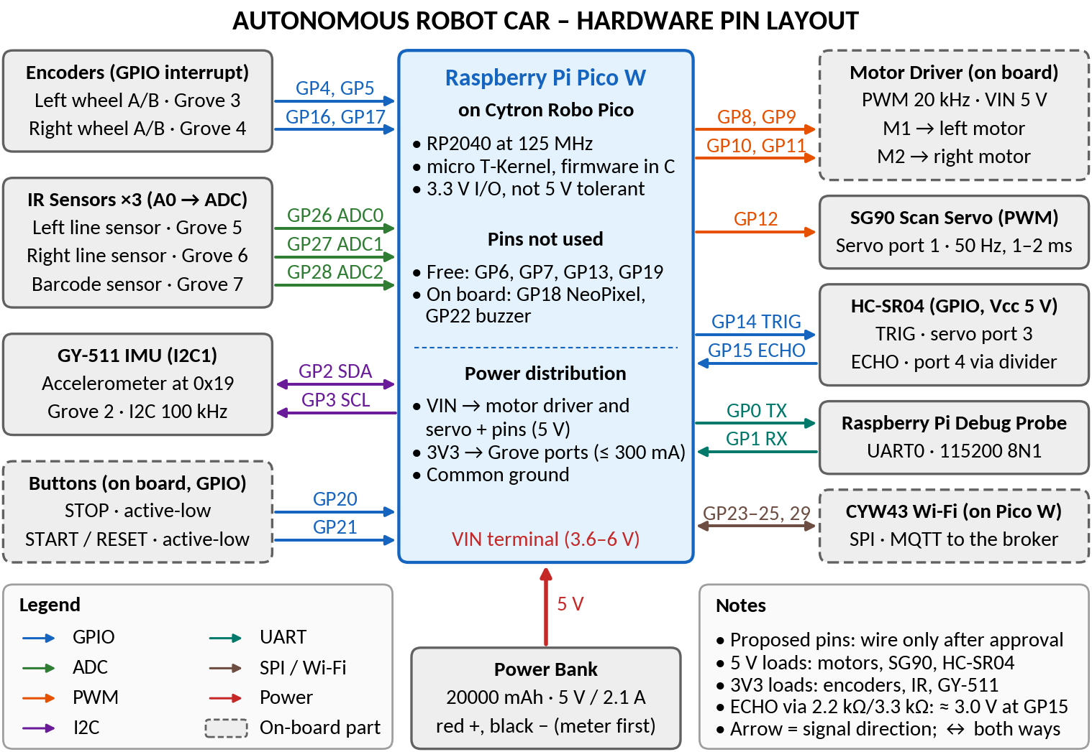
Fig. 1. Proposed wiring by GPIO label (not header pins); arrows show signal direction. Dated pin approval is required before wiring.
Device / Module | Type | Signal Name | Sensor label | Pico GPIO Pin | Interface | Notes / RTOS Task Owner
Encoders (Grove 3, 4) | Sensor | ENC_L/R_A/B | A/B | 4/5, 16/17 | GPIO IRQ | ISR counts → Motion (B2); Line reads
Motor driver | Actuator | MOT_L/R_A/B | M1A–M2B | 8/9, 10/11 | PWM 20 kHz | Motion (B2); fault latch brakes
Scan servo (port 1) | Actuator | SERVO | SIG | 12 | PWM 50 Hz | Scan (B5); 1–2 ms, uncalibrated
HC-SR04 (servo 3/4) | Sensor | TRIG/ECHO | TRIG/ECHO | 14/15 | GPIO out/IRQ | Scan (B5); 5 V; ECHO divider
GY-511 (Grove 2) | Sensor | IMU_SDA/SCL | SDA/SCL | 2/3 | I2C1, 0x19 (expected) | IMU (B4); 100 Hz ODR; no gyroscope; address to be confirmed by an I2C bus scan at first power-up
IR line L (Grove 5) | Sensor | IR_LEFT | A0 | 26 | ADC0 | Line (B3); GP26 contact; D0 open
IR line R (Grove 6) | Sensor | IR_RIGHT | A0 | 27 | ADC1 | Line (B3); GP27 contact only
IR barcode (Grove 7) | Sensor | IR_BARCODE | A0 | 28 | ADC2 | Line (B3); VBAT jumper open
Buttons (on board) | Input | STOP, START/RESET | on board | 20/21 | GPIO in | Safety/Vehicle (B5); active-low (A8)
Console (UART) | Comms | TX/RX | TX/RX | 0/1 | UART0 115k | Start-up refusal diagnostics (B1)
CYW43 (Pico W) | Comms | WL_* | on module | 23–25, 29 | SPI | Radio owner P9 (B1)

3. RTOS Task Table
Task | Purpose | Inputs | Outputs | Trigger | Priority
Safety · B5 coord. | Stop and supervise | STOP, terrain, heartbeats | Fault latch, BRAKE, watchdog | 2 ms | P1 highest
Motion · B2 | Leased motion → PWM | Request, encoder deltas | PWM, pose, completion | 5 ms | P2
Line · B3 | Line, barcode, junction | ADC0–2, encoder totals | Steering, code, junction edge | 2 ms | P3
Vehicle · B5 (B3 nav.) | Mission supervisor | Snapshots, GP21, motion | Motion/scan requests, state | 10 ms | P4
IMU · B4 | Tilt, motion, hump | I2C1 sample, Motion path | Tilt, peaks, collision flag | 10 ms | P5
Scan · B5 | Sweep and ranging | Echo times, scan request | Servo, TRIG, range profile | 2 ms | P6
Comm · B1 | Commands, STOP first | RX + STOP buffers | Remote STOP; others counted | 5 ms | P7
Telemetry · B1 | JSON telemetry | Shared snapshot | TX: status 5 Hz, others 1 Hz | 200 ms | P8
Radio owner · B1 | lwIP, CYW43, MQTT | Wi-Fi, TX buffer | Publish; RX, STOP buffers | ≥ 2 ms | P9 lowest
Priority and ownership justification:
Priority Rationale:
- Safety (P1): Pre-empts all mission work to ensure safety controls take immediate effect.
- Motion (P2): Maintains tight PID timing loop and re-checks STOP status at motor commit.
- Line (P3): Samples faster than Vehicle (P4) consumes to guarantee data freshness.
- IMU (P5): Positioned below control tasks due to ~1.2 ms I2C busy-waits (max ~8 ms across transfer phases), delaying only lower-priority tasks.
- Scan (P6): Placing below IMU is safe because the GPIO ISR handles ECHO timing; an 8 ms delay remains well within the 150 ms range-age limit.
- Comm (P7) & Telemetry (P8): Comm outranks Telemetry so telemetry processing cannot delay STOP command dequeueing.
- Radio Owner (P9): Lowest priority; pre-empted by P1–P8. Remote STOP operates on a best-effort basis through this task.
System Supervision & Safety Mechanics:
- Responsibility: Buddy 5 (B5) coordinates Safety and application integration.
- Watchdog Feeding: Fed only while P2–P7 tasks remain fresh.
- Freshness Checks: Uses wrap-safe ages where a stamp published after a check start counts as age 0.
- Latency: Priorities do not constrain interrupt or critical-section latency.

4. Task Interaction Diagram
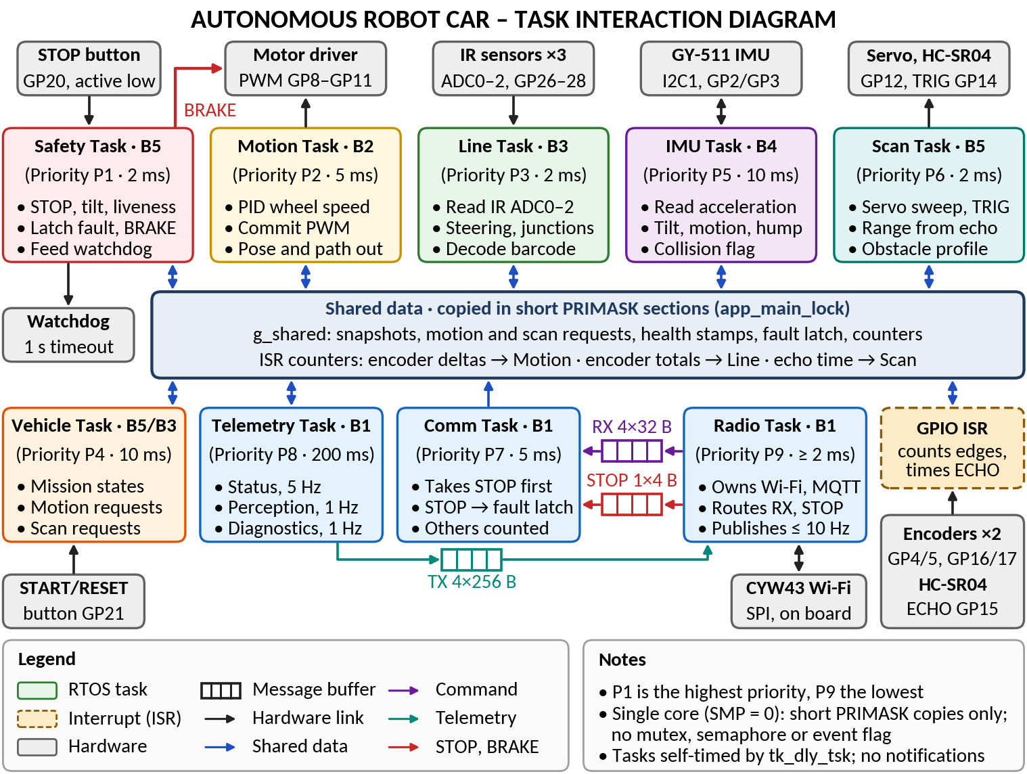
Fig. 2. Nine RTOS tasks, the GPIO ISR, hardware, the shared-data store and the three radio message buffers. BRAKE is drawn from Safety; any task that latches a fault brakes the same way.
Brief explanation of the main communication paths:
Communication Rules & Ownership:
- Task Responsibilities: Only Vehicle issues motion and scan requests; only Motion writes drive PWM (STOP and fault inhibit are rechecked in its PRIMASK write).
- Concurrency & Execution: Single-core system (SMP=0 enforced via make guard and #error in app_main.c). Core 1 never runs; short PRIMASK copies isolate task and ISR operations without requiring mutexes, semaphores, or event groups.
- Interrupt Data Flow: GPIO ISR only counts encoder edges and times ECHO pulses (Motion consumes deltas, Line reads non-consuming totals, Scan consumes echo times, IMU uses Motion's path).
- Radio Message Isolation: Message buffers isolate the radio into dedicated queues (RX 4×32 B, STOP 1×4 B drained first by Comm, TX 4×256 B).
Abort, Fault Conditions & Safety Mechanics:
Fault Action: Any task that latches a fault (robot_app_fault), as well as Vehicle while in the FAULT state, can only force a BRAKE command.

5. System-Level Statechart
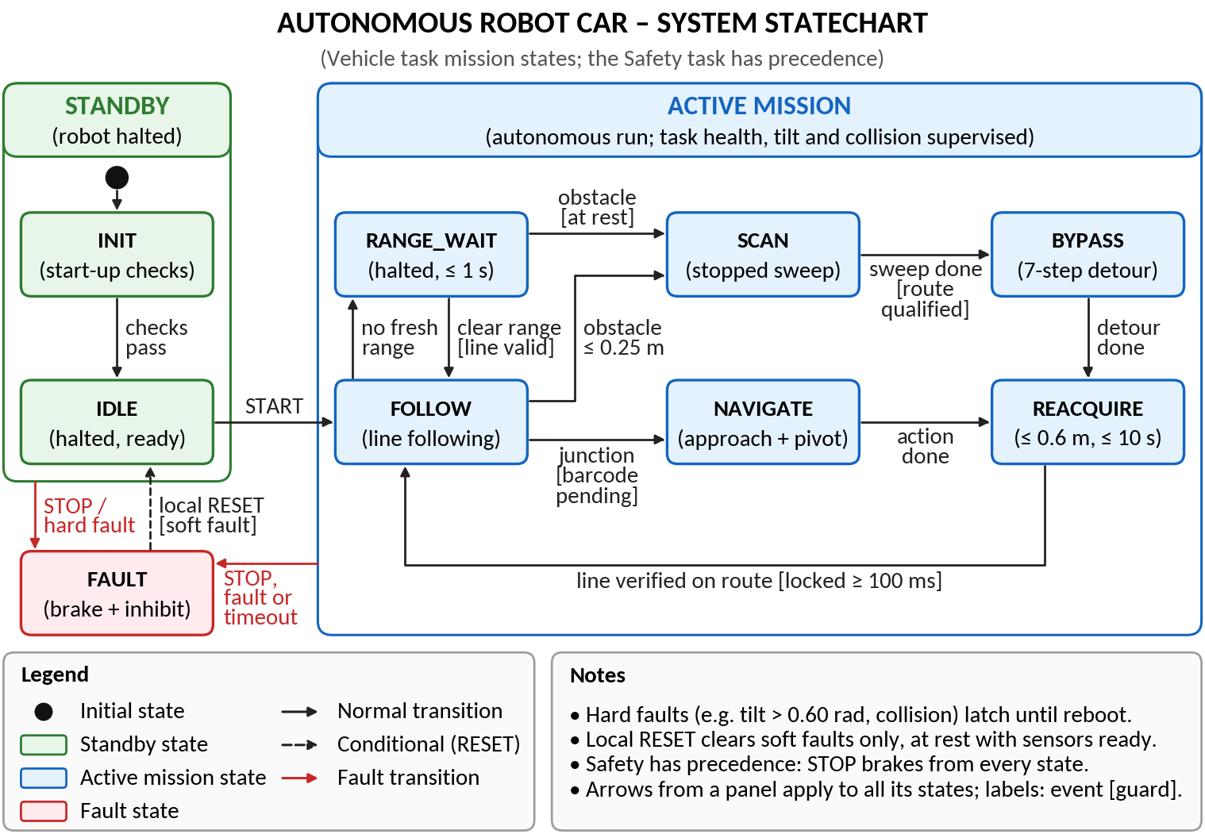
Fig. 3. Vehicle mission states (vehicle_state_t names) with Safety precedence; guards are design intent, not measured behaviour.
Explain the main states and any important assumptions:
START needs the start-up gates, a valid line and a fresh clear range. RANGE_WAIT halts for at most 1 s and waits for a fresh range reading taken at rest: obstacle → SCAN; clear range and a valid line → FOLLOW; non-clear range or the timeout → FAULT. NAVIGATE (at a later junction) drives the edge-to-axle approach, then pivots. STOP in any state, including INIT and IDLE, enters FAULT with zero drive.
- Soft faults: Allow an eligible local RESET (healthy, stationary, gates confirmed) → IDLE, then a separate START. Includes local or remote STOP and tilt unavailable (unusable tilt, tilt older than 100 ms, or an IMU sample PENDING over 50 ms). Every FAULT that the Vehicle supervisor enters is also soft, including a RANGE_WAIT, SCAN, REACQUIRE or pending-code timeout, REACQUIRE's 0.6 m drive ending without the line, a lost line, a lost or non-clear range, no qualified route, or a new code while one is pending. In RANGE_WAIT, a new code or a junction edge for a pending code also causes a FAULT.
- Hard faults: Latch until reboot and win over soft faults: valid tilt over 0.60 rad; collision; encoder error; IMU INVALID during a run (I2C error, saturation or inconsistent status; an overrun is not a fault); stale task owner; wheel stall; motion lease expiry, timeout, rejected request or sensor fault; optical sensor fault; a second code before Vehicle takes the first; scan abort or the scan task's 20 s limit; motor-output fault once calibration is confirmed (before that, the motors are braked without a fault); supervisor step failure.
Design limitation: There is no finish state implemented (FR12).

6. Subsystem Statecharts

6.1 Subsystem Statechart 1: Communications (Buddy 1)
Field | Student Entry
Subsystem name | Communications (Buddy 1)
Related RTOS task(s) | Comm P7, Telemetry P8, radio owner P9
Purpose | Non-blocking MQTT telemetry and command intake.
Reason a statechart is needed | Setup, join, session and retry need bounded recovery.

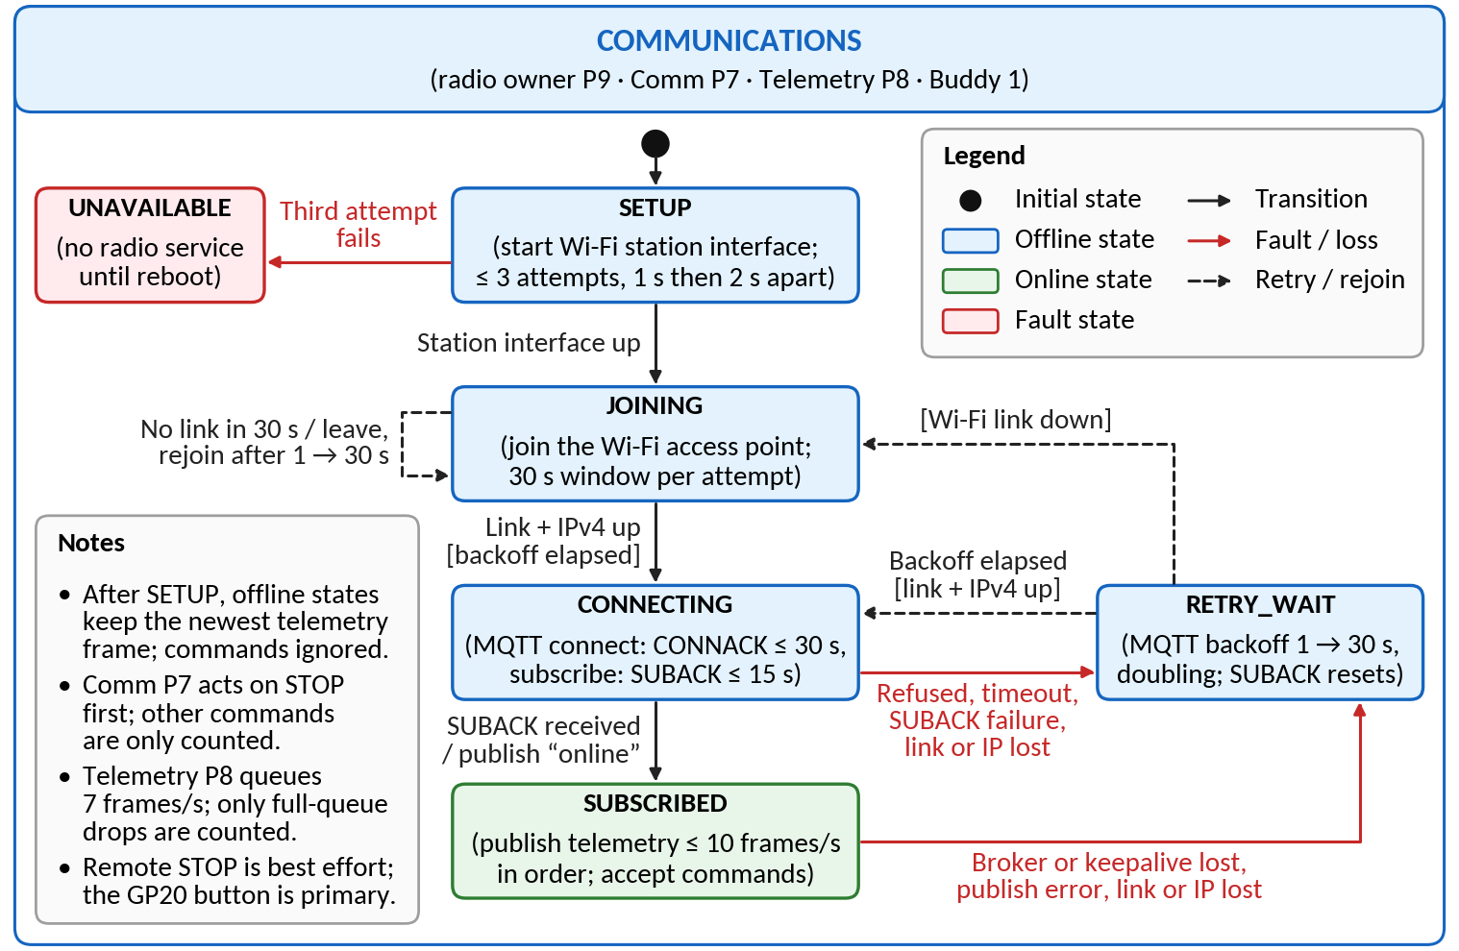
Fig. 4. Communications: radio setup, Wi-Fi join and MQTT session (logical modes derived from net_mqtt.c flags).
Brief explanation of states, events, and fault handling:
- Fault Conditions & Error Handling:
  - Radio Setup Failure: A third failed radio setup transitions the system to UNAVAILABLE until reboot.
  - Wi-Fi Link Loss: Loss of Wi-Fi link returns the state to JOINING.
  - Session Loss & Retries: A refused or lost MQTT session enters RETRY_WAIT, retrying with an exponential backoff from 1 s to 30 s.
- Operational Constraints & Limitations:
  - Session Confirmation: The MQTT session is considered active (SUBSCRIBED) only after receiving SUBACK from the broker (CONNECTING → SUBSCRIBED).
Remote STOP Delivery: Due to QoS 0 and the unsupervised radio owner, remote STOP is delivered on a best-effort basis; GP20 button serves as the primary STOP mechanism.

6.2 Subsystem Statechart 2: Motion Control (Buddy 2)
Field | Student Entry
Subsystem name | Motion Control (Buddy 2)
Related RTOS task(s) | Motion P2 (fault latches may force BRAKE)
Purpose | Leased requests → PID wheel speed, odometry, completion.
Reason a statechart is needed | Renewal, completion and inhibition each decide differently whether a request may keep driving the wheels or drive them again.

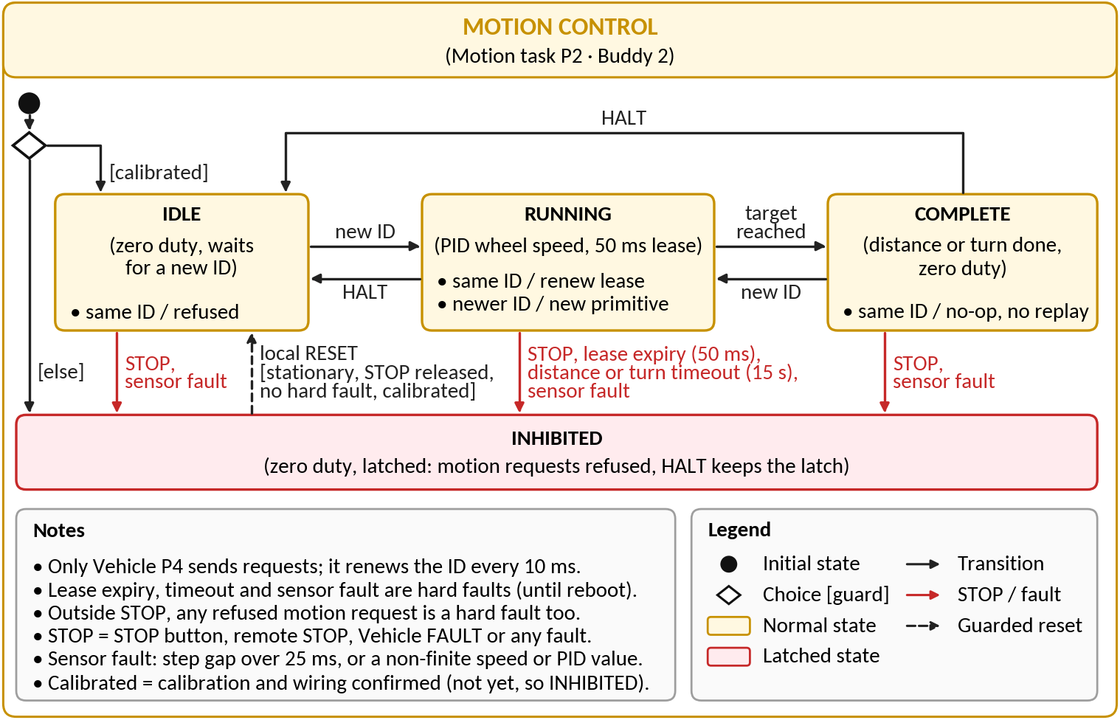
Fig. 5. Motion task states (motion_state_t).
Brief explanation of states, events, and fault handling:
- Lease & Execution: Renewal extends the running ID's 50 ms lease. A completed ID is never replayed.
- Abort & Fault Conditions: STOP, lease expiry (50 ms), distance/turn timeout (15 s), or sensor fault transitions the system to INHIBITED (hard fault unless triggered by STOP).
Design Limitations: No acceleration ramp is implemented. Integral output is clamped to ±0.35 duty cycle and freezes during saturation. Unmeasured stall threshold duty is set to 0.15.

6.3 Subsystem Statechart 3: Optical Navigation (Buddy 3)
Field | Student Entry
Subsystem name | Optical Navigation (Buddy 3)
Related RTOS task(s) | Line P3, Vehicle P4 (with B5), Motion P2
Purpose | Follow the line, decode barcodes, act at the next junction.
Reason a statechart is needed | A code must wait for a later, debounced junction edge.

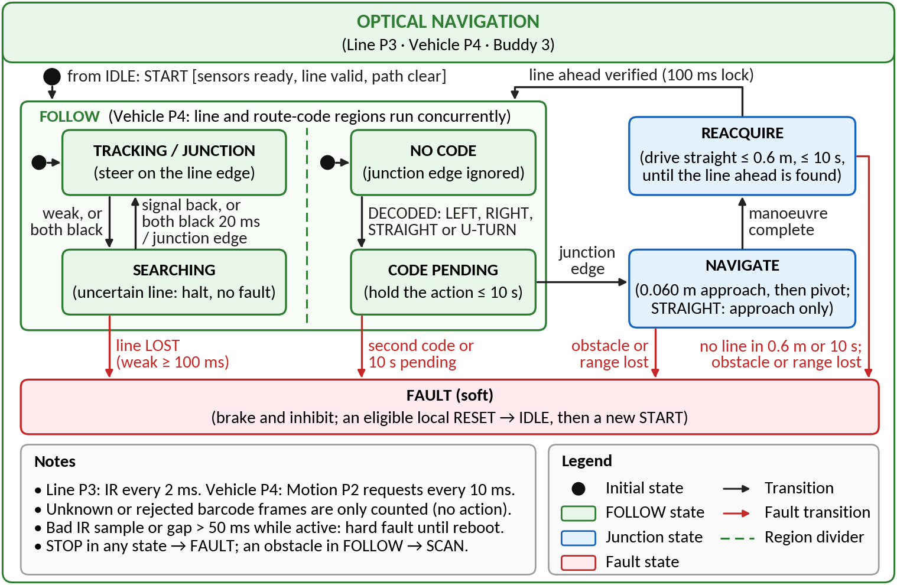
Fig. 6. Line following, pending barcode action and junction navigation (line_ctrl, barcode and Vehicle states).
Brief explanation of states, events, and fault handling:

- Frame Handling: Rejected and unknown barcode frames are counted with no action; a frame still open when FOLLOW ends counts as rejected. Codebook is empty until confirmed.
- Fault Conditions & Limits: A second code, reaching the 10 s pending limit, or entering LOST triggers FAULT. REACQUIRE faults after driving 0.6 m without the verified line or reaching 10 s.
- Navigation Action: NAVIGATE drives 0.060 m (unmeasured) then pivots (STRAIGHT drives the approach only).

6.4 Subsystem Statechart 4: Terrain and Hump Height (Buddy 4)
Field | Student Entry
Subsystem name | Terrain and Hump Height (Buddy 4)
Related RTOS task(s) | IMU P5, Safety P1, Telemetry P8
Purpose | Tilt, motion class, hump height, run peak.
Reason a statechart is needed | Fresh, pending and invalid samples recover differently.

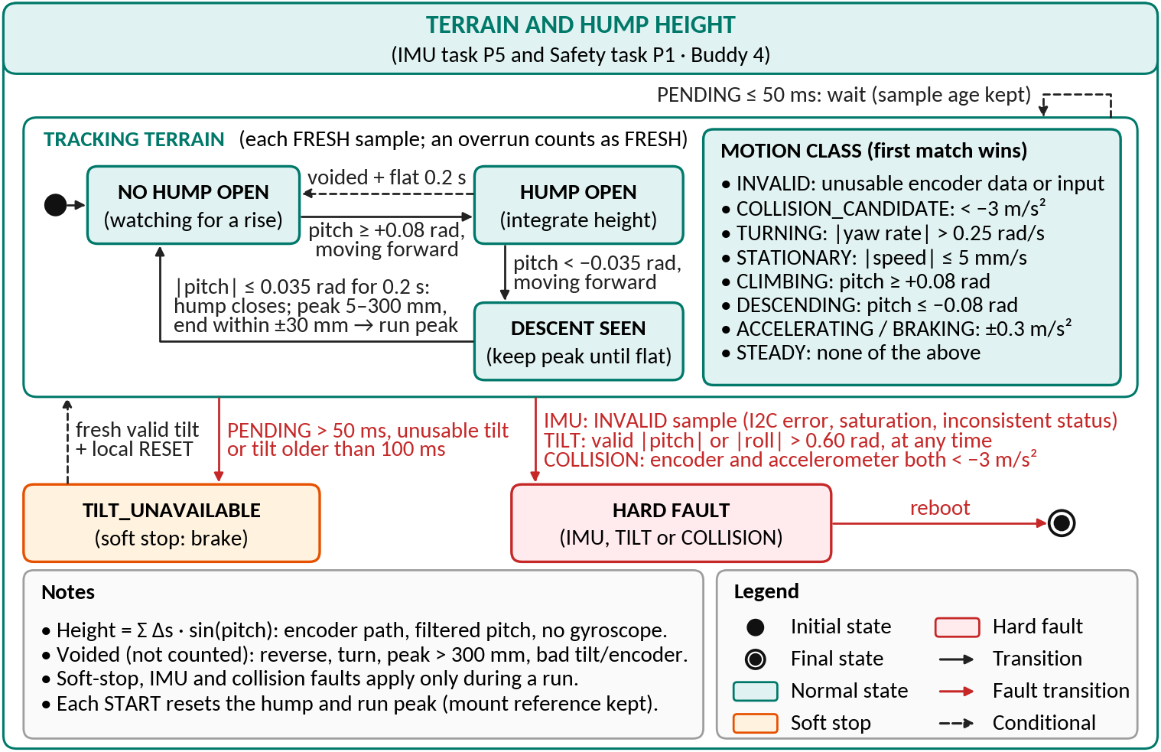
Fig. 7. Hump phases, IMU sample status and motion classes.
Brief explanation of states, events, and fault handling:
- Sample Handling & Overrun: An overrun is treated as the newest FRESH sample.
- Soft Stop Conditions: PENDING sample > 50 ms, unusable tilt, or tilt older than 100 ms triggers a soft stop.
- Hard Fault Triggers: INVALID sample (I2C error, saturation, inconsistent status), tilt > 0.60 rad, or collision triggers a hard fault (reboot required).
- Collision Detection: Encoder deceleration is count-quantised (T-53).
Height Calculation & Limitations: Height = Σ Δs·sin(pitch) based on Briefing p7's IMU mounting assumption near the centre of gravity (A5); does not use h ≈ v²/2g due to lack of a gyroscope to track tilt over the bump.

6.5 Subsystem Statechart 5: Obstacle Handling (Buddy 5)
Field | Student Entry
Subsystem name | Obstacle Handling (Buddy 5)
Related RTOS task(s) | Scan P6, Vehicle P4, Motion P2, Line P3
Purpose | Stationary profile, bypass, original-line recovery.
Reason a statechart is needed | Settle, echo wait and route permission need sequencing.

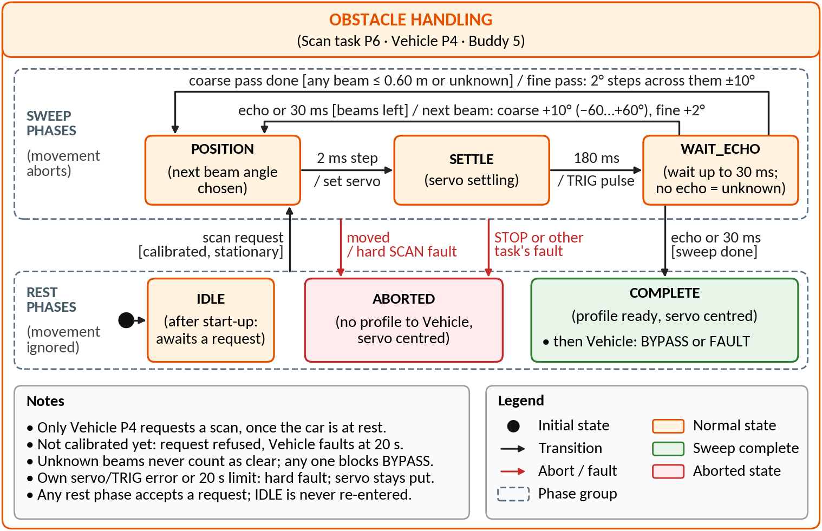
Fig. 8. Scan task phases (scanner_phase_t).
Brief explanation of states, events, and fault handling:
- Movement mid-scan → ABORTED (hard SCAN fault).
- No qualified route or 20 s timeout → FAULT.
- Unknown echo is never clear.
Limitation: REACQUIRE drives ≤ 0.6 m straight on the scan-entry heading, no lateral search: ≈ 1–2° heading or turn error can miss the 18 mm sensor pair (safe FAULT; redesign T-52).

7. Assumptions
ID | Assumption | Risk if wrong | Validation method | Owner | Status
A1 | Pico W radio and broker work in the lab; remote STOP with local START is allowed | No telemetry; policy conflict | Broker trial with outage (T-35); dated lecturer answer | B1 | Open
A2 | Two-channel encoders on the drive motors (else the kit's single-channel slot sensors, supported by a firmware build option); counts per turn, signs, 32.5 mm wheel radius, 140 mm track | Wrong distance, turns, bar widths | Hand-count edges, measure wheels (T-30) | B2 | Open
A3 | Three IR spots resolve the 18 mm line and narrowest bar at 0.08 m/s | Lost line; rejected frames | Spot photos, calibration, resolution study (T-06, T-32) | B3 | Open
A4 | Codebook, next-junction rule, 0.060 m approach (edge detection to axle over crossbar centre) | Wrong or misplaced turn; a U-turn needs a junction, else FAULT | Lecturer answer (Q1–Q3); measure edge-to-crossbar-centre travel | B3, B2 | Open
A5 | IMU flat near the centre of gravity (Briefing p7); Σ Δs·sin(pitch) gives height | False tilt fault; wrong peak | Six-face calibration, known humps, Q5 (T-33) | B4 | Open
A6 | Obstacle depth ≤ 0.30 m; swept corridor clear; straight reacquire meets line | Collision; FAULT after missed line | Footprint; both-side and heading-error trials (T-34) | B5 | Open
A7 | Task periods, 4 KiB stacks and 1.2 ms I2C reads fit the target | Stale data; watchdog reset | Jitter, sample gaps, stack high-water (T-36) | All | Open
A8 | GP20/GP21 buttons read low when pressed (internal pull-ups) | STOP never registers | Bench: GP20 low only when pressed, before motor power; press test before every run | B5 | Open

8. AI-Supported Design Evidence

8.1 Pre-Submission AI Ideation
At the team coordinator's request, Claude Code ran one AI session per subsystem (Claude Opus 5.5, 25 Sep 2026), each with a prompt written for that subsystem. A second AI session checked every suggestion against the firmware and drafted the row; each buddy owns the decision in their row. The prompts, replies and checks are private team records (not in the public repository), available on request and at Tribunal 1. Adoptions are post-freeze work.
Buddy | AI prompt or discussion used | Useful AI ideas | Weak or unrealistic AI ideas | Team decision
Buddy 1 | Asked AI to critique our MQTT telemetry and remote STOP: what could lose or delay a STOP or starve control | Repeat remote STOP until status shows the stop flag; after 1 s with no frames, press GP20 STOP | Sequence numbers on commands: a restarted dashboard's STOP would be refused; a replayed STOP is harmless | Modify (T-02): no sequence/ack protocol; status stop flag confirms STOP, repeat until seen; 1 s silence → GP20
Buddy 2 | Asked AI to review our 5 ms wheel PID, leases, stall check and STOP commit: risks and first changes | Feedforward from per-wheel duty sweep (duty per m/s, breakaway): untuned PI needs ≈ 3 s to reach 0.15 duty | Soft lease-expiry fault: no gain, as Safety hard-faults a Vehicle stale > 40 ms before the 50 ms lease ends | Adopt: plan duty sweep and feedforward in T-05, breakaway sets stall duty (T-59), tune in T‑31; lease stays hard
Buddy 3 | Asked AI to critique our IR line follower, encoder bar widths and next-junction 60 mm-then-pivot rule | End the NAVIGATE pivot on the leading line sensor's first black edge; encoder angle kept as a ±30° bound | Reverse 180 mm to re-read a rejected frame: junctions also give rejected frames; no rear ranging or reverse following | Adopt as B3 follow-up (±30° bound tuned in T-31): NAVIGATE ends in REACQUIRE, which cannot fix turn error. No re-read
Buddy 4 | Asked AI to critique our GY-511 tilt fault, collision test, motion classes and path × sin(pitch) height | Two contacts: Σ Δs·sin(pitch) averages over wheelbase L; the AI's example L = 110 mm reads a 30 × 100 mm triangular hump as ≈ 14 mm | Subtract encoder dv/dt from a_x before pitch: one count in 10 ms is 5.7 m/s²; unusable until T-53's window | Modify: T-08 models two-contact height with measured L; terrain.c changes only via T-22 after Q5; formula kept now
Buddy 5 | Asked AI to stress-test our ±60° sonar scan, side choice, bypass and reacquire: failure modes and fixes | 15° sonar cone widens apparent width by ≈ 2r·tan 7.5° (≈ 80 mm at 0.30 m); scanner.c has no correction | Aim sonar 60° sideways on the pass leg to find depth: loses our only forward guard; oblique faces fake an edge | Adopt in T-34 (B5): the cone term corrects the reported width only; raw width keeps the bypass offset conservative

8.2 Team-Reviewed Architecture Freeze
AI or initial idea | Team decision | Engineering reason | Affected artefact
One PWM owner (Motion), one requester (Vehicle) | Accepted: only Motion commits drive PWM, only Vehicle writes requests; a fault latch may only brake | No conflicting motor commands | §§3–4, Fig. 5
Unknown or stale range halts, never clear | Accepted: no echo = UNKNOWN; invalid/≥ 150 ms-old range halts FOLLOW (RANGE_WAIT ≤ 1 s), else FAULT | Absent echo is not free space | Figs. 3, 8; A6
Averaged speed window, raw-count distance | Accepted: PID uses a 50 ms time-window mean speed; pose, progress and IMU path sum every raw count | Less quantisation, no lost path | Figs. 5, 7
Act at a later junction; reset needs a new START | Accepted: a code waits for a later junction edge (10 s limit); RESET → IDLE, then a new GP21 START | No premature turn or restart | Figs. 3, 6
Defer ‘reverse and reattempt’ (Write-up p9, Q6) | Accepted: deferred to Week 10 (T-51, B5) pending Q6; a no-route scan stays a soft FAULT (safe stop) | No rear ranging to prove clear | FR8; A6

8.3 Final AI-Vetted Gap Check
Rows 1–4: earlier AI repository audits (21–23 Sep; private records); rows 5–6 and the last row: the team's own run of this prompt (25 Sep).
AI-identified gap | Team response | Action taken | Evidence or reason
IMU overrun (two samples per 10 ms poll) latched a reboot-only fault | Fixed | Overrun = newest FRESH sample; I2C error, saturation stay hard | Host tests; ODR bench choice (B4)
NAVIGATE pivoted before the axle reached the junction | Partially fixed | Approach 0.060 m, then pivot | Host tests; offset and turn trial open
Newer shared stamp read as ≈ 49 days stale | Fixed | Wrap-safe age (newer stamp = 0) | Host regression scenarios
Straight reacquire and bypass time vs Briefing p8 bands | Deferred | Redesign (T-50 time, T-52 search) in Week 10; limitation in §6.5 | Estimate ≈ 31–36 s vs band D < 10 s
Accelerometer-only tilt and collision: stops or humps may trip faults | Needs validation | A transient makes tilt invalid: a soft stop, not a hard fault (logged in T-67); collision windowing T-53 | Collision trips on one 10 ms sample; tilt on one sample of 80 ms-filtered pitch or roll; false-alarm hump, start and stop trials in T-33
Range exits beyond FOLLOW undrawn; A6 depth unmeasured | Needs validation | NAVIGATE, REACQUIRE, BYPASS fault on lost range; A6 in T-34 | vehicle.c range checks; Q6

9. Design Consistency
Check | Student Response
Which task owns each hardware device? | Motion: motor PWM (any fault latch can force BRAKE). ISR: encoder edges, ECHO. Line: IR ADC0–2. IMU: GY-511. Scan: servo, TRIG. Safety: STOP GP20, watchdog. Vehicle: GP21. Radio: CYW43. Initial task: UART0 console (start-up refusal only).
Which task has the highest priority, and why? | Safety P1: STOP, tilt, collision and stale-owner checks must pre-empt all mission work within 2 ms; the radio owner is lowest.
Which subsystem statechart corresponds to which RTOS task or subsystem? | Fig. 3 Vehicle under Safety; Fig. 4 Comm, Telemetry, radio (B1); Fig. 5 Motion (B2); Fig. 6 Line, Vehicle navigation (B3); Fig. 7 IMU (B4); Fig. 8 Scan (B5).
How are functional requirements reflected in the task and statechart design? | FR1–3 Line, FOLLOW/NAVIGATE; FR4 Motion; FR5–6 IMU, Safety; FR7–8 Scan, SCAN/BYPASS/REACQUIRE; FR9–10 Comm, Telemetry; FR11 FAULT; FR12 open.
What changes are still expected after the Week 6 review? | Codebook, finish, turn rules; measured calibration, junction approach, timing, stacks; 8.1 adoptions; reacquire and bypass-time redesign; the requirement change announced at Tribunal 1 (Week 8), implemented by Week 13 (T-40).
Review record | Design frozen 25 Sep 2026 on the firmware identified below. One later change: HC‑SR04 moved to 5 V with an ECHO divider on 26 Sep (kit photos; lecturer to confirm). Each buddy confirms their rows before submission (T-14).

