UI Decision Document
The general design of our digital Kanban board is that it should vaguely resemble that of a real-life board. Usually this is done with post-it notes sorted into categories, as seen in the image below:

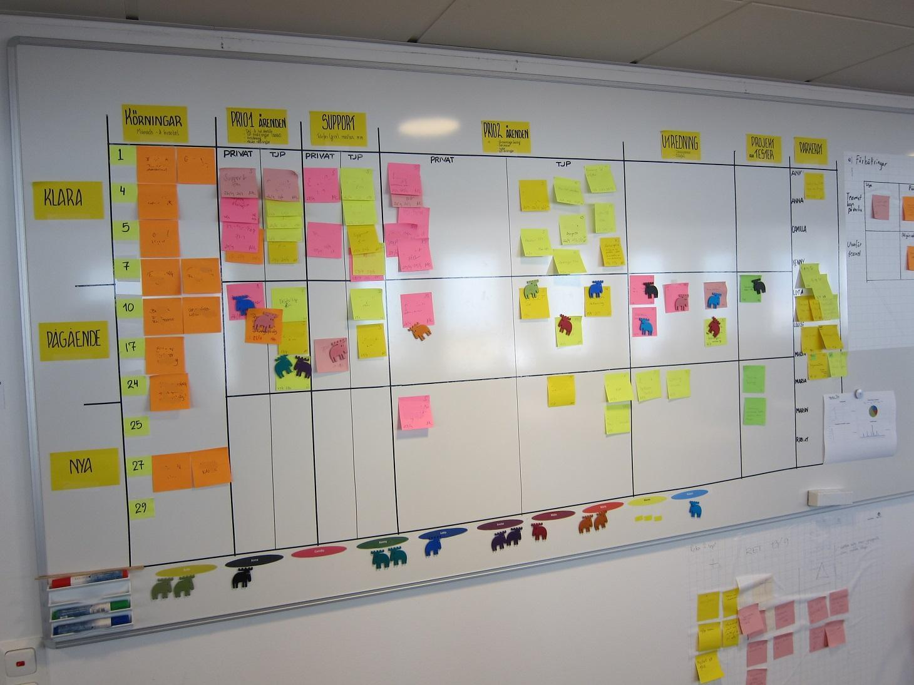
(Image source: https://cdn.technologyadvice.com/wp-content/uploads/2017/05/kanban1.jpg)

The general expectation of a Kanban board involves columns representing different stages of progression, such as (to-do, in progress, in review, finished).

Additionally, rows can possibly represent the teams or users involved in the project. Although we wanted this feature for our own digital board, due to time constraints we decided to cut this feature.

With the rows and columns in place, users involved in the project can now add tasks to the board, usually as new requirements pop up during development. Users may also move those tasks around to update the progress. Finally, users can remove them from the board if those tasks cease to be relevant, or to clear the board for additional space.

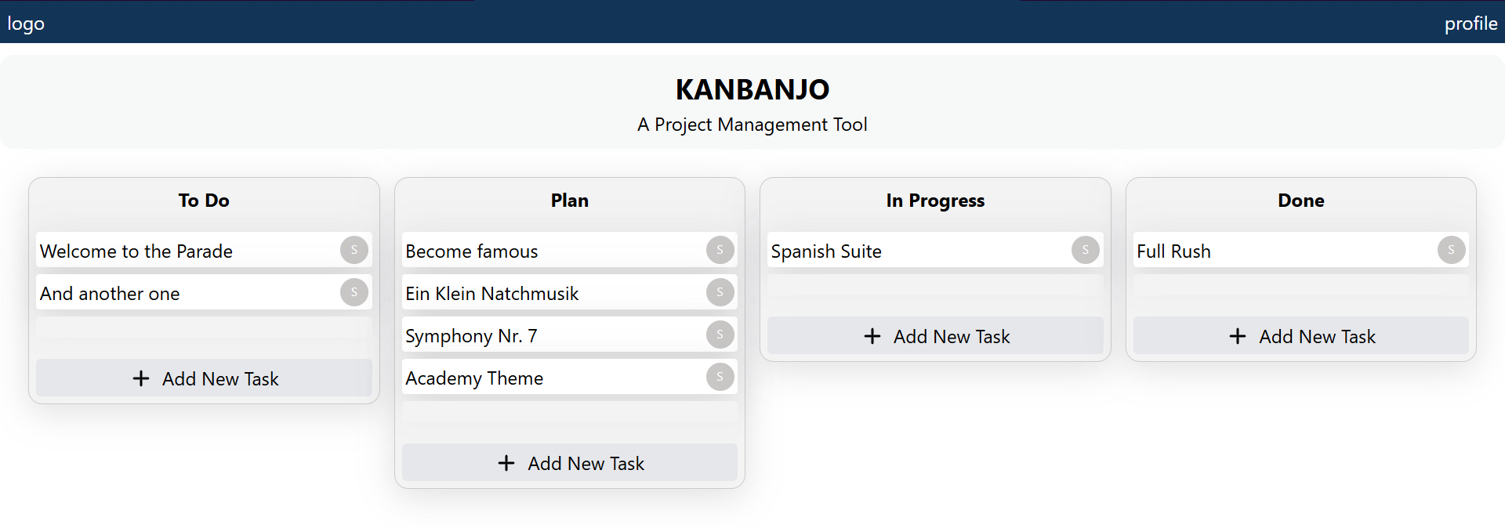
Digital Kanban Board

The digital kanban board is designed as a web application, meaning that it will be visible in the browser. For web pages in the browser, it is standard to include a header at the top of the page, usually displaying logo, navigation, search bars, and profile/accounts.

Before the board, we also have the title and a tiny description of the board. Since we do not yet have title and logo as part of the header, we have placed it above the board itself. It’s important that users can tell at glance what page/app they’re visiting.

In this app, users can add tasks by clicking the “Add New Task” button within the relevant columns. We placed the button in the area where users expect the new tasks to show up upon creation.

In general, users should be able to modify elements by clicking on them. For example, tasks can be moved around with drag-and-drop. Simulating a physical board like this is intended to make the interaction more intuitive, and it is an expected behaviour of kanban boards.
Tasks can be edited by clicking on the task, then modifying the contents through the pop-up window. A different approach would be to allow text to be clickable, and the text content could be modified, without any pop up. This would minimize clutter such as buttons, fields and menus, but we simply did not have the time.

Handling accounts is handled in the top right corner of the header. This is positioned by conventions of web design.

If we had the time to implement creating new boards, saving and loading, those would be handled in the top left corner of the header, by convention of GUI applications running on PC.

We also planned swim lanes. These are horizontal lanes that divide users into groups or teams. Had we implemented them, we would’ve considered using color coding to represent the swim lanes.

