

**PEASON MANHURU**

**REG NUMBER T1933105W**

**SOFTWARE ENGINEERING 2.2**

**CLASS B**

**PRAGRAMMING III**

**END OF SEMESTER MINI-PROJECT DOCUMENTATION**

**PROJECT NAME:**

**ESSENTIAL CAR HIRING MANAGEMENT SYSTEM LINKED WITH ESSENTIAL CAR HIRING WEBSITE**

**@2022**

ABSTRACT

# ABSTRACTION/EXECUTIVE SUMMARY

The project that had been develop is going to be concerning about the car rental management by a TelOne Software Engineering Student. The project will be known as Essential Car Hiring Management System and have six modules (Loading module, Login module, Cars module, Customers module, Dashboard module, Car rental module, Car return date module and a link that connects the windows application with Essential car hiring Website). Because of the Car Rental System, customers will be able to reserve their vehicles from anywhere in the world. Customers supply information to this application by entering their personal information. A consumer can reserve a car by creating an account on the website. The proposed system is a fully integrated offline windows form. It automates manual procedures effectively and efficiently. This automated method assists the administrator by allowing them to fill in the specifics based on the needs of their customers. It includes information on the type of vehicle available for rental, rented vehicles, return dates, and returned vehicles.

# DECLARATION PAGE

I declare that this is my original work except where sources have been cited and acknowledged. The work has never been submitted, nor will it ever be submitted to another college or university for the award of a diploma.



PEASON MANHURU 18/05/2022

# LIST OF ACRONYMS/ABBREVIATIONS

ECHMS – Essential Car Hiring Management System

Table of Contents

ABSTRACTION/EXECUTIVE SUMMARY ii

DECLARATION PAGE iii

LIST OF ACRONYMS/ABBREVIATIONS iv

INTRODUCTION 1

*Reason for the Project* 1

Problem Statements 1

Objective 2

Scope 3

Expected Output 4

Conclusion 5

LITERATURE REVIEW AND PROJECT METHODOLOGY 6

Introduction 6

Facts and Findings 6

Domain 6

Existing System 6

Case Study 7

Differences between manual and computerized system that was developed 8

Technique 8

PROJECT METHODOLOGY 9

Planning 9

Implementation 9

Testing 9

Documentation 9

FUNCTIONAL AND NON-FUNCTIONAL REQUIREMENTS 10

Functional Requirements 10

DATA FLOW DIAGRAMS 12

Data Flow Diagram (DFD) 12

Database management Structure 14

Use Case Diagram 15

ACTIVITY DIAGRAMS 16

Activity Diagram 16

Member Registration 16

Reservation of Car 17

Adding a New Car 18

Sequency diagrams 19

Reservation Car 19

Adding a New Car 20

CLASS DIAGRAM 21

Class Diagram 21

BIBLIOGRAPHY AND REFERENCES 22

Books Used: 22

References Used: 22

# INTRODUCTION

The administrator will register for driver who rented the car from the company, but client will register by their own through the company website. The client can login to the system with the internet. Client can search the type of car for their need to make booking of the specific car. When client choose the car, system will list out the car details. Essential Car Rental Management System give a security to the confidential data. It’s also preventing staff from make minor or major mistakes during managing the data.

## **Reason for the Project**

The advancement in Information Technology and internet penetration has greatly enhanced various business processes and communication between companies (services provider) and their customers of which car rental industry is not left out. This Offline Car Rental System is developed to provide the following services:

* Enhance Business Processes: To be able to use computational technology to keep track of the Client and to use internet technology to project the rental company to the global world instead of limiting their services to their local domain alone, thus increase their return on investment (ROI).
* Online Vehicle Reservation: A tool through which customers can reserve available cars online prior to their expected pick-up date or time.
* Offline Vehicle Reservation: A tool through which administrator can manage available and rented cars.
* Customer’s registration: A registration portal to hold customer’s details, monitor their transaction and used same to offer better and improve services to them.
* Short booking: Allows the customer to book space for airport pick-ups and drop-offs in the case of hotel drop-offs and pick-ups or corporate meetings (Event management).

## Problem Statements

The Process on searching the client details is slow if the company is using manual system and there are thousands of clients. Besides that, staffs have to record the booking manually and it is difficult to produce a monthly report or an annual report. Manual system does not allow client to booking online and hard to keep track on the record of rental cars.

## Objective

The main objective of this system is to provide convenience to the management team by developing a computerized system to make processes regarding car rental easier. In distinctive, the objectives of Essential Car Hiring are:

* To enhance searching speed for all information such as client and rental.
* To provide direct access to clients through web application system.
* To provide report generation and analyses the rental of car to give better decision making.

## Scope

The system that is going to be developed is known as the Essential Car Hiring Management System whereas the system is a Windows Form based application system. The system is mainly used by the administrator through the use of the website to get customer information and put it in the Management System Database. The website and Windows Form application databases are not integrated. This system is made up of seven modules. The modules are:

1. Client Information

User can register, login, view and update client information.

1. Car Information

Admin can add, view, update and delete car information.

1. Dashboard

Updates number of cars and customers.

1. Renting Out

User can update rental information status to renting out and system will record the time and staff who take the car.

1. Admin authentication

Admin logs in using their user name and password for security reasons.

The system is a windows based application since it was built using C# and .Net Framework. The .Net Framework is platform dependent and since the project was a strict combination of C# and other web based languages learnt from the previous semester (2.1), the developer was limited from building a cross platform application. The developer used Microsoft Visual Studio built-in SQL server as his database. The developer adopted the Software Development Life Cycle Principles using the incremental model and a little slice of the Scrum methodology during this project development.

## Expected Output

The system is expected to produce the same result if same input is provided infinitely. The system to be fault tolerant, if wrong data is fed a message box must pop, alert on what went wrong and what information to provide.

## Conclusion

Essential Car Hiring Management System will improve the management of rentals and bookings of cars. This system was developed in order to overcome the problems faced using the manual way. It acts as agent for car owners to rent out their car and the company can also earn profit from each of the transaction.

# LITERATURE REVIEW AND PROJECT METHODOLOGY

## Introduction

Literature review has covered searching, collecting, analyzing and drawing conclusion from all debates issues raised in relevant body of literature. While project methodology gives the approach and techniques used to complete the project. This chapter is the report analyzing the fact finding and the approaches and techniques that were used in completing the Essential Car Hiring Management System (ECHMS) project. The fact and finding are being analyzed by identifying the objectives and the current situation and the available resources.

## Facts and Findings

Most of the car rental services are manage using manual way and it cause a lot of problems to its Users. The invention of this System will upgrade the legacy way of collecting data and provides convenient to its user.

## Domain

(ECHMS) is actually an ICT business. It is a business because it combines the technology with business. It is using Information Technology to manage and record its car rental business. Essential Car Hiring is succeeding its business environment using web based application and it changes the manual way into computerized system.

## Existing System

Studying the current system is a method that is used to gather the requirements in the research. The purpose of studying the current system is to identify the existing entities and also gather requirements and identify problem in the current system. Few researches had been made on the manual system. The summary of the research made and are shown in below.

## Case Study

– Using Simulation to choose between car rental lots layouts

In the rental car industry, the number of cars that are waiting for or currently in the process of being cleaned directly translates into unrealized potential income. Although the actual time spent preparing a car for rental) e.g., cleaning, servicing and fueling) cannot be significantly reduced without affecting quality, the number of cars being prepared at a time can be modified. Of course there is a cost involved with any improvements to accomplish this.

From the point of view of a car rental company, there are three essential processes that occur in a rental lot. The first process details how the client is handled during the time spent checking out a vehicle. The second process is what happens while a client checks in the vehicle. The third operation, which is hidden from the client, is what happens to a vehicle between being parked in the check-in area by a client and being checked out by another client.

Each of these processes has their own operations and priorities. During the two phases involving clients, the primary goal is the satisfaction of the client. During vehicle preparation, there is a minimum amount of time required to be spent on each car in order to assure a certain level of quality. The goals in these areas are to minimize the amount of time vehicles spend moving or waiting unnecessarily. What follows is a brief description of each process that occurs in the rental car lot.

(Todd M Johnson (1999) Proceedings of the Winter Simulation Conference: USA)

## Differences between manual and computerized system that was developed

• Manual System:

Difficulties in checking vehicle status whether the vehicle is being used, repaired or available for rental.

Client does not know the detailed information about the car that they had rent.

Mistakes in giving vehicle to the correct client due to data redundancies that occurred because of the manual way are high.

Difficulties in referring to the previous data had been recorded since all the checking is done manually.

Searching client details are fast and easy.

• System to be:

Provide convenient to user to do the car rental process.

Customer can make vehicle rental anytime without relying to certain rules such as office hour.

## Technique

Gathering information and defining the requirements for the system is very important. There are several methods that can be used in gathering information and requirements for the to-be system such as referring to previous thesis, observation, questionnaire, interviews and through the internet. For Essential Car Hiring Management System, the requirements are gathered by interviewing the Cars Online director and its staff. Related documents such as the rental form and list of cars available also had been collected. Using this method, problem arise can be detected and solution can be made to overcome this problem.

# PROJECT METHODOLOGY

The SDLC method will be used to defining tasks performed at each step in the software development process. SDLC is a structure followed by a development team within the software organization. It consists of a detailed plan describing how to develop, maintain and replace specific software. The life cycle defines a methodology for improving the quality of software and the overall development process. The activities of the SDLC are planning, implementation, testing, documentation, deployment and maintenance and maintaining.

## Planning

Gathering Cars Online Company’s requirement and analyses the requirement by software engineers. After the requirements are gathered, a scope document is created in which the scope of the project is determined and documented.

## Implementation

Implement ECHMS by using C# as programing language and SQL Server as the database.

## Testing

Finding defects or bugs during peer review.

## Documentation

A written document about the system was drafted during and after development.

# FUNCTIONAL AND NON-FUNCTIONAL REQUIREMENTS

## Functional Requirements

Requirement analysis is a software engineering technique that is composed of the various tasks that determine the needs or conditions that are to be met for a new or altered product, taking into consideration the possible conflicting requirements of the various users.

Functional requirements are those requirements that are used to illustrate the internal working nature of the system, the description of the system, and explanation of each subsystem. It consists of what task the system should perform, the processes involved, which data should the system holds and the interfaces with the user. The functional requirements identified are:

1. Customer’s registration: The system should allow new customers to be entered into the database and generate total number of customers on the dashboard.
2. Online reservation of cars: Customers should be able to use the system to make booking and online reservation and that same information must be retrieved from the website and entered on to the ECHMS windows based native application.
3. Automatic update to database once reservation is made or new customer registered: Whenever there’s new reservation or new registration, the system should be able update the database without any additional efforts from the admin.
4. Feedbacks to customers: Most appearing customer names to indicate customer satisfaction.

**Non-Functional Requirements**

It describes aspects of the system that are concerned with how the system provides the functional requirements. They are:

1. Security: The subsystem should provide a high level of security and integrity of the data held by the system, only authorized personnel of the company can gain access to the company’s secured page on the system; and only users with valid password and username can login to view user’s page.
2. Performance and Response time: The system should have high performance rate when executing user’s input and should be able to provide feedback or response within a short time span usually 50 seconds for highly complicated task and 20 to 25 seconds for less complicated task.
3. Error handling: Error should be considerably minimized and an appropriate error message that guides the user to recover from an error should be provided. Validation of user’s input is highly essential. Also the standard time taken to recover from an error should be 15 to 20 seconds.
4. Availability: This system should always be available for access at 24 hours, 7 days a week. Also in the occurrence of any major system malfunctioning, the system should be available in 1 to 2 working days, so that the business process is not severely affected.
5. Ease of use: Considered the level of knowledge possessed by the users of this system, a simple but quality user interface should be developed to make it easy to understand and required less training.

# DATA FLOW DIAGRAMS

## Data Flow Diagram (DFD)

A Data Flow Diagram (DFD) is a graphical representation that depicts the information flow and the transforms that are applied as data moves from input to output.

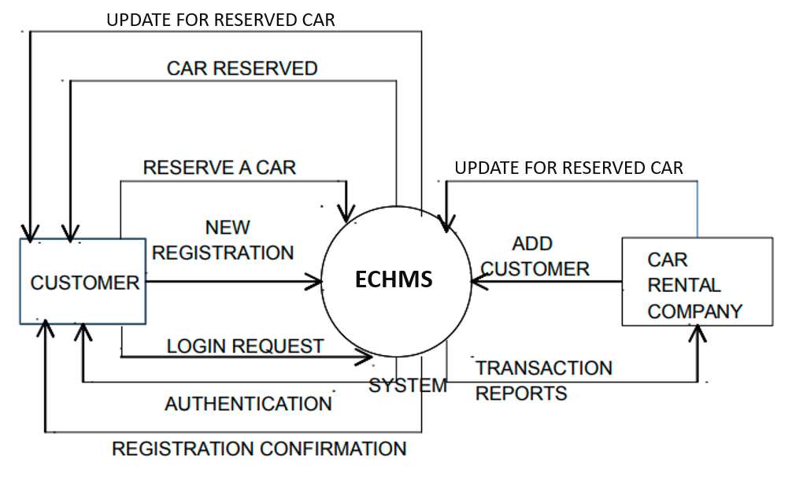

In this diagram, Customer and Car Rental Company are the two entity sets.

Functions of Customer:

* Log in to Essential Car Hiring website
* New Registration
* Login Request
* Provide credentials
* Choose car
* Provide information on rental date and return date
* Registration Confirmation by the System

Functions of Car Rental Company to the management system side:

* Reserve Car
* Car Issued by the System
* Check car picked by the client from website
* Add Customer

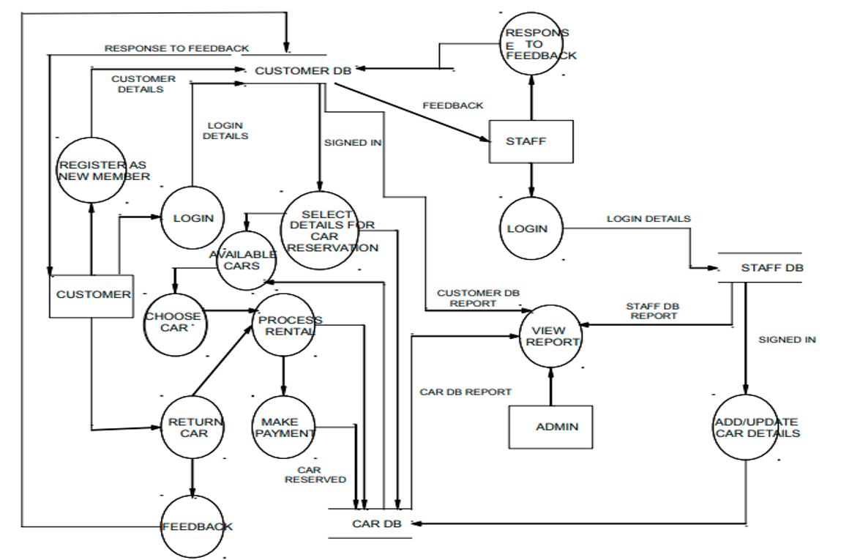

## Database management Structure

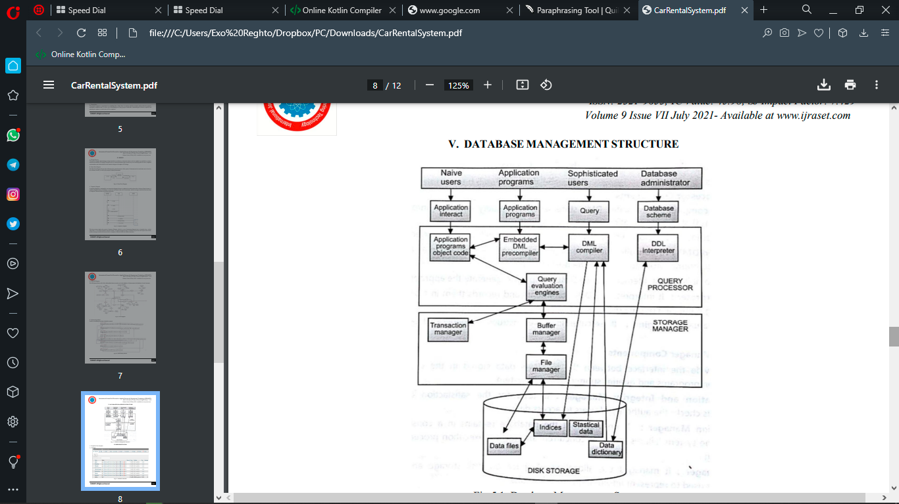

## Use Case Diagram

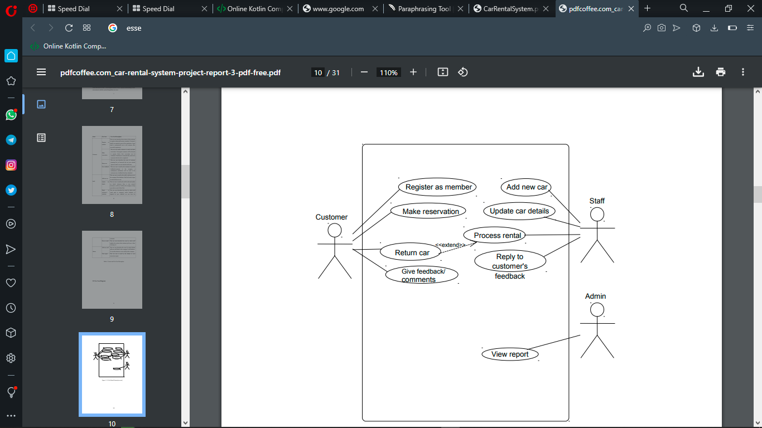

**Use-Case Dependency Diagram**

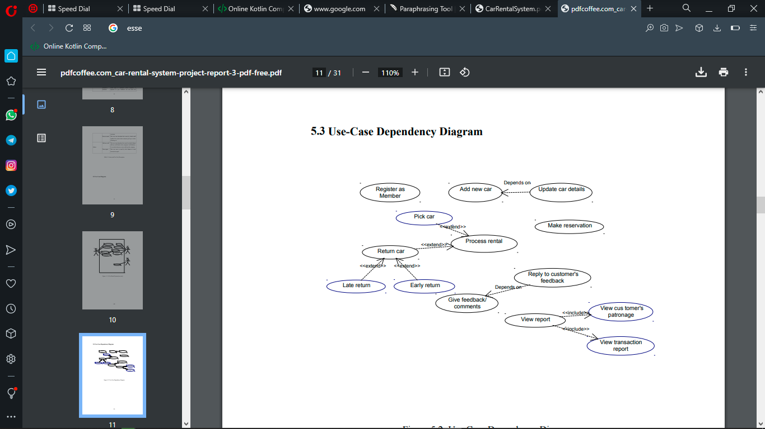

# ACTIVITY DIAGRAMS

## Activity Diagram

Activity diagrams graphically represent the sequential business and operational workflows of a system. It is a dynamic diagram that shows the activity and the event that causes the object to be in the particular state. The workflows from activity diagram will serve as guide for system navigation in the final design phase of the system.

## Member Registration

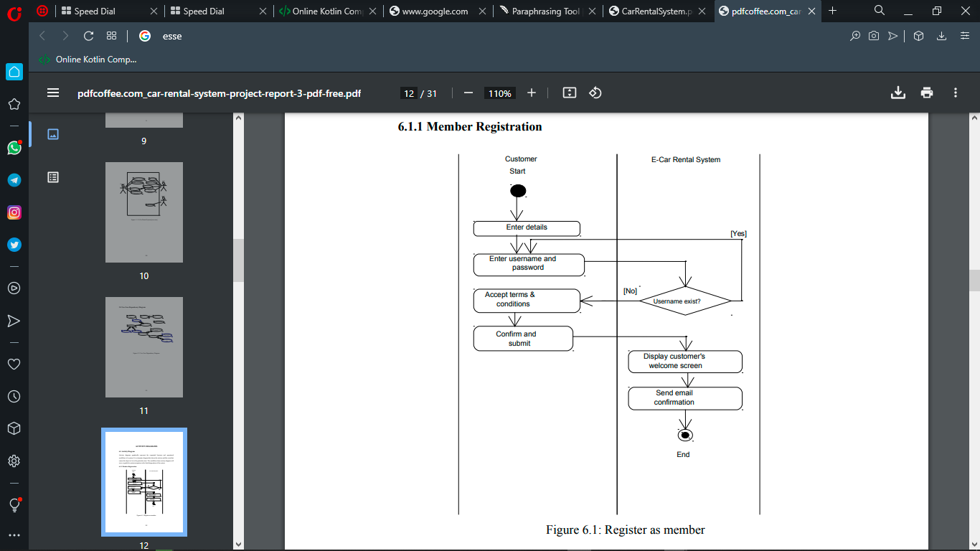

## Reservation of Car

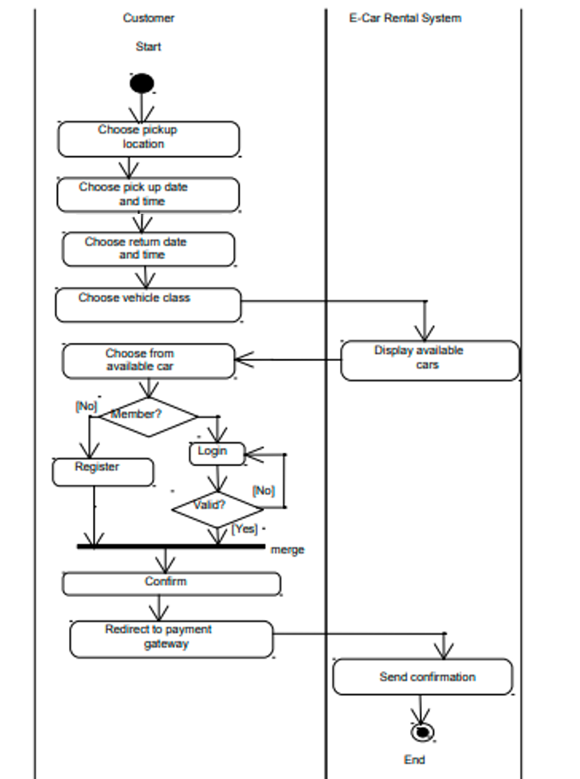

## Adding a New Car

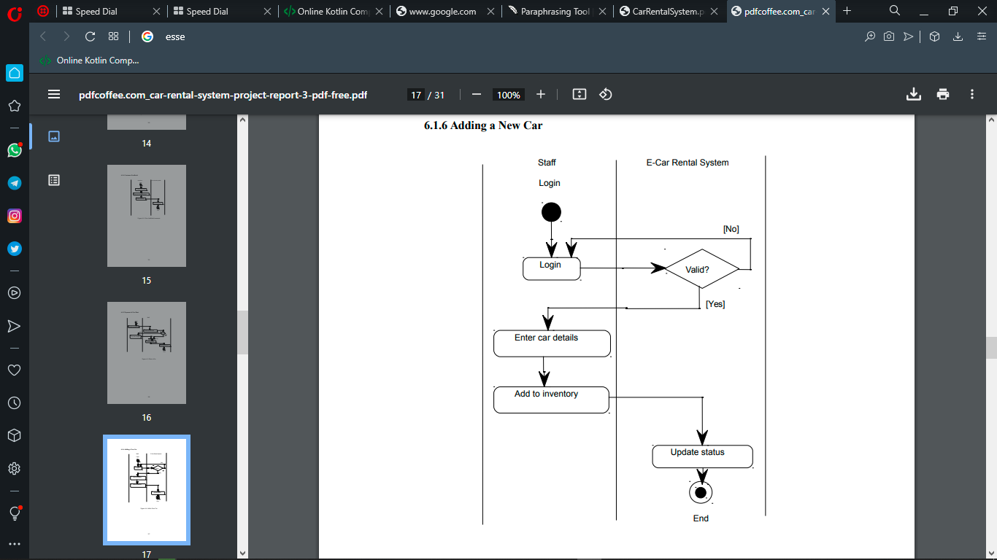

## Sequency diagrams

Sequence diagrams are used to demonstrate the behavior of objects in a use case by describing the objects and the messages they pass. It provides a graphical representation of object interactions over time. Sequence diagrams show an actor, the objects and components they interact with in the execution of a use case. One sequence diagram represents a single Use Case 'scenario' or events. Sequence diagrams show the flow of messages from one object to another, and as such correspond to the methods and events supported by an object.

## Reservation Car

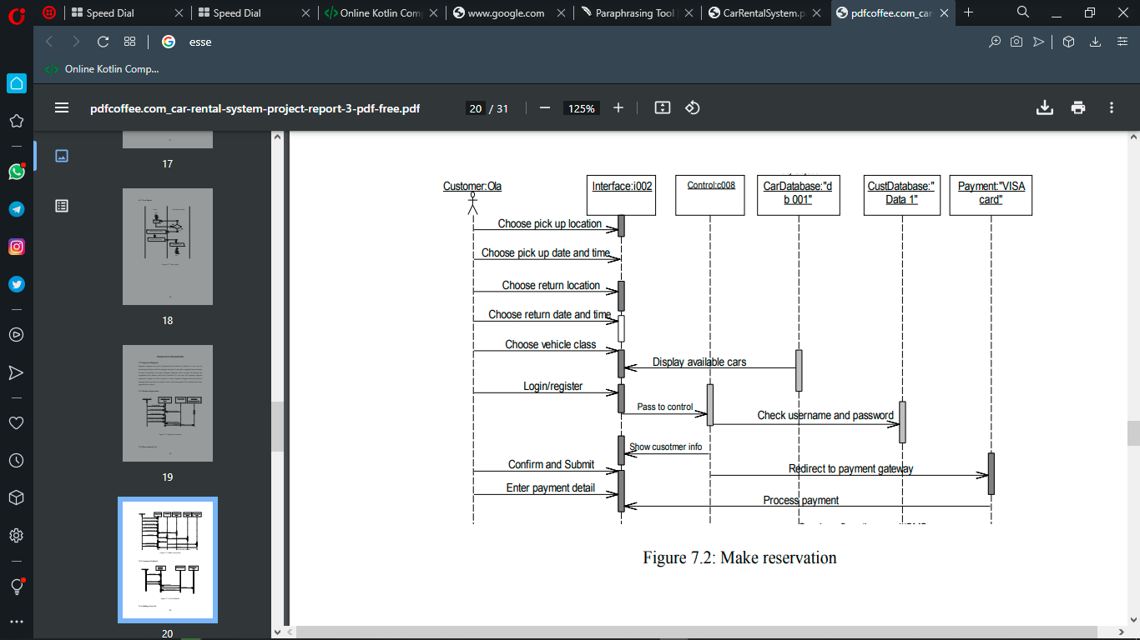

## Adding a New Car

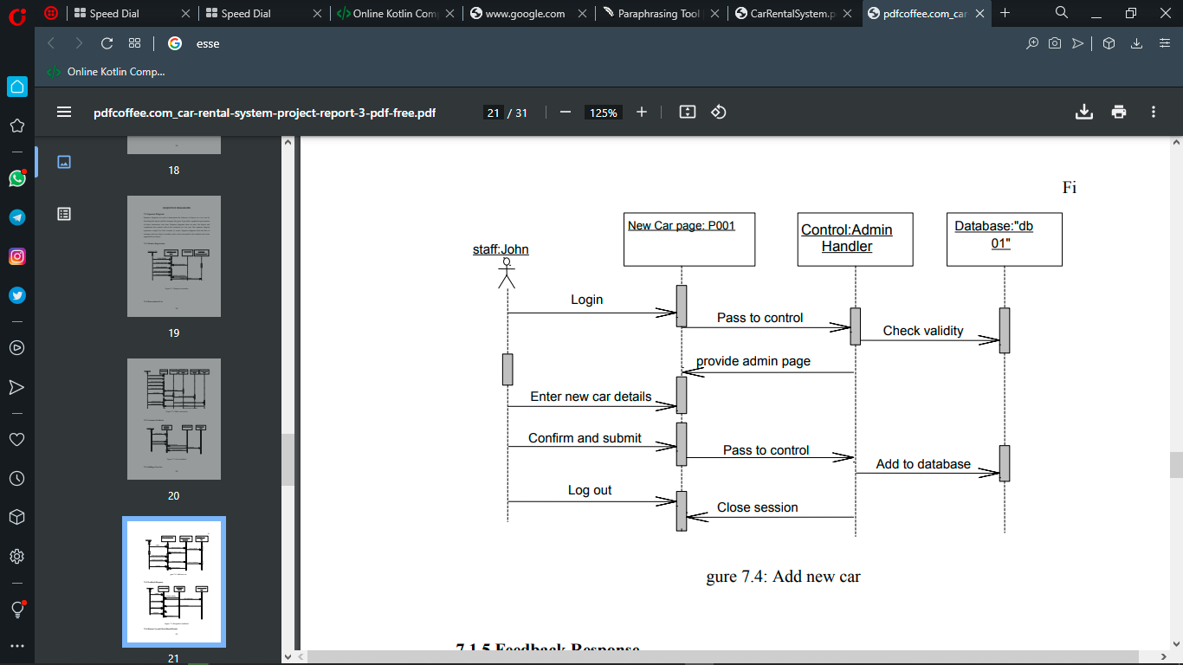

# CLASS DIAGRAM

## Class Diagram

The class diagram is the main building block, a number of classes are identified and grouped together in a class diagram which helps to determine the statically relations between those objects.

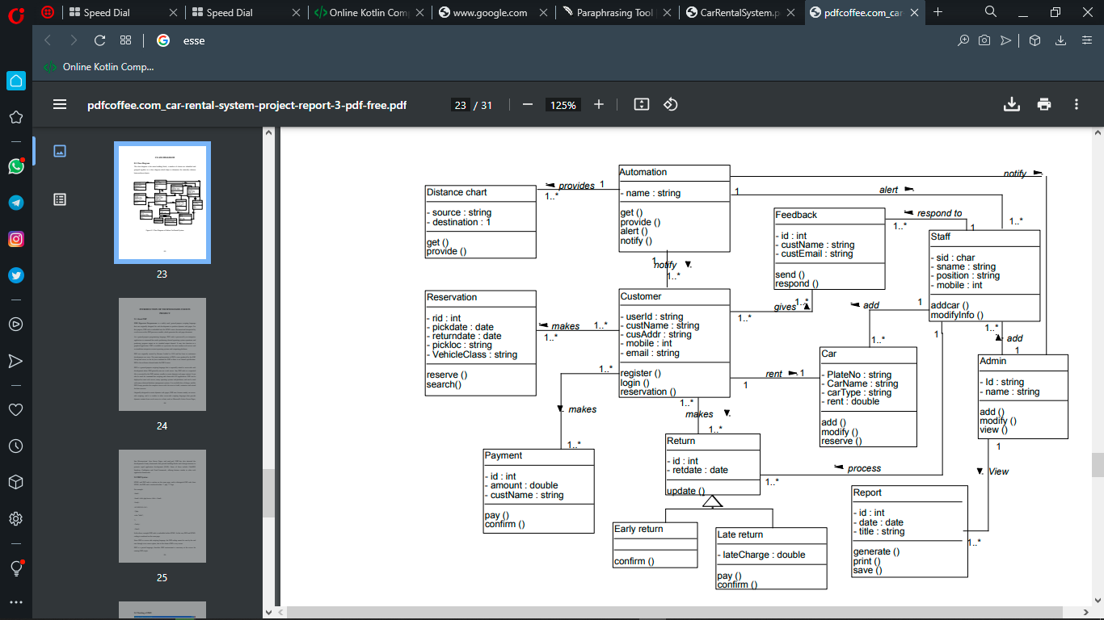

# BIBLIOGRAPHY AND REFERENCES

## Books Used:

• Software Engineering - R.S. Pressman

* Windows Forms in Action, Second Edition of Windows Forms Programming with C-Sharp; Erik Brown ( PDFDrive.com )
* Learn C-Sharp - Includes the C-Sharp 3.0 Features ( PDFDrive.com )

## References Used:

• <http://www.carrentingsolutions.com/>

• Wikipedia.org

• www.w3schools.com