Trained By ________________ Date _________ Person Trained_________________

SAFETY / ENVIRONMENTAL
Verify that all personnel that will be involved with this activity are familiar with this procedure, any risks or hazards that may be encountered, possess the required safety equipment, and are familiar with the site safety and environmental policies.
OBJECTIVE
The purpose of this Procedure is to train Personnel while working around Exos Aerospace Crane Operations and have them recognize appropriate Hand Signals and the zone of hazards that exists while conducting crane operations.

OVERVIEW
It is necessary for the personnel involved in executing this procedure to possess a working knowledge of the Crane operations, Hand Signals, and how to position one’s self during such operations. At no time should a person be directly underneath the load being lifted or moved. The persons directing the movement of the load should maintain visual contact with the Crane operator at all times. Persons supporting the stability of the object should approach from the side directly or with a control line, and ensure that the path the object will take is free of obstructions and personnel at all times. If the load being lifted shifts or otherwise appears to lack stability with the lifting straps, the load director should signal an emergency stop and the load stabilizer must get to a safe distance immediately until the load is secured or placed back on the ground.
Personnel safety is more important than any hardware!

- Equipment
  - _____ Current Crane operations where the crane is moving the Rocket or heavy equipment associated with launch or test operations should be conducted with a minimum of 2 persons, preferably 3. When 2 people are operating and moving the loads, verbal commands can suffice in lieu of hand signals as required.
- Setup
  - _____ Care should be taken to position the crane as needed while avoiding overhead hazards such as powerlines or beams.
  - _____ There must be sufficient space around the crane for the Outriggers to be fully extended and firmly support the crane center on all 4 feet.
  - _____ The Outriggers must be down and solid before the crane boom can be released and craning operations can begin
  - _____ At no time is the hook of the ball/2-block of the crane to be left stationary at head height. It should be raised so as not to present a bump hazard for persons working in the area after the crane operation is complete or is between operations.
  - _____ Inspect all straps and shackles that are to be used in advance of connecting to the load.
- Practice
  - _____ The Crane Director and Crane Operator must be familiar with the OSHA Crane Hand Signal Chart in this document.
  - _____ Both the Operator and the Director must demonstrate that knowledge by passing a practical review with an operator and a director with the trainer present.
  - _____ The General Crane Operations Participant must learn the nature of the Zones of Hazard that exist under and around the load being moved by the Crane, and must practice maneuvering the load without placing any body parts between the load and any fixed object.

- Zone of Hazards
  - _____ The persons conducting the crane operations must establish a Zone of Hazards prior to each lift that photographers and other personnel can remain clear of during the Crane operation. This will prevent those without proper training from getting too close to the operation at hand.
- Minimum Requirements
  - _____ Persons in these roles must be able to lift 50 lbs and withstand temperatures exceeding 100 degree Fahrenheit for more than an hour without assistance.
  - _____ Personnel in the Crane operator and Crane Director Roles must have passed a review of the hand signals required to communicate in case the Radio headsets cannot be used for verbal commands.
  - _____ General Operations participant and the Crane operator must check the surrounding area before Crane operations begin to ensure no overhead hazards and no errant personnel in the area.
  - _____ Crane Operation Persons must take a moment to review the lift with any other persons present to make sure that all other participants understand the zone of hazards and the direction of movement once the load is lifted.
- Role Execution
  - _____ When lifting singular large objects with no loose parts, Hard Hats are not required so that radio headsets may be used to communicate if needed. At no time shall any persons be directly beneath the suspended load. All loose parts if any must be removed from the load.
Crane Director and Crane Operator
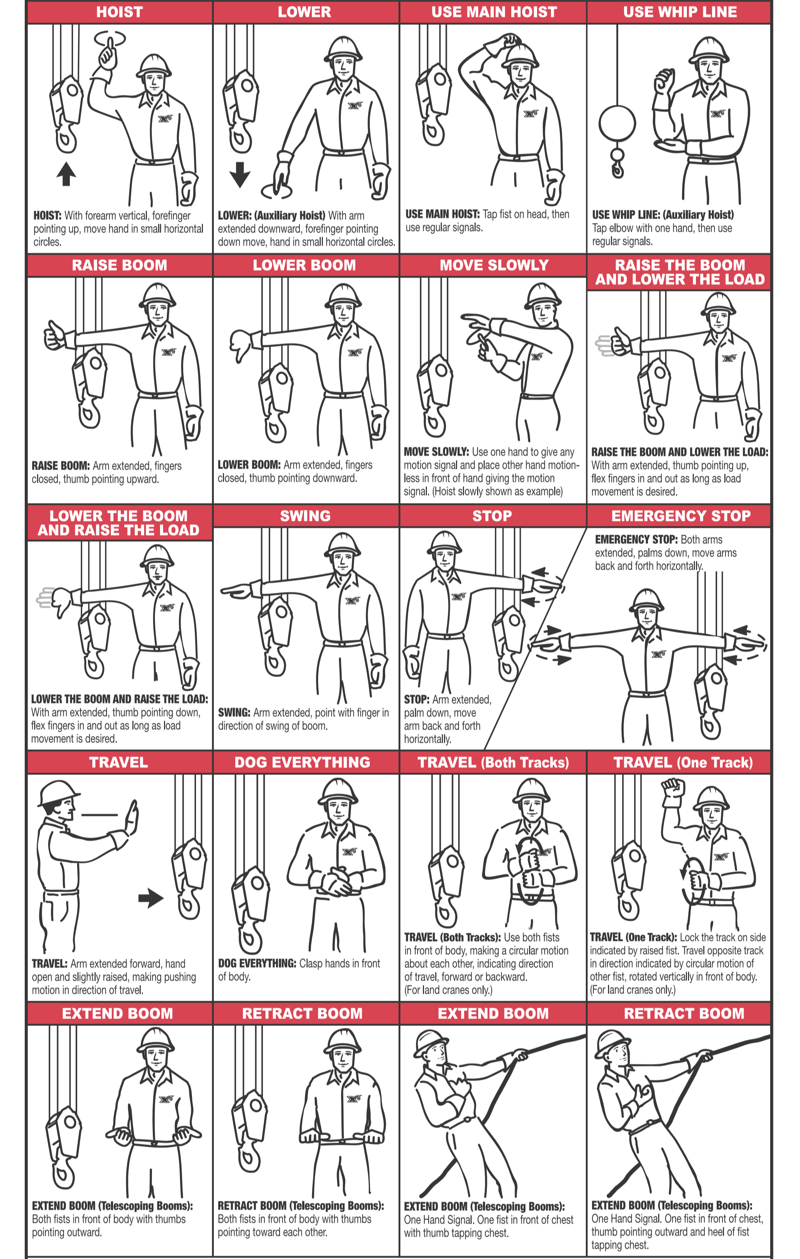
Hand Signals:
At the right is the official OSHA Crane Director Hand Signals chart that should be memorized and used while directing a Crane Operator to move the load as directed.

One must be tested on the hand signals and pass 100% in order to act as the Crane Director or Crane Operator.

By signing below I agree that I have received the appropriate training to work on or near the Exos Aerospace Crane Operations.

Second and Third Signatures are required for approval to act as either Crane Director or Crane Operator.

General Crane Operations:
Trainee Signature________________________ Date_______

Trainer Signature________________________ Date_______

Crane Operations Director:
Trainee Signature________________________ Date_______

Trainer Signature________________________ Date_______

Crane Operator:
Trainee Signature________________________ Date_______

Trainer Signature________________________ Date_______

