

Exos Aerospace Global
Purchasing Process and Procedures

Introduction
The purpose of these processes and procedures are to provide a framework and guideline for the purchase and payment for materials and services used in the general course of conducting business for Exos Aerospace Global S.A. (Exos), and its subsidiaries and/or affiliates. Regardless of departmental structures or personnel, these processes and procedures are intended to scale with the organization.

- Basic Purchasing Principle
  - Compliance: Exos will comply with the applicable laws and regulations of each country and international norms, act with integrity, and give proper consideration to safety, environmental, natural resource and human rights.
  - Fair and Equitable Transactions: Exos will select vendors and business partners in a fair and equitable manner and fosters an environment for healthy and transparent competition.
  - Business relationships: Exos strives to build long-term, mutually beneficial business relationships with our business partners, vendors and service providers. This is accomplished by maintaining appropriate communication to continuously enhance a trusting relationship.
  - Protection of information, intellectual property, and other assets: Exos will properly manage and protect the proprietary information, intellectual property, and other assets of both Exos and our business partners while procuring goods and services.
- Purchasing Requirements
Exos buys a wide range of goods and services that can roughly be divided into:
  - Office Supplies, Shop Supplies, & Miscellaneous
  - Contracted Services
    - Building Lease
    - Utilities including Internet, Telecom Power, Water & Sewer, Trash Removal, …
    - Software Services including HubSpot, Google Workspace, Cyber Security, Preveil Email, Adobe, QuickBooks, Teamwork, …
    - Software Leases including CAD, Sierra (engine), QuickShot (trajectory), …
    - Equipment rental and leases including cylinder rental, tank rental, equipment rental, …
  - Project Related
    - Small components such as hardware, wire,
    - Raw Supplies such as metal blanks, insulating blanket, ..
    - Specific Components such as propellant tanks, composite tubing, computer boards, valves, actuators, INS, GPS, …
    - Project related software & services such as GNC, aero-CFD, telemetry, …
  - Capital Assets
    - Machinery and equipment to be capitalized over multiple years
    - Furniture & fixtures, leasehold improvements, …
    - Real property
    - Launch and testing related resources to be used by Exos
  - Expenses
    - Travel related expenses such as airfare, hotels, meals…
    - Entertaining

- Definitions
  - Requisition: The business case directing the purchase of materials or services associated with the Company’s or department’s operational and budgetary needs.
  - Purchase order (PO): The document prepared by a company to delineate precisely what the Company is ordering from a vendor.
  - Receiving report: The Company’s documentation of goods it has received from a vendor.
  - Credit: The act of purchasing materials or services from a vendor and making payment later. These payment terms can range from 5 to 90 days, and can sometimes even longer.
  - Vendor invoice (Bill): The invoice or bill sent by the vendor for goods or services on credit.
  - Three-way match: The technique used to ensure payment of vendor invoices is valid and accurate, comparing the purchase order, receiving report, and vendor invoice to see if they match.
  - Vendor statement: Regular statement from a vendor listing the amounts remaining unpaid.
  - Exceptions Report: A monthly report maintained by the accounting department to identify any financial discrepancies found during reconciliations. This report will also identify the corrective courses of action taken.
  - Budgeted Expenditure: Each Exos department will be responsible for managing an ongoing budget. This budget should include both general line item budget items (ex.Office Supplies, Payroll, Utilities,...), as well as any planned major capital or other expenditures (ex. CNC machine, engineering software, rocket tanks,...).

Payment Guidelines
The Company generally requires that supplier purchases be made on credit when available, with payment terms of at least “Net-30”. However, recognizing that often purchases must frequently be made by other means, the following methods of payment to a vendor are outlined (in order of preference):

Payment Terms (on credit) resulting in a bank transfer or credit card payment to the vendor. Generated through the Company approved PO System, the process documents the authority and the approval to purchase. A check is made payable to a non-employee or third party vendor for the purchase of goods or services.
    - Vendors must be established through the purchasing department prior to the input of a PO.
    - PO’s are created and approved prior to the purchase of goods or services.
    - Use Blanket PO’s, or PO’s for regular periodic payments to the same vendor. (e.g. software subscriptions, utility services)
    - Payments to non-employees for services rendered require the individual to complete an IRS form W-9 prior to payment.
    - Payments for professional services require an approved Terms and Conditions for Services contract be signed prior to payment.
    - Payments for materials require an approved Terms and Conditions for Materials contract be provided to the vendor prior to payment.
    - All PO’s will be paid according to the terms established with the vendor, unless otherwise instructed.

Company credit card for immediate payment to a vendor. This option is for those departments or employees who are issued a card. When a credit card is issued, instructions are given to the responsible person on processing charges and the use of the credit card system app/website. Necessity dictates who will be assigned a card, and it is not to be considered a right. Usually those who travel or have extensive business off-site will be assigned a card.
    - The card should be used for purchases such as travel arrangements, registration fees, business lunches, small general administrative or operational supply purchases, and vendors that will not allow for a PO or will not invoice (ex. Amazon).
    - A credit limit will be established for each card. Periodically the need for a temporary increase of the credit limit is needed. In those instances, the department head should make the request to the accounting department.
    - Keep all receipts, and every effort should be made for the itemized receipt to be uploaded to the credit card system app/website.

Expense Reimbursement submitted by employees for reimbursement for payments made to a vendor on the Company’s behalf. The expense reimbursement form is required as part of an “accountable plan” as defined by the IRS. Use of this form makes the reimbursement not taxable as wages, as it provides the proper documentation.
    - The Company will either require that an expense reimbursement form be submitted to the accounting department electronically, or may provide a specific expense reimbursement system, in which the employee will be properly trained.
    - Expense reports are due no later than 60 calendar days after the expense was incurred. IRS rules state that the 60-day limit must be followed. Expense reports received after the 60-day limit will be reimbursed as taxable income.
    - Reimbursements must be in compliance with the Company’s policy on valid business expenses.
    - Expense reports must be signed by the employee and their department head. Expense reports of over $10,000 also require the signature of the Chief Financial Officer.

Cash Advance available through the use of a Purchase Order for expenses to be incurred in the future when another method of payment is not acceptable. Cash advances are only available through a PO, and are the least preferred method of payment. The cash advance is used to provide cash upfront for a future event, travel, or purchase. If no other method of payment is acceptable, please allow for ample time to acquire the cash advance.
    - Complete a PO through the procedures described above.

All expenses and receipts must be documented and turned in with an expense reimbursement form according to IRS rules and regulations. Failure to submit a corresponding reimbursement form within two weeks of the event will result in the cash advance being taxed as income.
***Original Receipts Must Be Submitted In All Circumstances***

- Complete Purchasing Process
  - Purchase Requisition: The purchase requisition will be a documented request prepared by an authorized responsible party of the user department. This requisition should be verified to fit within the predetermined departmental budget. If it is not, prior approval and acknowledgement by a departmental head should accompany the requisition. This purchase requisition should generally be prepared in three copies to include: the purchasing department, the operations department, and the user department should retain the third copy.
  - Identify the Sources of Supply: The purchasing department should maintain a list of approved suppliers, from whom materials and services are procured. When a supplier or vendor is not already on the approved list, the purchasing department is responsible for setting up the supplier as a new vendor (See New Vendor Setup).
  - Call for Quotations: On the basis of various sources of supply, the user department can call for quotations. Quotation methods are generally determined based on the estimated dollar value of the product or service to be purchased. The following generally describe the type of quotations to be solicited:
    - Single Quote: An RFQ is requested from only one source.
    - Restricted Quote: An RFQ is sent to multiple select sources on the basis of the past experience and their good will.
    - Open Quote: An RFQ is sent to all suppliers via an invite or advertisement through the appropriate channels.
A department generally may solicit quotations from suppliers for purchases up to $10,000. There are some restrictions that apply to items being purchased on contract. Purchases with a value expected to be greater than $10,000 are managed by the COO or his designee. The following value thresholds govern the purchase of goods and services:
    - Dollar Range $0- $14,999.99
Competitive quotations are encouraged, but not required. Departments can solicit quotations from suppliers. A fully executed PO with line items to be acquired as well as a line item for appropriate Terms & Conditions for Services or Materials should be signed for by the supplier on the bottom of the confirmed Purchase Order.
    - Dollar Range $15,000-$50,000
A minimum of three (3) quotations are required. Quotations must be received in writing (mail, email, fax). A good-faith effort must be made to include at least one (1) quote each from a minority-owned or woman-owned business. Departments can solicit quotations in most situations (some exceptions exist for State contracts and Group Purchasing Organization contracts). An Exclusive Acquisition Justification (EAJ) may be used in situations where the good or service may be proprietary or only one (1) supplier is capable of meeting the requirement.
    - Dollar Range $50,000.01 +
Consult with COO to determine the most appropriate procurement method. A formal solicitation process may be required. An EAJ may be used in situations where the good or service may be proprietary or only one supplier is capable of meeting the requirement.
  - Analysis and Selection of Quotations: All quotations should be reviewed by the purchasing department and the following terms should be considered while selecting the right source/supplier:
    - Price quoted by the supplier.
    - Time of delivery.
    - Quantity discount.
    - Cash discount.
    - Terms of payment.
    - Mode of delivery.
    - Past performance of the supplier.
    - Good will of the supplier in the market.
  - Issuing the Purchase Order (PO): Upon final approval of a requisition, a purchase order is created. Currently all purchase orders > $5,000 are final approved by the COO. The purchase order is a contractual document that in addition to specifying description, price, quantity and delivery requirements also specifies terms and conditions that govern the transaction between Exos Aerospace and the supplier. If the standard terms and conditions are insufficient to govern the transaction, a contract is normally issued which will include any additional contractual requirements. After selecting the right supplier, the purchasing department can prepare and issue a PO to the supplier without delay. Thresholds shall be established to determine the specific requirements for PO’s to be approved, and by whom, prior to issuance. A PO is the commitment by the Company to pay for materials or services ordered. Similarly, it is the supplier’s authority to charge the buyer for the materials or services.
Once approved and sent, a copy of the PO should be sent to the supplier, the initial party making the requisition, the accounting department, and the operations department.
  - Follow Up of PO: The time, date and mode of delivery are mentioned in the PO. If the order is not executed as per the specifications of the PO, the purchasing department should follow-up with the supplier and take appropriate action.
  - Receipt and Inspection of Materials or Services: Upon the receipt of the materials or services ordered, they should be compared with the PO and delivery note issued by the supplier. If the materials are not received as per the specifications of the PO, the materials may be rejected. If the receipt is determined to be acceptable to terms, the purchasing department should document and issue a statement of goods received, copies should be sent to the supplier, the requisition department, and the accounting department.
  - Receipt of Invoice: The purchasing department should monitor the status of all open PO’s, those PO’s that have been open for 30-days or longer, should be confirmed, between the requisition department and the supplier, that it should remain open. Those that cannot be confirmed should be archived.
PO’s that have been fully received and confirmed should result in the supplier subsequently issuing an invoice/bill for payment. The bill should be compared to the terms of the PO, and if acceptable, the bill should be sent to the accounting department for payment. This should complete the “Three-way match” of verifying the procurement.
  - Schedule Bill Payment: The accounting department will work with finance to ensure that the scheduling of bill payments accommodate Company cash flow requirements. Payments should be scheduled to be paid per the terms of the PO, and should not be paid either early or late, unless otherwise notified by the accounting or finance department. If cash flow accommodates, and vendors offer a payment discount, efforts should be made to secure the discount.
  - Accounting and Reporting: The accounting department will ensure that the bill payment is booked into the accounting software, to improve real-time reporting capabilities, and allow finance to better manage cash flow needs. The accounting department will reconcile on a monthly the vendor balance on Company books with the stated balance on vendor statements. Any variances will be documented on the monthly exceptions report and corrected with the respective vendor in a prompt manner.

- Purchasing Flow Chart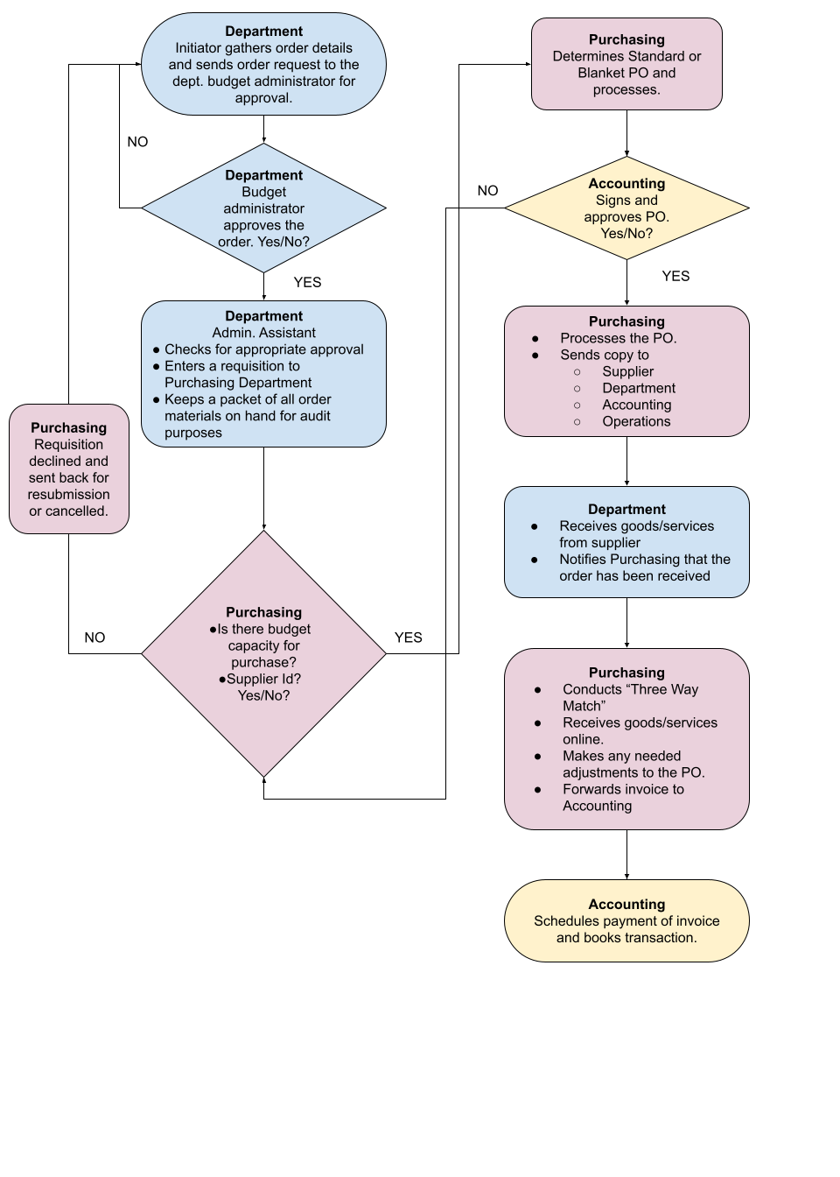
- Vendor and Supplier Management
The Purchasing department will work with the accounting and finance departments to establish and maintain a preferred supplier list to prevent maverick buying and position Exos to negotiate the most favorable buying terms. This list will be maintained by the purchasing department, who will also ensure that all service level agreements (SLA’s) are complete and reflected in the purchasing and payables system. Supplier master data should indicate product/service details, quality standards, deliver timelines, supplier responsibilities, and any regulatory compliance mandates that apply. A copy of the signed terms and conditions for each supplier will be stored in the “___________” folder of the Company drive.
All supplier relationships will be evaluated periodically (at least every 3-years) to ensure the Company is maintaining the best terms, and that the supplier is adequately meeting the Company’s needs. Supplier scorecards may be developed by the purchasing department to assist in this process.



