Proprietary — Unclassified
RESPONSE TO REQUEST FOR INFORMATION
Next Generation Hypersonic Cruise Missile (NGHCM) — DARPA-SN-26-93
Focus Area: Innovative Test & Evaluation — a Recoverable Suborbital Flight-Test Bed
Respondent | Exos Aerospace Systems & Technologies, Inc.
CAGE / UEI | 7EMY6 / CK24BPZGF854
NAICS | 541715 (R&D, Physical/Engineering) · 336414 (Guided Missile & Space Vehicle Mfg)
Business size | Small Business Concern · U.S.-owned and -controlled
Point of contact | John Quinn, Cofounder & CEO · jquinn@exosaero.com · +1-972-740-8355

1. Purpose of this Response
Exos Aerospace submits this response to DARPA-SN-26-93 to address the RFI's stated interest in innovative test-and-evaluation (T&E) technologies for a future Next Generation Hypersonic Cruise Missile program. Exos does not propose a missile system or weapon architecture. We offer a recoverable, reusable suborbital flight-test platform that can affordably and iteratively flight-qualify hypersonic-relevant subsystems and materials in relevant environments — reducing cost and schedule risk ahead of, and alongside, full-scale weapon demonstrators. This response is provided for informational purposes only and is not a proposal.
2. Who We Are
Exos Aerospace is one of only three FAA-licensed reusable rocket launch providers in the United States. Building on a flight lineage dating to 2018 (four SARGE suborbital missions), our BLK3 reusable suborbital vehicle is FAA-licensed and preparing for flight. Exos launches and recovers from minimal ground infrastructure and returns the vehicle and its payloads for inspection and reflight, designed and capable for reflight within 72 hours with a launch team of just 10.
3. Innovative T&E Capability Offered
• Recoverable suborbital flight of hypersonic-relevant subsystems — seekers, GNC, sensors, thermal-protection materials, and divert/attitude-control hardware — through boost, exo-atmospheric, and re-entry environments, with the article and full flight data returned for post-test analysis.
• Rapid, low-cost, iterative cadence — enabling multiple risk-reduction flights at a fraction of the cost and lead time of expendable sounding rockets or full-scale flight tests.
• Test-as-you-fly environments — vibration, acceleration, thermal, and separation — on a reusable platform, so hardware and instrumentation are recovered and reflown.
• Minimal infrastructure and U.S.-owned operations — rapid site activation and a domestic, controlled test lane.
4. Relevance to NGHCM
A recoverable suborbital test-bed complements the program's T&E needs by enabling early, affordable subsystem and materials risk reduction before commitment to a full weapon demonstrator, and by supporting iterative requalification as designs mature. It does not replace full-scale integrated flight test; it lowers the cost of the many component- and subsystem-level test cycles that precede and support it.
5. Interest and Teaming
Consistent with the RFI's encouragement of teaming arrangements, Exos is interested in participating as a test-and-evaluation / flight-test provider to prime performers and to the Government. We welcome the opportunity to discuss how a recoverable suborbital test capability could be integrated into the NGHCM T&E approach.
6. BLK3 Vehicle and Flight-Environment Data
The data below are drawn from the Exos BLK3 Payload User Guide (July 2026, approved for public release). BLK3 is a single-stage, pressure-fed LOX/ethanol vehicle of carbon-fiber composite construction. It traces directly to a 2021 U.S. Air Force contract to build BLK3 as a concept ground-launched hypersonic test vehicle; its precursor, SARGE, flew four times from Spaceport America.
Design reference mission | 135 kg payload to 100 km apogee (Spaceport America, NM)
Heavy-payload mission | Up to 200 kg to ~80 km (NASA Flight Opportunities class)
Payload bay | 636 mm (25.04 in) ID × 1,219 mm (48 in); standard 20 in adapter plate
Vehicle | Single stage, pressure-fed LOX/ethanol; 635 mm (25 in) dia.; 10.82 m stack
Boost / coast | MECO ≈ T+90 s at 3.8 G; peak velocity ≈ 1,100 m/s
Microgravity | ~150 s zero-G (T+130 to T+280 s), payload-mass dependent
Peak loads | Ballute 4.3 G; main-chute shock 6.8 G; touch-down ~7 G max
Vibration | Transonic ±1.5 G (1–5 Hz); remainder of boost ±0.5 G (10–50 Hz)
Bay environment | Sealed (double O-ring); ≥70 kPa; ≤60 °C absent payload heat loads
Payload services | 5/12/24 VDC power; two 0–24 VDC event triggers (e.g., zero-G onset, apogee); optional real-time downlink, external camera/antenna, viewport, vacuum bay, ejection
Mission duration | ~20–25 min launch to touch-down; recovery within 25–30 min

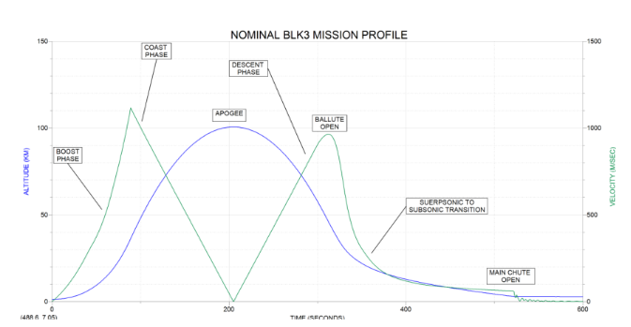
Figure 1. Nominal BLK3 mission profile, altitude and velocity vs. time (PUG §2.3).
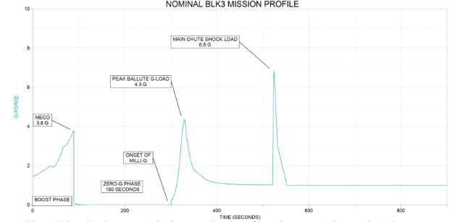
Figure 2. BLK3 acceleration profile: MECO 3.8 G, ~150 s zero-G, ballute 4.3 G, main chute 6.8 G (PUG §2.3).
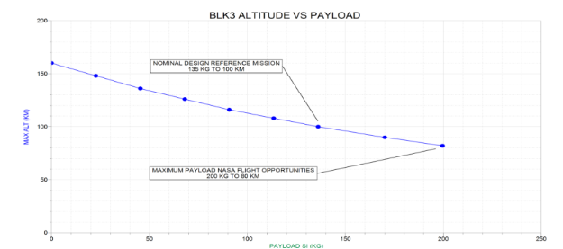
Figure 3. Apogee vs. payload mass: 135 kg to 100 km design reference; 200 kg to ~80 km (PUG §2.3).
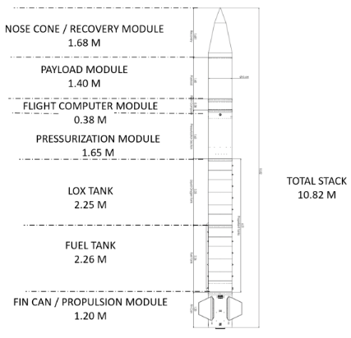
Figure 4. BLK3 vehicle stack, 10.82 m: recovery, payload, avionics, pressurization, tanks, propulsion (PUG §2).
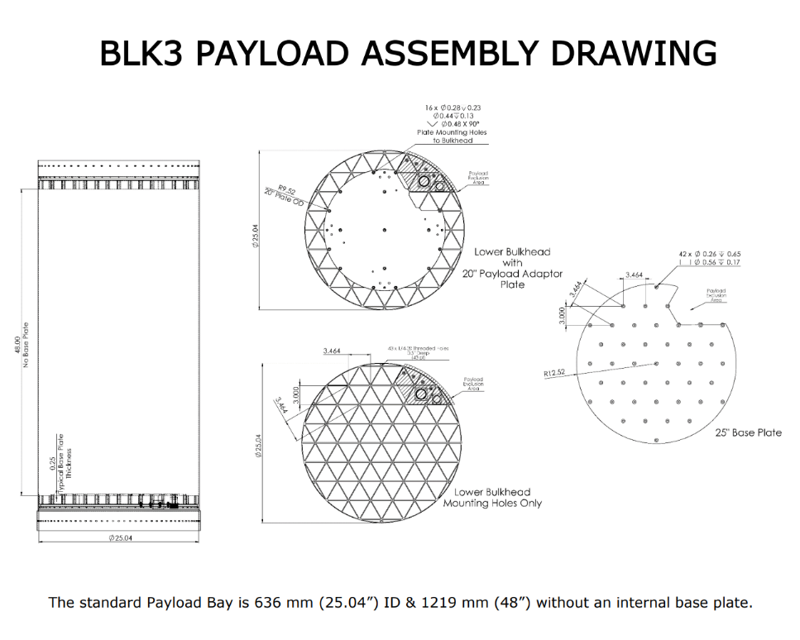
Figure 5. Payload bay assembly and adapter-plate interface: 636 mm ID × 1,219 mm (PUG §3.1).
7. Recovery, Inspection and 72-Hour Reflight
For NGHCM T&E, the key differentiator is that both the vehicle and the test article come back. Hardware, instrumentation and on-board recorders are recovered intact for post-flight inspection, failure analysis, and reflight of the same article, so iterative test campaigns can run on one serial number instead of consuming a new article each time.
• Two-stage guided recovery. A ballute deploys at the onset of milli-G to carry BLK3 through the supersonic regime. A ram-air parachute with an Autonomous Guidance Unit then glides the vehicle back to the recovery area near the pad and launch control.
• Same-day hands-on access. Nominal recovery is 25–30 minutes after launch. The vehicle is brought to "Flight Secure" and payloads are removed and returned to their owners on launch day. Providers who need urgent access can be stationed in the remote viewing area ~450 m from the pad.
• Rapid turnaround. BLK3 is designed and capable of reflight within 72 hours with a launch team of just 10 people. A second flight can be accommodated as early as two days after the first by installing a spare recovery system and pre-charged high-pressure helium. That leaves time for a full post-mission physical inspection and telemetry review between flights (PUG §2.6). This is a design capability. It has not yet been demonstrated on BLK3 in flight.
• Data return. Each flight returns the test article plus on-board data. Payload event triggers and optional real-time downlink support time-tagged correlation of article behavior to flight environment.
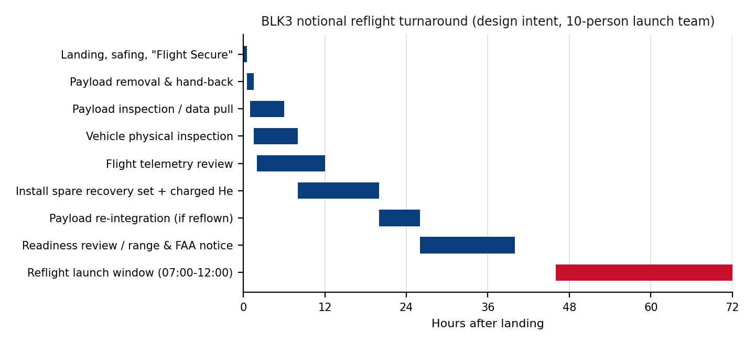
Figure 6. Notional post-landing turnaround to a reflight window within 72 hours (design intent; derived from PUG §2.6 and §4.5).
8. Launch Operations, Ranges and Deployability
Exos launches from the Vertical Launch Area at Spaceport America (32°53′58″N, 106°55′48″W, 1,400 m MSL) under an FAA AST launch license, with coordination among NMSA, White Sands Missile Range and the FAA. The primary Flight Hazard Area is a 6.5 km circle. GNC software terminates thrust if the vehicle would leave the FHA during boost. Launch control sits ~150 m from the tower. The windows are 07:00–12:00 local, with 30 days' advance notice and a standard two-day window (day two = weather/technical scrub day).
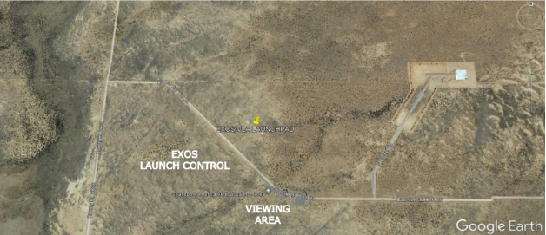
Figure 7. Spaceport America Vertical Launch Area: Exos launch pad, launch control and viewing area (PUG §2.4).
The entire campaign deploys by road from Greenville, TX: launch control trailer, GSE crane truck, propellants and vehicle. It needs only a pad, power and communications. The scripted sequence runs from departure at L−4 days to a dry run and abort practice at L−1, a mandatory Mission Readiness Review, then launch day and a post-mission review with FAA AST and the spaceport.
Trajectory guardrail. Exos has not flown suppressed (depressed) trajectories. Its SARGE flights and BLK3's licensed profile are near-vertical, recovered inside the launch-site FHA. Exos assesses that the vehicle is capable of more representative profiles, subject to FAA license modification and range approval. Options include: (a) commercial launch from Spaceport America with potential downrange landing on White Sands Missile Range; and (b) operations from ranges abroad, such as Australia, with the vehicle and test articles moved in Exos's secure shipping-container solution under a CRADA and with the required export authorizations. Exos would welcome DARPA's view on which profiles are of most T&E value.
9. Test-Article Integration Process
Integration is managed under an Interface Control Document. Exos supplies the mounting plate (custom adapters need only hole pattern details). Exos also runs a Combined Systems Test at Greenville in simulated-flight mode to verify triggers, EMI compatibility and no adverse vehicle/payload interaction, and carries FAA AST payload review as part of the service. The BLK3 launch license already includes safety approval for a wide range of payloads. Controlled items are protected by protocol: unrestricted GPS unlock codes are installed at Exos and not kept with the vehicle, engine internals are covered, and high-resolution telemetry is restricted to Exos and FAA AST.
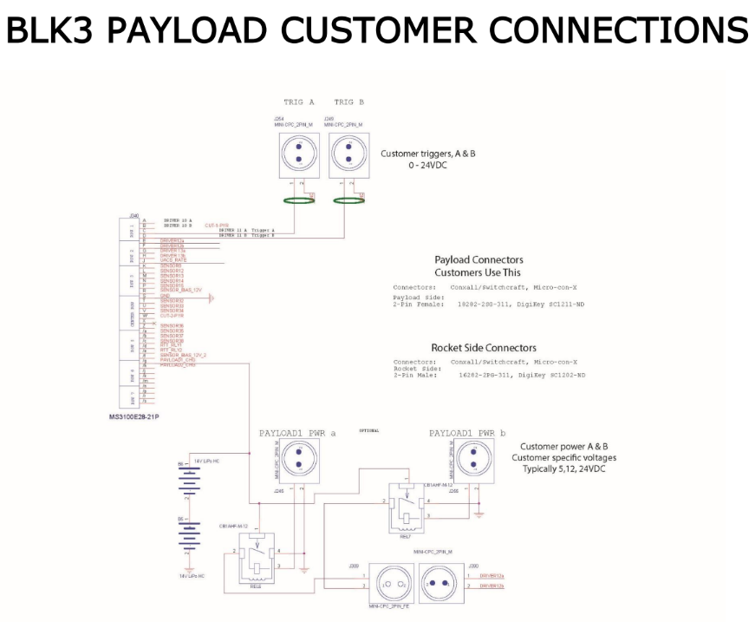
Figure 8. Payload customer electrical interface: two 0–24 VDC triggers and switched customer power A/B (PUG §3).
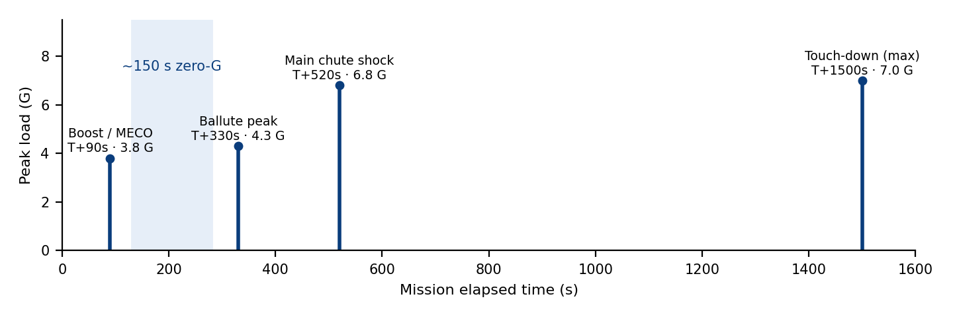
Figure 9. Design-load events a test article must survive across one BLK3 mission (PUG §2.3 data).
10. Export Control and Limitations
Exos is U.S.-owned and -controlled. Any exchange of technical data or performance of hypersonic subsystem testing is controlled under ITAR (USML Categories IV/XV) and/or the EAR; Exos will execute the appropriate export determinations and restrict access to U.S. persons as required. This response contains no controlled technical data and is marked "Proprietary — Unclassified." Exos does not self-designate CUI.
Point of contact: John Quinn, Cofounder & CEO · Exos Aerospace Systems & Technologies, Inc. · 299 FM 1903, Greenville, TX 75402 · jquinn@exosaero.com · +1-972-740-8355 · www.exosaero.com

