INTERNAL · DRAFT · NEGOTIATING TERMS · CEO / Board Eyes Only
EXOS AEROSPACE — SSLC OPTION B: ACQUISITION OFFER SUMMARY
October 7, 2026 · Exos Aerospace Systems & Technologies, Inc.
1. What SSLC Holders Receive
The Exos offer delivers liquidity, relief, and upside across four dimensions — without requiring any additional capital call from current SSLC shareholders.
• Cash at close $2,510,000 delivered to SSLC at acquisition close.
• Debt relief All SSLC debts paid at face value at close, including the Microcosm loan and Wertz notes (est. ~$500K, to be verified in QuickBooks). Jim Wertz's personal loans are made whole at closing.
• No further capital calls Once closed, SSLC's standalone cash drain stops. Shareholders stop funding a working-capital-negative entity.
• Earn-out — IM tank revenue 5% of Intuitive Machines tank revenue for 3 years, capped at $300K/year (up to $900K total). Tied to SSLC's existing firm IM demand.
• Earn-out — Exos stock 0.5%–1.0% of Exos fully diluted shares post-RTO listing (est. $1.0M–$3.0M at a $200M–$300M listing; $250M minimum MEV per Ainigma/FNEX mandate).
• Exos shares + Y5 hold value Stock earn-out is tradeable post-12-month lockup. Held to FY31 at a 16× EV/EBITDA multiple on the Exos plan (~$1.63B EV), a 0.75% grant (~0.525% after ~30% assumed dilution) is worth ~$8.5M (range $5.7M–$11.4M), ~4.6× its ~$1.875M value at listing. Management assumptions.
• IM program continuity No delivery interruption to Intuitive Machines; Exos-SSLC entity continues the contract, preserving SSLC's strongest commercial relationship.
2. Why the Growth Trajectory Requires Exos Capital
The bottleneck is not the technology or the IM demand — it is working capital. SSLC's most recent quarter (FY27 Q1) came in at $713K in revenue. Hitting $5M for FY27 requires averaging $1.43M per quarter in Q2–Q4 — exactly 2.0× that pace — starting immediately. That doubling is not achievable on SSLC's current $198K cash balance.
Standalone constraints (SSLC's own numbers):
• Cash position $198K at October 2, 2026 — roughly one month of operating burn.
• Working capital gap $300K–$700K needed to maintain delivery commitments and service new IM orders — before SSLC can ramp to the $5M/year run rate.
• Operating history FY26 operating loss: −$416K. No self-funding path to production scale.
• He-tank rework Rev3 GHe tank 4,400 psi proof issue unresolved (MC #3056). Remediation cost ~$175K to COPV ($300K gap). Resolves cleanly as intercompany under Exos.
• No capex capacity Production-scale equipment and headcount additions are not fundable from SSLC's cash position. Growth is capped at current run-rate without outside capital.
The With-vs-Without comparison, year-by-year CAGR figures, and cumulative revenue gap are in the model spreadsheet: EXOS_SSLC_OptionB_Acquisition_Model_2026-10-07.xlsx, sheet 'With vs Without Exos Capital'.
3. Total Compensation — 5-Year View (FY27–FY31)
Stacked chart below: funding delivered at close + earn-out forward potential. Base scenario shown; earn-out range (low/high) is in the model.
Component | Timing | Amount / Range
Cash at close | Close ~Q1 FY27 | $2,510,000
SSLC closing costs (Seller) | Close | $60,000
Exos stake credit (non-cash) | Close (credit) | $790,000
Debt relief (est., TBV) | Close | ~$500,000
WC bridge | Close | $500,000
Earn-out — IM tanks (3 yr) | FY27–FY29 | Up to $900,000
Earn-out — Exos stock (RTO) | Post-RTO ~FY28 | $1.0M–$3.0M
TOTAL (low / mid / high) | FY27–FY31 | $5.8M / $7.0M / $8.3M

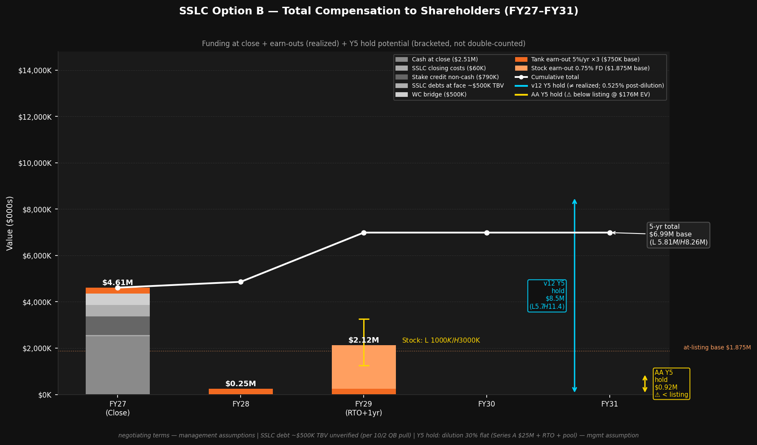
Chart: SSLC_OptionB_Total_Compensation_5yr_2026-10-07.png | Full model: EXOS_SSLC_OptionB_Acquisition_Model_2026-10-07.xlsx
4. Key Terms
Term | Detail
Agreement basis | May 2025 Asset Acquisition Agreement, §3 exclusivity trigger (non-exclusive → exclusive upon Exos financing agreement)
Total commitment | $3,360,000 ($2.51M cash + $60K costs + $790K Exos stake credit)
Exclusivity period | 90 days from SSLC confirmation; extension not unreasonably withheld while financing works in good faith (§3)
Holdback (§7) | 5% escrow, released at 12-month anniversary
SSLC debts assumed | Paid at face at close (est. ~$500K; verify QuickBooks)
Disinterested directors | Jon Quinn abstains from SSLC board vote; sends as Exos CEO (Cal. Corp. Code §310)
Fairness opinion | Eqvista engaged 8/14/2026; agreement still unsigned (held ~1 month)
Status | DRAFT — NEGOTIATING TERMS — not a final or binding offer

Detail in model: drafts/EXOS_SSLC_OptionB_Acquisition_Model_2026-10-07.xlsx · With-vs-Without comparison: sheet 'With vs Without Exos Capital' · Exclusivity rescue options: SSLC_Exclusivity_Rescue_Options_and_Draft_Message_2026-10-07_DRAFT_v2.docx
DRAFT — INTERNAL — NEGOTIATING TERMS — John Quinn, CEO, Exos Aerospace — 2026-10-07

