Whitepaper Response
Vandenberg Space Force Base (VSFB) Call for Whitepapers for Mission Development Zone (MDZ) Outgrant
Solicitation / Notice: VSFBMDZCall · SLD 30/XPR · Responses due 16 October 2026
Exos Reusable-Vehicle Recovery & Turnaround Zone
Option / reservation on MDZ parcels to establish a shared reusable-vehicle landing and turnaround zone on the Western Range, with MCMS-exo3 as the zone's coordination and scheduling system

Submitted by: Exos Aerospace Systems & Technologies, Inc.
299 FM 1903, Greenville, TX 75402
CAGE 7EMY6 · UEI CK24BPZGF854 · SAM.gov Active (All Awards) through 7 Oct 2027
NAICS 336414 (primary) · 541715 · 541330 · Small Business
Point of contact: John Quinn, Cofounder & Chief Executive Officer
jquinn@exosaero.com · +1 (972) 740-8355 · www.exosaero.com
Submitted to: Ainsley Allen, SLD 30 — 232909MissionDevelopmentZoneMDZFacilityConstruct@groups.af.mil

Informational whitepaper submitted in response to a call that is not governed by the FAR and is not an RFI, RFP or RFQ (call §2.1). Exos acknowledges that the USSF may use the information in this submission for MDZ scoping and planning (call §2.1). Concepts herein are proposed and pre-decisional; nothing in this paper is an offer, a financing commitment or a rent proposal. Exos launch operations at VSFB are planned targeted for Q2 2028, after BLK3 flight heritage (first flight planned early 2027 at Spaceport America) and subject to launch-site assignment, FAA licensing and range approvals; Exos holds no VSFB launch site, launch license for VSFB, or VSFB manifest today.
Attachments: (1) Texas Secretary of State Certificate of Fact (Status); (2) Officer Certification of U.S. Ownership (51 U.S.C. § 50101(7)).
Distribution: Exos Proprietary — Submitted for U.S. Government planning use under VSFBMDZCall §2.1; not for public release.

Executive Summary
Exos Aerospace's mission is “Make Every Space Vehicle Reusable.” Exos scopes this response to that mission. Exos asks SLD 30 to consider an option / reservation (outgrant under 10 U.S.C. § 2667) on Hazardous 30-acre Plots 10 and 11 (Exhibit B) to establish the Exos Reusable-Vehicle Recovery & Turnaround Zone — a shared landing and recovery pad that any reusable vehicle or capsule on the Western Range can use, with operator consent. Exos is not requesting a launch complex; the MDZ is not a space launch complex [1]. The land request leads because this is a real-property call; the facilities ask is a modest, expeditionary footprint, not permanent construction.
Why these parcels. Plots 10 and 11 are along Beach Road, closest to the coast and outside the airfield approach-departure clearance surface and APZ 2 (Exhibit B Fig. 4) [1]. They provide the open landing field this concept requires. Alternates: Plot 1 (same hazardous strip), or Hazardous 50-acre Parcel 1 (flood-plain justification: an open landing field with no permanent structures is the only use proposed, making flooding a manageable risk rather than a disqualifier).
Landing concept. The reusable vehicle deploys its guided parafoil over the ocean, upwind of the coast. Vandenberg's prevailing surface winds are west-northwest to west (NOAA NCEI engineering weather data, KVBG, 1988–2017 [19]), so the nominal glide path brings the vehicle across the coast and onto the recovery zone only when the canopy is nominal and the vehicle is safed (propellant vented, ordnance inert). Published guided-parafoil accuracy is approximately 100 m CEP (older published data, AIAA 2006-6793 [20]), which sets the size of the cleared dispersion area. Off-nominal descents land in the ocean with a flotation system and a standby recovery boat; no offshore catch structure is proposed.
Live winds from Mission Control. Before launch and before reentry/canopy deploy, Exos plans to fire rocket-launched radiosondes along the actual corridor to measure winds aloft in real time. These feed Mission Control's release-point computation and the go/no-go decision. This is based on an Exos-developed rocket-launched radiosonde concept (Exos heritage, circa 2016); the capability at Vandenberg is planned, not yet demonstrated. Over time the wind data shrinks the dispersion zone, and the radiosonde service can be offered to other Western Range users.
Mission Control as the differentiator. The zone's coordination system is MCMS-exo3 (Mission Control / exo3): scheduling across vehicles, crews, range and road calendars; signed chain of custody; range and FTS requirements in one process with human approval gates; the wind go/no-go; and a reusability ledger — turnaround status, inspection records, and reflight-readiness for every vehicle using the zone, with operator consent. Mission Control and the exo3 payload process are in use today on Exos operations [13]; their extensions to Vandenberg are proposed. Phase 0 offer: Exos will run a read-only Mission Control pilot for SLD 30 now, using Exos's Spaceport America operations as the live data source — no real property needed.
Facilities. Expeditionary and modular: a landing pad (~150 m²), containerized processing, a mobile Mission Control node, wind sensors, and perimeter — nothing permanent until a launch site is assigned.
Future vision (funded-future / vision, not demonstrated). Near term: BLK3 reusable suborbital, followed by BLK4 — a reusable replacement for Black Brant-class sounding rockets. Orbital: BLK4 Heavy (three BLK4 cores in parallel) is Exos's planned path to orbital launch, capital-dependent. Vandenberg is where that orbital future would fly, with reusable-stage recovery by propulsive landing on an offshore barge and/or return to this recovery zone. BLK3 has not flown; its first flight is planned early 2027 at Spaceport America.
1.0 CORPORATE ADMINISTRATION
1.1 Company legal name
Exos Aerospace Systems & Technologies, Inc. (dba Exos Aerospace) — CAGE 7EMY6, UEI CK24BPZGF854 [11].
1.2 Company legal form of ownership
Texas corporation, founded and incorporated in 2015; EIN 47-3491152. Exos is organized under the laws of the State of Texas and is registered and active in SAM.gov (All Awards) through 7 October 2027 [11]. Exos is a Small Business under its primary NAICS 336414 and claims no other socio-economic designation.
Eligibility as a United States commercial provider (51 U.S.C. § 50101(7)) [12]. Exos is a United States commercial provider as defined in 51 U.S.C. § 50101(7): a commercial provider organized under the laws of a State (Texas) that is more than 50 percent owned by United States nationals. Evidence of organization under Texas law: Texas Secretary of State Certificate of Fact (Status) (Attachment 1) [18]. Evidence of U.S. ownership: Officer Certification of U.S. Ownership signed by the Chief Executive Officer (Attachment 2).
1.3 Company legal place of business (address)
299 FM 1903, Greenville, TX 75402 (headquarters: engineering, final assembly, ground test).
1.4 Business address of company operating locations other than headquarters
• Spaceport America, New Mexico — current launch and recovery operations site for Exos reusable suborbital flights [10]. Exos operations are not limited to Spaceport America; Exos evaluates additional launch and operating sites as its manifest grows.
• Vandenberg SFB: none today. The MDZ outgrant option / reservation would establish the Exos Reusable-Vehicle Recovery & Turnaround Zone for planned Exos operations targeted for Q2 2028, after BLK3 flight heritage (first flight planned early 2027 at Spaceport America) and subject to launch-site assignment, FAA licensing and range approvals. Exos holds no VSFB launch site, launch license for VSFB, or VSFB manifest today.
1.5 Primary & alternate points of contact
Role | Name / title | Phone | E-mail
Primary | John Quinn, Cofounder & Chief Executive Officer | +1 (972) 740-8355 | jquinn@exosaero.com
Alternate | Lizi (Elizabeth) Quinn, Business Development | — | lquinn@exosaero.com

1.6 Company history and relevant past performance
Exos was founded in 2015 to build reusable suborbital launch vehicles. Its team carries over 25 years of experience in the rocket and space industry, with deep Armadillo Aerospace and Exos heritage: hundreds of rocket engines and dozens of flying vehicles built. Exos is an FAA-licensed reusable suborbital launch operator providing flight-test services for space, defense, research and commercial payloads [10], with payload recovery for post-flight inspection, analysis and iteration [14]. Its latest FAA-licensed vehicle, BLK3, is preparing for flight in early 2027.
Relevance to the MDZ. Exos runs the full launch-support lifecycle as an operator — vehicle and payload receiving, integration, launch operations, recovery and reflight — with a small ground footprint. Exos manages the payload side of that lifecycle today on exo3, an AI-managed payload process in Exos Mission Control with a seven-stage pipeline and a human approval-and-signature gate before any commitment [13].
Verified Federal past performance [8][9] (Department of the Air Force):
Contract | Value | Start | Scope (as titled)
FA9300-25-C-6022 | $1,897,824 | Sep 2025 | SBIR Phase II — Suborbital Hover Vehicle–Reusable Rocket (flight vehicle and flight demonstration; in performance)
FA8649-21-P-0838 | $750,000 | Mar 2021 | AFWERX SBIR Phase II — Prototype mobile low-cost reusable launch vehicle
FA9300-24-P-6006 | $189,406 | Apr 2024 | SBIR Phase I — Evaluation & design of reusable hover vehicle test bed
FA8649-20-P-0799 | $50,000 | Mar 2020 | AFWERX SBIR Phase I — Reusable launch vehicle
FA9300-26-C-6011 | $293,063 (FFP) | Sep 2026 | AFRL/RQ — Free-flight test program (newly executed)

Leadership. John Quinn, Cofounder & CEO (11 years building Exos; 14.5-year U.S. Navy Submarine Service veteran); Russel Blink, Cofounder & CTO (propulsion and vehicle engineering); Neil Milburn, Cofounder & COO (Armadillo Aerospace veteran; FAA liaison and program execution); David Mitchell, Cofounder & President (financing and investor relations); Kyle Ballard, CFO (financial reporting, controls and diligence).
2.0 PROPOSED OPERATIONS & FACILITIES
2.1 Concept of operations
Primary use: Exos Reusable-Vehicle Recovery & Turnaround Zone. The leased MDZ parcels would serve as a shared landing and recovery zone for reusable vehicles and capsules on the Western Range — open to any operator with SLD 30 approval and operator consent. The zone supports Exos's mission: Make Every Space Vehicle Reusable. The launch pad itself is outside the MDZ and would be assigned separately; the MDZ site supports recovery, turnaround, and operations.
Recovery landing concept. The reusable vehicle deploys its guided parafoil over the Pacific Ocean, upwind of the coast. Vandenberg's prevailing surface winds are west-northwest to west (NOAA NCEI KVBG, 1988–2017 [19]). The vehicle crosses the coastline only when the canopy is nominal and the vehicle is safed (propellant vented, pyrotechnics inert). It glides overland to a ~150 m² aim point inside the cleared dispersion area on the recovery zone. Published guided-parafoil accuracy is approximately 100 m CEP (older published data, AIAA 2006-6793 [20]), which drives the size of the dispersion buffer. An off-nominal descent lands in the ocean; the vehicle carries a flotation system and a standby recovery boat is stationed offshore. No offshore catch structure is proposed.
Wind go/no-go and live radiosonde measurements. Exos plans to fire rocket-launched radiosondes along the actual flight corridor before launch and before the reentry/canopy-deploy decision to measure winds aloft in real time. The radiosonde data feeds Mission Control's release-point computation and the go/no-go decision for canopy deployment. This is based on an Exos-developed rocket-launched radiosonde concept (Exos heritage, circa 2016); the capability at Vandenberg is planned, not yet demonstrated. Radiosonde solid motors are ordnance: they fly from the assigned launch site or a hazardous parcel with an explosives site plan and range approval — not from the inert recovery zone. Over time, accumulated wind data shrinks the required dispersion zone; the radiosonde service can be offered to other Western Range users.
MCMS-exo3 as the zone's coordination system. Mission Control schedules operations across vehicles, crews, range and road calendars; carries signed chain of custody at every handoff; integrates range and FTS requirements in one process with human approval gates; hosts the wind go/no-go workflow; and maintains a reusability ledger — turnaround status, inspection records, and reflight-readiness for every vehicle using the zone, with operator consent. Mission Control and the exo3 payload process are in use today on Exos operations [13]. Their extensions to Vandenberg and to a multi-vehicle zone are proposed.
Finance, design, construct, operate and maintain approach (call §1.2). Exos would hold the outgrant and operate and maintain the zone with a deliberately light footprint: the landing pad and dispersion area, wind sensors, a mobile Mission Control node and transportable turnaround shelters. Exos does not propose to build or finance cleanrooms, payload-processing bays or other capital-intensive facilities; that is not where Exos adds value. Exos's contribution is Mission Control facilities integration and management: scheduling, custody, range and safety coordination, and the reusability ledger across whatever facilities SLD 30 and other tenants build or already operate.
Function (call §1.3 wording) | Exos activity at the Recovery & Turnaround Zone
Spacecraft integration / payload processing | Receive and inspect recovered vehicles and payloads post-landing; turnaround and reflight preparation
Preparation and support of launch programs (§3.1) | Mission operations for recovery campaigns; coordination with Western Range for landing windows
Spaceport logistics / commodity storage | GSE staging and storage; transporter access for vehicle moves to/from the assigned launch site
Launch and mission control | Mission Control node for recovery, scheduling and go/no-go decisions (coordinated with SLD 30)
Administrative / engineering spaces | Exos operations and engineering support; no large administrative footprint planned initially

2.2 Desired facility developments at the MDZ
ID | Facility | Description | Phase
F0 | MCMS-exo3 — Mission Control digital system of record | Software in use on Exos operations (payload and vehicle scheduling); no MDZ construction needed; Phase 0 read-only pilot offered to SLD 30 now | 0
F1 | Recovery pad and dispersion area | ~150 m² hardened aim point; cleared dispersion buffer; perimeter markings; no permanent structures within the dispersion area | 1 (expeditionary)
F2 | Transportable turnaround shelter | Rented/containerized shelter for post-landing inspection and turnaround; no permanent structure | 1 (expeditionary)
F3 | Mobile Mission Control node | Containerized mission operations capability for recovery campaigns and go/no-go decisions | 1 (expeditionary)
F4 | Site works | Wind sensors; transporter apron and access from Beach Rd; perimeter fence; access control; utility connections | 1 (expeditionary)

Expeditionary first. All Phase 1 facilities are modular and containerized. Permanent construction is gated on launch-site assignment. The recovery zone's open character — no permanent structures within the dispersion area — is a feature, not a limitation. It keeps the zone available for any reusable vehicle.
Compatibility of the property (call §3.1). Hazardous 30-acre Plots 10 and 11 are along Beach Road, near the coast, outside the airfield approach-departure clearance surface and APZ 2 (Exhibit B Fig. 4) [1]. They are road-served and clear of the flood plain. The alternate, Hazardous 50-acre Parcel 1, is in the flood plain; Exos's justification: the proposed use is an open landing field with no permanent structures, making flooding a manageable operational risk rather than a siting conflict.
4.0 BENEFIT TO THE SPACEPORT ECOSYSTEM
4.1 Benefit to VSFB, the commercial space industry and USSF national security objectives
• Shared reusable-vehicle infrastructure on the Western Range. A dedicated recovery zone available to any reusable vehicle or capsule — not just Exos — advances the Western Range's position for the next generation of reusable launch. Any operator that can land a vehicle within the dispersion envelope can use the zone, with SLD 30 approval and operator consent.
• Mission Control coordination across operators. MCMS-exo3 gives SLD 30 a single scheduling and chain-of-custody system for the zone: who is landing, when, in what configuration, with what hazard profile. Range and FTS requirements are integrated into one process with human approval gates. This is the kind of operational visibility GAO found the Space Force currently lacks [3].
• Wind data service for the Western Range. Rocket-launched radiosondes along the recovery corridor generate winds-aloft data before each event. Over time this data can be offered to other range users — launch operators, range safety — as a weather service. Capability is planned, based on Exos heritage circa 2016.
• Reusability ledger. A per-vehicle record of turnaround, inspection, anomaly, and reflight-readiness — with chain of custody and operator consent — is the accountability infrastructure reusable launch needs on a Government range.
• Industrial base and MTP alignment. A U.S. small-business operator advancing reusable launch diversifies the Western Range supplier base; the zone's shared nature multiplies that value.
• Phase 0 pilot now. Exos offers SLD 30 a read-only Mission Control view of Exos's Spaceport America operations today — no real property required — so SLD 30 can evaluate the system before any lease is executed.
5.0 PARCEL SELECTION, UTILITY, & PERSONNEL REQUIREMENTS
5.1 Acreage required and preferred conceptual footprints (MDZ Parcel Map, Exhibit B)
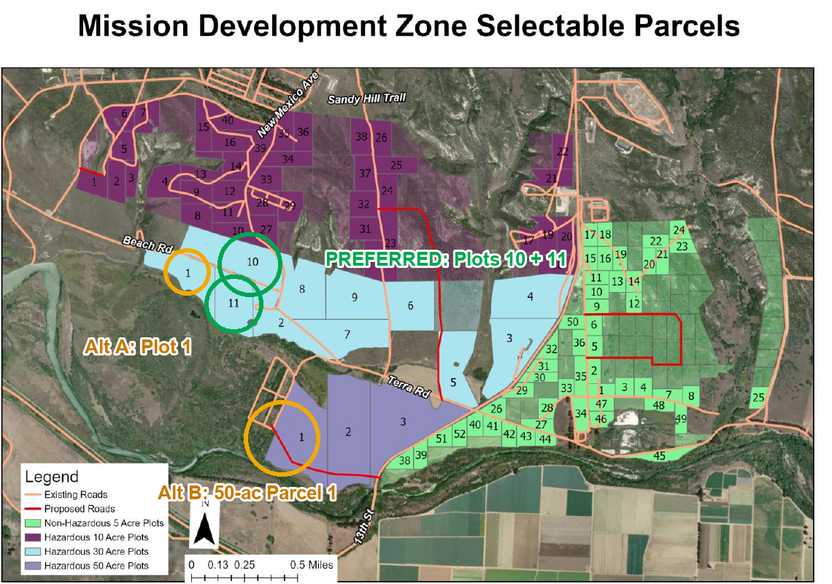
Parcel map. Exos parcel selection on the MDZ Parcel Map (Exhibit B, Fig. 2): preferred Hazardous 30-acre Plots 10 and 11 (green); alternates Plot 1 and Hazardous 50-acre Parcel 1 (amber). Annotation by Exos.
Siting logic for the Recovery & Turnaround Zone: (1) open field for landing and dispersion — no tall structures inside the dispersion area; (2) close to the coast to minimize overland flight distance after canopy deploy; (3) road access (Beach Rd) for vehicle transport and GSE; (4) outside the airfield approach-departure clearance surface and APZ 2 (Exhibit B Fig. 4) [1]; (5) hazardous parcel designation is appropriate — the vehicle lands safed and inert, but the reentry/landing hazard area requires hazardous-area coordination with SLD 30 range safety.
Priority | Area (Exhibit B) | Parcel(s) | Use / justification
Preferred | Hazardous 30-acre, Beach Rd / westernmost | Plots 10 & 11 (contiguous) | Primary recovery zone: coastal, road-served, outside airfield approach surfaces and APZ 2
Alternate A | Hazardous 30-acre, same strip | Plot 1 | Same strip; alternate if Plots 10–11 unavailable
Alternate B | Hazardous 50-acre Parcel 1 (flood plain) | Hazardous 50-acre Parcel 1 | Open landing field; no permanent structures — flood plain is a manageable operational risk for this use; justification provided per Exhibit B note

Reservation / option requested, not immediate build obligation. Exos requests an option or reservation on the preferred parcels (Plots 10 and 11) while Exos pursues launch-site assignment and FAA licensing. The ask is: hold these parcels for the Exos Reusable-Vehicle Recovery & Turnaround Zone. Exos will exercise the outgrant targeted for Q2 2028, after BLK3 flight heritage (first flight planned early 2027 at Spaceport America) and subject to launch-site assignment, FAA licensing and range approvals. No rent proposal is included, as none is requested by the call.
Zone name and shared access. The zone is named the Exos Reusable-Vehicle Recovery & Turnaround Zone and is offered as shared infrastructure for any reusable vehicle or capsule on the Western Range, with SLD 30 approval and operator consent. This is consistent with the call's intent to create infrastructure that serves the broader spaceport ecosystem.
5.2 Estimated peak and average daily on-site personnel (steady state)
Category | Average daily | Peak (recovery campaign) | Shifts
Exos operations, technicians, logistics, security | Minimal standing crew; zone is not continuously staffed between campaigns | Exos recovery crew deployed for landing window | Campaign-driven; extended during recovery windows
Other operators / payload teams | Per scheduled recovery event | Per event, coordinated in Mission Control | Per event
Visitors / Government | Occasional | Recovery-campaign reviews and range safety coordination | Day shift

Exos VSFB staffing scales to recovery-campaign cadence once a launch site is assigned; numeric counts will be provided with final design and utility coordination.
5.3 Estimated daily and peak requirements for power, water, road/traffic access and communications
Utility | Phase 1 requirement | Notes
Power | Light service to support mobile Mission Control node, wind sensors, perimeter lighting and vehicle checkout; load set in utility coordination | Backup power for Mission Control and environmental sensors
Water / sewer | Minimal domestic demand; set in utility coordination | No process wastewater; domestic use for small crew during campaigns
Road / traffic | Heavy-haul access from Beach Rd; transporter apron for vehicle moves | Vehicle moves to/from the assigned launch site scheduled with SLD 30
Communications | Commercial fiber or satellite link; range/mission-ops connections as authorized by SLD 30 | Range links and Mission Control data connections per SLD 30 requirements

6.0 IMPACTS AND SAFETY CONSIDERATIONS
6.1 Operational CONOPS (material logistics and security boundaries)
• Inbound (recovery operations): no vehicle hardware arrives at the zone by road before a recovery event. The vehicle descends onto the zone under its guided parafoil. GSE, personnel and the mobile Mission Control node are pre-staged on the parcels before the landing window.
• On site: post-landing, the vehicle is inspected, safed (confirmed), and secured. A scanned, signed custody event records receipt by Exos. The vehicle is then moved by transporter to the assigned launch site or a processing facility for turnaround.
• To and from the launch site: vehicle moves to and from the separately assigned launch site under SLD 30 transport procedures.
• Security boundaries: perimeter fence with one controlled entry; the zone is secured during recovery windows and between events. Export-controlled hardware and data handled under ITAR/EAR procedures with decisions by Exos's Empowered Official. No classified processing.
6.2 Anticipated quantities and types of propellants, commodities, or hazardous chemicals
No propellants or ordnance are stored or handled on the recovery zone parcels. The vehicle lands safed and inert: propellant tanks vented, pyrotechnics expended or inerted before canopy deployment. The zone would hold only ordinary field commodities: compressed inert gases (nitrogen, helium) for post-recovery procedures, lithium-ion batteries in payloads, and diesel for backup power — all in small, fire-code-compliant quantities. Radiosonde solid motors are ordnance and are handled only at the assigned launch site or a separately designated hazardous parcel with an explosives site plan and range approval; they are never handled at the recovery zone.
6.3 Anticipated explosive safety arcs and hazard areas (siting requirements)
Reentry/landing hazard area. The recovery zone has a reentry and landing hazard area (the dispersion footprint for the guided-parafoil descent) that will be coordinated with SLD 30 range safety and FAA under Part 450 (or equivalent). This is not a quantity-distance (QD) arc — it is a flight-safety exclusion area for the landing window, cleared and then released. The vehicle lands safed and inert; there is no explosive safety arc from ordnance or propellant at the recovery zone itself.
Off-nominal contingency. An off-nominal descent (failed canopy) lands in the ocean; the vehicle carries a flotation system and a standby recovery boat is pre-positioned. Range safety procedures for the off-nominal case will be coordinated with SLD 30 and documented in the flight safety analysis under FAA Part 450.
No QD arcs or hazardous-material siting are anticipated at the recovery zone. The hazardous parcel designation is appropriate for range-safety coordination of the landing hazard area. A future explosion-hazard use at these parcels is not part of this request and would require a separate explosives site plan under DoD explosives safety standards (DESR 6055.09 / DAFMAN 91-201).
6.4 Mitigation alternatives for impacts on neighboring operations and transportation routes
• Landing windows are discrete, pre-coordinated events; Mission Control flags conflicts with range and road calendars before a window is approved.
• The dispersion area is cleared of personnel during the landing window and released immediately after landing and vehicle safeing confirmation.
• Off-nominal ocean landing contingency keeps risk away from the base during any vehicle anomaly.
• No engine testing or launch activity at the recovery zone; backup generator exercised on a set schedule.
• Stormwater, lighting and habitat measures as required by the base environmental review; Exos would support NEPA with site data.
6.5 New construction or modifications required to existing VSFB infrastructure
• Utility extensions (power, fiber, minimal water/sewer) to the selected parcels; light-service loads only.
• Transporter apron and turning-radius improvements at Beach Rd for vehicle moves; no new public roads.
• Connection to base security and entry control as directed by SLD 30.
• No modifications to the airfield. Launch-site infrastructure is outside this MDZ request and depends on separate launch-site assignment.
7.0 CONCEPTUAL PROJECT TIMELINE
7.1 Notional schedule from initial site access to operational capability
Exos requests a reservation / option on the preferred parcels now. Build-out of Phase 1 expeditionary facilities is planned targeted for Q2 2028, after BLK3 flight heritage (first flight planned early 2027 at Spaceport America) and subject to launch-site assignment, FAA licensing and range approvals. Durations are notional and measured from outgrant execution (M0). No hard operations date is proposed at this stage.
Phase / milestone | Activity | Notional timing
Phase 0 (now) | Read-only Mission Control pilot for SLD 30 using Exos Spaceport America operations; no real property needed | From submission, on SLD 30 interest
In parallel | BLK3 first flight at Spaceport America; accumulate flight heritage; launch-site assignment request; FAA license modification and range approvals for VSFB (outside the MDZ) | Starting on submission
Reservation | Option / reservation on Plots 10 & 11 (or alternate) executed by SLD 30 | As agreed with SLD 30
M0 | Outgrant executed; initial site access | After BLK3 flight heritage and launch-site assignment
Site / expeditionary | Site preparation; wind sensors; pad marking; containerized processing and Mission Control node deployed | From M0; rapid standup — modular equipment
Phase 1 activation | Recovery zone operational for Exos recovery campaigns | Target Q2 2028, subject to approvals
Phase 2 gate | Mission Control integration and management extended to additional operators and to facilities built by SLD 30 or others; no Exos-funded permanent construction; gated on demand and SLD 30 concurrence | After Phase 1 track record

7.2 Requested award approach
The primary instrument Exos requests is the MDZ outgrant (option / reservation) under 10 U.S.C. § 2667 on its normal real-property path [12].
For Mission Control range-integration work, Exos asks SLD 30 to refer Exos to the appropriate Space Force / SSC contracting path; Exos does not specify the instrument.
8.0 ADDITIONAL ENHANCEMENTS
8.1 Enhancements offered for Government consideration
• MCMS-exo3 zone coordination system. Scheduling across vehicles, crews, range and road calendars; signed chain of custody; range and FTS requirements in one process with human approval gates; wind go/no-go workflow; reusability ledger for every vehicle using the zone, with operator consent. Built on Mission Control and the exo3 process in use today [13]. Extensions are proposed.
• Phase 0 read-only Mission Control pilot for SLD 30. Exos will configure a read-only view of Exos's Spaceport America operations for SLD 30 stakeholders — no real property required — to demonstrate the system before any lease is executed.
• Winds-aloft data service (planned). Rocket-launched radiosonde data from recovery corridor flights, offered to other range users over time. Capability is planned, based on Exos heritage circa 2016.
• Shared zone access. Any reusable vehicle or capsule on the Western Range can use the recovery zone, with SLD 30 approval and operator consent — multiplying the value of the infrastructure.
• Government-dedicated coordination view. Customer-consented, read-only SLD 30 access to zone scheduling and vehicle readiness status in Mission Control [3].
8.2 Optional opportunity: Exos Mission Control implementation for zone and payload management services
Separately from the outgrant, Exos offers USSF/SLD 30 the option to have Exos implement and operate Exos Mission Control — the Exos-built operations software Exos uses today to schedule its own payloads and vehicles and to run its seven-stage exo3 payload process with a human approval gate [13] — as a zone and payload management service for the MDZ. The option is not a condition of the lease and would be scoped and priced separately under an instrument the Government chooses.
Service area | What Exos Mission Control would provide
Zone management | Parcel and facility calendars; landing-window scheduling across operators; access and escort scheduling; work orders and maintenance tracking
Vehicle and payload management | Recovery records, turnaround status, inspection logs, and reflight-readiness per vehicle; signed chain of custody at each handoff
Range and road scheduling | Vehicle moves, transporter windows, and recovery milestones checked against range and base calendars before approval
Wind go/no-go workflow | Pre-recovery radiosonde data and Mission Control release-point computation; go/no-go decision record with human approval gate (planned capability)
Government visibility | Customer-consented, read-only view for SLD 30 of zone schedules and vehicle readiness [3]
Controls | Human approval gates on every commitment; export-control indicators routed to Exos's Empowered Official, never auto-cleared

Implementation path. (1) Phase 0 demonstration to SLD 30 on Exos's own operations, now; (2) configuration for the Exos recovery zone at Phase 1 activation; (3) optional extension to SLD 30 and other MDZ tenants. Mission Control and the exo3 process are in use today on Exos operations; they have not been deployed at Vandenberg or on Government networks. Hosting, data rights, cybersecurity authorization and any Government-network interface would be defined with SLD 30 before use.
Origin: a range-coordination concept. Exos developed Mission Control's range-coordination concept alongside its Montana Spaceport & Test Range work (program operating agreement, May 2026; development-stage, not a licensed site) to coordinate many users, vehicles and test events on one range under human approval gates. The same need applies to multi-user test ranges such as the Montana “super range” for advanced weapons and technology testing that the President announced on 14 Oct 2026 [21], as well as to the Western Range. Exos has no role in that range today.
Exos Mission Control today. Figures 1–4 show Exos Mission Control tracking Exos rocket missions today: mission and flight-readiness gates, payload operations, logistics (ERP/MRP), and financial integration (screens captured 15 Oct 2026, 18:24 CDT; counts are live at capture time; customers anonymized). They illustrate the service offered above; none of it is deployed at Vandenberg.
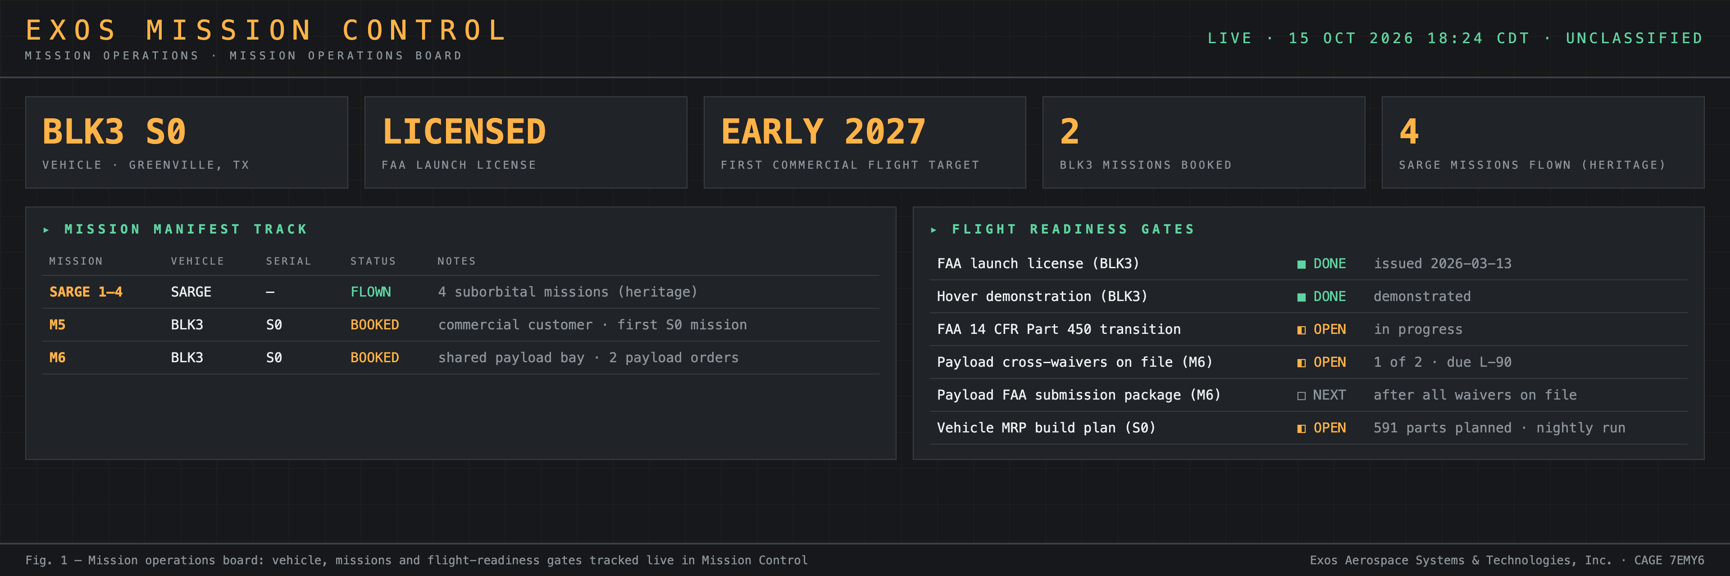
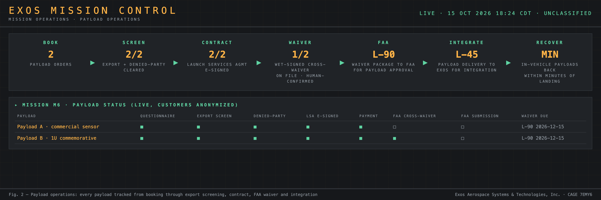
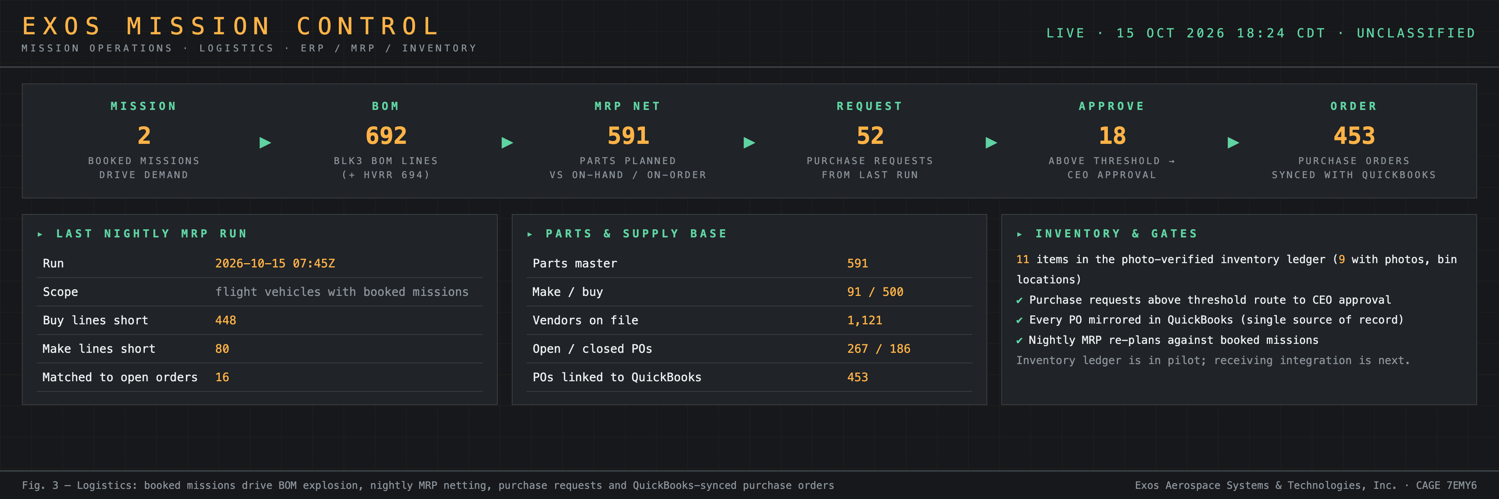
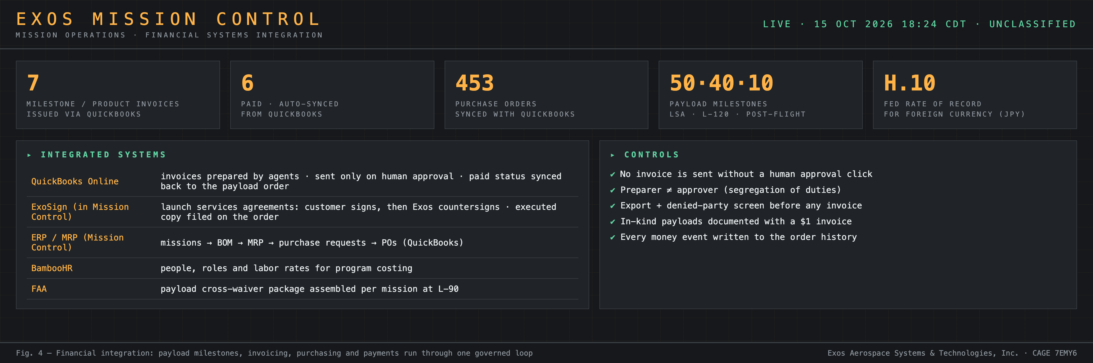
9.0 FUTURE VISION (Funded-Future / Vision — Not Demonstrated)
This section describes Exos's planned trajectory — capital-dependent and not yet demonstrated. Nothing in this section represents a current Exos capability or a commitment.
9.1 Near-term: reusable sounding-rocket replacement (BLK4)
BLK3 is Exos's current vehicle — FAA-licensed, preparing for first flight in early 2027 at Spaceport America. Following BLK3, Exos is developing BLK4 as a reusable suborbital vehicle in the Black Brant class — a reusable replacement for expendable sounding rockets used for science, defense research, and atmospheric measurements. BLK4 at Vandenberg would use the Recovery & Turnaround Zone to support a rapid-turnaround, reusable sounding-rocket cadence on the Western Range. BLK4 is a planned program; it has not flown.
9.2 Orbital future: BLK4 Heavy (capital-dependent vision)
Exos's planned path to orbital launch is BLK4 Heavy — three BLK4 cores in parallel — a configuration that is capital-dependent and not yet funded or under development. Vandenberg SFB is where Exos envisions that orbital future flying: a polar or sun-synchronous orbit capability on the Western Range. Recovery of reusable stages would be by propulsive landing on an offshore barge and/or return to the Recovery & Turnaround Zone. The recovery zone requested in this whitepaper is designed to support this long-term vision as well as the near-term guided-parafoil recovery concept.
Exos does not have an orbital vehicle. Exos has not flown BLK3. BLK4 Heavy is a funded-future concept. These items are presented to give SLD 30 context for why Vandenberg — and this specific coastal recovery zone — is the right long-term site for Exos's reusable launch program.
Statement of Status (demonstrated vs. proposed / planned)
Item | Status
Exos launch operations at VSFB | Planned — targeted for Q2 2028, after BLK3 flight heritage (first flight planned early 2027 at Spaceport America) and subject to launch-site assignment, FAA licensing and range approvals; no VSFB launch site, license or manifest today
Exos launch operations today | FAA-licensed reusable suborbital operator from Spaceport America, NM [10]
BLK3 | Latest FAA-licensed vehicle; preparing for first flight, early 2027 at Spaceport America; has not flown
exo3 payload process (7 stages, human gate) | In use today for Exos payload operations; not deployed at Vandenberg [13]
Exos Mission Control (payload and vehicle scheduling) | In use today on Exos operations; offered as optional zone and payload management service (8.2); not deployed at Vandenberg [13]
MCMS-exo3 extensions and zone coordination features | Proposed / in development
MCMS-exo3 range / FTS process integration | Proposed, for contract with SLD 30; process work only, not FTS hardware
Recovery zone facilities F1–F4 | Proposed expeditionary concept; no design, financing or Government commitment
Rocket-launched radiosonde wind measurement at VSFB | Planned; based on Exos-developed concept circa 2016; not demonstrated at Vandenberg
BLK4 reusable suborbital (Black Brant-class replacement) | Planned program; not yet in development; has not flown
BLK4 Heavy orbital configuration (three BLK4 cores) | Funded-future vision; capital-dependent; not under development; no orbital vehicle exists
Certifications | Small Business. NIST SP 800-171 implemented; CMMC 2.0 self-assessment complete (via Atomus). AS9100 in implementation; no facility clearance

Appendix A — Compliance Matrix
Maps every request in the call (Section 3 and Exhibit A) to this response. Page references are to the PDF version.
Call reference | Requirement | Response section | PDF page
Exh. A 1.1 | Company legal name | 1.1 | 3
Exh. A 1.2 | Legal form of ownership + evidence of U.S. organization | 1.2 | 3
Call §1.2 / 51 U.S.C. § 50101(7) | Respondent is a United States commercial provider | 1.2 | 3
Exh. A 1.3 | Legal place of business | 1.3 | 3
Exh. A 1.4 | Other operating locations | 1.4 | 3
Exh. A 1.5 | Primary & alternate POCs | 1.5 | 3
Exh. A 1.6 | Company history / relevant past performance | 1.6 | 3
Exh. A 2.1 / Call §3.1 | Concept of operations; property compatibility | 2.1 | 4
Call §1.3 / §1.4 | Use matches MDZ intended uses; MDZ not a launch complex | 2.1 | 4
Call §1.2 | Approach to finance, design, construct, operate, maintain | 2.1 | 4
Exh. A 2.2 / Call §3.1 | List and description of desired facility developments (expeditionary/modular) | 2.2 | 5
Exh. A 4.1 / Call §3.3 | Benefit to VSFB spaceport ecosystem, industry, USSF | 4.1 | 6
Exh. A 5.1 / Call §3.4 | Parcels: Plots 10 & 11 (Hazardous 30-acre, Beach Rd); alternates: Plot 1, Hazardous 50-acre Parcel 1 | 5.1 | 7
Exh. B note | Justification for Hazardous 50-acre Parcel 1 (alt): open landing field, no permanent structures | 5.1 | 7
Exh. A 5.2 / Call §3.4 | Peak and average daily personnel | 5.2 | 8
Exh. A 5.3 / Call §3.4 | Power, water, road/traffic, communications | 5.3 | 9
Exh. A 6.1 / Call §3.5 | Operational CONOPS, logistics, security boundaries | 6.1 | 9
Exh. A 6.2 / Call §3.5 | Hazardous materials: none at recovery zone; vehicle lands safed/inert | 6.2 | 9
Exh. A 6.3 / Call §2.4, §3.5 | Hazard area: reentry/landing dispersion footprint; no QD arcs; coordinated with SLD 30 and FAA Part 450 | 6.3 | 9
Exh. A 6.4 / Call §3.5 | Mitigation of impacts on neighbors and routes | 6.4 | 10
Exh. A 6.5 / Call §3.5 | New construction / modifications to VSFB infrastructure (light-service utilities only) | 6.5 | 10
Exh. A 7.1 / Call §3.6 | Schedule: reservation now; build-out after BLK3 flight heritage and launch-site assignment; target Q2 2028 | 7.1 | 10
Exos addition | Award approach: MDZ outgrant option/reservation; referral to SSC contracting path for MC range-integration work | 7.2 | 11
Exh. A 8.1 | Enhancements: Phase 0 MC pilot; winds-aloft service; shared zone access; reusability ledger | 8.1 | 11
Exos addition (optional) | Exos Mission Control for zone and payload management services | 8.2 | 12
Exos addition | Future vision: BLK4 sounding-rocket replacement; BLK4 Heavy orbital (funded-future/vision, not demonstrated) | 9.0 | 14
Exh. A 1.2 evidence | Texas SOS Certificate of Fact (Status); Officer Certification of U.S. Ownership | Attachments 1–2 | —
Call §4.2 | Maximum 30 pages | Whole document | 17 pp total
Call §4.3 | MS Word or PDF; DoD SAFE delivery; separate receipt confirmation | Submission checklist | —

Sources
[1] SAM.gov, “Vandenberg Space Force Base (VSFB) Call for Whitepapers for Mission Development Zone (MDZ) Outgrant,” Special Notice VSFBMDZCall, notice ID 053436c19dbd4979a19587b059158969, posted 30 Sep 2026 (due date extended to 16 Oct 2026, 4:00 PM PT), with attachment 260901_RFI-VSFB_MDZ.pdf (SLD 30/XPR, 14 Aug 2026), Exhibits A and B.
[2] SLD 30 Public Affairs, “SLD 30 Celebrates 5th Anniversary,” May 2026 — vandenberg.spaceforce.mil/News/Article-Display/Article/4485076.
[3] U.S. Government Accountability Office, GAO-25-107228, “National Security Space Launch: Increased Commercial Use of Ranges Underscores Need for Improved Cost Recovery,” 2025 — files.gao.gov/reports/GAO-25-107228/index.html.
[4] Space Systems Command, “Space Systems Command Expands Space Vehicle Processing Capacity,” 7 Oct 2025 — ssc.spaceforce.mil/Newsroom/Article/4333969.
[5] Space Systems Command, “Space Force increases on-orbit warfighter capability support through expanded space vehicle processing” (All Points Logistics, $250M NSSL SV Processing CSO, Vandenberg capacity by 2029), 2026 — ssc.spaceforce.mil/Newsroom/Article/4558913.
[6] Military & Aerospace Electronics, “Space Force to outline its launch vision for the future at upcoming industry day,” 29 Jun 2026 — militaryaerospace.com/home/article/55387166.
[7] Air & Space Forces Magazine, “Vandenberg Plans ‘Zone’ for New Launch Support Facilities,” 2026 — airandspaceforces.com/vandenberg-zone-new-launch-support-facilities-on-site-manufacturing.
[8] USASpending.gov, recipient Exos Aerospace Systems & Technologies, Inc. (UEI CK24BPZGF854), prime awards FA9300-25-C-6022, FA8649-21-P-0838, FA9300-24-P-6006, FA8649-20-P-0799 (retrieved 25 Sep 2026).
[9] Contract FA9300-26-C-6011, AFRL/RQ, effective 24 Sep 2026 (executed contract on file at Exos).
[10] Exos Aerospace, “Reusable Flight Test Infrastructure / Capabilities,” exosaero.com/capabilities (accessed Oct 2026).
[11] SAM.gov Entity Registration, Exos Aerospace Systems & Technologies, Inc., UEI CK24BPZGF854 / CAGE 7EMY6, status Active (All Awards), expiration 7 Oct 2027 (verified 11 Oct 2026).
[12] 51 U.S.C. § 50101(7) (definition of “United States commercial provider”); 10 U.S.C. § 2667 (leases of non-excess property).
[13] Exos Mission Control, Payloads-exo3 program record (program start 26 Jun 2026; seven-stage pipeline with human approval gate) and Exos payload and vehicle scheduling records — Exos internal system of record, available for Government review on request.
[14] Exos Aerospace, “Reusable Suborbital Flight Test Services” (EXOS at a Glance: FAA-licensed reusable suborbital launch operator; payload recovery for post-flight inspection), exosaero.com, accessed 12 Oct 2026.
[15] 15 U.S.C. § 638(e)(4)(C) (SBIR “third phase” = work that “derives from, extends, or completes efforts made under prior funding agreements under the SBIR program”) and 15 U.S.C. § 638(r) (Phase III awards) — law.cornell.edu/uscode/text/15/638 (accessed 11 Oct 2026).
[16] Exos SBIR Phase II award record, FA9300-25-C-6022, U.S. Space Force topic SF233-0019 (award documents on file at Exos).
[17] Exos records: BLK3 reusable rocket design work performed under AFWERX SBIR Phase II FA8649-21-P-0838 (confirmed by Exos CEO, 11 Oct 2026).
[18] Texas Secretary of State, Certificate of Fact (Status), Exos Aerospace Systems & Technologies, Inc., obtained via SOSDirect, October 2026 (Attachment 1).
[19] NOAA National Centers for Environmental Information, “Engineering Weather Data — KVBG (Vandenberg AFB / VSFB),” ICAO_KVBG_EWD_SI.pdf, 1988–2017 climatology — ncei.noaa.gov/pub/access/cebrequests/engineeringwx/ICAO_KVBG_EWD_SI.pdf (accessed Oct 2026). Prevailing surface wind directions at KVBG are west-northwest to west, consistent with onshore flow from the Pacific.
[20] Yakimenko, O.A., Dobrokhodov, S.N., and Kaminer, I.I., “On Estimation of Terminal Accuracy for Several Steerable Parafoil Systems,” AIAA Paper 2006-6793, AIAA Guidance, Navigation, and Control Conference, 2006 (older published data; accuracy varies by system and conditions; cited as a general reference for guided-parafoil CEP class).
[21] Fox News, “Trump announces Montana ‘super range’ at midterm rally for Pentagon to test advanced war technology,” 15 Oct 2026 — foxnews.com/politics/trump-announces-montana-super-range-midterm-rally-pentagon-test-advanced-war-technology.

