EXOS AEROSPACE
MTP · Consortium M&A Engine v2
Filling Industrial-Base Gaps Every ~9 Months · Revised 2026-10-06 | v2: adds Scorpius acquisition benchmark

──────────────────────────────────────────────────────────────────────────────────────────

1. Massive Transformative Purpose (MTP)
"Make Every Space Vehicle Reusable."

Exos Aerospace is the enabling Integrated Pressurized Structures (IPS) platform — not a launch provider. IPS is the moon-proven, TRL-9 Type-V composite that overcame cryogenic microcracking; it enables reuse, long-duration cryo storage, zero-loss cryo transfer, refueling/depots, reusable launch/reentry, orbital transfer vehicles, and lunar/cislunar systems. The BLK3 reusable suborbital vehicle is the real-world IPS demonstration, not the headline.

The consortium M&A cadence replaces and exceeds the Scorpius acquisition revenue that the expired ROFR took off the table. The ROFR expired 2026-10-06; no Exos acquisition of SSLC/Scorpius is being pursued. Instead, each ~9-month consortium cycle targets a capability gap and adds a revenue stream that, in aggregate, is designed to exceed the $21M Y5 revenue the v12 Scorpius acquisition model projected. The single Scorpius/SSLC commission stream (15% sales commission, Exos 18% passive equity retained) is retained as a stable annuity but is not the growth engine — the consortium M&A cadence is. See benchmark table and chart below (Section 5a).
──────────────────────────────────────────────────────────────────────────────────────────

2. Consortium Model — Exos as Prime Integrator
Exos holds the prime-integration layer: single ITAR/CUI compliance boundary (GCC High via Atomus), the capacity-of-record for cryo structures, the FAA-licensed reusable test platform, and the AI-native operating layer (Mission Control + governed agent fleet). Partners supply specialized scope FFP and keep their IP and other customers. Exos is the orchestration node, not a single-revenue rocket company.

Governance model per partner node:
- Master instrument: 2-page MNDA + IP split + non-circumvention + scope-bounded FFP + exclusivity window + exit clause.
- Per-pursuit: 1-page FFP Work Order. Vehicle menu: Teaming Agreement → FFP subcontract · standing Consortium MOU · JV · License.
- Each partner quotes its own scope FFP, keeps autonomy, IP, and other customers.
- Exos retains the prime contract, integration margin, and the contingency/backup bench.

Six advantages that make Exos the integrator, not an interchangeable node:
- TRL-9 IPS (Scorpius Type-V, lunar-flown on Odysseus and Athena — management-characterized; Intuitive Machines public filings are the primary source for IM mission heritage).
- Zero-loss cryo transfer architecture (Princeton Cryogenics / David Money — management assumption; unverified externally).
- Reusable-launch validation: FAA-licensed BLK3, Exos flight heritage since 2018 (SARGE). BLK3 not yet flown; first commercial BLK3 flight targeted early 2027.
- Consortium capacity (acquire/JV/license/partner cadence — this document).
- AI-native operating platform (Mission Control + governed agent fleet). Instantiated 2026; active build-out.
- Industry-wide reusability demand (SpaceX opened the market; prime manifests are full — source: SpaceX public manifest and press; management assessment of demand trend).
──────────────────────────────────────────────────────────────────────────────────────────

3. Repeatable M&A / Commercialization Cadence (~9-Month Cycles)
Each cycle follows the same four-phase pipeline. The ~9-month clock starts at the Engage gate and ends at Integration Complete / First Revenue:

Phase | Months | Exit Gate | Owner
1 Engage | M0–M1 | NDA executed; initial fit confirmed | Jon + Exo
2 Diligence | M1–M3 | DD PASS; no disqualifying export/ITAR; price range set | Exo (scripts/third_party_fit_scorer + DD dossier)
3 Structure | M3–M6 | LOI or term sheet signed; consideration mix locked | Jon + Keyes (Counsel, pre-signature only)
4 Close + Integrate | M6–M9 | Docs executed; first revenue contribution logged in MC | Jon + Exo
Repeat → |  | Next gap enters Engage while prior cycle is in Integrate

Classification logic:
- Acquire: full-ownership M&A; use stock currency (post-RTO/Series A) where possible to conserve cash.
- Partner/supply: consortium teaming with FFP subcontract; no ownership change required.
- License: IP-only deal, fastest cash impact, lowest integration cost (~M3–M6 close).
- JV: shared-ownership operating entity; deploy when neither side will full-sell.
Funded-vs-demonstrated gate (hard rule): every cycle's projected revenue is labeled 'funded / in pursuit' or 'demonstrated / contracted.' Projections in the financial model use management assumptions for new deal revenue; see Assumptions sheet in v15.
──────────────────────────────────────────────────────────────────────────────────────────

4. Candidate Gap Pipeline
All entries below are CANDIDATES drawn from the live Capability-Gap Ledger (mission-control/data/capability-gaps.json) and the third-party fit-scorer. They are UNVERIFIED and NOT CONTACTED for M&A purpose as of this document date. None of the deal values, multiples, or revenue contributions below are sourced figures — they are management assumptions (labeled MA-unverified). No external communication has been initiated.

Gap: Composite structures mfg scale + tooling [GAP-7dfa] · partner → supply
Candidate: Southwest Composite Works (SWC), Albuquerque NM
~30-yr domestic ITAR-compliant (since 2022) composites + tooling shop near Sandia. Carley Hendren POC (carley@swcompositeworks.com). DD: PASS on ledger. Fills BLK3/BLK4 second-source + surge bench under an Exos-prime FFP teaming node.
Sequencing: Re-sequenced FIRST (was 'post-Scorpius acquire'): ROFR expired → no Scorpius acquisition path; SWC fills the immediate manufacturing scale gap without an ownership transfer. Structure: Teaming Agreement + FFP supply contract. MA-unverified.

Gap: Type-5 composite resin + mfg capacity [GAP-826a / GAP-a447] · buy (re-sequenced)
Candidate: CTD (Composite Technology Development, Lafayette CO) + Composite Builders LLC (Holland MI)
CTD: broader materials house (cyanate-ester product lines, origin shop). Ken Runkles warm-path (Stratintelligence). NOTE: SSLC's final resin IP is SSLC-owned, not CTD-dependent — CTD's value is the broader materials platform, NOT the Type-5 resin (correction Jon 8/28/26). Composite Builders: prepreg/infusion carbon-fiber mfg + tooling/fixtures; WOSB; Danielle MacInnes CEO. DD dossier: drafts/DD_Composite_Builders_2026-09-20.docx.
Sequencing: Re-sequenced SECOND: both were 'post-Scorpius-acquisition' targets; since ROFR expired and no acquisition is pursued, evaluate as standalone materials/capacity roll-ups via Ken Runkles warm path. Consideration mix: cash + stock (post-public-currency). MA-unverified.

Gap: RDRE flight-weight hardware [GAP-cebf] · license
Candidate: NASA MSFC RDRE license or GTL fully-machined RDRE method
Two trade-study options per HVRR Phase II program (FA9300-25-C-6022). Exos provides the FLIGHT VEHICLE + flight demonstration — Exos does NOT develop/own the RDRE engine hardware (per Jon 9/25). License cost ~$5M (management assumption, MA-unverified). MSFC = primary option; GTL = down-select. Gloyer comms owned by Jon directly.
Sequencing: Cycle 3: license path (fastest close, no equity dilution). Revenue impact: HVRR Phase II contract execution + follow-on AFRL awards (MA-unverified).

Gap: Orbital mobility / OTV / in-space transportation [GAP-4f22 / GAP-3426] · partner or acquire
Candidate: Momentus Space (NASDAQ: MNTS, Vigoride OTV) and/or Loft Orbital (satellite-as-a-service)
Momentus: distressed public valuation, Nebula-tank + Juno-RDRE synergy, multi-vector (acquire/consortium/JV/partner/license). Loft: well-capitalized hosted-payload prime — partner/consortium only (NOT acquire). These expand the SSLC tank demand channel beyond IM. Public company (MNTS) — acquirer would need SEC/shareholder path. MA-unverified.
Sequencing: Cycle 4: post-public-currency or post-Series A. Orbital BLK4-Heavy path is capital-gated; OTV partnership advances the 'Make Every Space Vehicle Reusable' MTP without requiring BLK4-Heavy to be operational. MA-unverified.

──────────────────────────────────────────────────────────────────────────────────────────

5. Sequenced First 4 Cycles
Start clock: October 2026 (post-commission-only re-baseline). Each ~9-month cycle is intended to reach 'first revenue contribution' before the next cycle Engages.

Cycle | Window | Gap | Candidate | Mode | Revenue Label
C1 | Oct 26 – Jun 27 | Composite mfg scale (GAP-7dfa / GAP-c9ba) | Southwest Composite Works (candidate, unverified) | Partner / FFP supply | ~$200K–$500K/yr supply-chain margin on BLK3 structures (MA-unverified)
C2 | Jul 27 – Mar 28 | Materials house + tooling capacity (GAP-826a / GAP-a447) | CTD + Composite Builders LLC (candidates, unverified) | Acquire (stock-heavy post-public) | ~$1–3M/yr materials throughput + WOSB set-aside revenue (MA-unverified)
C3 | Apr 28 – Dec 28 | RDRE license (GAP-cebf) | NASA MSFC license or GTL (candidates, unverified) | License ~$5M | HVRR Phase II follow-on + AFRL RDRE awards (MA-unverified)
C4 | Jan 29 – Sep 29 | OTV / orbital mobility (GAP-4f22 / GAP-3426) | Momentus (MNTS) / Loft Orbital (candidates, unverified) | Acquire or JV (post-public currency) | SSLC tank demand expansion + orbital services margin (MA-unverified)

Note: Cycles are intended estimates; actual deal velocity depends on counterparty readiness, diligence findings, capital availability, and export/regulatory clearance. All cycle revenue figures are MA-unverified management assumptions.
──────────────────────────────────────────────────────────────────────────────────────────

5a. Scorpius Acquisition Benchmark vs. Consortium M&A (Management Assumptions)
──────────────────────────────────────────────────────────────────────────────────────────
Line Item | Y1 (FY2027) | Y2 (FY2028) | Y3 (FY2029) | Y4 (FY2030) | Y5 (FY2031)
REPLACED: Scorpius acquisition revenue (v12 consolidated plan) | $0.9M | $3.5M | $5.25M | $10.5M | $21.0M
Consortium M&A base-case (demonstrated, LOI/close-gated) | $0 | $0.2M | $1.7M | $2.7M | $7.7M
Gap (consortium minus benchmark) | −$0.9M | −$3.3M | −$3.6M | −$7.8M | −$13.3M
% of benchmark closed | 0% | 6% | 32% | 26% | 37%
⚠ MANAGEMENT ASSUMPTION: Benchmark from EXOS_Financial_Model_Full_Revenue_FIXED_v12 ("Scorpius Space Corp — Tank Manufacturing & Related Sales", consolidated post-acquisition). Consortium projections from v15 model — unverified, no LOIs signed as of 2026-10-06. Revenue gated at LOI/close (demonstrated). See Assumptions tab rows 82–96.
──────────────────────────────────────────────────────────────────────────────────────────
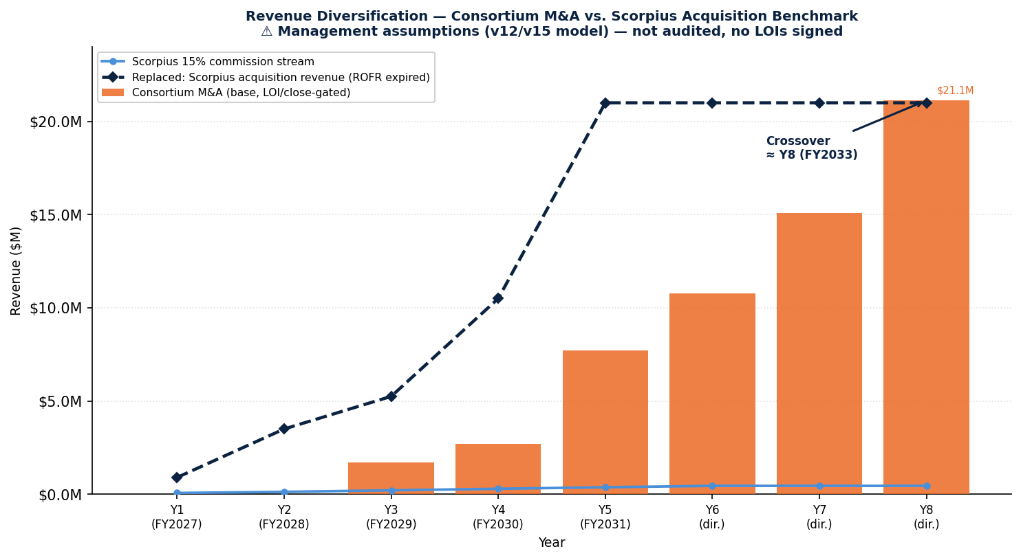

6. Revenue Diversification — Consortium vs. Scorpius Acquisition Benchmark
The chart and table below compare the consortium M&A base-case revenue ramp against the Scorpius asset-acquisition consolidated revenue plan (v12 model, management assumption). The ROFR acquisition plan projected $21M by Y5 (FY2031). The consortium base-case closes that gap at approximately Year 8 (FY2033) at 40% YoY growth on the Y5 base — approximately 9–10 nine-month cycles from Oct-2026. Management assumption; see caveat in Assumptions tab.

Year | SSLC Commission ($K) | Consortium / M&A ($K) | Other Exos ($K) | SSLC % of Total
Y1 (Jul26–Jun27) | 68 | 0 | 1,800 | 4%
Y2 | 128 | 200 | 3,200 | 4%
Y3 | 210 | 600 | 5,000 | 4%
Y4 | 293 | 1,500 | 7,500 | 3%
Y5 | 375 | 3,500 | 12,000 | 2%
Y6 (directional) | 450 | 7,000 | 20,000 | 2%

Visual narrative: the Scorpius 15% commission is a stable, low-risk annuity shown as a separate small line. The growth story is the consortium M&A cadence (stacked bars). The dashed line is the REPLACED Scorpius acquisition revenue benchmark — the revenue the expired ROFR acquisition plan would have delivered. Consortium crossover target: Y8 (FY2033). ⚠ All figures are management assumptions (v12/v15 model), not audited.
──────────────────────────────────────────────────────────────────────────────────────────

7. Key Assumptions (see v15 Assumptions sheet for full detail)
Assumption | Value | Source / Label
Deal cadence | ~9 months per gap cycle (Engage → First Revenue) | Management assumption — unverified
Per-deal revenue add (avg, Y1–Y5) | $200K–$3.5M depending on deal type; see revenue table above | Management assumption — unverified
Purchase multiples (acquire) | 3–5× revenue; 8–12× EBITDA for targets <$20M revenue | Management assumption — unverified; comparable public M&A multiples for small-cap aerospace composites as of 2024: 6–10× EBITDA (no direct source available)
Integration costs per deal | ~$150K–$400K (legal, diligence, integration labor) | Management assumption — unverified
Consideration mix | ~40% cash / 40% stock / 20% earnout (targets <$20M EV); stock requires post-RTO or post-Series-A public currency | Management assumption — unverified
Ramp curve | 12–18 months from close to full revenue contribution | Management assumption — unverified
Scorpius commission base | 15% on third-party tank sales; 15% rebate credit on Exos own buys; 18% passive equity carried at cost | Per commission-only agreement 2026-10-06 (internal docs)
Funded vs demonstrated gate | All M&A revenue is labeled 'pursuit/funded' until LOI signed; 'contracted' at close; 'demonstrated' at first revenue received | Hard rule per feedback_demonstrated_vs_funded_gate
BLK3 first commercial flight | Targeted early 2027 (FAA-licensed; not yet flown) | Exos internal program status — management-characterized
BLK4-Heavy orbital path | Capital-gated; 3-core parallel stick; not operational — in development | Management assumption — BLK4 not yet designed or funded
──────────────────────────────────────────────────────────────────────────────────────────

8. Governance & Immediate Next Steps
Pending Decision — Adopt v15 consortium MTP + model (Jon approval):
- Jon approves v15 model + this MTP document as canonical (Decision card posted).
- Exo initiates C1 Engage for Southwest Composite Works: confirm Carley Hendren contact, send MNDA under Jon's instruction.
- Exo re-sequences CTD engagement: brief Jon on Ken Runkles warm-path timing vs. capital availability.
- Exo adds consortium cycle tracking to Mission Control capability-gaps.html (status field: Cycle / Phase / ETC).
- v15 model reviewed by Jon; any restated figures flow to Series A data room.
──────────────────────────────────────────────────────────────────────────────────────────
CONFIDENTIAL — FOR INTERNAL USE ONLY. This document contains forward-looking statements based on management assumptions. It is not an offering document. All M&A targets are labeled candidates, unverified, and not contacted as of 2026-10-06. No external communication regarding any acquisition has been initiated. Counsel (Keyes) is engaged only at ready-to-sign documents.

