Exos Aerospace Systems & Technologies, Inc. | NIH STTR Phase I (R41) | PA-27-102 (Omnibus STTR) — due September 8, 2026 | Proposed component: NIBIB (primary) / NIA (secondary)
A Reusable Suborbital Microgravity Platform for Onset-Kinetics and Post-Flight Recovery Screening of Human Intestinal Organoid Chips Before ISS Commitment
Small Business Concern (applicant): Exos Aerospace, Greenville, TX. Research Institution: Purdue University.
Purdue biomedical lead: Prof. Sunghee (Estelle) Park (Weldon School of Biomedical Engineering). Suborbital platform & methods: Exos Aerospace (BLK3 operator).
Project Summary / Abstract
Human organoid chip models are central to NIH's mission to improve the predictivity of preclinical models. The NCATS/NIBIB Tissue Chips in Space program demonstrated that microgravity meaningfully perturbs human tissue models, yet access to microgravity remains dominated by the International Space Station (ISS), where multi-year timelines, high cost, and launch/transit delays make it impractical to screen hardware or to isolate the earliest phase of the microgravity response. There is no rapid, recoverable, low-cost platform to de-risk an organoids-on-a-chip payload before an ISS commitment. This STTR pairs Exos Aerospace — operator of BLK3, one of only three FAA-licensed reusable suborbital launch vehicles in the United States and a platform with peer-reviewed suborbital life-science heritage (living human glioblastoma stem cells; npj Microgravity 2023;9:92) — with the organoids-on-a-chip engineering laboratory of Prof. Sunghee (Estelle) Park at Purdue University (Weldon School of Biomedical Engineering; organoids / microphysiological systems (MPS); Science, Nat Methods), with Exos providing the suborbital flight platform and experiment methods. We will (Aim 1) design and flight-qualify a standardized, environmentally controlled, recoverable BLK3 payload module that maintains human intestinal organoid chips during flight with automated fixation at defined timepoints and intact recovery; (Aim 2) characterize the onset kinetics of the intestinal organoid response across the first approximately 3–4 minutes of microgravity and quantify the tissue's post-flight regenerative capacity after re-embedding in fresh extracellular matrix, a dataset not obtainable on ISS; and (Aim 3) validate the end-to-end suborbital screening pipeline and define a quantitative go/no-go framework for de-risking a subsequent ISS flight. The deliverable is a validated, reusable screening platform and a first intestinal organoid chip onset-and-recovery dataset that lower the cost and risk of orbital science. Phase II expands to a multi-flight campaign, adds the Park lab's additional human organoid models, including liver organoids, and stands up a standing screening service for NIH-funded MPS and organoid investigators, commercialized through Exos's payload-services business.
Project Narrative
Organoids and microphysiological systems (“organ chips”) that model the human intestine are increasingly used to study epithelial regeneration, differentiation, and responses to environmental stress, and evidence shows microgravity alters cellular organization and regenerative capacity in ways relevant to both spaceflight health and ground-based disease modeling. Sending these models to the International Space Station is slow and costly, and late hardware failures waste scarce research dollars. This project develops and validates a low-cost, reusable suborbital flight platform that lets investigators screen and de-risk organoid chip experiments — capturing the first seconds-to-minutes of the microgravity response and the tissue's post-flight regenerative capacity — before committing to an orbital campaign.

Specific Aims
Human organoid models and microphysiological systems (MPS) now underpin NIH efforts to improve the physiological relevance of preclinical research [refs], and the NCATS/NIBIB Tissue Chips in Space program established that microgravity can alter human tissue organization and function [refs]. However, the International Space Station (ISS) remains the principal microgravity environment for this work. Its cost, multi-year cadence, and launch and return constraints make it impractical to screen payload hardware, isolate the earliest seconds-to-minutes of the microgravity (µg) response, the onset window where gravisensing and fluid-shift signaling initiate. Just as importantly, ISS makes it operationally hard to interrogate what happens to the tissue on return: recovering intact epithelium quickly and measuring its regenerative capacity. Investigators therefore fly expensive orbital payloads with un-screened hardware and no onset or recovery baseline, and absorb late-stage failures.
We propose to close this gap with a reusable suborbital screening platform. Exos Aerospace operates BLK3, an FAA-licensed reusable suborbital vehicle that delivers approximately 3–4 minutes of recoverable microgravity with full payload return and rapid turnaround at a fraction of ISS cost and lead time. Teamed with the Purdue organoids-on-a-chip laboratory of Prof. Estelle Park and Exos's suborbital flight and experiment methods, we will build and validate the platform and generate the first quantitative intestinal organoid chip onset-and-recovery dataset. Human small intestinal organoids (enteroids) will be used to test post-flight survival, organoid-forming capacity, restoration of epithelial composition, and recovery of barrier integrity. Our central hypothesis is that suborbital µg induces reproducible changes in cellular cytoskeletal organization and mechanotransduction during flight and that these early responses are associated with the timing and extent of post-flight epithelial regeneration. Defining these responses will establish suborbital flight as a practical, low-cost platform for screening biological conditions and de-risking subsequent ISS studies. We will pursue three aims:
AIM 1. Design and flight-qualify a recoverable organoid payload module for BLK3 (Exos lead). In Aim 1, we will
develop a standardized payload module providing perfusion, thermal control, and gas exchange for a perfused human intestinal organoids maintained in an extracellular matrix (ECM) supported OCTOPUS device (ref), with automated chemical fixation/quench at defined timepoints and intact recovery. Milestone: the module passes vibration, thermal, fixation, and recovery qualification; the interface control document (ICD) is frozen; and cell viability in a flight-representative ground profile is comparable to static 1g controls.
AIM 2. Characterize onset kinetics and post-flight recovery of the intestinal organoid response to microgravity (Purdue/Park lead). In Aim 2, we will
fly human enteroids on BLK3 and fix samples at approximately 0, 60, 240 seconds of µg, with matched ground controls and an in-flight 1g control (centrifuge or matched-hardware). Onset measurements will quantify viability, cytoskeletal organization (F-actin), and mechanotransduction markers (YAP/TAZ localization). A live cohort will be recovered, transferred to fresh ECM gel. Recovery will be quantified by time to sustained outgrowth, organoid-forming efficiency, growth rate, and crypt-like bud formation. Ki67 or EdU will measure proliferation, while KRT20 and MUC2 will determine whether absorptive and secretory differentiation is restored. Selected functional measurements, including glucose-responsive calcium signaling and MUC2 secretion, will be incorporated after ground qualification. Milestone: a statistically powered onset-and-recovery dataset that distinguishes responses to suborbital µg exposure from 1g controls and captures early response kinetics that are difficult to measure during an ISS mission.
AIM 3. Validate the end-to-end screening pipeline and a de-risk-for-ISS decision framework (Joint; Exos suborbital methods).
Establish and document the preparation → integration → flight → staged fixation → recovery → re-embedding → assay pipeline with defined turnaround, and derive a quantitative go/no-go criteria that maps suborbital onset and recovery metrics to ISS-campaign readiness. Exos provides the suborbital experiment design and reduced-gravity flight validation. Milestone: reproducible pipeline across at least two flights and a validated scoring rubric adopted into the Phase II service concept.

IMPACT: This project will deliver a validated, reusable, low-cost microgravity screen and a first intestinal organoid chip onset-and-recovery dataset that reduce the cost and risk of NIH orbital MPS and organoid research and seed a self-sustaining suborbital screening service.

Research Strategy
A. Significance
The problem. NIH has invested heavily in microphysiological systems (MPS) and organoid models to improve preclinical predictivity, and the NCATS/NIBIB Tissue Chips in Space program (a NCATS + NIBIB partnership) showed that microgravity is a uniquely revealing stressor for these systems. MPS flown to ISS displayed altered barrier function and tissue phenotype relevant both to astronaut health and to ground disease and aging models [refs]. Intestinal organoids are a particularly high-value model because the intestinal epithelium undergoes continuous stem cell-driven renewal and must rapidly restore its cellular composition after environmental stress [refs]. Adult intestinal stem cells generate absorptive and secretory lineages through a sequence of proliferation, differentiation, and 3D morphogenesis [ref] that can be quantified after flight. These linked outcomes make it possible to determine whether a brief flight exposure changes immediate cellular organization or instead becomes evident only when the recovered tissue attempts to regrow and differentiate, enabling us to determine how microgravity affects intestinal development, specialized function, and regeneration. The principal access point for microgravity research remains the ISS, where multi-year lead times, six- to seven-figure cost, constrained crew time, and launch/transit delays that both gate throughput and blur the earliest phase of the biological response. Two consequences follow. First, investigators fly un-screened hardware: a fluidic seal, bubble-management, or viability failure discovered on orbit is enormously expensive. Second, the onset window — the first seconds to minutes in which gravisensing, cytoskeletal remodeling, and fluid-shift signaling initiate — and the tissue's post-return regenerative response are essentially unobservable on ISS, because payloads reach microgravity hours after handling and are recovered on a timeline far removed from the cells' first exposure.
Why suborbital, and why now. A reusable suborbital vehicle provides approximately 3–4 minutes of microgravity plateau with the payload in the investigator's hands within hours — recovered intact for immediate assay and for post-flight culture. This flight profile is the natural instrument for three things ISS cannot cheaply provide: (1) low-cost, rapid-turnaround screening to de-risk hardware and protocols before an orbital commitment; (2) direct capture of onset kinetics; and (3) measurement of post-flight regenerative capacity from intact, quickly recovered tissue. Suborbital flight does not replace sustained-µg ISS science; it screens and de-risks before it, and it interrogates time windows ISS obscures. The NIH SBIR/STTR program was reauthorized in April 2026; microgravity is investigator-initiated (not a named topic), and a device/platform framing fits NIBIB, which co-funded the Tissue Chips in Space program and already holds microgravity MPS in its portfolio (NIA secondary for µg-accelerated-aging angles).
Significance of success. A validated suborbital screen would let every NIH-funded organoid and MPS groups to test hardware and protocol before spending orbital dollars — “screen on BLK3, fly the winners to ISS” — and would create the first systematic onset-and-recovery datasets for intestinal (and, in Phase II, liver) organoid chips. A successful Phase I study will define sensitive biological endpoints, identify stage-specific payload requirements, and provide quantitative readiness criteria for longer-duration organoid chip studies. The same payload architecture and decision framework can subsequently support additional human organoid models.

B. Innovation
Platform innovation. Exos will convert BLK3 into a standardized, environmentally controlled, recoverable suborbital organoid chip research platform rather than a one-time biological payload. The module will maintain intestinal organoids in OCTOPUS device [ref], automate fixation or quenching of independent samples at defined flight times, and preserve a parallel live cohort for intact recovery.
Measurement innovation. The study treats onset kinetics AND post-flight recovery as first-class measurements. Automated in-flight fixation at staged µg timepoints isolates the 0–240 s response window ISS cannot resolve, while intact rapid recovery uniquely enables a regeneration readout (re-embed, organoid-forming efficiency, cellular organization, and mechanotransduction) that ISS operations make impractical — turning the limitations of short-duration flight into the core scientific product.
• Method: A screen-before-ISS decision framework. We define quantitative go/no-go metrics linking cheap suborbital data to orbital-campaign readiness — a reusable methodology, not just a dataset.
• Economics: A commercial reuse model. Because BLK3 is reusable with rapid turnaround, the same qualified module supports a recurring, low-cost screening service for the broader NIH organoid/MPS community, giving the platform a self-sustaining commercialization path beyond the award.
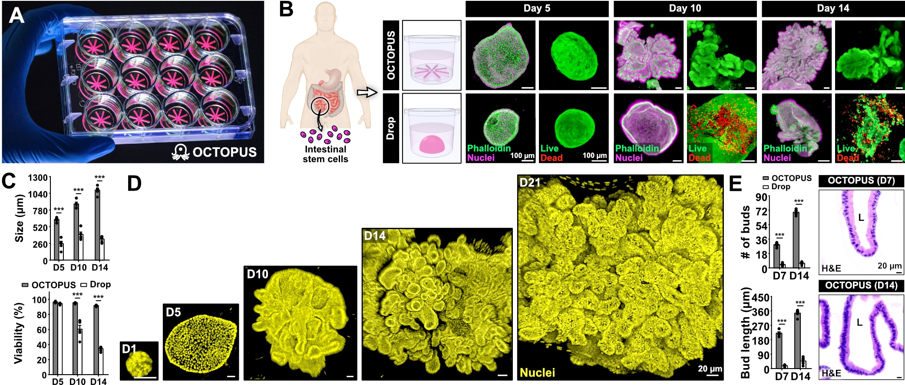
Distinct from prior art: existing microgravity-MPS work is ISS/orbital and captures chronic exposure; parabolic flight offers only ~20-second, non-recoverable, repeated transients. Neither delivers a single clean multi-minute µg plateau with intact recovery, staged fixation, and a post-flight regeneration readout. That combination is the novelty, and the intestinal organoid — highly regenerative and barrier-defined — is the model that makes the recovery readout maximally informative.
C. Approach
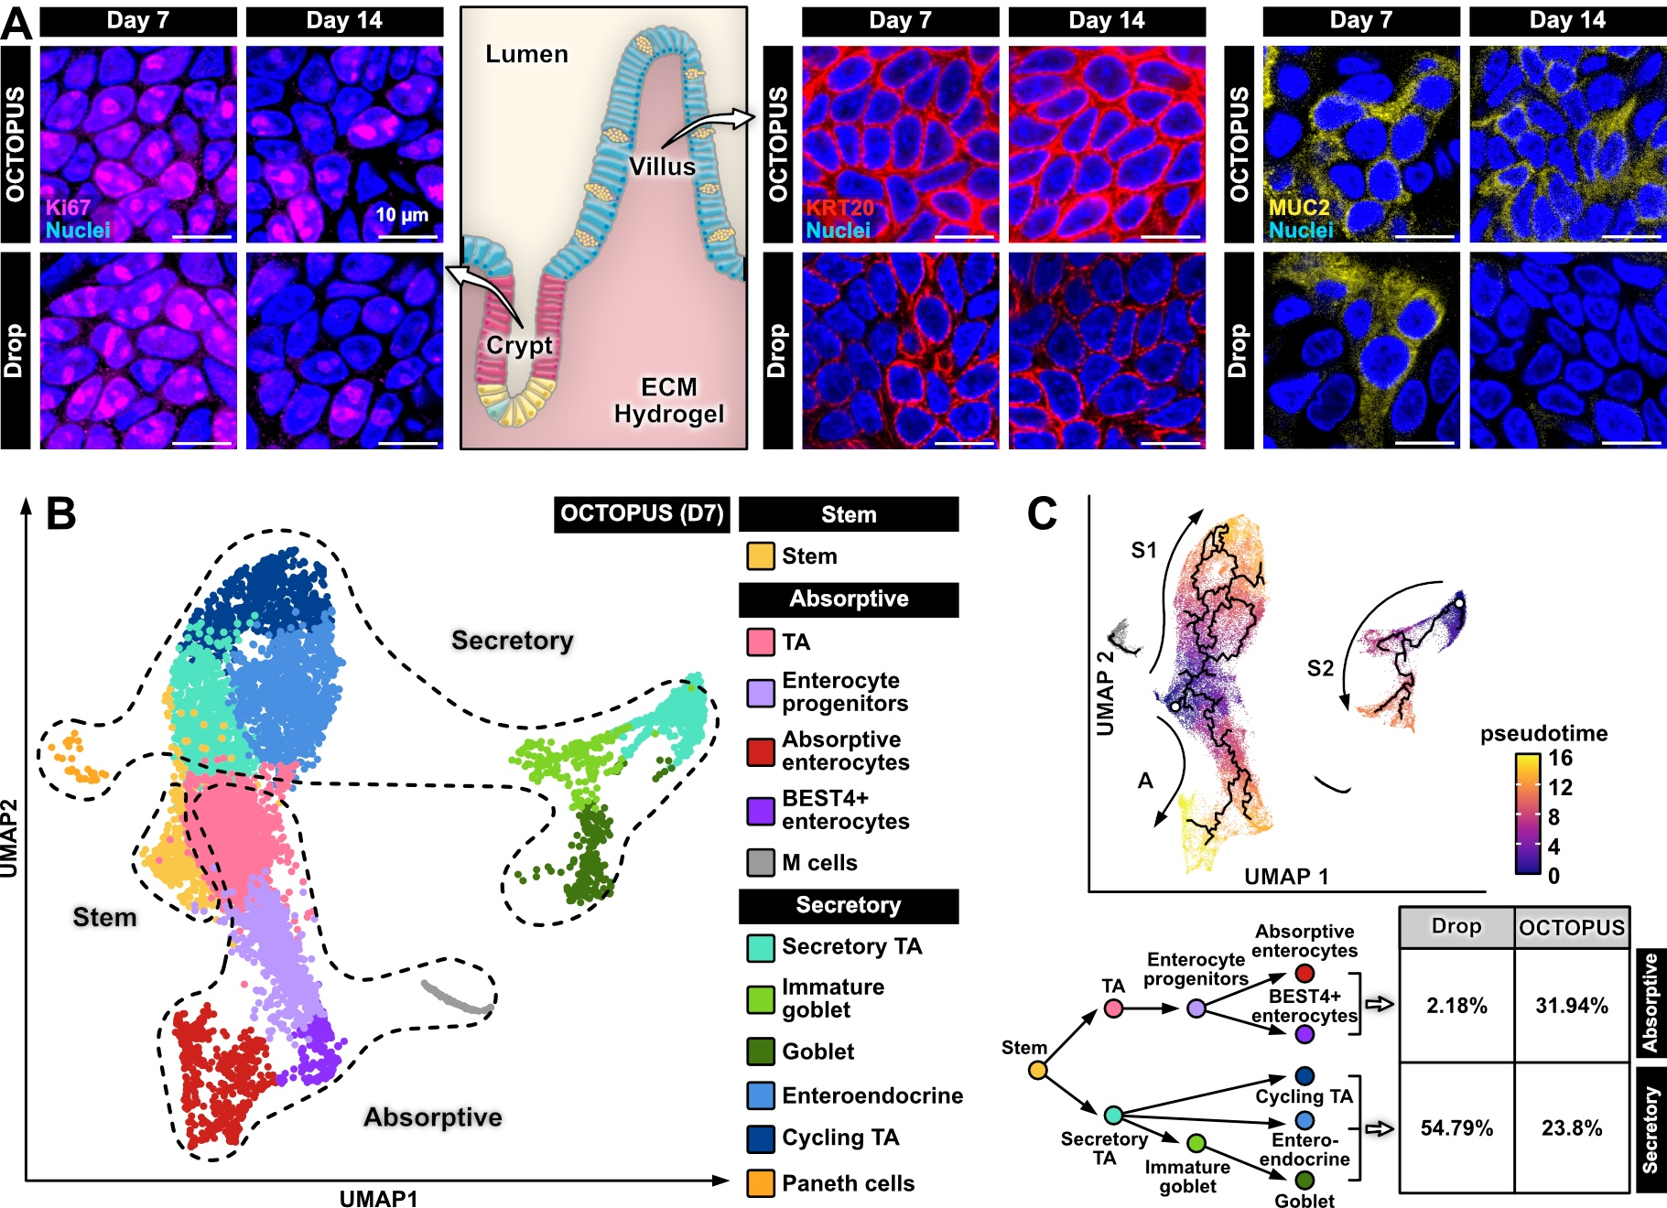
Team and roles. Exos Aerospace (the small-business applicant; STTR statutory work share ≥40%) owns the vehicle, the payload module, integration, flight operations, and recovery, and contributes peer-reviewed suborbital life-science heritage. Purdue University (single Research Institution; the balance, up to ~60%, subject to the ≥30% research-institution floor) owns the biology and the methods: the Park laboratory (Weldon BME) owns the human intestinal organoid science, organoids-on-a-chip designs, assays, controls, onset-kinetics analysis, and post-flight recovery/organoid readouts. Exos owns the suborbital experiment design and reduced-gravity flight methods. STTR permits the PD/PI at either the small business or the research institution; a Multi-PI leadership plan is proposed. All µg durations, g-levels, and viability claims below are design targets to be verified in Aim 1. Biological endpoints are supported by the Park Lab’s published intestinal organoid chip work and will be qualified for the flight hardware before launch. Specific cell sources, exact assays, and effect sizes will be finalized with the Park lab.
Figure 2. Epithelial proliferation and differentiation in human enteroids. (A) Ki67, KRT20, and MUC2 staining identifies proliferative cells, absorptive enterocytes, and goblet cells, respectively. (B) scRNA-seq identifies epithelial cell populations. (C) Trajectory analysis resolves absorptive and secretory differentiation.
Figure 1. Long-term growth and viability of human enteroids in OCTOPUS. (A) Culture platform. (B–C) Representative images and quantification of organoid viability and size. (D) Continued growth during extended culture. (E) Quantification of bud formation and representative histology.
Preliminary Data
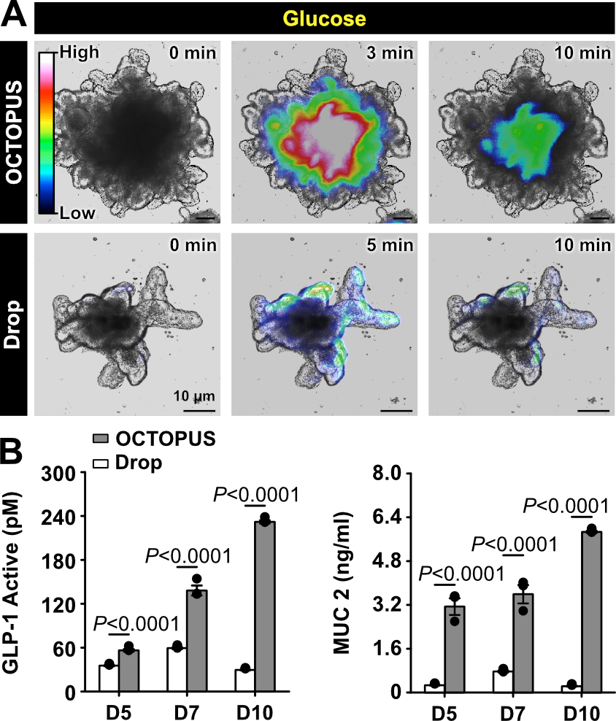
The Park laboratory has established long-term culture and quantitative analysis of human small intestinal organoids (enteroids) derived from adult intestinal stem cells [ref]. In the published OCTOPUS platform (Figs. 1A, 1B), human enteroids remain viable during extended culture and increased more than 10-fold in size over one month without passaging (Figs. 1C, 1D). Developing enteroids formed progressively larger number of crypt-like buds, providing quantitative measures of organoid growth and morphogenesis that can applied directly to post-flight recovery (Fig. 1E). Ki67-positive proliferative cells localized to crypt-like domains, while increased KRT20 and MUC2 expression demonstrated absorptive and secretory differentiation, respectively (Fig. 2A). Single-cell RNA sequencing (scRNA-seq) further confirmed the presence of intestinal stem, absorptive, and secretory cell populations (Fig. 2B) and resolved their differentiation trajectories during extended culture (Fig. 2C). The same study established glucose-responsive calcium imaging (Fig. 3A) and secretion assays for MUC2 and GLP-1 as functional measurements of epithelial activity (Fig. 3B). Organoids retained their capacity for passaging after extended culture, supporting the feasibility of recovering flight-exposed tissue, re-embedding it in fresh matrix, and quantifying organoid-forming efficiency and subsequent differentiation (Fig. 4). Together, these published data establish the human intestinal organoid chip model, imaging and molecular-analysis workflows, and regenerative endpoints required for Aim 2. The Park Lab has also established liver organoids with measurable growth, hepatic differentiation, and metabolic function (Data not shown). Following validation of the suborbital platform in Phase I, these liver organoids will be incorporated in Phase II to determine whether the screening workflow can be extended to a metabolically specialized epithelial tissue.
Figure 3. Functional characterization of intestinal organoids. (A) Glucose-induced intracellular calcium responses. (B) GLP-1 and MUC2 secretion in OCTOPUS and Matrigel drops.
Figure 4. Passaging and expansion of human enteroids. Schematic of organoid recovery and re-embedding in fresh Matrigel, with representative images showing expansion after passaging in OCTOPUS and Matrigel-drop cultures.
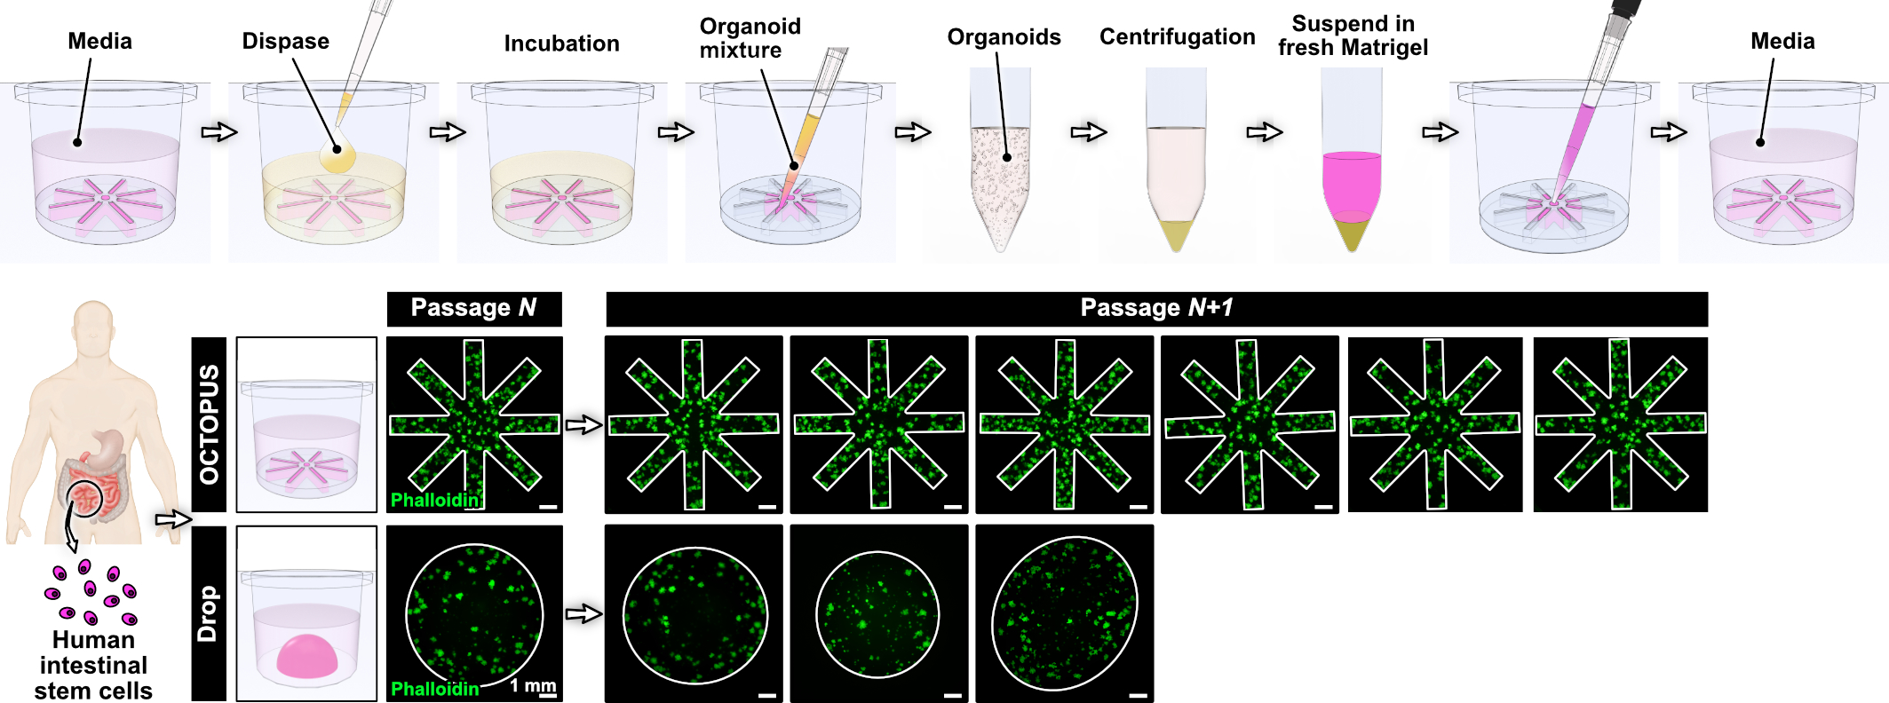

Aim 1. Design and flight-qualify a recoverable organoid chip payload module for BLK3 (Exos lead; months 1-6).
• Design a self-contained module providing closed-loop perfusion, thermal control (37°C), and gas exchange sized to the Park-lab intestinal organoid chip system, with automated reagent actuation for fixation/quench at commanded timepoints, a parallel recover-intact path for post-flight culture, and sealed, recoverable containment consistent with FAA payload safety and biosafety handling.
• Freeze an interface control document (ICD) with Purdue (fluidics, power, data, thermal, biosafety) and define the recovery-to-assay chain (target payload-in-hand within hours of landing).
• Qualify against a flight-representative environment — boost/ascent loads and transient shock, thermal, and recovery — using Exos ground facilities (Greenville: manufacturing, test, and tethered-hover only; no launch on site). Verify cell viability in a ground flight-profile run relative to static 1g controls before committing cells to flight.
Milestone / go–no-go (M6): qualified module + frozen ICD + viability parity in ground profile. Failure here re-scopes Aim 2 timepoints or module before any flight cell use.
Aim 2. Characterize onset kinetics and post-flight recovery of the intestinal organoid response to microgravity (Purdue/Park lead; months 4–11).
Rationale and hypothesis. Microgravity may rapidly alter cytoskeletal organization and mechanotransduction [refs] without immediately reducing cell viability. The biological consequences of these early responses may become evident after recovery as delayed organoid growth, reduced organoid-forming efficiency, impaired crypt-like budding, or incomplete restoration of epithelial differentiation and function. We hypothesize that suborbital microgravity induces reproducible, measurable changes in F-actin organization and YAP/TAZ localization that are associated with the onset and extent of post-flight organoid recovery.
Experimental design. Human enteroid chips from the same production batch will be randomized between staged-fixation and live-recovery cohorts. At least three independent samples will be fixed at approximately 0, 60, and 240 seconds of microgravity. Controls will include conventional incubator chip cultures and hardware-matched ground controls subjected to the same loading and handling schedule. An in-flight 1g centrifuge control will be included if technically feasible. Acceleration and temperature telemetry will be linked to each sample. If an in-flight 1g control cannot be implemented, results will be interpreted as responses to the integrated suborbital flight exposure relative to matched ground controls.
Onset-response measurements. Fixed organoids will be analyzed for Live/Dead viability, F-actin organization, and nuclear-to-cytoplasmic YAP/TAZ localization. Confocal images will be acquired using standardized acquisition settings and analyzed under blinded conditions. The primary onset endpoint will be the change in nuclear YAP/TAZ localization across flight timepoints. Quantitative analysis of F-actin organization and viability will provide complementary measurements. Cleaved caspase-3 or TUNEL staining will determine whether early cellular responses are accompanied by apoptosis.
Post-flight recovery measurements. A parallel cohort will be recovered alive and re-embedded in fresh ECM using standardized viable organoid-fragment inputs. Brightfield imaging at 0, 6, 12, 24, 48, and 72 hours and on days 7 and 14 will quantify time to sustained outgrowth, organoid-forming efficiency, growth rate, and abnormal morphology. Crypt-like bud number and length will measure structural regeneration. Ki67 staining or EdU incorporation will quantify proliferation, while KRT20 and MUC2 expression will assess restoration of absorptive and secretory differentiation. scRNA-seq will define epithelial cell composition and determine whether flight exposure alters stem, progenitor, absorptive, or secretory cell populations and their differentiation trajectories during recovery. Glucose-responsive calcium signaling and MUC2 secretion will provide complementary functional measurements after ground qualification.
Rigor, replication, and statistical analysis. Sample size will be determined from the variability and effect sizes measured during Aim 1 ground qualification. Experiments will include at least three independent enteroid production batches and will be reproduced across at least two flights. Samples will be randomized before payload loading, and image analysis will be blinded. Time-to-event analysis will compare the onset of sustained outgrowth. Mixed-effects models will evaluate longitudinal growth, budding, differentiation, and functional measurements, with flight condition and recovery time as fixed effects and production batch or donor as a random effect. Primary endpoints and exclusion criteria will be prespecified before flight. Biological sex will be evaluated as a biological variable.
Expected outcomes. We anticipate that enteroid viability will remain largely preserved during the brief flight interval, while mechanotransduction and post-flight regeneration measurements will reveal more sensitive effects. Flight-exposed enteroids may exhibit delayed growth, reduced organoid-forming efficiency, altered budding, or incomplete restoration of differentiated epithelial populations. These studies will determine whether early F-actin and YAP/TAZ responses are associated with subsequent epithelial regeneration and function.
Potential problems and alternative strategies. If YAP/TAZ or F-actin responses are smaller than anticipated, we will prioritize the most reproducible onset markers identified during ground qualification and increase the number of organoids analyzed per sample. If payload handling reduces viability in both flight and ground controls, ECM concentration, medium formulation, organoid size, loading density, temperature control, and holding time will be optimized before flight. If outgrowth is delayed but not absent, recovery will be extended to distinguish a temporary delay from loss of organoid-forming capacity. If material is insufficient for all differentiation and functional measurements, analyses will prioritize organoid-forming efficiency, budding, proliferation, KRT20, and MUC2. A null response will define the sensitivity and appropriate biological applications of the suborbital platform.

Milestone (M11): Completion of a statistically powered dataset defining the onset and post-flight recovery of human intestinal organoid chip responses. With a valid in-flight 1g reference, the analysis will distinguish microgravity-associated responses from other components of flight; otherwise, it will quantify responses to the integrated suborbital flight exposure relative to matched ground controls.

Aim 3. Validate the end-to-end screening pipeline and a de-risk-for-ISS decision framework (Joint; Exos suborbital methods; months 6–12).
Rationale and objective. A suborbital screening platform will be useful only if payload preparation, staged fixation, recovery, and biological analysis can be performed reproducibly within defined operating limits. In addition, investigators need objective criteria for determining whether an organoid experiment is sufficiently robust to advance to a longer and more costly orbital mission. The objective of Aim 3 is to validate the complete suborbital workflow and translate its technical and biological outputs into a quantitative ISS-readiness framework. We hypothesize that standardized operating procedures and prespecified acceptance criteria will identify hardware, handling, and biological failure modes before an orbital commitment.
Pipeline validation. Exos and Purdue will document the complete preparation → payload integration → flight → staged fixation → recovery → ECM re-embedding → assay workflow. Exos will lead payload integration, suborbital experimental design, automated fixation, environmental monitoring, reduced-gravity flight validation, and payload recovery. Purdue will lead human intestinal organoid chip preparation, biological qualification, post-flight processing, and analysis of epithelial regeneration and function. Biological validation will assess the reproducibility of F-actin and YAP/TAZ imaging, organoid-forming efficiency, outgrowth kinetics, crypt-like budding, and proliferation. KRT20 and MUC2 measurements will evaluate epithelial differentiation, while ground-qualified calcium-signaling and MUC2-secretion assays will assess functional recovery. Selected samples will undergo scRNA-seq to evaluate epithelial cellular composition and differentiation-associated transcriptional programs. Workflow reproducibility will be evaluated across at least two flights. If the second flight cannot be completed within Phase I because of vehicle scheduling, one flight will be supplemented with a matched ground flight-profile replicate reproducing the payload timeline, environmental conditions, fixation sequence, and recovery workflow. This contingency will support procedural validation but will not substitute for demonstration of biological reproducibility across flights.
ISS-readiness framework. We will develop a quantitative go/no-go rubric incorporating four domains:
- Payload performance: containment integrity, thermal stability, and fixation accuracy.
- Sample recovery: recoverable intestinal organoid fraction, viability, and time from landing to re-embedding.
- Assay performance: proportion of samples yielding interpretable measurements and variability of primary onset and recovery endpoints. For selected scRNA-seq samples, quality assessment will include viable-cell yield and sequencing quality.
- Biological readiness: organoid-forming efficiency, time to sustained outgrowth, crypt-like budding, proliferative recovery, and reproducibility of epithelial differentiation and functional measurements.

Acceptance thresholds will be established using Aim 1 ground-qualification results and initial Aim 2 flight data, then fixed before evaluation of subsequent validation samples. A study will receive a go when the payload operates within qualified limits, sufficient viable material is recovered, and primary biological endpoints meet predefined reproducibility criteria. A revise designation will identify correctable hardware, handling, or biological limitations. A no-go will identify conditions unlikely to produce interpretable data during a longer-duration mission. The Phase I framework will evaluate operational and biological readiness for an ISS campaign. It will not claim that suborbital responses predict orbital outcomes without paired ISS validation. Phase II studies will test whether the selected suborbital metrics are associated with outcomes during longer-duration microgravity exposure.

Expected outcomes, potential problems, and alternative strategies. Aim 3 will produce a reproducible end-to-end workflow, a finalized interface control document, standardized operating procedures, and a quantitative readiness rubric. The resulting framework will allow investigators to identify payload failures, sample-handling limitations, excessive assay variability, and inadequate biological recovery before committing to an ISS mission. Vehicle scheduling represents the principal operational risk. Ground qualification and workflow validation will therefore proceed independently of a specific flight date. If biological variability exceeds the prespecified threshold, Purdue will standardize starting organoid size, passage number, culture duration, loading density, and viable fragment input for recovery assays. Donor and production-batch effects will be evaluated separately from technical variability.

• Derive a quantitative go/no-go rubric mapping suborbital onset and recovery metrics to ISS-campaign readiness (which failure modes suborbital screening catches; which endpoints predict orbital outcomes).
Milestone (M12): reproducible pipeline across ≥2 flights + validated scoring rubric carried into the Phase II service concept.
Compliance, risk, and feasibility
• Vehicle: BLK3 is FAA-licensed but has not yet flown commercially; the March 2027 flight provides a concrete near-term target, and Aim 1 qualification precedes any cell flight. Schedule risk is mitigated by decoupling module qualification (Aim 1) from the specific flight date and by planning ≥2 flights.
• Biological materials: Established human small intestinal organoid (enteroid) lines only; no vertebrate animals or direct human-subjects interaction anticipated. Cell identity, donor sex, passage number, sterility, mycoplasma status, and culture duration will be documented before flight with authentication of key biological resources.
• Safety: Sealed, recoverable containment; standard human organoid culture/MPS biosafety; no select agents.
• Scientific: If µg-onset or recovery signals are small, the powered multi-flight design and prespecified primary endpoints will preserve interpretability. A null result will define the sensitivity and appropriate applications of the suborbital screening platform.
Phase I deliverables and path to Phase II / commercialization
• Flight-qualified, recoverable human organoid chip payload module with automated fixation and a frozen ICD (reusable and adaptable across investigators).
• First quantitative intestinal organoid onset-and-recovery dataset and a validated de-risk-for-ISS scoring framework.
• Phase II: Conduct a multi-flight campaign; extend the platform to the Park Lab’s human liver organoids; and test whether microbiota-derived metabolites modify intestinal organoid responses and post-flight recovery. Establish a recurring suborbital screening service for NCATS TraCe MPS / Tissue-Chips and NASA-funded investigators. Commercialization will leverage Exos's existing payload-services business (recoverable capacity, published per-flight pricing), providing a direct transition from platform validation to revenue-generating flight services.

Bibliography & References Cited
1. Exos Aerospace suborbital life-science heritage — living human glioblastoma stem cells flown suborbital; npj Microgravity 2023;9:92.
2. NCATS/NIBIB Tissue Chips in Space program (microphysiological systems on the ISS National Laboratory) — program overview and demonstrated microgravity effects on MPS barrier function and tissue organization.
3. NIH SBIR/STTR program reauthorization (April 2026) and PA-27-102 Omnibus STTR (R41/R42) funding opportunity announcement.
[Reference list to be finalized with the Park lab — intestinal MPS / organoid barrier, mechanotransduction, and regeneration citations — during package assembly.]

Budget Summary (reference — for R&R Budget forms; not part of the page-limited narrative)
Period: ~12 months (Phase I). Total to the NIH SBIR/STTR Phase I guideline of $314,363 (this ceiling INCLUDES the 7% SBC fee), allocated to the STTR statutory split for a single-research-institution team:
• SBC share: Exos Aerospace (small-business concern) — $138,085 = $117,519 base (40%) + $20,566 SBC fee (7%): platform, payload module, integration, flight operations, recovery.
• RI share: Purdue University (single Research Institution) — $176,278 inclusive of Purdue F&A (60% of the cost base, above the ≥30% research-institution floor): intestinal-MPS science, assays, and post-flight recovery/organoid readouts (Park lab).
Detailed R&R budget and justification, subaward/consortium budget, and statement of work to be built to the final guideline amount during Purdue sponsored-programs routing.

