CIT_2102: Hardware, Software, and Peripherals
Research on Network Topologies

John Karl L. Lopez
IT3C
November. 04, 2024
Prof. Mar Eli C. Sagsagat

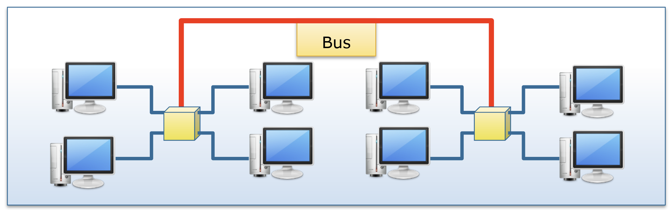

Advantages:
- Easy to Install – The bus topology is very simple to install and does not require to have complex networking equipment’s.
- Simple to Comprehend – This structure is straightforward, making it easy for beginners to understand how it works.
- Flexible – This structure works well into small networks where only a few devices are connected.
Disadvantages:
- Hard to troubleshoot – Finding problem in this network can be challenging since it may affect the other devices that connected;
- Performance – Due to multiple devices is connected, network performance can slow down due to traffic on the bus.
- Limited Range – The length of the cable limits how many devices can be connected.

Bus topology is an easy network layout where all devices hook up with a single imperative cable, known as the bus. Data travels alongside this cable, and each tool listens for messages addressed to it. One of the principal characteristics of bus topology is that it is simple to set up and calls for much less cable than other topologies, making it fee powerful. However, if the critical bus fails, the entire network stops running. This topology is high-quality carried out in small networks, such as in a domestic workplace or a small business, where only some computers or gadgets need to speak. For example, a temporary setup all through an occasion would possibly use bus topology because of its low fee and simplicity, however it isn’t best for larger networks because it may struggle with multiplied visitors and reliability problems.
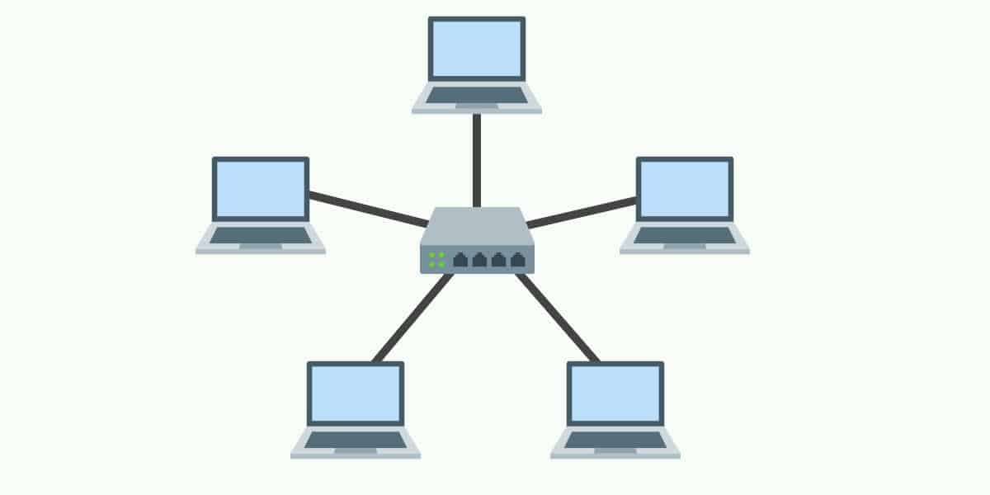
Advantages:
- Easy to Setup – The star topology is easy to set up and manage because of all device connect to a central hub.
- Troubleshooting – Problems can be quickly identified since each device connects separately to the hub.
- Reliability – If one cable or device fails, it does not affect the rest of the network.
Disadvantages:
- Problem on hub – In star topology if the central hub fails, the entire network goes down and all connections.
- Storage – The setup may require more physical storage for the cabling and more.
- High Cost – It requires more cable and equipment, making it more expensive to set up.

A star topology is a network design in which all devices are connected to a switch hub. Each device has its own cable connected to this hub, making it easy to monitor and troubleshoot the network. One of the main characteristics of star topology is its reliability; When one device or line fails, the rest of the network continues to operate normally. This system is particularly suitable for environments where stability is important, such as office buildings or homes with multiples computers. For example, many businesses use star topology in their local area networks (LANs) because it makes it easy to expand; New devices can be added without affecting the entire system. Overall, star topology works best where efficiency and fast troubleshooting are required.
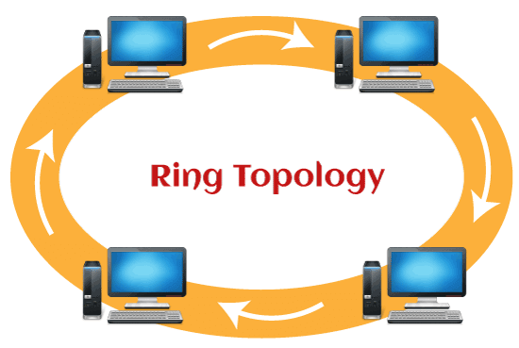
Advantages:
- Simple to setup – Ring topology is relatively easy to set up, as each device connects to two others in a loop.
- Equal – Each device has equal access to the network.
- Advantage for small networks – It works well in smaller networks where traffic is manageable.
Disadvantages:
- Hard time to troubleshoot – Identifying the problems can be challenging, as a failure can affect all devices connected to the ring.
- Single points failure – If one device encounter problem all devices and network will be affected.
- Limited Scalability – Adding new devices can be hard, as it required to break the ring and reconnect again.

A ring topology is a network design in device is connected to two other devices, creating a circular path for data to travel. In this system, data travels in one direction around the ring, which can help prevent data collisions and improve communication efficiency. One of the key characteristics of the ring topology is its predictable performance, as each device has exactly the same access to the network. This topology is feasible for use in small networks where data traffic rates need to be controlled, such as in a classroom or small office. For example, some schools use a ring topology in their computer labs because it allows them to communicate efficiently between devices without overloading data but realize that if one device or connection fails, it can destroy entire network, making reliability a concern in large-scale systems.
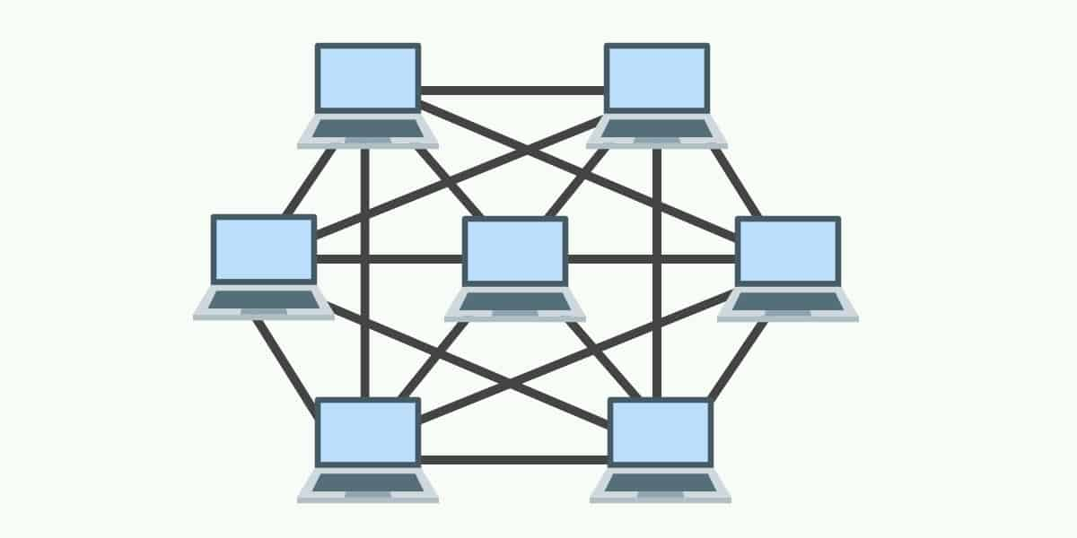
Advantages:
- Performance – Data can travel along several paths.
- Reliability – If one connection fails, data can still find paths to keep the network running.
- Scalability – New device can add without disconnecting the network.
Disadvantages:
- Expensive – Requires more cable and hardware than other topologies.
- Troubleshooting – Due to numerous connections troubleshooting must be hard.
- Space requirement – physical space is required since there are extensive cablings.

A mesh topology is a network design in which each device is connected to many other devices, providing multiple paths for data to travel. A key characteristic of mesh topology is its ability to manage network performance, as there are many ways to optimize data Mesh topology especially in environments where frequent connections are required and high availability, such as large corporate networks or data centers -Can use topologies for ensuring that their systems continue to function even if some connections experience problems but due to complexity and cost, mesh topologies are generally more appropriate for larger organizations that can invest in infrastructure it is in need.

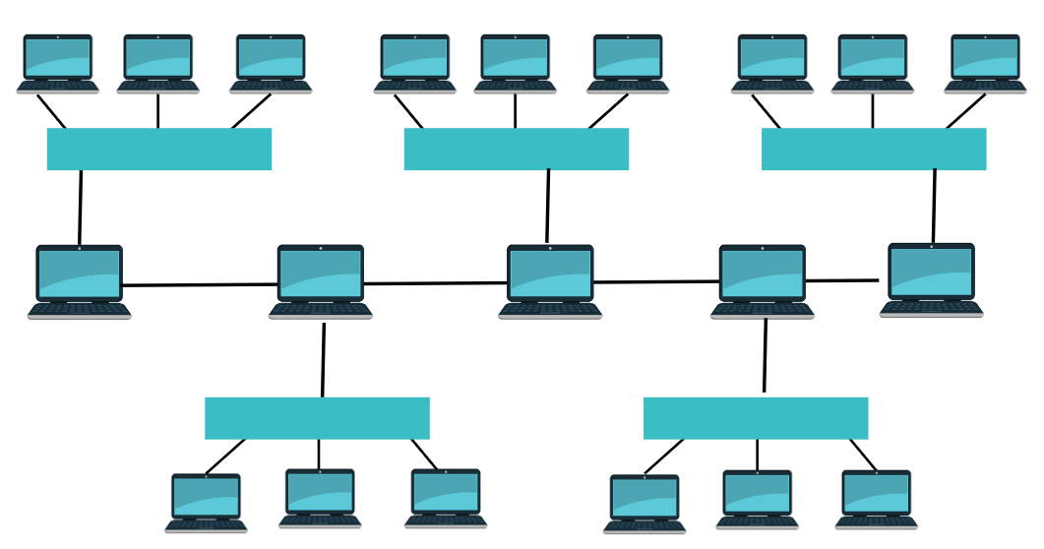
Advantages:
- Flexibility - Hybrid topology combines specific community types (like celebrity, ring, and bus), permitting it to be tailor-made to precise needs and environments.
- Scalability - It’s easy to feature new devices or segments without disrupting the entire community, making it appropriate for developing agencies.
- Performance - By using the strengths of different topologies, hybrid networks can optimize performance for diverse tasks and programs.
Disadvantages:
- Complex Design - The mixture of various topologies can make the network design complicated, requiring extra planning and control.
- Higher Cost - Setting up a hybrid community may be extra high priced due to the want for numerous kinds of hardware and cabling.
- Maintenance Challenges - Managing and troubleshooting a hybrid network can be extra tough, as one-of-a-kind parts can also require exclusive techniques or equipment.
A hybrid topology is a network design that combines different topologies, such as star, ring, and bus, to create a flexible and efficient system Each part of the network can use the most appropriate topology for its specific needs, which provides allows based customization on performance and reliability needs Key characteristics are its scalability; It can easily adjust to changes by adding or removing devices with minimal disruption. This topology is best used in large organizations where departments may have different networking needs, such as a university that connects several buildings, each using different topologies for example, the company may use a star topology role for its office system that uses a bus topology for a research lab, maximizes productivity and resources become demanding a mix of reliability, efficiency and flexibility.

