

University of the East
Caloocan City
College of Engineering

An E-Governance System for Barangay Hulong Duhat Malabon City

A Methods of Research presented to
the Faculty of Department of Computer Studies and Systems
College of Engineering

Allister Jed T. Andaya
Lester Adriane P. Gervacio
Reth Jaren A. Hijapon
John Karl L. Lopez
Joshua D. Roxas

March 29, 2026

TABLE OF CONTENTS

TABLE OF CONTENTS 2
CHAPTER 1 - INTRODUCTION 3
1.1. Background of the Study 3
1.2. Statement of the Problem 4
1.3. Objectives of the Study 5
1.3.1 General Objective 5
1.3.2 Specific Objective 6
1.4. Significance of the Study 7
1.5. Scope and limitations of the study 8
CHAPTER 2 – ANALYSIS OF RELATED RESEARCH 11
2.1. Review of Related Studies 11
2.2. Synthesis of Related Studies 15
2.3. Conceptual Framework 16
2.4. Definition of Terms 18
CHAPTER 3 – METHODOLOGY 22
3.1. Research Methods 22
3.2. Project Design 23
3.3. Project Development 25
3.4. Work Plan of the Study 28
3.5. Ethical Consideration 35
3.6. Testing and evaluation procedure 36
3.7. System requirements 42
3.7.1. Hardware requirements 42
3.7.2. Software requirements 44
REFERENCES 47

CHAPTER 1 - INTRODUCTION

Background of the Study
Barangay Hulong Duhat, located in Malabon City, is a big community of approximately 12,000 residents. The barangay hall serves as the main center for essential government services, including the issuance of certificates, clearances, assistance, and blotter reports. The barangay handles a high volume of public service requests, with approximately 50 requests daily and hundreds per month, which highlights its critical role in providing services to the community.
The current operational system at Barangay Hulong Duhat is mostly manual and paper-based. A team of five staff members handles a large amount of work, including processing documents and answering resident inquiries. The existing manual, paper-based system, while functional for years, has led to significant challenges. Its reliance on manual processes often results in extended waiting times and redundant transactions for residents. The staff frequently experience issues such as typographical errors and incomplete document submissions, which contribute to increased workload and residents’ dissatisfaction.
This study is based on the principles of e-governance and information systems. By using database-powered e-governance system, the project aims to make barangay services more accurate, efficient, and transparent. These innovations follow modern IT practices that support digital transformation in government services.

Therefore, the researchers come up with the implementation of an e-governance to address these issues, the project aims to efficient service, reduce manual errors and improve the overall experience for both residents and barangay staff. The transition to a digital platform allows Barangay Hulong Duhat to offer more efficient, accurate, and accessible public services, paving the way for more effective and responsive in local governance.

Statement of the Problem
This study aims to develop an e-governance system to address operational issues faced by Barangay Hulong Duhat, Malabon City. The project’s goal is to create a digital platform that will automate and streamline major services that will benefit both residents and barangay staff. Specifically, this study aims to answer the following questions:
    - What are the existing challenges and limitations encountered in the current manual system of Barangay Hulong Duhat in terms of processing transactions, data management, and service delivery?
    - How can an e-governance system automate service requests such as indigency certificates and clearances to reduce manual errors and transaction delays?
    - What system features including online request submission, real-time tracking, notification, and a chatbot for inquiries can improve accessibility, transparency, and resident satisfaction?

    - How do the respondents evaluate the performance of the proposed system in terms of:
- Functional suitability,
- Usability,
- Performance Efficiency,
- Reliability, and
- Security?
    - What recommendation plan is being implemented for the Barangay?

Objectives of the Study

General Objective
The main objective of this study is to develop and implement an e-governance system for Barangay Hulong Duhat, Malabon City. This system will directly address the problems outlined in Statement of the Problem by automating services such as certificates, indigency, and clearances. This will significantly reduce manual errors and delays. By adding features like online requests, real-time tracking, and automated notifications, the system aims to give residents better access to services, more transparency, and a better experience overall. The most important goal is to evaluate if the system’s accuracy, data security, and staff efficiency, reduce workload, and improve service speed, and improve public trust in Barangay Hulong Duhat administration.

Specific Objective
  - To address the challenges encountered by the respondents.
  - To implement an e-governance system based on the needs of Barangay Hulong Duhat, Malabon City.
  - To improve the efficiency and accessibility of barangay services through digital transformation.
  - To evaluate the performance of proposed system based on:
    - Functional suitability
    - Usability
    - Performance Efficiency
    - Reliability
    - Security
  - To address the recommendations being implemented by barangay.

Significance of the Study
This study is important because it benefits multiple groups in the community. For residents, it offers faster and more convenient access to barangay services such as clearances and certifications. For barangay officials and staff, it reduces manual workload, improves efficiency, and ensures better record management.
This study is beneficial to the following:
Barangay Officials - This study will be helpful for the officials and staff of barangay because it can increase efficiency in daily operations and better access to information.
Residents - This study will be helpful for the residents of barangay Hulong Duhat, through faster and more convenient access to services like barangay clearances and certifications
Future Researchers - This study can help the future researchers as a guide and basis in composing their own study.
Local Government Units – This study can serve as a model for other barangays and LGUs that aim to transition from manual to digital operations.
Municipality of Malabon – This study supports the municipality’s initiative to implement an e-governance system at the barangay level, which can enhance the efficiency of communication, improve record management, and promote a more connected and data-driven local administration.

Scope and limitations of the study
This section describes the specific areas of the study that will be covered as well as the limitations that will be observed. The scope and limitations are important in guiding the research process and ensuring that the objectives of the study are realistic and achievable.
Scope
- The system will provide User Authentication and Account Management to ensure secure access for both residents and authorized barangay personnel.
- It will feature a Request Tracking System allowing residents to monitor the real-time status of their document applications through a unique Reference ID.
- The platform will include Announcement and Information Management for posting official news, advisories, and barangay updates.
- It will provide a dedicated module for Events and Projects Information to showcase upcoming community programs and local government initiatives.
- The system will implement Role-Based Access Control (RBAC) for Administrators to define specific permissions for different staff levels, ensuring data security and accountability.
- It will automate Document Generation for essential barangay paperwork, including clearances, indigency, and residency certificates.
- It will include Incident Report Management for the digital filing and systematic handling of community disputes or reported concerns.
- It will utilize Dashboard Analytics to provide a visual overview of transaction volumes, resident demographics, and service efficiency.
- Automated notifications will be sent via email or SMS to inform users of their request status and important community alerts.
- The platform will be accessible via both desktop and mobile browsers.
- The system will be deployed and tested exclusively within Barangay Hulong Duhat, Malabon City.
Limitations
- The system is limited to selected barangay workflows and does not cover full LGU functions such as business permitting, tax collection, procurement, budgeting, civil registry, or court-level case management.
- The system does not support online payment integration and will not include a payment gateway in the initial version.
- The platform is web-based and requires internet access, limiting usability for residents without connectivity.
- The system does not cover health-related functions or services.
- Forecasting and analytics depend on pre-generated outputs, external script execution, and file generation, so data is not fully real-time.
- SMS notifications and AI/chat features rely on third-party services and API keys, making the system vulnerable to outages or misconfigurations.
- The chatbot is restricted to barangay and e-governance topics and may not respond accurately to out-of-scope questions.
- The system primarily manages internal barangay records and does not integrate with national government systems or other LGUs.
- Staff training and adaptation may temporarily affect service speed and accuracy.
- System performance may be constrained by the barangay’s existing hardware and IT infrastructure.

CHAPTER 2 – ANALYSIS OF RELATED RESEARCH

This chapter includes the related research studies and literatures published research as basis in the development of the project.

Review of Related Studies
Web-Based Barangay Information and Management Systems
Several studies focused on the implementation of web-based systems to improve barangay operations.
Jholan et al., (2023) developed the Web-Based Barangay Profiling and Issuance System to digitize barangay operations, improve efficiency, and automate document issuance. The system reduces manual paperwork and processing delays while centralizing resident profiling. It enhances accessibility, accuracy, and transparency, supporting more effective local governance.
Similarly, Melendres and Aranda (2024) also developed a Web-Based Resident Information Management System using the RAD model. Evaluated under ISO 25010 standards, the system obtained mean scores between 3.42 and 3.62, proving it could effectively maintain resident records and improve service efficiency.
Taruc et al. (2023) also designed Docu-Go, a document requesting system developed with a modified waterfall model. Evaluation using ISO 25010 revealed positive results from both IT experts and residents, proving the system useful and acceptable.
Digital Governance and Community Engagement
Various researchers emphasized the role of e-governance in enhancing community participation and digital transformation.
Andaya et al. (2025) conducted a scoping review on Digital Governance in the Philippines, highlighting its potential for improving public service delivery while pointing out adoption barriers, financial limitations, and lack of digital literacy. They emphasized the importance of emerging technologies such as blockchain and AI for future research.
Padilla (2024) introduced Barangay Connect, a Management Information System for Surigao del Norte. With real-time notifications and automated data processing, it achieved a 91.28% usability percentile based on the SUS. The study emphasized enhanced efficiency and citizen engagement.
In similar effort, Ailing et al. (2025) implemented E-BIMS in Barangay Trinidad, streamlining administrative processes. Feedback from officials indicated improved transparency, efficiency, and productivity.

Specialized Barangay Systems
Several studies developed systems addressing specific barangay functions.
Del Pilar et al. (2024) developed B-GIS, a geographic information system for Barangay 99, Tondo, Manila. Using Agile Scrum, the platform scored highly in functional suitability (3.59), usability (3.58), and system reliability (3.55).
Blancaflor et al. (2024) conducted a Risk Assessment of a Barangay Management System Portal. Their findings highlighted risks related to security, accessibility, and data integrity, stressing the importance of IT risk management.
Antonio (2020) developed a Web-Based Crime Monitoring Module integrating Google Maps for crime mapping. The system enhanced barangay justice administration and was successfully tested through Black Box Testing.
Jamis et al. (2022) proposed One Barangay, a mobile and web management system to address data mishandling in manual records. Their system demonstrated potential in providing long-term solutions for secure community data management.
Jacobe et al. (2021) created a Barangay Profiling System with Analytics, allowing authorized users to generate statistical reports and improve decision-making. This system automated resident profiling and supported budget allocation.
Cerna (2023) developed an Office Automation System for BLGUs using extreme programming. With nine functional modules, it streamlined administrative transactions and demonstrated efficiency in service delivery.
Senaris (2023) implemented a barangay management system evaluated using ISO 25010. Results showed excellent usability (4.73) and technical functionality (4.59), proving its effectiveness as an extension service.
Garon et al. (2023) proposed oneBarangay for Barangay Malanday, using OCR technology for transaction processing. Based on FURPS criteria, the system enhanced efficiency and reliability in local governance.
Finally, Balilia et al. (2023) designed a Barangay Document and Issuance System (BDIS) with RAD methodology. Using the SUS tool, it scored 4.58, interpreted as “strongly agree” in terms of acceptability.

Digital Transformation of Governance Systems
Studies conducted abroad highlight the global relevance of digital transformation in governance.
Szedmák et al. (2025) analyzed a document management system across Hungarian municipalities. Results highlighted improvements in transparency, efficiency, and shorter administrative processes, stressing the importance of centralizing IT management.
Bayona-Ore and Lozada (2021) examined e-services in 10 city halls. They found that many LGUs remain in the early stages of e-government maturity and identified success factors such as ICT infrastructure, management support, and legal framework.
Citizen Adoption, Inclusivity, and Satisfaction
Research also focused on public participation and satisfaction in e-governance systems.
Sabani et al. (2023) studied e-Government adoption in Indonesia using the UTAUT model. They found performance expectancy, system quality, and transparency to be major factors, while ICT literacy was less influential.
Djatmilko et al. (2025) emphasized Digital Transformation and Social Inclusion in e-Government. They identified digital literacy, infrastructure, and institutional barriers as challenges, proposing public-private partnerships and AI/blockchain adoption for inclusivity.
Lastly, Mo and Loo-See Beh (2025) investigated citizen satisfaction in digital government using the ACSI framework. They concluded that government responsiveness enhances service quality and strengthens citizen trust.

Synthesis of Related Studies
The reviewed local and foreign studies collectively emphasize the increasing importance of digitization in community governance. Local studies (Jholan et al., 2021; Melendres & Aranda, 2024; Taruc et al., 2023) highlight the success of web-based barangay management systems in streamlining administrative processes, improving record-keeping, and enhancing service efficiency. These systems generally obtained positive evaluation scores under ISO and SUS standards, showing that digital platforms are technically feasible and socially acceptable in the Philippine context.
Other local initiatives, such as those by Padilla (2024), Ailing et al. (2025), and Garon et al. (2023), demonstrate how innovations like real-time notifications, OCR technology, and automated profiling contribute to transparency, accessibility, and accountability in barangay operations. However, challenges remain in terms of risk management, data security, and sustainability of digital solutions, as raised by Blancaflor et al. (2024) and Andaya et al. (2025).
Foreign studies similarly highlight the transformative role of e-government and digital governance. Research in Hungary (Szedmák et al., 2025) and city halls abroad (Bayona-Ore & Lozada, 2021) stressed that centralized IT systems and adequate infrastructure are critical for efficiency. Meanwhile, studies from Indonesia (Sabani et al., 2023) and Malaysia (Mo & Beh, 2025) point to citizen adoption and satisfaction as vital indicators of success, underscoring that technology must be complemented by user trust, inclusivity, and government responsiveness.
Overall, both local and foreign literature indicate that digital transformation in governance leads to efficiency, transparency, and citizen empowerment. However, recurring issues such as limited ICT literacy, inadequate infrastructure, and data security risks remain barriers. These gaps underscore the need for a more integrated and secure barangay information system that not only automates administrative tasks but also ensures accessibility, inclusivity, and data protection.

Conceptual Framework
Input

Residents Demographic
Name
Age
Gender
Address
Occupation
Types of Requests
Indigency
Clearance
Incident Report
Complaint Information
Date
Incident Details
Persons Involved
Uploaded Supporting Documents

Process

Resident Registration and Verification
Service Request Submission
Request Evaluation and Approval
Document Generation and Record Update
Notification and Monitoring
Output

Processed and issued barangay documents with unique Reference ID
Centralized and updated resident and request database
Figure 1 Conceptual Framework
The conceptual framework presents the structure and flow of the proposed E-Governance System for Barangay Hulong Duhat using the Input–Process–Output (IPO) model. This framework illustrates how data moves through different stages to improve the barangay’s operations. The Input stage consists of essential information provided by residents, such as their name, age, gender, address, and occupation. It also includes service request details like indigency certificates, clearances, and blotter reports, as well as complaint-related data such as incident details and uploaded supporting documents. These inputs form the foundation for all system transactions and ensure that each request is properly recorded and verified.
In the Process stage, the collected information undergoes a series of automated and human-assisted operations. It starts with resident registration and verification, where users create accounts and submit their data for validation. Next, residents submit their service requests, and the system automatically generates a Reference ID to track each transaction. The barangay staff then evaluate and approve the requests, after which the system generates digital copies of certificates or blotter reports. All records are stored in a centralized database, ensuring data accuracy and accessibility. The process concludes with automated email or SMS notifications and feedback collection, which help maintain transparency and continuous system improvement.
Finally, the Output stage reflects the results and benefits of the entire process. The system produces processed and verified barangay documents with unique reference IDs, creating a reliable and organized record of transactions. This leads to faster and more accurate services, reduced manual workload for barangay staff, and improved transparency and accountability. Overall, the conceptual framework shows how applying digital solutions to local governance can enhance efficiency, accessibility, and citizen satisfaction, paving the way for a more modern and responsive barangay administration.

Definition of Terms
- Administrative Dashboard – The Administrative Dashboard is a centralized interface in the system that allows barangay staff to manage user accounts, monitor transactions, approve requests, and generate reports for efficient operations.
- Audit Log – The Audit Log is a built-in feature that records all user and administrator activities to ensure accountability, transparency, and security within the system.
- Barangay Online Governance and Information System (BOGIS) – Barangay Online Governance and Information System is the proposed e-governance platform designed to automate barangay services, streamline processes, and provide residents with faster and more transparent access to public transactions.
- Chatbot Support – Chatbot Support refers to an automated virtual assistant integrated into the system to respond to resident inquiries, guide users through online transactions, and improve communication efficiency.
- Complaint Information – Complaint or Blotter Information represents the documented reports of incidents, disputes, or complaints submitted by residents and recorded digitally in the barangay’s system database.
- Data Management – Data Management involves the secure collection, organization, storage, and updating of resident information and service records to maintain system accuracy and reliability.
- Database Server – The Database Server is the digital storage system that houses all barangay data, ensuring that records are protected, organized, and retrievable when needed.
- Digital Transformation – Digital Transformation is the process of converting traditional, manual barangay operations into digital, automated workflows to improve efficiency, transparency, and accessibility.
- Document Generation – Document Generation is an automated process that produces digital versions of barangay certificates, clearances, and reports once requests are approved by authorized personnel.
- E-Governance – E-Governance refers to the use of information and communication technology to enhance public service delivery, strengthen transparency, and increase citizen engagement in local governance.
- Feedback and Monitoring – Feedback and Monitoring is the process of gathering residents’ responses and system performance data to assess efficiency and identify areas for improvement.
- Notification Module – The Notification Module is a system component that automatically sends residents real-time updates through email or SMS regarding the status of their service requests.
- Reference ID – The Reference ID is a unique identification code automatically generated by the system to track and manage each submitted request efficiently.
- Registration and Verification – Registration and Verification is the initial process where residents create user accounts, input personal data, and confirm their identity for system access.
- Request Evaluation and Approval – Request Evaluation and Approval refers to the review process conducted by barangay staff to verify submitted details, check compliance, and decide whether to approve or reject a request.
- Request Tracking System – The Request Tracking System enables residents to monitor the real-time status of their service applications using their assigned Reference ID.
- Resident Information – Resident Information includes essential personal details such as name, address, and contact number, which are used for identification and transaction processing.
- Service Request Module – The Service Request Module is the section of the system that allows residents to submit applications for barangay documents and upload necessary supporting files online.
- System Administrator – The System Administrator is the authorized personnel responsible for managing system operations, user permissions, maintenance, and data security.
- System Evaluation Metrics – System Evaluation Metrics are the performance criteria such as functionality, usability, reliability, efficiency, and security used to assess the overall quality of the developed system.

CHAPTER 3 – METHODOLOGY
In this chapter, the comprehensive procedures and processes to complete the entire research are discussed. Research methods, development model, testing procedure, evaluation techniques and work plan were covered in this part.

Research Methods
The researchers used Developmental, Library, and Quantitative Research Methods to conduct the study. The Developmental Method was used to design, develop, and evaluate the e-governance system for Barangay Hulong Duhat, focusing on creating a functional and user-friendly web-based platform. The Library Method was applied to gather information from books, journals, and online sources that provided background knowledge and related studies supporting the system’s development. Lastly, the Quantitative Method was used to collect numerical data through surveys and system evaluations from residents and barangay staff, allowing the researchers to measure the system’s performance, usability, and effectiveness using statistical results.

Project Design
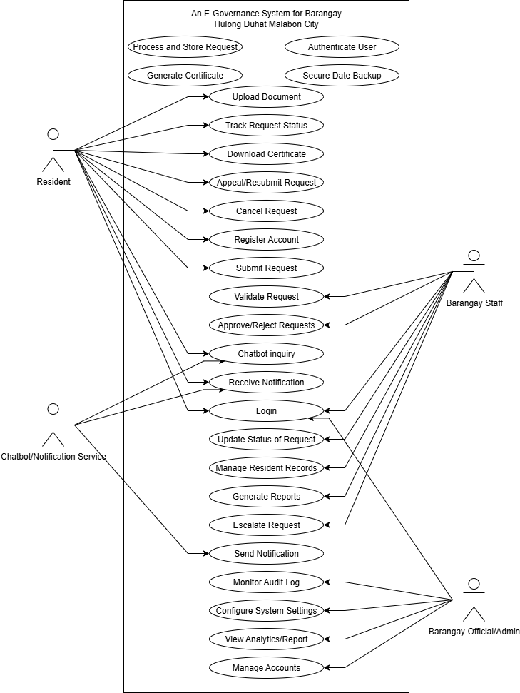
Figure 2 Unified Modeling Language
The Use Case Diagram for the E-Governance System of Barangay Hulong Duhat, Malabon City illustrates how different users interact with the system to perform their respective roles and functions. The diagram highlights four main actors: the Resident, Barangay Staff, Barangay Official or Administrator, and the Chatbot or Notification Service. Each actor has specific interactions that contribute to the overall digitalization of barangay operations and service delivery.
The Resident serves as the primary user of the system, responsible for registering an account, logging in, and submitting various service requests such as certificates and clearances. They can upload supporting documents, track the status of their requests, download certificates once approved, and cancel or appeal requests when necessary. Additionally, residents receive notifications and can communicate with the chatbot for inquiries and assistance, ensuring transparency and accessibility in the process.
The Barangay Staff manages and validates all requests submitted by residents. They are responsible for approving or rejecting requests, updating request statuses, managing resident records, generating reports, and escalating issues to higher officials if needed. On the other hand, the Barangay Official or Administrator oversees the entire system, ensuring data security and efficiency by managing accounts, configuring system settings, monitoring audit logs, and viewing analytics and reports. The Chatbot or Notification Service provides automated responses and real-time updates to users, promoting faster communication. Overall, this use case diagram demonstrates how the system streamlines governance by integrating technology into administrative operations, leading to faster, more organized, and more transparent barangay transactions.

Project Development

Initiation
Release
Review &
Retrospective
Planning
Implementation

Figure 2 Scrum Model

The researchers used the Scrum Model, a specialized framework under the Agile methodology, for the development of the E-Governance System because of its flexible and iterative nature. This framework was selected because of its flexible, iterative, and adaptive nature, which allows continuous collaboration, feedback, and system enhancement throughout the development cycle. Unlike traditional linear approaches, Scrum divides the project into short, time-boxed iterations called sprints, where each sprint delivers a functional system module. This approach ensured that the researchers could test, refine, and improve the system progressively while maintaining close coordination with barangay officials, staff, and residents.
These are the descriptions of the following phases for the development of the E-Governance System using the Scrum Model:
Initiation Phase
In this phase, served as the comprehensive list of all the features and requirements necessary for the development of the E-Governance System. Information was gathered through interviews and consultations with Barangay Hulong Duhat officials, staff, and residents to identify the limitations of their existing manual processes in handling requests, issuing documents, and managing records. From the data collected, the researchers determined the essential features that would make the system efficient, accessible, and user- friendly. These included resident registration, online document requests for clearances and certificates, real-time tracking, chatbot assistance, and automated notifications.
Planning Phase
During this phase, the researchers outlined the overall development strategy and selected the initial features from the Product Backlog to form the Sprint Backlog, which defined the specific modules to be completed within each sprint. The Laravel framework was selected as the primary back-end technology for development because of its robust architecture and security features, which allowed faster and cleaner coding. The front-end of the system was developed using HTML, CSS, and JavaScript to ensure a responsive and user-friendly interface, while Supabase PostgreSQL was integrated for efficient data storage and management. Python was used for the dashboard to provide dynamic analytics and reporting. The team established a Scrum Board with columns labeled To Do, In Progress, Testing, and Completed, allowing continuous tracking of development progress.
Implementation Phase
The implementation phase focused on the actual coding and development of the system based on the tasks defined in the Sprint Backlog. The researchers developed each module in iterative sprints, ensuring that each feature underwent design, development, and testing within its sprint cycle. Laravel’s built-in routing, authentication, and database migration tools were utilized to efficiently manage resident data, service requests, and document generation. The team also conducted Daily Scrum Meetings to discuss progress, identify blockers, and make necessary adjustments. The Sprint Burndown Chart was used to measure work completed against time, allowing the researchers to track productivity and ensure timely completion of sprint goals. Feedback from barangay officials and staff was gathered after every iteration to further improve system usability, efficiency, and design.
Review and Retrospective Phase
In this phase, the researchers conducted a Sprint Review to demonstrate the completed Laravel modules to barangay officials and staff and gather feedback. This included presenting fully functional features such as online document requests, resident record management, and the automated notification system. Any issues or improvement suggestions were documented and added to the Product Backlog for future sprints. After the review, a Sprint Retrospective meeting was held to evaluate team collaboration, time management, and workflow efficiency.

Work Plan of the Study
Table 1 Gantt Chart for the First Semester

ACTIVITIES | AUGUST |  |  |  | SEPTEMBER |  |  |  | OCTOBER |  |  |  | NOVEMBER
Initial Planning | W  1 | W  2 | W  3 | W  4 | W  1 | W  2 | W  3 | W  4 | W  1 | W  2 | W  3 | W  4 | W  1 | W  2 | W  3 | W  4
Project Proposal
Search for the Topic
Title Proposal
Documentation
Chapter 1
Revision for Chapter 1
Research of
related studies
Revision for Research of related studies
Methodology
Revision for Methodology
Defense Preparation
Presentation
Revision for Chapter 1-3

The Gantt Chart presented in Table 1 shows the timeline and sequence of activities conducted by the researchers from August to November for the development of the E-Governance System. It illustrates how each phase of the study was carefully planned and executed week by week to ensure that the project was completed in an organized and timely manner.
During the month of August, the researchers focused on the initial planning, project proposal, and topic selection to establish a clear direction for the study. They also worked on the title proposal and began the documentation process to record the study’s objectives and scope. These early tasks helped set the foundation for the project’s overall development.
In September and October, the researchers concentrated on writing and revising Chapter 1 and the Review of Related Studies, ensuring that all gathered information was accurate and relevant. This period also covered the methodology formulation, which defined the research design and system development process. By late October and early November, the researchers focused on defense preparation, presentation, and revision for Chapters 1 to 3 to finalize the documentation. The Gantt Chart clearly demonstrates the systematic scheduling and progressive workflow followed by the researchers to achieve their project goals efficiently within the allotted timeframe.

Table 2 Gantt Chart for the Second Semester

ACTIVITIES | NOVEMBER |  |  |  | DECEMBER |  |  |  | JANUARY |  |  |  | FEBUARY |  |  |  | MARCH
Initial Planning | W  1 | W2 | W  3 | W  4 | W1 | W2 | W  3 | W  4 | W1 | W2 | W3 | W  4 | W1 | W  2 | W  3 | W  4 | W  1 | W  2 | W  3 | W  4
Planning
Revision of Documents
Design
GUI Layout
Interface Design
Website Design
Database Design
Implementation
Coding
Construct Database
Developing System
Testing
System testing
Debugging
Monitoring

The Gantt Chart presented in Table 2 shows the timeline and sequence of activities conducted by the researchers from November to March for the development of the E-Governance System. It illustrates how each phase of the study was carefully planned and executed week by week to ensure that the project was completed in an organized and timely manner.
During the month of November, the researchers focused on initial planning, which involved identifying the project objectives, scope, and overall direction of the study. This phase served as the foundation of the project and allowed the researchers to establish a clear development plan before proceeding to the technical and documentation stages.
From late November to January, the researchers concentrated on the revision of documents and the design phase of the system. This included preparing and refining the necessary project documentation, as well as developing the GUI layout, interface design, website design, and database design. These activities were essential in ensuring that both the visual appearance and structural framework of the E-Governance System were well-organized and aligned with the intended functions of the project.
During the implementation phase, which extended from late November to March, the researchers worked on the actual development of the system. This stage included coding, database construction, and system development, where the designed features and planned functionalities were transformed into a working portal. The implementation process was carried out progressively to ensure that each component of the system was properly integrated and functional.
In the final stage, from February to March, the researchers focused on testing, system testing, debugging, and monitoring. These activities were conducted to identify and correct errors, evaluate the performance of the system, and ensure that all features operated smoothly and efficiently. This phase was important in improving the reliability, usability, and overall quality of the E-Governance System before its final completion.

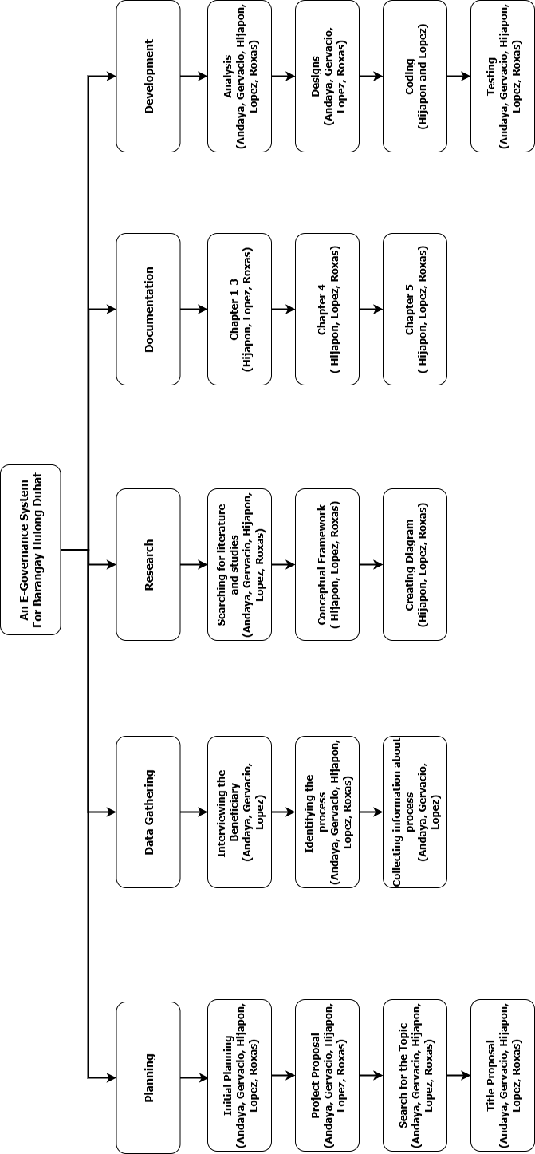

Planning
This is the first stage of the project where the researchers established the main goals, objectives, and direction of the study. During this phase, the team focused on activities such as initial planning, project proposal, searching for the topic, and title proposal. These tasks helped define the scope of the E-Governance System and ensured that the project started with a clear and organized plan. The researchers also discussed the timeline, expected outputs, and individual responsibilities to build a strong foundation for the study.
Data Gathering
In this phase, the researchers focused on collecting the necessary information needed for the development of the system. The activities included interviewing the beneficiary, identifying the process, and collecting information about the existing processes in the barangay. This stage allowed the team to understand the current procedures, challenges, and needs of the barangay officials and residents. The gathered data served as a basis for identifying the system requirements and ensuring that the proposed E-Governance System would address real community concerns effectively.
Research
This phase involved conducting a thorough review of related literature and studies to support the development of the project. The researchers performed searching for literature and studies, developed the conceptual framework, and worked on creating the necessary diagrams for the study. These activities helped strengthen the academic and technical basis of the project by identifying relevant concepts, theories, and similar systems. This phase also ensured that the study was supported by reliable references and a clear framework that guided the overall development process.
Documentation
In this phase, the researchers focused on preparing and organizing the written outputs of the study. The tasks included writing and completing Chapter 1 to Chapter 3, followed by the preparation of Chapter 4 and Chapter 5. This stage ensured that all parts of the research were properly documented, including the introduction, methodology, findings, and conclusions of the project. The documentation served as an essential record of the study, reflecting the progress, structure, and significance of the E-Governance System for Barangay Hulong Duhat.

Development
This phase covered the actual creation and implementation of the E-Governance System. The researchers worked on analysis, designs, coding, and testing to transform the planned concepts into a functional system. During the analysis stage, the team identified the system requirements and user needs. In the design stage, they prepared the layout, structure, and system workflow. The coding stage involved developing the actual features and functionalities of the system, while the testing stage ensured that the system operated correctly, efficiently, and met the intended objectives. This phase was crucial in bringing the project from concept to completion.

Ethical Consideration
The researchers followed ethical rules by protecting the rights and privacy of all users. They complied with the Data Privacy Act of 2012 (RA 10173) to ensure that personal information was handled properly. Before gathering any data, the researchers asked for permission from all respondents and explained the purpose of the study. Participation was voluntary, and respondents could withdraw at any time.
Personal information such as names and addresses was collected only for barangay transactions. Only authorized personnel could access the data, and residents were given the right to view, correct, or delete their information. During system evaluation, the identities of respondents were kept confidential. The system also kept logs to track user activities for accountability.
After the project was complete, the researchers turned over the fully documented system and conducted training for Barangay Hulong Duhat. The researchers kept ownership of the source code, while the barangay owned all data entered into the system. Those steps ensured that the study respected user privacy and followed ethical and legal standards.

Testing and evaluation procedure
- Measurable objectives
In line with the project testing procedure as seen on Table 5, the following criteria are defined to determine if the research objectives are properly measured:

Table 3 Testing Procedure
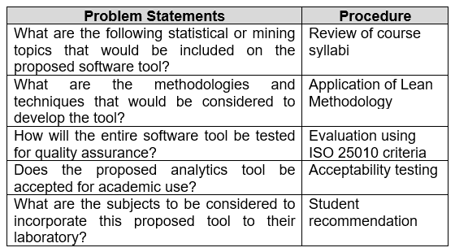
- ISO 25010 standard for software quality assurance
- Functional Suitability - This characteristic represents the degree to which a product or system provides functions that meet stated and implied needs when used under specified conditions. This characteristic is composed of the following sub-characteristics:
  - Functional completeness - Degree to which the set of functions covers all the specified tasks and user objectives.
  - Functional correctness - Degree to which a product or system provides the correct results with the needed degree of precision.
  - Functional appropriateness - Degree to which the functions facilitate the accomplishment of specified tasks and objectives.
- Performance efficiency - This characteristic represents the performance relative to the number of resources used under stated conditions. This characteristic is composed of the following sub-characteristics:
  - Time behavior - Degree to which the response and processing times and throughput rates of a product or system, when performing its functions, meet requirements.
  - Resource utilization - Degree to which the amount and type of resources used by a product or system, when performing its functions, meet requirements.
  - Capacity - Degree to which the maximum limits of a product or system parameter meet requirements.
- Compatibility - Degree to which a product, system or component can exchange information with other products, systems or components, and/or perform its required functions while sharing the same hardware or software environment. This characteristic is composed of the following sub-characteristics:
  - Co-existence - Degree to which a product can perform its required functions efficiently while sharing a common environment and resources with other products without detrimental impact on any other product.
  - Interoperability - Degree to which two or more systems, products or components can exchange information and use the information that has been exchanged.
- Usability - Degree to which a product or system can be used by specified users to achieve specified goals with effectiveness, efficiency and satisfaction in a specified context of use. This characteristic is composed of the following sub-characteristics:
  - Appropriateness recognizability - Degree to which users can recognize whether a product or system is appropriate for their needs.
  - Learnability - Degree to which a product or system can be used by specified users to achieve specified goals of learning to use the product or system with effectiveness, efficiency, freedom from risk and satisfaction in a specified context of use.
  - Operability - Degree to which a product or system has attributes that make it easy to operate and control.
  - User error protection - Degree to which a system protects users against making errors.
  - User interface aesthetics - Degree to which a user interface enables pleasing and satisfying interaction for the user.
  - Accessibility - Degree to which a product or system can be used by people with the widest range of characteristics and capabilities to achieve a specified goal in a specified context of use.
- Reliability - Degree to which a system, product or component performs specified functions under specified conditions for a specified period of time. This characteristic is composed of the following sub-characteristics:
  - Maturity - Degree to which a system, product or component meets needs for reliability under normal operation.
  - Availability - Degree to which a system, product or component is operational and accessible when required for use.
  - Fault tolerance - Degree to which a system, product or component operates as intended despite the presence of hardware or software faults.
  - Recoverability - Degree to which, in the event of an interruption or a failure, a product or system can recover the data directly affected and re-establish the desired state of the system.
- Statistical treatment of data
The data gathered from the respondents through surveys and system evaluation were statistically treated to determine the level of acceptability of the developed E-Governance System. The researchers used descriptive statistics, particularly the weighted mean, to interpret the responses based on the five-point Likert Scale shown in Table 4. This method was used to measure the overall perception of the respondents in terms of functionality, usability, reliability, and performance efficiency of the system.
The formula used for computing the weighted mean is:

(12)
Where:
- f = frequency of responses
- w = weighted value assigned to each response
- N = total number of responses
The computed weighted mean for each criterion was then interpreted according to the scale in Table 4 to determine whether the system met the standards of ISO 25010 and the expectations of the end-users.

Table 4 Likert's Scale
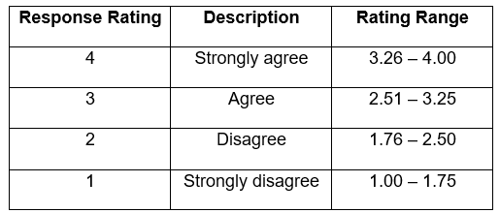

- Types of respondents
The respondents of the study were selected from individuals directly involved in the operation and use of the barangay system. They were chosen using purposive sampling to ensure that the feedback gathered is relevant to the system’s intended users. The respondents were divided into three groups as follows:
- Barangay Officials – These include the Barangay Captain, Secretary, Treasurer, and other key administrative personnel. They are responsible for verifying, approving, and managing various records and transactions in the barangay. Their evaluation focused on the functionality, reliability, and efficiency of the system in streamlining daily administrative processes.
- Barangay Staff and Encoders – These respondents are the primary users who encode, manage, and retrieve resident records and reports. Their feedback centered on usability, learnability, and operability, as they interact with the system’s interface and perform day-to-day tasks using the developed application.
- Residents / End Users– These respondents represent the citizens of Barangay Hulo who use the system to request barangay clearances, certificates, and other services online. Their evaluation focused on the user-friendliness, accessibility, and satisfaction provided by the system during transactions.

System requirements
The system requirements describe the minimum and recommended hardware and software components needed to properly develop, deploy, and operate the proposed E-Governance System for Barangay Hulong Duhat. These requirements ensure that the system performs efficiently, securely processes data, and supports the operational needs of the barangay staff and administrators.

Hardware requirements
The hardware requirements include the necessary server infrastructure and client workstations needed to run the system effectively. The server hardware handles the application processing, database management, and analytics modules, while the client workstations allow barangay personnel to access and manage the system through a web browser.
Table 5 Server Hardware (Minimum)
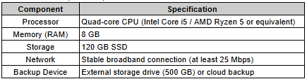
The minimum server hardware requirements represent the baseline specifications needed to deploy and operate the system in a functional environment. These specifications are suitable for small-scale implementation, testing, and initial deployment where the number of concurrent users is limited.
Table 6 Server Hardware (Minimum)
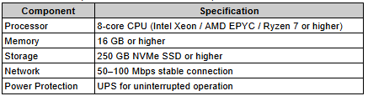
The recommended server hardware specifications are intended for full-scale production deployment of the system. These requirements provide better performance, improved scalability, and greater reliability, especially when handling larger volumes of data, multiple simultaneous users, and continuous system availability.
Table 7 Client Workstation (Barangay Staff/Admin)
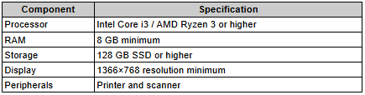
The client workstation requirements refer to the computers used by barangay staff and administrators to access the system through a web browser. These workstations should be capable of running modern browsers smoothly and supporting routine administrative tasks such as encoding records, generating reports, printing documents, and scanning attachments.

Software requirements
The software requirements consist of the operating systems, development frameworks, runtime environments, and supporting tools required to deploy and maintain the E-Governance System. These components ensure compatibility, security, and efficient performance of the web-based platform.
Server Software
The server software requirements refer to the core technologies needed to host, execute, and maintain the application on the server. These components include the operating system, web server, application framework, database management system, and supporting runtime environments used for backend processing and analytics.
- Operating System: Ubuntu 22.04 LTS (recommended) or Windows Server 2019/2022
- Web Server: Nginx or Apache
- PHP: Version 8.2 or higher
- Framework: Laravel 12
- Database Management System: PostgreSQL 14+ (recommended PostgreSQL 15/16)
- Package Manager: Composer 2.x
- Frontend Build Tools: Node.js 20 LTS or 22 LTS, NPM 10+
- Python Runtime: Python 3.10+ (for analytics modules)
Required PHP Extensions
The required PHP extensions are additional modules that enable the Laravel-based system to perform essential functions such as database connectivity, file processing, encryption, internationalization, and generation of reports or media assets. These extensions must be installed and enabled on the server to ensure proper system functionality.
- bcmath
- ctype
- curl
- dom
- fileinfo
- intl
- json
- mbstring
- openssl
- pdo
- pdo_pgsql
- tokenizer
- xml
- zip
- gd

Client Software
The client software requirements refer to the applications needed by end-users and barangay staff to access and interact with the system. Since the proposed platform is web-based, users primarily require a modern web browser and optional productivity tools for viewing and managing exported reports and generated documents.
- Web Browser: Latest Google Chrome, Microsoft Edge, Mozilla Firefox, or Safari
- PDF Viewer: Built-in browser PDF support
- Office tools (optional) for report exports and documentation
Operational / Deployment Requirements
The operational and deployment requirements refer to the additional configurations and services needed to ensure secure, stable, and reliable production use of the system. These requirements support background task processing, secure communication, automated maintenance, and accurate timestamp handling in accordance with the local deployment environment.
- HTTPS / SSL Certificate for secure communication
- Cron Scheduler for automated Laravel tasks
- Queue Worker Service for background processing
- Daily automated backups and log rotation
- Time zone configured to Asia/Manila

REFERENCES

A Risk Assessment of a Barangay Management System Portal: A case study. (2024, February 1). IEEE Conference Publication | IEEE Xplore. https://ieeexplore.ieee.org/abstract/document/10579921

B-GIS: Modernizing Local Governance through a Web-Based Barangay Geographic Information System for Barangay 99, Tondo, Manila. (2024, December 17). IEEE Conference Publication | IEEE Xplore. https://ieeexplore.ieee.org/abstract/document/10912845

Cuevas, J. A. A. (2024). Enhancing the Barangay Information System by Integrating Geolocation Technology and Tagalog Chatbot using NLP Algorithm for Efficient Community Engagement and Service. Journal of Electrical Systems, 20(5s), 1136–1149. https://doi.org/10.52783/jes.2426

Eduardo Junio Andaya, R. J. G. O., & Ilustre, R. G. (2025). Digital governance in the Philippines: a scoping review of current challenges and opportunities. Global Sustainability Research, 4(1), 89–111. https://doi.org/10.56556/gssr.v4i1.1204

Development and implementation of an office automation system for Barangay local government units. (2023, May 26). IEEE Conference Publication | IEEE Xplore. https://ieeexplore.ieee.org/abstract/document/10170650

Garcia, A. R., Filipe, S. B., Fernandes, C., Estevão, C., & Ramos, G. (n.d.). Enhancing Barangay Justice System through the Development of a Web-Based Crime Monitoring Module. 1–18.

Garon, J., Christian, M., Relox, T., Dorine, G., Mariñas, K., Therese, M. E., Velasco, C. S., Legaspi, J., Benedict, C., & Lalata, J.-A. P. (n.d.). oneBarangay: An e-Government System for Online Transaction Processing of Barangay Malanday Main Office through Web and Mobile Application with Implementation of OCR Technologies.

Jacobe, B., Pascua, M. L., Tumbali, B. J., Aquino, M. C., & Gumabay, M. V. (2021). Barangay Profiling System with Analytics. International Journal of Advanced Trends in Computer Science and Engineering, 10(4), 2697–2700. https://doi.org/10.30534/ijatcse/2021/071042021

Jholan, M., Ballaran, G., Joven, M., Donaire, M., Singzon, R. M., Naz, M., Tanael, D. V., & Centeno, C. J. (2023). Development and evaluation of web-based barangay profiling and issuance system using regression analysis.
Joyce, C., Balilia, M., Alheizen, J., Acoba, A., Pagulayan, L. I., Mebaña, J.-E. C., Ann, L., & Cruz, D. (2020). Windows-Based Information Management System With Project Monitoring for Barangay. EnRB Engineering Research Bulletin, XXX(No. X(Xxx)), 69–78. www.urdc.usl.edu.ph

Melendres, U. M., & Aranda, K. M. (2024). Development and Evaluation of a Web-Based Resident Information Management System. Journal of Computer, Software, and Program, 1(1), 14–22. https://doi.org/10.69739/jcsp.v1i1.50

Mo, H., & Beh, L. S. (2025). From Expectation and Participation to Satisfaction: The Moderating Role of Perceived Government Responsiveness in Digital Government. Administrative Sciences, 15(9), 1–21. https://doi.org/10.3390/admsci15090364

One barangay: a mobile and web barangay management system. (2022, December 1). IEEE Conference Publication | IEEE Xplore. https://ieeexplore.ieee.org/abstract/document/10071652

Padilla, A. T. (2024). Enhancing Local Governance in Surigao del Norte through Barangay Connect: A total Management Information System for Barangays. Journal of Information Systems Engineering and Management, 2025(27s), 2468–4376. https://www.jisem-journal.com/
Sabani, A., Thai, V., & Hossain, M. A. (2023). Factors Affecting Citizen Adoption of E-Government in Developing Countries: An Exploratory Case Study From Indonesia. Journal of Global Information Management, 31(1), 1–23. https://doi.org/10.4018/JGIM.318131

Senaris, E. J. S. (2023). Implementation of Barangay Management System: An Extension Service of CvSU-Tanza Campus. International Journal of Research in Education Humanities and Commerce, 04(04), 222–230. www.ijrehc.com

Szedmák, B., Varga, L., & Szabó, R. Z. (2025). Digital Transformation of Public Services: The Case of the Document Management Application. International Journal of Public Administration, 00(00), 1–18. https://doi.org/10.1080/01900692.2025.2520522

T. Aliling, J., Santa Ana, B. B., & Soberano, K. T., PhD. (2025). Digitalizing Governance: A Transformation on the Processes of One Community in the Philippines. International Journal of Multidisciplinary Research and Analysis, 08(06), 3620–3625. https://doi.org/10.47191/ijmra/v8-i06-68

Taruc, F. S., Martin, T. A. S., Olipas, C. N. P., & Alegado, R. T. (2023). Docu-Go: The Development and Assessment of a Web-Based Barangay Document Requesting System. International Journal of Information Technology and Computer Engineering, 34, 40–49. https://doi.org/10.55529/ijitc.34.40.49

