**Session 8**

**Depth Perception and Applications in Robotics**

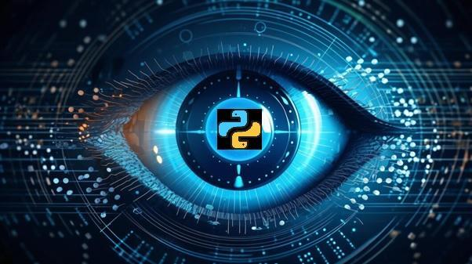

This session explains the intricacies of depth perception, It elucidates the role of depth perception in robotics. Further, it explores a myriad of applications.

**Objectives**

* Explain the basics of stereo vision for depth perception
* Describe Light Detection and Ranging (LiDAR) technology and its role in depth sensing
* Describe the concept of depth perception and its applications in robotics
* Explain the fundamentals of point clouds
* Illustrate processing, analysis, filtering, segmentation techniques, and feature extraction from point clouds
* Explain the integration of depth perception in robotics
* Illustrate challenges and future developments in applying depth perception to autonomous vehicles

**8.1 Principles of Stereo Vision and LiDAR**

Stereo Vision and LiDAR are two techniques that are used by modern robotics to visually sense the world. These two technologies are getting popularity in the modern world as they can sense the real-time scenarios.

**8.1.1 Basics of Stereo Vision**

Stereo vision, also known as stereopsis, is a technique used in computer vision and robotics that mimics human binocular vision. It involves capturing and processing images from two or more cameras to perceive depth and create a three-dimensional (3D) representation of the environment.

The working principle of stereo vision includes:

**Stereo Image Pair**

Stereo vision requires at least two cameras placed at different positions, capturing images simultaneously. The images obtained from these cameras create a stereo image pair.

**Disparity Map**

Disparity refers to the pixel-level differences between the images in the stereo pair. By calculating the disparity, the depth information can be derived.

**Depth Perception**

The brain processes the pixel disparities to perceive depth, similar to how human eyes create depth perception.

Applications of stereo vision are as follows:

**Obstacle Avoidance**:Robots use stereo vision to detect obstacles and navigate around them.

**Object Recognition:** Stereo vision aids in recognizing and localizing objects in the environment.

**3D Mapping**: It contributes to the creation of accurate 3D maps for robotic navigation.

**Stereo Correspondence and Disparity**:

Stereo vision involves capturing a scene from two or more vantage points to simulate human binocular vision. The process of stereo correspondence aims to match corresponding points in the images from different viewpoints, establishing a correspondence map. Disparity, the pixel-wise difference between the positions of corresponding points, is computed to perceive depth information.

**Depth Map Generation**:

By analyzing the computed disparities, a depth map is generated, representing the distances of objects within the scene. This depth information is crucial for applications such as 3D reconstruction, object detection, and autonomous navigation, making stereo vision a fundamental technique in computer vision.

**8.1.2 LiDAR Technology**

LiDAR, which stands for Light Detection and Ranging, is a remote sensing technology that uses laser light to measure distances. In robotics, LiDAR is employed for precise depth sensing and environmental mapping.

**Working Principles of LiDAR**: The working principles of LiDAR include:

**Laser Emission**:LiDAR systems emit laser beams toward the surroundings.

**Time-of-Flight Measurement**: The system measures the time it takes for the emitted laser pulses to return after hitting an object. Based on the time-of-flight, the distance to the object is calculated.

**360-Degree Scanning**:LiDAR sensors often rotate or use multiple lasers to scan the environment from all directions.

Applications of LiDAR are as follows:

LiDAR is a key technology for self-driving cars, providing real-time 3D mapping for navigation.

**Autonomous Vehicles**

Used for creating high-resolution topographic maps and surveying terrains.

**Surveying and Mapping**

LiDAR aids in monitoring and assessing changes in vegetation, terrain, and infrastructure.

**Environmental Monitoring**

**Point Cloud Generation from LiDAR**:

LiDAR technology generates a point cloud, a collection of 3D points representing the surfaces of objects in the scanned area. Each point in the cloud corresponds to a location in physical space, providing a comprehensive and accurate representation. Point clouds from LiDAR find applications in fields such as autonomous vehicles, forestry, urban planning, and archaeology.

LiDAR are verry sophisticated and requrires specialized equipment the developer will generate a random data using numpy library.

In the LiDAR data generation, the developer can use the open3d library of Python to render the point cloud and see how the point cloud looks.

To install all the necessary packages, use this command in the command line:

|  |
| --- |
| pip install open3d |

Code Snippet 1 shows how to LiDAR is used in Python.

**Code Snippet 1:**

|  |
| --- |
| import open3d as o3d  import numpy as np  # Generate a simulated point cloud  num_points = 1000  points = np.random.rand(num_points, 3) * 10 # Random 3D points in a 10x10x10 cube  # Create a PointCloud object  lidar_cloud = o3d.geometry.PointCloud()  lidar_cloud.points = o3d.utility.Vector3dVector(points)  # Visualize the point cloud  o3d.visualization.draw_geometries([lidar_cloud]) |

In code snippet 1 the developer is using the open3d library generates a simulated LiDAR point cloud. It creates a random 3D point cloud with 1000 points, where each point's coordinates are generated within a 10x10x10 cube. The code then creates an open3d PointCloud object and assigns the generated points to it. Finally, it visualizes the simulated LiDAR point cloud using the draw_geometries function. It's important to note that the random points simulate LiDAR data but do not represent real-world LiDAR measurements; actual LiDAR data would be obtained from a LiDAR sensor scanning the environment.

Figure 8.1 shows the visualisation of data generated by code snippet 1.

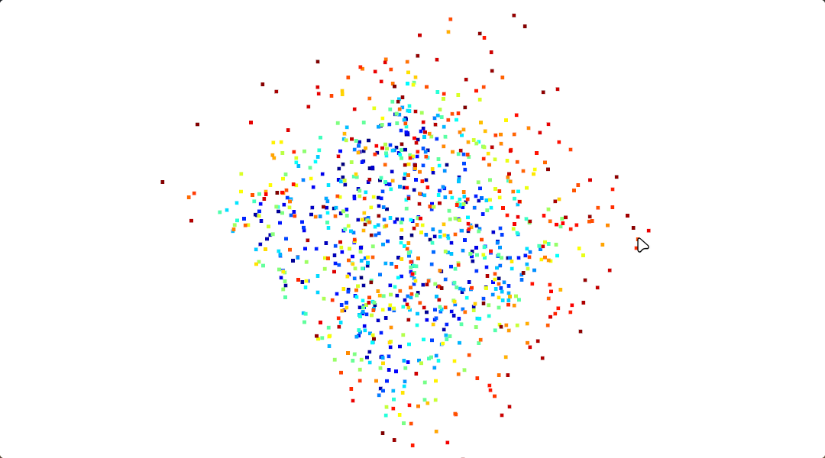**Figure 8.1: Rendered Point Cloud LiDAR Data Generated by Code Snippet 1**

The output is a real-time 3D visualization of a simulated LiDAR point cloud, allowing users to interactively explore and analyze the randomly generated 3D points within the specified cube using computer graphics tools and libraries like open3d. This interactive capability enables dynamic manipulation and examination of LiDAR data for various applications.

**8.2 Depth Perception Techniques**

Depth perception is a cornerstone in robotics, unlocking the spatial dimension for machines to interpret and navigate their environment. There are various techniques employed for depth perception, shedding light on their principles and applications in the realm of robotics.

**8.2.1 Understanding Depth Perception**

Depth perception, the ability to perceive the world in three dimensions, is a cognitive marvel that robots strive to emulate. By comprehending the spatial relationships and distances between objects, robots equipped with depth perception capabilities can navigate, interact, and function more effectively.

Techniques for depth perception include:

Utilizes the slight disparities between images captured by two or more cameras to calculate depth.

**Stereo Vision**

Depth cues perceived with a single camera, including:

**Size Disparity**: Objects of known size appear smaller when farther away.

**Overlap (Occlusion)**: Objects in front can partially or fully cover those behind them.

**Linear Perspective**: Parallel lines converge as they extend into the distance.

**Monocular Cues**

Observing the relative motion of objects at different distances to estimate their depth.

**Motion Parallax**

Utilizing the eye's ability to adjust focus based on the distance of an object.

**Focus Cues**

**Monocular and Binocular Depth Cues**:

Depth perception relies on various cues, including monocular cues observed with one eye and binocular cues based on the convergence of both eyes. Monocular cues, such as relative size, interposition, and linear perspective, provide depth information with a single viewpoint. Binocular cues, such as retinal disparity and convergence, leverage the slight differences in the images seen by each eye, enabling the brain to perceive depth.

**Role of Perspective in Depth Perception**:

Perspective plays a crucial role in depth perception. Objects appear smaller as they move farther away, and parallel lines converge toward a vanishing point. The comprehension of these perspective cues helps the brain interpret spatial relationships, contributing to an accurate perception of depth in a visual scene.

**8.2.2 Applications in Robotics**

In the realm of robotics, the application of point cloud processing extends to enhancing perception capabilities. By leveraging feature extraction from point clouds, robots can discern and interact with objects more intelligently, facilitating tasks such as precise manipulation, object recognition, and navigation in dynamic environments. This heightened perception contributes to the overall efficiency and adaptability of robotic systems in diverse applications, from manufacturing and logistics to autonomous vehicles and assistive robotics.

**Applications of Depth Perception in Real-world Robotics**: Applications in robotics include:

**Obstacle Avoidance**:Robots use depth perception to detect obstacles and plan collision-free paths.

**Object Recognition and Manipulation**: Enables robots to recognize objects in their environment and manipulate them with accuracy.

**Autonomous Navigation**: Vital for autonomous vehicles and drones to navigate through dynamic and varied terrains.

**Human-Robot Interaction**: Depth perception enhances the robot's ability to interact with humans by comprehending their gestures and positions.

**Surveillance and Security**: Depth perception aids in monitoring and tracking objects or individuals within a given space.

The comprehension of depth perception is fundamental for robots to operate effectively and safely in real-world scenarios, making it a crucial aspect of robotic systems design and implementation.

**Robotics Navigation and Obstacle Avoidance**: The importance of robotics include:

**Navigation**: Helps robots navigate through complex environments, avoiding obstacles and planning efficient paths.

**Object Manipulation**: Enables robots to grasp and manipulate objects with precision.

**Environment Understanding**:Enhances a robot's ability to interpret and interact with its surroundings.

**8.3 Point Cloud Processing Basics**

Point clouds serve as a rich source of spatial information, capturing the intricate details of a physical environment. The fundamental aspects of point cloud processing are explored from their introduction to the techniques used for analysis and feature extraction.

**8.3.1 Introduction to Point Clouds**

Point clouds are 3D representations of surfaces, constructed by collecting a multitude of points in space. These points, often obtained through technologies such as LiDAR or stereo vision, collectively create a detailed map of an object or environment.

**Characteristics**: Characteristics of point clouds include:

Each point in the cloud is defined by its X, Y, and Z coordinates in the 3D space.

**XYZ Coordinates**

The density of points determines the level of detail in the representation, with higher densities capturing finer features.

**Density**

Point clouds include additional information such as color or intensity, enhancing the visual representation.

**Color and Intensity**

To download the point cloud file, download **airplane.ply** and save it into current working directory from the course files.

Code Snippet 2 demonstrates the rendering of the point cloud using the Open 3d library.

**Code Snippet 2**:

|  |
| --- |
| import numpy as np  import open3d as o3d  print("Load a ply point cloud, print it, and render it")  ply_point_cloud = './airplane.ply'  pcd = o3d.io.read_point_cloud(ply_point_cloud)  print(pcd)  print(np.asarray(pcd.points))  o3d.visualization.draw_geometries([pcd]) |

In Code Snippet 2, the developer utilizes the Open3D library to load a 3D point cloud from a PLY file named 'airplane.ply'. It prints information about the point cloud object, including its geometry details, and displays the coordinates of the points as a NumPy array. Finally, it visualizes the point cloud using the draw_geometries function from Open3D, providing an interactive 3D rendering of the loaded point cloud. Figure 8.1 shows the output of Code Snippet 2 rendered ply file. Figure 8.2 shows the output of Code Snippet 2.

**Figure 8.1**: **Output of Code Snippet 2 Rendered Ply File**

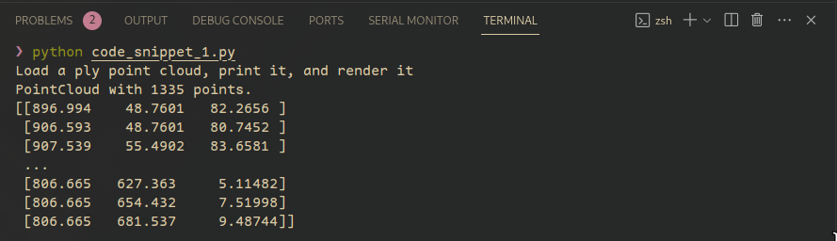

**Figure 8.2**: **Output of Code Snippet 2**

The output consists of three parts: Firstly, it confirms the successful loading of a point cloud with 1335 points. Secondly, it prints a snippet of the point coordinates as a NumPy array, illustrating the spatial distribution. Lastly, a separate window opens, visually presenting an interactive 3D rendering of the loaded point cloud, enabling exploration of its geometry as shown in Figure 8.1.

**8.3.2 Processing and Analysis**

The processing and analysis of point clouds involve intricate techniques to derive meaningful insights from the voluminous 3D data. These steps encompass tasks such as filtering, segmentation, and feature extraction, enabling a comprehensive understanding of spatial structures, object relationships, and environmental characteristics. The combination of these processes lays the foundation for applications spanning robotics, autonomous systems, urban planning, and various domains reliant on detailed 3D scene interpretation. To use point cloud effectively, it has to be processed and analyzed.

Processing Steps of the point cloud include:

**Data Acquisition**: Obtain point cloud data through sensors such as LiDAR or stereo cameras.

**Registration**: Align multiple point clouds into a common coordinate system for comprehensive mapping.

**Downsampling**: Reduce data size by removing redundant points while preserving essential details.

Normalization: Normalize point cloud data for consistent scales and orientation.

Analysis techniques of point cloud include:

Reconstructing surfaces from point cloud data for a comprehensive 3D model.

**Surface Reconstruction**

Identifying and categorizing objects within the point cloud.

**Object Recognition**

Analyzing differences between multiple point cloud captures to identify changes in the environment.

**Change Detection**

All the **.ply** files are downloaded from course files.

Code Snippet 3 shows how to analyze a point cloud file by doing surface reconstruction, object recognition and change detection on **apple.ply.**

**Code Snippet 3:**

|  |
| --- |
| import open3d as o3d  import numpy as np  # Load the first PLY file  ply_file_1 = "./apple.ply"  point_cloud_1 = o3d.io.read_point_cloud(ply_file_1)  alpha = 0.1  print(f"alpha={alpha:.3f}")  mesh = o3d.geometry.TriangleMesh.create_from_point_cloud_alpha_shape(point_cloud_1, alpha)  mesh.compute_vertex_normals()  o3d.visualization.draw_geometries([mesh], mesh_show_back_face=True) |

In code snippet 3 the developer is utilizing the Open3D library, performs alpha shape reconstruction on a 3D point cloud sourced from a PLY file (e.g., **‘./apple.ply’**). Initially, the code loads the point cloud using o3d.io.read_point_cloud and visualizes it. Subsequently, an alpha value of 0.030 is set to influence the concavity of the reconstructed mesh. The create_from_point_cloud_alpha_shape method generates a triangle mesh based on the alpha shape reconstruction, and vertex normals are computed for visual enhancement. The final step involves visualizing the reconstructed mesh, with both front and back faces shown, providing insights into the quality and structure of the reconstructed 3D model. This way develop can recognize the object and finally a whole rendered image can also give insight into the change it has been made.

Figure 8.3 shows the point cloud without any mesh.

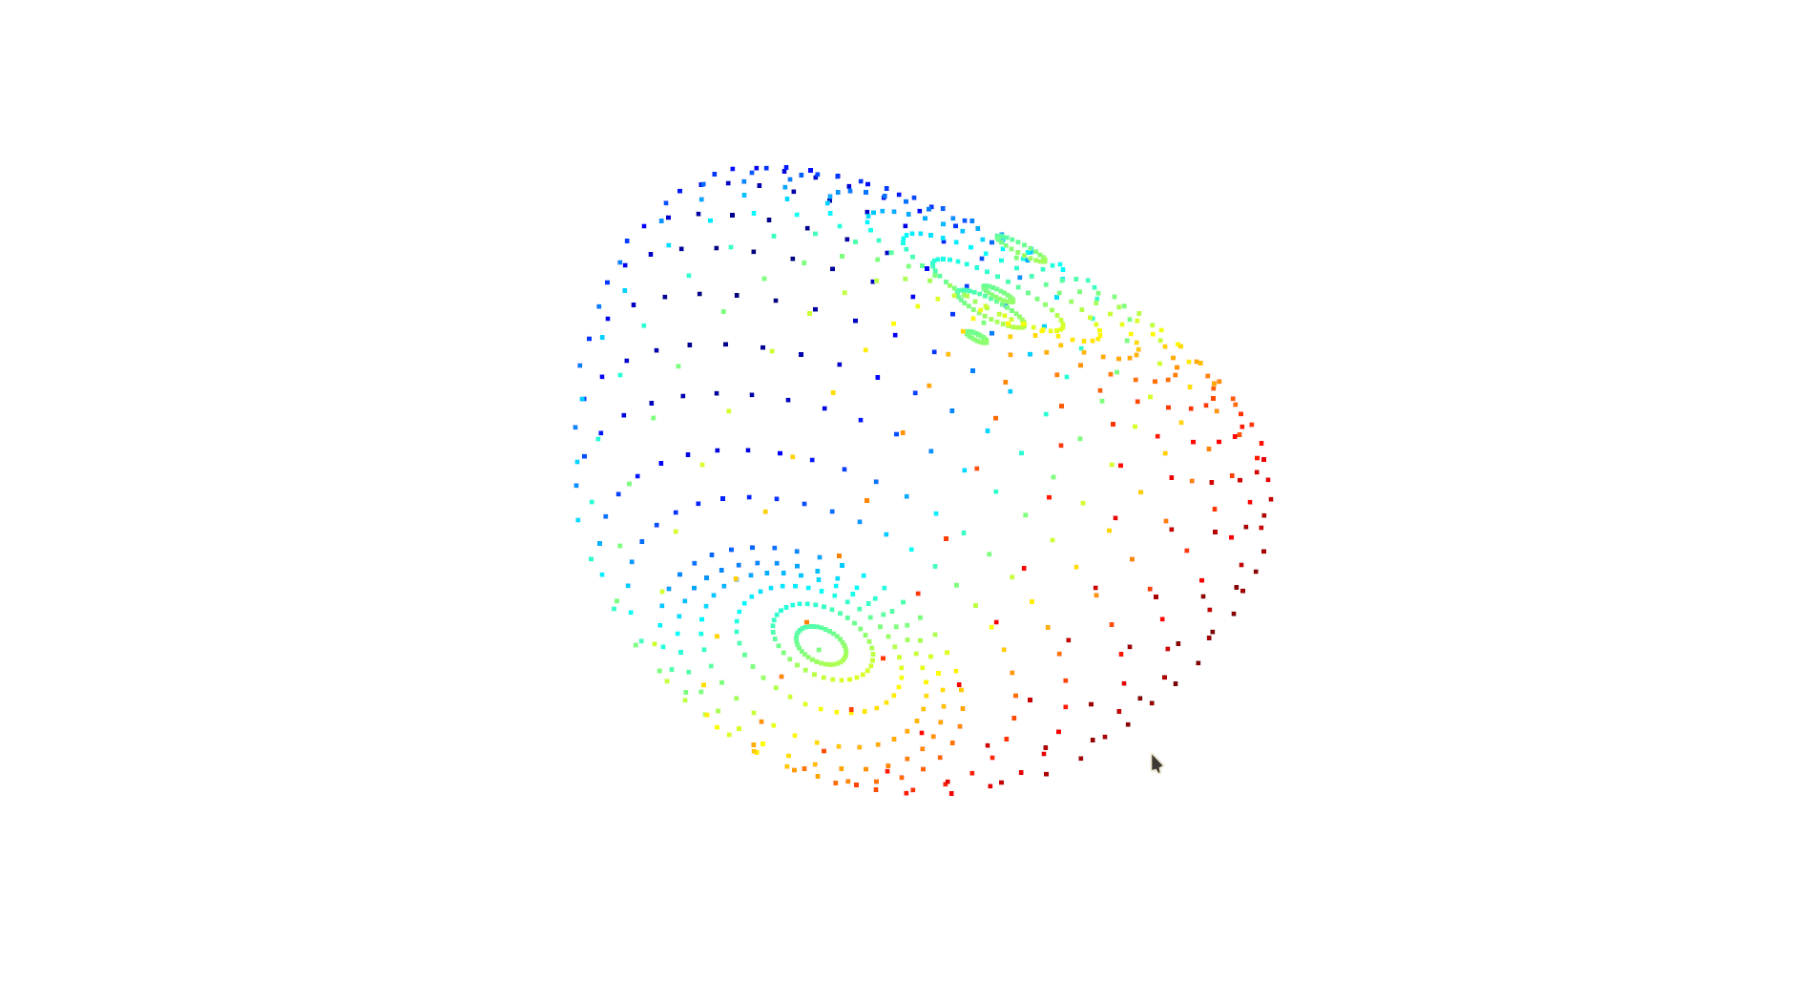

**Figure 8.3: Apple point cloud without mesh generated by Code Snippet 3**

Figure 8.4 shows the point cloud with mesh to recreate the shape it could have hold.

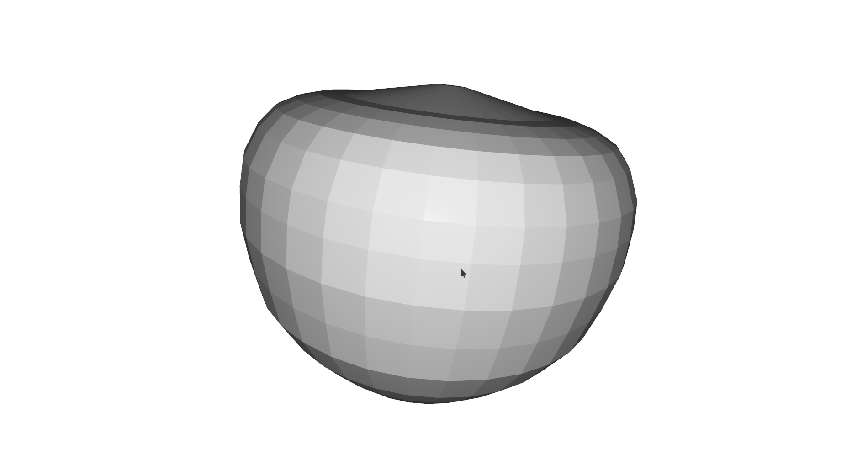

**Figure 8.4: Apply Point Cloud with Mesh Generated by Code Snippet 3**

In both rendered images, the second one is obviously better because it can help the developer to get the idea of what point cloud he is dealing with.

**8.3.3 Filtering and Segmentation Techniques**

The filtering and segmentation techniques are important steps before any data is processed in real life. As video and image data is such a large dataset these techniques become even more important.

**Filtering**: This technique includes:

**Noise Removal:** Eliminate outliers and sensor-generated noise for cleaner data.

**Smoothing**: Apply filters to reduce irregularities and create a smoother representation.

**Segmentation**: This technique includes:

**Region Growing**: Identify connected regions with similar properties.

**Plane Segmentation**: Separate point clouds into distinct planes, aiding in surface analysis.

**Statistical Outlier Removal**:

This technique identifies and removes outliers in the point cloud based on statistical measures, ensuring the accuracy of the data by eliminating anomalies.

**Voxel Grid Downsampling**:

Voxel grid downsampling involves dividing the point cloud into voxel grids and retaining a single point per grid, reducing the overall density and preserving key features.

**Pass-Through Filtering**:

Pass-through filtering sets limits along specified axes to filter out points outside a defined range, focusing on a particular region of interest.

**Radial Basis Function (RBF) Smoothing**:

RBF smoothing applies mathematical functions to interpolate point values, producing a smoother representation of the point cloud.

**Euclidean Clustering**:

Euclidean clustering groups nearby points based on their spatial proximity, aiding in the identification of distinct objects or surfaces.

**Region Growing**:

Region growing identifies connected regions in the point cloud, facilitating the segmentation of surfaces or objects with similar properties.

**Connected Components Labeling**:

Connected components labeling assigns labels to connected groups of points, aiding in the identification and differentiation of separate structures.

**Planar Segmentation**:

Planar segmentation extracts planar surfaces from the point cloud, providing information about flat structures within the environment.

Different scenarios requires different Filtering Techniques according to their strength and weakness. The developer will work with a common techniques to fillter and sement data. In this example the developer will be using a simple file which is already pretty small so difference can not be very discering until it is observed carefully.

Code Snippet 4 shows how to do Voxel Grid Downsampling on a **apple.ply** file which can be downloaded from course files.

**Code Snippet 4:**

|  |
| --- |
| import open3d as o3d  import numpy as np  # Load point cloud  pcd = o3d.io.read_point_cloud('./apple.ply')  # Voxel Grid Downsampling  voxel_size = 0.05  pcd_downsampled = pcd.voxel_down_sample(voxel_size)  o3d.visualization.draw_geometries([pcd_downsampled]) |

In code snippet 4 the developer utilizes the open3d library to process and visualize a 3D point cloud. It begins by loading a point cloud from a specified PCD file. Subsequently, it performs voxel grid downsampling on the loaded point cloud, reducing its density based on a specified voxel size. The downsampling process creates a downsampled version of the point cloud (`pcd_downsampled`). Both PCD are rendered one by one first the orignial and then the second downsampled one. Figure 8.5 shows the orignial **apple.ply** without any downsampling done to it.

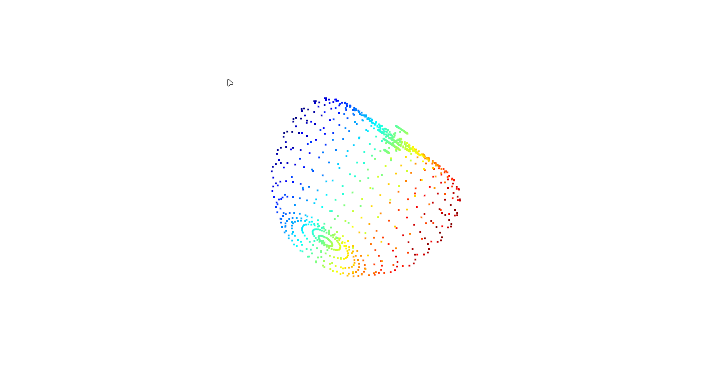**Figure 8.5: Orignial File Rendered by Code Snippet 4**

Figure 8.6 shows the downsample file done by Voxel Grid Downsampling technique.

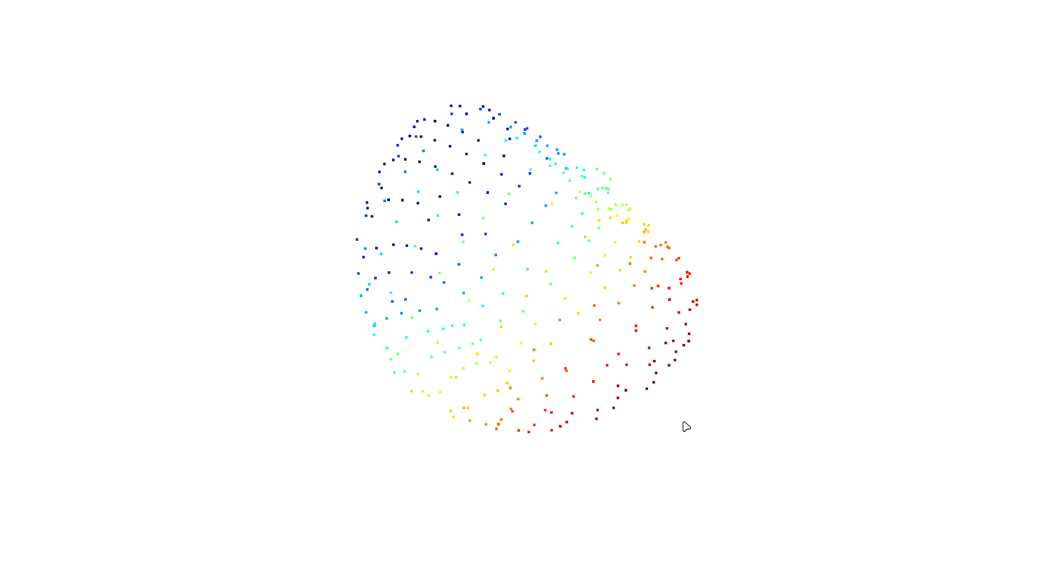**Figure 8.6: Downsampled File Rendered by Code Snippet 4**

The developer can clrearly see that one is more detailed compared to the downsampled file. The second one contains less data but it is more easy and fast to use by computers. As the sample file is already pretty small in real world data this will give pretty much boost the computer needs to do task faster on these datas.

**8.3.4 Feature Extraction from Point Clouds**

Feature extraction from point clouds involves identifying distinctive characteristics within the 3D data that contribute to a richer comprehension of the environment. These features can include edges, corners, key points, or other salient points that provide valuable information for subsequent analysis. The meaningful extraction of features is crucial for tasks such as object recognition, scene understanding, and generating descriptors that capture the unique attributes of structures within the point cloud.

Features from point clouds include:

**Curvature**: Identify regions with varying surface curvatures.

**Edges and Corners**: Detect sharp changes in the point cloud, indicating edges or corners.

**Descriptors**:Extract unique characteristics for object recognition.

The developer will extract curvature and edges from a sample **ply** file which can be downloaded from the course files.

Code snippet 5 shows how to extract from point cloud.

**Code Snippet 5:**

|  |
| --- |
| import copy  import numpy as np  import open3d as o3d  # Load a point cloud from a file  point_cloud = o3d.io.read_point_cloud("./ant.ply")  # Compute curvature  def calculate_surface_curvature(pcd, radius=0.1, max_nn=30):  pcd_n = copy.deepcopy(pcd)  pcd_n.estimate_covariances(  search_param=o3d.geometry.KDTreeSearchParamHybrid(radius=radius, max_nn=max_nn)  )  covs = np.asarray(pcd_n.covariances)  vals, vecs = np.linalg.eig(covs)  curvature = np.min(vals, axis=1) / np.sum(vals, axis=1)  return curvature  curvature = calculate_surface_curvature(point_cloud)  # Compute edges  def calcuate_edges_and_line_set(pcd, radius=0.02):  point_cloud.estimate_normals()  # Create a KDTree for efficient nearest neighbor search  kdtree = o3d.geometry.KDTreeFlann(point_cloud)  # Set the radius for edge computation  radius = 0.02  # List to store lines (edges)  edges = []  # Iterate through each point in the point cloud  for i in range(len(point_cloud.points)):  # Find neighbors within the specified radius  [k, idx, _] = kdtree.search_radius_vector_3d(point_cloud.points[i], radius)  # Connect the current point to its neighbors with lines  for j in range(1, len(idx)):  edges.append([i, idx[j]])  # Create a LineSet for visualization  line_set = o3d.geometry.LineSet(  points=o3d.utility.Vector3dVector(np.asarray(point_cloud.points)),  lines=o3d.utility.Vector2iVector(edges),  )  return edges, line_set  edges, line_set = calcuate_edges_and_line_set(point_cloud)  print(edges, curvature)  # Display the results (visualization)  o3d.visualization.draw_geometries([point_cloud]) |

This Python script utilizes the Open3D (o3d) library to process a point cloud loaded from a PLY file. Let's break down the code:

1. **Loading Point Cloud:**

The script begins by loading a point cloud from a PLY file using `o3d.io.read_point_cloud`. The `./ant.ply` file contains the 3D coordinates of points in space, representing the geometry of an object.

2. **Curvature Computation:**

The `calculate_surface_curvature` function is defined to compute the surface curvature of the point cloud. It uses the `estimate_covariances` method to estimate the covariance matrices for each point's neighbors, and subsequently calculates the eigenvalues. The curvature is then computed as the ratio of the minimum eigenvalue to the sum of all eigenvalues.

3. **Edge Computation and Visualization:**

The `calcuate_edges_and_line_set` function is defined to compute edges within the point cloud. It estimates normals using `estimate_normals` and employs a KDTree for efficient nearest neighbor search. The script then iterates through each point, finding neighbors within a specified radius and connecting them with lines, resulting in a list of edges. The function returns both the edges and an `o3d.geometry.LineSet` for visualization.

4. **Displaying Results:**

The script prints the computed edges and curvature values and visualizes the original point cloud using `o3d.visualization.draw_geometries`. The visualization includes the original point cloud along with the edges.

In summary, the script combines curvature computation and edge extraction, providing valuable insights into the geometric characteristics of the loaded 3D point cloud. The visualization aids in understanding the structure of the point cloud and the relationships between points.

Applications of point cloud include:

**Object Recognition**

Matching features to known objects for identification.

**Navigation**

Extracting features for path planning and obstacle avoidance.

**Augmented Reality**

Enhancing virtual objects' interaction with the real world.

Point cloud processing, from acquisition to feature extraction, is a critical step in leveraging 3D spatial data for applications in robotics, computer vision, and various other fields.

**8.4 Applications in Robotics and Autonomous Vehicles**

Robotics and autonomous vehicles leverage depth perception technologies to enhance their capabilities and navigate dynamic environments. The integration of depth perception in robotics is explored along with challenges and future developments in this rapidly evolving field.

**8.4.1 Integration of Depth Perception in Robotics**

The integration of depth perception in robotics signifies the incorporation of advanced sensor technologies, such as LiDAR or stereo cameras, to provide a three-dimensional understanding of the surroundings. This integration empowers robots with the ability to accurately perceive distances, enabling applications such as precise navigation, obstacle avoidance, and informed decision-making in dynamic and complex environments. From autonomous vehicles to robotic manipulation, depth perception enhances the versatility and efficiency of robotic systems across various domains.

**Enhanced Navigation**: Depth perception enhances navigation in robots as follows:

**Obstacle Avoidance**: Robots use depth perception to detect and navigate around obstacles, ensuring safe movement in cluttered environments.

**Terrain Understanding**: Depth perception aids in recognizing changes in terrain, helping robots adapt their locomotion for various surfaces.

**Autonomous Vehicles and Depth Sensing**:

Depth perception plays a pivotal role in the integration of autonomous vehicles. Depth sensors, such as LiDAR or stereo cameras, enable vehicles to accurately perceive the distance to objects in their surroundings. This is crucial for obstacle detection, path planning, and ensuring safe navigation in dynamic environments.

**Robotics Manipulation and Grasping with Depth Perception**:In robotics manipulation, depth perception enhances the capabilities of robots in tasks such as object grasping. Depth information allows robots to precisely assess the spatial arrangement of objects, improving the accuracy of manipulation and enabling more sophisticated interactions with the environment. Robots equipped with depth perception can grasp and manipulate objects with accuracy, as they can estimate the distance and shape of the objects.

**Human-Robot Interaction**:

Depth perception can increase the synergy between robots and humans as follows:

**Gesture Recognition**: Depth perception enables robots to interpret human gestures, facilitating more intuitive communication.

**Safe Collaboration**: Robots can work alongside humans more safely by perceiving their proximity and movements.

**3D Environment Mapping**: Depth perception can help robots in 3D mapping tasks as follows:

**Spatial Awareness**: Depth perception contributes to creating detailed 3D maps of the environment, allowing robots to comprehend and navigate complex spaces.

**8.4.2 Challenges and Future Developments**

The addressing of the challenges in depth perception applications involves overcoming issues such as occlusions, varying lighting conditions, and the requirement for real-time processing. Future developments in this field are expected to focus on advancing sensor technologies, robust algorithms, and adaptive systems capable of handling diverse scenarios. The ushering in innovations can have improved accuracy and efficiency in the applications of depth perception.

**Overcoming Challenges in Depth Perception Applications**: the challenges in depth perception include:

**Real-Time Processing**

Achieving fast and efficient processing of depth data in real-time applications is a persistent challenge.

**Adaptation to Dynamic Environments**

Ensuring robust depth perception in environments with changing lighting conditions, moving objects, or varying terrains.

**Sensor Limitations**

Overcoming limitations of sensors, such as the range and accuracy of LiDAR or stereo vision systems.

**Integration with Other Sensors**

Integrating depth perception seamlessly with other sensors for a holistic comprehending of the environment.

**Future Innovations in Robotics and Autonomous Systems**: Future developments include:

**Advanced Sensor Technologies:** Continued advancements in LiDAR, stereo vision, and other depth sensing technologies for improved accuracy and range.

**Machine Learning (ML)**: **Integration**Utilizing ML algorithms to enhance depth perception capabilities, allowing systems to learn and adapt to diverse scenarios.

**Multi-Modal Sensor Fusion**: Integrating depth perception with data from other sensors, such as cameras and inertial sensors, for a more comprehensive understanding of the environment.

**Edge Computing**: Implementing edge computing solutions to process depth data on-board, reducing latency and improving real-time performance.

**Standardization of Depth Data Formats**: Establishing standardized formats for depth data exchange to promote interoperability among different robotic systems.

The integration of depth perception in robotics presents exciting opportunities for innovation. Overcoming current challenges and embracing future developments play a pivotal role in realizing the full potential of depth sensing technologies in autonomous systems.

**8.5 Summary**

* Stereo vision utilizes two cameras to calculate depth, while LiDAR measures distances using laser beams.
* Depth perception involves perceiving the world in three dimensions, employing techniques such as stereo vision, monocular cues, motion parallax, and focus cues.
* Point clouds are 3D representations created by collecting numerous points in space, with processing steps including data acquisition, registration, downsampling, and normalization.
* Analysis techniques for point clouds encompass surface reconstruction, object recognition, and change detection.
* Integration of depth perception in robotics enhances navigation, object manipulation, and human-robot interaction.
* Applications include obstacle avoidance, terrain understanding, precise grasping, 3D environment mapping, and vision-based control.
* Challenges in depth perception include real-time processing, adaptation to dynamic environments, and sensor limitations.
* Future developments involve advanced sensor technologies, ML integration, and standardized depth data formats.
* Depth perception is fundamental for robots, providing the ability to comprehend and interact with a 3D environment, with ongoing advancements shaping the field.

**8.6 Check Your Progress**

1. What is the primary role of LiDAR technology in robotics?

|  |  |  |  |
| --- | --- | --- | --- |
| **A** | Object recognition | **B** | Depth sensing |
| **C** | Surface reconstruction | **D** | Human robot interaction |

1. Which of the following techniques utilize the slight disparities between images captured by two or more cameras to calculate depth?

|  |  |  |  |
| --- | --- | --- | --- |
| **A** | Monocular cues | **B** | Motion parallax |
| **C** | Stereo vision | **D** | Focus cues |

1. What is the common application of point clouds in robotics?

|  |  |  |  |
| --- | --- | --- | --- |
| **A** | Image recognition | **B** | Audio processing |
| **C** | 3D environment mapping | **D** | Temperature sensing |

1. In point cloud processing, what is a key step in downsizing the data without losing essential details?

|  |  |  |  |
| --- | --- | --- | --- |
| **A** | Normalization | **B** | Registration |
| **C** | Downsampling | **D** | Analysis |

1. What is one of the challenges associated with depth perception in robotics?

|  |  |  |  |
| --- | --- | --- | --- |
| **A** | Reducing sensor accuracy | **B** | Real-time processing |
| **C** | Minimizing sensor range | **D** | Ignoring environmental changes |

**Answers to Check Your Progress**

|  |  |
| --- | --- |
| Question | Answer |
| 1 | B |
| 2 | C |
| 3 | C |
| 4 | C |
| 5 | B |

**Try It Yourself**

1. Apply basic point cloud processing techniques using the Open3d library in Python.
2. Experiment with a depth perception sensor or simulator, such as a stereo camera or depth-sensing software. Capture or simulate a point cloud of a real-world scene and apply basic filtering or segmentation techniques to enhance the interpretation of the environment. Reflect on the challenges encountered and share insights on how depth perception can influence robotic applications.