RESEARCH STATUS REPORT

Predicting genomic adaptation from ancestral multivariate genetic effects
  - A critical reconstruction of the Synergistic Pleiotropy / GWAS–selection manuscript
As of 3 November 2026 • Internal working memorandum • Reconstructed from original manuscript, scripts 00–58, numerical output tables and three regional notes.
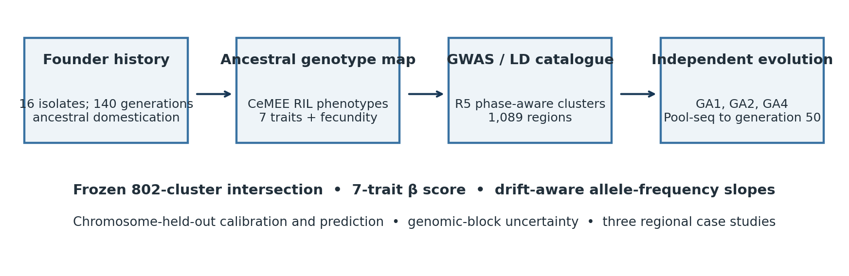
Figure 1. Study architecture and frozen comparison. The original progenitor sample and experimental histories precede a standardized R5 GWAS / Pool-seq comparison. Schematic; not to scale.

Executive summary
The original manuscript advanced the claim that pleiotropy limits the predictability of adaptive genomic evolution. The updated evidence supports a different, more defensible statement: ancestral GWAS effects projected onto a fitness-derived multivariate direction contain a reproducible but modest association with subsequent allele-frequency change. The result is biologically important because genomic evolutionary responses are measured independently of the RIL genotype–phenotype and fitness associations; it is not proof of a causal role of molecular pleiotropy.
Central fact | Current evidence
R5 genomic catalogue | 1,089 phase-aware LD clusters; 802 eligible evolutionary responses; GA1/GA2/GA4 primary
Genome-wide prediction | Effect–evolution correlation r = 0.3045 (2-Mb block CI 0.199–0.431); LOCO predictive R² = 0.0796
Comparators | SB R² = 0.0716; three-trait R² = 0.0539; direct β GWAS R² = 0.0630; PC1 R² ≈ 0.0474
Regional caveat | β–PC1 difference is dominated by chr V block V_3; apparent successes are linked, not independent
Open gates | WF extreme-tail calibration; MCMCglmm covariance diagnostics; direct haplotype-resolution tests; prospective vs calibrated prediction

1 How the scientific question changed

1.1 The starting manuscript
The original draft, “Pleiotropy Limits the Predictability of Adaptive Genetic Evolution,” aimed to contrast GWAS trait-effect estimates with frequencies of loci undergoing salt adaptation. The first analysis described a polygenic genome-wide response, low overlap between selection outliers and GWAS hits, low single-trait explanatory power, and an improved fit when genetic effects were projected onto a composite fitness-related phenotype.
Those conclusions were based on earlier LD thresholds and simpler selection scans: for example, the original manuscript quoted 166 selected haplotypes, 23 overlapping GWAS loci and three directly selected traits. These exact counts and inferential claims must not be carried into the revised main text because the current pipeline changes both the test and the universe of genomic regions. [S1]

1.2 The revised central question
The revised work asks: if genetic effects on seven measured traits and their relationships to fitness are estimated before experimental adaptation, how well can those effects predict the sign and magnitude of subsequent phase-aligned allele-frequency trends across the genome? A second-level question is whether measured multivariate information explains deviations from a univariate or fitness-blind genetic-axis forecast.
The strongest feature of the work is the independent data-generating process for genetic effects versus evolutionary responses. The main limitation is that the numerical chromosome-held-out predictor is linearly calibrated on the evolutionary responses of other chromosomes. It is a cross-chromosome generalization test, not a fully prospective prediction with a predefined scale and no evolutionary calibration. [S2, code 45]

1.3 Evidence labels used below
Label | Meaning
Verified output | Recomputed or directly tabulated from supplied CSV / run output
Historical result | Supported by the original manuscript or your earlier region notes but not re-estimated using the current R5 pipeline
Conditional result | Depends on an incompletely validated statistical null or uncertain inference
Pending | Script exists or analysis discussed, but no final results supplied

2 System, data and analytical workflow

2.1 Biological system and experimental design
The ancestral, highly polymorphic C. elegans population was derived from 16 wild isolates and maintained for approximately 140 generations in a benign laboratory environment before high-salt selection. The original manuscript reports 10,000 worms per generation, 2,365 phenotype movies and 996 mapped CeMEE RILs; the current matched phenotype-prediction analysis uses 960 RILs for locomotion, and 940 for area.F / β. The difference reflects revised filtering and trait completeness and should be explained in a sample flow diagram. [S1, S2, 51 outputs]
The unified primary genomic analysis follows three surviving selected populations, GA1, GA2 and GA4. GA3 became extinct and is retained only as a sensitivity analysis. The shared ancestral A00 sample is not an independent ancestral observation for each evolved population. Time-course Pool-seq measurements used in the current focal analysis include generations 10, 36 and 50; detailed coverage and population-specific manifests must be taken from the frozen sample registry. [S2, code 43–45, 58]

2.2 Phenotype adjustment and fitness-gradient estimation
Seven traits are analyzed: six locomotion transitions (SF, SB, FS, FB, BS, BF) plus body area (area.F). Script 00 adjusts replicate-level phenotypes for recorded environmental / session and RIL effects and produces RIL BLUEs. Relative fitness is reconstructed from line fecundity on its log scale, with one fitness record per RIL. A multivariate linear regression of relative fitness on the seven BLUE-standardized traits yields partial Lande–Arnold directional selection gradients. Conversion to the replicate-standardized GWAS scale is explicit; β is the fixed linear combination of those seven standardized phenotypes. [Code 00]
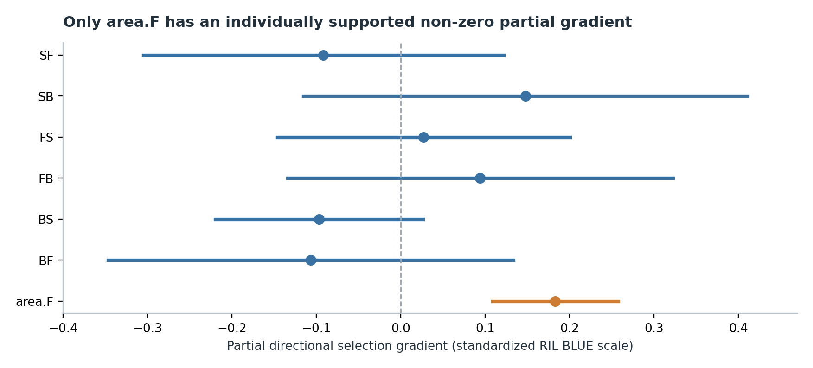
Figure 2. Point estimates and nominal 95% intervals from selection_gradients_NaCl.csv. Confidence intervals are conditional on the fitted fitness regression and should not be read as proof that other traits experience no selection.
Trait | Partial β | 95% interval | p
SF | -0.092 | [-0.305, +0.122] | 0.398
SB | +0.148 | [-0.116, +0.411] | 0.271
FS | +0.027 | [-0.146, +0.201] | 0.759
FB | +0.094 | [-0.134, +0.323] | 0.418
BS | -0.097 | [-0.220, +0.026] | 0.123
BF | -0.107 | [-0.347, +0.133] | 0.382
area.F | +0.183 | [+0.109, +0.258] | 2.28e-06

Only area.F has an individually supported nonzero positive partial gradient in this current fit (p ≈ 1.6×10⁻⁶). SB has an estimated positive gradient (+0.148), but its interval crosses zero. A lack of individual significance does not mean a trait or correlated genomic predictor is evolutionarily irrelevant. The joint multivariate test and the historical 2023 phenotypic-selection model should be presented separately.

2.3 GWAS and phase-aware LD catalogue
Scripts 01–06 perform mixed-model trait mapping, merge significant SNPs into LD components and split incompatible effect orientations by signed LD phase. The principal threshold is R5 (pairwise r² > 0.5, with sign alignment). The final R5 registry contains 1,089 association clusters. These are associated LD-defined regions, not 1,089 independently validated causal loci. The original manuscript’s R²-clustering catalogue (e.g., 1,058 at R5 under older settings) is not directly interchangeable with the revised registry. [S1, S2, code 02, 43]

2.4 Pool-seq outcomes: drift-aware trends, not direct selection coefficients
Scripts 08–09f prepare aligned allele counts and fit an approximate generalized least-squares (GLS) allele-frequency slope with Wright–Fisher neutral covariance, read-depth uncertainty and a working Ne = 1,000. Each SNP is oriented to the same GWAS allele; the final cluster response is the median of the eligible phase-aligned SNP slopes. This slope is measured in allele-frequency units per generation and should not be labeled a direct estimate of a selection coefficient s. [Code 09f, 43, 45]
Script 43 constructs a unified frequency-inclusive catalogue: 1,089 R5 clusters → 804 with covered Pool-seq information → 802 with testable evolutionary outcomes. The predictor catalogue retains all 802 eligible clusters without using selection significance as an inclusion criterion. Importantly, a prespecified GWAS tag is used to test evidence against drift, whereas multiple eligible SNPs can contribute to the cluster-level outcome; these are separate summaries. [S2, code 43–45]

2.5 Prediction and uncertainty
For each genomic cluster j, the primary score is b_j = Σ_k a_jk β_k, the sum of seven phase-aligned GWAS trait effects weighted by fitness gradients on the common association scale. The chromosome-held-out model estimates an intercept and slope relating that score to observed GLS outcomes using five chromosomes and predicts the sixth. Performance is R² = 1 − SSE/SST across held-out predictions. Chromosome-by-2-Mb-block resampling provides uncertainty on effect–evolution correlations and paired prediction differences. [Code 13, 45]
Additional comparators include the SF/SB/area.F reduced index, SB alone, a separate direct β-GWAS effect and covariance- or correlation-scaled PC1 of the GWAS-effect matrix (PC loadings fitted on training chromosomes). The PC1 comparison probes whether the fitness-selected direction adds value beyond the dominant trait-association axis; it is not a molecular pleiotropy test. [Code 45, 53]

3 Results: phenotype and genetic architecture

3.1 Extensive association signal but limited held-out phenotype prediction
The older in-sample genetic-score reconstructions yielded squared correlations of 0.468 for SF, 0.512 for SB, 0.479 for area.F and 0.303 for β. These are descriptive fits on the same data used for marker selection, not independent prediction. Revised five-fold random-RIL held-out analyses show substantially smaller predictive values, with trait-specific contrasts between a training-selected 75-marker GWAS model and genome-wide GBLUP. [S2, 51 output]
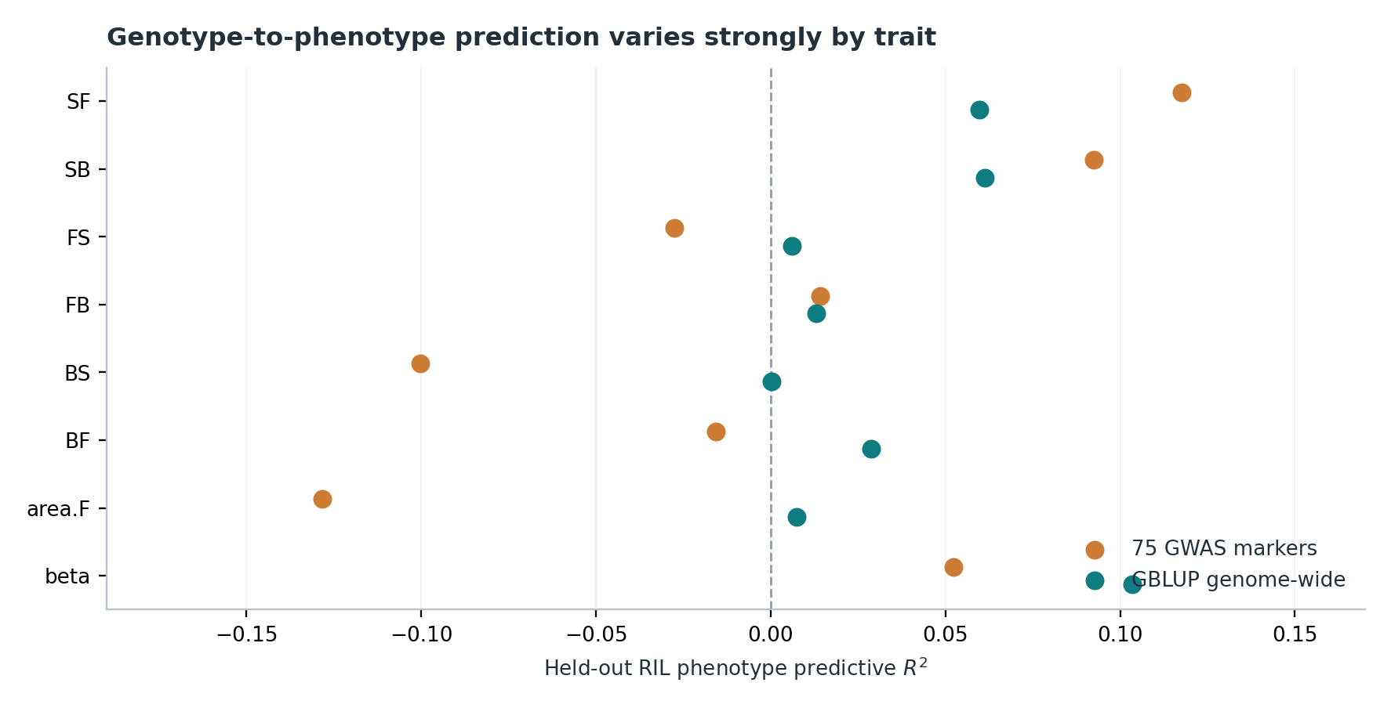
Figure 3. Five-fold random-RIL out-of-fold predictive R² from script 51. A fixed 75-marker budget and GBLUP use matched folds; the old in-sample score is excluded from this chart because its R² has a different interpretation.
For β, GBLUP R² = 0.103 versus matched 75-marker R² = 0.052. For SB the sparse GWAS score (0.092) exceeds GBLUP (0.061). Area.F is particularly poorly predicted out-of-fold despite its clearly supported partial fitness gradient. These contrasts argue against using GWAS detection counts or descriptive fitted-score R² to claim that a large portion of phenotypic genetic variance has been mapped. Paired uncertainty for the β sparse-versus-GBLUP comparison still requires the original output CSV. [51 output]

3.2 Collinear multivariate association space
The seven GWAS trait-effect vectors are strongly correlated: VIF values are approximately 11.1 (SF), 14.7 (SB), 12.0 (FS), 11.5 (FB), 6.0 (BS), 11.0 (BF), and 1.5 (area.F). Across held-out PC1 calculations, the leading component explains roughly 59–65% of variation in these GWAS-effect vectors. This is compatible with genetic integration and widespread LD; it cannot separate one causal pleiotropic mutation from multiple trait-specific causal mutations in linkage. [13 VIF, 53 outputs]
Earlier distance-based “synergistic pleiotropy” investigations compared sums of standardized effects against effective trait dimensionality using Manhattan and Euclidean null exponents. Their raw numerical fit, bias-correction and MCMCglmm-dependent uncertainty are not present in the available final figure tables. They should be retained as a methodological appendix or supplementary hypothesis until a fully validated analysis is produced; they do not justify a title asserting a universal pleiotropic mechanism.

3.3 MCMCglmm among-RIL covariance estimation
The seven-trait repeated-measures model estimates a full among-RIL covariance matrix (us(trait):pop_label), with date/session and residual structure, rather than treating the covariance of BLUEs as an error-free genetic matrix. Original post-processing expected 28 unique covariance entries, while MCMCglmm exported all 49 entries of the symmetric 7×7 block; the error occurred after chain fitting. A corrected, checkpointed script was supplied and the run restarted. No final diagnostics or posterior covariance estimates have been supplied for the current report. The matrix should be called among-RIL genetic/line covariance unless a genomic relatedness or pedigree model identifies additive genetic covariance. [Code 07a, S2]

4 Results: predicting evolution genome-wide

4.1 Positive yet limited association
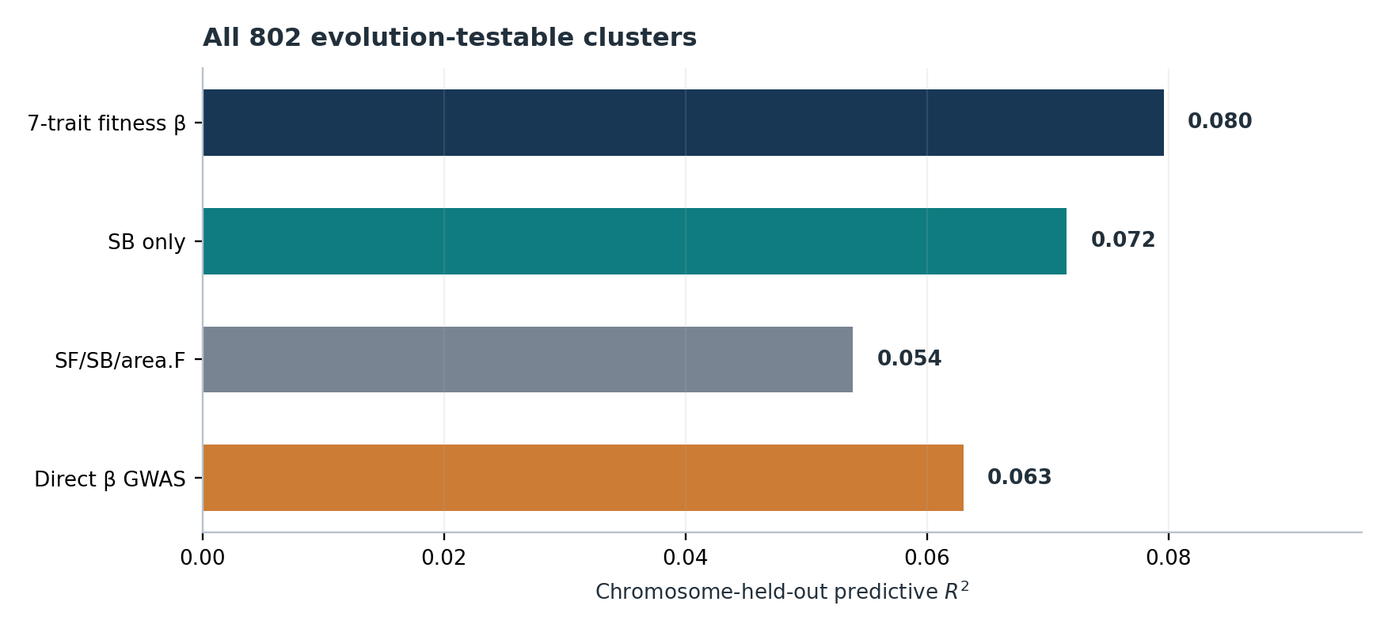
Figure 4. Primary surviving-population (GA1/GA2/GA4) held-out R² for 802 R5 clusters. Positive predictive performance is modest; the full β model is not reliably superior to SB alone.
The full seven-trait score correlates with the phase-aligned evolutionary response at r = 0.3045, with a genomic-block 95% interval of 0.199–0.431. Its chromosome-held-out R² is 0.0796. The reduced SF/SB/area.F score has R² = 0.0539, SB alone 0.0716, and direct β-GWAS 0.0630. Including the extinct GA3 reduces the full model R² to 0.0573. These outcomes describe one frozen response for each of the 802 clusters and do not rely on first declaring particular regions selected. [45 outputs]
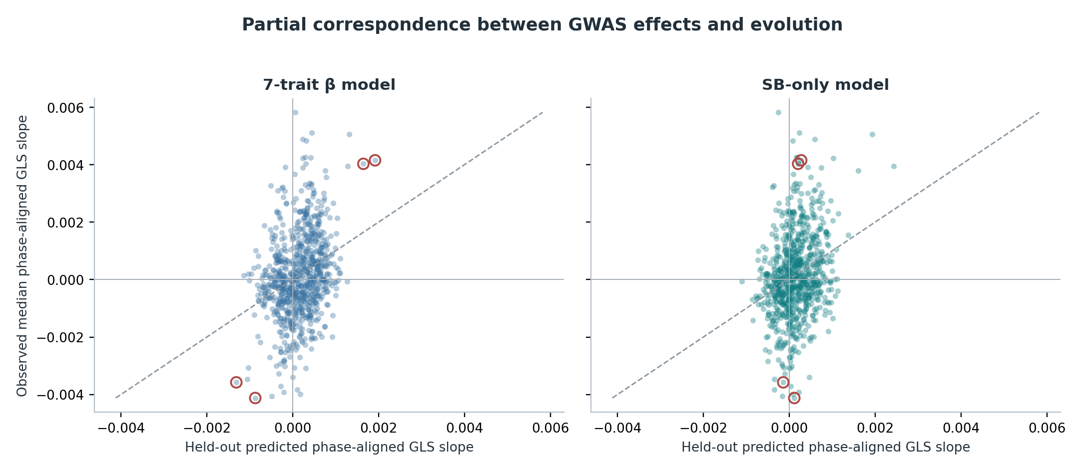
Figure 5. Predicted versus observed phase-aligned GLS slopes for the primary 802 clusters; circles outline chr V groups 848, 851, 853 and 854. Models are calibrated on the other five chromosomes, and the dotted line is equality; residual spread greatly exceeds fitted response.

4.2 Is a fitness-weighted seven-trait index superior?
Paired 2-Mb block bootstrap comparisons favor full β over the reduced three-trait and direct-β GWAS models (exploratory paired p ≈ 0.0145 and 0.0005, respectively) but do not establish an advantage over SB (p ≈ 0.861). SB was identified retrospectively as a good predictor, whereas full β was specified from ancestral fitness information. This a priori-vs-post hoc distinction is substantive, but it does not validate a mechanistic claim of molecular pleiotropy or prove that β is an optimal prediction rule. [45 paired outputs]
Sampling 1,500 selection-gradient vectors from the fitted joint regression leaves the seven-trait effect–evolution correlation positive in all samples in the earlier common-frequency catalogue; this assesses gradient uncertainty only and does not propagate GWAS effect, Pool-seq outcome or LD uncertainty. Against 4,000 random trait-weight directions, 6.4% produced an equal or larger signed correlation, so the exact fitness-derived direction was favorable but not uniquely exceptional. These analyses predate the unified full 802-cluster catalogue. [13 outputs]

4.3 Beta versus the dominant GWAS-effect PC1
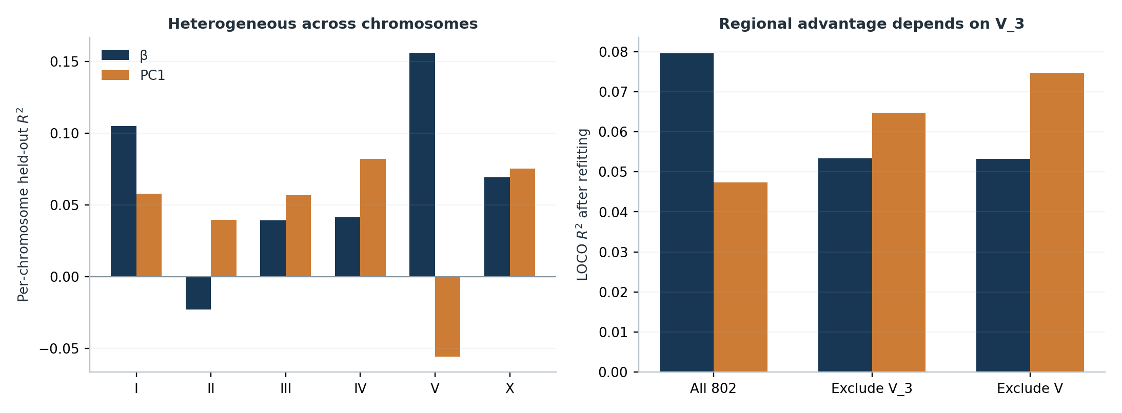
Figure 6. Left: chromosome-level held-out R²; right: sensitivity after refitting models with chr V block V_3 or the whole chromosome omitted. No formal inference of a population-general advantage follows from these exploratory exclusions.
Across all 802 regions, full β gives R² = 0.0796 and covariance-scaled PC1 R² = 0.0474. The paired genomic-block interval for the β–PC1 improvement contains zero. Chromosome V drives the numerical contrast: the 6–8 Mb block V_3 contains 12 eligible clusters, and removing that block reverses the ranking (refitted β ≈ 0.0534, PC1 ≈ 0.0648). Removing all of chromosome V gives β ≈ 0.0532 versus PC1 ≈ 0.0748. Those omissions were guided by the observed data; they identify leverage, not independent validation. [53 outputs]

4.4 Evolution differs across biological replicates
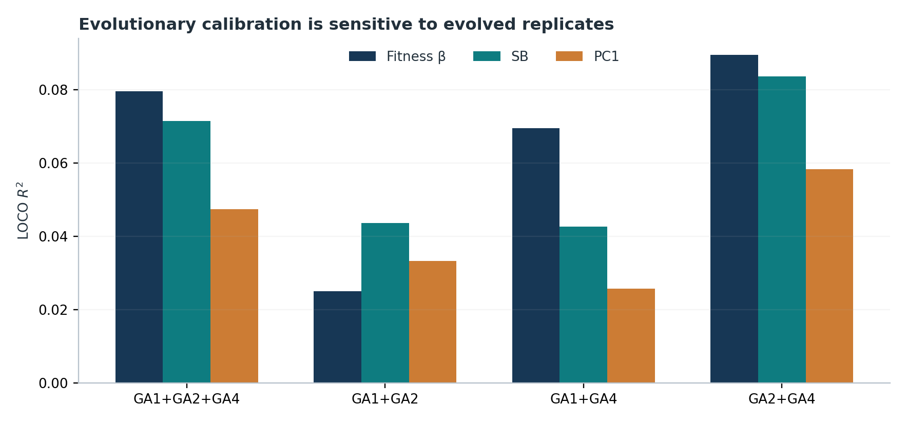
Figure 7. Sensitivity obtained by refitting the same frozen 802-cluster GLS outcomes after leaving out each surviving population. Two-population results contain only two biological replicates and cannot be treated as independent full validations.
For GA1+GA2 alone, β R² declines to 0.0251 (SB 0.0437, PC1 0.0334). Retaining GA4 gives β R² = 0.0696 (GA1+GA4) or 0.0896 (GA2+GA4). All pairwise differences are statistically uncertain in block resampling. These results show that the apparent forecast depends materially on the realized replicate composition; the direction of the chromosome V focal response nevertheless remains β-consistent without GA4. [58 outputs]

5 Selection scans and neutral-model limits
The original scans used a conventional genome-wide SNP screening logic and were subsequently reanalyzed because quasi-binomial dispersion and excess drift-sensitive signal made naïve significant-SNP counts unreliable. The modern test selects one GWAS tag per R5 cluster, models Wright–Fisher drift and read sampling at Ne = 1,000, uses upper-bounded Monte Carlo p-values and a dependence-conservative Benjamini–Yekutieli correction. The primary run reports 12/802 clusters with BY q < 0.05 (37 using BH), but zero at BY q < 0.01; supplementary all-GA reports eight BY q < 0.05. These are conditional model-based candidates, not 12 independently causal selected mutations. [44 output, code 44]
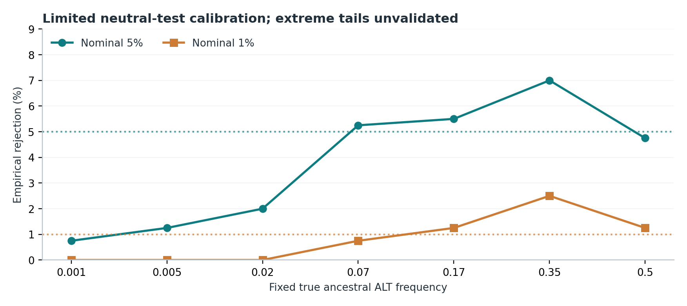
Figure 8. Fixed-true-ancestral-frequency null validation with 400 outer simulated datasets per frequency and 2,500 inner simulations. The extreme multiplicity-relevant tail cannot be assessed by this design. At true p0=0.35, nominal 1% rejection was 2.5% (10/400), indicating a sensitivity concern despite no flagged familywise lower bound.
The conservative Monte Carlo upper bound prevents overstating the certainty of a finite-simulation tail probability, but it cannot establish that the biological Wright–Fisher null is calibrated at the p-values required by 802 simultaneous tests. Coverage, overdispersion, real Ne and bottleneck history, and ancestral-frequency posterior treatment remain important. Manuscript gate: if rare-tail and intermediate-frequency null calibration cannot be defended, report regional findings descriptively and preserve the main genome-wide prediction result. [43b, 44, S2]

6 Regional biology: three complementary hypotheses
The three user-authored “Beta cluster” notes are older, hypothesis-generating analyses with original graphical evidence and selected RIL phenotype comparisons. They are incorporated here alongside the recent quantitative R5 outputs. Different sample sets, original cluster definitions, founder ancestry assignments and regression specifications mean that historical regional results should not be passed off as re-estimated main-pipeline statistics. [S3–S5]

6.1 Chromosome I: alternative RC301/PX174-associated variants (5.88–8.00 Mb)
The chr I note identifies a broad 2.1-Mb interval with 37 focal SNPs and contrasting founder signatures. Thirteen were classified as shared between RC301 and PX174, whereas five were described as RC301-private; they showed distinguishable allele-frequency trajectory patterns in the original figures. Historical RIL mapping contrasts approximately 530 N2-like lines, 162 shared RC301/PX174 lines and 65 lines carrying RC301-private alleles. The note reports positive β effects for both classes, stronger for the RC301-private class, and no body-area association. The described competition between haplotypes remains a hypothesis until their population-specific frequency trajectories and statistical dependence are jointly modeled. [S3]
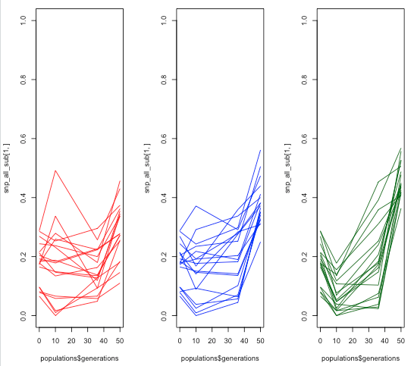
Figure 9. Historical chromosome I allele trajectories as plotted in the original region note. This graphical illustration has not been refitted with the unified R5 drift-aware approach. Source: Beta_cluster_1.docx.
A high-impact mechanistic test would identify the exact founder-proxy signatures, independently fit their allele-frequency changes in GA1/GA2/GA4, and compare RIL trait effects of shared and private components conditional on local background. “Competing haplotypes” should not be used causally until compositional and LD-driven anticorrelation have been excluded.

6.2 Chromosome IV: domestication mutation at 10,499,135 in tax-6
The chr IV note locates IV:10,499,135 in an exon of tax-6 on WBcel235 (annotation as reported in the note). It describes a clear post-founder mutation on a CB4856-related background, and the user has independently confirmed its domestication origin. Historical mapping was contrasted among non-CB4856, CB4856-related and CB4856-plus-mutant backgrounds; sample counts 206, 754 and 98 are reported, but class definitions/overlap must be reconciled before quoting inferential sample size. The note reports an effect on the composite β score and not body area, with exploratory trait plots suggesting coordinate locomotion effects. [S5]
Earlier script-based work also nominated IV:8,892,663 as an additional founder-absent variant, but the current short note is centered on IV:10,499,135. Its mechanistic interest depends on distinguishing the novel mutation’s effect from CB4856 ancestry, local LD and the fitness consequences of the entire chromosome-IV background. Gene annotation and exact nucleotide changes should be reconfirmed against the frozen genome assembly rather than inferring a tax-6 functional change solely from genomic location.
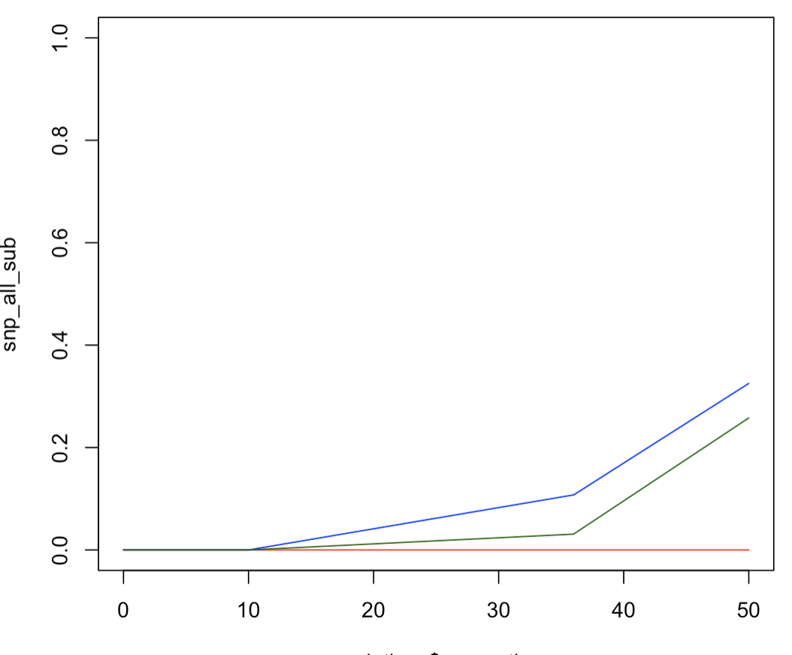
Figure 10. Original chromosome IV frequency-trajectory illustration from the user note (historical descriptive plotting, not a calibrated R5 slope test). Source: Beta_cluster_3.docx.

6.3 Chromosome V: a new mutation inside a coupled regional response
The chr V historical note describes 15 SNPs across a roughly 1.23-Mb region (V:6,046,042–7,278,103), identifies focal positions V:6,322,080, V:6,637,695 and V:6,826,421, and interprets V:6,322,080 as a domestication-origin mutation. The user has confirmed its post-founder origin. The historical local annotation places it in an intron of cest-24, near the noncoding T28C12.15 locus; this has not been experimentally linked to function. Earlier RIL allele-pattern comparisons found composite β associations but no area.F effect. [S4]
The new R5 deep dive expands this into four focal groups 848, 851, 853 and 854 within chr V block V_3, whose raw phenotypic effect vectors give β and PC1 opposed predicted directions. RIL tag-pair r² ranges roughly 0.48–0.69 among selected pairs, and 960 RILs show strongly unbalanced four-tag patterns: 839 are 0000, 40 are 1111 and 39 are 0001. These are multilocus marker patterns, not directly resolved ancestral haplotypes. [54–57 outputs]
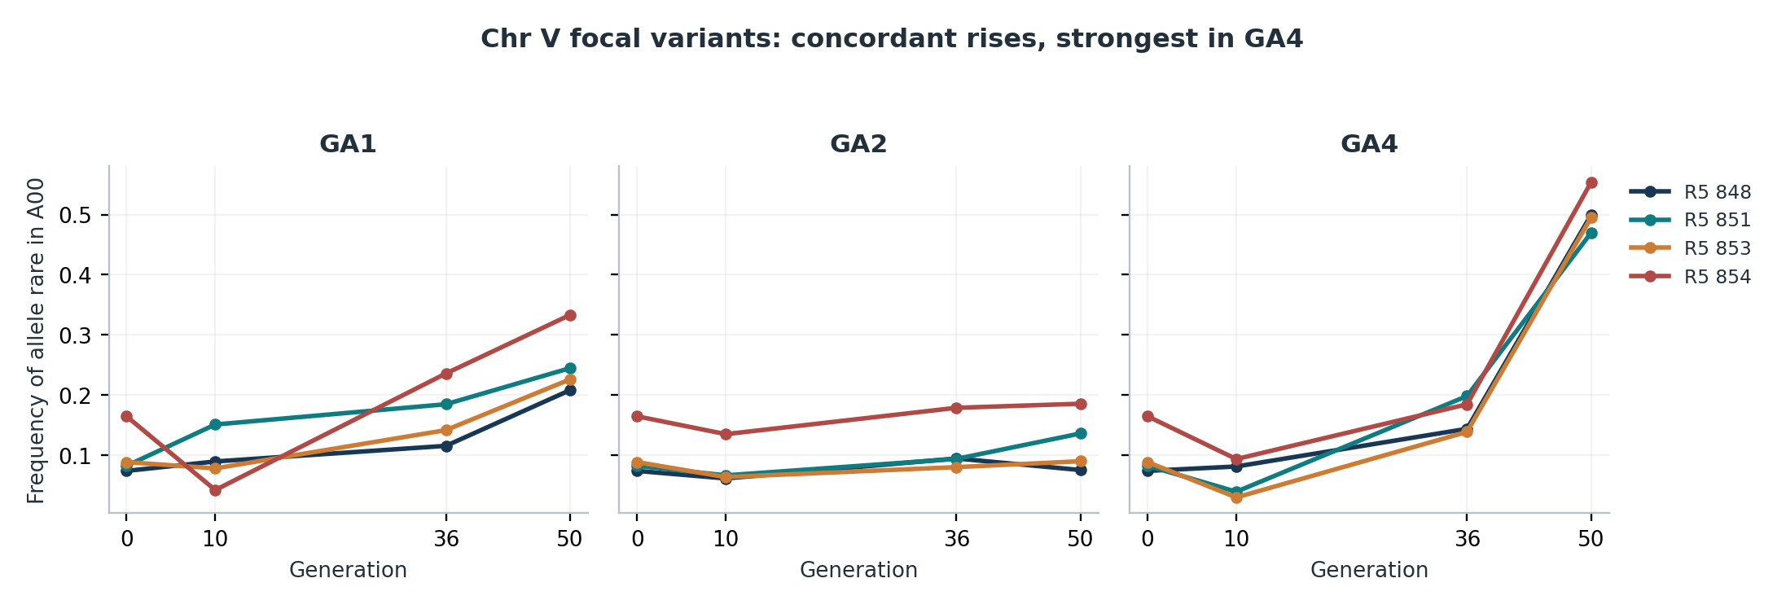
Figure 11. Pool-seq exact-tag frequencies, oriented to the allele rare in the common A00 sample. Three population-specific profiles show a late, large concordant rise in GA4 and smaller or weaker responses in GA1/GA2. These curves do not establish whether markers belong to one causal haplotype.
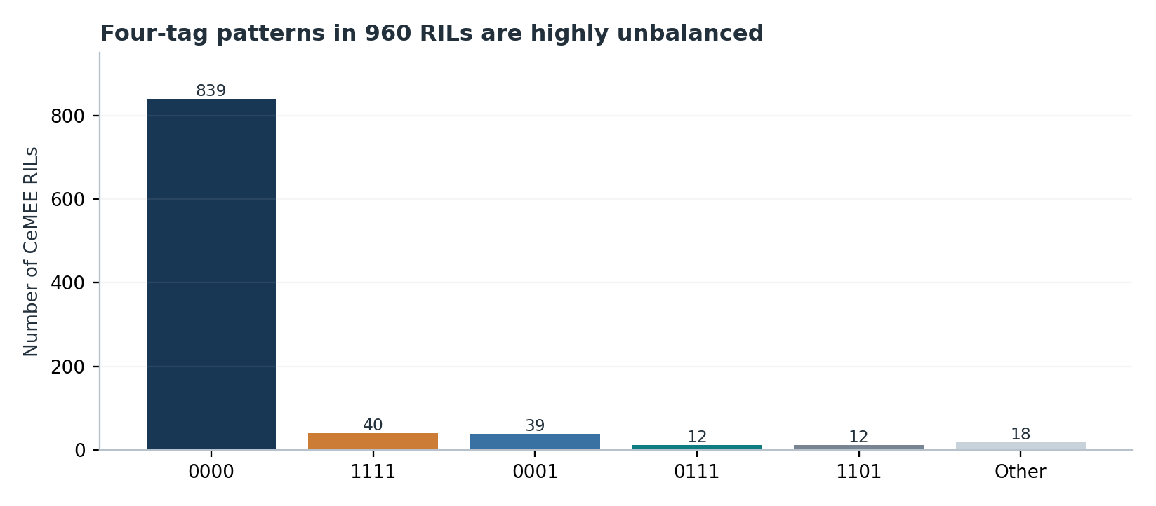
Figure 12. The four-tag frequency distribution among 960 resolved RILs. Codes are ordered 848–851–853–854 and indicate the rare-in-A00 allele (1) versus the alternative (0). The class imbalance limits conditional tests.
Script 57 reports four-tag class associations with SF (BH q = 4.46×10⁻⁹) and FB (8.51×10⁻¹⁰) after five genome-wide PC covariates, but not with SB or area.F. Within R5 group 848, exploratory conditional SNP fits favor V:6,322,080 as an SF/FB association and V:6,300,718 as a BS association. This is consistent with potentially separable linked trait signals, not proven causal pleiotropy. The marker grouping needs a full-kinship conditional GWAS and haplotype-resolution analysis. [57 output]
Four clusters 848/851/853/854 account for most of the net genome-wide difference in β-versus-PC1 squared error, but their high LD and coordinated trajectories mean they cannot be counted as four independent confirmations. The refitted omission of V_3 reverses overall predictor ranking; GA4 accounts for much of the magnitude but does not wholly determine the direction. [53–58 outputs]

6.4 Cross-region synthesis
Region | Distinctive evidence | What is not yet proven
I: 5.88–8.00 Mb | Shared RC301/PX174 vs RC301-private signatures; different β-associated classes | Direct haplotype competition or causal differences in multivariate fitness
IV: 10.50 Mb | Domestication-origin mutation on CB4856-related background; reported tax-6 exon | Causal effect of that nucleotide independent of local ancestry
V: 6.05–7.28 Mb | New domestication allele; linked SF/FB and BS associations; coordinated change | Molecular pleiotropy or four independent evolving genetic units

Three genomic histories with different ancestries and different local patterns could provide a memorable narrative, but they are not yet evidence that a single mechanistic class explains the entire genome-wide forecast. Each must be presented as a case study with explicitly constrained inference.

7 Claims audit against the original manuscript
Original or implied statement | Status | Recommended language
“GWAS fails to predict adaptation” | Replace | GWAS-derived multivariate effects predict a modest component of genomic evolution.
“Three traits are under direct selection” | Revise | The current joint fitness fit supports area.F individually; other partial effects remain uncertain.
“Integrating pleiotropy improves prediction” | Qualify | Seven-trait β beats some reduced scores, not reliably SB or PC1.
“Selected haplotypes are significantly polygenic sweeps” | Qualify | 12 model-dependent BY candidates; extreme-tail calibration incomplete.
“Pleiotropy limits genomic predictability” | Unsupported mechanistically | Association-based multivariate effects may reflect molecular pleiotropy, LD, or mediation.
“Regional linked loci demonstrate epistasis/competition” | Exploratory | Local signatures suggest linked and potentially competing genetic backgrounds.
“Genetic correlations explain genomic response” | Pending covariance | Among-RIL covariance and fitness-axis alignment require MCMCglmm diagnostics.

8 Main message and manuscript structure

8.1 Recommended thesis
“The evolutionary response of genomic regions is partially forecastable from ancestral effects on measured phenotypes projected along a biologically estimated fitness direction; genomic linkage, heterogeneous haplotype composition and replicate-specific dynamics limit how that information translates into independent allele-frequency trajectories.”
This is a positive claim with a quantified limitation. It neither requires showing a statistically significant improvement over the best retrospectively identified single trait nor asserts that pleiotropy is the unique mechanism.

8.2 Candidate titles
- Ancestral multivariate genetic effects partially predict genomic adaptation
- From GWAS to evolution: partial predictability of allele-frequency change in a sexual population
- Why genotype–phenotype associations only partly forecast genomic adaptation

8.3 Proposed four main figures
Main figure | Proposed panels and intended argument
Fig. 1 System and fitness landscape | Ancestral/founder timeline, surviving/extinct populations, seven selection gradients, MCMC G axes only if robust.
Fig. 2 Ancestral genetic map | R5 association distributions, trait effect covariance, sparse-vs-GBLUP held-out prediction.
Fig. 3 Central evolutionary test | All 802 clusters, phase-aware β-effect vs GLS slope, six-chromosome LOCO and block uncertainty, SB comparator.
Fig. 4 Three regional histories | I: RC301/PX174; IV: tax-6/background; V: new mutation plus linked trait effects; clear genotype and replicate trajectories.

The PC1 sensitivity, rare-tail validation, distance-based synergistic-pleiotropy analysis, phenotype three-panel full set, population omission and candidate-tag tables belong in supplementary material unless a robust new general principle emerges.

9 Journal strategy and conditional decisions

9.1 Current evidence versus intended journals
Tier | Journal(s) | Assessment
Very broad generalist | Science / Nature | Not warranted by current causal breadth and dependence on three surviving replicate populations.
High-impact broad evolutionary | Nature Ecology & Evolution; PLOS Biology | Stretch only with compelling independent predictive insight and resolved mechanisms.
High-visibility multidisciplinary | Nature Communications | Potentially arguable if a general framework and strongly validated regional biology emerge.
Ambitious specialist | Evolution Letters; PLOS Genetics | Plausible if one concise, original, robust conceptual result dominates.
Strong current fit | Evolution; GENETICS | Best justified by current multivariate GWAS–experimental evolution evidence.

Journal scopes checked 3 November 2026: Evolution Letters emphasizes concise advances of broad evolutionary importance; PLOS Genetics welcomes major evolutionary/genomic results with rigorous evidence; Evolution explicitly welcomes evolutionary genomics and quantitative genetics. PLOS Biology and the Nature family require substantially broader conceptual impact. These are assessments of fit, not acceptance probabilities. [E1–E5]

9.2 What would materially raise the ceiling?
A convincing elevated-journal story would need at least one of the following: (i) biological-effect forecasts of distinct haplotypes tested independently across populations without selecting the best model after observing the test evolution; (ii) a replicated mechanistic demonstration separating a new mutation from linked background and showing how this changes fitness; or (iii) a simulation-plus-empirical decomposition showing predictability limited by a particular measurable genetic architecture, beyond signal inflation due to correlated tags. Merely adding more GWAS QTL plots, significance stars or regional panels is unlikely to raise the ceiling.

9.3 Decision tree
If genome-wide prediction remains robust but local causality remains exploratory, finish the neutral calibration and direct comparison audit, write a lean Evolution/GENETICS manuscript, and do not delay for a perfect seven-trait covariance estimate. If the three genomic regions yield a clear generalizable test of haplotypic predictability, target Evolution Letters or PLOS Genetics, with PLOS Biology / Nature Communications only after further independent validation. A Science/Nature submission would currently be speculative and should not drive the project workflow.

10 Remaining analyses, information and required files

10.1 Essential decision gates
Priority | Action | Required evidence / output
A – Essential | Neutral-model extreme-tail and Ne/coverage calibration | Higher-powered empirical type-I simulations, model sensitivity across Ne; 43b and 44 validation outputs.
A – Essential | Finish MCMCglmm post-processing and posterior checks | 07a_MCMC_diagnostics.csv; posterior VCV / RData; trace plots; 07b outputs if satisfactory.
A – Essential | Freeze R5 catalogue, GA sample manifest and exact genome assembly | 43 registry, frozen tags, 58 sample manifest, software versions and allele orientation keys.
B – High | R5 regional comparison on I / IV | Per-SNP evolutionary trajectories, cluster membership, RIL founder-background assignments, mixed-model estimates.
B – High | Kinship-adjusted local SNP / multi-marker association on V | Two-SNP / local GRM conditional GWAS results, confidence intervals, segregation checks.
B – High | Population-level predictive validation with correct biological units | Per-population GLS slopes across all 802, GA-specific uncertainty, candidate held-out trajectories.
C – Complementary | Repeat β-weight uncertainty on full R5 catalogue | Joint gradient covariance draws and region-specific sign probabilities.
C – Complementary | Final figure and text package | High-resolution figures, exact exclusion counts, complete Methods and provenance table.

10.2 Specific files to request next
- MCMCglmm: final `RData_G_NaCl/07a_multivariate_G_final.RData`, diagnostic CSV, variance / correlation credible-interval tables and run configuration.
- Original chromosome I: SNP list with R5 cluster group identifiers; one table of SNP allele frequencies per GA replicate/generation, founder/RIL haplotype calls and kinship-adjusted contrast results for N2, shared RC301/PX174, RC301-private alleles.
- Original chromosome IV: exact RIL genotypes/VCF calls for IV:10,499,135 and IV:8,892,663, CB4856-background assignment per RIL, trait/β mapping contrasts with SE and overlapping-class definitions, plus sequence annotation and REF/ALT details.
- For a finished figure 4: the original high-resolution vector or PDF regional figures from the three short reports (heatmaps, IGV tracks, selected SNP trajectories and trait boxplots). Embedded screenshots are usable only for a working report.
- For full methods: the `43_Unified_R5_cluster_registry.csv`, `43_FROZEN_selection_tags.csv`, full `44_primary_survivors_WF_cluster_selection.csv`, complete sample manifest and R session/package versions.
- For phenotype-prediction inference: `51_Paired_GWAS_vs_GBLUP_fold_stratified_bootstrap.csv` and out-of-fold predictions underlying the original main three-panel figure.
- For a strong cross-region test: whether ancestral domestication population genotype timepoints exist between founder crossing and A00; this would help date origin and rise of the novel variants.

10.3 What is already sufficient
No additional files are needed to present the principal selection-gradient table, 802-cluster prediction association, β/SB/PC1 comparisons, block-bootstrap limitations, GA4 sensitivity or current chr V genotype-pattern summary. These have been assembled and graphed here directly from the supplied outputs. The additional files above are mainly required to make the regional mechanistic story and the Methods publication-ready.

11 Evidence inventory, reproducibility and source notes
The R scripts in Code_previous_chat.zip span 00 through 51, with additional scripts 52–58 generated and executed in subsequent discussions. Their methods and associated outputs are grouped below; absence of a final output must not be converted into a completed result.
Analytical stage | Script numbers | Current status
Data cleaning; GWAS; LD | 00–06 | Completed revised analysis; sample / marker manifest needs final publication audit.
Multivariate covariance | 07a, 07b | Model refit under way; no final posteriors supplied.
Aligned Pool-seq and GLS | 08–12 | Implemented; orientation and drift-aware outcome used in unified analysis.
β uncertainty and genetic architecture | 13–17 | Most central CSV diagnostics available; linkage screen exploratory.
Historical regional investigations | 18–32 | Codes supplied; detailed I/IV result tables not all supplied, short notes available.
Frequency-inclusive neutral testing | 33–44 | Unified 802 catalogue and candidate counts available; extreme-tail calibration pending.
Genome-wide prediction / RIL prediction | 40–51 | Primary LOCO and phenotype-prediction summary verified; some original figure CSVs missing.
Conditional, PC1, chr V follow-up | 52–58 | Core summary and outputs reviewed; population and LD qualifications incorporated.

Sources and provenance
[S1] 2026_pleiotropy_GWAS.docx. Original manuscript draft (12 pages).
[S2] Publication_strategy_and_remaining_analyses_memo.docx. Previous decision memo, 30 October 2026.
[S3] Beta_cluster_1.docx. Chromosome I exploratory founder/allele/trait maps (6 pages).
[S4] Beta_cluster_2.docx. Chromosome V exploratory founder/mutation/trait maps (8 pages).
[S5] Beta_cluster_3.docx. Chromosome IV tax-6 mutation analysis (5 pages).
[D] User-supplied numeric outputs: selection_gradients_NaCl.csv; 43b, 44, 45, 51; 13, 17, 53; chrV_deep_dive.zip; 57_58_outputs.zip. See chart captions for derived plots.
[Code] Code_previous_chat.zip (scripts 00–51); 53b and 54–58 scripts supplied in subsequent conversation.
[E1] Mallard, Afonso & Teotónio (2023), eLife 12:e80993. doi:10.7554/eLife.80993.
[E2] Xiao, Nolte & Schlötterer (2026), GENETICS 234:iyag181. doi:10.1093/genetics/iyag181.
[E3] Evolution Letters author guidelines / aims: https://academic.oup.com/evlett/pages/author-guidelines
[E4] PLOS Genetics scope: https://journals.plos.org/plosgenetics/s/journal-information
[E5] Evolution scope: https://academic.oup.com/evolut/pages/author-guidelines; PLOS Biology https://journals.plos.org/plosbiology/s/journal-information; Nature Ecology & Evolution https://www.nature.com/natecolevol/aims; Nature Communications https://www.nature.com/ncomms/aims.

