Pleiotropy Limits the Predictability of Adaptive Genetic Evolution

Over the past two decades, advances in genomics have transformed our ability to identify the genetic basis of complex traits. Genome-wide association studies (GWAS) identify hundreds to thousands of loci underlying phenotypic variation in humans, model organisms, and natural populations, while populations whole genome sequencing allows to track through time the allele frequency trajectories of these loci. Combined, these developments have raised the possibility of resolving a core evolutionary objective: if we know how genetic variants affect phenotypes under selection, can we predict how evolution will shape their frequencies?

Our ability to predict genetic evolution relies on our understanding of the genotype-phenotype-fitness associations. GWAS measures how genetic variants contribute to phenotypic variation, whereas natural selection acts on differences in fitness. Our ability to predict genomic evolution thus depends on the link between a trait variation and its effect on fitness. At the phenotypic level, quantitative genetic theory predicts that the evolutionary response of a trait depends not only on the strength of selection and its additive genetic variance, but also on its genetic covariation with other traits. Indeed, empirical studies repeatedly show that traits experiencing directional selection often evolve more slowly than expected or in directions that differ from univariate predictions. Multivariate models incorporating the genetic covariance matrix substantially improve predictions of phenotypic evolution, demonstrating that adaptation is constrained by genetic correlations among traits. At the genomic level, several mechanisms could generate a discrepancy between trait associations and evolutionary dynamics. Pleiotropic mutations simultaneously affect multiple phenotypes and its response to selection will depend on the summed effect of these multivariate phenotypic changes on fitness. Additionally, linkage disequilibrium will create genetic correlations between different traits, causing selection to act on haplotypes rather than on individual mutations. Epistatic interactions between linked loci may further modify the fitness effects of alleles depending on their genetic background.

The evolutionary response of a genetic variant will therefore depend not only on its effect on a focal phenotype but also on its broader genetic and phenotypic context. Yet, despite decades of quantitative genetic theory and the explosion of genomic data, there has been remarkably little empirical evaluation of whether GWAS derived effect sizes can predict the evolutionary trajectories of the loci they identify.

Here, we address this question by combining experimental evolution in a stressful environment with genome-wide association mapping of a quantitative trait under directional selection. We directly compare predicted and observed allele-frequency changes at several hundreds of quantitative trait loci (QTL) over the course of adaptation during 50 generations. By comparing predictions from univariate and multivariate phenotypes, we explore the role of pleiotropy in shaping genomic response and discuss the genetic architecture of these pleiotropic effects.

Results

Populations adapted and multiple phenotypes are under direct selection

We performed experimental evolution in Caenorhabditis elegans using large, non-overlapping populations of 10,000 individuals per generation. The ancestral population was generated by crossing 16 wild isolates and subsequently maintained for 140 generations under a stable, non-stressful laboratory environment, while retaining extensive standing genetic variation. Three independent replicate populations were then evolved for 50 generations under gradually increasing salt concentrations, imposing strong osmotic stress. All three evolved populations showed increased fitness relative to the ancestor, accompanied by significant changes in body size and locomotor behaviour measured using high-throughput phenotyping (REF).

We previously showed that selection acted directly on three of the seven measured traits after accounting for genetic correlations among traits (REF). These analyses revealed a striking constraint on phenotypic evolution: one locomotor trait experienced selection in the opposite direction to its genetic correlation with the other selected traits. Specifically, this trait was negatively selected despite being positively genetically correlated with the other traits under directional selection. Consistent with these genetic constraints, phenotypic responses were moderate, and one of the locomotor trait even evolved significantly in the opposite direction to the selection gradient.

This system therefore provides a direct test of whether the genomic response to selection can be predicted from the genetic effects underlying phenotypic variation. We combined whole-genome sequencing of evolving populations with phenotyping of recombinant inbred lines to identify loci associated with the selected traits, track their allele-frequency trajectories during adaptation, and resolve the genetic architecture underlying the correlations among traits (Fig. 1).

GWAS reveals a highly polygenic architecture of phenotypic variation

Using genome-wide association analyses of 996 sequenced recombinant inbred lines from the CeMEE panel (REF) and 2,365 high-throughput behavioural recordings, we identified hundreds of QTLs associated with body size and six locomotor traits (Fig. XX; Fig. SXX). These QTLs are sufficient to reproduce both the RILs phenotypic distributions as well as the phenotypic correlations among traits (Fig. SXX), indicating that our statistical power captures a substantial fraction of the genetic architecture underlying these phenotypes and their genetic covariances.

This genetic architecture is highly polygenic and distributed across all chromosomes, with substantial variation among chromosomes in both the number of associated variants and the physical length of associated regions. These patterns are consistent with the distribution of genetic variation and the recombination landscape of C. elegans as we observe larger clusters in chromosomal centers. We next quantified pleiotropy as the number of traits associated with each QTL. QTLs shared among traits occurred more frequently than expected by chance, consistent with the strong genetic correlations among these phenotypes (Fig. SXX). Moreover, highly pleiotropic QTLs tended to have larger average effects, although this relationship was restricted to QTLs located in the central regions of chromosomes. This pattern is consistent with the non-random genomic distribution of genes with essential functions previously reported in C. elegans (REF).

Adaptation to high salt involves genome-wide allele-frequency changes that are only partially explained by selection on measured traits

In parallel, we tracked genomic changes during experimental evolution by pool-sequencing the ancestral populations and the three replicate populations at generations 10, 36 and 50. We estimated allele-frequency trajectories for segregating variants and used linear mixed-effects models to identify loci showing parallel responses across replicate populations. The genomic response was widespread, with significant changes detected across the genome and no apparent enrichment on chromosome arms or central regions (3,364 SNPs; q < 10⁻⁵). This genome-wide response is consistent with selection acting on a highly polygenic genetic architecture.

To compare the genomic response with the genetic architecture identified by GWAS, we grouped significant SNPs into 166 selected haplotypes using the same LD-based approach as above. Strikingly, only 14% (23 out of 166 haplotypes) contained SNPs significantly associated with at least one of the three traits under directional selection. Thus, most genomic regions showing a reproducible response to selection were not detected as associated with the measured traits. While we require both strong statistical support and parallel responses across replicate populations, we are likely to underestimate the number of loci contributing to adaptation. Nevertheless, this limited overlap indicates that selection on the three measured traits explains only a fraction of the genomic response to salt stress.

Moreover, even among the selected haplotypes that overlapped with GWAS loci, only a subset of the constituent SNPs were associated with the measured traits, suggesting that the phenotypic effects identified by GWAS account for only part of the selective forces driving changes in haplotype frequency (Fig. XX). These results reveal a substantial gap between the genetic architecture of the measured phenotypes and the genomic response to selection.

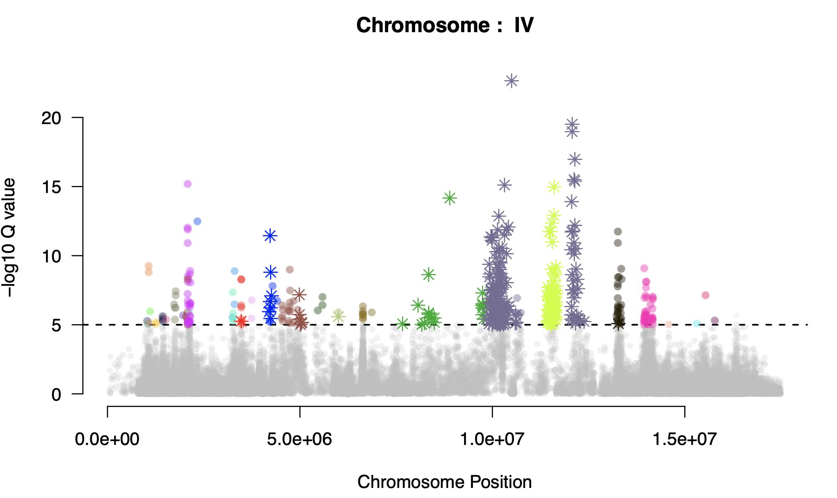
FigureXX: Manhattan plot of the genomic response to selection on chromosome IV. Significant SNPs are grouped into haplotypes based on linkage disequilibrium (LD) in the RILs and are colored accordingly. Stars indicate SNPs significantly associated with at least one of the selected traits in the GWAS. Of the 32 haplotypes showing a significant response to selection, 8 were also identified in the GWAS, highlighting the overlap between loci responding to selection and loci associated with the focal traits.

GWAS effects fail to predict the genomic response of traits under direct selection

We next directly tested whether GWAS allelic effects predict evolutionary change by comparing the effect size of each allele on the three traits under directional selection with its selection coefficient estimated during experimental evolution. For all three traits, the relationship between phenotypic effect and evolutionary change was weak, despite the substantial heritable variation and large number of QTLs detected for each phenotype (Fig. XX). All three traits showed a significant positive relationship between GWAS effect size and selection coefficient (P<0.05), but the SB is under negative selection and we should expect a negative slope. This pattern is consistent with the phenotypic evolution predicted from the overall G-matrix in our previous study as SF and SB are strongly correlated but selected in opposite direction. All three models explained only a limited fraction of the variation in allele-frequency change (R² for SF, SB and FS are respectively 0.04, 0.18 and 0.04).

Thus, although our GWAS captured a highly polygenic architecture underlying traits experiencing direct selection, the effect of individual loci on these traits provided little information about which alleles would increase or decrease in frequency during adaptation. Polygenicity may contribute to the limited magnitude of individual allele-frequency changes, as many loci of small effect can collectively produce substantial phenotypic evolution. However, polygenicity alone does not explain the weak correspondence between GWAS effects and the direction of evolutionary change. Instead, these results suggest that the marginal effect of a locus on a single trait does not adequately capture its contribution to fitness.

Together, these findings provide a direct demonstration of the gap between genotype–phenotype associations and evolutionary dynamics: even for traits experiencing directional selection and for which their underlying genetic architecture can be mapped with substantial power, single-trait GWAS effects have limited ability to predict the genomic response to selection.
FigureXX: Relationship between GWAS-derived allelic effects and selection coefficients estimated during experimental evolution. For each of the three traits under directional selection, GWAS allelic effects do not predict accurately which loci increase or decrease in frequency during experimental evolution. Out of 1058 significant haplotypes identified across the GWAS, selection coefficient was estimated for 976, all shown here. Black points indicate haplotypes significantly associated with the focal trait in the GWAS, whereas red points are significant in both the GWAS and the selection analysis. Grey points represent haplotypes that are not significantly associated with the focal trait in the GWAS, and pink points represent haplotypes showing significant selection during experimental evolution but no significant association with the focal trait in the GWAS. The green line represents the linear relationship between GWAS effect sizes and selection coefficients; this relationship is not significant for any of the traits.

Integrating pleiotropic effects improves prediction of genomic evolution

The failure of single-trait GWAS effects to predict allele-frequency change suggests that the selective value of genetic variants cannot be captured by their effects on individual phenotypes. To account for pleiotropy, we projected the seven dimensional phenotypic space onto the direction of multivariate selection by constructing a composite phenotype as the linear combination of the seven traits weighted by their respective selection gradients. This projection represents the phenotypic axis along which selection acts most strongly and integrates the effects of genetic variants across correlated traits. Despite limited additive genetic variance along this direction (REF), GWAS identified 331 QTLs significantly associated with the composite phenotype (see Table SX) out of which we reliably estimated selection coefficients for 313 .

We then repeated our comparison between GWAS effects and allele-frequency changes during experimental evolution. Allelic effects on the composite phenotype were significantly associated with subsequent allele-frequency changes (slope = 0.05, P < 10⁻⁸; Fig. XX), suggesting that incorporating multivariate phenotypic effects improves the prediction of genomic evolution. To quantify the contribution of individual QTLs to the overall phenotypic response, we multiplied their mean allele-frequency change over the 50 generations by their GWAS effect. Most QTLs contributed in the direction of the observed phenotypic response, whereas only a small number contributed negatively (Fig. XXb). This means the loci for which single-trait GWAS incorrectly predicted the direction of selection tended to undergo smaller allele-frequency changes, suggesting that accounting for pleiotropic effects reduces, but does not eliminate, the discrepancy between predicted and observed genomic evolution.
FigureXX: Relationship between GWAS-derived allelic effects and selection coefficients estimated during experimental evolution for our composite trait

Dissecting selected QTLs reveals complex genetic architectures underlying evolutionary change

To understand why integrating pleiotropic effects improves, but does not fully restore, prediction of genomic evolution, we analyzed the three QTLs that contributed most strongly to the predicted response of the composite phenotype. By reconstructing founder haplotypes and resolving the SNP combinations that changed in frequency during evolution, we found that these QTLs represented distinct genetic architectures linking genotype, phenotype and fitness. The first QTL increased in frequency independently in all three replicate populations and affected only a single locomotor trait. Its effect was therefore largely independent of the positive genetic correlations constraining the other selected traits, providing a relatively simple case in which variation at a single locus can contribute predictably to adaptation. The second QTL revealed a more complex architecture in which the evolutionary effect could not be attributed to a single variant. Two closely related founder haplotypes increased in frequency, but differed in their phenotypic effects: one affected locomotion alone, whereas the other carried three additional variants associated with body area. The combination of these variants produced a non-additive interaction between effects on locomotion and body area, indicating that the fitness consequences of the haplotype emerge from interactions among variants affecting different traits. Yet, the combination carrying favourable effects across both sets of traits was absent from the ancestral population. Selection may therefore favour a genetic combination that is not accessible from the standing variation, providing a potential constraint on the rate of adaptation. The third QTL provided a contrasting example of genetic contingency. A single variant increased in frequency on the same haplotype in two replicate populations but was lost in the third. The variant was absent from the ancestral founder haplotypes, consistent with its having arisen during the preceding domestication phase, although its precise origin cannot be established from our data. Its parallel increase on the same genetic background in two populations suggests that the same genetic solution can be repeatedly favoured when it becomes available, whereas its loss in the third population illustrates the stochastic effect of drift.

Together, these QTLs reveal that the genetic basis of adaptation cannot always be reduced to marginal effects of individual variants. Evolutionary change can instead depend on the genetic background in which variants occur, interactions among linked variants affecting different traits, and the availability of particular allele combinations. Two of the three selected QTLs involved closely related founder haplotypes, including pairs classified as the same isotype in the CaeNDR wild-isolate resource, suggesting that the genetic combinations capable of producing fitness-enhancing multivariate effects are rare within the available standing variation. Thus, even in a population harbouring extensive genetic variation and hundreds of GWAS loci, only a subset of genetic architectures may provide accessible routes through the multivariate fitness landscape. This genetic contingency offers a mechanistic explanation for why incorporating pleiotropic effects improves the prediction of genomic evolution, but does not fully resolve it.

Conclusion/Discussion

Predicting evolutionary change from genetic variation is a central goal of evolutionary biology. Quantitative genetic theory has provided a powerful framework for doing so at the phenotypic level: given the strength and direction of selection and the additive genetic variance–covariance matrix, the expected response of a population can be predicted even when traits are genetically correlated. Our results show that despite our ability to predict phenotypic evolution, predicting the genomic changes underlying it remains challenging. In our experimental populations, multivariate quantitative genetic models captured the direction of phenotypic evolution, yet the marginal effects of individual loci measured by GWAS had little power to predict their allele-frequency trajectories during adaptation.
Our dataset provides a direct connection between the three levels of evolutionary change: phenotype, genotype and fitness. Experimental evolution has long been recognized as a powerful way to test evolutionary theory because the selective environment and evolutionary trajectories can be observed under controlled conditions, while genomic approaches have increasingly made it possible to resolve the genetic basis of adaptation. Our study combines these approaches to test a question that is difficult to address in natural populations: whether knowing the genetic effects underlying a phenotype is sufficient to predict which alleles will evolve.
The first important result is that adaptation to salt stress was highly polygenic. We detected thousands of SNPs showing parallel frequency changes across replicate populations, distributed throughout the genome, while hundreds of QTLs contributed to the phenotypic variation measured in the ancestral population. This pattern is consistent with a growing body of experimental and theoretical work showing that adaptation of complex traits can involve many loci, each contributing relatively small changes in allele frequency rather than a small number of classical selective sweeps. Polygenic adaptation therefore presents an immediate challenge for evolutionary prediction: even when the aggregate phenotypic response is substantial, the evolutionary contribution of any individual variant may be small. However, our results reveal a limitation beyond polygenicity itself. The direction of allele-frequency change was poorly predicted by the GWAS effect of a locus on the focal trait. Thus, the problem is not simply that many loci contribute too little to be detected individually; rather, the phenotypic effect measured at a locus does not fully describe the selective consequences of that locus.
This distinction is important because genomic prediction has largely been developed around the genotype-to-phenotype relationship. GWAS and genomic prediction have demonstrated that highly polygenic traits can be reconstructed, and in agricultural systems genomic prediction is routinely used to predict breeding values and accelerate artificial selection. Population-genetic approaches have likewise begun to incorporate GWAS effect sizes to detect signatures of polygenic adaptation by asking whether allele-frequency differences across populations are aligned with the genetic effects on a phenotype. Our experiment exposes a different problem: even when the relevant phenotype is itself under directional selection, the marginal genetic effects estimated from GWAS do not necessarily predict the evolutionary trajectory of those variants. This suggests that genotype-to-phenotype prediction and genotype-to-evolution prediction are fundamentally different problems.
The reason is that natural selection acts on fitness rather than on individual traits. A variant with a positive effect on body size, for example, may simultaneously alter locomotion or other components of performance, and the net consequence of these effects determines whether the variant is favored. This is the genomic counterpart of the genetic correlations captured by the G-matrix. Genetic covariance can constrain phenotypic evolution because the genetic variation available to selection may not be aligned with the direction of the selection gradient. Our results show that the same constraint has a genomic manifestation: the allelic effects relevant to evolution are multivariate rather than trait-specific. Pleiotropy has long been recognized as a fundamental property of the genotype–phenotype map and as a potential constraint on adaptation, although its measurement depends strongly on which traits are considered and on the power to detect genetic effects.
Consistent with this interpretation, incorporating the full selection gradient substantially improved our ability to predict allele-frequency changes. Rather than considering the effect of a locus on a single trait, we projected genetic effects onto the multivariate direction of selection and recovered a significant relationship between these composite effects and evolutionary change. Therefore, when the genetic architecture is considered in the same multivariate space in which selection acts, information from single-trait GWAS may become predictive of evolution. In our case however, the improvement was only partial as a a large fraction of the genomic response remained unexplained, mostly because our locomotion and body size phenotypes are not fully capturing the phenotypic space under selection and thus are not sufficient to reconstruct the genotype–fitness map.
Our dissection of selected QTLs provides clues to why this prediction remains incomplete. The three regions with the strongest contributions to the multivariate response represented qualitatively different genetic architectures. These observations suggest that when linkage, epistasis and pleiotropy interact, selection may act on genetic combinations whose fitness effects cannot be inferred from the marginal effect of any constituent variant. This may explain why substantial standing genetic variation does not necessarily translate into equally predictable evolutionary change.
Our results also highlight an important distinction between predicting the evolution of phenotypes and predicting the evolution of genomes. The G-matrix summarizes the additive genetic covariance among traits and therefore provides an effective low-dimensional description of the genetic variation relevant to phenotypic response. It does not, however, specify which individual alleles or haplotypes will change in frequency to generate that response. Many different combinations of allele-frequency changes can produce similar changes in the mean phenotype, particularly in highly polygenic systems. Conversely, individual variants can have fitness consequences that are not expressed through the focal phenotype used in a GWAS. Thus, phenotypic predictability does not imply genomic predictability: the phenotype may evolve along a predictable direction even when the molecular paths taken by evolution remain highly contingent.
This distinction has implications beyond experimental evolution. The rapid expansion of population-scale sequencing and GWAS has created the expectation that increasingly complete maps of genetic variation will eventually allow evolutionary trajectories to be forecast. Such approaches are already being used to study polygenic adaptation and are central to genomic prediction in breeding. Yet genomic scans primarily identify footprints of past selection, and the broader question of predicting future adaptive change from genomic information remains unresolved. Our results suggest that increasing the number of sequenced individuals or mapped loci alone will not fully solve this problem. Prediction requires knowledge of how variants combine to affect multiple phenotypes and, ultimately, fitness. The challenge is therefore not to replace quantitative genetics with genomics, but to connect the two. The classical G-matrix provides a successful framework for predicting the phenotypic response to selection, while genomic data provide unprecedented resolution of the underlying genetic variation. Our results show that these levels of description are not interchangeable: the information sufficient to predict a change in phenotype is not necessarily sufficient to predict the genetic path by which that change occurs. A predictive evolutionary genomics will therefore require models that bridge genotype, multivariate phenotype and fitness, explicitly incorporating pleiotropy, linkage and genetic interactions. Such a framework could move evolutionary prediction beyond identifying the loci associated with phenotypes towards predicting which genetic combinations are likely to respond to selection.

Our results also highlight an important distinction between experimental evolution in clonal populations and adaptation from standing variation in genetically diverse, sexually reproducing populations. In bacteria, yeast and other microbial systems, experimental evolution has revealed strikingly reproducible patterns of genomic adaptation, often involving recurrent mutations or large-effect genetic changes that can rise rapidly in frequency and sometimes reach fixation. Long-term Escherichia coli experiments, for example, have demonstrated how repeated evolution and genome sequencing can identify recurrent genetic targets of selection and reveal the dynamics of adaptive mutations in real time. These systems provide an exceptionally powerful framework for connecting genetic changes to fitness, but their genetic architecture differs fundamentally from that of a highly polymorphic sexual population.

Our populations instead began with extensive standing variation generated by the combination of 16 wild isolates, and adaptation occurred in the presence of recombination and a large number of segregating variants. Rather than a small number of new mutations sweeping, we observed a genome-wide response involving thousands of variants and many selected haplotypes. This difference is critical for evolutionary prediction. In clonal or near-clonal populations, a mutation with a sufficiently large fitness effect can provide a relatively direct molecular target for selection, whereas in a recombining population the evolutionary fate of an allele depends on its genetic background, linkage to other variants and effects across multiple traits. Experimental evolution using standing genetic variation has increasingly revealed this complexity, including heterogeneous and polygenic responses to selection. Our results extend this perspective by showing that the difficulty is not simply identifying which loci respond to selection, but predicting their trajectories from their measured effects on complex phenotypes.

An important question is how broadly this framework can be applied across modes of selection. Our experiment provides a particularly favourable test of genomic prediction because the environment imposes strong directional selection, producing measurable phenotypic responses and reproducible allele-frequency changes across replicate populations. Stabilizing selection presents a substantially more difficult challenge. When fitness is maximized around an intermediate phenotype, selection can act strongly on genetic variation while producing little or no change in the population mean. The absence of directional phenotypic evolution would therefore provide little information about which genetic variants are being favoured or opposed, and allele-frequency changes may be smaller and more difficult to distinguish from drift. Yet the same multivariate genetic architecture that constrains directional responses should also determine how standing variation is reshaped under stabilizing selection. Extending our framework to stabilizing selection would therefore require moving beyond changes in trait means and explicitly modelling changes in genetic variance, covariance and the distribution of phenotypes. In this context, the G-matrix remains informative about the expected phenotypic response, but the genomic consequences of selection may be even less directly predictable because multiple genetic configurations can maintain the same phenotypic optimum. Combining replicated experimental evolution with dense temporal sequencing and multivariate phenotyping could provide a powerful test of whether the gap between phenotypic and genomic predictability identified here is a general property of complex adaptation or depends on the mode and strength of selection.
Final paragraph tests ? -> should be positive
GWAS successfully predicts the genetic architecture of phenotypic variation, but single-trait GWAS effects are insufficient to predict the genomic trajectory of adaptation. Incorporating the multivariate direction of selection restores part of this predictability, revealing that the missing information lies in the mapping from genotype to organismal fitness. The next objective of evolutionary genomics is therefore not simply to map more loci, but to predict how combinations of genetic variants alter organismal fitness and respond to selection.

Methods

Supplementary File

Figure SXX: Number of QTLs as a function of the LD r2 threshold used to merge the SNPs into clusters

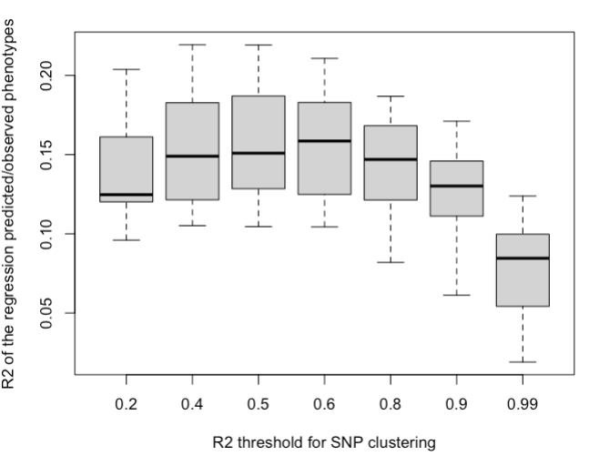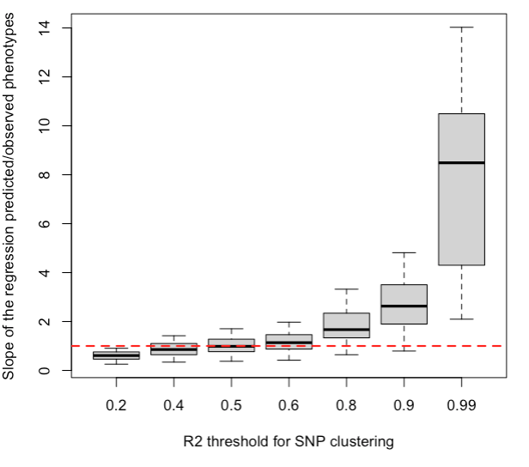

Figure SXX: The threshold r²=0.5 maximize the linear fit between the observed and predicted phenotype (left) and the slope of the regression for this value is closest to 1 (right).
Fig SXXX: Distribution of the number of SNPs among the 601 QTLs

Fig SXXX: Distribution of the length the 601 QTLs

Figure SXX: Length and number of SNPs in QTLs depending on their location
Figure SXX: Synergistic pleiotropy in both arm and centers.

Table S1. Number of clusters and singletons at different R² thresholds (out of 33,510 significant SNPs for at least one trait out of 8)
R² threshold | Number of clusters | Number of singletons
0.2 | 601 | 199
0.4 | 893 | 326
0.5 | 1,058 | 392
0.6 | 1,240 | 474
0.8 | 1,955 | 832
0.9 | 2,948 | 1,375
1.0 | 8,882 | 5,187

Table S2. Number of clusters by trait and R2 threshold
Trait | R² = 0.2 | R² = 0.4 | R² = 0.5 | R² = 0.6 | R² = 0.8 | R² = 0.9 | R² = 1.0
SF | 131 | 162 | 192 | 210 | 324 | 473 | 1,372
SB | 194 | 269 | 318 | 376 | 600 | 878 | 2,588
FS | 88 | 107 | 120 | 137 | 193 | 261 | 560
FB | 179 | 229 | 253 | 277 | 400 | 588 | 1,725
BS | 39 | 44 | 47 | 53 | 73 | 109 | 252
BF | 33 | 36 | 38 | 39 | 50 | 61 | 138
Area | 190 | 245 | 275 | 322 | 480 | 763 | 2,682
Beta | 225 | 297 | 331 | 373 | 565 | 809 | 2,410

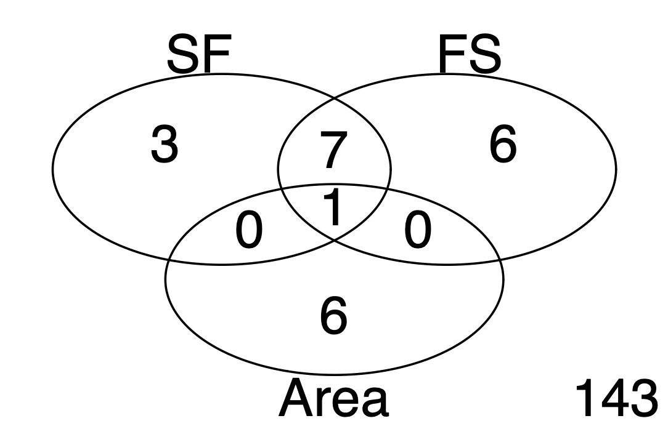

FigureSXX: Number of selected haplotypes that constrained at least one SNP significantly associated with one of the three traits under directional selection in our environment.

