Area cluster 25 – 36 SNPs / 50kb

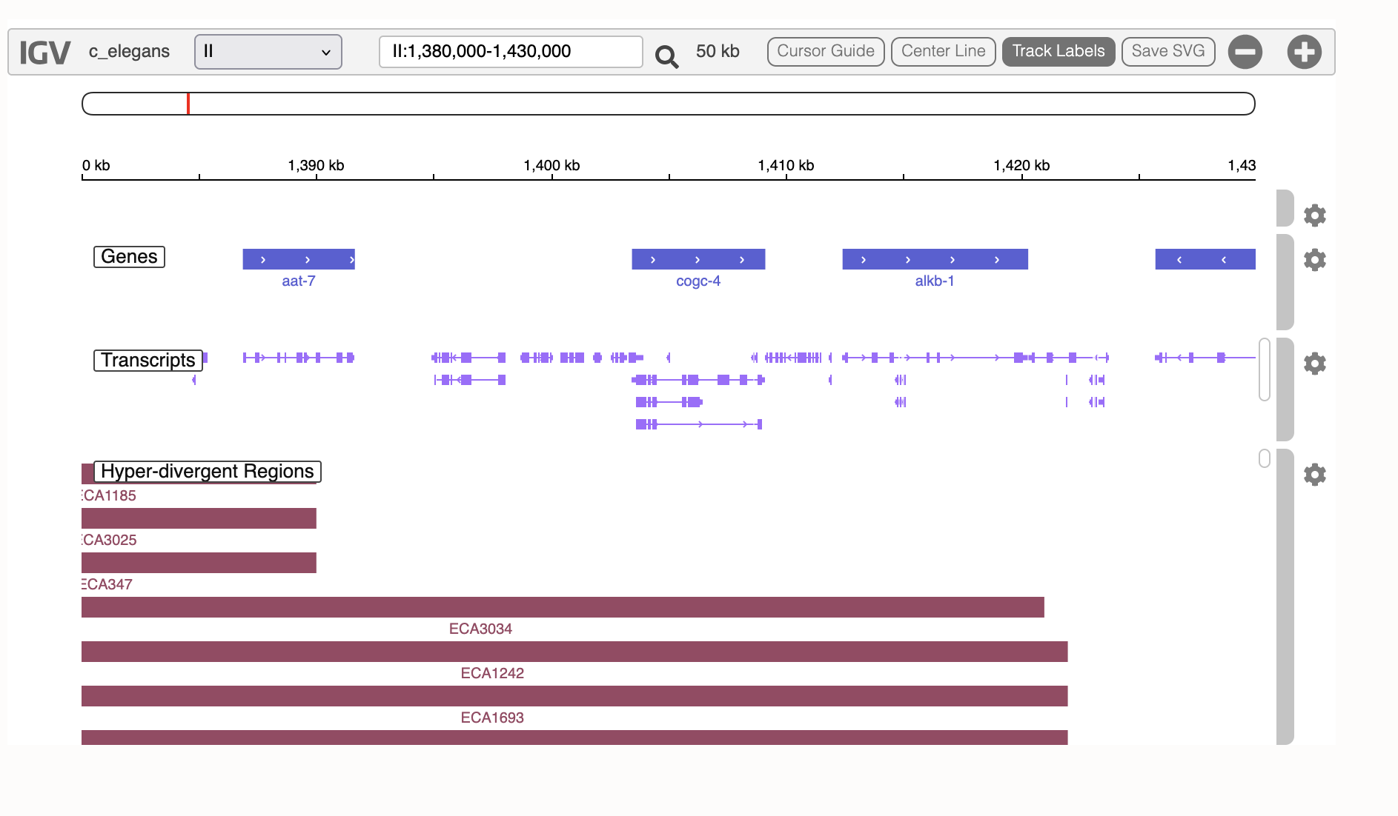
Region seems swept :
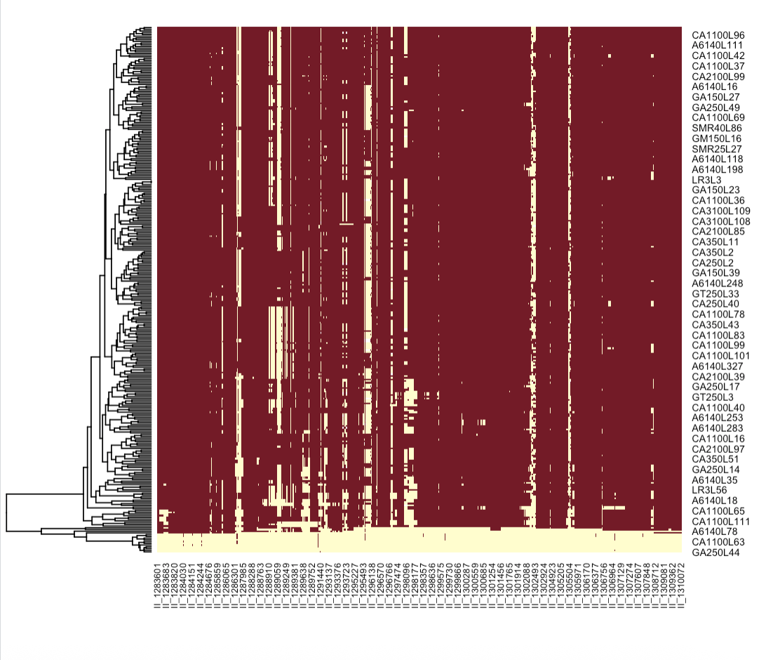

The few sign. SNPs are all in a single founder – MY16
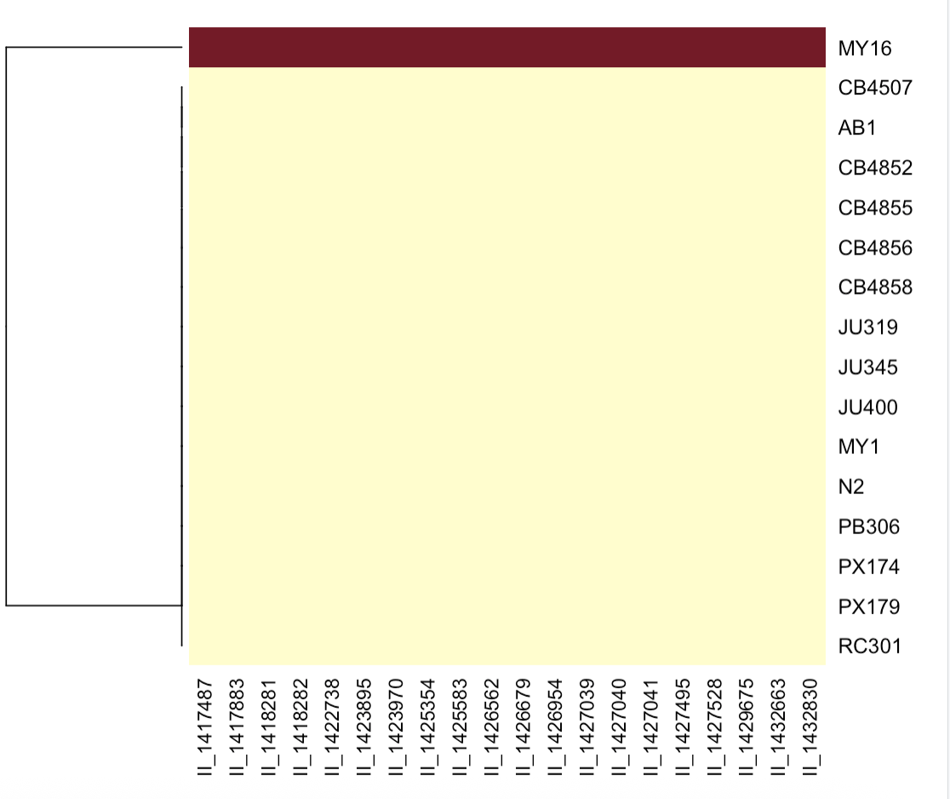

Trajectories
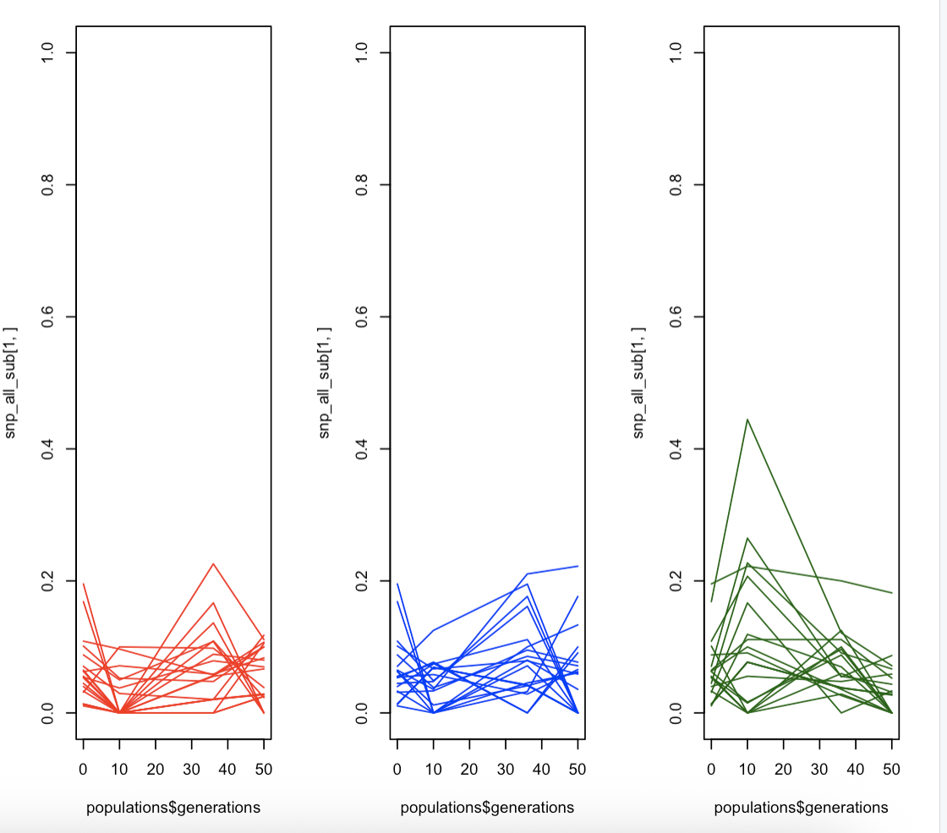

What is strange is that the cluster is significant for both beta and area.
But the effect is stronger for area


