Area cluster 55 – 6 SNPs / 80kb

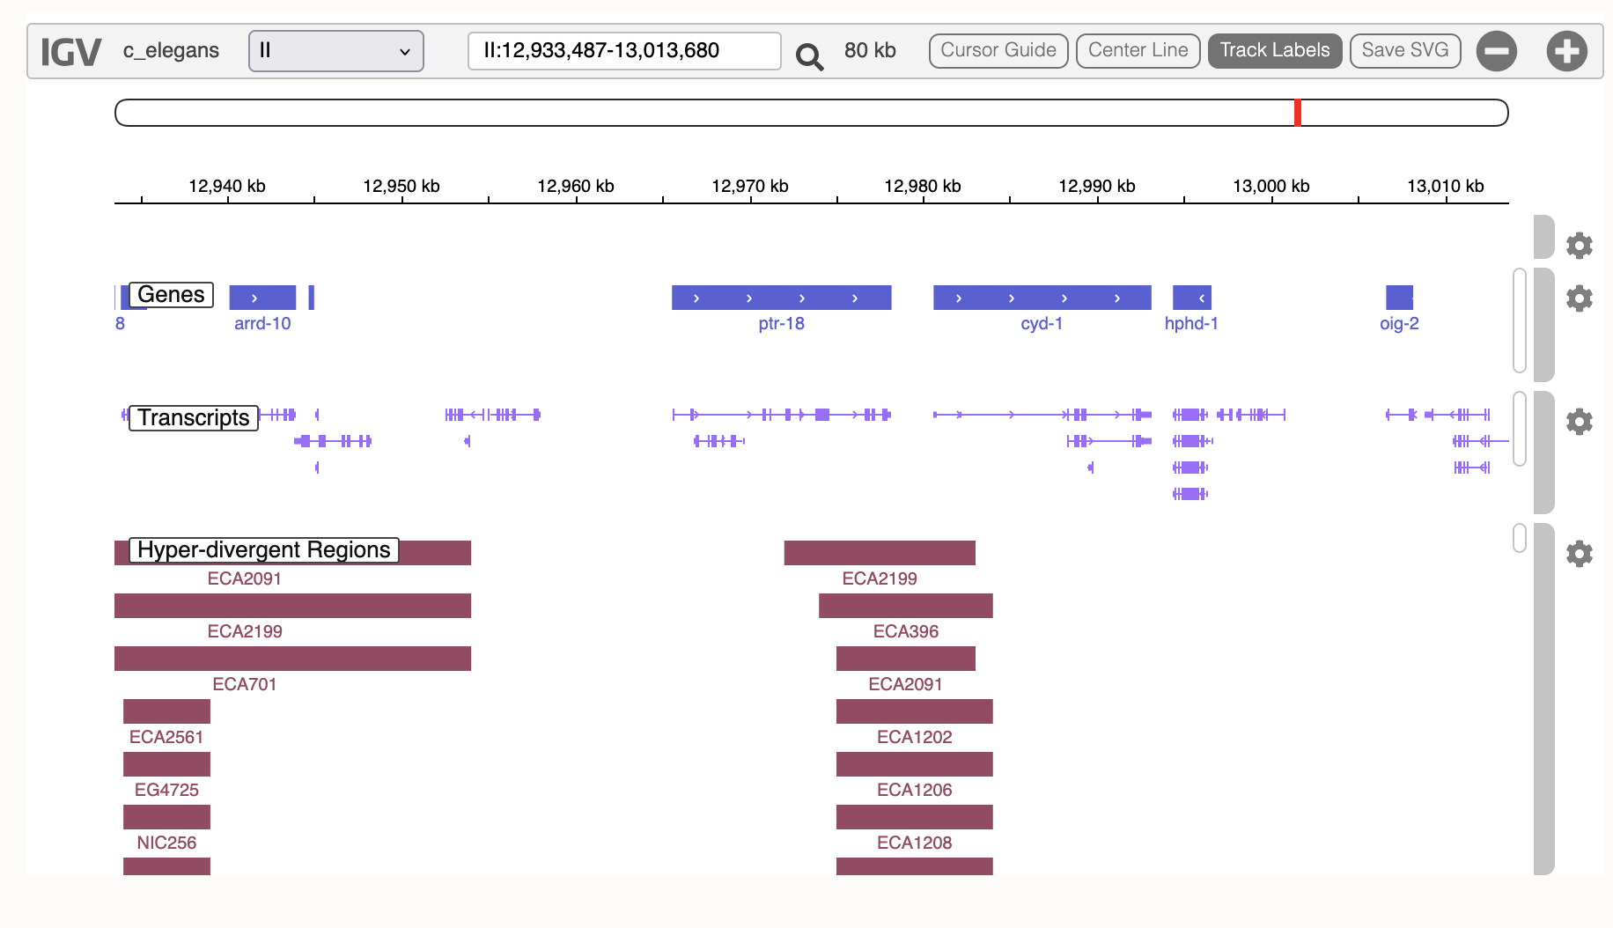

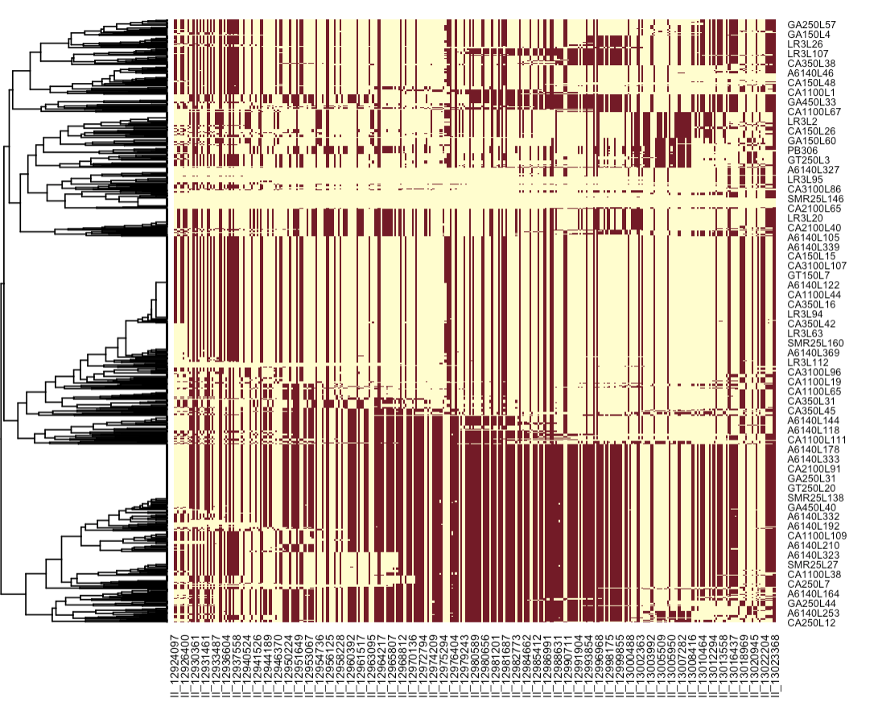
The few selected SNPs are all in a single founder
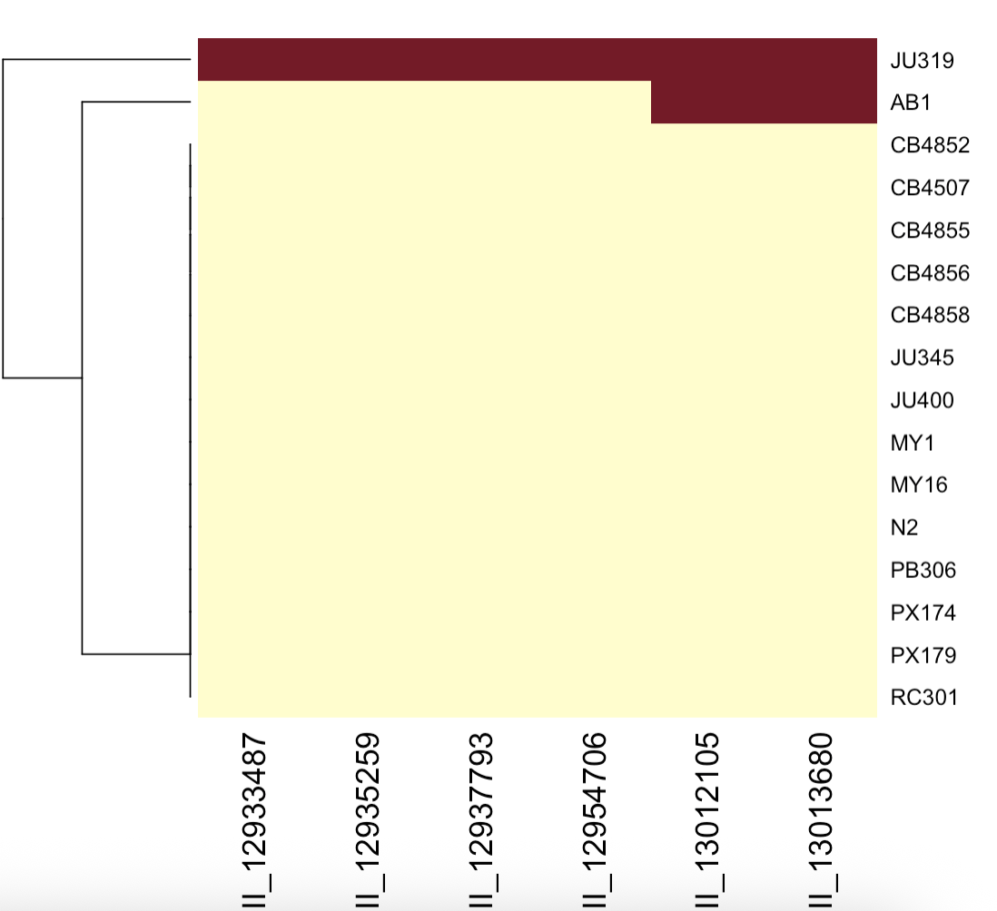

Trajectories
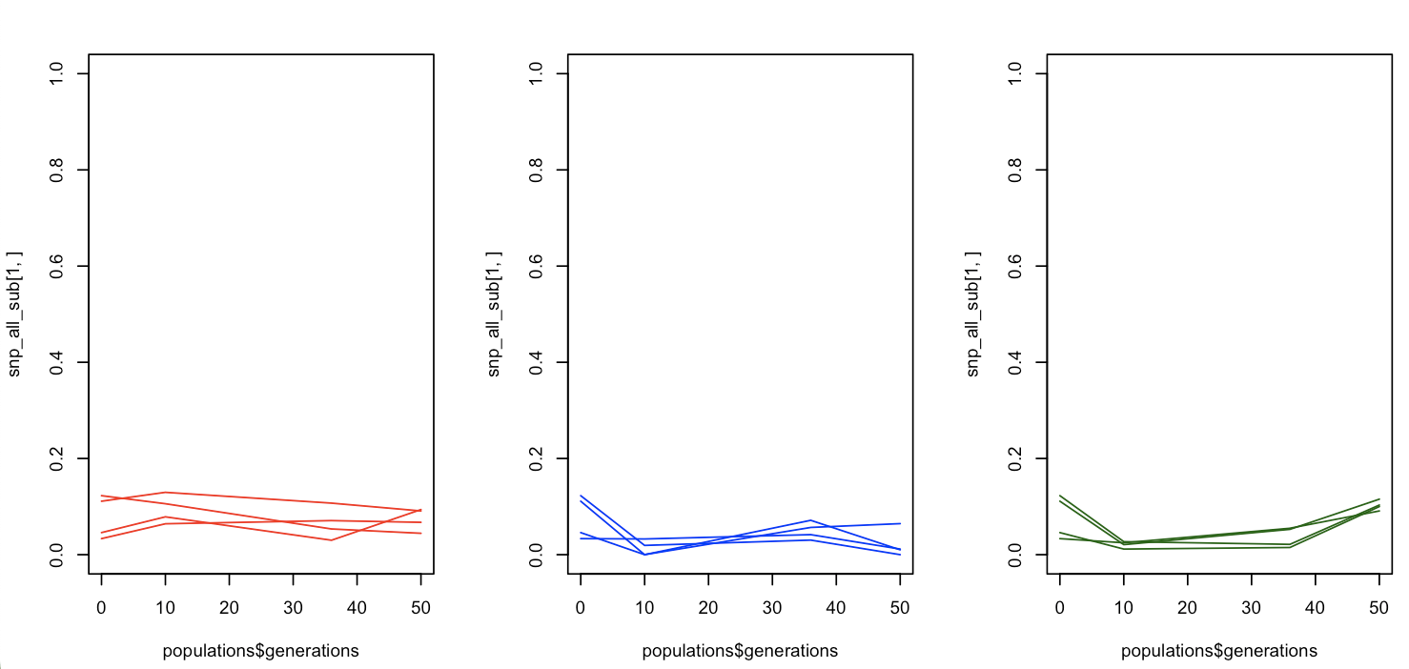

What is strange is that the cluster is significant for both beta and area.
But the effect is stronger for area


