Area cluster 132 – 132 SNPs / 178 kb

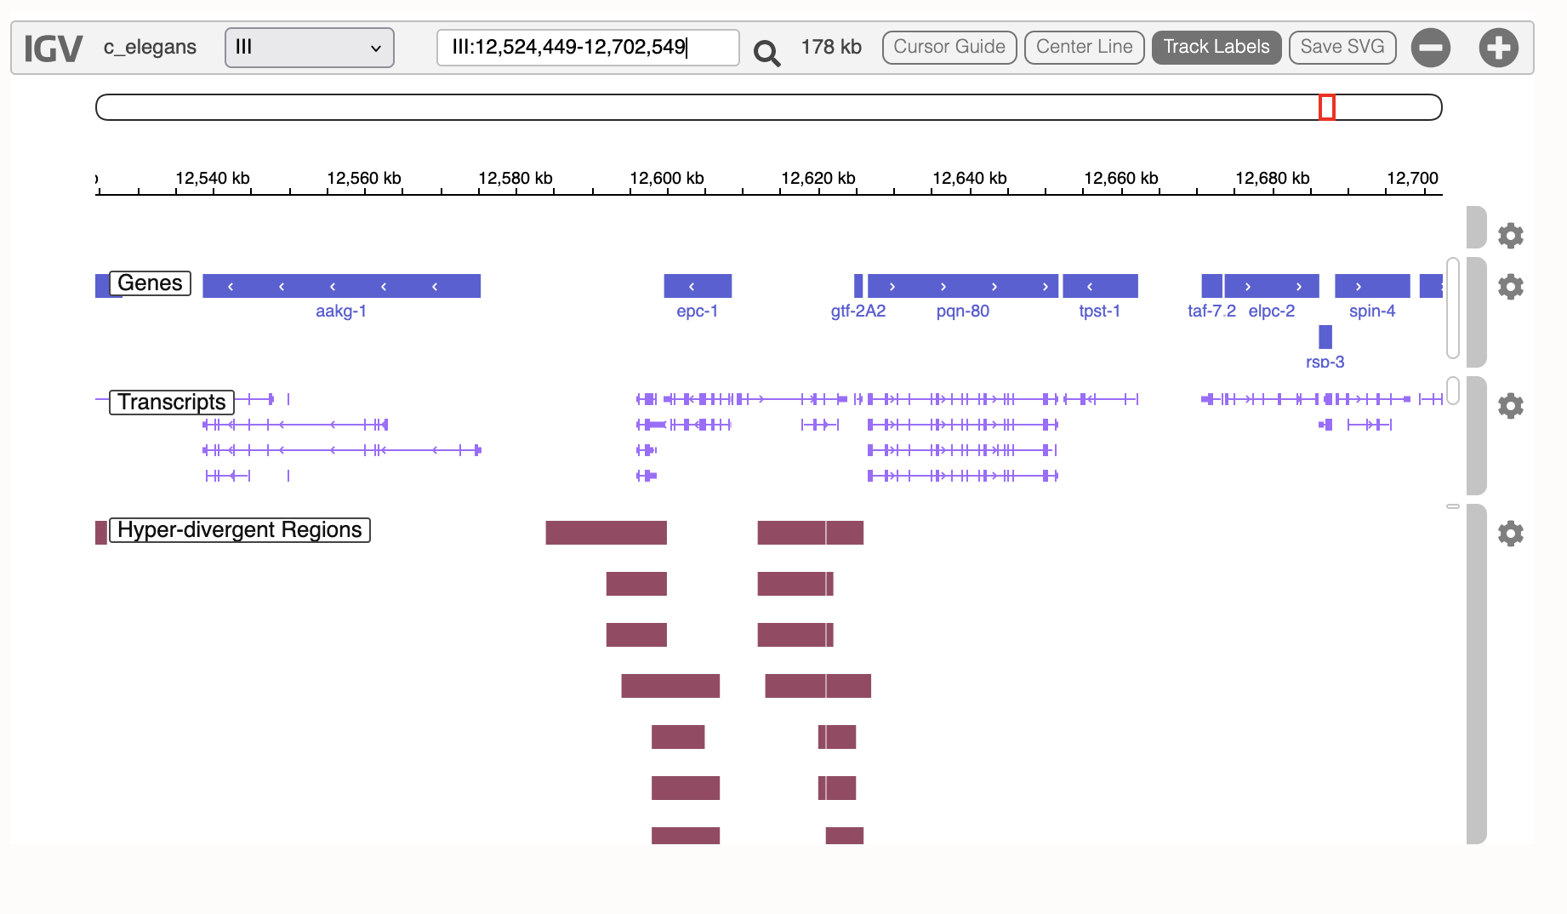
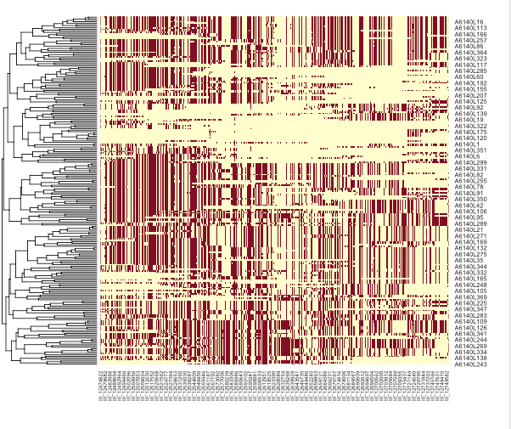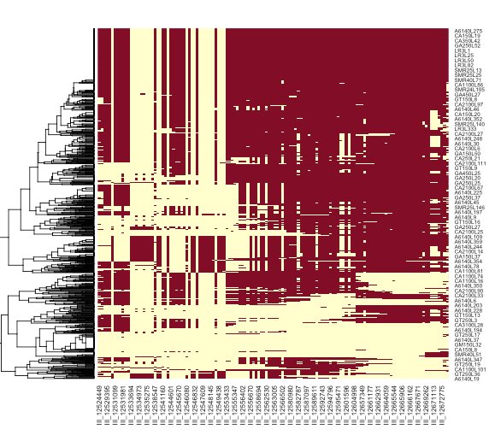

Several different founder haplotypes – one have a significant pattern though
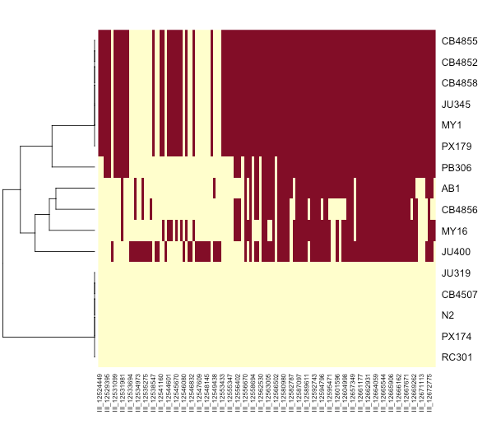
Out of the

Trajectories
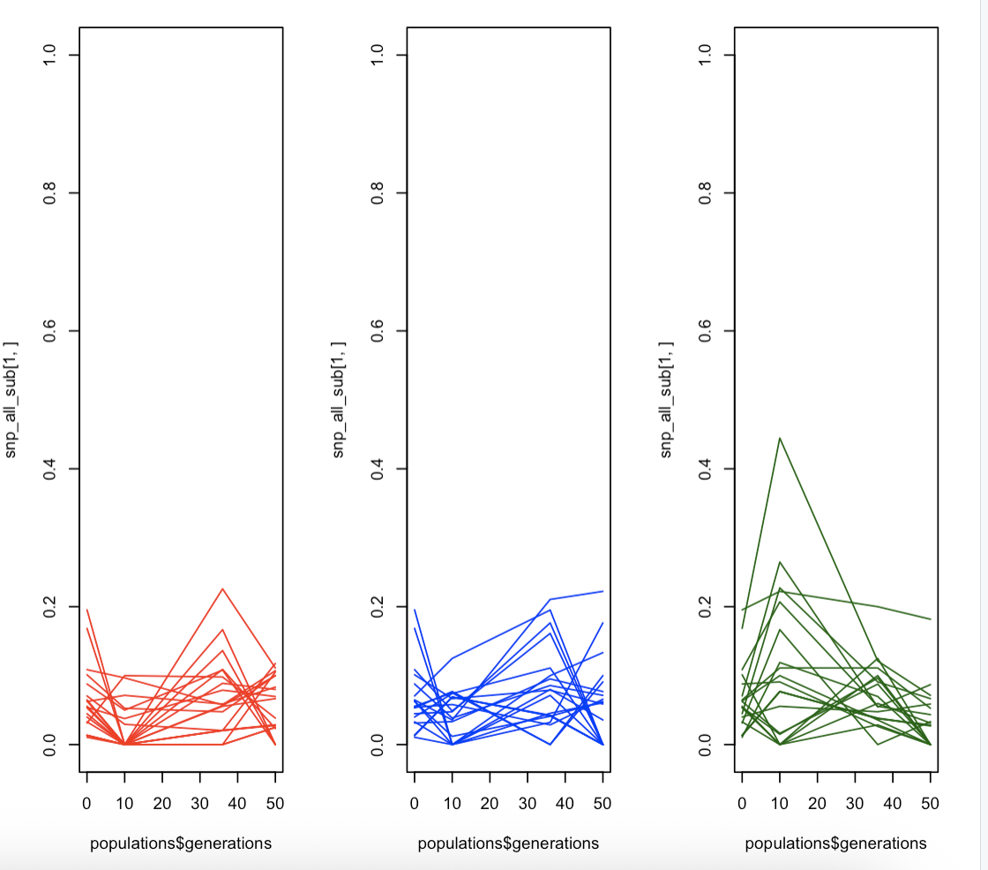

What is strange is that the cluster is significant for both beta and area.
But the effect is stronger for area


