Area cluster 185

X : 15764235-16589303
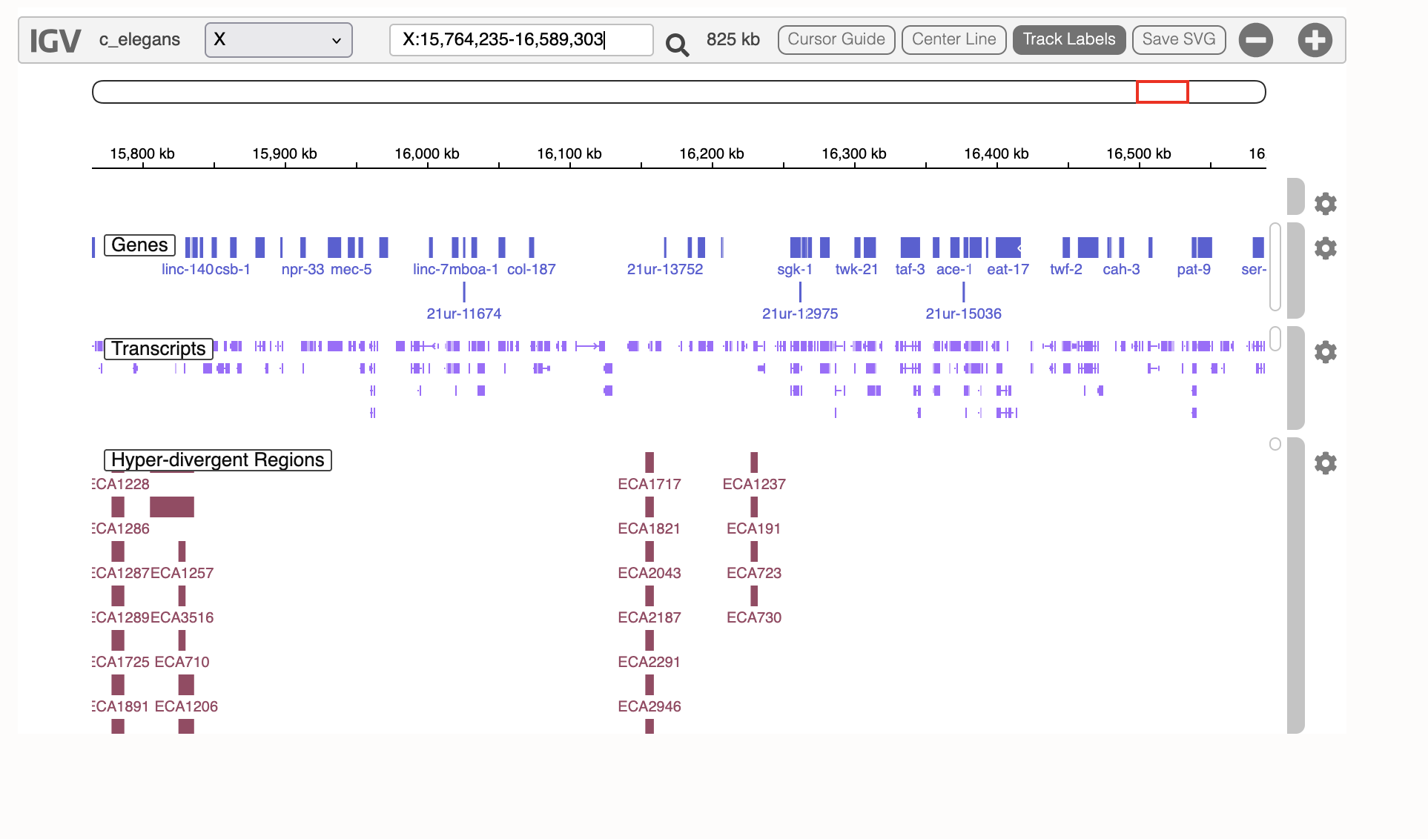
Here again we have a large cluster – 825kb made of 185 SNPs. It contains 3 different HDRs.

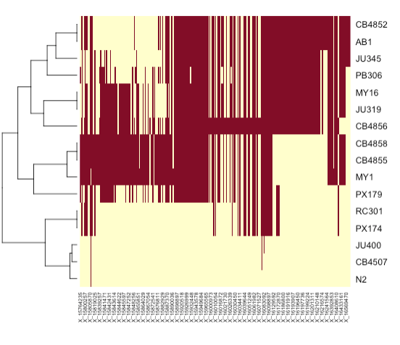
When split into three different alternative alleles based on founders, two affects beta, which is not necessarily expected. All three affect Area but linearly only.

There are located at two independent HDR and are much smaller.

MY1/CB4855/CB4858: 29 SNPs

X:15798848-15888648 90kb only
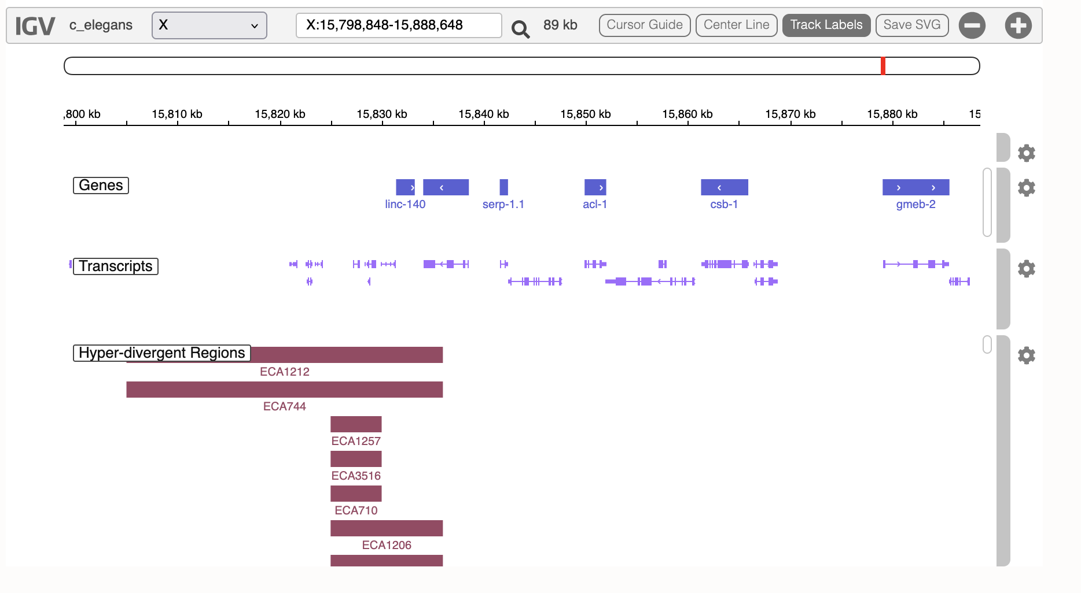

And AB1/CB4852
X:16214976-16241564 26 kb
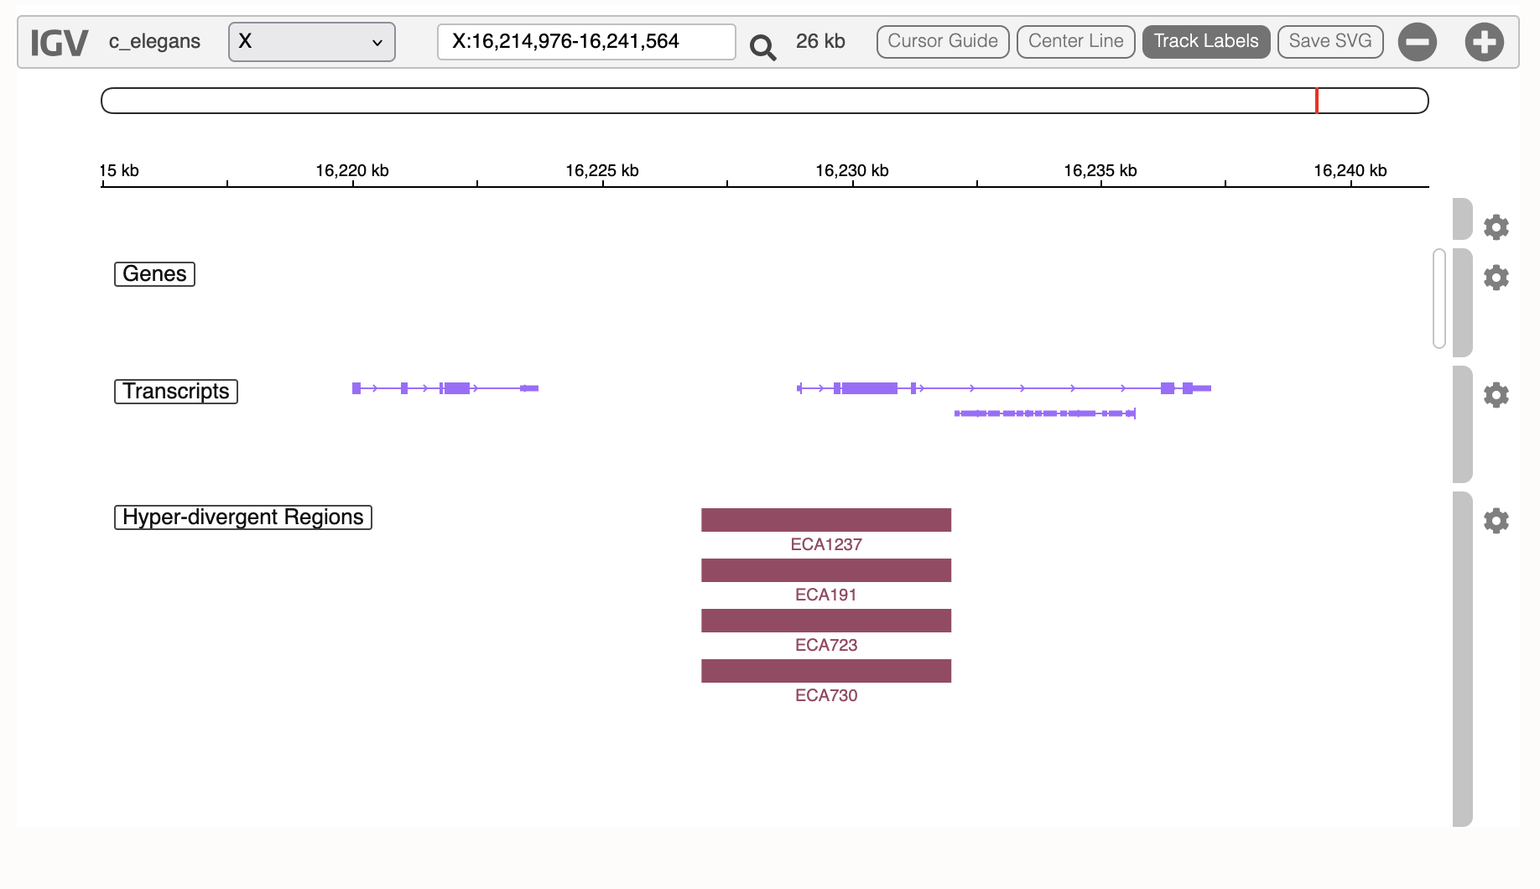

On the opposite, area seems mainly to respond to a combination of genotypes
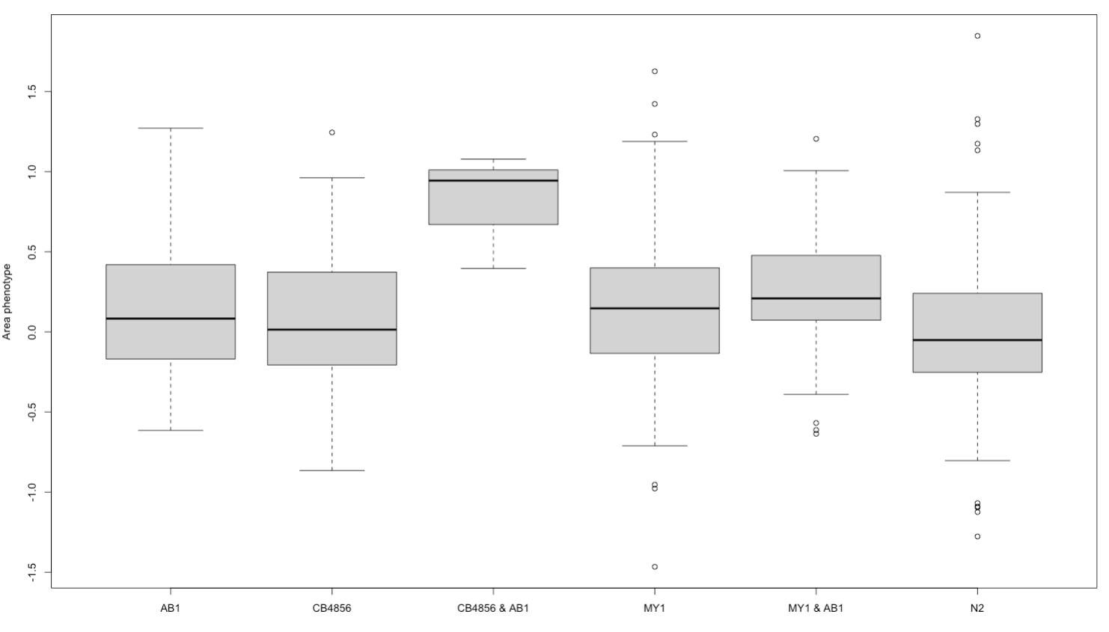
But only 9 lines -> so nothing signi

