Beta – Cluster Nb XX – 37 SNPs – 2Mb
I: 5883574-7996414

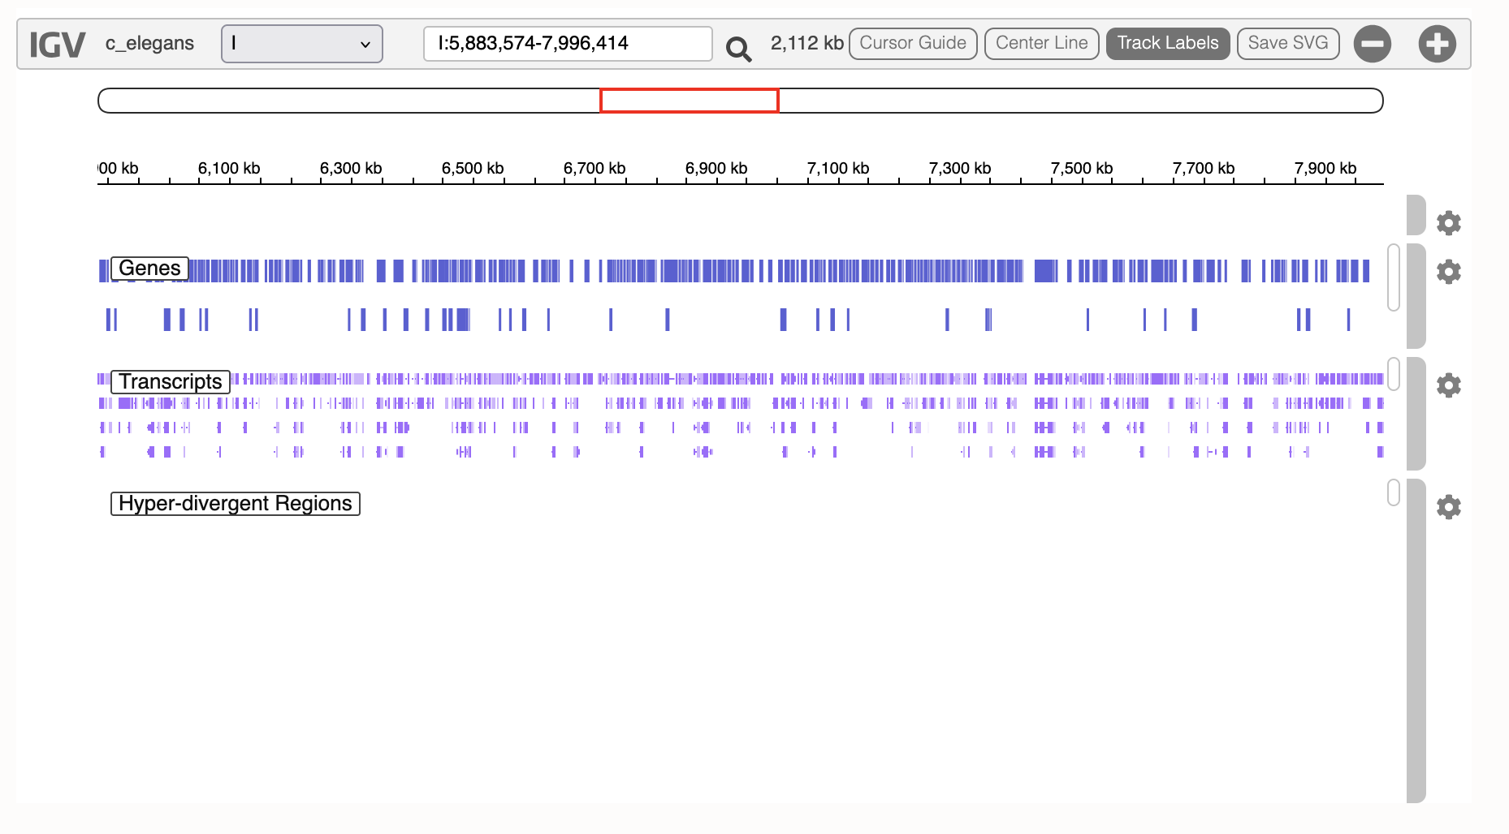

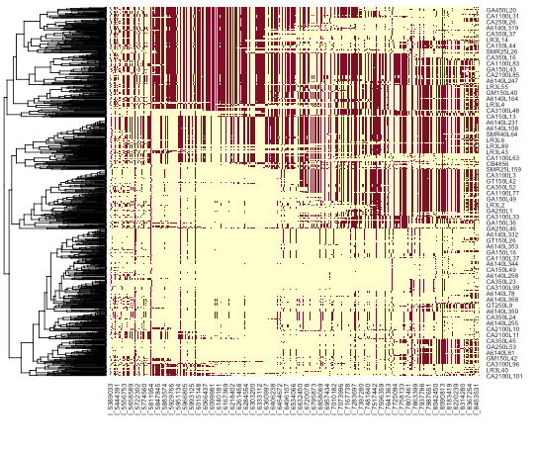

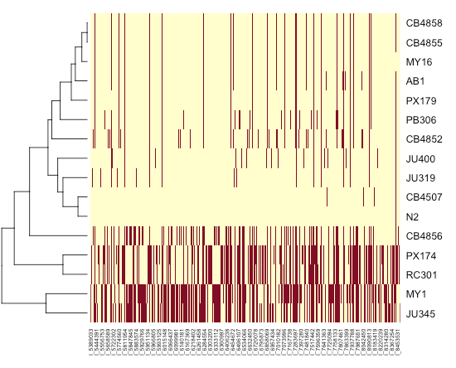

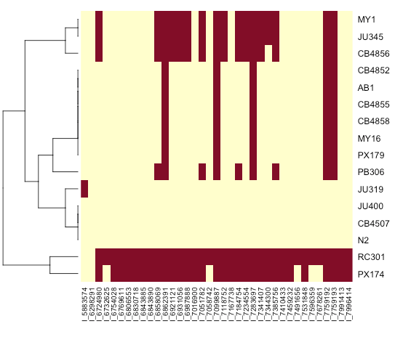

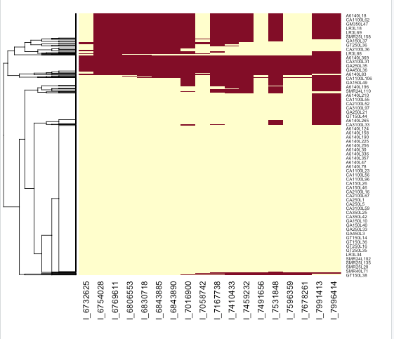

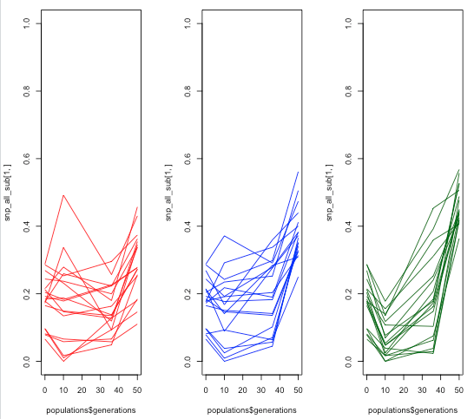

Trajectories reveal two sets of SNPS ? -> Shared RC301-PX174 (13 SNPs) or only RC301 (5 SNPs)

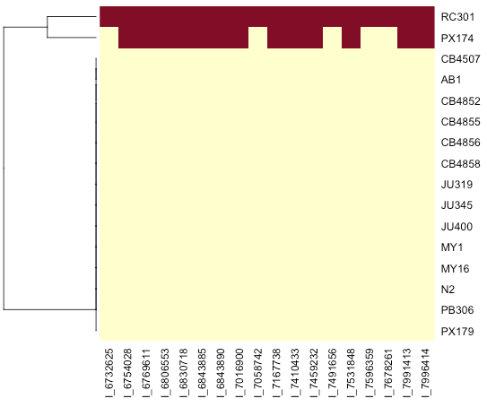

We can redo the mapping with three alleles :
- All N2 (530 CeMEE lines)
- Shared RC301/PX174 SNPs (162 CeMEE lines)
- RC301 private alleles (65 CeMEE lines)

Results of the mapping:
1/ No effect on body area
2/ Both affect positively beta, but the RC301 private alleles are much stronger
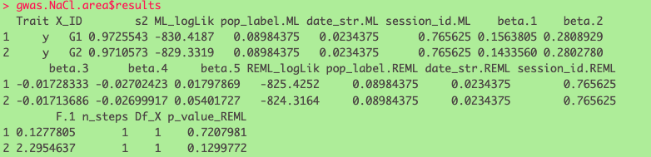

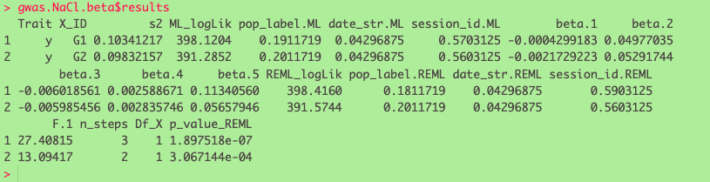

If I do a simple regression (without GRM)


