Beta – Cluster Nb XX – 15 SNPs – 1.2Mb
V: 6046042-7278103

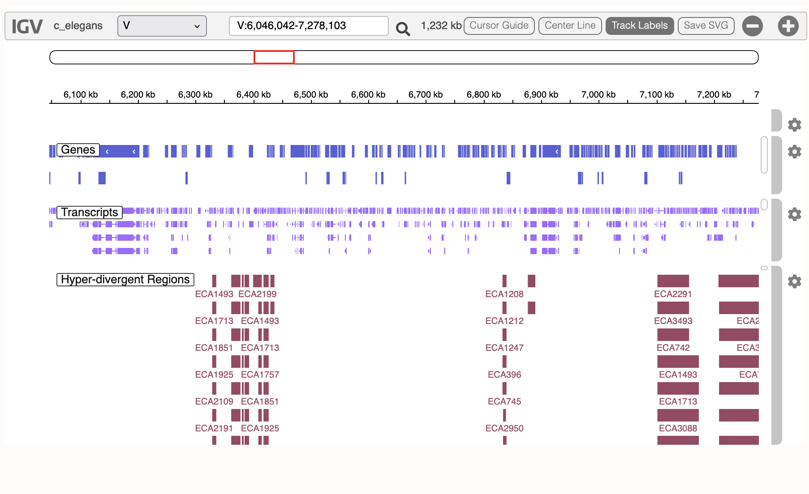

Region poor of SNPs -> much more just after
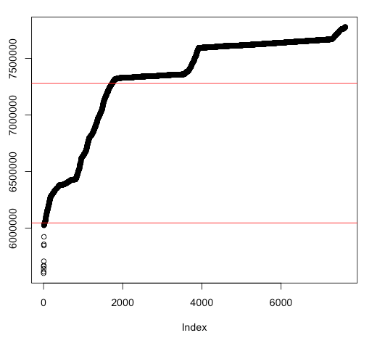
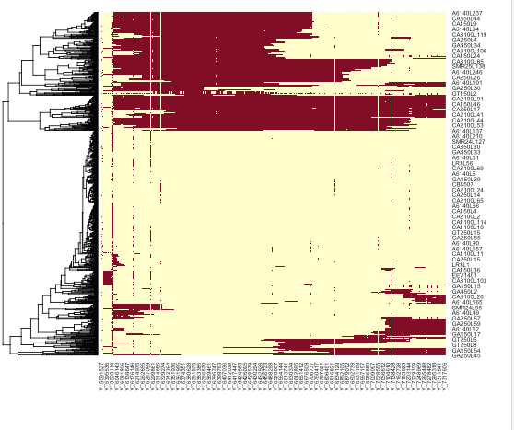
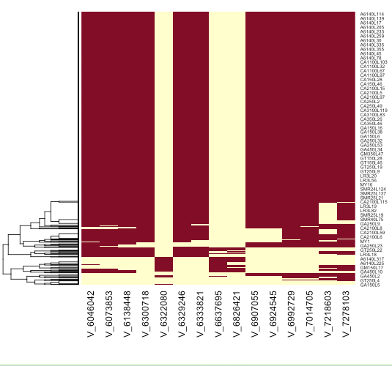
Out of these 15 SNPs :
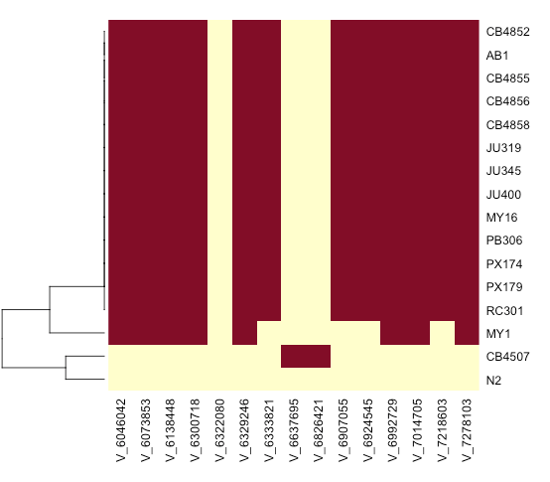
Small difference between N2 and CB4507 – match one of the sub-cluster with R=0.8

Trajectories of these three SNPs:
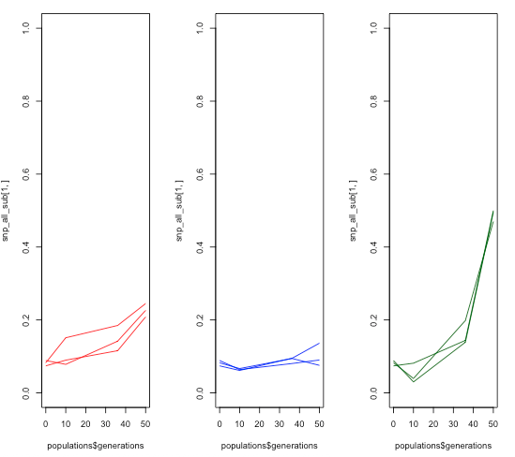

Trajectories of the other ones:
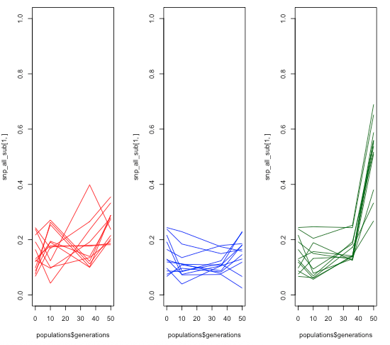
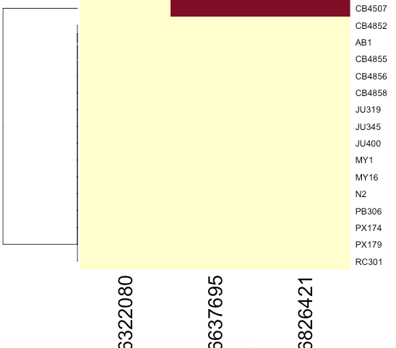

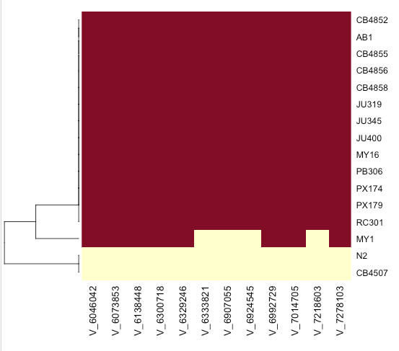

Evidence for a new mutation ? -> weird as the frequencies are not low at all. Occurred early maybe.

Three mutations, one absent in the founders !
V: 6322080,6637695,6826421

500kp away – no HDR
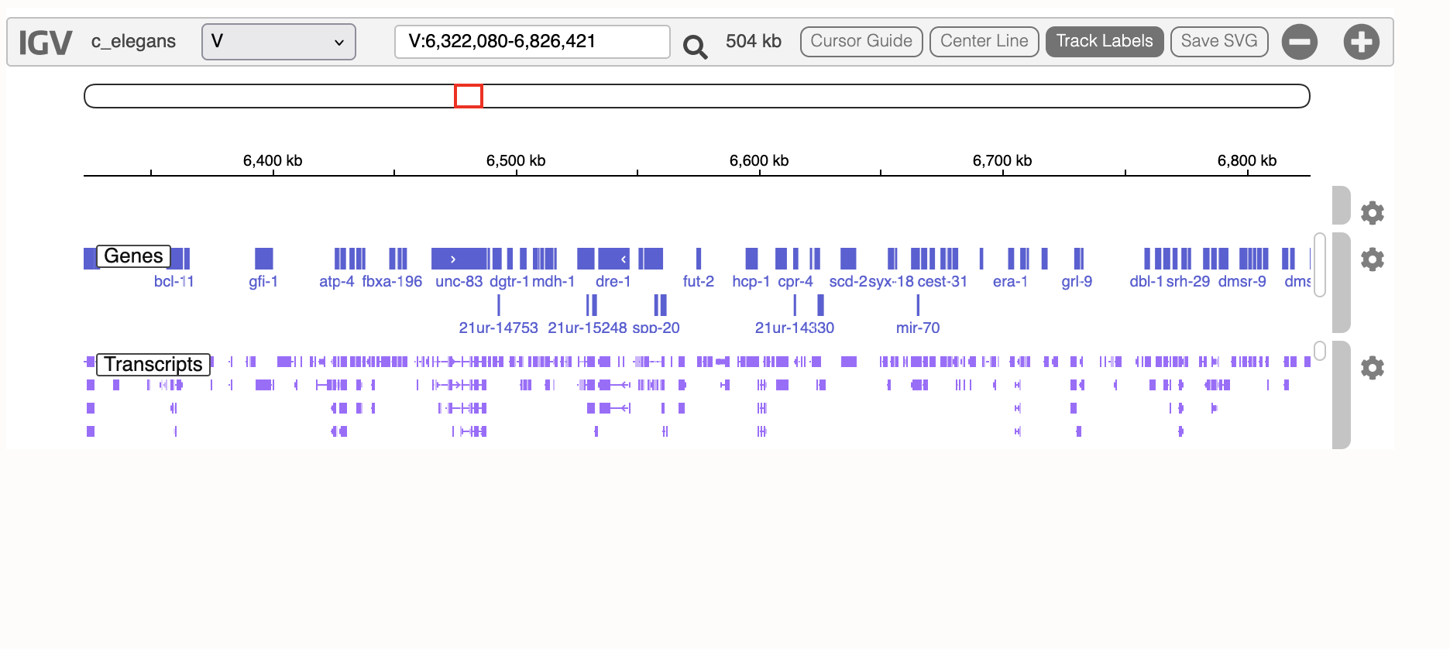

The new mutation is an intron of cest-24
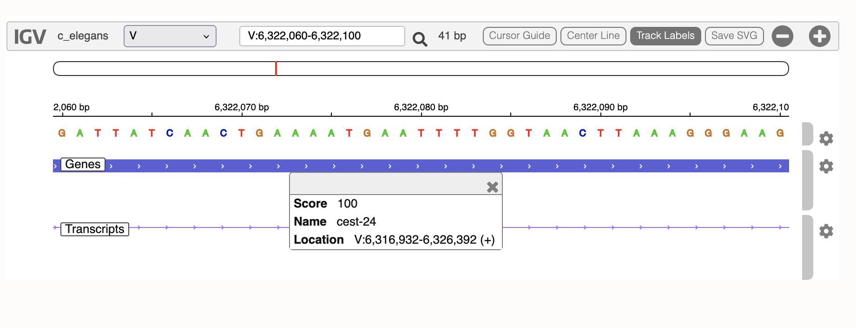
But also 200 bp away from an intronic gene T28C12.15

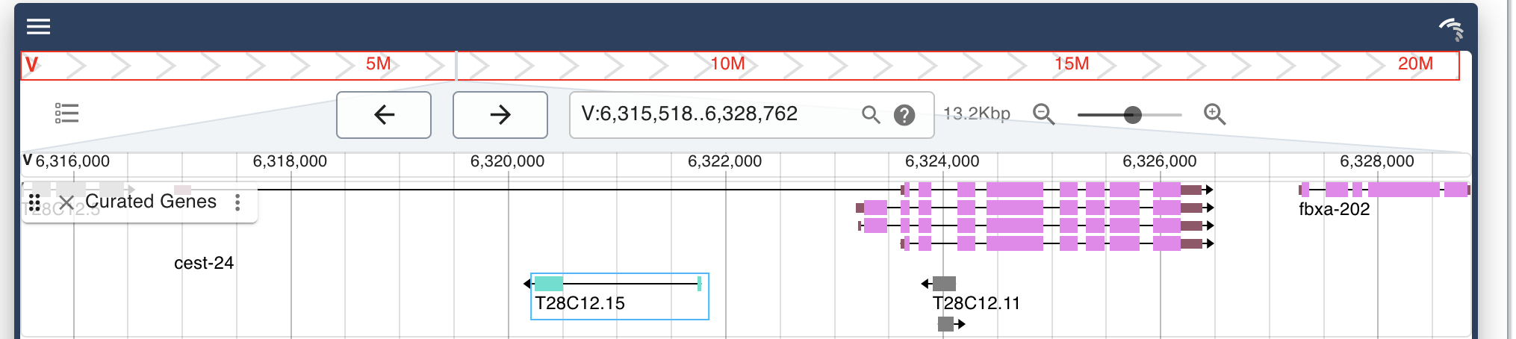
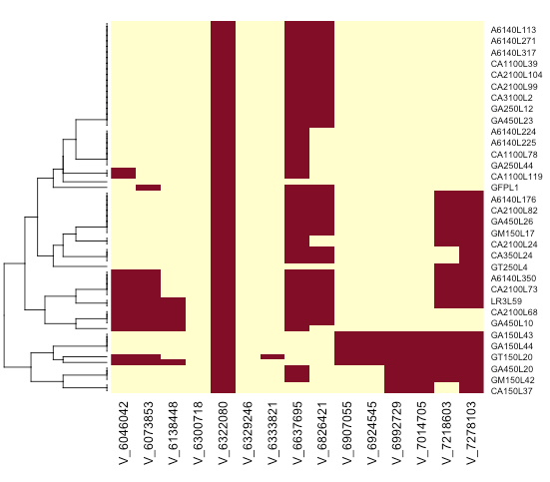

We can re-do the mapping with the following alleles :

- New mutation : 64 lines
- All three : 40 lines
- None of the other ones 38 lines
- All the other ones : 674 lines

Mapping results:
- None affect body area
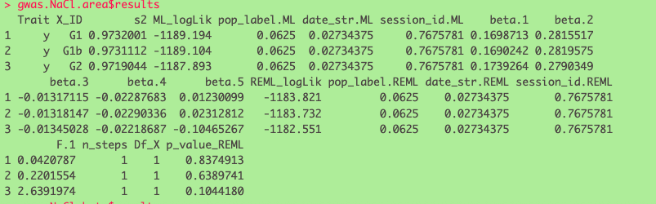
- Only new mut / all three affects beta
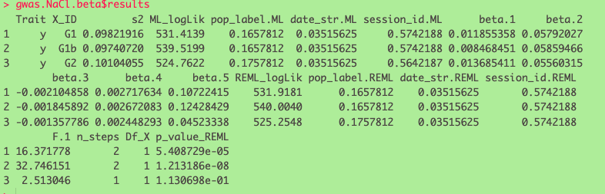

Regression:



