Beta – Cluster Nb XX – 1 SNP
IV: 10499135 – Exon of tax-6
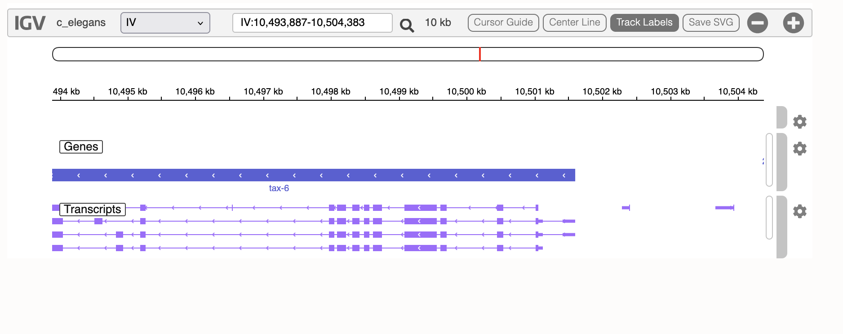
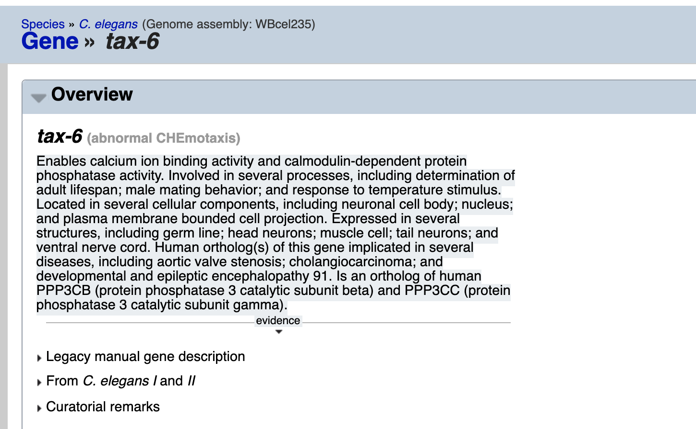

Region poor of SNPs -> much more just after

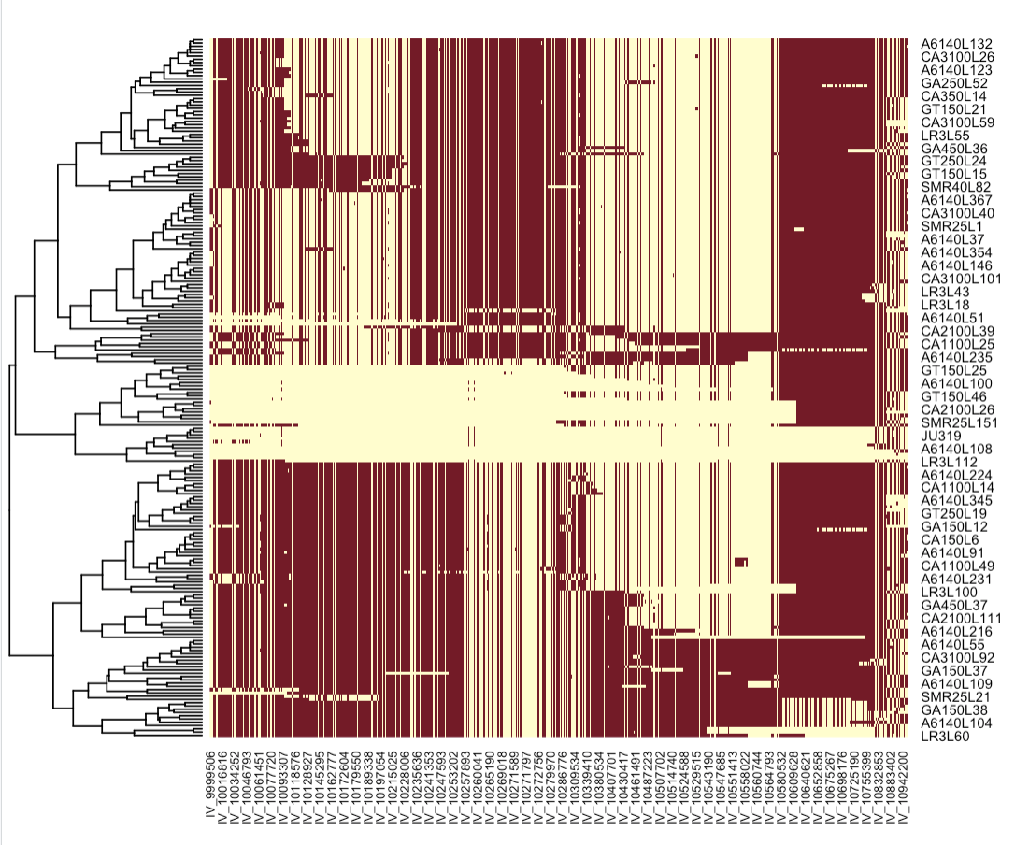
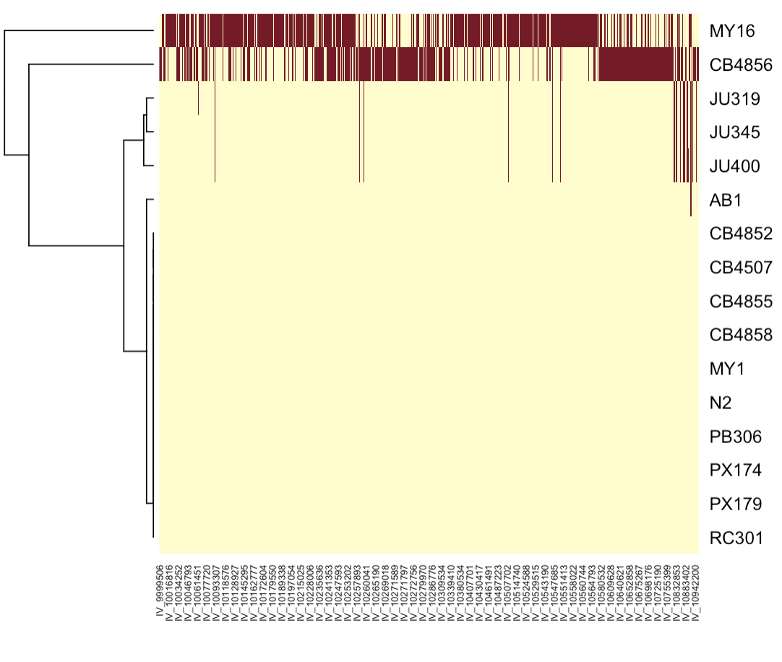
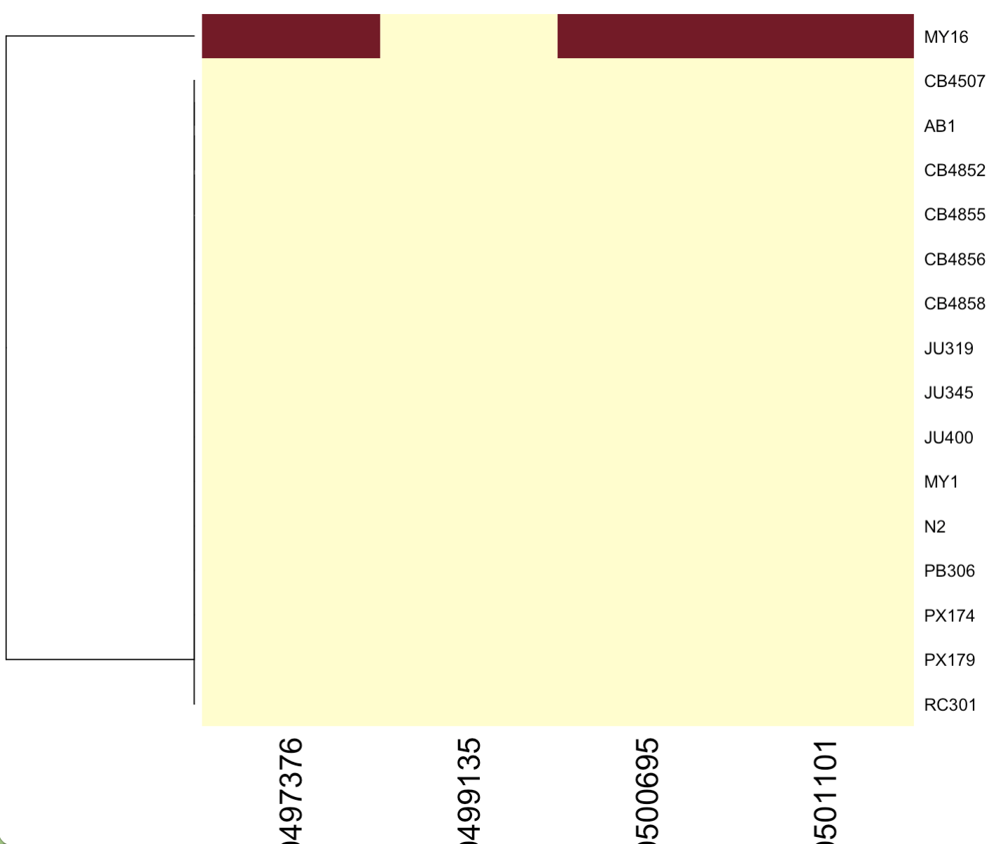
The SNP is absent ?!?
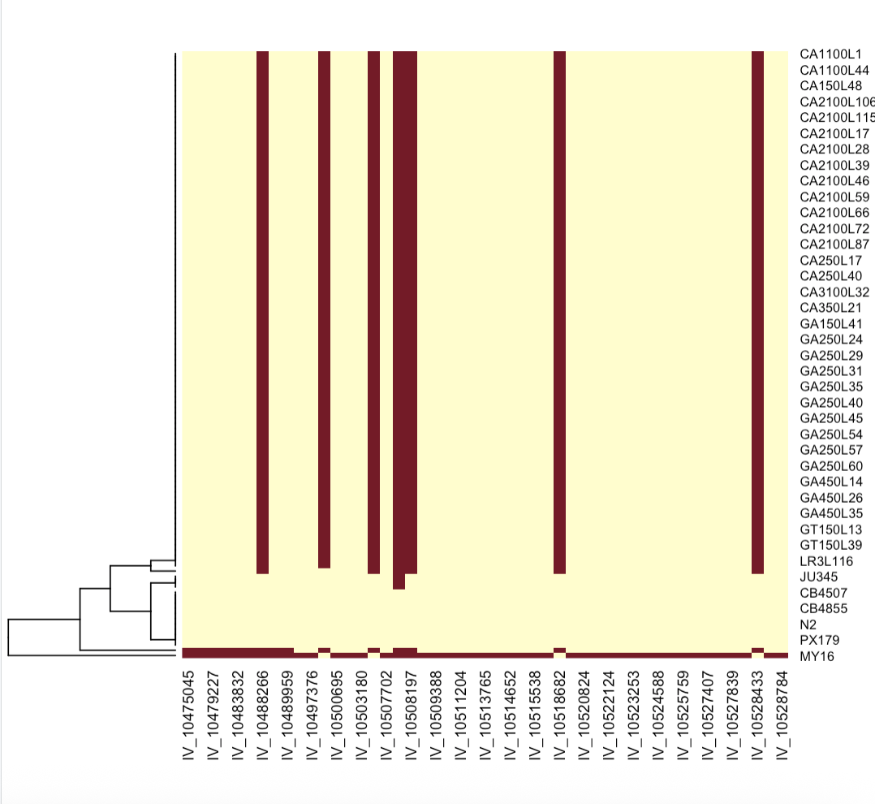

Inserted in a single background : CB4856

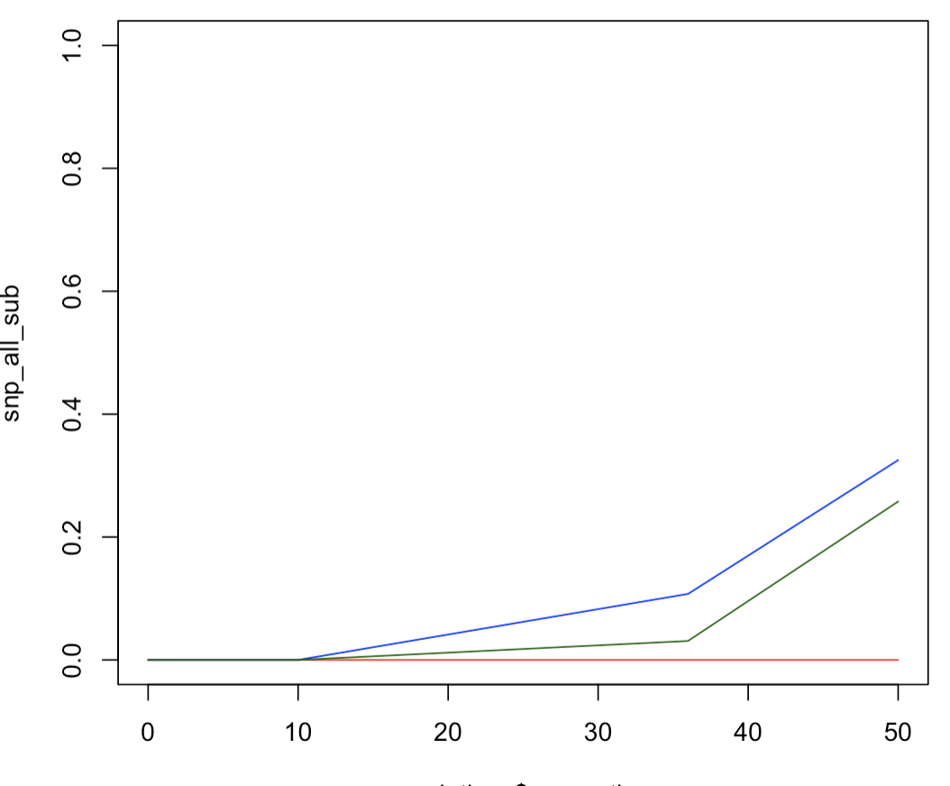

Evidence for a new mutation – very clear, in the CB4856 background

We can re-do the mapping
With:
- All bcgk but CB4856 (206)
- CB4856 backgd (754)
- CB4856+new mut (98)

Mapping results:
- None affect body area
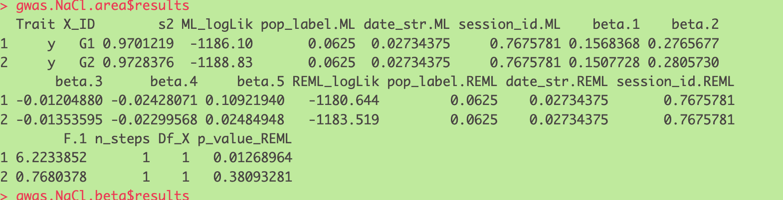
- Only new mut affects beta
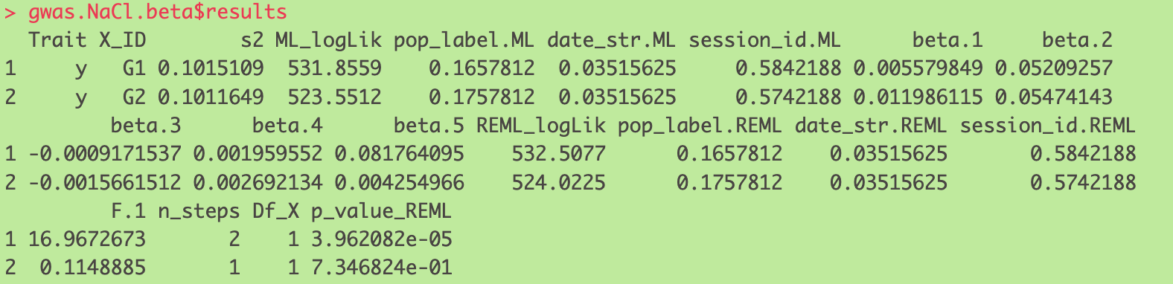

Regression:

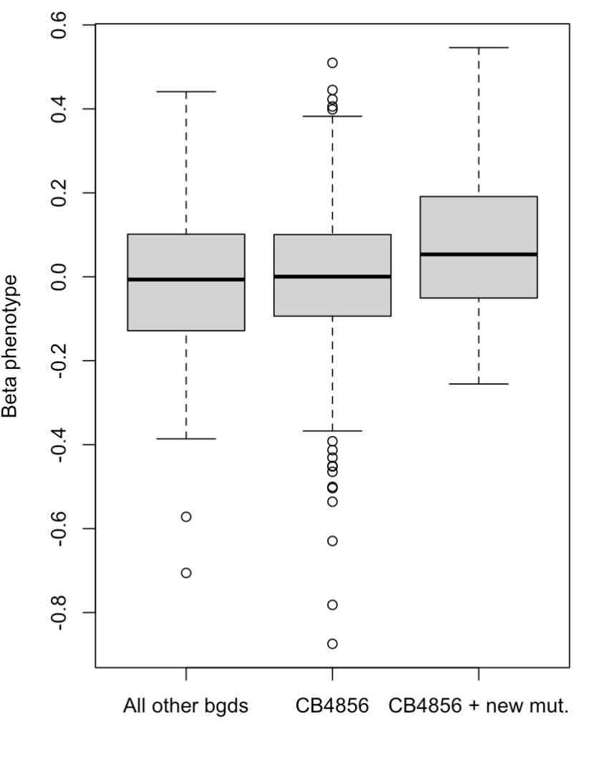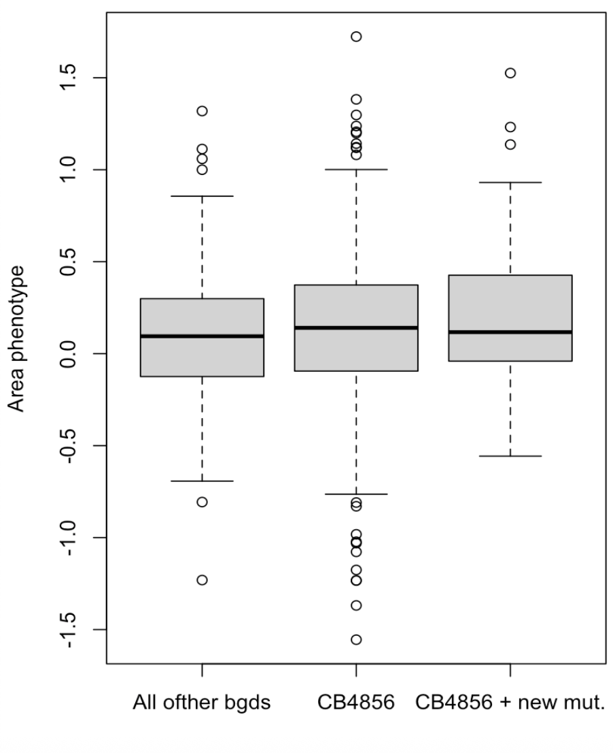
It affects the first two traits in the same direction !!!!


