Pleiotropy Limits the Predictability of Adaptive Genetic Evolution

Over the past two decades, advances in genomics have transformed our ability to identify the genetic basis of complex traits. Genome-wide association studies (GWAS) identifies hundreds to thousands of loci underlying phenotypic variation in humans, model organisms, and natural populations, while populations whole genome sequencing allows to track through time the allele frequency trajectories of these loci. Combined, these developments have raised the possibility of resolving a core evolutionary objective: if we know how genetic variants affect phenotypes under selection, can we predict how evolution will shape their frequencies?

Our ability to predict genetic evolution relies on our understanding of the genotype-phenotype-fitness associations. GWAS measures how genetic variants contribute to phenotypic variation, whereas natural selection acts on differences in fitness. Our ability to predict genomic evolution thus depends on the link between a trait variation and its effect on fitness. At the phenotypic level, quantitative genetic theory predicts that the evolutionary response of a trait depends not only on the strength of selection and its additive genetic variance, but also on its genetic covariation with other traits. Indeed, empirical studies repeatedly show that traits experiencing directional selection often evolve more slowly than expected or in directions that differ from univariate predictions. Multivariate models incorporating the genetic covariance matrix substantially improve predictions of phenotypic evolution, demonstrating that adaptation is constrained by genetic correlations among traits. At the genomic level, several mechanisms could generate a discrepancy between trait associations and evolutionary dynamics. Pleiotropic mutations simultaneously affect multiple phenotypes and its response to selection will depend on the summed effect of these multivariate phenotypic changes on fitness. Additionally, linkage disequilibrium will create genetic correlations between different traits, causing selection to act on haplotypes rather than on individual mutations. Epistatic interactions between linked loci may further modify the fitness effects of alleles depending on their genetic background.

The evolutionary response of a genetic variant will therefore depend not only on its effect on a focal phenotype but also on its broader genetic and phenotypic context. Yet, despite decades of quantitative genetic theory and the explosion of genomic data, there has been remarkably little empirical evaluation of whether GWAS derived effect sizes can predict the evolutionary trajectories of the loci they identify.

Here, we address this question by combining experimental evolution in a stressful environment with genome-wide association mapping of a quantitative trait under directional selection. We directly compare predicted and observed allele-frequency changes at several hundreds of quantitative trait loci (QTL) over the course of adaptation during 50 generations. By comparing predictions from univariate and multivariate phenotypes, we explore the role of pleiotropy in shaping genomic response and discuss the genetic architecture of these pleiotropic effects.

Results

Populations adapted and multiple phenotypes are under direct selection

We performed experimental evolution of Caenorhabtis elegans in high population size (10⁴ individuals) and non-overlapping generation.The ancestral population, created from the cross of 16 wild-isolates, was initially domesticated during 140 generations in a non-stressful stable lab environment and retained extensive standing genetic variation before the experiment. Three independent replicate populations were then evolved during 50 generations in a gradually increasing salt-concentration environment that induces strong osmotic stress. After evolution, all three replicates showed increased fitness relative to the ancestor and phenotypic evolution of body size, together with locomotion behavior, measured using high-throughput phenotyping (REF). We enriched our previous results, confirming that three of these seven traits were under directional selection after removing the influence of genetic correlations between traits (REF). Strikingly, one of the locomotion traits is negatively selected while all three traits are genetically positively correlated. Indeed, we previously showed that phenotypic evolution was constrained by genetic correlations between phenotypes. As a results, we observed moderate phenotypic evolution for these phenotypes and this last locomotion behavioral trait even significantly evolved in the opposite direction of the selection gradient. Here we leverage whole-genome sequencing of populations during evolution and phenotype recombinant inbred lines to question our ability to predict genomic evolution and understand what is the genetic architecture of these genetic correlations (Figure 1).

GWAS reveal a highly polymorphic genetic architecture and predict trait distributions and correlations within lines

Using GWAS on a set of 996 sequenced recombinant inbred lines (the CeMEE panel, REF) and more than XX movie recordings, we identified more than a hundred of QTLs associated with body size (Figure XX) and our selected locomotion traits (Figure SXX). These QTLS were present in all chromosomes and their numbers of associated single-nucleotide polymorphisms and physical length on each chromosome varied according to the distribution of genetic variation in the populations both in the wild and in our laboratory, which is led by the recombination landscape of the species.

Adaptation in high-salt is led by genome-wide allele frequency changes and only partially driven by selection for body size and locomotion traits

In parallel, we used pool-sequencing of the ancestral populations and of our three evolved populations at generation 10, 36 and 50 to estimate selection coefficients. Using linear mixed-models on SNPs allele frequency dynamics during evolution, we identified regions with parallel genetic response in all populations. We show that the genetic response is distributed genome wide, with no obvious pattern between chromosome arms or centers (3,3364 SNPs were significant, q-value<0.00001). This is coherent with polygenic adaptation acting on numerous QTLs. Using the same procedure as for GWAS, we merged these SNPs in 166 selected haplotypes using stringent criteria (r² < 0.2). Among these 166 haplotypes, only 23 contained SNPs that were also associated with one of the three traits under directional selection (Figure XX). By constraining for high significance and parallel response among populations, we are likely underestimating the regions under selection. Yet overall, most of the response to selection seems to affect traits that are not measured or for which we lack power to significantly detect an effect in our GWAS. For some of the selected haplotype, only a small proportion of the selected SNPs are significant in the GWAS, suggesting that we only partially explain the reason why these haplotypes are changing in frequency (Figure XX)

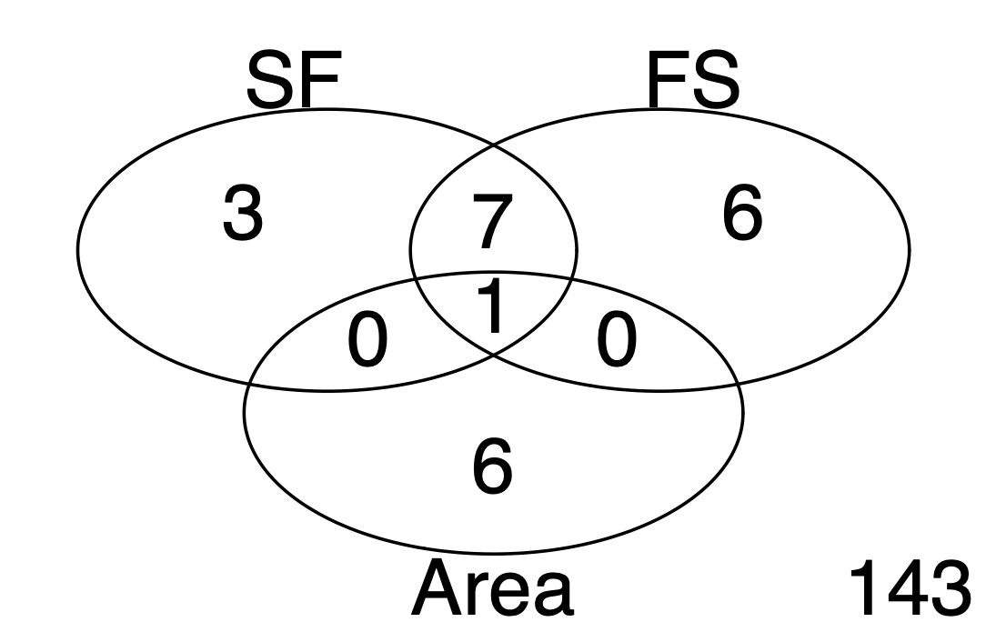

FigureXX: Number of selected haplotypes that constrained at least one SNP significantly associated with one of the three traits under directional selection in our environment.

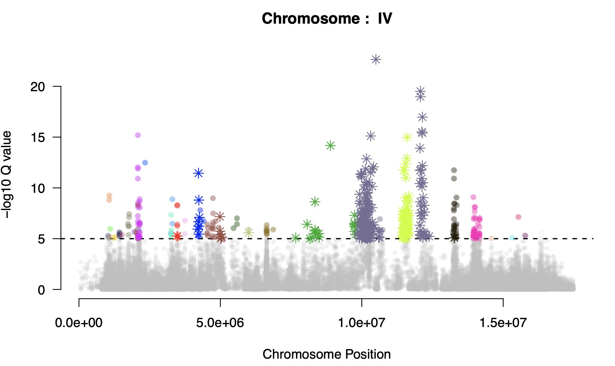
FigureXX: Manhattan plot of the genomic response to selection on chromosome IV. Significant SNPs are grouped into haplotypes based on linkage disequilibrium (LD) in the RILs and are colored accordingly. Stars indicate SNPs significantly associated with at least one of the selected traits in the GWAS. Of the 32 haplotypes showing a significant response to selection, 8 were also identified in the GWAS, highlighting the overlap between loci responding to selection and loci associated with the focal traits.

Genomic evolution of phenotypes under direct selection are not predicted from GWAS

By combining our results from GWAS and selection measurements, we can see that for each of the selected traits, the allelic effect of the traits poorly explains the selection measured in the experiment. We only detected a significant positive linear relationship for SB (slope=0.03, p-value=8x10⁻⁵). While this traits are highly polymorphic and we obtained sufficient power to detect a large number of underlying QTLs for these traits, we have very little power to detect which of the alleles will increase or decrease during evolution. The significance in the SB traits actually resembles what is expected under the infinitesimal model where a lot of loci exhibit very little change in frequency while still having an overall change in the phenotype in the direction that is expected.

FigureXX: Relationship between GWAS-derived allelic effects and selection coefficients estimated during experimental evolution. For each of the three traits under directional selection, GWAS allelic effects do not predict which loci increase or decrease in frequency during experimental evolution. All 553 significant haplotypes identified across the GWAS are shown. Black points indicate haplotypes significantly associated with the focal trait in the GWAS, whereas red points are significant in both the GWAS and the selection analysis. Grey points represent haplotypes that are not significantly associated with the focal trait in the GWAS, and pink points represent haplotypes showing significant selection during experimental evolution but no significant association with the focal trait in the GWAS. The green line represents the linear relationship between GWAS effect sizes and selection coefficients; this relationship is significant only for the second trait.

Multivariate GWAS -> still needed ?

Using the vector of the selection gradient, we computed a new composite phenotype made of the linear combination of all seven previous traits proportionally to its own selection coefficient, thus performing a rotation of the phenotypic landscape in the direction of selection. We then performed a final GWAS on this composite trait. Despite limited additive genetic variation along this phenotypic direction (REF), we identified XXX QTLs. Describe the coefficients values compared from before.

Genetic architecture of pleiotropic selected alleles

4 paragraphes / 1 Figure par paragraphe

Conclusion/Discussion (1000 mots / 8000 char with spaces)

While GWAS can identify accurately the genetic basis of phenotypic variation, it only provides a partial view of the genetic basis of adaptation.

This is because evolution acts on organismal fitness, not on individual traits, and the mapping from genotype to fitness is inherently multivariate. Bridging this gap requires moving beyond single-trait associations towards an explicitly multivariate view of genetic architecture in which pleiotropy, linkage, and genetic interactions are treated as integral components of evolutionary prediction

Methods

