Describe GWAS results :

- Slightly more hits for body size in NaCl than NGM but not stronger effect (expected ?)
  - Similar when only keeping the clusters

- More negative than positive in NaCl (more detrimental ?, see with allele frequency I think) -> Could be an issue with the polarization.

We can look how the effect size of the alleles are related to the frequency in the domesticated population:
Indeed we find a negative relationship (here beta~pq), color is +/- sign (sym)

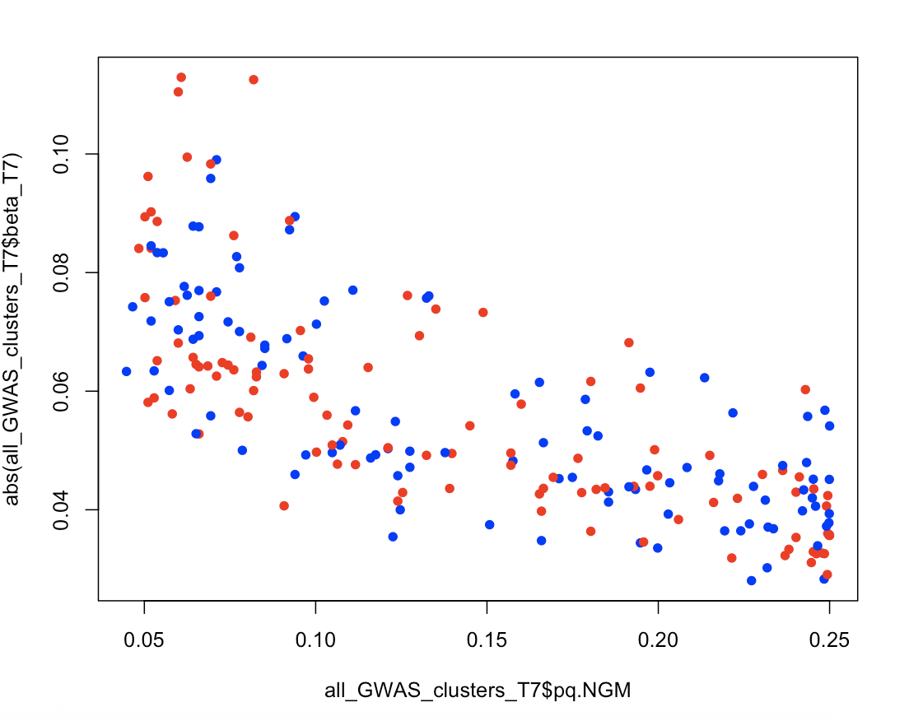

In NaCl, the same (although not on stabilizing selection)
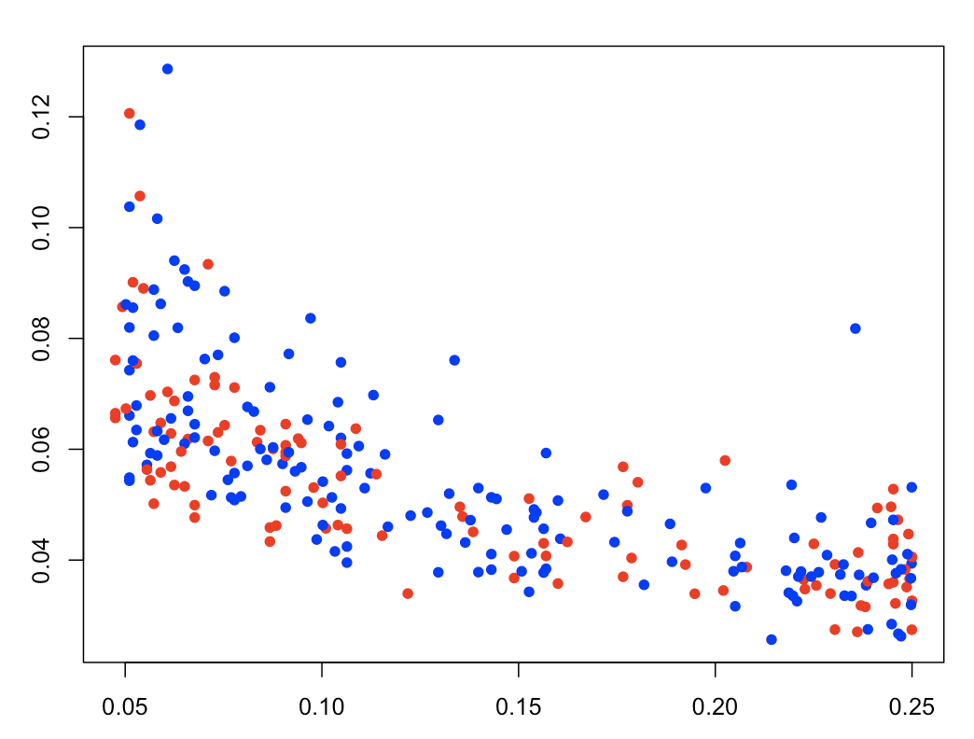

But, we don’t see that SNPs that only affect body size in NaCl are at larger frequencies (would be expected if neutral ?)
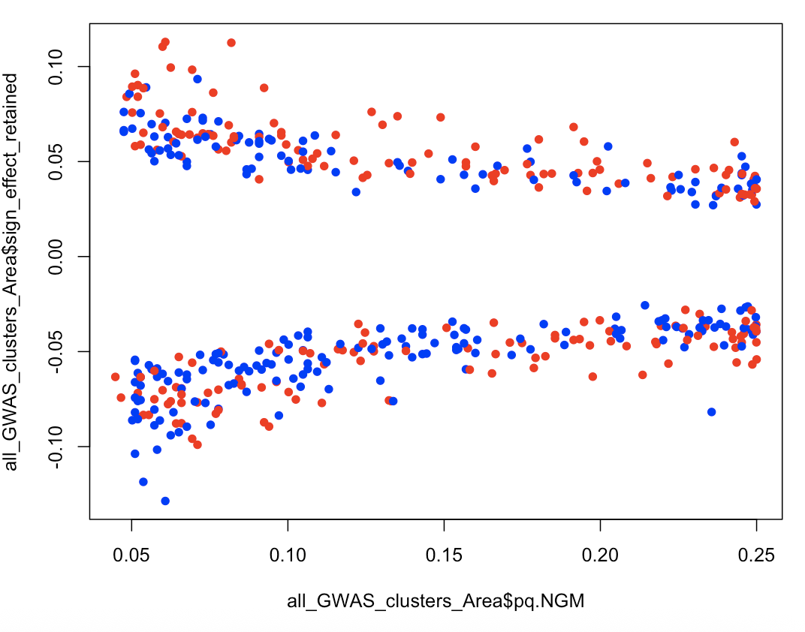

WARNING: here allele frequency of the panel, not of the A6140 populations / Should it be replaced ? … probably

