<https://arxiv.org/pdf/1709.01213.pdf>

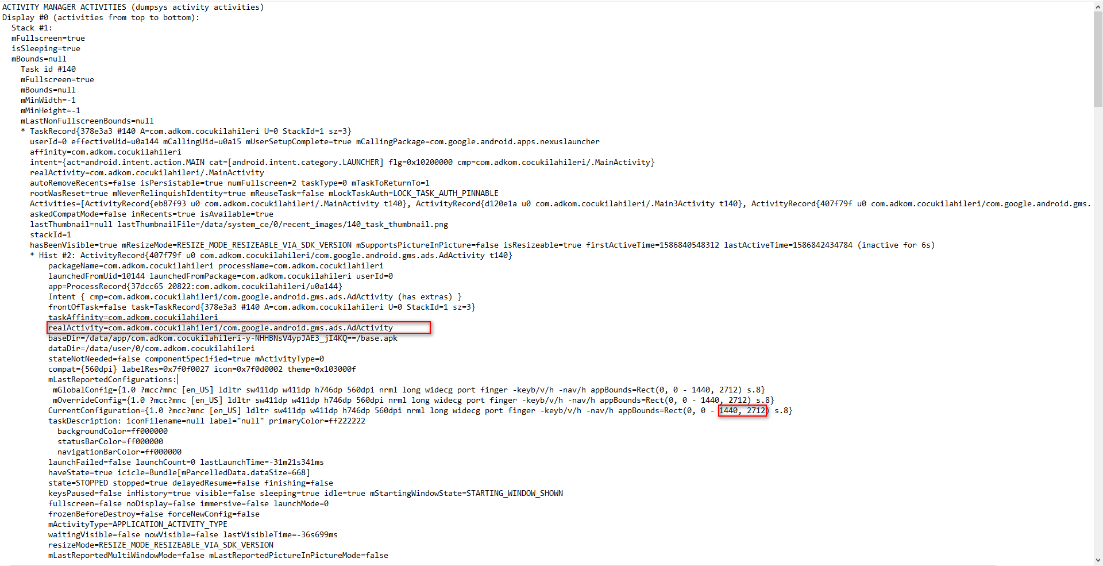

KeyWord: AdActivity

realActivity=com.adkom.cocukilahileri/com.google.android.gms.ads.AdActivity

Size = 1440\*2712

Physical size: 1440x2880

2712/2880 = 94.17%

Ad ratio [0.9,1]

