During coronavirus, Banking Trojans use fake coronavirus propaganda page to conduct phishing attacks. Banking Trojans will steal the victim's credit card information, SMS, contacts, call records, etc.

Fishing Domain：

<http://c-ovid19.space/>

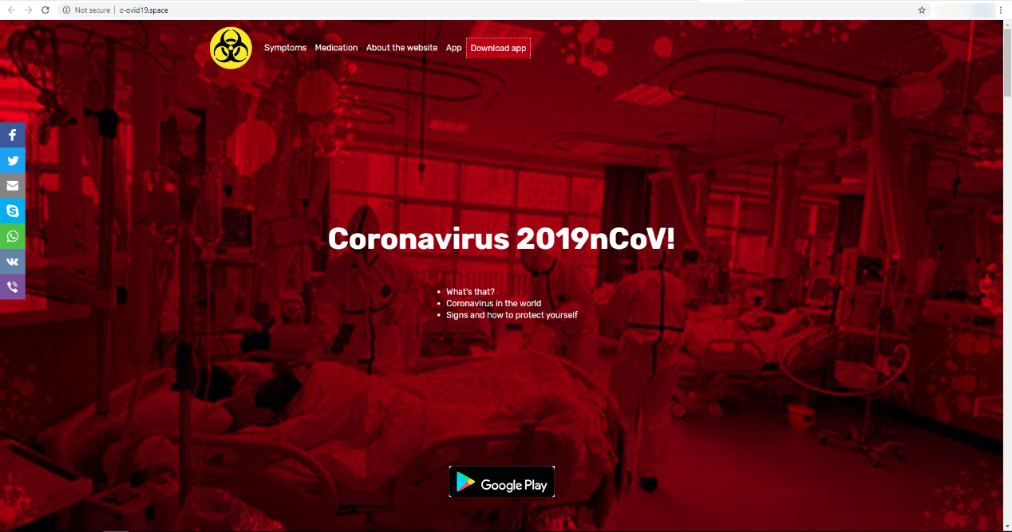

<https://covidapp-19.site/>

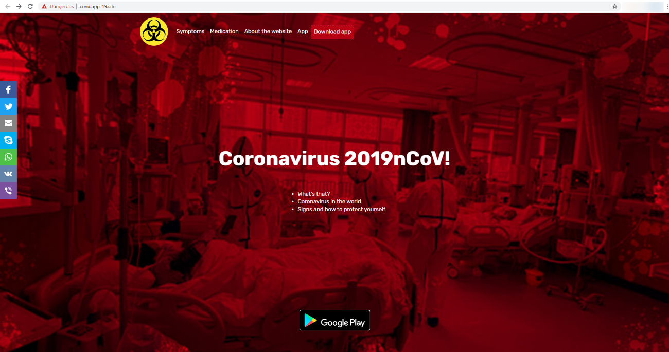

Download Banking Trojan

<https://covidapp-19.site/Covid-19tracker.apk>

<http://c-ovid19.space/CovidTracker.apk>

Indicators of Compromise:

|  |  |  |
| --- | --- | --- |
| Sha256 | Downloadd Name | Trend Micro Pattern Detection |
| fe5c9cab4f91b621eac9cc9b95984bfc8263d4d8bf68120814777fd92b85188d | Covid-19tracker.apk | AndroidOS_Hqwar.HRXI |
| 8e28ae16f571101f4029a04e3d10b759e32023dc8cee2076836051538dfef6a5 | CovidTracker.apk | AndroidOS_Hqwar.HRXI |