Product Name



Expectationeering Workbook

Version – June 2026

Contents
Product Name 1
Introduction 4
How to use the document? 4
Intended users of the document 4
Scope of the document 4
Report Out 4
Application 5
Stakeholders (INFORMAL) 5
Problem 5
Expectations 5
Ideal Product Model 6
Business ‘Requirements’ 8
Context (FORMAL) 9
Intended Use 9
Medical Device Classification 9
Context Diagram 10
Users 11
User Groups 11
User Requirements / Needs 11
User DFMEA 11
Use Scenarios 12
Usability FMEA 12
Usability Requirements 13
Concept 14
UI/UX Design 14
Actors 14
Use Cases 14
Design Decisions 15
Development 15
SOLUTION: <NAME> 15
External Interfaces 15
Requirements 15
Verification 17
Architecture 18
Detailed Design 18
DFMEA 19
Items 19
APPENDIX A: DOCUMENT STRUCTURE 21

Introduction
This workbook is designed to help you capture the expectations and requirements for your product. Defining and managing expectations and requirements is critical to the success of any product, as it ensures that the product meets the expectations of stakeholders and is aligned with the overall goals of the project. This workbook will be a useful tool for you and your team as you work to develop and deliver high-quality products that meet the expectations of stakeholders.

How to use the document?
All requirement items have a unique identifier in this document, starting with the stakeholder expectations. If an item is translated and traced into a next/lower item, then the cell it is colored green. By using the Navigation View (View-Menu) you can search for the traced items by simply typing the unique identifier in the search window. The traced items will light up in yellow. Use menu View-Split to investigate of modify the traceability.

Take the following rules into account when collaborating:
- This document is a TEAM effort.
- Do not add or remove content individually without agreeing with the team first.
- You can add comments instead to indicate a possible improvement.
- Never delete an ID, make it strikethrough if it becomes redundant.
- Before adding an ID, search if it is used already.
- Do not use track changes!

Intended users of the document
<Users in scope>

Scope of the document
<Product in scope>

Report Out
<Agenda report out>
- Setting the stage: why?
- What have we been doing?
- Results: Document.
- Next Steps: How to continue?

Application

Stakeholders (INFORMAL)
The stakeholder level is the start of the requirement approach but is not the start of the formal documentation and therefore labelled as non-DHF. Capturing the expecations is normally executing mostly during VPC but can be extended in EXP, AD and A&PC.

Problem
The starting point of requirement engineering is to capture the scope of the problem to be solved in a product agnostic way (e.g. the problem can be solved by a range of applicable products). The problem domain is captured by the actual state and the desired state. For this document the problem domain is defined as:

Domain Description
<Describe the applicable domain where your product and the competitor products provide a solution for>

Actual state
<Describe the pros and cons of the actual situation>

Desired state
<Describe the pros and cons of the desired situation (keep the pros of the actual state>

Identified Gaps
Formulate the desired design changes to move from the actual state to the desired state.
ID | Description
DC_ | <Describe the design changes for the desired situation>

Expectations
Identify the stakeholder for the defined problem domain and their corresponding expectations. Write the expectations in a way that they are “product free”. Meaning that they could apply to all products in the problem domain, including your competitor. The stakeholder expectations are the so-called problem statements because they refine the problem domain in more detail.

User Expectations

<User Stakeholder>
<Description of User Stakeholder>
ID | Expectation | Traces
UE_
UE_
Format: The <user stakeholder> wants <expectation> to <benefit driver>

Market Expectations

<Market Stakeholder>
<Description of Market Stakeholder>
ID | Expectation | Traces
ME_
ME_
Format: The <market stakeholder> wants <expectation> to <benefit driver>

Business Expectations

<Business Stakeholder>
<Description of Business Stakeholder>
ID | Expectation | Traces
BE_
BE_
Format: The <business stakeholder> wants <expectation> to <benefit driver>

Regulatory Expectations

<Regulatory Stakeholder>
<Description of Regulatory Stakeholder>
ID | Expectation | Traces
RE_
RE_
Format: The <regulatory stakeholder> wants <expectation> to <benefit driver>

For the identified stakeholder the corresponding expectations are elicited that again are written in a way that they are “product free”. Meaning that they could apply to all products in the problem domain, including your competitor. The stakeholder expectations are the so-called problem statements because they refine the problem domain in more detail.

Ideal Product Model
The Ideal Product Model is a core element of the value proposition, serving as a blueprint to align stakeholder expectations with product capabilities. It defines the key features, performance standards, and user interactions required to meet critical needs while enabling innovation. By creating a clear, shared vision of the end product, the Ideal Product Model minimizes ambiguity, accelerates development, and ensures the final product delivers maximum value to users, businesses, and regulatory stakeholders.

ID | Benefit Driver | Expectation | Proposition Attributes | Superior to | Priority | Feasible | Risk | Rationale
KA_ |  |  |  | Superior | Must Have | New | High | Combination of Superior / Must Have and / New makes this a high development risk. Failing means no produt release.
KA_ |  |  |  | On Par | Nice to Have | Unique | Medium | Being Unique makes this attribute a challenge to realize, but because it is a Nice To Have we are not at risk of not being able to release the product if this attribute failes tob e implemented. Therefore medium risk.
KA_ |  |  |  | On Par | Delighter | Difficult | Low | Even this attribute is difficult to realize, since it is a delighter we have no risk if this attribute fails to be released.
KA_ |  |  |  |  |  | Easy

Business ‘Requirements’
This business ‘requirements’ describe the conceptual project inputs from all business stakeholders that apply to the entire lifecycle of the product (e.g. development, launch, manufacturing, deployment, operation & use, end of life). Business ‘requirements’ need to be confirmed before release!
ID | BR_
Description
Rationale
Stakeholder
Importance
Traces

Context (FORMAL)
The context level is the starting point of the solution domain (DHF) based on the problem domain and the stakeholder expectations.

Intended Use
The intended use (also known as Intended Purpose) is the starting point of your formal documentation and is described by the following 5 aspects:
- Medical Device: What is the product?
- Medical Indication: What does it do?
- User Profile; Who is the intended audience?
- Use Environment: Where is it used?
- Operating Principle: How does it work?

ID | Description
IU_ | <Add description of the intended use>

Medical Device Classification
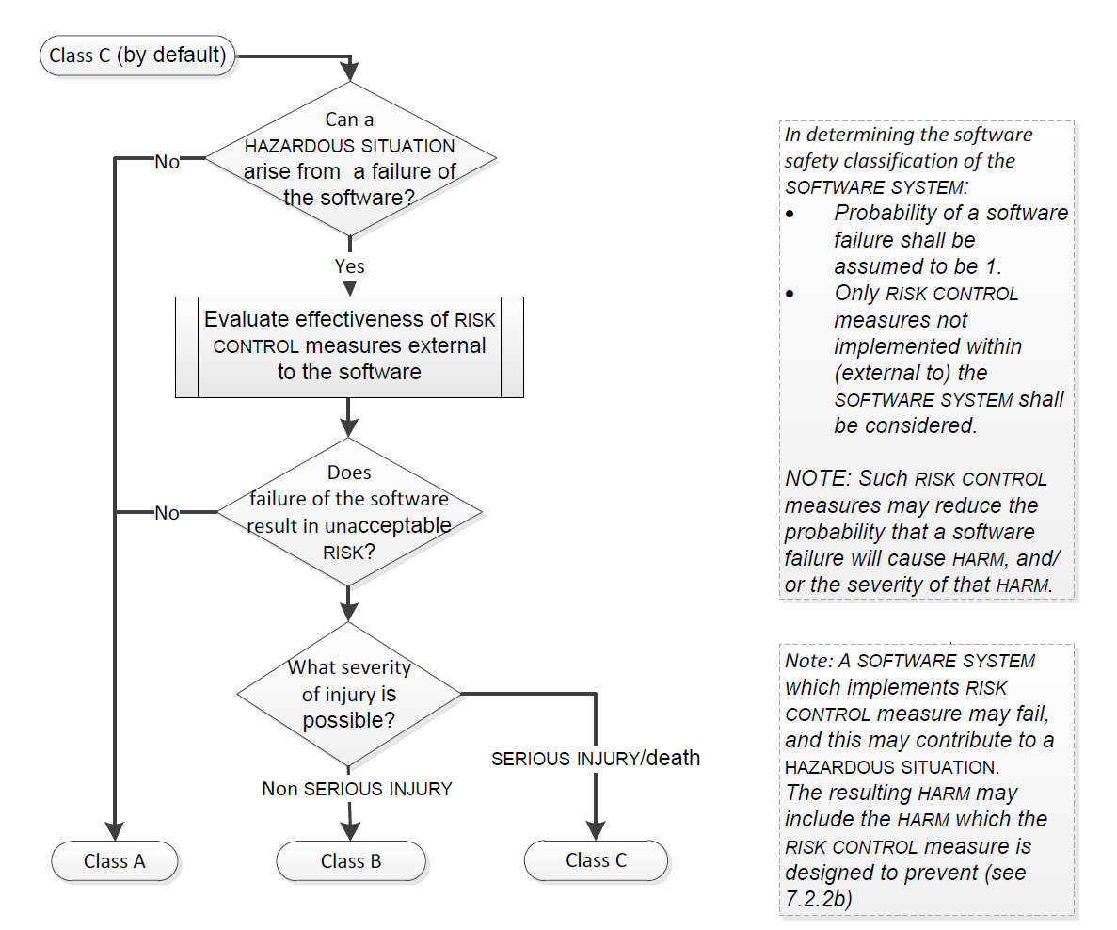
Figure 1: The IEC 62304 software classification

ID | MD_
Description | <Describe the assessed classification>
Traces

Context Diagram
The context diagram identifies the system of interest in relation to its context. The system of interest contains all elements that are part of the design.

<Add graphical image>
Figure 2: The product context

Product Information
A short product description that frames the rest of the context section: what the product is, what it is meant to deliver, and the principal way it operates. The detailed elements (system of interest, context boundary, interfaces) follow below.
<Description of the Product>

System of Interest
The System of Interest is the part of the broader system that this document is about: the product, subsystem, or component you are responsible for designing. Everything outside it is a context element, connected to it through external interfaces.
System Elements | Description
<SOI> | <Description>

Context Elements
The context elements are essential elements for your product but are not part of the design.
Context Elements | Description
<Element> | <Description>

External Interfaces
The external interfaces are the connections between the system of interest and the context elements in one of the following ways: mechanical, chemical, electronic, digital, logical etc.
ID | Name | Port 1 | Port 2 | ICD
IF_ | <Interface Name> | <Source> | <Destination> | <ICD Ref>

Users

User Groups
User groups are collections of users who share common characteristics, such as demographics, interests, or behaviors. User groups are often used in user-centered design and marketing to create products or services that meet the specific expectations of different user segments. A synonym for User Group could be User Role.
User | User Group | User Profile
<User 1> | <Group 1> | <Profile>
<User 2>
<User 3>
<User 4> | <Group 2> | <Profile>
<User 51>

User Requirements / Needs
At this point the user expectations are translated over the product context into user requirements. Meaning that we can use the elements that are identified in the product context in the description of the user requirements. In this way the user requirements are SMARTER than the user expectations and form the base for product validation. As opposed to user expectations, the user requirements are specific to YOUR product.

<User Group 1>
ID | UR_
Description | 1. As a <User Group 1> I want <feature> so that <benefit>  2. The <User Group 1> shall be able to <feature> with <benefit>
Classification | <Inherited from KA / PA>
Traces

<User Group 2>
ID | UR_
Requirement | 1. As a <User Group 2> I want <feature> so that <benefit>  2. The <User Group 2> shall be able to <feature> with <benefit>
Classification | <Inherited from KA / PA>
Traces

User DFMEA
A structured analysis of the ways users might misuse, misinterpret, or fail to operate the product, the consequences of those failures, and the mitigations the design must include. The output feeds the usability requirements.
ID | USER_DFMEA_
Item/Function
Requirement
Failure mode
End-effect
Rationale
Failure Cause
Severity
Prevention
Classification
Traces

Use Scenarios
Concrete narratives of how the product is used in the real world, walking through the steps a user takes from a triggering situation to a successful outcome. Use scenarios make abstract user requirements tangible and reveal interactions that drive design.

<Scenario 1>
ID | Use Task | Task Description | Traces
UT_ |  |  | UR_
UT_ |  |  | UR_
UT_ |  |  | UR_

Usability FMEA
An FMEA focused specifically on usability: where the user interface, workflow, or interaction model can lead to errors, slow operation, or unsafe outcomes. The findings drive the usability requirements and validation tests.
ID | UFMEA_
Scenario Title
Use Error
Cause
Effect
HF Cause
Rational
Usability Impact Level
Mitigation (existing)
Mitigation (new)
Classification
Traces

Usability Requirements
Measurable requirements for how the product must perform from a user perspective: task completion times, error rates, learnability, accessibility, and other usability characteristics. These are validated through usability testing.
ID | USR_
Requirement
Classification | <Inherited from UR>
Traces

Concept

UI/UX Design
The conceptual user interface and user experience design: wireframes, interaction flows, navigation structures, and visual design principles. This translates the user requirements into a tangible product concept that stakeholders can review and validate before development starts.

<Add UX/UI Designs>
Figure 3: The UX/UI Design

Actors
Actors are individuals, groups or systems who perform specific roles or tasks within the system or process. In the context of business analysis or process modeling, actors can be used to identify the different stakeholders, users, and other entities involved in a process or system.
Actor | Description
<Actor> | <Description>

Use Cases
<Add a diagram of the use cases>
Figure 4: The use-case diagram for <SOI>

<Use-Case 1>
ID | UC_ |  | Ref
Title | <Title of use-case>
Actor
Goal
Satisfies | UR_
Classification | <Inherited from UR>
Precondition
Main  Succes  Scenario | Scenario for normal use:
 | 1
 | 2
 | 3
 | 4
 | Do not type text in this line, insert a new line instead
Alternative  Scenario <1> | Alternative for step <#> of <MSS#, AS#>: <Deviation>
 | 1
 | 2
 | 3
 | Do not type text in this line, insert a new line instead
Exception  Scenario <1> | Exception for step <#> of <MSS#, AS#>: <Use Error>
 | 1
 | 2
 | 3
 | Do not type text in this line, insert a new line instead
Post Condition
Traces

Design Decisions
A design decision refers to the choices made by designers during the design process. Design decisions may involve selecting materials, choosing a manufacturing process, determining the product features, and deciding on the overall design approach. Design decisions are often subjective and can be influenced by a designer's experience, personal preferences, and design principles. Key aspect of formulating a design decision is by listing the considered alternatives and the rationale why the final choice has been made. In this paragraph, elaborate on the context diagram and describe the design decisions for the concept design (including UI).
ID | DD_<SOI>_
Decision
Alternatives
Rationale
Traces

Development

SOLUTION: <NAME>

External Interfaces
The external interfaces of this system: the points where it connects to context elements, sub-systems, or other systems. Each interface specifies the type of connection (mechanical, electrical, digital, logical, etc.), the data or signals exchanged, and the protocols or standards involved.

<Add a diagram of the product black box design>
Figure 5: The product black box design

Requirements
The full set of requirements the system must satisfy, derived from the user requirements and constrained by the context, regulatory requirements, and design decisions made so far. System requirements are SMART (Specific, Measurable, Achievable, Relevant, Time-bound) and form the basis for system verification.

Interface Requirements
ID | RQ_IF_
Description
Rationale
Classification
Traces

Functional Requirements
Requirements that describe what the system must do: the functions, features, and behaviors it offers to its users and other connected systems. Each functional requirement traces back to a use case or user requirement.

<Function 1>
ID | RQ_FN_
Description
Rationale
Classification
Traces

<Function 2>
ID | RQ_FN_
Description
Rationale
Classification
Traces

Performance Requirements
Quantitative requirements on how well the system must perform its functions: response times, throughput, accuracy, capacity, availability, and other measurable performance characteristics.
ID | RQ_PR_
Description
Rationale
Classification
Traces

Non-Functional Requirements
Requirements that describe how the system should behave rather than what it should do: reliability, maintainability, security, scalability, portability, and similar quality attributes. Compliance and training requirements often live here as well.
- Compliance Requirements
- Labeling Requirements
- Security Requirements
- Privacy Requirements
- Sustainability Requirements
- Environmental Requirements
- (Image) Quality Requirements
- Cleaning Requirements
- Work Instruction Requirements
- Training Requirements
ID | RQ_NF_
Description
Rationale
Classification
Traces

Constraint Requirements
External constraints the system must respect: regulatory rules, applicable standards, technology choices imposed by the wider ecosystem, environmental conditions, and any other boundaries that limit the design space rather than describe behavior.
ID | RQ_CS_
Description
Rationale
Classification
Traces

Verification
The set of verification activities that prove each system requirement is met: tests, analyses, inspections, and demonstrations. Each requirement traces to one or more verification methods so that completeness can be checked at the end of development.
ID | SV_
Description | Scenario: <Scenario title>  Given <condition>  And <condition>  When <action>  Then <respone>  | <parameter1> | <parameter2> |  | <value1> | <value2> |  | <value1> | <value2> |
Result | PASSED / FAILED
Traces

Architecture
The decomposition of the system into items (subsystems, components, modules) and the internal interfaces that connect them. The architecture is a deliberate response to the requirements and the design decisions taken in the Concept domain, and it enables independent development of items.

<Add a Whitebox diagram>
Figure 6: The product white box design

Items
ID | Name | Description

Internal Interfaces
ID | Name | Port 1 | Port 2 | ICD
IF_ |  | <Elemement1> | <Elemement2> | <Ref>

Detailed Design
The next layer of design beyond architecture: the specific algorithms, data structures, sequence flows, and control logic that implement each system function. The detailed design provides enough information for developers to implement the system without re-deriving structural choices.
ID | DS_
Description
Rationale
Classification
Traces

Sequence Diagrams
Sequence diagrams visualize the order of interactions between actors, the system, and its internal components for a given use case or function. Each diagram shows the messages exchanged and the timing relationships, making the runtime behavior explicit.

<Function 1>
<Add sequence diagrams per use-case>
Figure 7: The sequence diagram for <use-case 1>

Design Specifications
The tightly-defined specifications that result from detailed design: data formats, message structures, algorithm parameters, tolerances, and any other implementation details that the developer needs to build the system exactly as designed.

DFMEA
A Design FMEA at the system level: the ways the design itself can fail to meet its requirements, the consequences of those failures, the likelihood of occurrence, and the mitigations built into the design. The DFMEA drives risk-control measures and feeds back into the requirements and architecture.
ID | SYS_DFMEA_
Item/Function
Requirement
Failure mode
End-effect
Rationale
Failure Cause
Severity
Prevention
Classification
Traces

Items
The list of items the system has been decomposed into during architecture. Each item is detailed in its own subsection further down: its external and internal interfaces, requirements, architecture, detailed design, and DFMEA, in the same structure as the parent system.

ITEM: <NAME>
External Interfaces
Requirements
Verification
Architecture
Detailed Design
DFMEA
Item / Units

APPENDIX A: DOCUMENT STRUCTURE

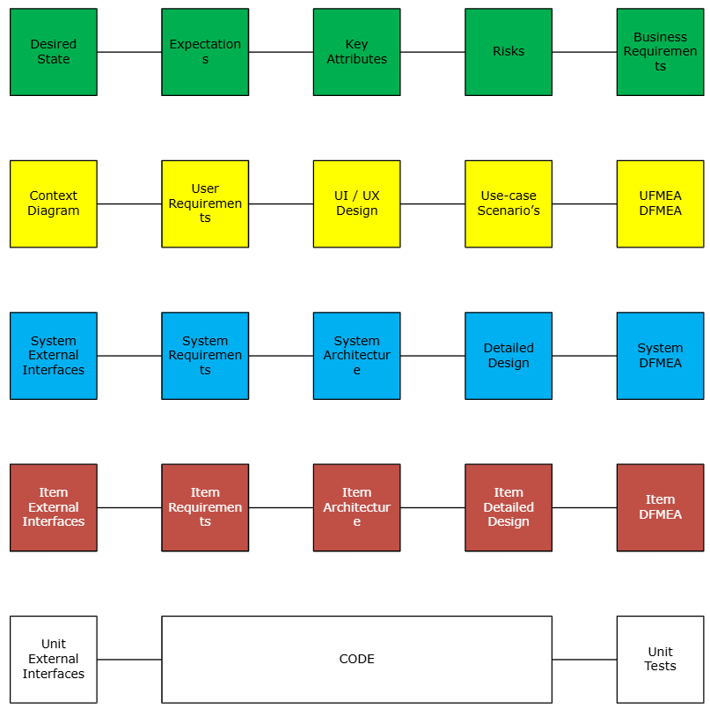
Figure 8: The workbook structure

