Mobile Monitor for Critical Care
AI Driven Diagnostic Support
Project Description
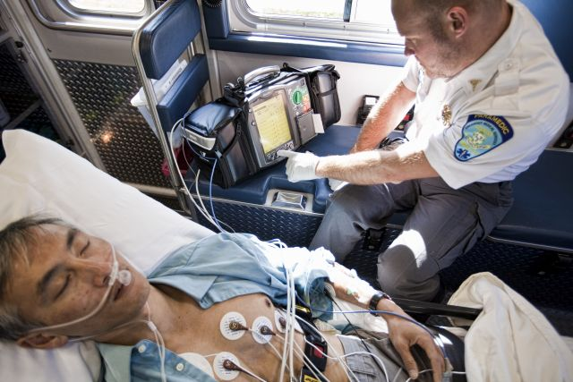

Mobile Monitoring Software Solution (MMSS)
Date: 2026-03-02

1. Project Overview

1.1 Purpose
The purpose of the MMSS project is to develop medical device software that transforms an existing portable patient monitor from a passive vital signs display into an active clinical decision-support tool. By integrating an AI-driven diagnostic engine into the monitoring software, MMSS enables clinicians — particularly in pre-hospital and mobile care settings — to receive ranked, real-time diagnostic candidates alongside raw vital signs data, converging to a predictive diagnosis within two minutes of patient connection.
The software acquires data from a defined set of non-invasive measurement devices through standardised interfaces, processes it through an AI analysis engine, presents vital signs and diagnostic output on a connected monitor display, generates clinical alarms for abnormal conditions and sensor faults, and optionally shares data with hospital information systems. The project delivers the complete MMSS software stack — from device acquisition through AI processing to user presentation and hospital integration — as a regulated medical device software product compliant with IEC 62304.

2. Scope
This project covers software development only. No hardware development, hardware modification, or hardware procurement is in scope. All physical components — the host CPU platform, measurement devices (ECG monitor, pulse oximeter, blood pressure monitor, thermal probe, capnometer, EEG monitor), monitor display, and physical enclosure — are treated as existing, fixed elements. MMSS interfaces with these components through defined interface control documents; their internal design and physical characteristics are outside the scope of this project.
In scope:
- Application software only — all five software items: AC, DAC, DEC, DPREC, DPROC
- Interfacing with the external Open Evidence AI library
- The AI model is used as a commercially validated off-the-shelf component
- Drivers and polling logic for the six measurement device types
- Vital signs display, alarm presentation, and diagnostic candidate rendering
- Hospital information system integration for second opinion
Out of scope:
- Hardware design, selection, or modification of any physical component
- Device behavior is fixed and accessed through published interfaces
- Physical enclosure, portability, weight, or battery design

3. Intended Use and Classification

3.1 Intended Use
The Mobile Monitor for critical care is intended to provide a comprehensive, real-time monitoring solution for critically ill patients. Its primary purpose is to ensure continuous tracking of key vital signs and offer diagnostic support through advanced technologies such as Artificial Intelligence (AI). The Mobile Monitor is portable, user-friendly, and non-invasive to provide maximum efficiency and comfort in various critical care environments, including intensive care units (ICU), emergency rooms, and mobile medical units. The Smart Mobile Monitor is intended to be used by trained medical professionals.

3.2 Medical Device Classification
Field | Value
Standard | IEC 62304
Initial Class | Class C — Failing software may result in death of the patient
After Mitigation | Class B — Alarming and diagnosis functions mitigated to independent systems

4. Product Context
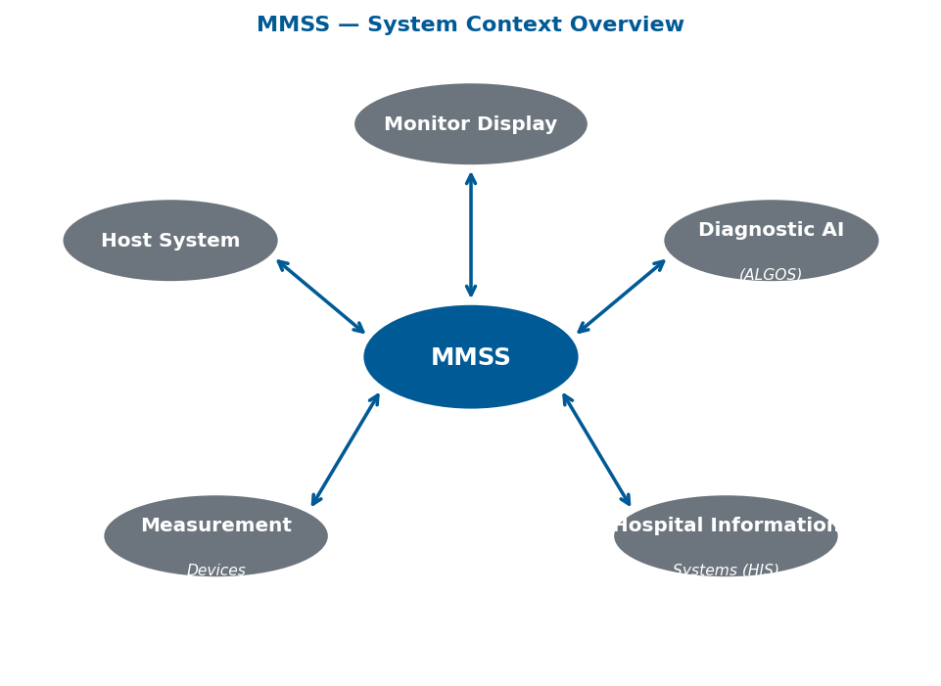

5. System Requirements
Requirement | Target
System Activation | < 10 seconds
Vital Signs Display | < 1 second after acquisition
Vital Sign Alarm Display | < 1 second after detection
Connection Alarm Trigger | 5 seconds of inactivity
Connection / Misplacement Alarm Display | < 1 second after trigger
Diagnose Candidates Display | < 1 second after receipt from AI
Diagnose Candidates → HIS | < 1 second
DPROC latency budget | ≤ 200 ms
DPREC latency budget | ≤ 800 ms
DEC latency budget | ≤ 800 ms
Diagnosis Convergence (ALGOS) | 2 minutes maximum
Vital Signs Input Rate | ≥ 0.1 Hz
UI Update Interval | 1 second (timer-based)

6. Constraints and Assumptions
Type | Statement
Constraint | First release must use commercially available validated AI model (Open Evidence) — no custom model
Constraint | Software must comply with ANSI AAMI IEC 62304 as Class C (mitigated to B)
Constraint | Must support 6 device types: ECG, Pulse Oximeter, BP Monitor, Thermal Probe, Capnometer, EEG
Constraint | 2-minute diagnosis convergence is an ALGOS budget — not an MMSS budget
Constraint | MMSS display latency budget is 1 second (DPREC ≤ 800 ms, DPROC ≤ 200 ms)
Assumption | Clinician users are trained medical professionals
Assumption | Host system is a compact embedded CPU with real-time OS capabilities
Assumption | Open Evidence provides structured diagnose candidates to MMSS
Assumption | HIS interface protocol TBD (HL7/FHIR) — ICDs to be defined
Assumption | ALGOS sends audible notification independently on 2-minute timeout — no residual MMSS risk

7. Risk Register
ID | Risk | Prob. | Impact | Mitigation
R_01 | AI algorithm regulatory clearance delays | Medium | High | Use commercially validated Open Evidence model; engage regulatory early
R_02 | AI model validation complexity | High | High | Off-the-shelf validated model mandated for v1.0
R_03 | Connectivity / real-time integration challenges | High | High | Prototype early; prioritise ICD definition for external interfaces
R_04 | Sensor misplacement not detected → wrong diagnosis | Medium | Critical | DEVICES must auto-detect misplacement
R_05 | Clinician misinterpretation of AI candidates | Medium | Critical | Mandatory simulation training mode in MMSS; hands-on training
R_06 | Diagnosis timeout not communicated → delay of treatment | Low | Critical | ALGOS and MMSS both notify on 2-minute timeout
R_07 | Connection failure not detected → missed vital signs | Low | Critical | DEVICES generate independent audible alarms; MMSS shows connection alarm
R_08 | Portability targets exceed budget | Medium | Medium | Confirm hardware platform weight/size targets early

