SAFETY EQUIPMENT DETECTION IN SPACE STATIONS USING YOLOv8 AND FALCON SYNTHETIC DATA

By: Prompt Pirates

Tagline: Spotting danger before it becomes a problem.

Hack Beyond 2025, Duality AI Challenge

INTRODUCTION

Space stations are highly controlled environments where accessibility to emergency equipment can mean life or death during crises such as cabin depressurization, chemical leaks, fire outbreaks, or oxygen system failures. Manual monitoring is insufficient due to limited crew size and continuous operational demands.
This project introduces a computer-vision system capable of automatically detecting safety equipment in real time using YOLOv8 and domain-randomized synthetic data.

Methodology

The dataset was generated using Falcon’s digital twin simulation platform. It include:-

1. Oxygen Tank
2. Nitrogen Tank
3. First Aid Box
4. Fire Alarm
5. Safety Switch Panel
6. Emergency Phone
7. Fire Extinguisher
Model Architecture
- Model Used: YOLOv8n (nano variant, fast + lightweight)
- Framework: Ultralytics YOLOv8
- Number of Classes: 7
- Losses Optimized: Box Loss, Objectness Loss, Classification Loss

Training Configuration

Parameter | Value
Epochs | 10
Batch size | 8
Image size | 640×640
Optimizer | Adam
Dataset file | yolo_params.yaml

Training Pipeline
1. Load and prepare dataset
2. Define YAML configuration
3. Initialize YOLOv8n model
4. Train for 10 epochs
5. Evaluate on validation + test sets
6. Save model and plots in runs

Results

Final Detection Performance

Metric | Score
Precision | 0.7729
Recall | 0.4600
F1 Score | 0.4021
mAP@0.5 | 0.5224
mAP@0.5:0.95 | 0.4021

Interpretation
- Strong precision (model predicts correct classes when confident)
- Moderate recall (misses some objects, especially small or occluded)

Class-wise Average Precision

Class | AP Score
Oxygen Tank | 0.562
Nitrogen Tank | 0.528
First Aid Box | 0.524
Fire Alarm | 0.269
Safety Switch Panel | 0.304
Emergency Phone | 0.251
Fire Extinguisher | 0.378

Observations
- Best performance → Oxygen Tank, Nitrogen Tank
- Worst performance → Emergency Phone, Fire Alarm

Model Architecture

YOLOv8n was selected due to its speed, efficiency, and suitability for deployment in constrained onboard systems.

The model consists of:

Backbone: CSP-based feature extractor
Neck: PANet for multi-scale feature fusion
Head: Decoupled detection head optimizing classification, bounding box regression, and objectness

Loss functions used:

- Box Loss
- Classification Loss
- Objectness Loss

CHALLENGES

Challenge 1: Poor Recall (Missed Objects)

Issue: Recall was only 0.46, meaning the model missed many objects.

Cause: Limited training epochs, small model size (YOLOv8n).

Fix: Increase epochs to 50+, add Mosaic augmentation.

Expected Impact: Higher mAP@0.5 and Recall.

Challenge 2: Low AP for Certain Classes
Fire Alarm and Emergency Phone had AP < 0.30.

Cause:
- Small objects
- Fewer samples
- High similarity to background

Fix:
- Class weighting
- Oversampling rare classes
- Increase image resolution to 768

Expected Result: Improved per-class AP consistency.

Challenge 3: Occlusions and Complex Lighting

Problem: Strong misclassifications with dark shadows or partial visibility.

Fix: motion blur, shadow augmentation.

Expected Result: Model robustness across lighting conditions.

Challenge 4: Underfitting Due to Short Training
10 epochs is insufficient for YOLOv8n.

Expected Result: Lower loss, smoother PR curve.

Challenge 5: Imbalanced Class Occurrence
Emergency Phone appeared less frequently → low AP.

Fix:
- SMOTE-like augmentation
- Copy–paste augmentation

Expected Outcome: Balanced class performance.

Challenge 6: Training required significant time

Challenge 7: Frequent wrong predictions by the model

Process Flowchart
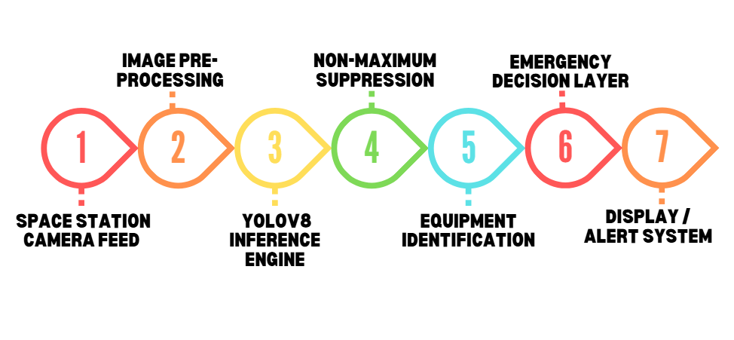
Conclusion

We successfully trained a YOLOv8-based object detection model to detect 7 critical safety objects inside a simulated space station. Using Falcon’s synthetic data, we achieved:

- mAP@0.5 = 0.5224
- Precision = 0.7729
- Recall = 0.4600

The model performs well for large and distinct objects (Oxygen Tank, Nitrogen Tank) but struggles with small, low-contrast objects.

This project demonstrates how synthetic data combined with YOLOv8 can create reliable AI systems for environments that are otherwise inaccessible, such as space stations.

Future Improvements

- Train longer (10 epochs)
- Use YOLOv8m or YOLOv8l instead of YOLOv8n
- Add more domain randomization
- Implement object tracking for real-time deployment
- Train with augmented small-object-focused dataset
- Explore transformer-based detectors (RT-DETR, YOLOv8)

